# **Mobile Computing**

WS 2022-23

**Provisioning of 5G Stand- Alone Systems using 5GCore and UERANSIM**

Prof. Armin Lehman

Master's in Engineering

Information Technology

**Project Members**

*Jenny Nadar 1427226*

*Nasteeyan*

*Shiva Kumar Biru*

*Sriram Karunanithi* *1438891*

**Table of Contents**

# Introduction

A 5G Standalone (SA) system is a 5G network architecture that functions separately from current 4G/LTE networks. All network elements in a 5G SA system, including the core network and radio access network (RAN), are built using 5G specifications and protocols. To test and validate the deployment and functionality of 5G networks, UERANSIM is a tool for simulating 5G User Equipment (UE) and Radio Access Network (RAN) devices. Our objective is to develop a 5G stand-alone system using the 5G network functionalities like User Plane Function (UPF), Access and mobility management function (AMF), Session Management Function (SMF), Network Slicing Selection Function (NSSF), User Equipment (UE) and gNb.

# 2. Theoretical Foundation

The different ideas that were applied to reach the project's objectives are discussed in detail in this section. Use of UERANSIM is utilized to achieve the VoIP, file sharing and streaming services between different tenant groups. The ‘Network slicing’ is thus performed to access these services, however it can only be achieved through UERANSIM. Since network slicing is not compatible with gNB, thus the direct connection between the UE and data network is achieved. The implementation of all the services and architectural behaviour is described briefly in this section.

### 2.1 Open5GS

Open5GS is an open-source implementation of 5G Core Network (5GC) and EPC (Evolved Packet Core), designed to provide a platform for researchers, developers, and operators to experiment, test, and deploy 5G networks. It offers a flexible and modular architecture, allowing for customization and extension to meet various deployment scenarios and requirements. Open5GS aims to promote innovation and collaboration in the 5G ecosystem by providing an accessible and interoperable framework for building next-generation mobile networks.

### 2.2 EURANSIM

UERANSIM is an open source 5G UE & 5G RAN (gNodeB) implementation. It can be considered as a 5G mobile phone and a base station in basic terms. There are 3 main interfaces in UE/RAN perspective,

* Control Interface (between RAN and AMF)
* User Interface (between RAN and UPF)
* Radio Interface (between UE and RAN).

UERANSIM supports to run with Open5GS and Free5GC 5G Core networks. We can connect UERANSIM to one of these 5G Core network and test the functionality.

### 2.3 5G Core Network

The 5G Core Network (5GC) is a key component of the 5G architecture, responsible for managing and orchestrating various network functions to deliver enhanced mobile broadband, ultra-reliable low-latency communication (URLLC), and massive machine type communication (mMTC). Here is a detailed breakdown of the components and functions within the 5G Core Network:

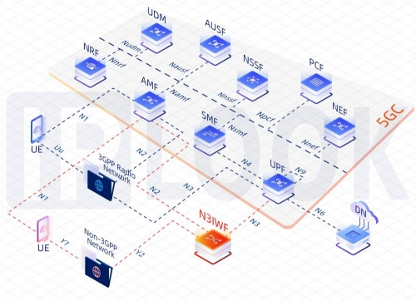

Figure 1: 5G Core Network

Components of 5G Core

1. Access and Mobility Management Function (AMF):

* Handles the authentication, authorization, and mobility management of user devices (UEs).
* Coordinates the connection setup, mobility, and handover procedures.
* Manages user plane security.

2. Session Management Function (SMF):

* Establishes and manages data sessions for user devices.
* Handles the routing and forwarding of user data packets.
* Implements policies for quality of service (QoS) and traffic steering.

3. User Plane Function (UPF):

* Provides the data forwarding functionality for user traffic.
* Performs packet routing, forwarding, and encapsulation/decapsulation.
* Supports various user plane functions such as packet inspection, filtering, and optimization.

4. Authentication Server Function (AUSF):

* Handles authentication and key management functions for user devices.
* Validates user credentials and generates security keys for secure communication.

5. Unified Data Management (UDM):

* Manages subscriber data and profiles.
* Stores user subscription information, authentication credentials, and service profiles.
* Provides functions for subscriber data retrieval and management.

6. Network Exposure Function (NEF):

* Provides APIs for external systems to access network functions and services.
* Enables third-party applications and services to interact with the 5G Core Network.

7. Application Function (AF):

* Supports service-specific functions and applications.
* Provides interfaces for integrating specialized services such as network slicing, edge computing, and IoT services.

8. Policy Control Function (PCF):

* Implements policy enforcement and management.
* Defines and enforces policies for QoS, traffic prioritization, and network resource allocation.

9. Binding Support Function (BSF):

* Supports interworking between 5G and non-3GPP access networks.
* Facilitates mobility and session management across different access technologies.

10. Policy and Charging Rules Function (PCRF):

* Manages policy and charging rules for network services.
* Enforces policy decisions related to charging, billing, and resource allocation.

11. Network Slice Selection Function (NSSF):

* Selects appropriate network slices based on service requirements and network conditions.
* Facilitates the creation and management of network slices tailored to specific use cases.

12. Non-3GPP Interworking Function (N3IWF):

* Enables connectivity between 5G networks and non-3GPP access technologies such as Wi-Fi.
* Handles protocol conversion and signalling translation between different access networks.

These components work together to provide a scalable, flexible, and efficient infrastructure for delivering a wide range of services and applications in the 5G ecosystem. The modular architecture of the 5G Core Network enables operators to deploy and customize network functions according to their specific requirements and use cases.

### 2.4 Network Slicing

Network slicing is a fundamental concept in 5G networks that allows the creation of multiple virtual networks, each tailored to serve specific types of applications, services, or customers. It enables the efficient allocation of network resources and the customization of network behaviour to meet diverse requirements, such as ultra-reliable low-latency communication (URLLC), massive machine type communication (mMTC), and enhanced mobile broadband (eMBB).

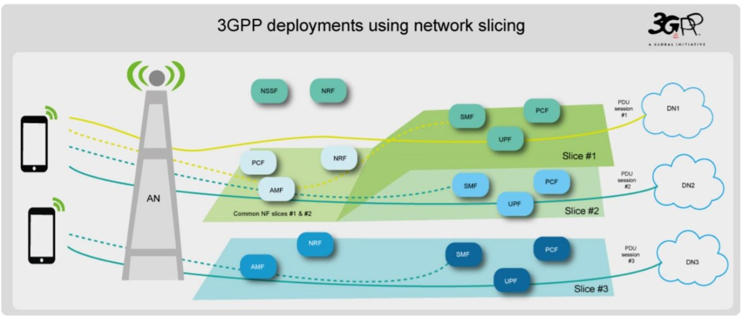

Figure 2: Network Slicing

Network slicing involves dividing a physical network infrastructure into multiple virtual networks or slices, each with its own isolated resources, configuration, and management policies. Each network slice is treated as an independent logical network, providing dedicated and customizable connectivity, performance, and service characteristics.

There are several types of network slices, including service-based slices designed to accommodate specific services or applications, tenant-based slices allocated to individual customers or tenants for enhanced security and performance, and vertical slices customized for specific industries or sectors. This versatility enables service providers to offer differentiated services and premium features, catering to diverse user needs and market demands.

The implementation of network slicing relies on advanced technologies such as software-defined networking (SDN) and network function virtualization (NFV). SDN enables centralized control and programmable management of network resources, while NFV allows the virtualization of network functions, facilitating flexible and efficient resource allocation. Through the orchestration and coordination of these technologies, network slicing ensures seamless connectivity and service delivery across the entire network infrastructure.

The benefits of network slicing are manifold. It enhances resource efficiency by dynamically allocating capacity and bandwidth according to the requirements of each slice, optimizing network utilization. Additionally, it enables service customization by allowing operators to tailor network behaviour and performance parameters to meet specific service-level agreements (SLAs) or quality of service (QoS) requirements. Moreover, network slicing enhances security by providing logical isolation between slices, preventing interference, and ensuring data privacy and integrity.

Furthermore, network slicing promotes scalability and flexibility, enabling operators to rapidly deploy and scale services to meet evolving demands. This agility is crucial in supporting emerging applications and use cases, such as edge computing, IoT, and smart cities. Finally, network slicing creates new monetization opportunities for service providers, allowing them to offer premium services, value-added features, and specialized solutions to customers, thereby driving revenue growth and market differentiation.

### 2.5 Next Cloud

Nextcloud is a versatile, open-source cloud platform offering individuals, teams, and organizations a comprehensive suite of tools for secure file storage, collaboration, and communication. With Nextcloud, users can upload, sync, and access files across multiple devices, ensuring seamless access to data from anywhere. Its robust versioning and conflict resolution capabilities streamline collaboration, while built-in document editing, and real-time collaboration features facilitate efficient teamwork. Nextcloud prioritizes security and privacy, providing end-to-end encryption, two-factor authentication, and access control features, ensuring users have full control over their data. Moreover, it integrates communication tools like video conferencing and chat, along with calendar and contacts management functionalities, enhancing productivity and organization. Nextcloud is highly customizable and extensible, with a wide range of plugins available to tailor the platform to specific needs. It supports self-hosting, allowing users to deploy the platform on their own servers or cloud infrastructure, ensuring data sovereignty and compliance with privacy regulations. Overall, Nextcloud offers a flexible, feature-rich, and secure cloud solution for those seeking control over their data and collaboration tools.

# 3. Design and Implementation

### 3.1 Architecture

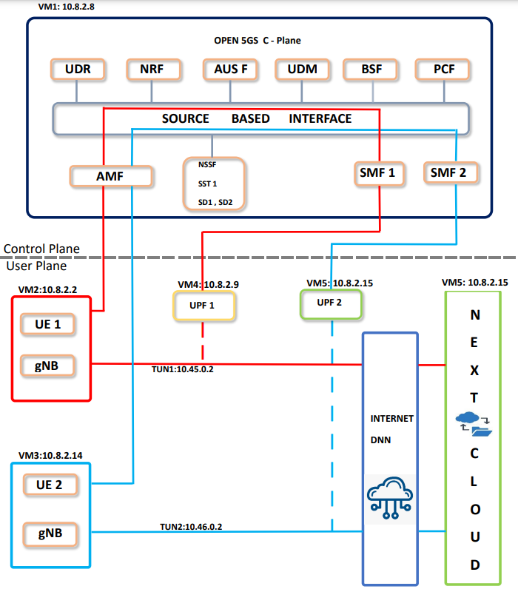

### 3.2 Installation Procedures

### 3.3 Implementation