# Working with git and Visual Studio

## Install Git

### Install Git tools for Visual Studio

1. If you haven’t installed git tool at initial installation of VS go to tab ‘Tools’ in Visual Studio and click ‘Get Tools and Features’.  
   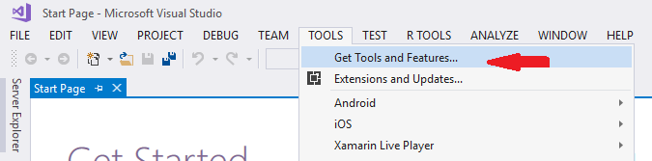
2. Now a new application named ‘Visual Studio installer opens’
3. Select ‘Git for Windows’ and ‘GitHub extension for Visual Studio’ under ‘individual components’ and click modify.  
   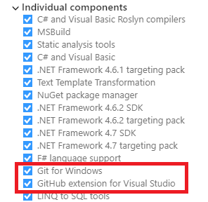

### Install Git without Visual Studio

1. Go to <https://git-scm.com/download/win> and follow instructions. Use according version for Linux.

## Clone repository

### Using Visual Studio

1. Go to ‘Team Explorer’ and click ‘connect’ under GitHub.  
   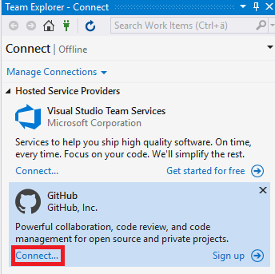
2. Enter you GitHub credentials
3. Click ‘Clone’
4. Select our repository from list
5. Enter your desired path.
6. Click ‘Clone’  
   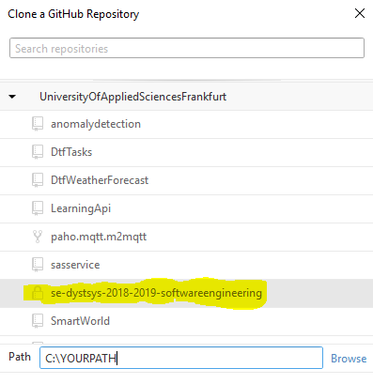
7. You can now see the repository in the list of local repositories in Team Explorer.  
   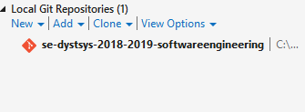

### Using command line

1. Go to the GitHub.com and navigate to the repository.
2. Click on ‘Clone or download’ and copy the URL.  
   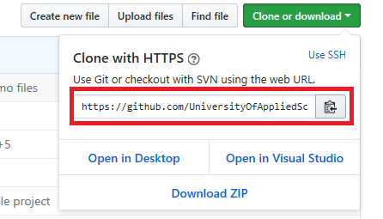
3. Open Command line tool / Git bash and navigate to the folder you want the repository data to be stored in.
4. Type following command end press enter: ‘git clone https://github.com/UniversityOfAppliedSciencesFrankfurt/se-dystsys-2018-2019-softwareengineering.git’  
   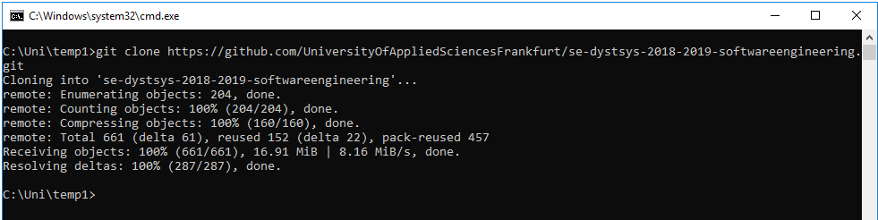
5. Done!

## Creating your branch

### Using Visual Studio

1. Double-click the repository in the ‘local repositories’ list.  
   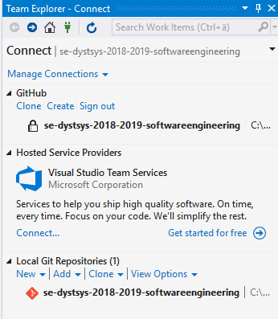
2. Click on ‘Branches’  
   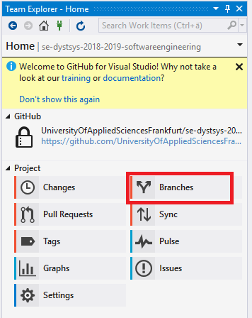
3. Click ‘New branch’
4. Enter a name for your branch (your name)
5. Click ‘Create’
6. Done!

### Using command line

1. Navigate to the repository root folder
2. Type ‘git checkout -b YOURBRANCH’(your name)
3. Type ‘git push origin BRANCHNAME’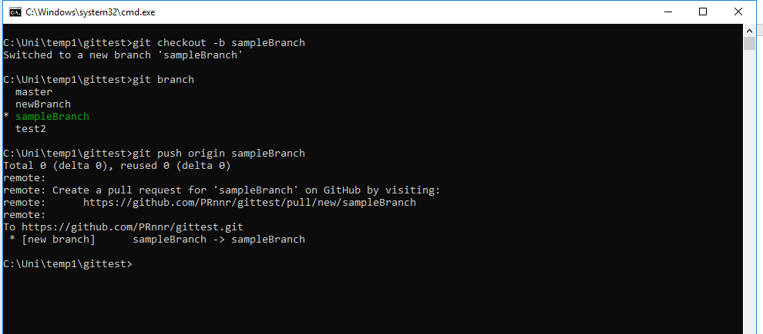
4. Done!
5. Note that you can see which branch you’re working in by using the command ‘git branch’

## Committing your work

### Using Visual Studio

1. In order to work on projects, you can select existing one from ‘Solutions’ create a new one or add another existing which you copied into the repository folder by clicking ‘open’  
   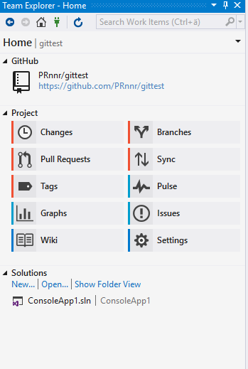
2. When you made changes to your projects go to changes and see all changes made to you work.
3. Enter a description for your changeset and click ‘Commit all’
4. Be sure your working in your branch!

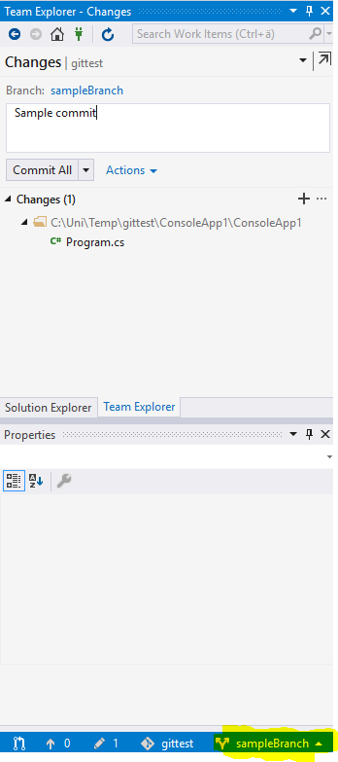

1. Go To ‘Sync’
2. Click ‘Sync’

### Using command line

Navigate to the repository your changes were made in.

Type ‘git add -A && git commit -m “DESCRIPTION” and press enter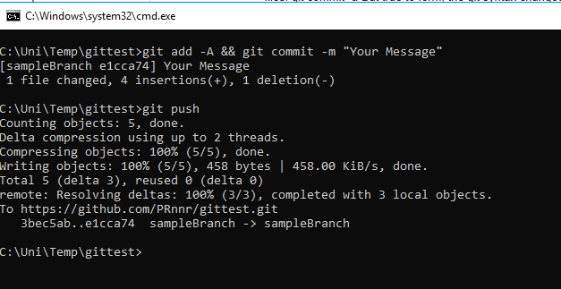

Done!