TODos

# Semester Todos

## Create git classroom and repository

1. Go to [GitHub Classroom](https://classroom.github.com/classrooms) and sign in.
2. Click ‘New Classroom’ and select the Universities organization on the next page.  
   
3. Enter a name (for example se-cloud-2021-2022) and click ‘Create Classroom’.
4. Skip next two steps for now.
5. Create a new group assignment  
   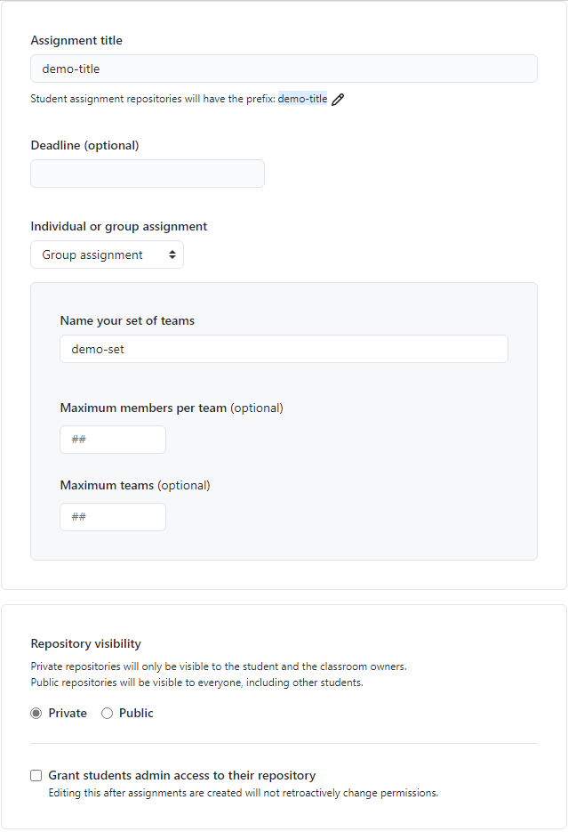
6. Copy invitation link and open it.
7. Create a new team. It is the team all students must join later.
8. Close the page and open the link again. You will now be asked to accept the assignment. If you do so, the repository will be created for the classroom.
9. Go to repository settings and change name.
10. Clone repository and add .md files and Samples to it
11. Update .md files with new due dates etc.

## Prepare Azure Subscription for Cloud Computing

Check if resources like Azure accounts have to be set up or ordered from university. Mostly talk back to Mr. Pech in order to get access. Example: Azure Subscriptions

## Update project document

1. Mark migrated projects from previous semester.
2. EXAMPLE, How to mark them.Add new projects to the document. Talk to Mr Dobric about that.

## Prepare Excel documents

There a two Excel documents to maintain. One public document, where students can enter their information and group names. Important are git account and URL to their branch and group project.  
The other one is to keep track of progress and projects. Get the required information from public document

## Update LinkedIn group

1. Remove all students, who don’t attend this semester, from LinkedIn group.
2. Create a new topic with link to git classroom and Excel list

## Check exercises each week

1. Check each student’s branch for exercises of the week.
2. Grading depends on meeting deadlines, quality of code and shape.
3. Enter grade for exercise into column in Excel document.
4. For more detailed explanation to grading talk to Mr Dobric

## Track issues

1. Check if issues have tags, indicating action is required, like ‘help-wanted’ and provide assistance.
2. Check if students replied on requests and remove ‘waiting-for-feedback’ tags.

## Migrate very good projects

1. Create the project folder in the repos that contains scoring of all projects:  
   [se-cloud-2019-2020/Projects at master · UniversityOfAppliedSciencesFrankfurt/se-cloud-2019-2020 (github.com)](https://github.com/UniversityOfAppliedSciencesFrankfurt/se-cloud-2019-2020/tree/master/Projects)  
   Check which projects got an 1 or 2 grade this semester.
2. Talk back which of those have to be migrated.
3. Run Tests and check if everything still works.
4. Add those projects and their documentation to the overview page.