Priority Disaster Management Zones in California:
A Composite GIS Analysis of Wildfire Hazard and Population Density
Jenna Lee
GEO 388 | Spring 2026

1. Introduction
California is one of the most wildfire-prone states in the United States. In recent decades, the state has experienced increasingly frequent and destructive wildfires driven by prolonged droughts, rising temperatures, and the expansion of human settlements into fire-prone areas. These events have resulted in significant loss of life, property damage, and long-term environmental consequences.
As California’s population continues to grow in high-risk areas, the need for effective and data-driven disaster management has become more critical than ever. Traditional approaches to disaster planning often rely on single-variable assessments, such as wildfire hazard alone, without accounting for the human exposure dimension. A more comprehensive approach that integrates both environmental hazard and population vulnerability is essential for prioritizing limited resources and planning effective evacuation strategies.
This project aims to address this gap by using GIS to identify Priority Disaster Management Zones across California. By intersecting wildfire hazard potential data with population density, this analysis produces a Composite Risk Index that reflects both the physical risk of wildfire and the human populations exposed to it. The goal is to provide a spatially explicit, data-driven foundation for disaster response planning and resource allocation.

2. Data
Four primary datasets were used in this analysis, each selected for their relevance to wildfire hazard assessment and population vulnerability.

2.1 Wildfire Hazard Potential
The Wildfire Hazard Potential (WHP) raster dataset was obtained from the USDA Forest Service (2023). This dataset provides a national-standard classification of wildfire potential based on topography, vegetation type, and historical weather conditions. The data is classified into five categories: Very Low (1), Low (2), Moderate (3), High (4), and Very High (5), as well as Non-burnable (6) and Water (7) classes. The dataset was downloaded as a GeoTIFF file covering the contiguous United States.

2.2 Population Density and Census Boundaries
Population density and administrative boundary data were obtained from the U.S. Census Bureau TIGER/Line Shapefiles (2024). Block Group-level boundaries were used as the primary unit of analysis for population density calculation, as they provide a fine-grained spatial resolution appropriate for this type of analysis. County boundaries were used for the Zonal Statistics analysis. Population counts were obtained from the U.S. Census Bureau data portal using Table B01003 (Total Population).

2.3 California Fire Perimeters
Historical fire perimeter data was downloaded from the California Open Data Portal, sourced from CAL FIRE (2024). This dataset includes the boundaries of documented wildfire burn areas across California. It was included in the analysis to provide historical context and to validate the results of the Composite Risk Index by comparing modeled high-risk zones with areas that have experienced actual wildfires.

2.4 Road Network
Primary and secondary road network data for California was obtained from the U.S. Census Bureau TIGER/Line Shapefiles (2024). This dataset was used to visualize evacuation route accessibility in relation to high-risk zones identified by the Composite Risk Index.

3. Methodology

3.1 Coordinate System Alignment
All datasets were projected to a common coordinate system, NAD 1983 Contiguous USA Albers, using the Project and Project Raster tools in ArcGIS Pro. This equal-area projection was selected because it accurately preserves area measurements across large extents, which is essential for population density calculations and spatial overlay analysis. All layers were clipped to the California state boundary prior to analysis.

3.2 Population Density Calculation
Population density was calculated at the Block Group level by joining Census population counts to the TIGER/Line Block Group boundaries using the GEOID field as the common key. Density was expressed as persons per square kilometer, calculated by dividing total population by land area converted from square meters to square kilometers.
Due to the highly skewed distribution of population density across California, where a small number of urban areas have extremely high densities compared to the majority of rural areas, a log transformation was applied to the density values prior to rasterization. This transformation compresses the range of values and allows for more meaningful visual differentiation across the map.

3.3 Reclassification
Both the WHP raster and the population density raster were reclassified to a common 1-5 scale using the Reclassify tool in ArcGIS Pro. For the WHP raster, the existing 1-5 risk classes were retained, while Non-burnable areas were reassigned a value of 1, and Water areas were set to NoData and excluded from analysis. For the population density raster, values were divided into five classes corresponding to values 1 through 5.

3.4 Weighted Overlay
A Weighted Overlay analysis was performed to produce the Composite Risk Index. A weight of 60% was assigned to wildfire hazard potential and 40% to population density. This weighting reflects the prioritization of wildfire hazard as the primary determinant of disaster risk, while acknowledging population density as a critical secondary factor that determines human vulnerability. The resulting Composite Risk Index ranges from 1 (lowest risk) to 5 (highest risk).

3.5 Zonal Statistics
The Zonal Statistics as Table tool was used to calculate summary statistics for the Composite Risk Index within each California county boundary. The mean Composite Risk Index value per county was used to rank all 58 California counties by overall disaster risk priority.

4. Results

4.1 Composite Risk Index Map
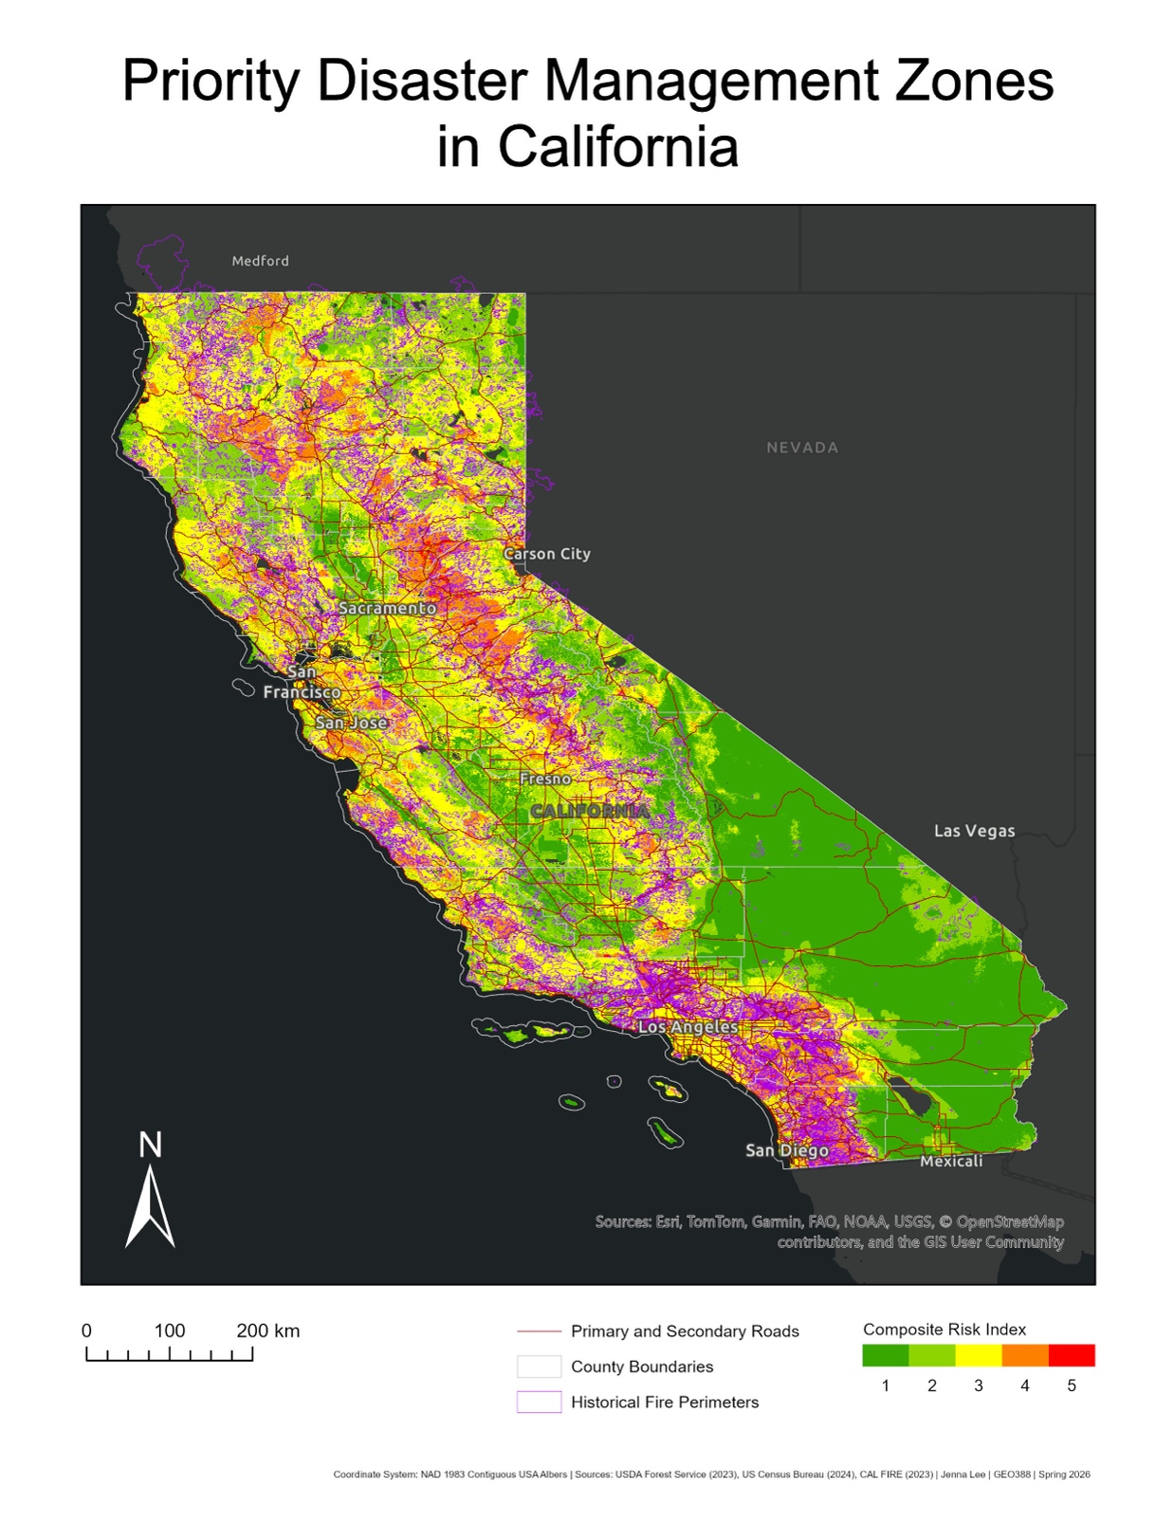
The Composite Risk Index map reveals a clear spatial pattern of wildfire disaster risk across California. The Composite Risk Index map is shown in Figure 1 below.
Figure 1. The Composite Risk Index Map
The highest-risk areas are concentrated along the Sierra Nevada foothills in Northern and Central California, as well as along coastal areas near San Francisco and Sacramento. These regions are characterized by a combination of high wildfire hazard potential and significant population density, making them particularly vulnerable to wildfire disasters.
In contrast, the southeastern desert region of California, including the Mojave Desert, shows predominantly low risk values. Although these areas experience dry conditions, they have sparse vegetation and relatively low population density, resulting in lower composite risk scores.
Southern California, Particularly the Los Angeles and San Diego metropolitan areas, also exhibits elevated risk values. This reflects the combination of high population density and significant wildfire hazard in the region, consistent with the area’s history of destructive wildfires. The historical fire perimeters from CAL FIRE largely overlap with areas identified as high-risk by the Composite Risk Index, providing validation for the analytical approach.

4.2 County-Level Risk Ranking
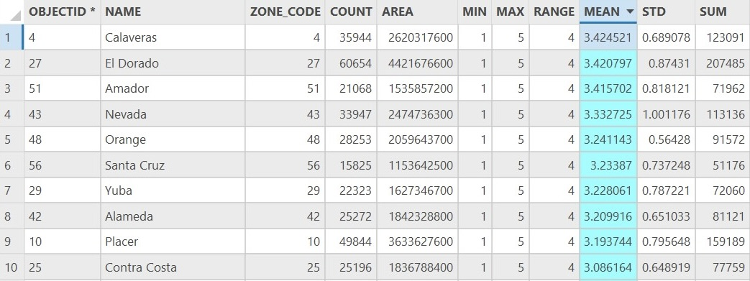
The Zonal Statistics analysis produced mean Composite Risk Index values for all 58 California counties. The top 10 highest-priority counties are shown in Table 1 below.
Table 1. Top 10 Highest-Risk Counties by Mean Composite Risk Index
The top 4 counties (Calaveras, El Dorado, Amador, and Nevada) are all located along the Sierra Nevada foothills. This geographic clustering reflects the region’s unique combination of dense vegetation, a dry Mediterranean climate, steep terrain that accelerates fire spread, and growing rural residential communities. These counties should be considered the highest priorities for evacuation planning and disaster resource allocation.

5. Discussion
The results of this analysis demonstrate the value of a composite, multi-factor approach to disaster risk assessment. A wildfire hazard-only analysis would identify the Sierra Nevada foothills and remote mountain areas as the highest-risk zones but would fail to account for the human dimension of disaster risk. By incorporating population density, this analysis highlights areas where the intersection of environmental hazard and human vulnerability creates the greatest need for disaster management resources.
The finding that all top 4 highest-risk counties are located along the Sierra Nevada foothills is consistent with California’s recent wildfire history. The 2018 Camp Fire, which destroyed the town of Paradise in Butte County, is a prominent example of the catastrophic potential of wildfires in this region. The results of this analysis suggest that neighboring counties such as Calaveras, El Dorado, Amador, and Nevada face similar levels of risk and warrant comparable levels of preparedness.
The road network overlay adds an important dimension to the analysis by highlighting areas where high wildfire risk coincides with limited evacuation route accessibility. Many high-risk areas in the Sierra Nevada foothills are served by only one or two primary roads, which can become quickly overwhelmed or cut off during a wildfire event. Identifying these bottlenecks is an important first step toward improving evacuation planning.

6. Limitations
Several limitations of this analysis should be acknowledged. First, only primary and secondary roads were included in the road network analysis. Forest service roads and unpaved roads, which may provide important secondary evacuation routes in rural areas, were not incorporated. Future work should include a more comprehensive road network to better assess evacuation accessibility.
Second, while population density was used as a proxy for human vulnerability, the exact number of people exposed to high-risk zones was not quantified in this analysis. A more precise assessment would involve calculating total population counts within high-risk Composite Risk Index zones.

7. Conclusion
This project developed a GIS-based Composite Risk Index for identifying Priority Disaster Management Zones across California. By integrating wildfire hazard potential and population density through a Weighted Overlay analysis, the project produced a spatially explicit risk map that highlights areas where both environmental hazard and human exposure are elevated.
The analysis identified Calaveras, El Dorado, Amador, and Nevada counties as the highest-priority zones for disaster management intervention, all located along the Sierra Nevada foothills. These findings provide a data-driven foundation for prioritizing evacuation planning, resource allocation, and community preparedness efforts in California’s most vulnerable regions.
Future work could expand this analysis by incorporating additional vulnerability factors such as age demographics, income levels, and housing density, as well as more comprehensive road network data for evacuation route analysis. Integration of climate change projections could also allow for forward-looking risk assessments that account for increasing wildfire frequency and intensity under future climate scenarios.

8. Data Sources
CAL FIRE. (2024). California Fire Perimeters. California Open Data Portal. https://data.ca.gov/dataset/california-fire-perimeters-all

U.S. Census Bureau. (2024). TIGER/Line Shapefiles: Block Groups and Counties, California. https://www.census.gov/cgi-bin/geo/shapefiles/index.php

U.S. Census Bureau. (2024). American Community Survey 5-Year Estimates, Table B01003: Total Population. https://data.census.gov/table?q=B01003&g=040XX00US06$1500000

USDA Forest Service. (2023). Wildfire Hazard Potential for the Conterminous United States. Forest Service Research Data Archive. https://www.fs.usda.gov/rds/archive/catalog/RDS-2015-0047-4

