**Using Census Data to Understand Borough Park**

*What does the current demographic pattern tell about the neighborhood?*

Borough Park is a neighborhood in southwest Brooklyn that is, both historically and currently, home to many Orthodox and Hasidic Jewish residents—one of the largest such communities in the U.S. (Beyer, 2010). On a Friday evening or Saturday morning, the streets are mostly desolate as residents observe Shabbat. In smaller numbers, there are also historic Italian and Irish communities. The neighborhood has a 711-bed hospital, Maimonides Medical Center, and more than 300 religious institutions (Beyer, 2010). Most religious institutions are Jewish, but not all. For example, there’s a Roman Catholic church on 58th street that offers mass in English and Polish (Beyer, 2010).

For this lab, five census tracts in the northeastern half of the neighborhood were chosen to represent the Borough Park neighborhood. When Borough Park is mentioned in relation to Census data in this lab, these five census tracts should be inferred. The selected census tracts are: 472, 476, 474, 234, and 232 (see figure 1). None of these census tracts changed between the 2000 and 2010 census. The 5-year American Community Survey for 2005-2009, 2010-2014, and 2015-2019 provides relevant data on demographics for these census tracts, including: race and ethnicity, age, highest level of education, median household income, and household renter status.

In the most recent 5-year ACS survey, the census tracts representing Borough Park show that the neighborhood is 95% white and not Latinx (see figures 2 and 3). Smaller percentages—less than 2% of the total population—are Asian or Black and African American. The distribution of ages in the neighborhood skews younger. Based on the Census categories for age in the 2015-2019 ACS survey, the categories with the greatest percentage of the population include ages less than 15 years old and 30-34 years old (see figure 5). There aren’t noticeable differences in these percentages by sex.

In general, these demographic trends make sense, given the history of the neighborhood and the communities that currently live there. For example, the high percentages of younger children reflect the Hasidic tradition of raising large families (Beyer, 2010). The small percentages of Latinx and Asian residents reflect the proximity—and interconnectedness—of neighborhoods like Sunset Park and Bensonhurst with Borough Park. Both adjacent neighborhoods have much larger Latinx and Asian populations.

*How did population change over the past? What would be the population size 20 years from now.*

Since 2005-2009, the population in Borough Park has not changed significantly. There was a small increase from 2005-2009 to 2010-2014 and since 2010-2014 there has been a slight decrease in the population (see figure 6). In general, since 2005, total population estimates have hovered around 20,000 residents. For 2005-2009, the total population estimate from ACS data is 20,048. For 2010-2014, the total population estimate is 21,545. The most recent ACS survey for 2015-2019 shows a population of 18,663 residents. Based on the formula for 20-year population projections, and the population growth rates for Brooklyn as a whole, the population of these census tracts in Borough Park will rise to 20,012 by 2040—an increase of 1,348 residents. The calculation for the 20-year population projections is as follows: $${Pop}_{2040}= {Pop}_{2020} ×\left(1+G_{2020-2030}\right)×(1+ G_{2030-2040})$$

$$20,012= 18,663 ×\left(1+0.04\right)×(1+ 0.031)$$

*Is the neighborhood gentrifying?*

Overall, Census data do not suggest that Borough Park is gentrifying. According to the Furman Center’s 2015 State of the City, gentrification describes neighborhoods that were majority households with low socioeconomic status and that have since experienced an influx of households with higher socioeconomic status. The report assesses gentrification through the lens of income and rent growth; “gentrifying neighborhoods” are those that were low-income in 1990 and experienced rent growth above the median sub-borough area rent growth (Furman Center, 2015).

In Borough Park, the median household income varies by census tract and has fluctuated overtime (see figure 7). However, on average, the median household income has stayed relatively constant—there is a slight upward trend—between the periods of the ACS 5-year surveys (2005-2009, 2010-2014, and 2015-2019). Census Tract 232 is the only census tract that experienced an increase in the median household income between each period of the ACS 5-year survey; other tracts saw a decrease in the median household income between 2010-2014 and 2015-2019 or decreased between each period of the ACS 5-year survey. Census Tract 232, located the farthest north of all selected census tracts in figure 1, is bordered by both the D and F trains—transit options that might attract residents to the neighborhood with higher incomes. Overall, ACS data on median household income do not provide substantial evidence that the other census tracts are gentrifying.

Additionally, gentrification is characterized by an increase in rents. Between the periods of 2005-2009, 2010-2014, and 2015-2019, the share of renter-occupied households did not change (see figure 8). However, since the share of renter-occupied households is quite high (68%), there are many households in the selected census tracts that may be vulnerable to sudden or significant increases in monthly rents prices. It does not appear that renter households, at present, are affected by any rent increases. In the periods 2005-2009, 2010-2014, and 2015-2019, the share of households that had remained in the same house longer than 1 year was greater than 93%. In 2010-2014 and 2015-2019, the share was 96%. The high share of households that haven’t moved suggests that displacement has historically been low in these census tracts and that Borough Park households have not been affected by any sudden rent increases. In 2015-2019, the average median rent across all five census tracts was $1535.60, which was only slightly higher than the average median rent across all of Brooklyn for the same period ($1,514.86). ACS data on renter status and movement of households further support the claim that Borough Park is not gentrifying.

**Works Cited**

Beyer, G. (2010, Oct. 8). Borough Park, Brooklyn. *The New York Times.* <https://www.nytimes.com/2010/10/10/realestate/10living.html>.

NYU Furman Center. (2015). State of New York City’s Housing and Neighborhoods in 2015. <https://furmancenter.org/files/sotc/NYUFurmanCenter_SOCin2015_9JUNE2016.pdf>.

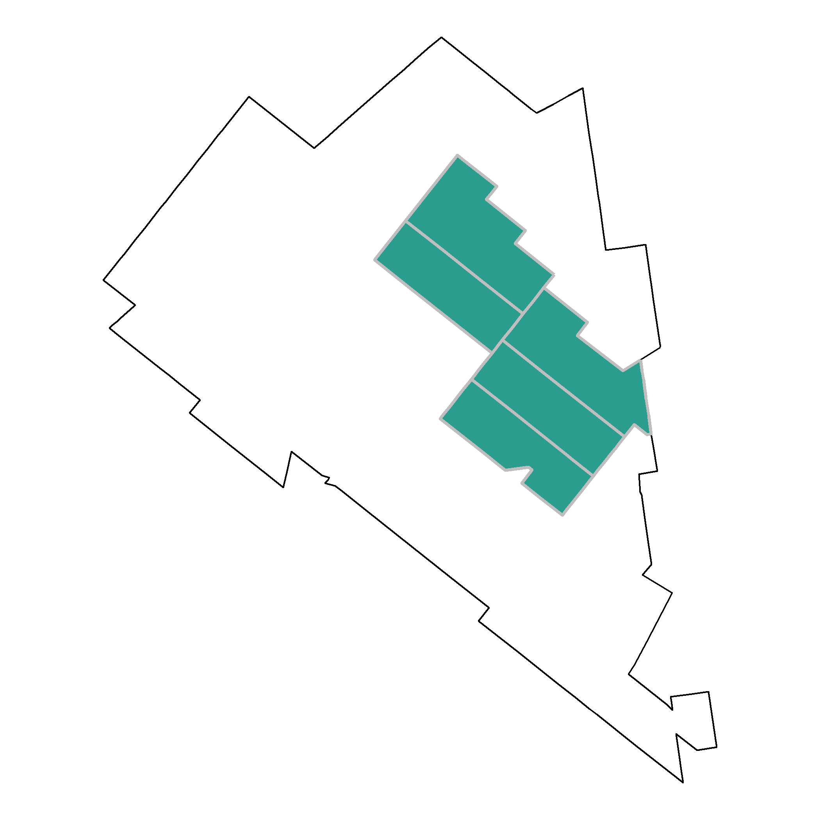**Appendix**

Figure 1. Map of Borough Park with Selected Census Tracts

Figure 2. Race Percentages from the ACS Survey 2015-2019

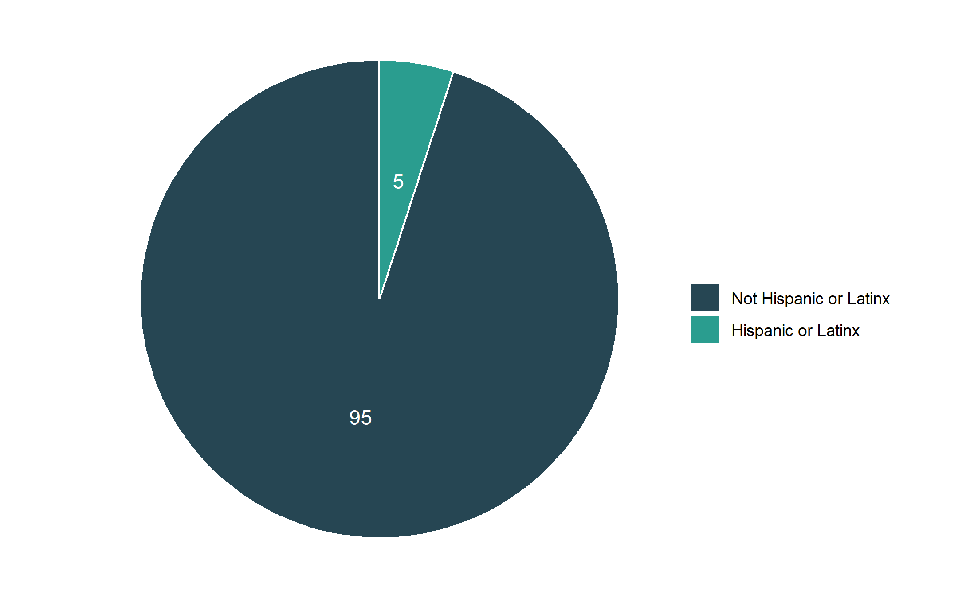Figure 3. Ethnicity Percentages from the ACS Survey 2015-2019

Figure 4. Race and Ethnicity Over Time

Figure 5. Population Pyramid from the ACS 5-year survey, 2015-2019

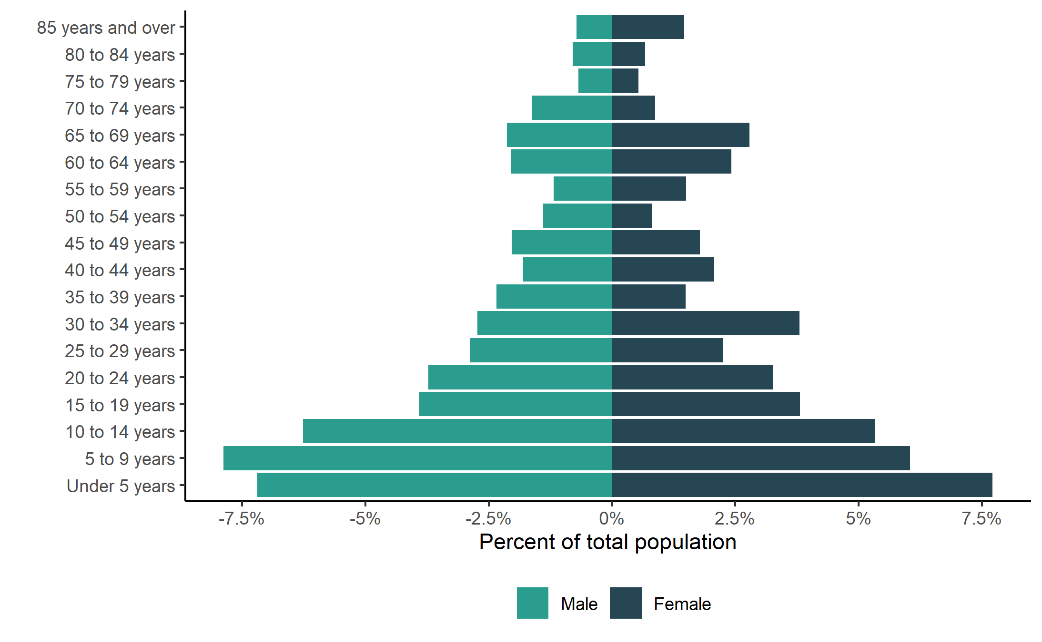

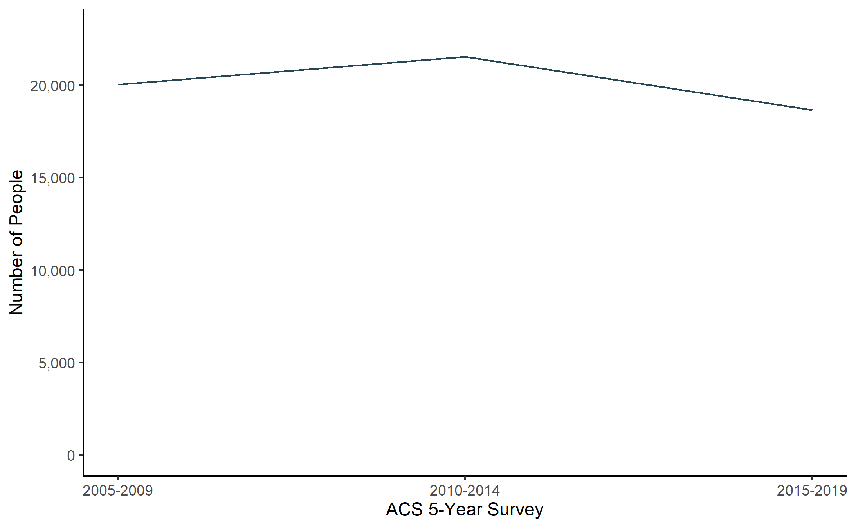Figure 6. Total Population in Selected Census Tracts Over Time

Figure 7. Median Household Income Over Time

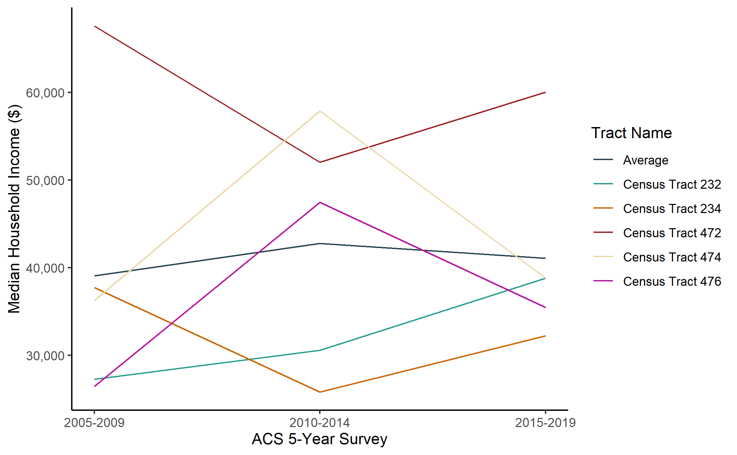

Figure 8. Owner- and Renter-Occupied Share of Households Over Time

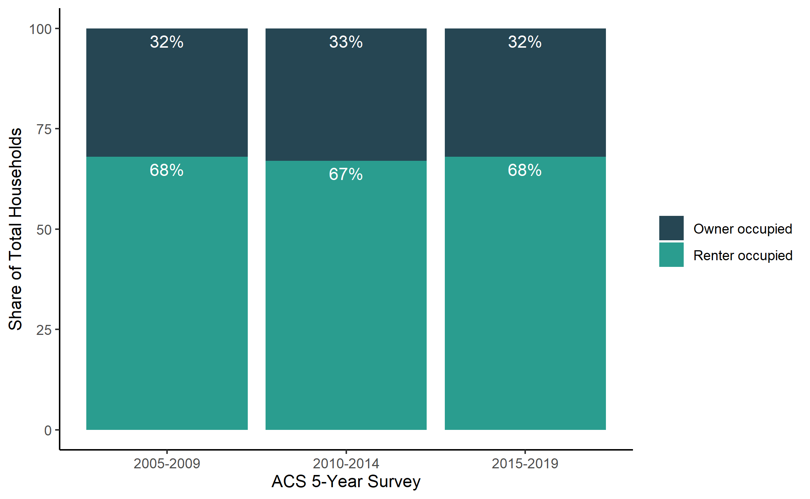

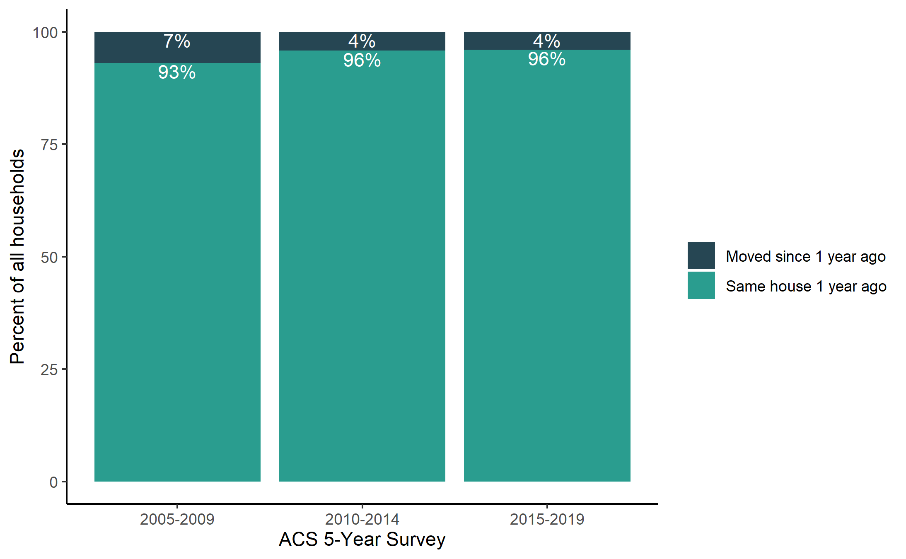Figure 9. Movement of Households Over Time[1]

1. Households that moved since 1 year ago are calculated as the total number of households – households in the same house 1 year ago.