**ZOHO CRM/Desk Ticket Simulation Project**

Steps:

1. I set up a ticket management and CRM system for a fictional company, Rita’s Realty, in the Zoho Desk and Zoho CRM free tier. Rita’s Realty uses this system to manage employee inquiries/requests and track leads and contacts. Due to the limitations of Zoho Desk, I was only able to create one department, named “IT support” with 2 agents, myself and an employee named Bob Jones, who also works as a Software Developer.
2. The role hierarchy I set up in Zoho CRM for IT was CEO > Manager > System Administrator > Developer. Due to the limited number of users I was able to create, I assigned the other two fictional employees in the company, Bob Jones and Sue Smith multiple roles.
3. I filled in geographical and contact information for Rita’s Realty and its employees, agents, and leads. I created several tickets simulating various technical difficulties users might experience with various levels of severity that a company’s IT support team might need to solve. I created contacts to represent the employees in the other departments at Rita’s Realty who are experiencing technical difficulties and who submitted tickets to the IT support team.
4. I tried to synchronize the information between Zoho CRM and Desk, but since that is not available in the free tier, I tried to manually synchronize the information by downloading a CSV file of the contacts from Zoho Desk and then uploading it to Zoho CRM.
5. I simulated creating a Knowledge base by creating three sections of articles to help employees and IT support agents: 1) IT Asset Management, 2) Security and Incident Response, 3) System Administration. I then made subsections in each section and created numerous realistic articles.

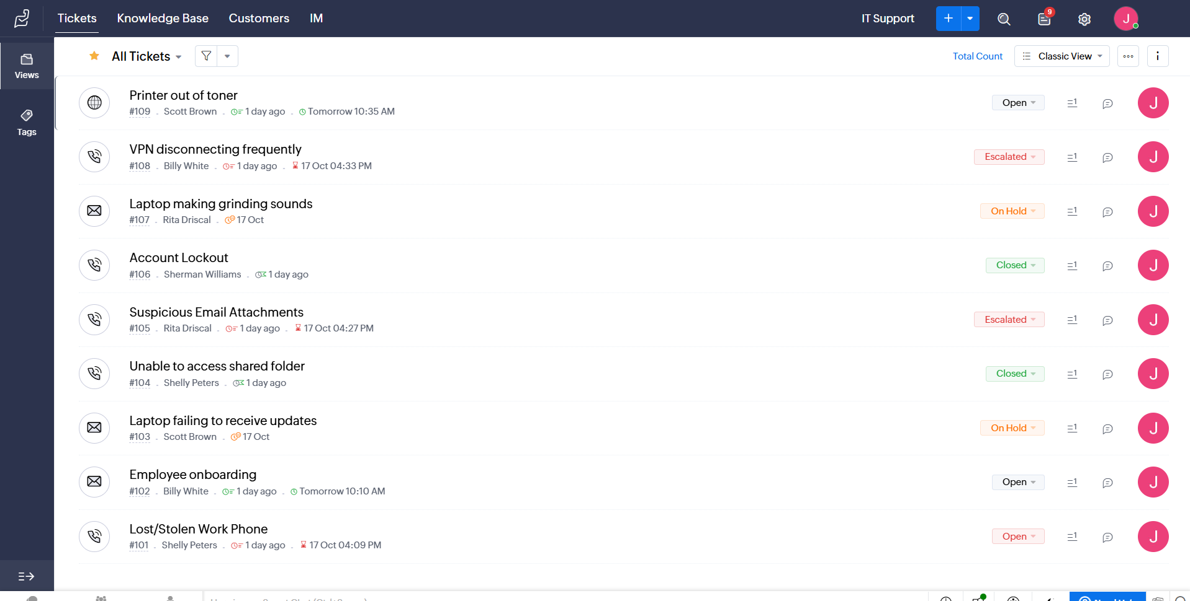

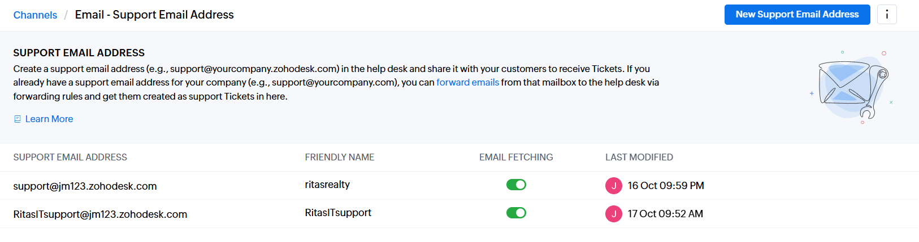

1. I used the Zoho Desk API to simulate managing tickets and employee contact data through automated API calls in addition to manually entering them through the UI. First, I registered a Zoho Desk (self-client) test application to obtain a client ID and secret to generate an OAuth 2.0 token for authentication. To securely connect my script to the API, I implemented the OAuth 2.0 authorization flow using an authorization code, refresh token and access token. I obtained an authorization code from Zoho, then exchanged it for a refresh token and initial access token. I used the requests library in Python to send HTTP requests to the Zoho Desk Rest API endpoints and the json module to format and parse the data I sent/received. Once I was authenticated, I used Zoho Desk’s Tickets API to create a new ticket and view the previous tickets and contacts I had entered. This simulated how a client would submit a ticket via a web form in real life.
2. The name of my python script to send a ticket and receive the tickets/contacts from the API was test_zoho.py. This is the output from my script.

1. I also wrote a simple python script using the Pandas library to analyze the tickets and contact information stored in the CSV files that I downloaded from Zoho desk. The name of the script is zoho_pandas.py and this is the output.

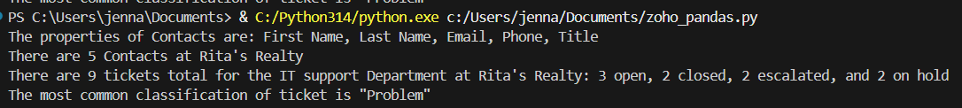

1. I downloaded the tickets CSV file from Zoho Desk into a table and cleaned/formatted the information for each ticket. I then created pivot tables with slicers so that the tickets could be filtered by Status, Classification, and Priority. This Excel file is named tickets.xlsx.