Virtual Network Writeup and Running Configuration Files
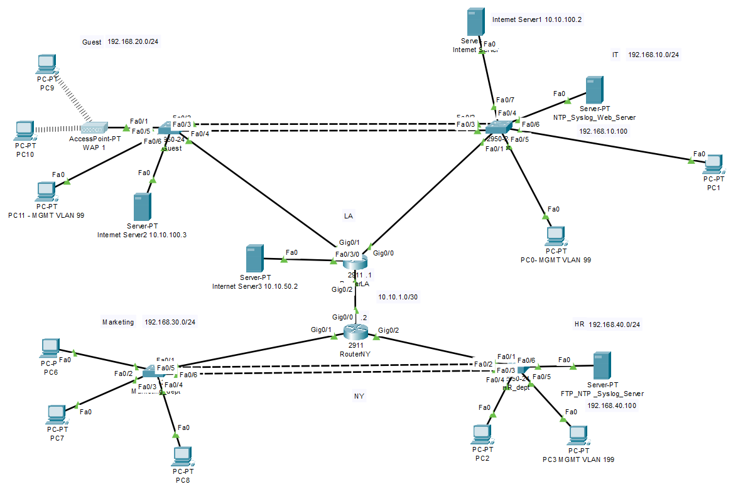
5 main networks:
1.192.168.10.0/24 – IT VLAN
2.192.168.20.0/24 – Guest VLAN
3.192.168.30.0/24 – Marketing VLAN
4.192.168.40.0/24 – HR VLAN
5. 10.10.1.0/30 – between NY and LA routers
Services configured:
-Routing: RIP and default routes
-Dynamic IP addresses with DHCP
-IPSec site to site VLAN
-Firewall ACLs
-VLANs, trunking and Router-on-a-Stick
-EtherChannel with LACP
-Rapid spanning tree
-Syslog
-NTP
Legend
Guest – Guest switch. SVI IP address: 192.168.99.10
IT_dept – IT department switch. SVI IP address: 192.168.99.11
Marketing_dept – Marketing department switch. SVI IP address0: 192.168.199.12
HR_dept – HR department switch. SVI IP address: 192.168.199.10
RouterLA -Router for LA office
RouterNY – Router for NY office
NTP_Syslog_Web_Server- Server running NTP, Syslog and employee resources website for LA office. In IT VLAN (10). IP address 192.168.10.100
FTP_NTP_Syslog_Server – Server running FTP, NTP, Syslog services for NY office. In HR VLAN (40). IP address 192.168.40.100
PC0 – attached to IT switch, in management VLAN (99). LA office.
PC1-attached to IT switch, in IT VLAN (10). LA office.
PC2- attached to HR switch, in HR VLAN (40). NY office.
PC3-attached to HR switch, in MGMT VLAN (199). NY office.
PC6-attached to marketing switch, in marketing VLAN (30). NY office.
PC7-attached to marketing switch, in marketing VLAN (30). NY office.
PC8-attached to marketing switch, in marketing VLAN (30). NY office.
PC9-attached to guest switch, in guest VLAN (20). NY office.
PC10-attached to guest switch, in guest VLAN (20). LA office.
PC11-attached to guest switch, in management VLAN (99). LA office
Internet Server1 – attached to IT switch. IP address: 10.10.100.2. LA office.
Internet Server2 – attached to guest switch. IP address: 10.10.100.3. LA office.
Internet Server3 – attached to LA router. IP address: 10.10.50.2.

IT Switch Running Configuration
Building configuration...

Current configuration : 3041 bytes
!
version 12.1
no service timestamps log datetime msec
no service timestamps debug datetime msec
no service password-encryption
!
hostname Switch
!
!
!
!
!
!
spanning-tree mode rapid-pvst
spanning-tree extend system-id
!
interface Port-channel1
switchport trunk allowed vlan 10,20,99-100
switchport mode trunk
!
interface FastEthernet0/1
switchport mode trunk
duplex full
speed 100
!
interface FastEthernet0/2
switchport trunk allowed vlan 10,20,99-100
switchport mode trunk
channel-group 1 mode active
!
interface FastEthernet0/3
switchport trunk allowed vlan 10,20,99-100
switchport mode trunk
channel-group 1 mode active
!
interface FastEthernet0/4
switchport access vlan 10
switchport mode access
switchport port-security
switchport port-security maximum 2
switchport port-security violation restrict
duplex full
speed 100
spanning-tree portfast
!
interface FastEthernet0/5
switchport access vlan 99
switchport mode access
switchport port-security
switchport port-security maximum 2
switchport port-security violation restrict
duplex full
speed 100
spanning-tree portfast
!
interface FastEthernet0/6
switchport access vlan 10
switchport mode access
switchport port-security
switchport port-security maximum 2
switchport port-security violation restrict
duplex full
speed 100
spanning-tree portfast
!
interface FastEthernet0/7
switchport access vlan 100
switchport mode access
duplex full
speed 100
spanning-tree portfast
!
interface FastEthernet0/8
switchport mode dynamic auto
!
interface FastEthernet0/9
switchport mode dynamic auto
!
interface FastEthernet0/10
switchport mode dynamic auto
!
interface FastEthernet0/11
switchport mode dynamic auto
!
interface FastEthernet0/12
switchport mode dynamic auto
!
interface FastEthernet0/13
switchport mode dynamic auto
!
interface FastEthernet0/14
switchport mode dynamic auto
!
interface FastEthernet0/15
switchport mode dynamic auto
!
interface FastEthernet0/16
switchport mode dynamic auto
!
interface FastEthernet0/17
switchport mode dynamic auto
!
interface FastEthernet0/18
switchport mode dynamic auto
!
interface FastEthernet0/19
switchport mode dynamic auto
!
interface FastEthernet0/20
switchport mode dynamic auto
!
interface FastEthernet0/21
switchport mode dynamic auto
!
interface FastEthernet0/22
switchport mode dynamic auto
!
interface FastEthernet0/23
switchport mode dynamic auto
!
interface FastEthernet0/24
switchport mode dynamic auto
!
interface Vlan1
no ip address
shutdown
!
interface Vlan99
ip address 192.168.99.11 255.255.255.0
!
ip default-gateway 192.168.99.1
!
banner motd ^CThis device is the property of Ritas Realty. Any unauthorized use is strictly prohibited. Keep your passwords confidential and never write them down. Never install unsafe or unauthorized software. This system is subject to monitoring. ^C
logging trap debugging
logging 192.168.10.100
!
!
!
line con 0
!
line vty 0 4
password 1234
login
transport input telnet
line vty 5 15
login
!
!
!
ntp server 192.168.10.100
!
end

Guest Switch Running Configuration
show run
Building configuration...

Current configuration : 2575 bytes
!
version 12.1
no service timestamps log datetime msec
no service timestamps debug datetime msec
no service password-encryption
!
hostname Switch
!
!
!
!
!
!
spanning-tree mode rapid-pvst
spanning-tree extend system-id
!
interface Port-channel1
switchport trunk allowed vlan 10,20,99-100
switchport mode trunk
!
interface FastEthernet0/1
switchport access vlan 20
switchport mode access
duplex full
speed 100
!
interface FastEthernet0/2
switchport trunk allowed vlan 10,20,99-100
switchport mode trunk
channel-group 1 mode active
!
interface FastEthernet0/3
switchport trunk allowed vlan 10,20,99-100
switchport mode trunk
channel-group 1 mode active
!
interface FastEthernet0/4
switchport mode trunk
duplex full
speed 100
!
interface FastEthernet0/5
switchport access vlan 99
switchport mode access
duplex full
speed 100
!
interface FastEthernet0/6
switchport access vlan 100
switchport mode access
duplex full
speed 100
!
interface FastEthernet0/7
switchport mode dynamic auto
!
interface FastEthernet0/8
switchport mode dynamic auto
!
interface FastEthernet0/9
switchport mode dynamic auto
!
interface FastEthernet0/10
switchport mode dynamic auto
!
interface FastEthernet0/11
switchport mode dynamic auto
!
interface FastEthernet0/12
switchport mode dynamic auto
!
interface FastEthernet0/13
switchport mode dynamic auto
!
interface FastEthernet0/14
switchport mode dynamic auto
!
interface FastEthernet0/15
switchport mode dynamic auto
!
interface FastEthernet0/16
switchport mode dynamic auto
!
interface FastEthernet0/17
switchport mode dynamic auto
!
interface FastEthernet0/18
switchport mode dynamic auto
!
interface FastEthernet0/19
switchport mode dynamic auto
!
interface FastEthernet0/20
switchport mode dynamic auto
!
interface FastEthernet0/21
switchport mode dynamic auto
!
interface FastEthernet0/22
switchport mode dynamic auto
!
interface FastEthernet0/23
switchport mode dynamic auto
!
interface FastEthernet0/24
switchport mode dynamic auto
!
interface Vlan1
no ip address
shutdown
!
interface Vlan99
ip address 192.168.99.10 255.255.255.0
!
ip default-gateway 192.168.99.1
!
banner motd ^CThis device is the property of Ritas Realty. Any unauthorized use is strictly prohibited. Keep your passwords confidential and never write them down. Never install unsafe or unauthorized software. This system is subject to monitoring.^C
logging trap debugging
logging 192.168.10.100
!
!
!
line con 0
!
line vty 0 4
password 1234
login
transport input telnet
line vty 5 15
login
!
!
!
ntp server 192.168.10.100
!
End

Marketing Switch Running Configuration
show run
Building configuration...

Current configuration : 2920 bytes
!
version 12.1
no service timestamps log datetime msec
no service timestamps debug datetime msec
no service password-encryption
!
hostname Switch
!
!
!
!
!
!
spanning-tree mode rapid-pvst
spanning-tree extend system-id
!
interface Port-channel1
switchport mode trunk
!
interface FastEthernet0/1
switchport mode trunk
duplex full
speed 100
!
interface FastEthernet0/2
switchport access vlan 30
switchport mode access
switchport port-security
switchport port-security maximum 2
switchport port-security violation restrict
duplex full
speed 100
!
interface FastEthernet0/3
switchport access vlan 30
switchport mode access
switchport port-security
switchport port-security maximum 2
switchport port-security violation restrict
duplex full
speed 100
!
interface FastEthernet0/4
switchport access vlan 30
switchport mode access
switchport port-security
switchport port-security maximum 2
switchport port-security violation restrict
duplex full
speed 100
!
interface FastEthernet0/5
switchport trunk allowed vlan 30,40,199
switchport mode trunk
duplex full
speed 100
channel-group 1 mode active
!
interface FastEthernet0/6
switchport trunk allowed vlan 30,40,199
switchport mode trunk
duplex full
speed 100
channel-group 1 mode active
!
interface FastEthernet0/7
switchport access vlan 40
switchport mode access
duplex full
speed 100
!
interface FastEthernet0/8
switchport mode dynamic auto
!
interface FastEthernet0/9
switchport mode dynamic auto
!
interface FastEthernet0/10
switchport mode dynamic auto
!
interface FastEthernet0/11
switchport mode dynamic auto
!
interface FastEthernet0/12
switchport mode dynamic auto
!
interface FastEthernet0/13
switchport mode dynamic auto
!
interface FastEthernet0/14
switchport mode dynamic auto
!
interface FastEthernet0/15
switchport mode dynamic auto
!
interface FastEthernet0/16
switchport mode dynamic auto
!
interface FastEthernet0/17
switchport mode dynamic auto
!
interface FastEthernet0/18
switchport mode dynamic auto
!
interface FastEthernet0/19
switchport mode dynamic auto
!
interface FastEthernet0/20
switchport mode dynamic auto
!
interface FastEthernet0/21
switchport mode dynamic auto
!
interface FastEthernet0/22
switchport mode dynamic auto
!
interface FastEthernet0/23
switchport mode dynamic auto
!
interface FastEthernet0/24
switchport mode dynamic auto
!
interface Vlan1
no ip address
shutdown
!
interface Vlan199
ip address 192.168.199.12 255.255.255.0
!
ip default-gateway 192.168.199.1
!
banner motd ^CThis device is the property of Ritas Realty. Any unauthorized use is strictly prohibited. Keep your passwords confidential and never write them down. Never install unsafe or unauthorized software. This system is subject to monitoring.^C
logging trap debugging
logging 192.168.40.100
!
!
!
line con 0
!
line vty 0 4
password 1234
login
line vty 5 15
login
!
!
!
ntp server 192.168.40.100
!
End

HR Switch Running Configuration
show run
Building configuration...

Current configuration : 2933 bytes
!
version 12.1
no service timestamps log datetime msec
no service timestamps debug datetime msec
no service password-encryption
!
hostname Switch
!
!
!
!
!
!
spanning-tree mode rapid-pvst
spanning-tree extend system-id
!
interface Port-channel1
switchport trunk allowed vlan 30,40,199
switchport mode trunk
!
interface FastEthernet0/1
switchport trunk allowed vlan 30,40,199
switchport mode trunk
!
interface FastEthernet0/2
switchport trunk allowed vlan 30,40,199
switchport mode trunk
switchport port-security
switchport port-security maximum 2
switchport port-security violation restrict
duplex full
speed 100
channel-group 1 mode active
!
interface FastEthernet0/3
switchport trunk allowed vlan 30,40,199
switchport mode trunk
switchport port-security
switchport port-security maximum 2
switchport port-security violation restrict
duplex full
speed 100
channel-group 1 mode active
!
interface FastEthernet0/4
switchport access vlan 40
switchport mode access
switchport port-security
switchport port-security maximum 2
switchport port-security violation restrict
duplex full
speed 100
!
interface FastEthernet0/5
switchport access vlan 199
switchport mode access
duplex full
speed 100
!
interface FastEthernet0/6
switchport access vlan 40
switchport mode access
duplex full
speed 100
!
interface FastEthernet0/7
switchport mode dynamic auto
!
interface FastEthernet0/8
switchport mode dynamic auto
!
interface FastEthernet0/9
switchport mode dynamic auto
!
interface FastEthernet0/10
switchport mode dynamic auto
!
interface FastEthernet0/11
switchport mode dynamic auto
!
interface FastEthernet0/12
switchport mode dynamic auto
!
interface FastEthernet0/13
switchport mode dynamic auto
!
interface FastEthernet0/14
switchport mode dynamic auto
!
interface FastEthernet0/15
switchport mode dynamic auto
!
interface FastEthernet0/16
switchport mode dynamic auto
!
interface FastEthernet0/17
switchport mode dynamic auto
!
interface FastEthernet0/18
switchport mode dynamic auto
!
interface FastEthernet0/19
switchport mode dynamic auto
!
interface FastEthernet0/20
switchport mode dynamic auto
!
interface FastEthernet0/21
switchport mode dynamic auto
!
interface FastEthernet0/22
switchport mode dynamic auto
!
interface FastEthernet0/23
switchport mode dynamic auto
!
interface FastEthernet0/24
switchport mode dynamic auto
!
interface Vlan1
no ip address
shutdown
!
interface Vlan199
ip address 192.168.199.10 255.255.255.0
!
ip default-gateway 192.168.199.1
!
banner motd ^CThis device is the property of Ritas Realty. Any unauthorized use is strictly prohibited. Keep your passwords confidential and never write them down. Never install unsafe or unauthorized software. This system is subject to monitoring^C
logging trap debugging
logging 192.168.40.100
!
!
!
line con 0
!
line vty 0 4
password 1234
login
line vty 5 15
login
!
!
!
ntp server 192.168.40.100
!
end

LA Router Running Configuration
show run
Building configuration...

Current configuration : 3955 bytes
!
version 15.1
no service timestamps log datetime msec
no service timestamps debug datetime msec
no service password-encryption
!
hostname Router
!
!
!
!
ip dhcp excluded-address 192.168.20.1
ip dhcp excluded-address 192.168.10.1
ip dhcp excluded-address 192.168.99.1
!
ip dhcp pool IT
network 192.168.10.0 255.255.255.0
default-router 192.168.10.1
ip dhcp pool guest
network 192.168.20.0 255.255.255.0
default-router 192.168.20.1
ip dhcp pool MGMT
network 192.168.99.0 255.255.255.0
default-router 192.168.99.1
clock timezone PST -8
!
!
!
!
ip cef
no ipv6 cef
!
!
!
!
license udi pid CISCO2911/K9 sn FTX15240HE3-
license boot module c2900 technology-package securityk9
!
!
!
crypto isakmp policy 10
encr aes
authentication pre-share
group 2
!
crypto isakmp key key1 address 10.10.1.2
!
!
!
crypto ipsec transform-set transform1 esp-aes esp-sha-hmac
!
crypto map map1 10 ipsec-isakmp
set peer 10.10.1.2
set transform-set transform1
match address 101
!
!
!
!
!
!
spanning-tree mode pvst
!
!
!
!
!
!
interface GigabitEthernet0/0
no ip address
duplex full
speed 100
!
interface GigabitEthernet0/0.10
encapsulation dot1Q 10
ip address 192.168.10.1 255.255.255.0
!
interface GigabitEthernet0/0.99
encapsulation dot1Q 99
ip address 192.168.99.1 255.255.255.0
ip access-group 140 in
!
interface GigabitEthernet0/0.100
encapsulation dot1Q 100
ip address 10.10.100.1 255.255.255.0
!
interface GigabitEthernet0/1
no ip address
duplex full
speed 100
!
interface GigabitEthernet0/1.20
encapsulation dot1Q 20
ip address 192.168.20.1 255.255.255.0
ip access-group 130 in
!
interface GigabitEthernet0/2
ip address 10.10.1.1 255.255.255.252
duplex full
speed 100
crypto map map1
!
interface FastEthernet0/3/0
switchport access vlan 50
switchport mode access
duplex full
speed 100
!
interface FastEthernet0/3/1
switchport mode access
!
interface FastEthernet0/3/2
switchport mode access
!
interface FastEthernet0/3/3
switchport mode access
!
interface Vlan1
no ip address
shutdown
!
interface Vlan5
mac-address 0090.2b59.8801
no ip address
!
interface Vlan50
mac-address 0090.2b59.8802
ip address 10.10.50.1 255.255.255.0
!
router rip
version 2
network 10.0.0.0
network 192.168.10.0
network 192.168.20.0
distance 150
no auto-summary
!
ip classless
ip route 0.0.0.0 0.0.0.0 10.10.1.2
!
ip flow-export version 9
!
!
access-list 130 permit udp any any eq bootpc
access-list 130 permit udp any any eq bootps
access-list 130 deny ip 192.168.20.0 0.0.0.255 192.168.10.0 0.0.0.255
access-list 130 deny ip 192.168.20.0 0.0.0.255 192.168.30.0 0.0.0.255
access-list 130 deny ip 192.168.20.0 0.0.0.255 192.168.40.0 0.0.0.255
access-list 130 deny ip 192.168.20.0 0.0.0.255 192.168.99.0 0.0.0.255
access-list 130 deny ip 192.168.20.0 0.0.0.255 192.168.199.0 0.0.0.255
access-list 130 permit ip 192.168.20.0 0.0.0.255 any
access-list 140 permit udp any any eq bootpc
access-list 140 permit udp any any eq bootps
access-list 140 deny ip any host 192.168.99.2
access-list 140 deny ip any host 192.168.99.3
access-list 140 deny ip any host 192.168.99.4
access-list 140 deny ip any host 192.168.99.5
access-list 140 permit ip any any
access-list 101 permit ip 192.168.10.0 0.0.0.255 192.168.30.0 0.0.0.255
access-list 101 permit ip 192.168.10.0 0.0.0.255 192.168.40.0 0.0.0.255
access-list 101 permit ip 192.168.10.0 0.0.0.255 192.168.199.0 0.0.0.255
access-list 101 permit ip 192.168.99.0 0.0.0.255 192.168.30.0 0.0.0.255
access-list 101 permit ip 192.168.99.0 0.0.0.255 192.168.40.0 0.0.0.255
!
banner login ^CThis device is the property of Ritas Realty. Any unauthorized use is strictly prohibited. Keep your passwords confidential and never write them down. Never install unsafe or unauthorized software. This system is subject to monitoring.^C
!
!
!
!
logging trap debugging
logging 192.168.10.100
line con 0
!
line aux 0
!
line vty 0 4
password 1234
login
transport input telnet
!
!
ntp server 192.168.10.100
ntp master 2
!
End

NY Router Running Configuration
#show run
Building configuration...

Current configuration : 3102 bytes
!
version 15.1
no service timestamps log datetime msec
no service timestamps debug datetime msec
no service password-encryption
!
hostname Router
!
!
!
!
ip dhcp excluded-address 192.168.40.1
ip dhcp excluded-address 192.168.30.1
ip dhcp excluded-address 192.168.40.100
ip dhcp excluded-address 192.168.199.1
!
ip dhcp pool market
network 192.168.30.0 255.255.255.0
default-router 192.168.30.1
ip dhcp pool HR
network 192.168.40.0 255.255.255.0
default-router 192.168.40.1
ip dhcp pool MGMT
network 192.168.199.0 255.255.255.0
default-router 192.168.199.1
!
!
!
ip cef
no ipv6 cef
!
!
!
!
license udi pid CISCO2911/K9 sn FTX15241WQX-
license boot module c2900 technology-package securityk9
!
!
!
crypto isakmp policy 10
encr aes
authentication pre-share
group 2
!
crypto isakmp key key1 address 10.10.1.1
!
!
!
crypto ipsec transform-set transform1 esp-aes esp-sha-hmac
!
crypto map map1 10 ipsec-isakmp
set peer 10.10.1.1
set transform-set transform1
match address 101
!
!
!
!
!
!
spanning-tree mode pvst
!
!
!
!
!
!
interface GigabitEthernet0/0
ip address 10.10.1.2 255.255.255.252
duplex full
speed 100
crypto map map1
!
interface GigabitEthernet0/1
no ip address
duplex full
speed 100
!
interface GigabitEthernet0/1.30
encapsulation dot1Q 30
ip address 192.168.30.1 255.255.255.0
!
interface GigabitEthernet0/2
no ip address
duplex auto
speed auto
!
interface GigabitEthernet0/2.40
encapsulation dot1Q 40
ip address 192.168.40.1 255.255.255.0
!
interface GigabitEthernet0/2.199
encapsulation dot1Q 199
ip address 192.168.199.1 255.255.255.0
ip access-group 140 in
!
interface Vlan1
no ip address
shutdown
!
router rip
version 2
network 10.0.0.0
network 192.168.30.0
network 192.168.40.0
distance 150
no auto-summary
!
ip classless
ip route 0.0.0.0 0.0.0.0 10.10.1.1
!
ip flow-export version 9
!
!
access-list 101 permit ip 192.168.30.0 0.0.0.255 192.168.10.0 0.0.0.255
access-list 101 permit ip 192.168.40.0 0.0.0.255 192.168.10.0 0.0.0.255
access-list 101 permit ip 192.168.199.0 0.0.0.255 192.168.10.0 0.0.0.255
access-list 101 permit ip 192.168.30.0 0.0.0.255 192.168.99.0 0.0.0.255
access-list 101 permit ip 192.168.40.0 0.0.0.255 192.168.99.0 0.0.0.255
access-list 140 permit udp any host 192.168.199.2 eq bootps
access-list 140 permit udp any host 192.168.199.2 eq 6
access-list 140 permit udp any host 192.168.199.2 eq bootpc
access-list 140 deny ip any host 192.168.199.2
access-list 140 permit ip 192.168.30.0 0.0.0.255 192.168.10.0 0.0.0.255
access-list 140 permit ip 192.168.30.0 0.0.0.255 192.168.40.0 0.0.0.255
access-list 140 permit ip 192.168.30.0 0.0.0.255 192.168.99.0 0.0.0.255
access-list 140 permit ip any any
!
banner login ^CThis device is the property of Ritas Realty. Any unauthorized use is strictly prohibited. Keep your passwords confidential and never write them down. Never install unsafe or unauthorized software. This system is subject to monitoring.^C
!
!
!
!
logging trap debugging
logging 192.168.40.100
line con 0
!
line aux 0
!
line vty 0 4
password 1234
login
transport input telnet
!
!
ntp server 192.168.40.100
!
End
IP Configuration for PC9 in guest VLAN (20)
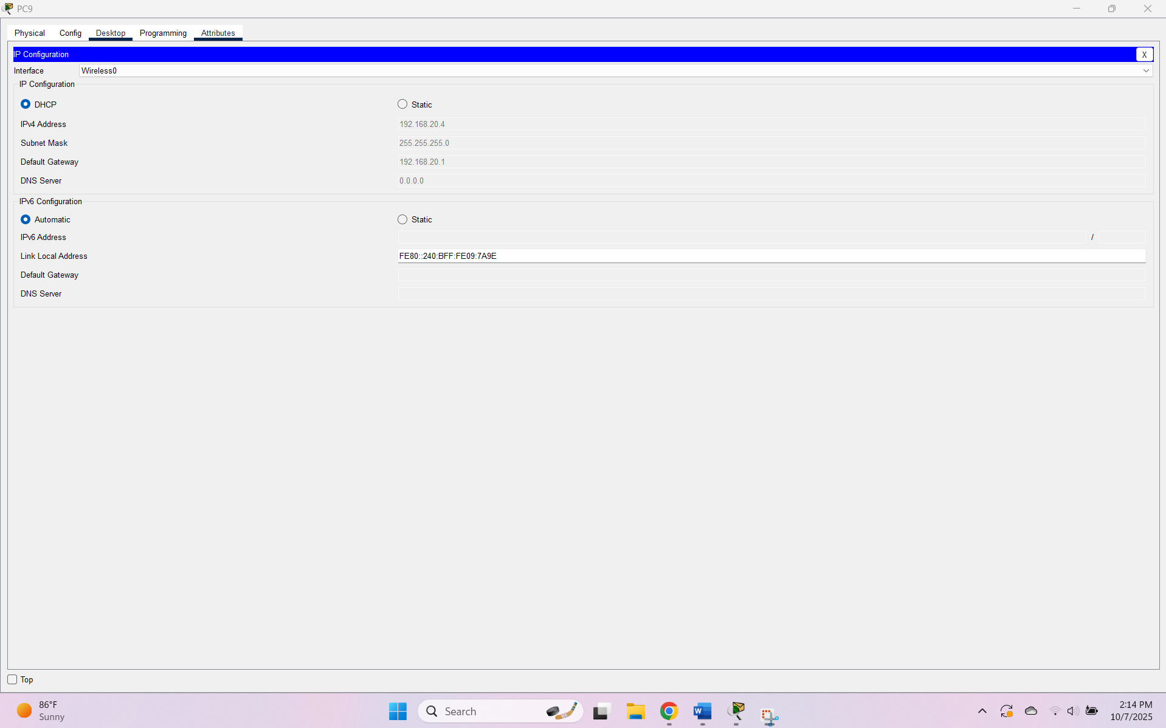

IP Configuration for PC10 in guest VLAN (20)
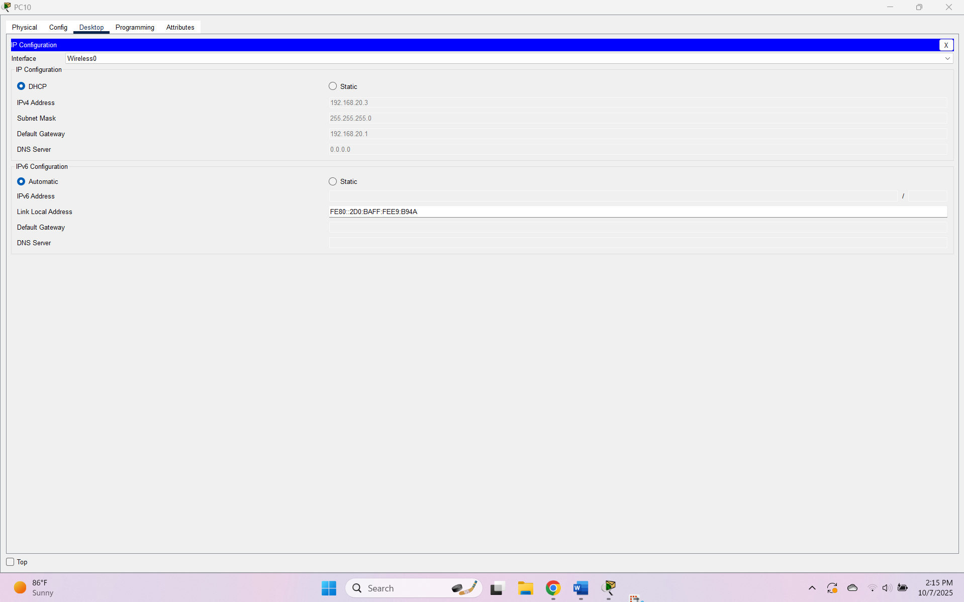
IP Configuration for PC11 in mgmt VLAN (99)
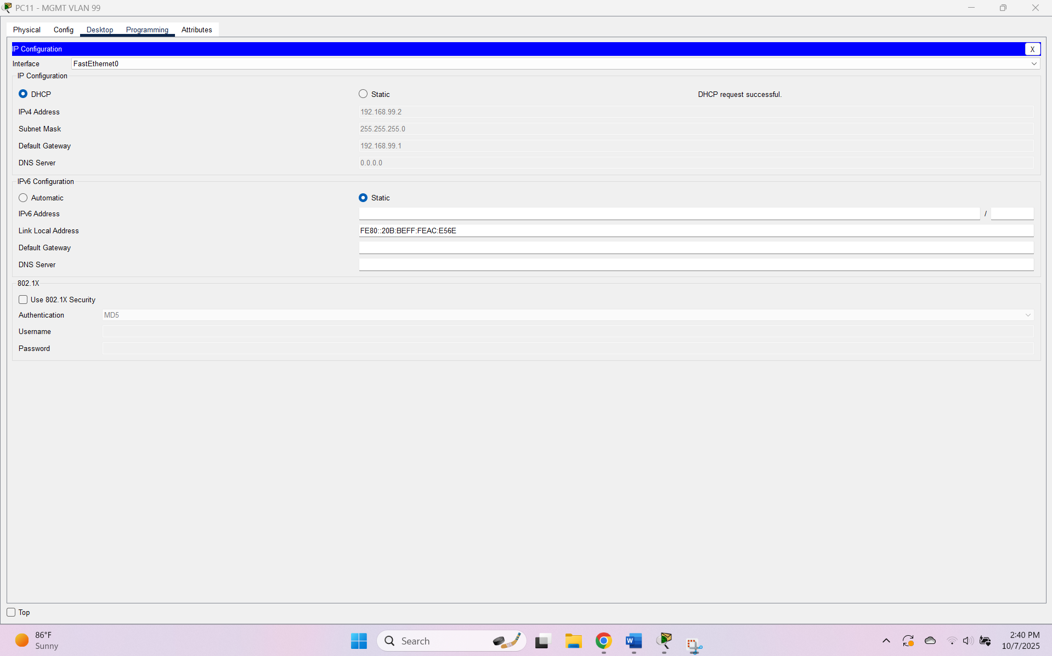
IP Configuration for PC0 in mgmt VLAN (99)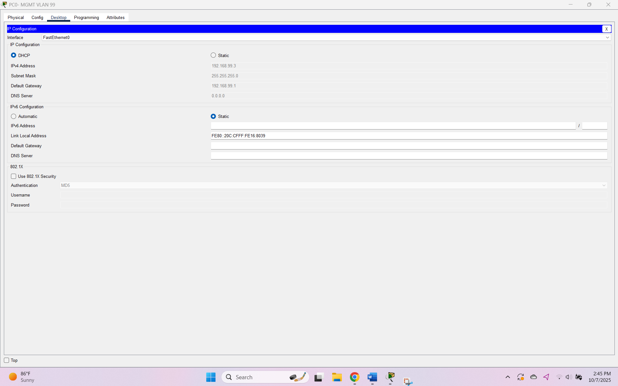

IP Configuration for PC1 in IT VLAN (10)
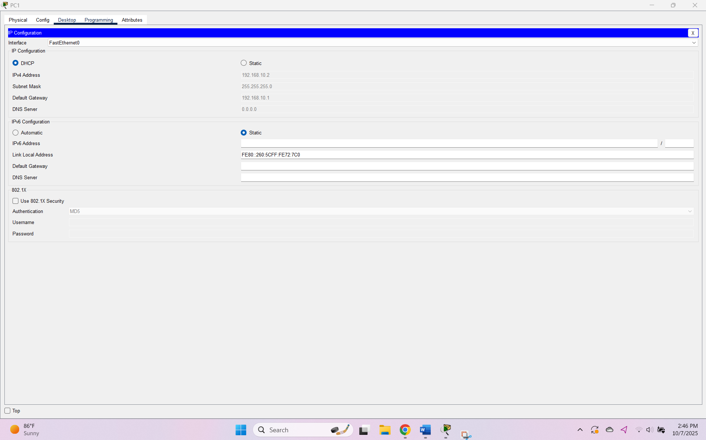
IP Configuration for PC6 in marketing VLAN (30)
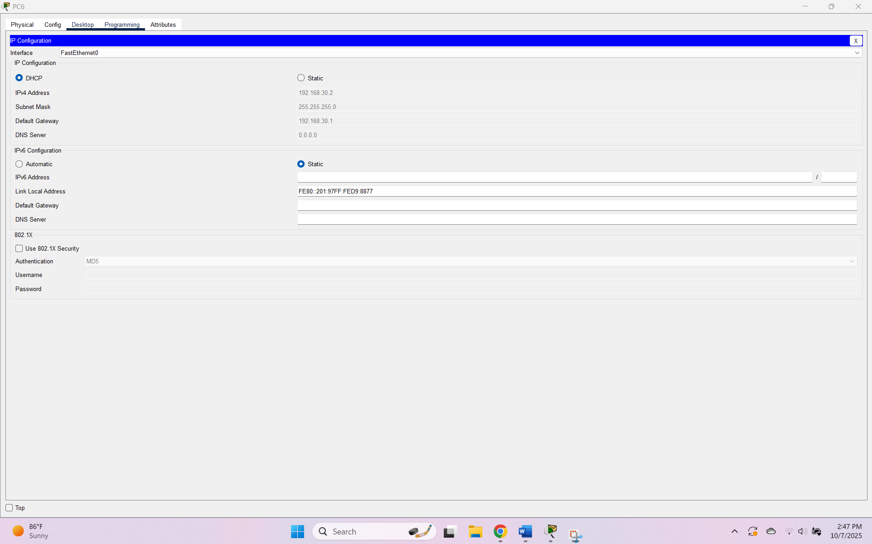
IP Configuration for PC7 in marketing VLAN (30)
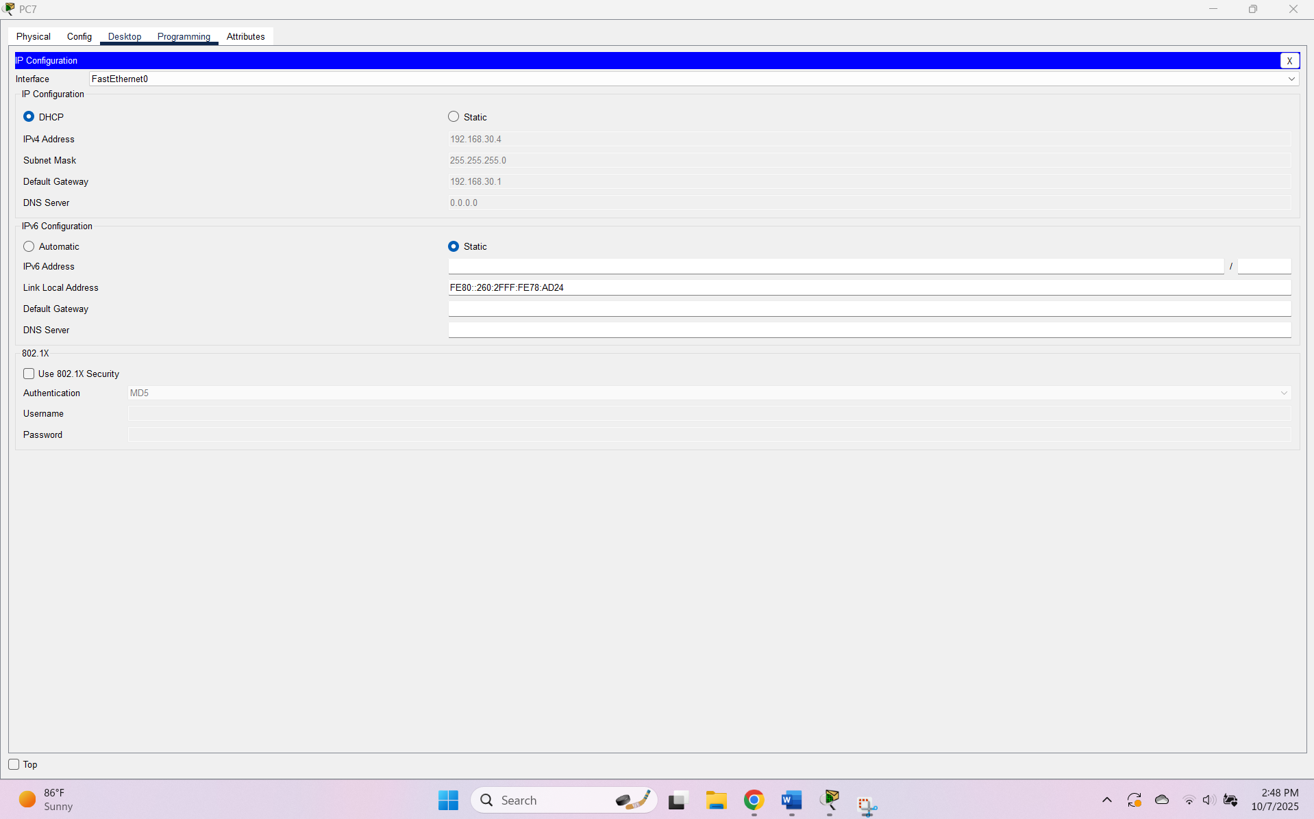

IP Configuration for PC8 in marketing VLAN (30)
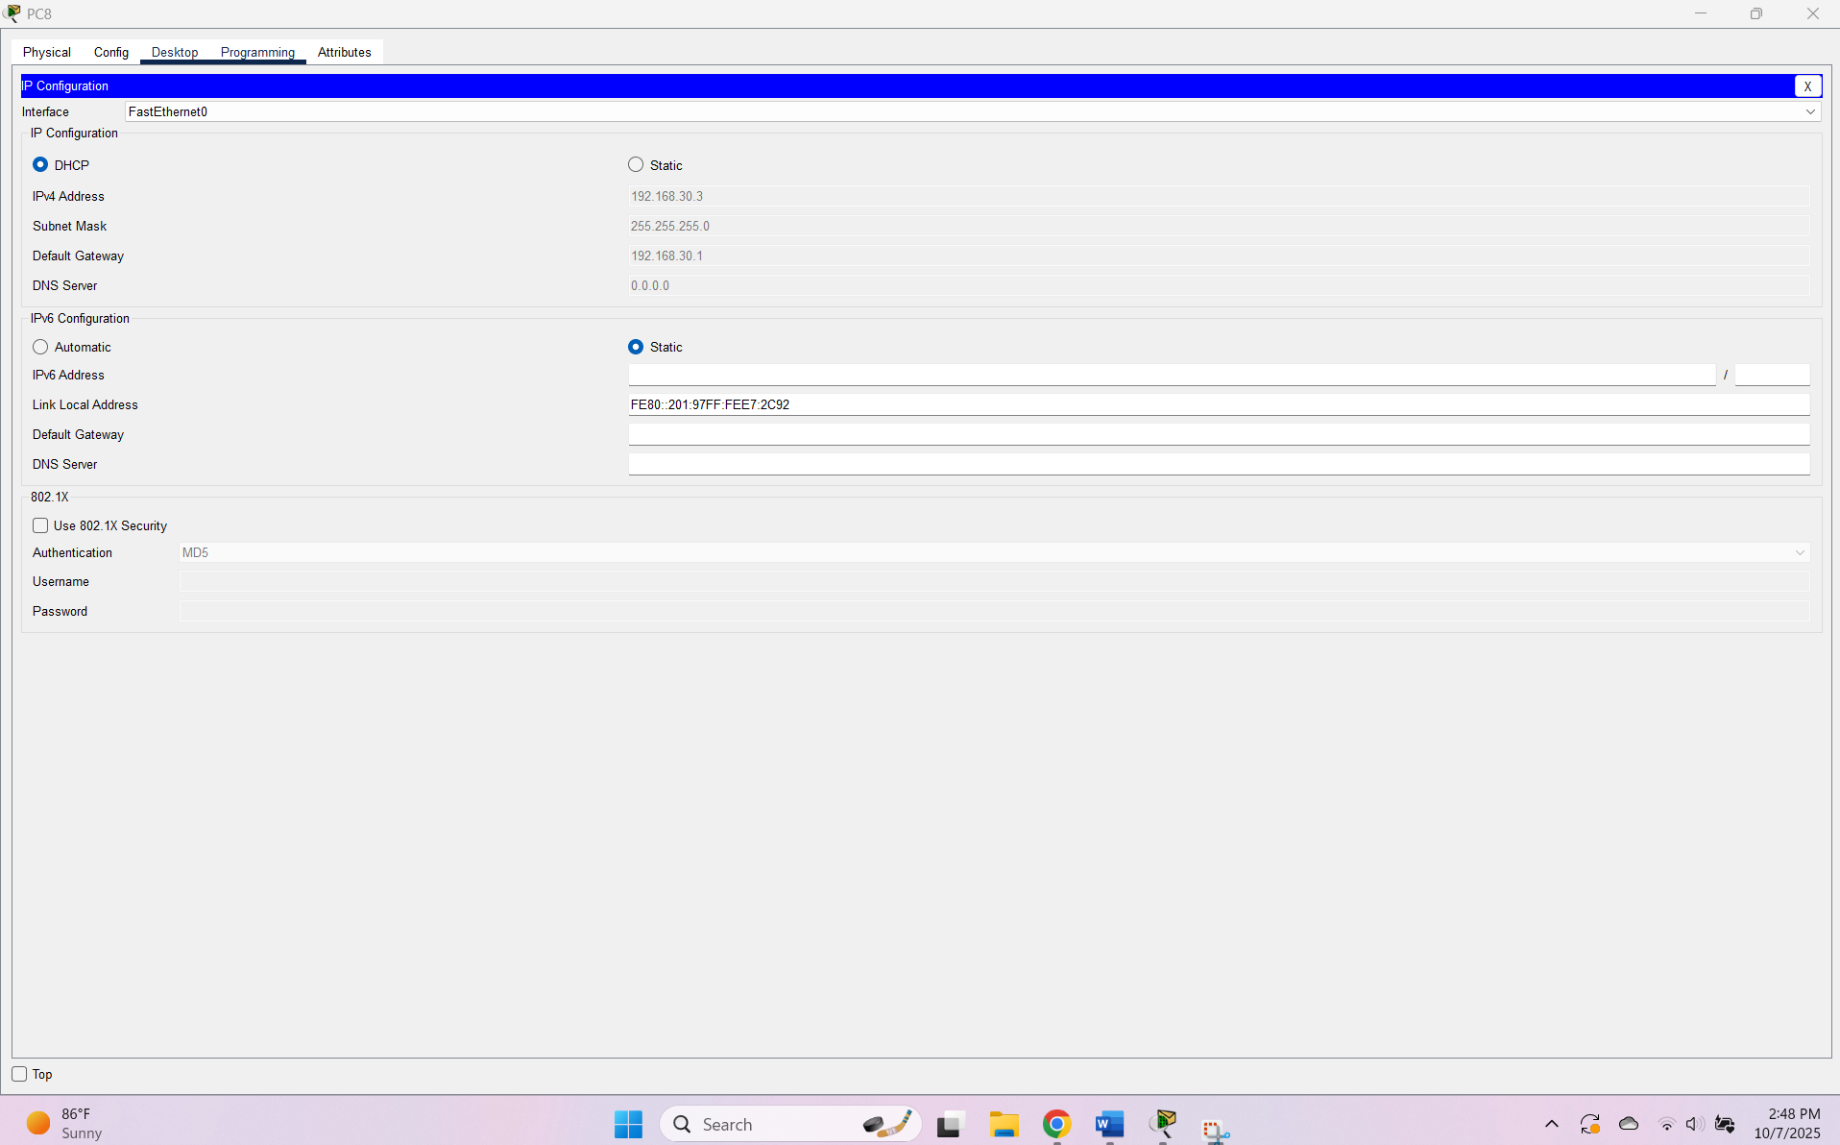
IP Configuration for PC2 in HR VLAN (40)
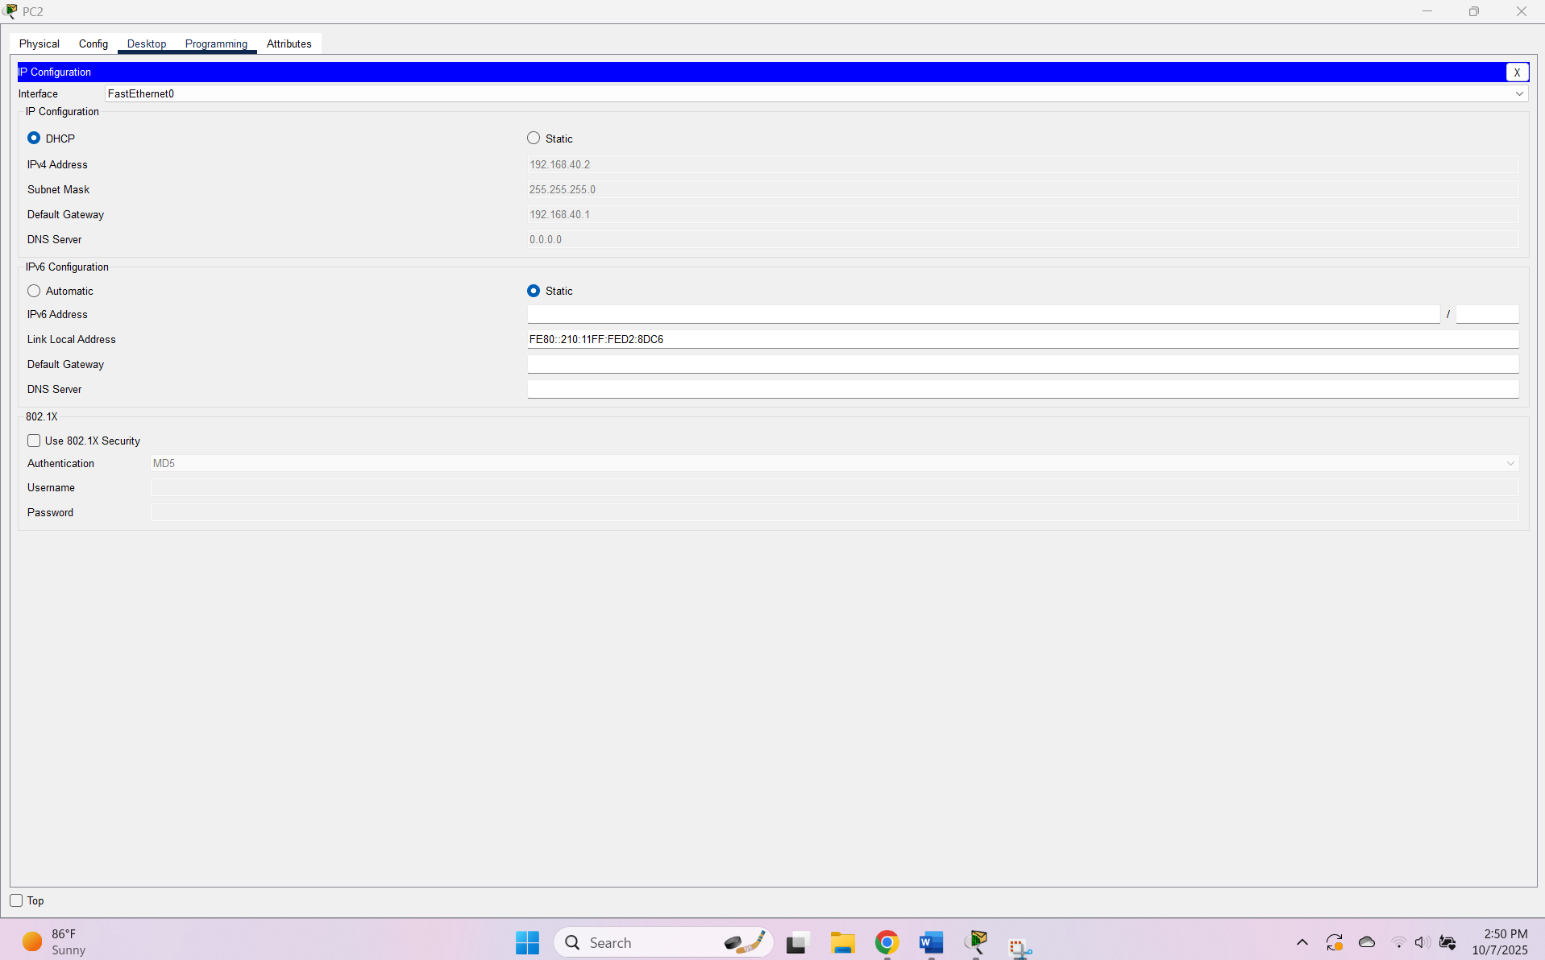
IP Configuration for PC3 in mgmt VLAN (199)
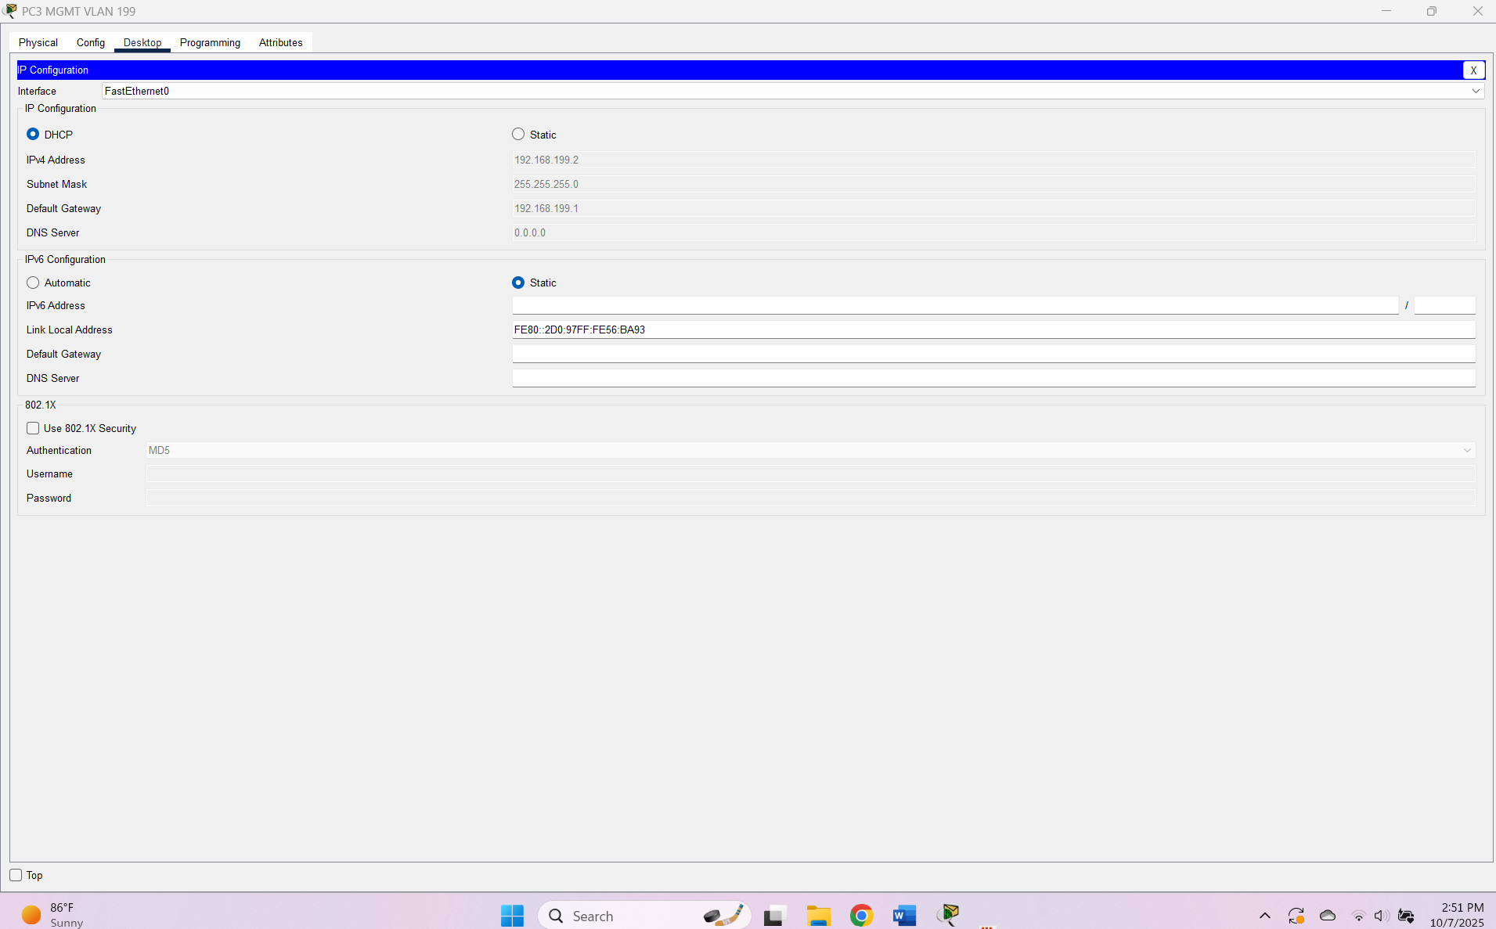
Static IP Configuration for NTP_Syslog_Web_Server in IT VLAN (10)
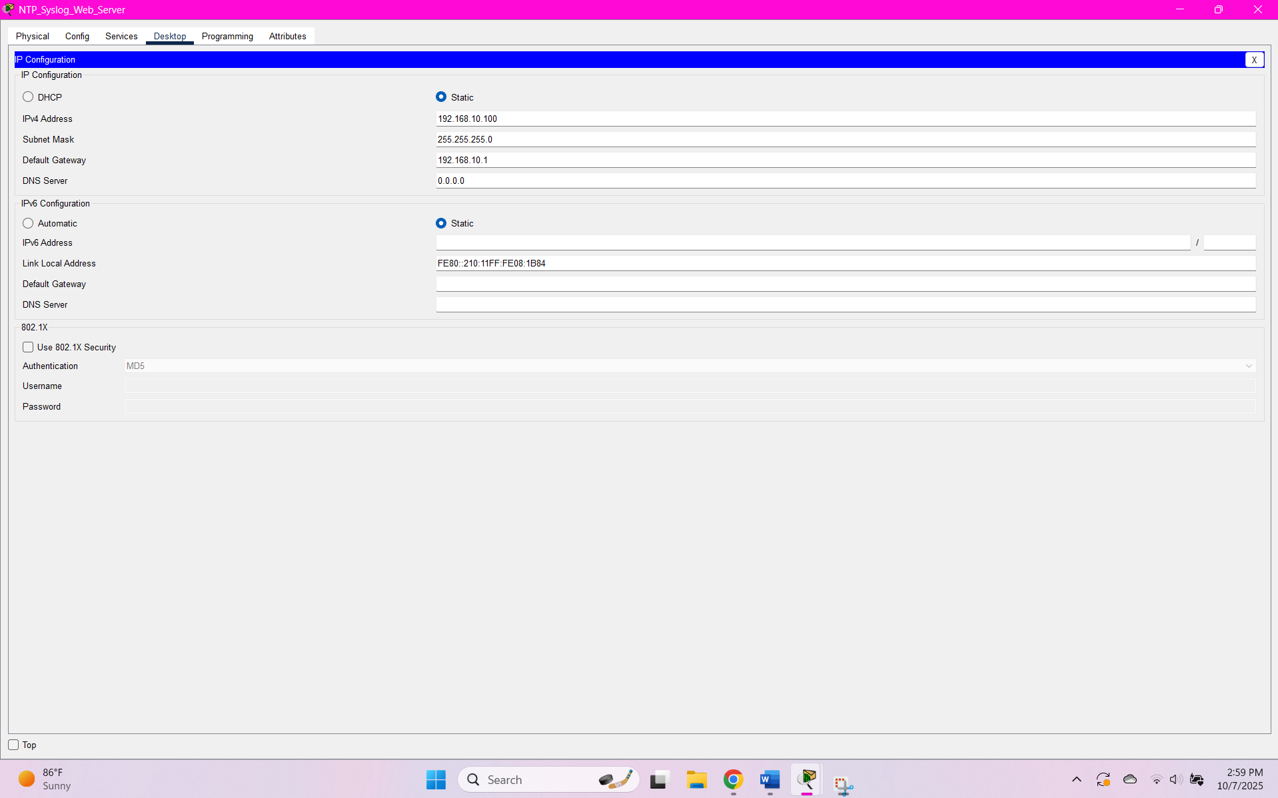
Static IP Configuration for Internet Server1 in internet VLAN (100)
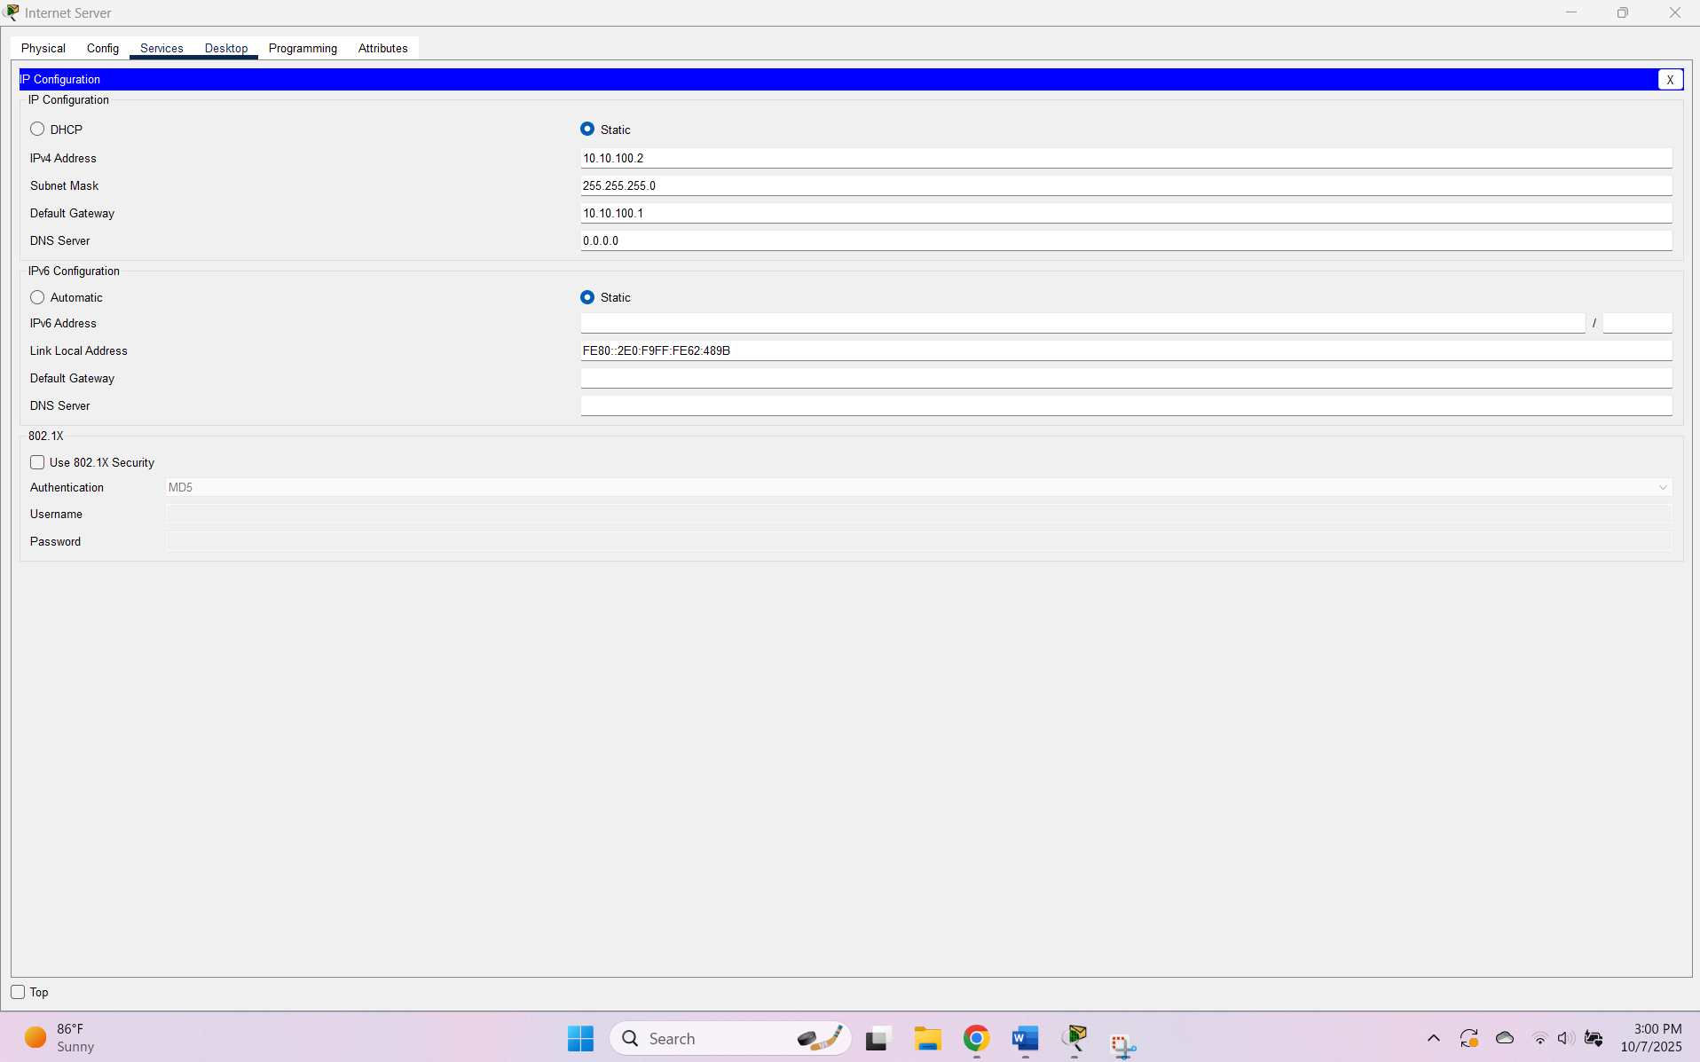
Static IP Configuration for Internet Server2 in internet VLAN (100)
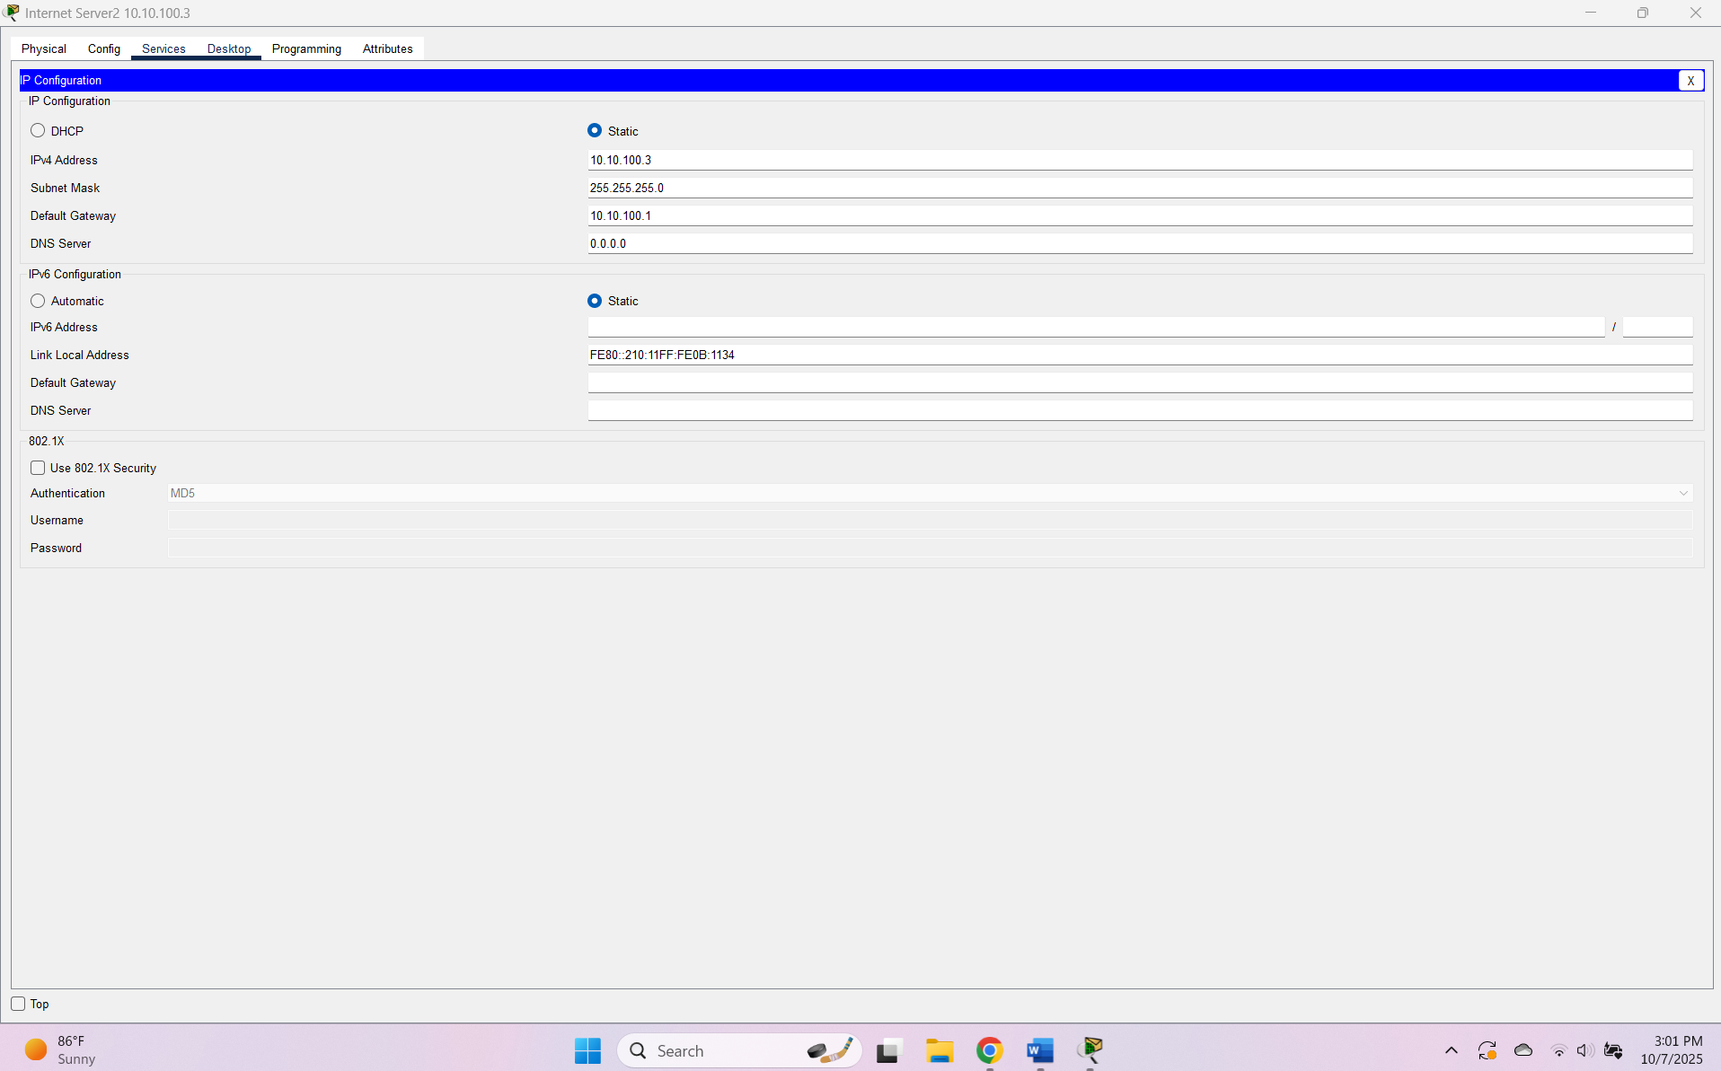
Static IP Configuration for Internet Server3 in VLAN 50 (attached to LA router)
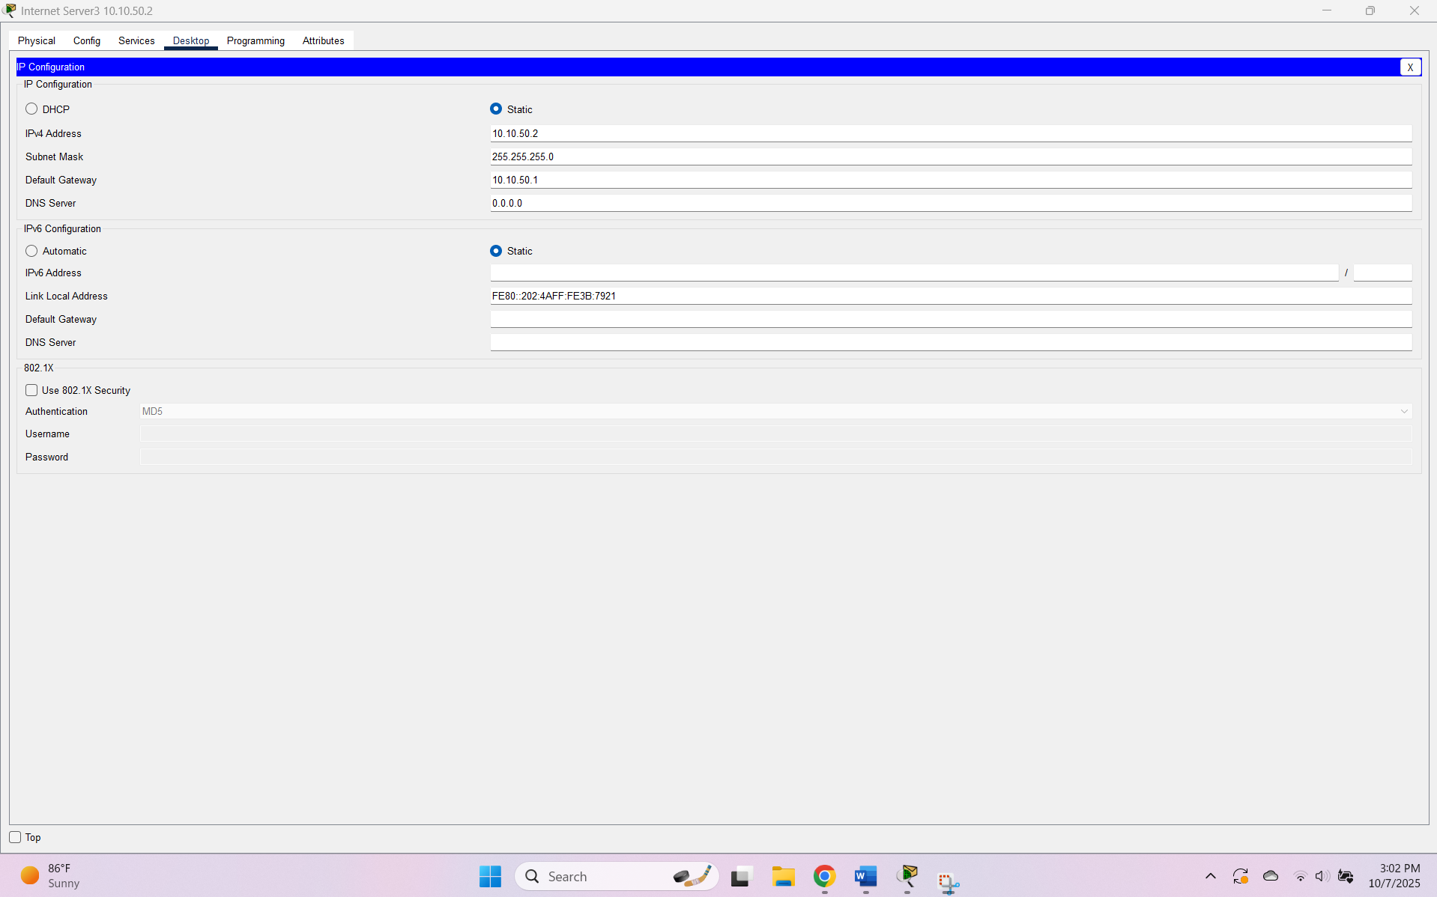

Static IP Configuration for FTP_NTP_Syslog_Server in HR VLAN (40)
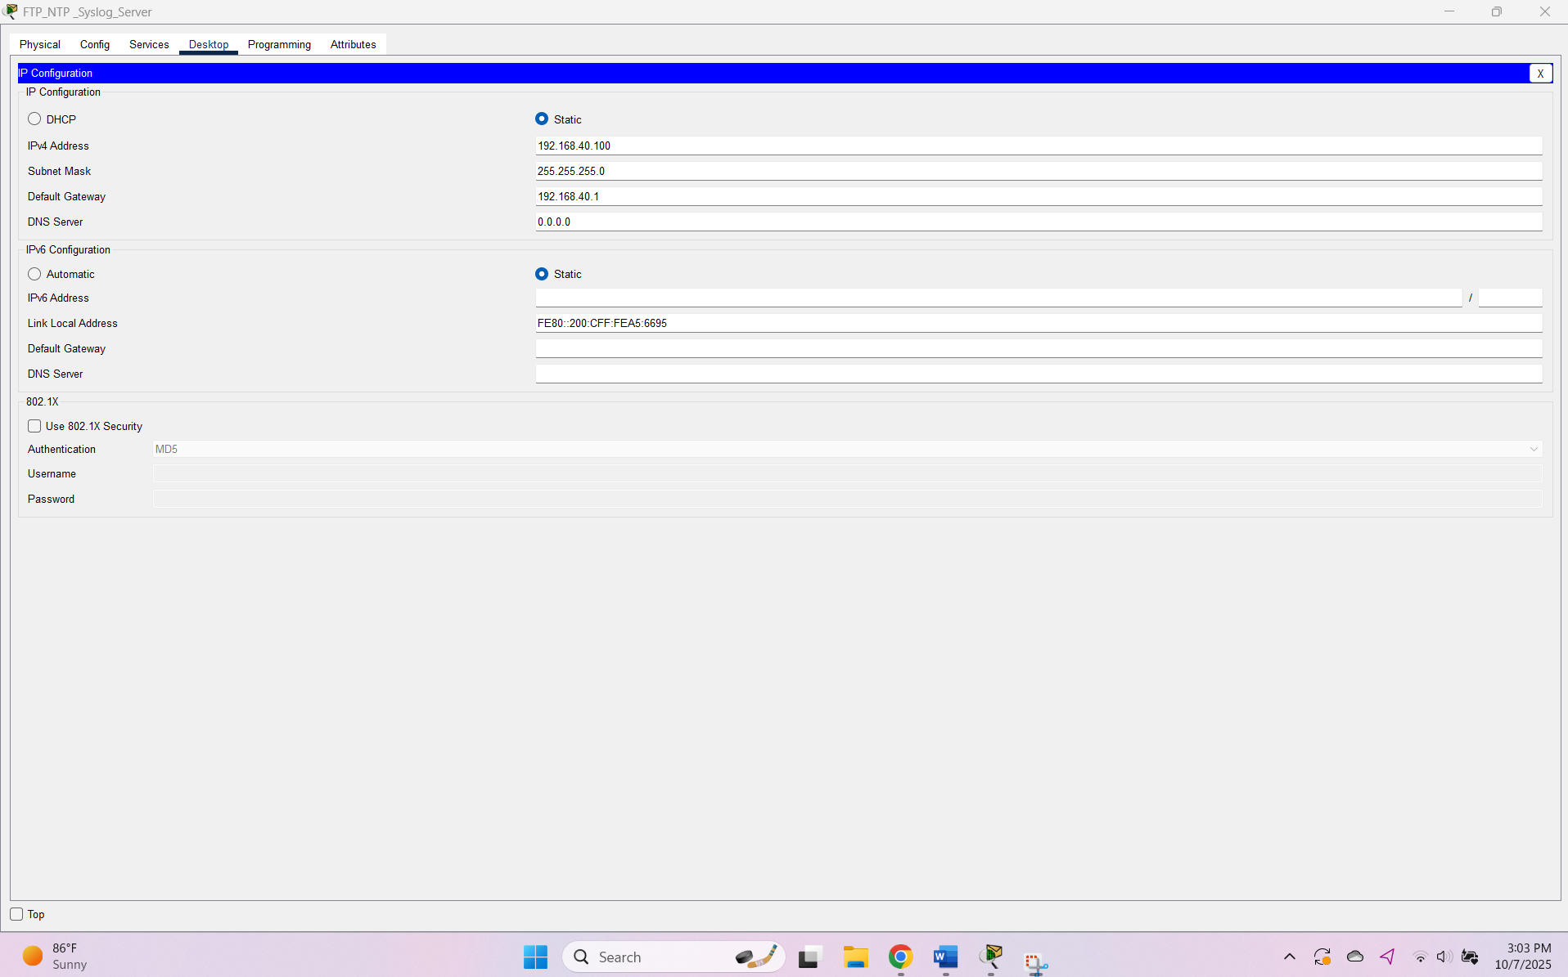

WAP Port 1 Configuration
