Washer Overflow Sensor

# INTRODUCTION

The overflow sensing system is an external circuit meant to interact with a liquid handling robot. The overflow sensor stops washer function after a liquid overflow has been sensed, to prevent damage to the machine. This document includes descriptions of this system, and procedures to clean and reset the washing machine in two situations: post-spill, and routine maintenance (approximately every 10 cycles). This document contains pictures and CAD files relevant to the BioTek ELx405, though the overflow sensor could be connected to other machines for a similar purpose. Each machine would need its own custom mount for attaching the sensor to the machine.

**Usage**

The washer needs to be manually reset through a toggle switch, so the user can clean up the spill and troubleshoot other irregularities before the washer proceeds. The external circuit is built within an enclosure box as pictured below.

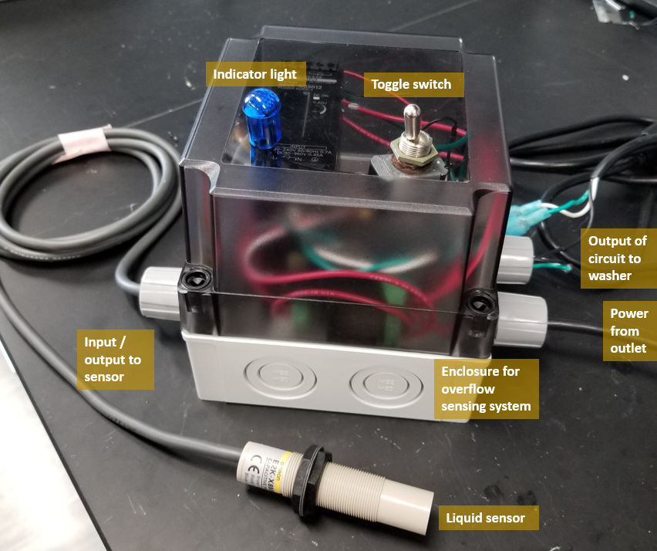

Figure 1: Overflow sensing system

The liquid sensor will attach to the washing machine via a stainless steel fixture detailed in the Background section.

# BACKGROUND

**Materials**

The Bill of Materials can be found in the documentation for this project on the shared drive. The SLDPRT and STL files for the sensor mount can be found in /Automation/Equipment/WasherOverflowSensor/CAD/final.

**Liquid Sensor**

The liquid sensor uses capacitive touch, which essentially detects changes in capacitance within about 1cm from its sensing points, the unmarked third of the sensor (segment farthest from wire). This means it could also sense the top of the machine or any other object if that is placed too close by, triggering a false positive.

While the sensor is powered and senses something in proximity, a red light where the sensor connects to the wire will light up, as seen in Fig 2 below.

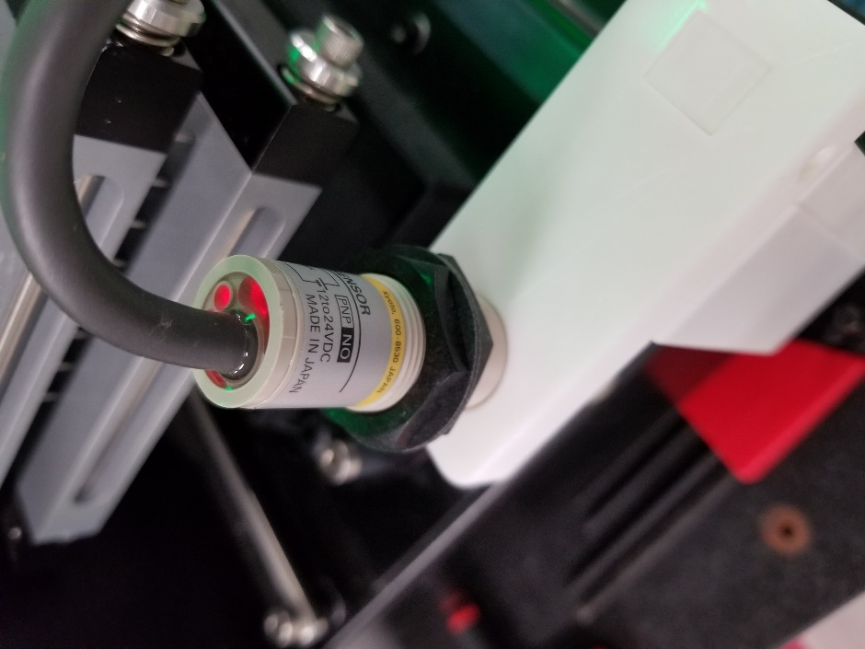

Figure 2: sensor's red light comes on when it senses something in proximity

There is a line marked on the sensor threading for the approximate height that protrudes from underneath the sensor mount, as pointed out in Fig 3 below.

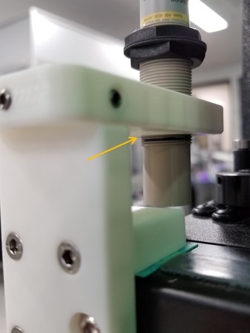

Figure 3: line on sensor marking protrusion from mount

**Sensor Mount**

The CAD files for the sensor mount can be found in /Automation/Equipment/WasherOverflowSensor/CAD/Final.

The sensor interfaces with the washing machine via a fixture held in place by a screw on the front of the machine. The location of the threaded screw hole is boxed in Fig 4.

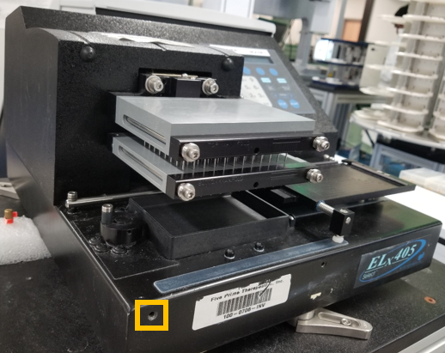

Figure 4: BioTek ELx405 washing machine, hole for fixture attachment is boxed.

The fixture is comprised of two modular pieces shown below. Piece 1 supports the liquid sensor, and Piece 2 interfaces with the washer. Notable parts of each piece are labeled in the figure and described here:

1A: Threaded holes for set screws to attach Piece 1 to Piece 2.

1B: Threaded hole for liquid sensor. Twist sensor in this hole to adjust height.

2A: Unthreaded hole for bolt to attach to washer at the location indicated in Fig 4.

2B: Indentations for set screw interface (one is out of sight in the figure).

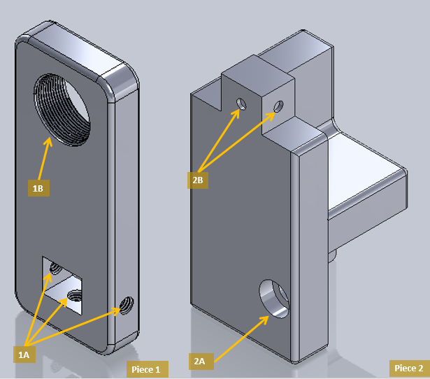

Figure 5: Labeled parts of modular fixture.

An assembled mount with a gasket, attached to the washer and to a liquid sensor is shown in Fig 6.

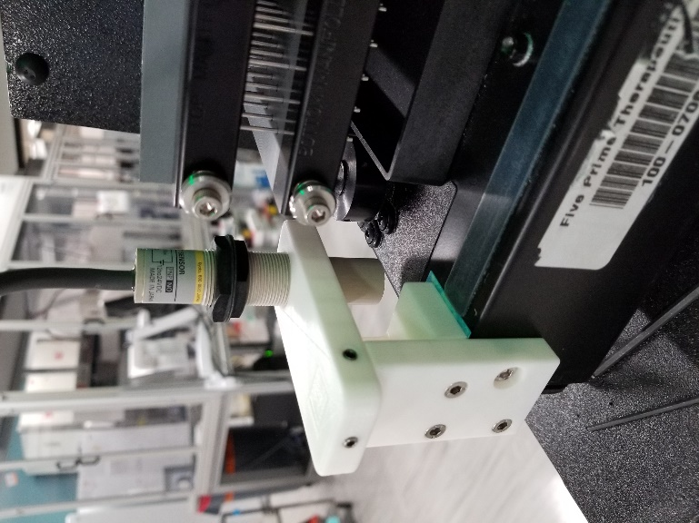

Figure 6: assembled mount (prototype) with gasket, attached to liquid sensor

**Gasket**

There is a gasket at the base of the sensor mount where it touches the washer. This is designed to prevent liquids from seeping between the sensor mount and the washer. The gasket may need to be periodically replaced during deep cleaning, but in spill response you may just clean around the gasket. Gasket cutout dimensions are available in the folder documenting this project, and gasket cutouts are attached to each washer for convenience whenever changing them out.

**Sensing Circuit**

The circuit for the overflow sensing system is in Fig 7 below. Additional wiring diagrams can be found in Automation/Equipment/WasherOverflowSensor/LatchingRelayCircuit.vsdx. Notable elements of the sensing circuit are mentioned in this section.

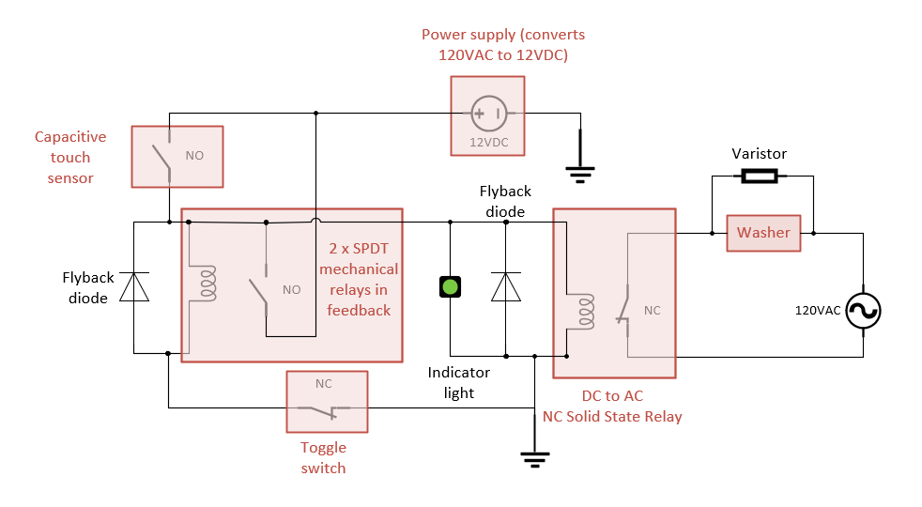

Figure 7: capacitive sensing circuit

*Normally closed DC to AC relay*. This relay serves as the “output” of the entire sensing circuit, as the electrical connection between the circuit and the washer. A DC-AC relay is used because the sensing circuit uses DC whereas the washer uses AC provided by the power outlet. Note that most solid-state DC to AC relays are Normally Open, but for this purpose a Normally Closed relay is used. This relay is an integrated part, but relays effectively work as an inductor with a switch, which is the representation of relays in the circuit diagram.

*Flyback diodes*. Flyback diodes are used in the part of the sensing circuit that utilizes direct current. After the circuit is tripped, the inductors become active magnetic coils which toggle the relay’s switch from Normally Closed to Open, or Normally Open to Closed. Inductors are resistant to current change, so when the toggle switch is toggled to restart the washer, the charged inductors will need to dissipate their stored current by acting as a current source. To protect this current, which causes a sudden and sharp voltage spike, from damaging the rest of the circuit, the diodes are attached parallel to the inductor (across the relay), to dissipate this current. These diodes are not critical for overflow sensor function but should regardless be placed in to protect circuit elements.

*Varistor*. Like flyback diodes but for alternating current, the varistor is placed across the washer (or equivalently, across the output of the AC relay) to protect it from voltage spike after the machine is reset. As with the flyback diodes, the varistor is not critical to circuit function but should be placed in to protect circuit elements.

*Connection between liquid handler and sensing circuit*. The sensing circuit is placed in series electrically to the washer such that when the normally closed sensing circuit breaks open, the washer will not be able to process any current and operate. This connection is achieved by connecting the output of the circuit to the washer through wires indicated in Fig 1.

*Toggle switch*. The toggle switch exists as the only circuit interface with the user. The circuit is designed to stop washer function until it is manually reset by the user, to ensure adequate cleanup and prevention of spill before the cycle resumes. After a liquid spill is detected, the washer will not be turned on until the switch is toggled.

**Indicator Light**

The indicator light is designed for the user to verify the state of the circuit’s electrical components. Refer to the following table for the accurate interpretation of what an on or off indicator light should mean.

* Light: whether the indicator light is turned on or off.
* Sensor State: Whether the sensor is actively sensing or has been tripped.
* Circuit State: Whether the washer re is an open or closed circuit on the washer end. An open circuit means that the normally closed switch of the AC Relay has opened, whereas a closed circuit means the normally closed switch is closed.
* Washer State: whether washer is turned on or off.

|  |  |  |  |
| --- | --- | --- | --- |
| **Light** | **Sensor State** | **Circuit State** | **Washer State** |
| On | Tripped | Open | Off |
| Off | Actively Sensing | Closed | On |

Table 1: light, sensor, circuit, and washer states

**Enclosure Box**

The enclosure box houses the overflow sensing circuit and should be opened only when changing out the indicator light.

*Circuit power supply.* The circuit’s power supply is marked in Fig 7 below. It takes in 120V AC from the power outlet and converts this into 12 VDC for the circuit. When the power supply is on, a green-yellow light (Fig 8) will come on, otherwise the light will be off. When checking whether the power outlet is functional, check if the light comes on when powering the overflow sensor circuit to see if the circuit is receiving power from the outlet.

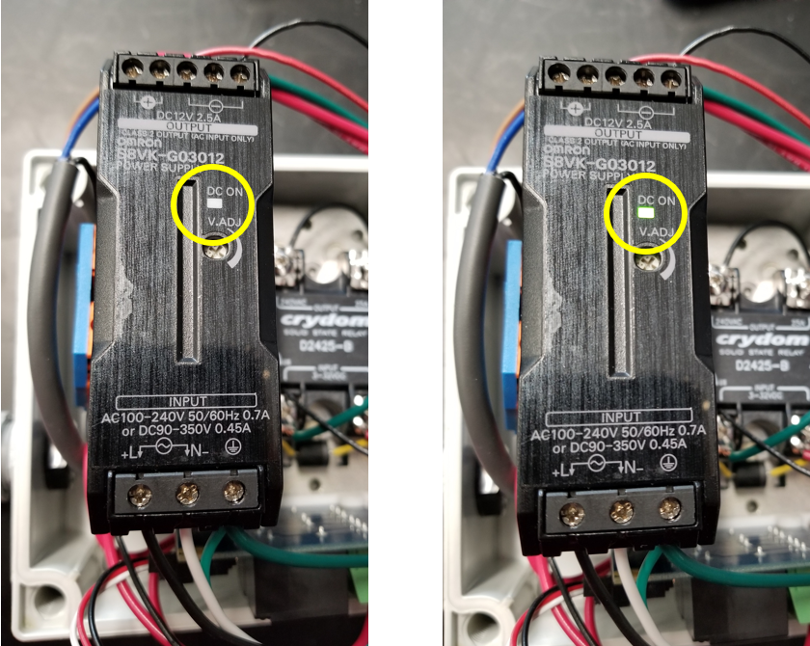

Figure 8: power supply indicator light

*Mechanical relay and mount*. The dual mechanical relay is attached to the base of the enclosure via a custom 3D printed mount, pictured below. The CAD file for this mount can be found at Automation/Equipment/WasherOverflowSensor/RelayMount.SLDPRT.

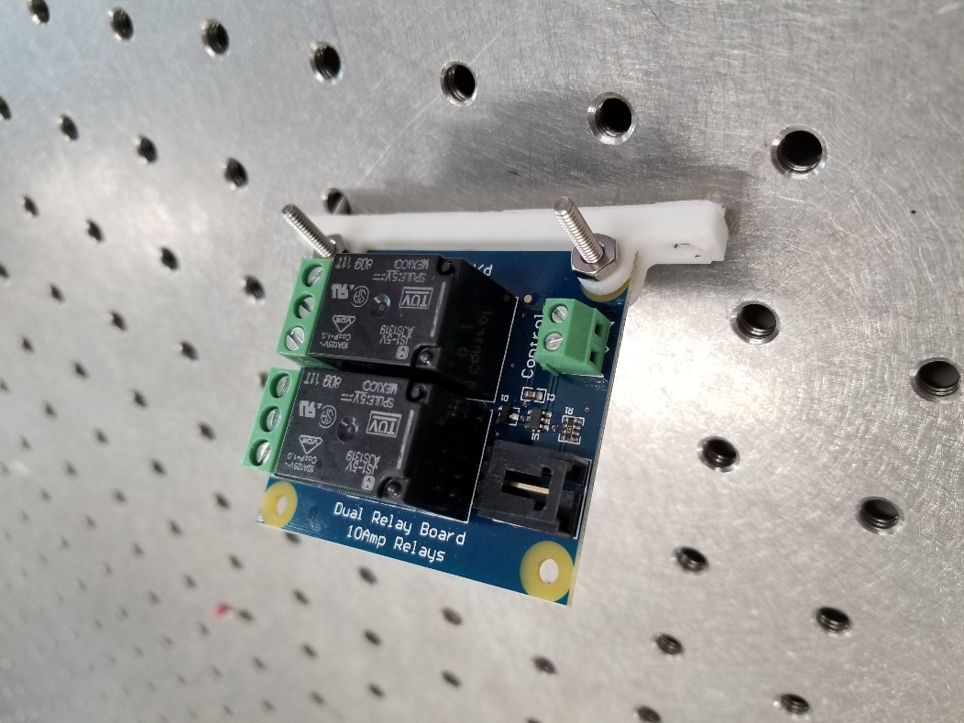

Figure 9: dual mechanical relay and custom mount

# PROTOCOLS

**Spill Response**: To reset washing machine and the overflow sensing system after a spill has been detected. Refer to Fig 5 for piece numbers and descriptions.

1. Detach the liquid sensor support (Piece 1) from the rest of the mount by loosening the set screws from the three threaded holes pointed out in Piece 1. Place this piece aside with the liquid sensor attached. Do not bother to screw or unscrew the liquid sensor within the fixture, and do not dismount the entire sensor mount.
2. Use ethanol (do not use bleach) to wipe away any liquid touching the bottom of the sensor, and any liquid that has pooled on top of the machine. Wipe around the gasket; do not remove it unless it seems that liquid seeped in under the gasket.
3. Check that the liquid did not damage your samples or the machine and resolve the source of the overflow or leak. If there is a massive overflow, consult the Routine Deep Cleaning protocol.
4. Place the sensor and its attached support back on and tighten the screws from the three holes in Piece 1.
5. Make sure the top of the washer is just beyond the distance that the sensor can sense, though it’s unlikely that this setting will have changed from before. You may need to readjust the height of the sensor above the washer.
   1. Make sure the marked line on the sensor (Fig 3) is just below the sensor support piece (Piece 1)
   2. Twist the sensor counterclockwise to increase the distance between it and the washer, and then twist it clockwise slowly to approach the optimal separation distance. If the sensor is too close, a red light at the base of the sensor will turn on (Fig 2).
6. Toggle the switch on the enclosure so that the indicator light turns off and the washer can turn on. Resume or restart your cycle on VWorks.

**Routine Deep Cleaning**: To thoroughly clean the washer top, overflow sensor, and fixtures of any residual spills that may have accumulated over time. Refer to Fig 5 for piece numbers and descriptions.

1. Unplug the liquid sensing system and the washer from the outlet (the two power plugs connected to the enclosure box).
2. Remove the fixture attached to the liquid sensor by removing the screws from the three holes pointed out in Piece 1.
3. Detach the liquid sensor by unscrewing it from the fixture you just removed.
4. Detach the Piece 2 from the washer machine by unscrewing the screw that connects it to the machine.
5. Pick up the gasket. Replacing the gasket is optional, and there should be extra gasket cutouts attached to each washer.
6. Wipe down all parts using ethanol and replace damaged or dirty pieces if necessary. Wipe down the top of the washer using ethanol. Do not use bleach.
7. Reattach Piece 2 to the washer. Make sure its edges are slightly covering the edges of the gasket.
8. Screw on the sensor holder (Piece 1) to the sensor approximately up to the same height on the threads, or approximately up to the indicator line (Fig 2).
9. Reattach the sensor holder via the three screws marked in Piece 1.
10. At this point, check that there are no moving or loose pieces.
11. Plug in the liquid sensing system (two plugs).
12. Make sure the top of the washer is just beyond the distance that the sensor can sense.
    1. You may need to readjust the height of the sensor above the washer. Twist the sensor counterclockwise to increase the distance between it and the washer, and then twist it clockwise slowly to approach the optimal separation distance.
    2. If the sensor is too close, a red light will turn on where the sensor wire connects to the sensor (Fig 2).
13. Toggle the switch so that the indicator light is turned off. The washer is ready for use.

**Replacing Indicator Light**: To replace the indicator light on top of the box after it burned out. Refer to Fig 7 for the circuit diagram.

1. If necessary, extend the wires attached to the indicator light by soldering on your desired length.
2. Unplug the overflow sensor and the washer from the power outlet. Note that there are two plugs associated with the enclosure to unplug.
3. Unscrew the four screws at the corners the enclosure lid and open the lid. There will be wires connecting elements on the base of the enclosure with the elements on lid of the enclosure, so be careful not to yank the lid.
4. Use a flathead screwdriver to disconnect the two wires of the indicator light from the rest of the circuit (at the AC relay). Consult the circuit wiring diagram if necessary. Remove the light through the top of the enclosure.
5. Thread the new indicator light through the lid of the enclosure and attach its two wires back into the circuit. Polarity does not matter (it doesn’t matter which wire is connected to which end of the open circuit).
6. Place the enclosure lid back on and tighten the four corner screws.
7. Plug in the enclosure box and ensure that the capacitive touch sensor is at a correct range: just beyond the top of the washer. Twist the sensor in its place, until the red light at the base of the sensor (Fig 2) just barely does not light up.
8. Toggle the switch so that the indicator light is off. The washer is ready for use.

# TROUBLESHOOTING / FAQ

**Why does the sensor detect liquid when there’s no spill?**

The sensor uses capacitive touch to detect nearby objects, so it may be placed too closely to the washer surface or another object. When the indicator light on the enclosure is on, the washing machine has stopped its cycle because an overflow has been detected. If there is no visible spill, check that the bottom of the sensor is not too close to the top of the washer. If it’s too close to the machine, slightly unscrew the sensor in the fixture by rotating the sensor counterclockwise. Check that the sides of the sensing segment (not including the threaded segment) is not placed too close to anything else either.

**How frequently should the deep clean be done?**

The frequency of washer usage and spill, and the nature of the liquid (for example, corrosive, etc) are factors that determine how often deep cleans should occur. For reference, the frequency of deep cleans should be approximately once every five spillovers. Keep in mind that during deep cleans, the mount and gasket are checked for damage or malfunction, so cleaning should be done even though the area looks acceptable.

**Does the gasket, screws, and/or actual material for the sensor mount need to be replaced during deep cleaning?**

In the unlikely event that the mount or its screws show severe wear and tear, they will need to be replaced. The gasket may need to be replaced more frequently, if there is a material buildup or if it is no longer sealing well (parts that are supposed to be sealed off are damp).

**Do electronic components in the enclosure box need to be periodically replaced?**

The indicator light on top of the enclosure box may burn out with time. The item is found in the BOM, though other lights also suffice if they are voltage and current compatible. Follow the protocol for replacing the indicator light to switch out the indicator light. Other electrical components are expected to have a longer lifespan.

**Why is the washer turned off when the indicator light is off as well?**

Check whether the light on the power supply is on (Fig 7). If the power supply is receiving power, the indicator light may have burned out. The indicator light can be replaced by following the protocol outlined for switching out the indicator light. The circuit states chart (Table 1) may be helpful as well.