Problem Statement:

Uneaten food is the single biggest component of municipal solid waste. In landfills, food gradually breaks down to form methane, a greenhouse gas that's at least 25 times more powerful than carbon dioxide. In terms of total mass, fresh fruits and vegetables account for the largest losses at the consumer level at 28 percent. Public awareness about food waste in the US is limited and is a huge contributor to the problem. One of the reasons food waste has become such a large problem is that it has not been effectively measured or studied. A comprehensive report on food losses in the US is needed to characterize and quantify the problem, identify opportunities and establish benchmarks against which progress can be measured.

<http://www.sustainabletable.org/5664/food-waste>

Team Goals:

* Create an IoT device that will monitor Ethylene levels inside of a container that monitors rotting fruit.
* This device will alert customers that they will need to consume or compost the food based on ethylene levels.

Business Objectives

* Scale – We envision this technology being used in drawers in Smart Refrigerators and Rubber Maid Containers making them “Smart”
* Sustainability – We envision changing the behavior of consumers by allowing them to monitor the state of their food allowing consumers to meal plan and reduce food waste to landfills which reduces methane in the atmosphere. Our goal is to include a feature in the app that will inform the customer of how much methane the costumer has reduced in the atmosphere by consumer the food and not sending the food to a landfill. This will “nudge” consumers to change their behavior.
* Continuous Delivery – We intend to be agile and continuously integrate our technology into more products and continuously deliver more features over time.
* Economy of Scale - ?

Background

* The United States wastes roughly 40 percent of its food - the equivalent of about $165 billion per year. Food is wasted at every point along the food chain: on farms and fishing boats; during processing and distribution; in retail stores and restaurants; at home; and after it enters our trash cans.3 Of the estimated 133 billion pounds of food that goes to waste every year, much of it is perfectly edible and nutritious.
* USDA's Economic Research Service (ERS) defines food waste as "the component of food loss that occurs when an edible item goes unconsumed, as in food discarded by retailers due to color or appearance and plate waste by consumers
* In the US, an average family of four wastes 1,160 pounds of food annually, (about 25 percent of the food they buy), costing them $1,365 to $2,275 per year. In terms of total mass, fresh fruits and vegetables account for the largest losses at the consumer level (28 percent), followed by dairy (17 percent), meat (12 percent) and seafood (33 percent). Major contributors to household food waste include:
  + Food Spoilage - About two-thirds of food waste at home is due to food not being used before it goes bad. Food spoilage at home occurs due to improper storage, lack of visibility in refrigerators, partially used ingredients and misjudged food needs.
  + Over-Preparing - The remaining third of household food waste is the result of people cooking or serving too much food. Cooking portions have increased over time and large meals often include more food than we can finish. The Cornell Food and Brand lab found that since 2006, serving sizes in the classic cookbook The Joy of Cooking have increased 36 percent. In addition, people often forget to eat leftovers and end up throwing them away.
  + Date Label Confusion - According to a 2013 study by Harvard Law School and the Natural Resources Defense Council (NRDC), an estimated 90 percent of Americans prematurely discard food due to confusion over the meaning of date labels (e.g., "sell by," "best if used by," "expires," etc.). In reality, "sell by" and "use by" dates are not federally regulated and only serve as manufacturer suggestions for peak quality. Research on date labeling from the UK suggests that standardizing food date labeling and clarifying its meaning to the public could reduce household food waste by as much as 20 percent.
  + Overbuying - Sales on unusual products and promotions that encourage impulse and bulk food purchases at retail stores often lead consumers to purchase items that don't fit into their regular meal plans and spoil before they can be used.
  + Poor Planning - Without meal plans and shopping lists, consumers often make inaccurate estimates of what and how many ingredients they will use during the week. Unplanned restaurant meals or food delivery can also lead to food at home going bad before it can be used.

<http://www.sustainabletable.org/5664/food-waste>

Target Release:

March 25, 2018 1:00PM PST

Assumptions:

* Time Crunch – We only have one weekend to complete the project (Certain to Happen)
* Technical Abilities (Likely to Happen)
* Research
* Science (Plenty of resources available)

User Stories

* A user would like to select the type of fruit they just bought for the container and monitor this fruit?
* A user would like to view the progress of rot over time
* A user would like to know how to view the data for this app
* The user would like to view this data on their phone/laptop
* A user would like to receive notifications before it is too late to eat the fruit

Presentation Judging Criteria

1.Submission of code: By 1PM on GitHub

2. Presentation Time: 3 min

3. Theme idea:

- How relevant is your product to theme of sustainability?

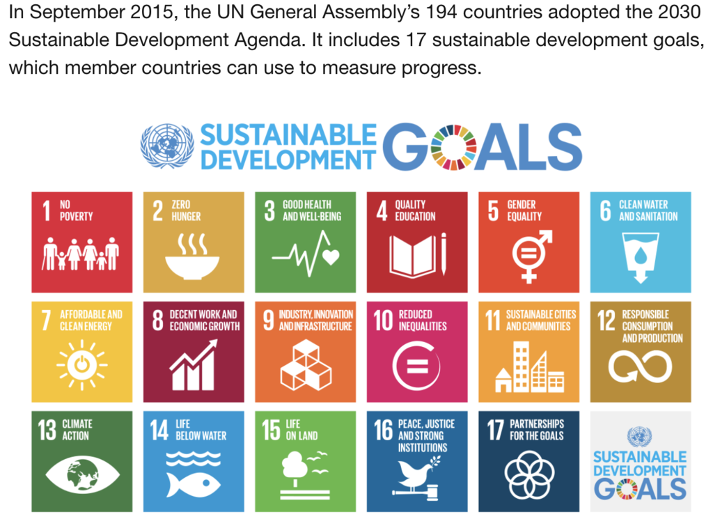

12 Responsible Consumption

13 Climate Action