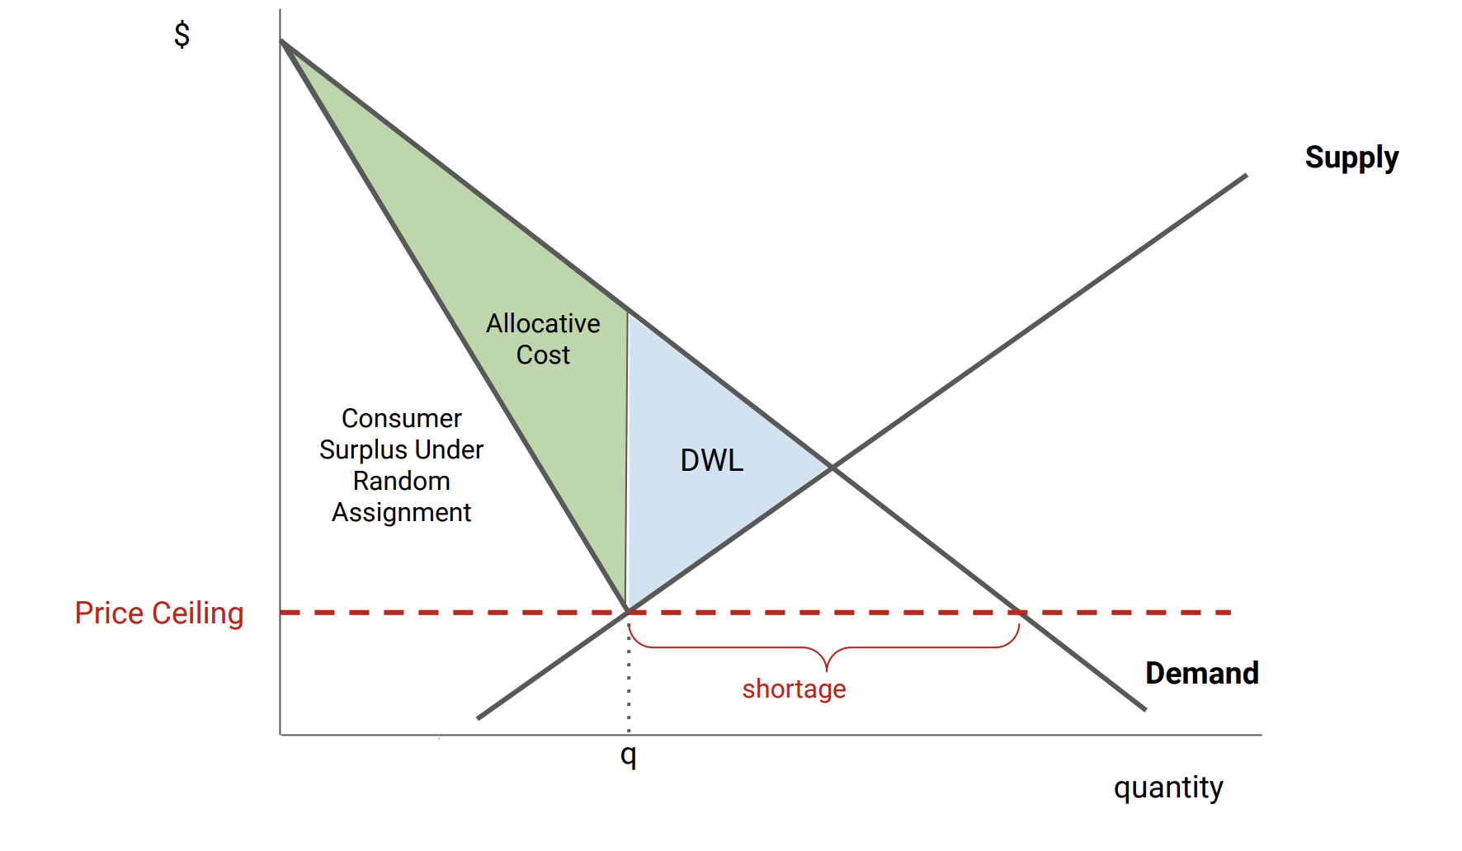
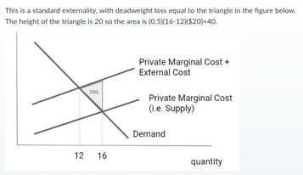
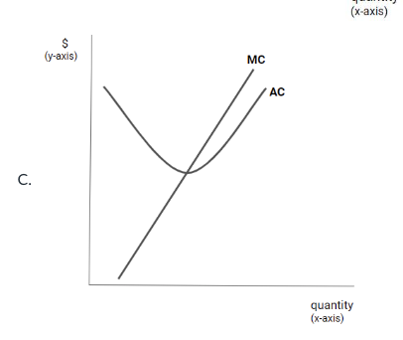
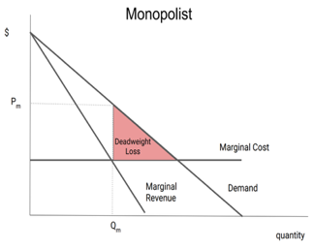
EEM Final Exam Cheat Sheet | Competitive Markets · Monopoly · Auctions · Futures · Hedging · Storage · Regulation · LCOE · Electricity · Externalities · Cap-and-Trade
1. Competitive Markets & Market Power  Short run: Capital fixed; P from supply/demand; price volatility ≠ market power  Long run: Entry/exit until P = MC = ATC (efficient)  Market power: Ability to raise P by restricting Q. Non-competitive firm reduces Q → price rises.  2. Monopoly  MR = MC → Q* → plug into demand for P*  For linear demand P = a − bQ:  MR = a − 2bQ (twice the slope)  TR = P(Q)·Q, MR = P + P'(Q)·Q  Result: Lower Q, higher P, deadweight loss vs. competitive  3. Dominant Firm + Fringe  Q_residual = Q_demand − Q_fringe  Dominant firm is a monopolist over residual demand.  Market power strongest when:  - Market demand is inelastic  - Fringe supply is inelastic  → Residual demand is most inelastic → most pricing power  4. Auctions  Uniform Price Auction  - All winners pay the clearing price  - Competitive firms bid ≈ MC  - If demand drops unexpectedly → price falls  Pay-As-Bid Auction  - Each winner pays their own bid  - Firms must forecast clearing price → bid above MC  - If demand drops → price stays high (bids already inflated)  Winner's Curse: Common-value auctions; more bidders → more overestimation risk  5. Futures vs. Forwards  6. Basis Risk  Basis risk: Risk that futures contract is poorly correlated with actual asset  Electricity: MOST basis risk — cannot store; prices vary by hour/location  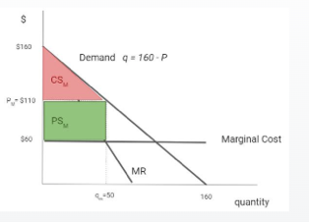  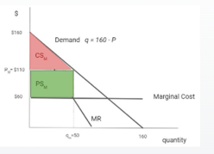  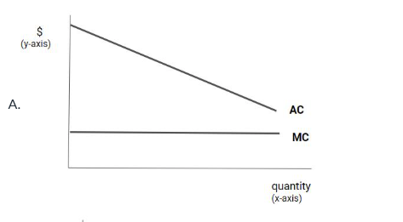  Crude oil: Less basis risk — storable; prices more uniform | 7. Hedging  Selling commodity → short futures (fear price drop)  Buying commodity → long futures (fear price rise)  Hedge Size = Exposure × Price Sensitivity  e.g. Solar plant selling 106,000 MWh; each $1 gas drop → $5/MWh electricity drop:  Hedge = 106,000 × 5 = 530,000 MMBTU (short)  8. Storage Economics  Carry cost = interest rate + storage cost  Contango: Futures > Spot → incentive to store  Backwardation: Futures < Spot → incentive to sell now  Super contango: Buy spot + sell futures → lock in profit  Storage reduces price volatility over time.  Store if: F_T > S_0 × (1+r) + storage cost  9. Transportation & Arbitrage  Arbitrage if: P₂ − P₁ > MC_transport  Trade equalizes prices net of transport cost.  Market power in transport → price wedge too large → DWL  10. Natural Monopoly  AC declining over entire market demand range = Natural Monopoly  MC < AC → AC falling | MC > AC → AC rising | MC = AC → AC minimum  Regulatory Options  - P = MC: Efficient but firm loses fixed cost (profit = −F)  - P = AC: Profit = 0; DWL vs. efficient quantity  - Two-part tariff: P = MC + fixed fee ≤ CS per consumer  Two-part tariff: Find CS at P=MC; that's max fixed fee.  DWL = 0.5 × (P_reg − MC) × (Q_eff − Q_reg)  11. Averch-Johnson Effect  Rate-of-return regulation → overinvestment in capital.  Allowed return > cost of capital → maximize rate base → build more infrastructure.  12. Tax Incidence  Less elastic side bears more of the tax.  Buyer share = Supply slope / (Supply slope + |Demand slope|)  Inelastic demand (insulin, gasoline) → buyers pay. Inelastic supply (land) → sellers pay.  Price ceiling: Shortage + DWL + allocative inefficiency  Secondary market: Fixes allocative cost but NOT DWL or shortage  13. Double Marginalization  Two monopolists in vertical chain each add markup → higher final P, lower Q, DWL.  Requires market power at BOTH upstream and downstream levels. | 14. LCOE (Levelized Cost of Electricity)  LCOE = constant real P/MWh that makes NPV = 0  Fixed MC:  LCOE = MC + Fixed Cost / Discounted MWh  Variable MC:  LCOE = Σ(Costs_t / (1+r)^t) / Σ(MWh_t / (1+r)^t)  Higher capacity factor → lower LCOE (fixed cost spread over more MWh)  Limitation: Ignores time, location, dispatchability — treats all MWh equally  Compare LCOE vs. wholesale price to assess viability (market prices don't enter LCOE formula).  15. Electricity Markets & Peak Pricing  Merit order: Renewables → Nuclear → Coal → Gas (low to high cost)  Market price = MC of marginal (most expensive) unit dispatched.  Fossil fuels typically set the price.  Gas Price Drop — Short Run vs. Long Run  - Short run: Capacity fixed; off-peak prices fall (MC ↓); peak prices unchanged (capacity-constrained)  - Long run: Capacity adjusts; lower build cost → more plants → peak prices fall more  Build Cost Rise — Long Run  - Less new capacity enters → peak prices rise more than off-peak  16. Externalities & Policy Instruments  Private equilibrium: MB = MPC (ignores external cost)  Social optimum: MB = MPC + MEC → lower Q, higher P  DWL = 0.5 × (Q_market − Q_social) × MEC  Pigouvian tax: Set tax = MEC → achieves Q*  3 Market Failures & Solutions  - Unpriced externalities: Pigouvian tax  - Imperfect information: EnergyGuide / ENERGY STAR labels  - Principal-agent (landlord/tenant): Min. efficiency standards  Instrument choice: Measurable emissions → Tax/Cap-and-Trade; Not measurable → Technology Mandate  17. Cap-and-Trade & MAC Equalization  At equilibrium: MAC_A = MAC_B = Permit Price P  X_A + X_B = Total Abatement Required  Lower-cost (flatter MAC) firm abates MORE; buys fewer permits.  MAC < permit price → Abate | MAC > permit price → Buy permits  Total cost = Σ(0.5 × X_i × P_i) for each firm  Offsets: Increase compliance options → permit price ↓ → electricity price ↓  Free permits: Opportunity cost still = market price (same as auctioned); free permits distort exit decisions  18. Carbon Leakage, Reshuffling & Behavioral Failures  Leakage: Regulation → production moves to less-regulated region (global emissions don't fall as much)  Reshuffling: Trading partners change, but total production unchanged (no real leakage)  Knowledge spillovers: Must flow to OTHER firms to be a market failure (positive externality). Internal R&D sharing is NOT a spillover.  Rebound effect: Efficiency ↑ → cost per use ↓ → usage ↑ (NOT a market failure)  CAFE standard: Fleet average MPG requirement; compliance via tech improvement or sales mix; credit trading allowed
  Feature | Futures | Forwards
  Traded | Exchange | OTC (private)
  Terms | Standardized | Customized
  Counterparty risk | Low (clearinghouse) | Higher
  Basis risk | Higher | Lower
  Liquidity | High | Low
  Term | Meaning
  Rate Base | Total value of regulated capital investments
  Rate of Return | Allowed profit on capital
  Cost of Capital | Min. required return on investment
  Used & Useful | Assets must be operating to enter rate base
  Depreciation | Largest expense for regulated utilities
  Policy | Fixes | Price | Emissions | Efficiency
  Carbon Tax | Price externality | Fixed | Uncertain | High
  Cap-and-Trade | Quantity | Uncertain | Fixed | High
  Tech Standard | Technology | None | Fixed/Indirect | Low
  Subsidy | Incentives | None | Uncertain | Medium
  Cmd & Control | Quantity/Method | None | Fixed | Low
