Jennifer Erving
4 center street, 123, Sussex N.J. 07461 9732193226, jennifererving1@gmail.com

Education

- UOP
- SCCC
- Bachelors in the science of psychology
- Psychology
- 3.8

Experience

[Dec 2016] – [2022]

[Home Health Aide] | [public partnerships ] | [Boston Ma]
I am a home health aid for my terminally ill mother. I cook, clean, and take care of her personally.

[Nov 2021] – [present]

[Yoga Instructor | [Journey With Jenne] | [Stockholm]
I have just started my own business.

[Dec 2025] -- [present]

[Junior Software Engineer]
I am getting certified with FES Institute to become a software engineer.

[Aug 2025] -- [present]

[Manager}
I am managing a cannabis store that I have been with for the last two years.

Awards & Acknowledgements
- [I have a 100 hour meditation certification
- 200 hour meditation certification
- 200 hour yoga certification
- 200 hour kundalini certification 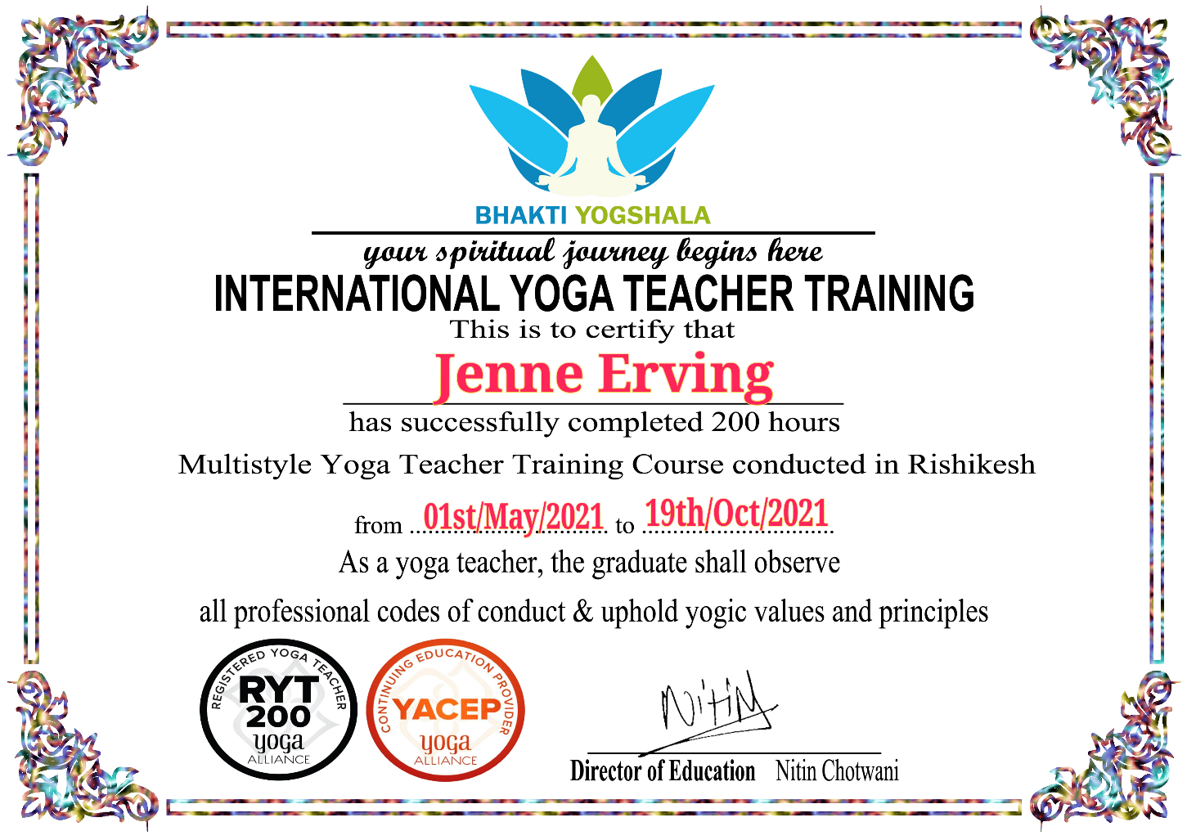

EXAMPLE COPYWRITES:

Kundalini Yoga the 5,000 year old tradition
Come experience what its like to feel the shakti-energy
Inside your body. 30$ a class will get you into
Kundalini Yoga the potent snake charmer.

Cbd is a potent and powerful chemical that
Can have a magical effect for some consumers.
Cbd is 100% plant based and natural, usually organic
And can alleviate anxiety. Women like to use this product
When its that time of the month.

Facebook is a social networking site where millions of people
Meet and get to see each other on a daily basis. Twitter is another
Social networking site that features this advantage. Instagram is
Another site where your data is taken and stored and you can see
Your friends daily.

