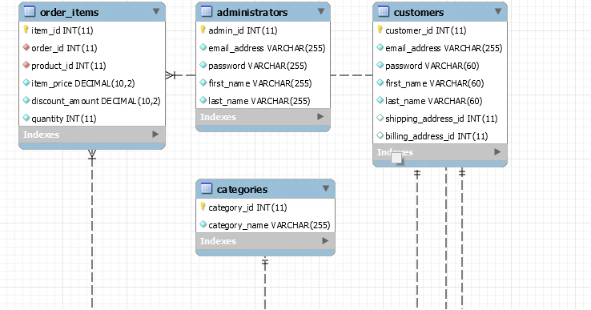

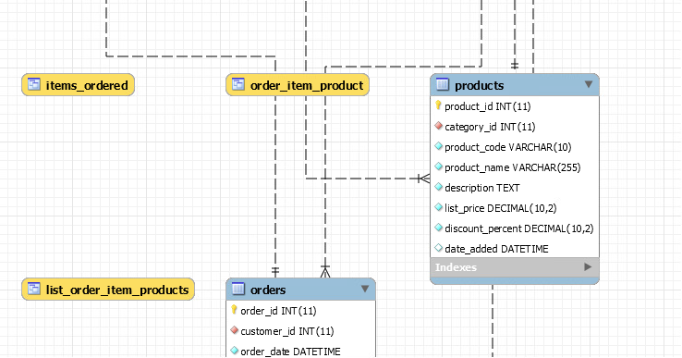

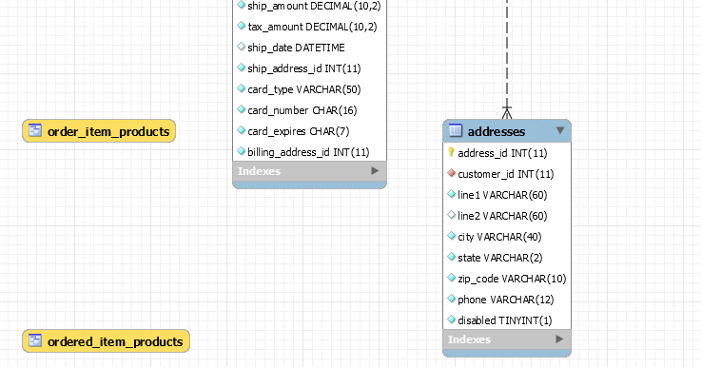

|  |  |  |  |  |  |  |  |
| --- | --- | --- | --- | --- | --- | --- | --- |
| Table | Order_items | Adminis-trators | customers | categories | products | orders | addresses |
| Primary key(s) | Item_id | Admin_id | Customer_id | Category_id | Product_id | Order_id | Address_id |
| Foreign key(s) | Order_id Product_id |  |  |  | Category_id | Customer_id | Customer_id |

But what are these? … views? Items_ordered List_order_item_products

Order_item_product Order_item_products Ordered_item_products

CARDINALITY

Because orders can have many items – orders to order_items: one to many relationship

Because categories can have many products – categories to products: one to many relationship

Because customer can have more than one order – customers to orders: one to many relationship

Because customers can have more than one order item – customers to order_items: one to many relationship

Assuming customers have only one address – customers to addresses: one to one relationship