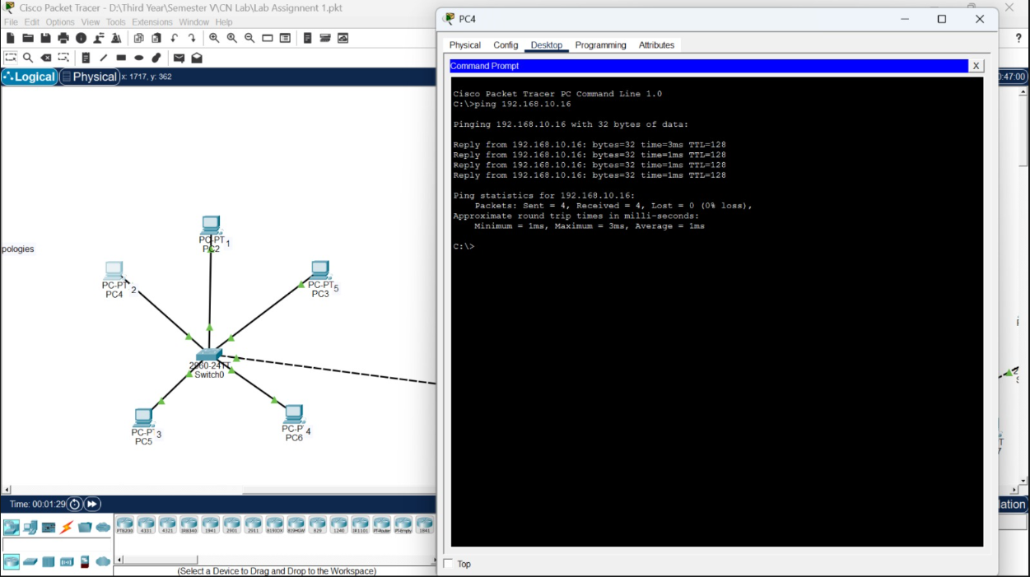
Star Topolgy
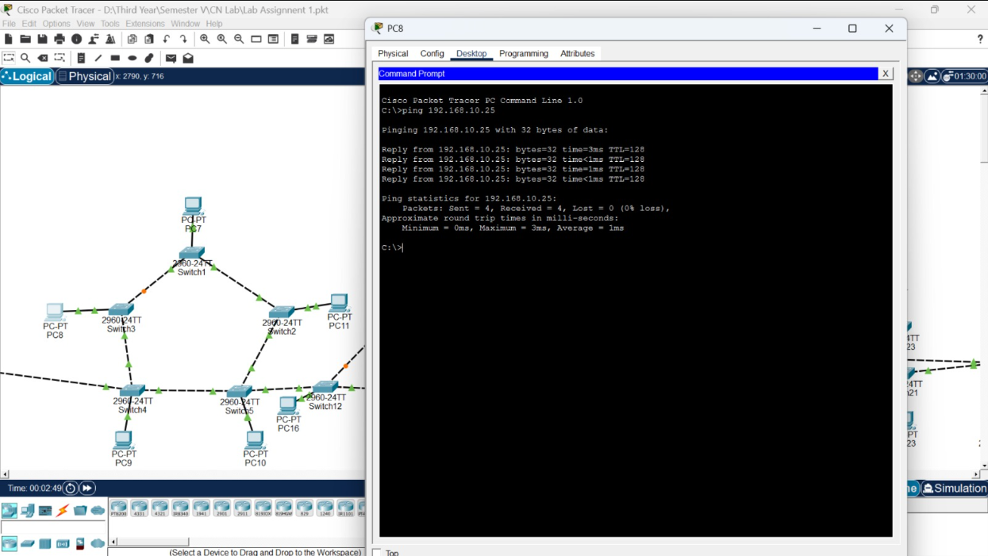
Ring Topology
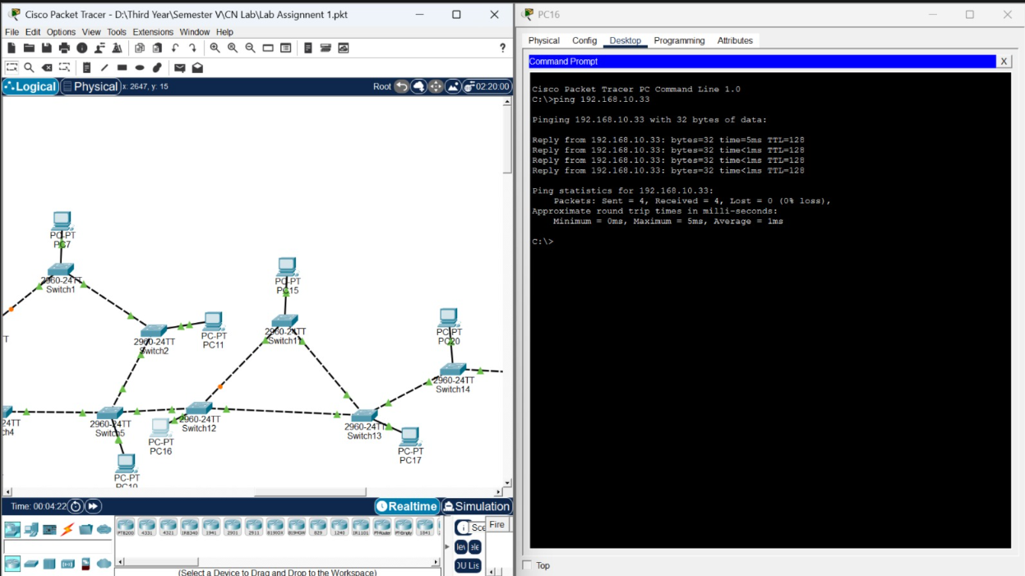
Mesh topology
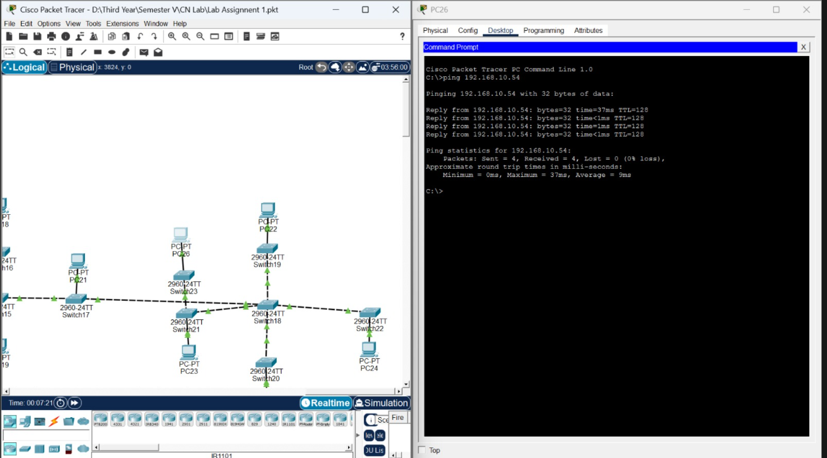
Bus Topolgy
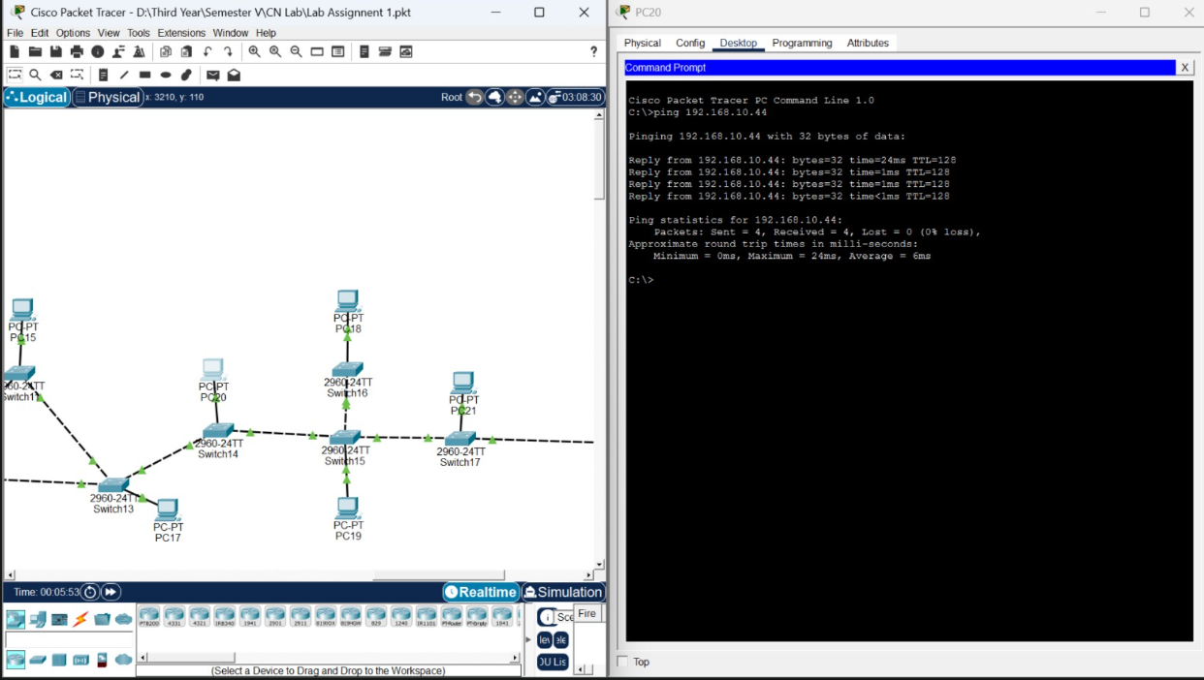
Tree topology
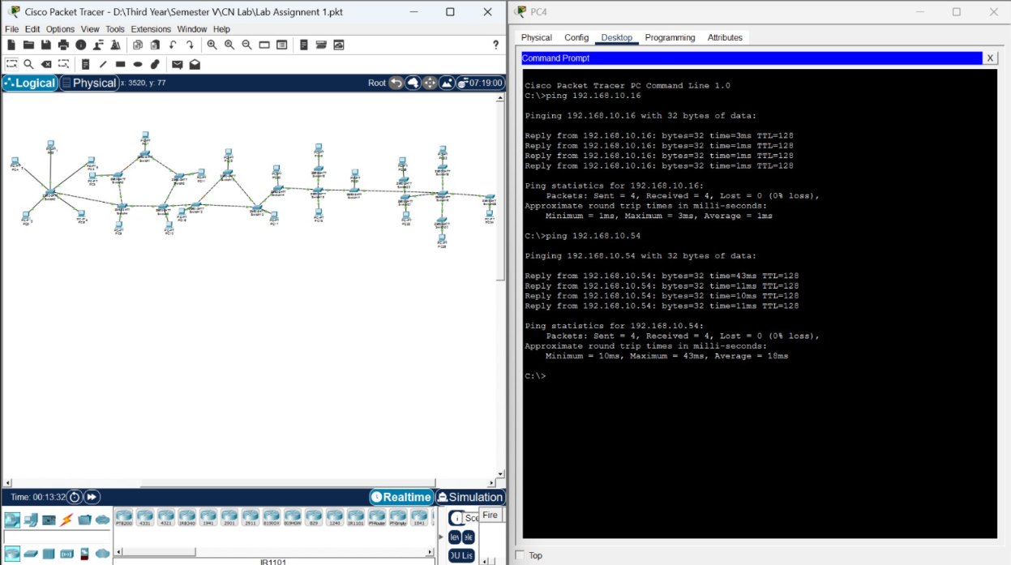
Hybrid topology

//code:
#include<stdio.h>
#define MAX 7
int main()
{
int arr[MAX];
int i;
int count_p1=0;
int count_p2=0;
int count_p3=0;
int count_s1=0;
int count_s2=0;
int count_s3=0;
int s1, s2, s3;
int receiver[MAX];
for(i=0; i<=6; i++)
{
arr[i]=0;
}
int sender_code;
printf("\nEnter sender code (4-bit): ");
scanf("%d", &sender_code);
printf("\nThe sender code is: %d", sender_code);

int rem;
for(i=6; i>=0; i--)
{
if(i!=3 && i!=5 && i!=6)
{
rem = sender_code%10;
sender_code=sender_code/10;
arr[i]=rem;
}
}
printf("\nThe array is: ");
for(i=0; i<=6; i++)
{
printf("%d", arr[i]);
}
//p1= 3, 6, 7
for(i=0; i<MAX; i++)
{
if((i==0 || i==2 || i==4) && arr[i]==1)
{
count_p1++;
}
}
if(count_p1%2==0)
{
arr[6]=0;
}
else
{
arr[6]=1;
}
printf("\nThe array after calculating p1 is: ");
for(i=0; i<=6; i++)
{
printf("%d", arr[i]);
}
for(i=0; i<MAX; i++)
{
if((i==0 || i==1 || i==4) && arr[i]==1)
{
count_p2++;
}
}
if(count_p2%2==0)
{
arr[5]=0;
}
else
{
arr[5]=1;
}
printf("\nThe array after calculating p2 is: ");
for(i=0; i<=6; i++)
{
printf("%d", arr[i]);
}
for(i=0; i<MAX; i++)
{
if((i==0 || i==1 || i==2) && arr[i]==1)
{
count_p3++;
}
}
if(count_p3%2==0)
{
arr[3]=0;
}
else
{
arr[3]=1;
}
printf("\nThe array after calculating p3 is: ");
for(i=0; i<=6; i++)
{
printf("%d", arr[i]);
}

//Receiver's code

printf("\nEnter receiver's code (7-bit): ");
for(i=0; i<MAX; i++)
{
scanf("%d", &receiver[i]);
}
for(i=0; i<MAX; i++)
{
if((i==0 || i==2 || i==4 || i==6) && receiver[i]==1)
{
count_s1++;
}
}
if(count_s1%2==0)
{
s1=0;
}
else
{
s1=1;
}
for(i=0; i<MAX; i++)
{
if((i==0 || i==1 || i==4 || i==5) && receiver[i]==1)
{
count_s2++;
}
}
if(count_s2%2==0)
{
s2=0;
}
else
{
s2=1;
}
for(i=0; i<MAX; i++)
{
if((i==0 || i==1 || i==2 || i==3) && receiver[i]==1)
{
count_s3++;
}
}
if(count_s3%2==0)
{
s3=0;
}
else
{
s3=1;
}

if(s1==1 || s2==1 || s3==1)
{
printf("\nError detected. Bit position is: %d", s3*4+s2*2+s1);
if(receiver[7-(s3*4+s2*2+s1)]==0)
{
receiver[7-(s3*4+s2*2+s1)]=1;
}
else
{
receiver[7-(s3*4+s2*2+s1)]=0;
}
printf("\n Corrected receiver's code (7-bit): ");
for(i=0; i<MAX; i++)
{
printf("%d", receiver[i]);
}
}
else
{
printf("\nNo error detected");
}

}
