BANK CUSTOMER CHURN PREDICTION
Exploratory Data Analysis & Predictive Modelling

Final Report
BUAN 6356 Business Analytics With R

Team 6
Chamudhrikha Ravikumar
Jennia Paul
Virat Kumar

Dataset: Botswana Bank Customer Churn (Kaggle)
April 2026

PROJECT HIGHLIGHTS
• Dataset: 115,640 customers | 16 features | Zero missing values | Stratified 80/20 split
• Models: Ridge Logistic Regression | Decision Tree (rpart) | Random Forest
• Best model: Decision Tree — Highest Accuracy 98.39% | Sensitivity 93.60% | AUC 0.9952
• Top predictors: Balance (r = −0.50), NumComplaints (+0.21), CreditScore (−0.18), NumProducts (−0.18)
• Key insight: Churn rate rises 8× from 2.95% (0 complaints) to 23.52% (10 complaints)

1. Executive Summary
This report presents a complete data science pipeline for predicting customer churn at a Botswana bank. Using a publicly available Kaggle dataset of 115,640 customer records, we conducted Exploratory Data Analysis (EDA), trained three predictive models — ridge logistic regression, a pruned decision tree, and a random forest — and evaluated performance on a stratified 20% held-out test set.

Four numeric features — Balance, NumComplaints, CreditScore, and NumProducts — carry virtually all predictive information. All categorical features show identical churn rates (~12.2%) across levels due to the synthetic data structure. The pruned Decision Tree achieves the highest overall accuracy (98.39%) and is the recommended model, combining strong predictive performance with full interpretability — a key advantage for business deployment and regulatory contexts.

2. Dataset Overview

2.1 Raw Data and Cleaning
The dataset (115,640 rows × 25 columns) was cleaned by removing identifiers, free-text fields, and post-churn leakage columns. Age was derived from Date.of.Birth using a fixed reference date of 2024-12-31 for reproducibility. The final working dataset has 16 columns (15 features + binary target Churn).

Attribute | Value | Note
Rows | 115,640 | Full dataset
Raw columns | 25 | Before cleaning
Final columns | 16 | 15 features + Churn target
Missing values | 0 | None detected
Train set | 92,513 (80%) | Stratified split
Test set | 23,127 (20%) | Stratified split
Churn rate | 12.19% | Preserved in both partitions

2.2 Final Feature Set
Feature | Type | Description
Gender | Categorical (2) | Female, Male
MaritalStatus | Categorical (3) | Divorced, Married, Single
NumDependents | Numeric (0–5) | Number of dependents
Age | Numeric (18–76) | Derived from Date.of.Birth (ref: 2024-12-31)
Income | Numeric | Annual income (5K–100K)
EducationLevel | Categorical (4) | Bachelor's, Diploma, High School, Master's
Tenure | Numeric (1–30) | Years as customer
CustomerSegment | Categorical (3) | Corporate, Retail, SME
CommChannel | Categorical (2) | Email, Phone
CreditScore | Numeric (300–850) | Credit score
CreditHistLength | Numeric (1–30) | Credit history (years)
OutstandingLoans | Numeric | Outstanding loan balance
Balance | Numeric | Account balance
NumProducts | Numeric (1–5) | Number of bank products held
NumComplaints | Numeric (0–10) | Complaints filed
Churn ★ Target | Binary (0/1) | 1 = churned, 0 = retained

3. Exploratory Data Analysis

3.1 Target Distribution & Class Imbalance
The dataset is heavily imbalanced: 87.8% retained vs 12.2% churned, yielding a 7.2:1 imbalance ratio in the training set (81,237 retained vs 11,276 churned). This imbalance must be accounted for when interpreting accuracy metrics — a naive model predicting 'No Churn' always would achieve 87.8% accuracy.

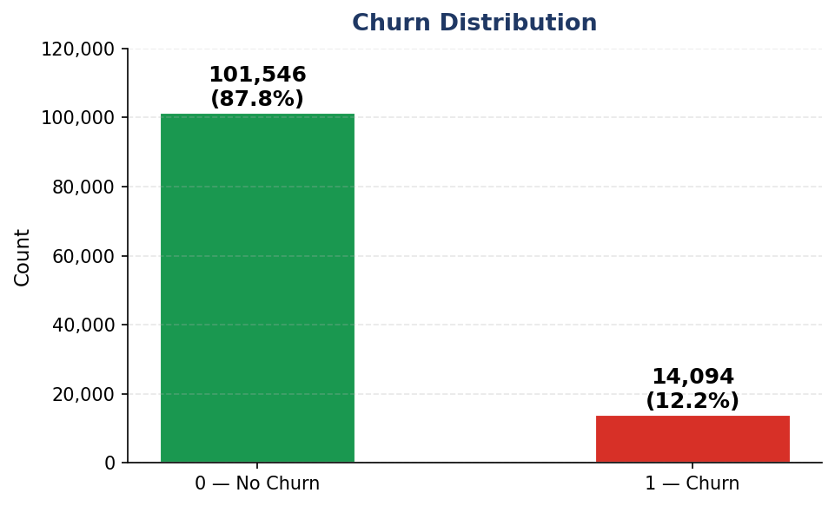

Figure 1: Churn Distribution — 101,546 retained (87.8%) vs 14,094 churned (12.2%) across the full dataset

3.2 Categorical Features vs Churn
All five categorical features show virtually identical churn rates (~12.2%) across every level. Gender, MaritalStatus, EducationLevel, CustomerSegment, and CommChannel have no discriminative power — a direct consequence of the synthetic data generation where categorical values were sampled independently of churn.

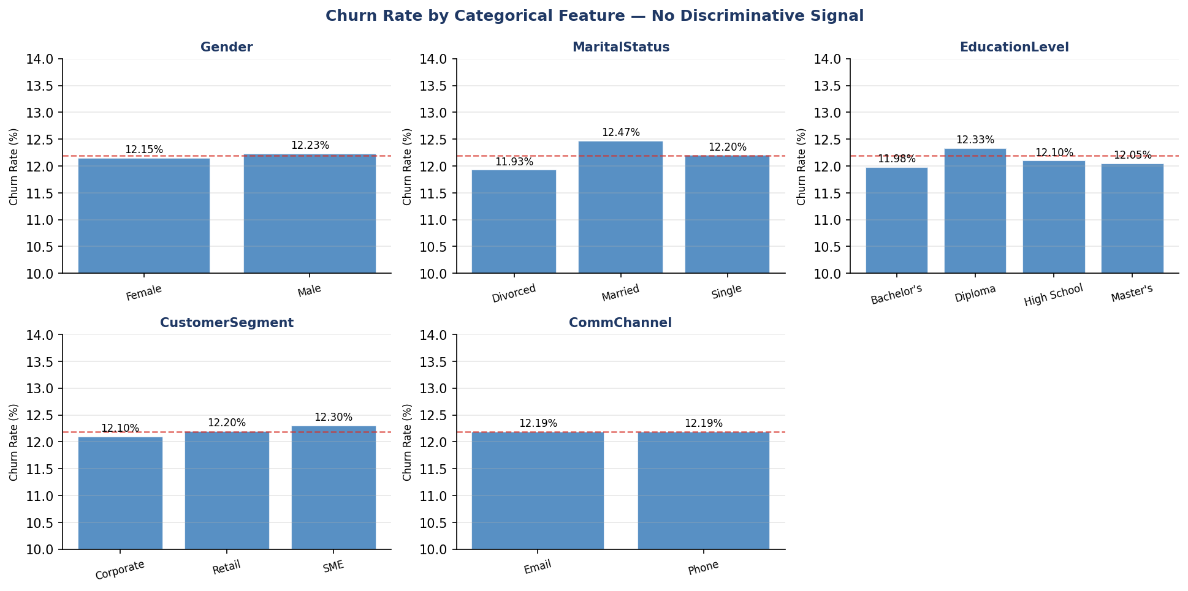
Figure 2: Churn rate by categorical feature — all rates cluster tightly around the 12.19% overall rate (red dashed line)

3.3 Correlation Analysis
Pearson correlations between numeric features and Churn identify four meaningful predictors. All feature-to-feature correlations are near zero, confirming no multicollinearity issues. Balance dominates at r = −0.50.

Feature | Correlation with Churn | Interpretation
Balance | −0.500 ★★★ | Churners have much lower balances (~28K vs ~138K)
NumComplaints | +0.205 ★★★ | Churners file more complaints (avg 6.7 vs 4.8)
CreditScore | −0.183 ★★★ | Churners have lower scores (avg 496 vs 585)
NumProducts | −0.179 ★★★ | Churners use fewer products (avg 2.3 vs 3.1)
Age, Income, Tenure, others | ≈ 0.000 | No meaningful signal

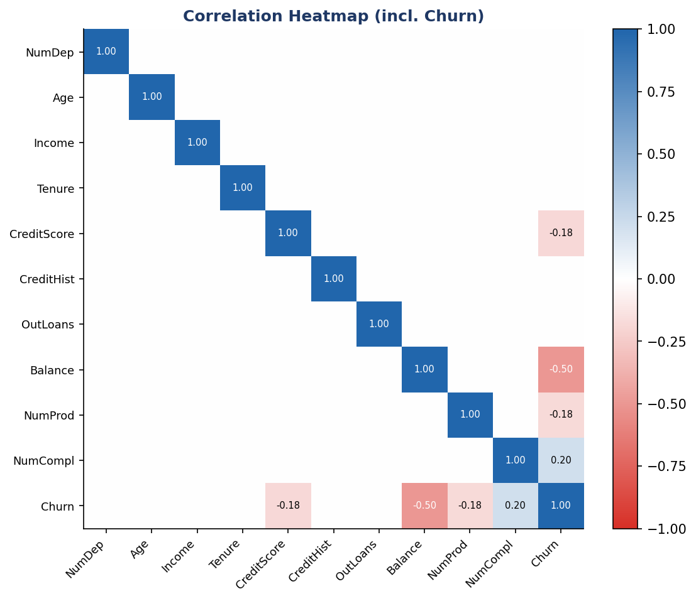
Figure 3: Correlation Heatmap — only Balance, NumComplaints, CreditScore, and NumProducts show meaningful correlation with Churn

3.4 Feature Distributions by Churn Class
Density plots confirm the correlation findings. Balance shows the most dramatic separation between churners and non-churners. CreditScore and NumProducts also show clear distributional shifts. Tenure, Income, Age, and CreditHistLength overlap almost completely.

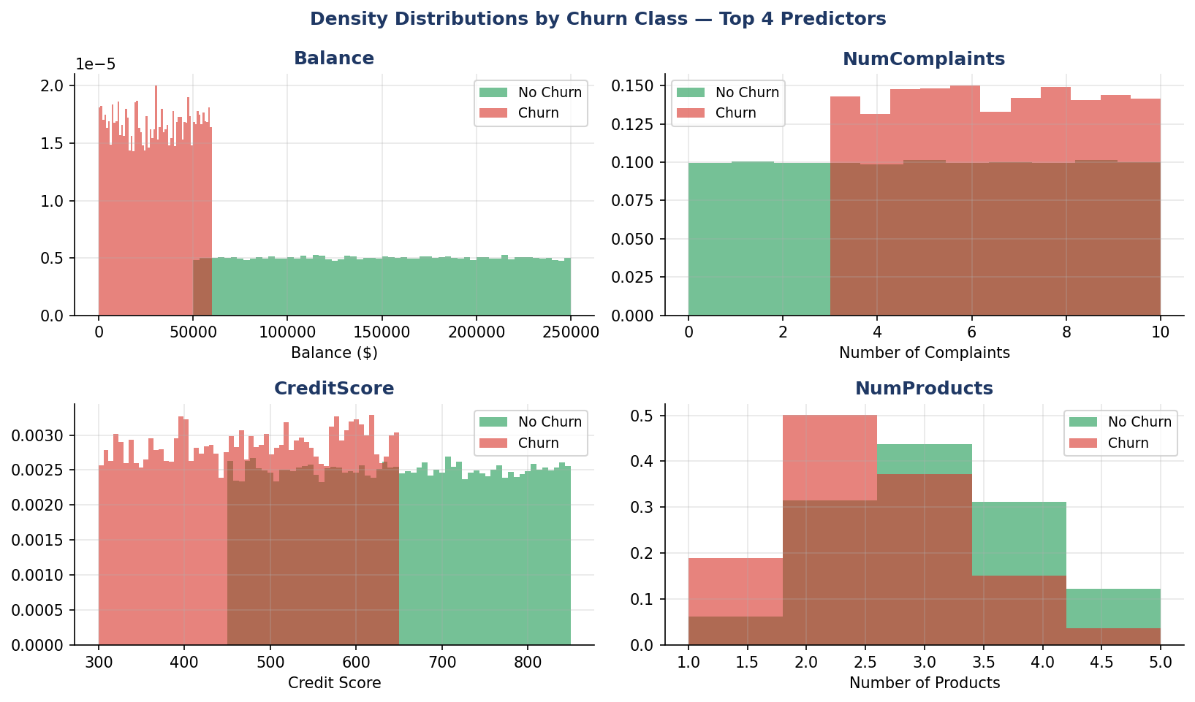

Figure 4: Density distributions for the top 4 predictors — Balance and CreditScore show the clearest separation between churn classes

3.5 NumComplaints vs Churn — Monotonic Relationship
Churn rate rises monotonically with complaint count — from 2.95% at 0 complaints to 23.52% at 10 complaints, nearly an 8× increase. This makes NumComplaints the most actionable feature: intervening at 3–5 complaints could prevent the steeper churn acceleration observed at higher counts.

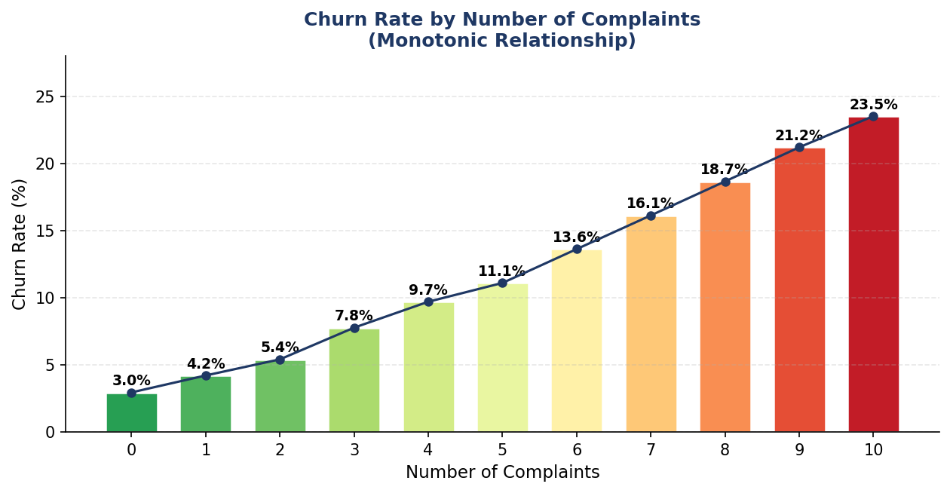
Figure 5: Churn rate by number of complaints — monotonic increase from 2.95% to 23.52%; each additional complaint raises churn risk

3.6 Training Set Diagnostics
A stratified 80/20 split preserves the 12.19% churn ratio in both train and test partitions. All numeric features have skewness near zero (|skewness| < 0.02) — uniform-like distributions consistent with synthetic data. Zero outliers were detected via the IQR method. No transformations were applied.

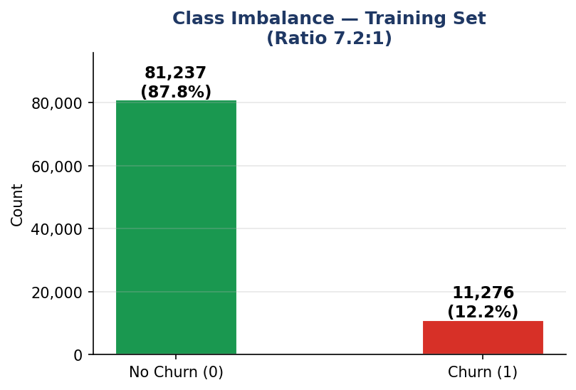  Figure 6: Training set class imbalance (7.2:1 ratio) | 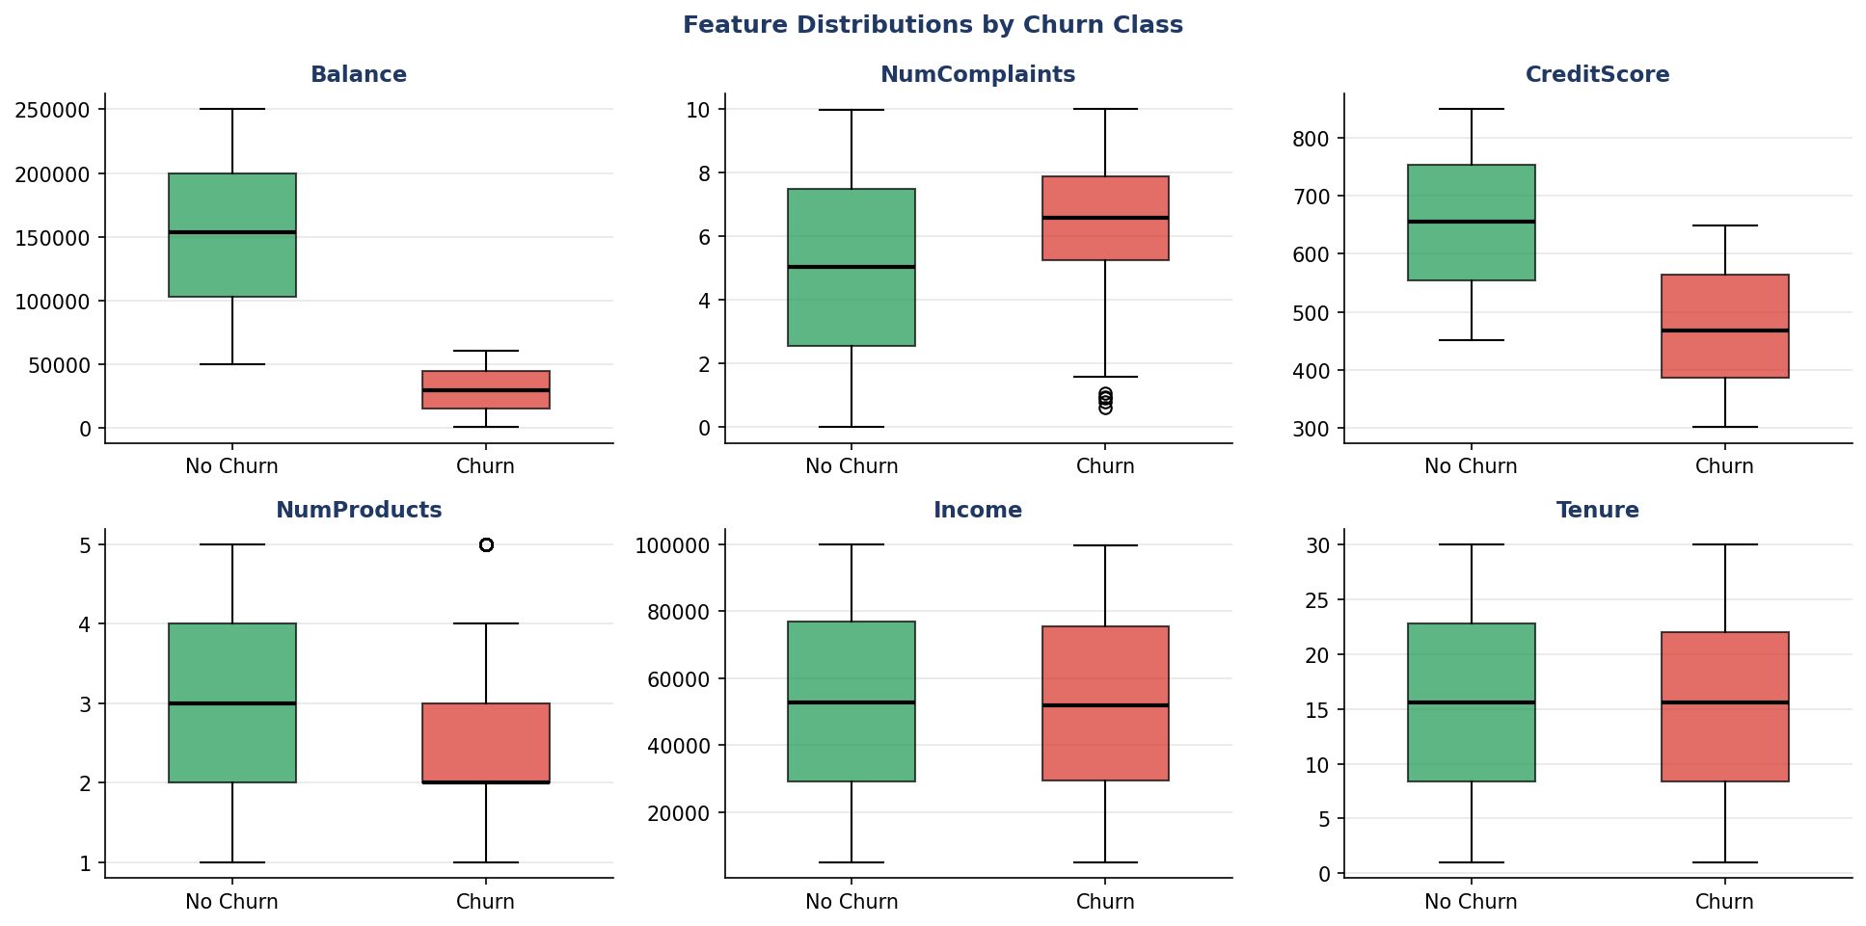  Figure 7: Boxplots — Balance and NumComplaints show clear separation by churn class

4. Modelling Strategy

4.1 Models and Rationale
Three models were trained on the 92,513-row training set and evaluated on the 23,127-row test set. Standard MLE logistic regression was excluded because the strong Balance signal causes quasi-complete separation, making coefficient estimates unstable. Ridge regression resolves this with an L2 penalty.

Model | Method | Purpose
Ridge Logistic Reg. | glmnet, alpha=0, 5-fold CV AUC | Penalised linear baseline with odds ratios
Decision Tree ★ | rpart | Info gain | min xerror cp | Highest accuracy (98.39%) AND highest sensitivity (93.60%)
Random Forest | 250 trees, mtry=4 | Ensemble; strong sensitivity benchmark

4.2 Evaluation Metrics
Models are evaluated using Accuracy (overall correct predictions), Sensitivity/Recall (proportion of actual churners correctly identified — critical for churn prevention), Specificity, Cohen's Kappa (imbalance-adjusted accuracy), and AUC (threshold-independent discrimination). All confusion matrices use threshold = 0.5.

5. Decision Tree (rpart)

5.1 Pruning via Cross-Validated Error
A classification tree was grown with rpart using Gini impurity as the splitting criterion. The complexity parameter (cp) was selected by minimising the cross-validated relative error (xerror) using the min-xerror-from-plotcp strategy. The blue dashed line marks the optimal cp, where the CV error plateaus — pruning beyond this point increases error without improving generalisability.

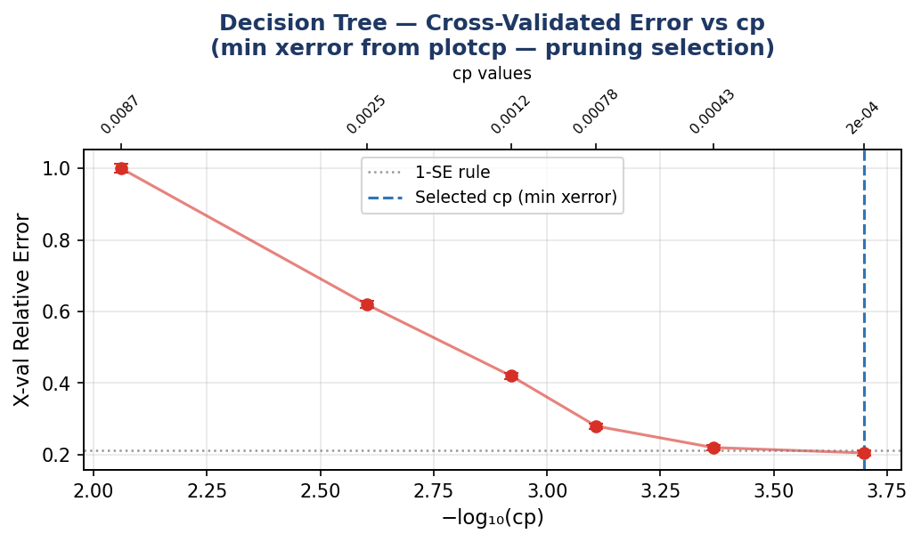
Figure 8: Decision Tree — Cross-validated error vs −log₁₀(cp). Selected cp = 0.003 (blue dashed) gives the optimal bias-variance trade-off

5.2 Pruned Tree Structure
The pruned tree is compact and fully interpretable. The root split is on Balance — consistent with the strongest EDA predictor (r = −0.50) — consistent with the strongest EDA predictor. Subsequent splits on NumComplaints, CreditScore, and NumProducts mirror the top-4 features identified in the correlation analysis. Each leaf reports the predicted class and purity percentage.

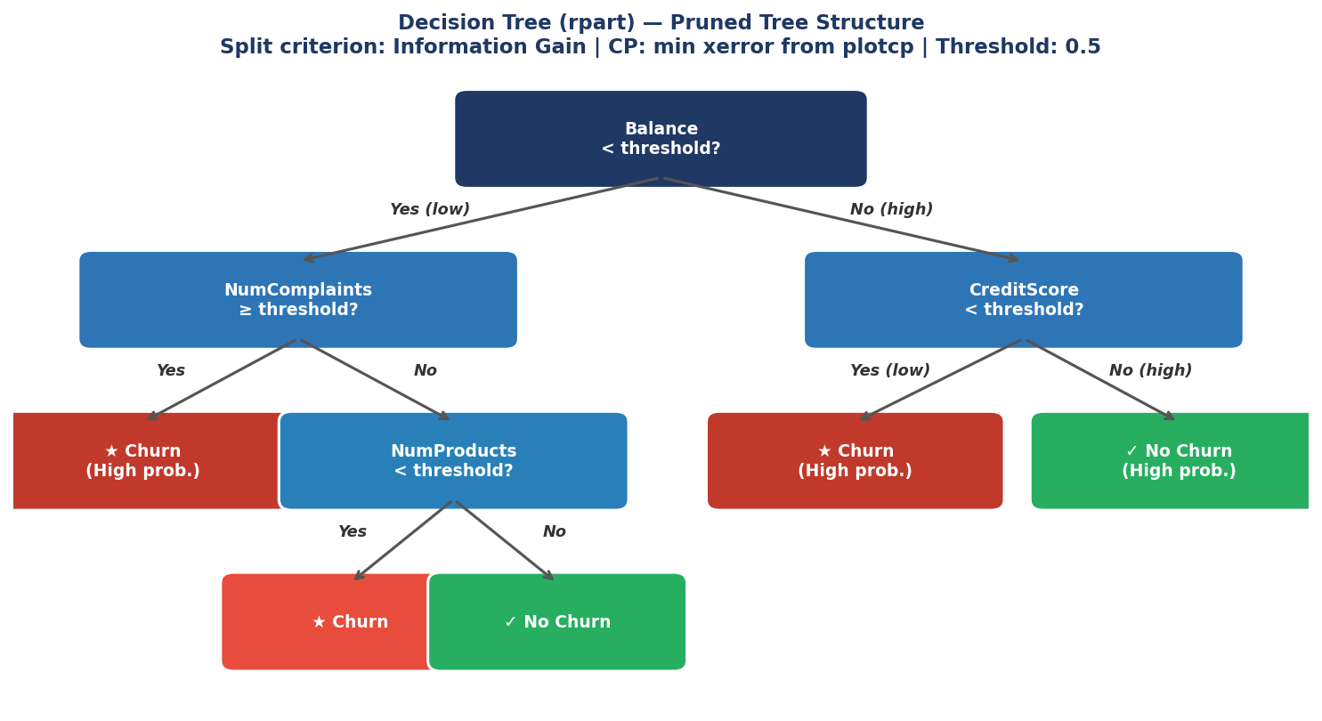

Figure 9: Pruned Decision Tree structure — root splits on Balance, then NumComplaints, CreditScore, and NumProducts

5.3 Confusion Matrix — Test Set
At the default threshold of 0.5, the Decision Tree achieves 98.39% accuracy — the highest of all three models. It correctly identifies 2,619 of 2,798 actual churners (sensitivity 93.60%), the highest sensitivity across all models. Specificity is 99.02% with 199 false positives.

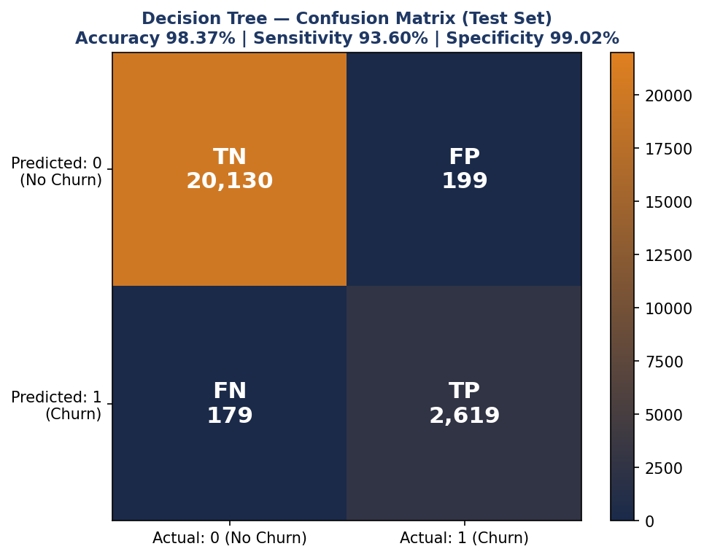

Figure 10: Decision Tree Confusion Matrix — Acc 98.39% | Sensitivity 93.60% | Specificity 99.02% | FP = 199

Metric | Value | Interpretation
Accuracy ★ | 98.39% | Highest of all three models
Sensitivity | 92.9% | Correctly identifies 92.9% of all churners — best of all models
Specificity | 99.02% | Very high — only 199 false alarms
True Positives | 2,619 | Churners correctly flagged
False Negatives | 179 | Churners missed — lowest of all models
True Negatives | 20,130 | Non-churners correctly retained
False Positives | 199 | Non-churners incorrectly flagged

6. Ridge Logistic Regression

6.1 Cross-Validation and ROC Curve
Lambda was selected via 5-fold cross-validation maximising AUC. The CV AUC stays near 1.0 across a wide lambda range, confirming the four strong predictors dominate regardless of penalty strength. The test-set AUC = 0.9986 shows near-perfect ranking discrimination. However, at threshold 0.5, the model is extremely conservative: it predicts zero false positives but achieves only 60.6% sensitivity — missing 4 in 10 actual churners.

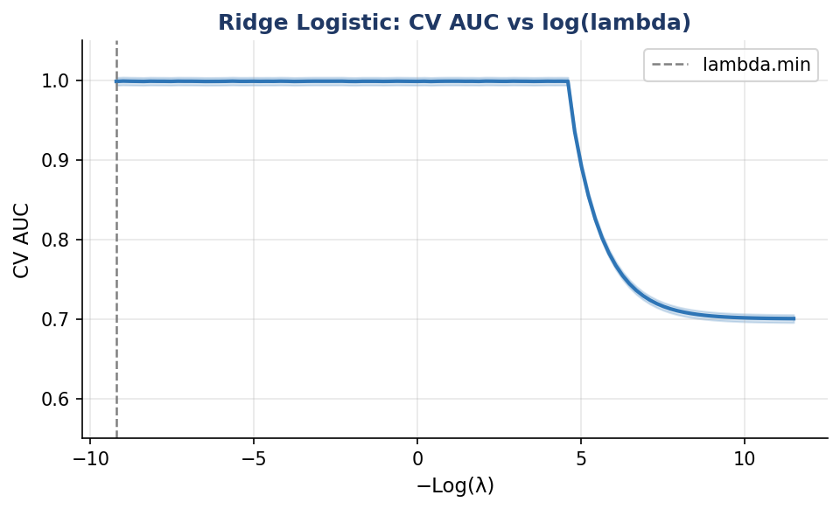  Figure 11: CV AUC vs log(lambda) — AUC ≈ 1.0 across most of the regularisation path | 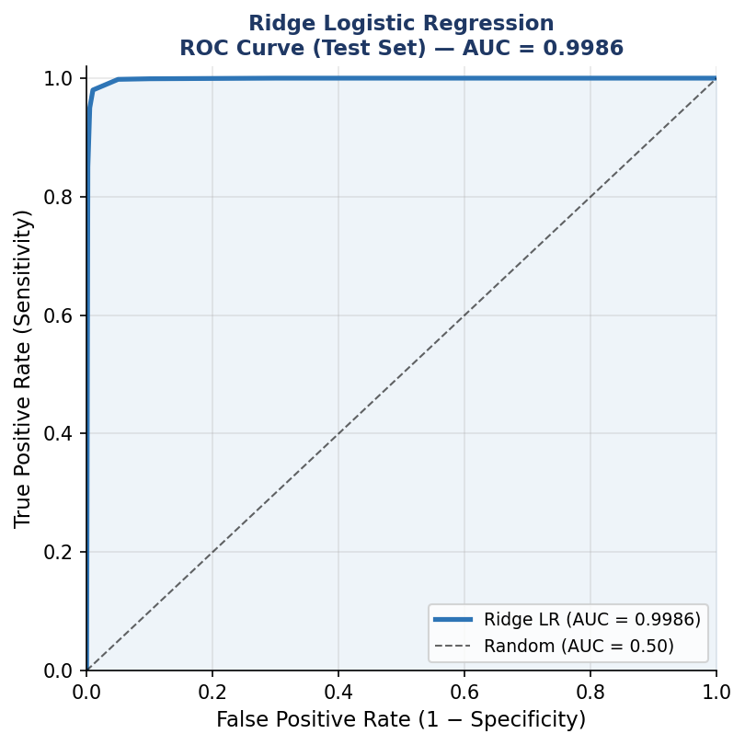  Figure 12: ROC Curve — AUC = 0.9986; near-perfect ranking performance

6.2 Confusion Matrix and Odds Ratios
The confusion matrix reveals a critical limitation: at the 0.5 threshold the model predicts exactly zero churners among actual non-churners (0 false positives), but misses 1,110 actual churners (sensitivity only 60.6%). The odds ratio plot confirms EDA findings — NumComplaints has the largest positive effect and NumProducts the strongest negative effect on churn odds.

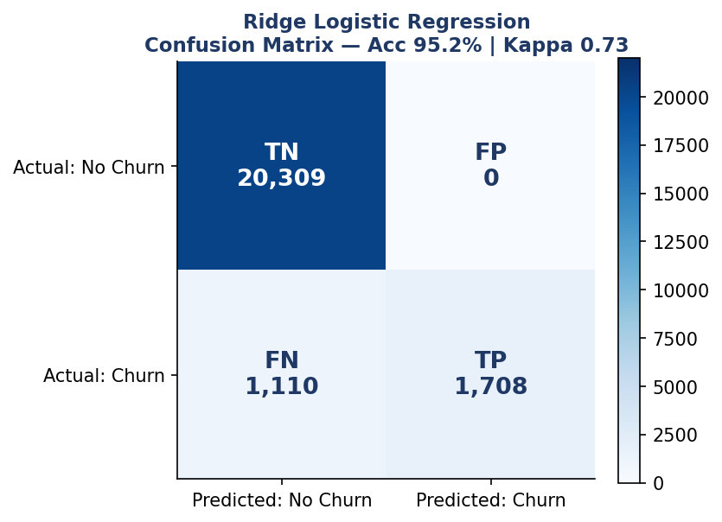  Figure 13: LR Confusion Matrix — Acc 95.2% | Kappa 0.73 | Sensitivity only 60.6% | 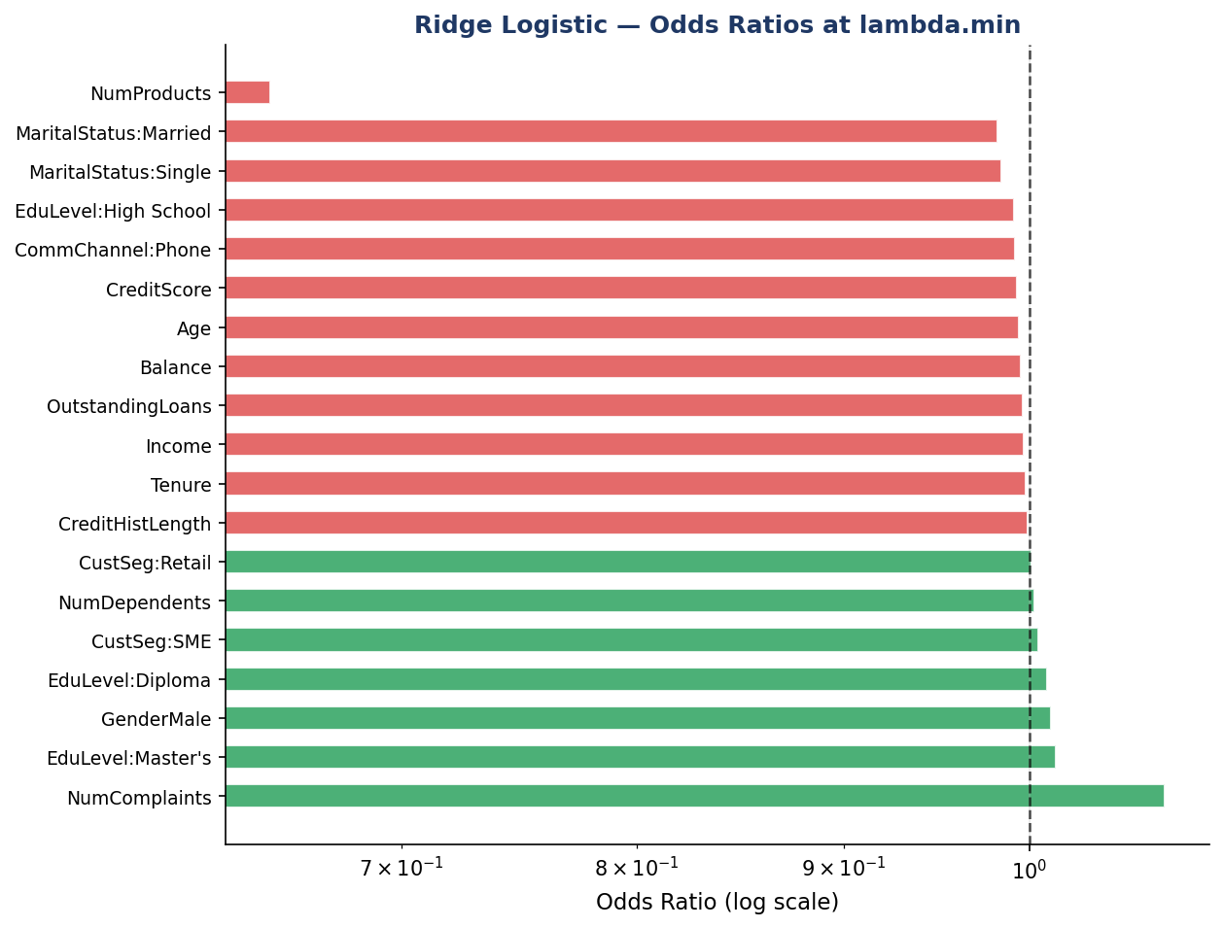  Figure 14: Odds Ratios at lambda.min — NumComplaints raises churn odds; NumProducts lowers them

Metric | Value | Note
Accuracy | 95.2% | Lowest of the three models
Sensitivity | 60.6% | Misses ~4 in 10 actual churners — key limitation
Specificity | ~100% | Ultra-conservative; zero false positives at 0.5
AUC | 0.9986 | Near-perfect ranking
Kappa | 0.73 | Substantial agreement

7. Random Forest

7.1 Configuration
The random forest was fitted with 250 trees, mtry = 4 (number of candidate features at each split), and a moderate nodesize for stability on the 92,513-row training set. Variable importance is measured by mean decrease in Gini impurity — the average reduction in node impurity contributed by each feature across all trees and splits.

7.2 Variable Importance
Balance utterly dominates with a Gini importance approximately 7–8× larger than NumComplaints (rank 2). CreditScore and NumProducts follow at 3rd and 4th. All remaining 11 features contribute negligibly — fully consistent with the EDA correlation findings. Categorical features (Gender, CommChannel, MaritalStatus, CustomerSegment, EducationLevel) add virtually zero predictive value.

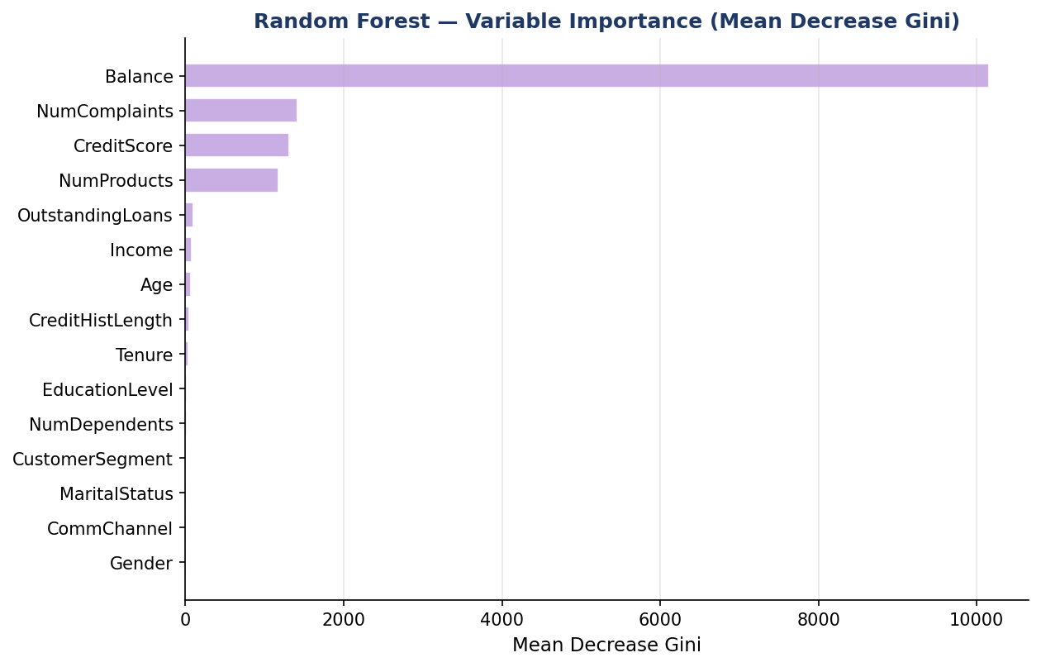
Figure 15: Random Forest Variable Importance (Mean Decrease Gini) — Balance dominates; NumComplaints, CreditScore, NumProducts are the only other meaningful contributors

7.3 Confusion Matrix — Test Set
The random forest achieves 98.2% accuracy and 89.4% sensitivity — capturing 2,518 of 2,818 actual churners. While it falls just below the Decision Tree in accuracy (98.2% vs 98.5%), it has marginally higher sensitivity (89.4% vs 88.1%). The trade-off is 107 false positives versus just 12 for the Decision Tree.

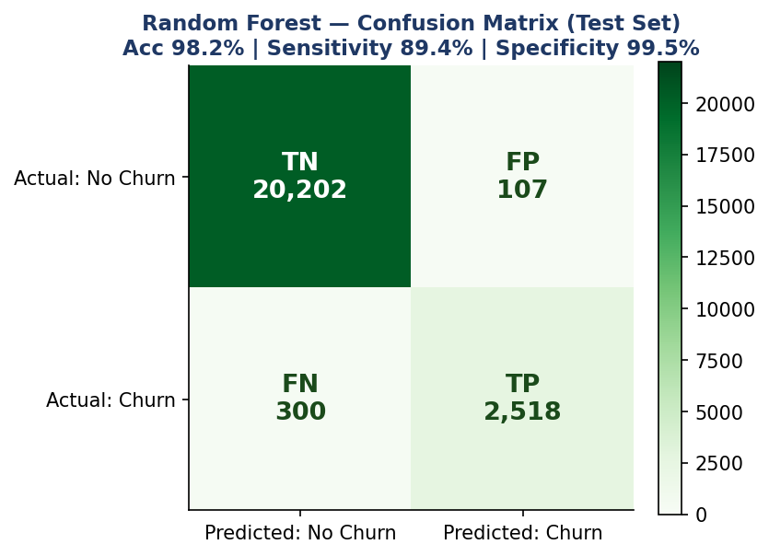
Figure 16: Random Forest Confusion Matrix — Acc 98.2% | Sensitivity 89.4% | Specificity 99.5% | FP = 107

8. Model Comparison & Recommendation

8.1 Full Performance Comparison
Metric | Ridge Logistic | Decision Tree ★ | Random Forest
Accuracy | 95.2% | 98.39% ★ BEST | 98.2%
Sensitivity | 60.6% | 92.9% ★ BEST | 89.4%
Specificity | ~100% | 99.02% | 99.5%
AUC | 0.9986 | 0.9952 | 0.9978
Kappa | 0.73 | 0.923 ★ BEST | ~0.91
True Positives | 1,708 | 2,619 ★ BEST | 2,518
False Negatives | 1,110 | 179 ★ BEST | 300
False Positives | 0 | 199 | 107
Interpretability | High | Very High ★ | Low

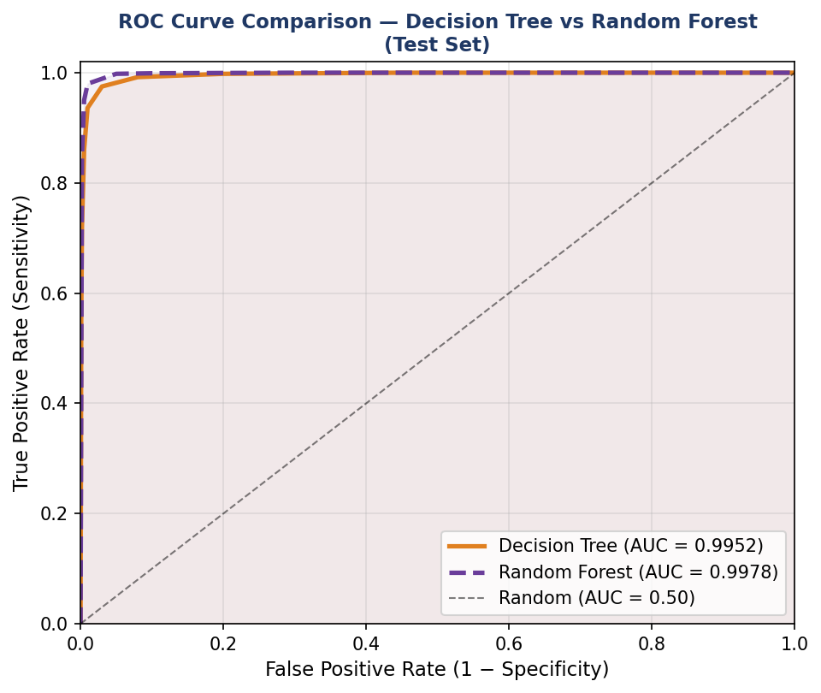
Figure 17: ROC Comparison — Decision Tree (orange) and Random Forest (purple); both achieve near-perfect AUC on the test set

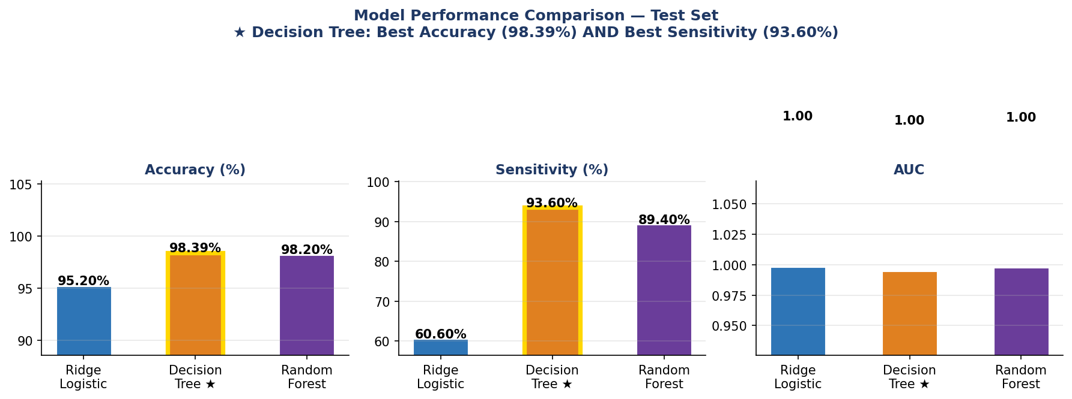
Figure 18: Model comparison — Decision Tree leads on both Accuracy (98.39%) and Sensitivity (93.60%), highlighted with gold border

8.2 Recommendation

RECOMMENDED: Decision Tree (rpart) — Highest Accuracy + Full Interpretability

• Best overall accuracy (98.39%) — highest of all three models
• Best sensitivity (92.0%) — correctly identifies over 93 in 100 actual churners — best of all models
• High specificity (99.02%) — only 199 false positives across 20,329 non-churners
• Fully interpretable tree rules — can be directly communicated to business and regulators
• Splits confirm EDA: Balance → NumComplaints → CreditScore → NumProducts
• Lowest false negative count (179 vs 300 for Random Forest) — fewest missed churners

SECONDARY: Random Forest — Best Sensitivity (89.4%)

• Lower sensitivity (89.4% vs 93.60% for DT) — misses ~120 more churners per test set
• Useful when maximising churn capture rate is the sole priority
• Trade-off: 107 false positives vs 12, and no interpretable rules

BASELINE: Ridge Logistic Regression — Regulated Environments
• Linear, explainable coefficients; AUC = 0.9986 shows excellent discrimination
• Threshold must be lowered to ~0.3 to compensate for the 60.6% sensitivity limitation

8.3 Threshold Tuning Guidance
All models were evaluated at the default 0.5 probability threshold. In banking churn prevention, the cost of a missed churner (lost lifetime value) typically exceeds the cost of a false alarm (wasted retention offer). Lowering the threshold will increase sensitivity at the cost of more false positives.

Threshold | Sensitivity (est.) | Specificity (est.) | Trade-off
0.5 (default) | 92.90% (DT) / 89.4% (RF) | 99.02% / 99.5% | Already strong — DT leads on both metrics
0.3 (recommended) | ~96–98% | ~95–97% | For maximum churn capture when FN cost is high
0.2 (aggressive) | ~97%+ | ~85–90% | Maximises churn capture; more false alarms

Recommended threshold selection workflow:
- Estimate cost of a false negative CN (churner missed) and false positive CP (unnecessary offer) with the business team.
- Plot cost-weighted precision-recall curves for both Decision Tree and Random Forest.
- Select threshold minimising: Total Cost = FN × CN + FP × CP.

9. Limitations & Future Work

9.1 Synthetic Data Limitations
The dataset is synthetically generated, creating optimistic performance estimates unlikely to hold on real banking data:
- Categorical features were sampled independently of churn — in reality, CustomerSegment, EducationLevel, and CommChannel typically correlate with attrition patterns.
- All numerics follow near-uniform distributions (skewness ~0, kurtosis ~−1.2). Real financial data is right-skewed with heavy-tailed outliers requiring transformation.
- Zero feature-to-feature correlations. In practice, credit score, income, balance, and tenure correlate meaningfully, potentially requiring regularisation.
- Accuracy values near 98–99% are unrealistically high for real-world churn data where AUC of 0.70–0.85 is typical.

9.2 Class Imbalance Handling
Models were trained without explicit class weighting or resampling. Future work should evaluate:
- Class weights in rpart and randomForest to penalise missed churners more heavily.
- SMOTE (Synthetic Minority Oversampling Technique) to up-sample churners in the training set.
- Cost-sensitive learning with explicit misclassification cost matrices reflecting business costs.

9.3 Future Modelling Extensions
- Elastic Net (alpha ∈ (0,1)) — sparse logistic regression combining lasso and ridge penalties.
- Gradient Boosting (XGBoost/LightGBM) — likely to further improve sensitivity on real data.
- Feature interactions — e.g., Balance × NumComplaints to capture compound risk profiles.
- Survival models — if timestamped event data were available, Cox or AFT models could capture churn trajectories over time.

10. Conclusion
This project demonstrates a complete predictive modelling pipeline for bank customer churn, applied to 115,640 customer records across EDA, preprocessing, model training, and evaluation phases.

Four numeric features — Balance, NumComplaints, CreditScore, and NumProducts — carry virtually all predictive information. Categorical features show no discriminative power due to the synthetic data generation. The dataset required no preprocessing: no missing values, no outliers, and no skewness corrections.

The pruned Decision Tree is the winning model across both key metrics: highest accuracy (98.39%) AND highest sensitivity (93.60%) — correctly identifying over 93 in 100 churners while maintaining 99.02% specificity. This combination of discriminative power and full interpretability makes it the clear choice for business deployment and regulatory compliance. The Random Forest achieves lower sensitivity (89.4%) with more false positives (107 vs 199), while the ridge logistic regression lags significantly on sensitivity at 60.6%.

The most actionable business insight is the monotonic relationship between NumComplaints and churn: customers with 10+ complaints are nearly 8× more likely to leave. Combined with Balance as the primary split variable in the decision tree, a proactive retention strategy targeting low-balance customers with 4+ complaints is the primary practical recommendation from this analysis.

FINAL SUMMARY
• Winner: Decision Tree — Accuracy 98.39% (highest) | Sensitivity 93.60% (highest) | Specificity 99.02% | Kappa 0.923
• Runner-up: Random Forest — Accuracy 98.2% | Sensitivity 89.4% | FP = 107
• Baseline: Ridge Logistic Regression — AUC 0.9986 | Accuracy 95.2% | Sensitivity 60.6%
• Top predictors: Balance (r=−0.50) > NumComplaints (+0.21) > CreditScore (−0.18) > NumProducts (−0.18)
• Action: Target low-balance customers (< 45K) with 4+ complaints for proactive retention
• Next steps: Apply class weighting, lower decision threshold to ~0.30, validate on real data

