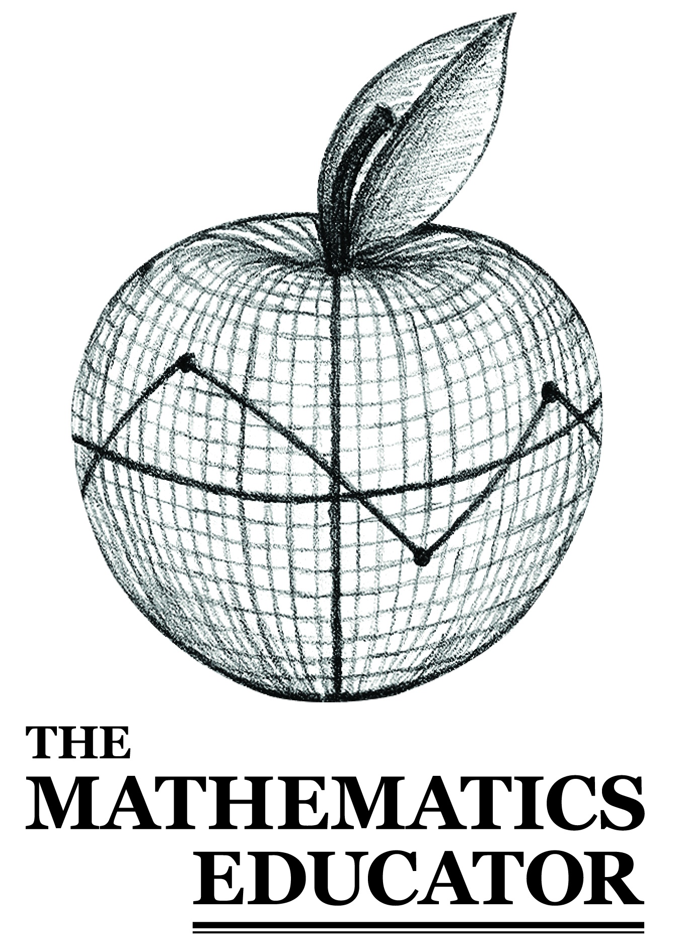
VOLUME 34 · NUMBER 1
Spring 2026

An Official Publication of the Mathematics Education Student Association · University of Georgia
Cover art by Keith Przybyla-Kuchek

THE MATHEMATICS EDUCATOR

An Official Publication of the
Mathematics Education Student Association
The University of Georgia

VOLUME 34 · NUMBER 1
Spring 2026

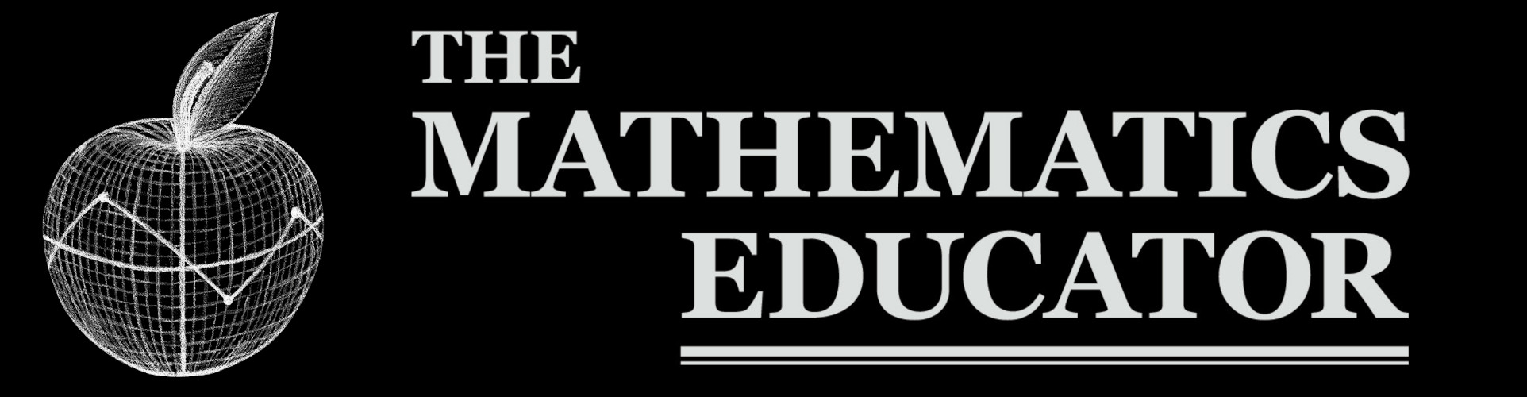 | EDITORIAL STAFF  Vol. 34, No. 1 (2026)  ISSN 1062-9017 (print) 2331-4451 (online)
◆ Cultivating scholarly discourse in mathematics education since 1990 ◆
Published by the Mathematics Education Student Association · University of Georgia · Peer Reviewed · Open Access

EDITORIAL BOARD  Editors  Jennifer Kleiman  [Co-Editor Name]  Associate Editors  [Associate Editor]  [Associate Editor]  Advisor  [Advisor]  Copy Editor  [Copy Editor] | MESA OFFICERS 2026-2027  President  [President]  Vice-President  [VP]  Secretary  [Secretary]  Treasurer  [Treasurer]  NCTM Representative  [NCTM Rep]  Colloquium Chair  [Chair]

 | RESEARCH ARTICLE  Vol. 34, No. 1 (2026), pp. 1–24  doi.org/10.xxxxx/tme.2026.34.1.01  ISSN 1062-9017 (print) 2331-4451 (online)
◆ Cultivating scholarly discourse in mathematics education since 1990 ◆
Published by the Mathematics Education Student Association · University of Georgia · Peer Reviewed · Open Access

[Article Title Goes Here]
[Author One]^{1†}
¹[Affiliation]
† Corresponding author: [email@uga.edu]
RECEIVED [Date] · REVISED [Date] · ACCEPTED [Date] · PUBLISHED [Date]

ABOUT THE AUTHORS
[Author One]
[Bio paragraph.]

ABSTRACT
[Abstract paragraph goes here.]
Keywords: [keyword one] · [keyword two]

[Body Heading]
[First body paragraph of the article.]
[Second paragraph.]

