Automatic Detection of Hard Exudates in Retinal Fundus Images

Prithika Shakthi A , 19BCE1820, Jennifer Mento Clemens, 19BCE1673, Sanjana Reddy P , 19BCE1581

Vellore Institute of Technology, Chennai.

*Abstract****:*— Diabetic Retinopathy or DR is a retinal disorder that affects the people having diabetes which is one of the main reasons for the preventable blindness all over the world. If not detected early, the patient may progress to severe stages of irreversible blindness. When a patient has DR, the blood vessels develop sacks and eventually break. The blood leaks from these broken sacks into the eyes and forms a yellowish patch. These patches are the Hard Exudates. Nowadays, there is a lack in the number of Ophthalmologists, considering the growing number of DR patients. Hence, the purpose of this paper is to automate the detection of Hard exudates in fundus images of the retina using a deep learning algorithm.**

*Keywords*— **Image Processing, Hard Exudates, Convolution Layer, Deep Learning, Fundus Images.**

1. **INTRODUCTION**

In recent years, there has been an increase in the number of diabetic patients suffering from diabetic retinopathy (DR). Diabetic retinopathy is an eye condition that can cause loss of vision and blindness in people who have diabetes. It affects blood vessels in the retina which is the light-sensitive layer of tissue in the back of one’s eye. [8][3].

Clinically, DR is classified into two major types, ‘Non Proliferative Diabetic Retinopathy (NPDR)’ or ‘Early Diabetic Retinopathy’ and ‘Proliferative Diabetic Retinopathy (PDR)’ or ‘Advanced Diabetic Retinopathy’. NPDR weakens the walls of your retinal blood vessels and also causes dilation of larger retinal vessels.In PDR, the earlier damaged blood vessels are closed off, stimulating the growth of new, abnormal blood vessels within the retina, which are most likely to leak blood and fluid into the clear, jelly-like substance filling the central area of your eye. [4].

Treatments for the vision-threatening complications of diabetic macular edema (DME) or Non Proliferative Diabetic Retinopathy (NPDR) and proliferative diabetic retinopathy (PDR) have greatly improved over the past decade. [5].

It may also be noted that It may be noted that diabetes and diabetic retinopathy are emerging as a significant non-communicable disease leading to ocular morbidity.

In the year 2019, The Union [Health](https://www.business-standard.com/category/news-ani-health-1520301.htm) Ministry's first National Diabetes and Diabetic Retinopathy Survey (2015-19) has revealed that the prevalence of Diabetic Retinopathy (DR) is 16.9 percent while the prevalence of sight-threatening DR is 3.6 percent. [6].

DR affects the central vision of the patient and if the disease progresses without treatment, the patient may get irreversible blindness. DR is one of the significant reasons for preventable blindness all over the world.[7].

It is very difficult for a patient to understand or identify apparent changes in vision until the DR becomes worse. But early symptoms of DR can be detected using the fundus images. Due to the sensitivity of eye fundus to some vascular diseases, fundus imaging technique is more suitable for such noninvasive screening. The result of the screening approach depends on the quality and accuracy of the fundus image extraction technique along with efficient image processing methodologies for identifying the abnormalities. [8][9].

Early symptoms of DR can be detected using fundus imaging as discussed above.

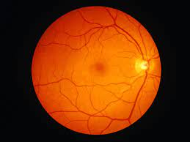

Fig 1.1 - Healthy Retina [11]

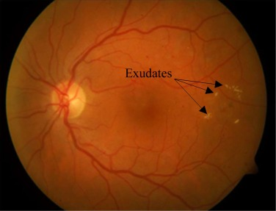

Fig.1.2 - Retina with Hard Exudates .[10]

Exudates have three different appearances: hard exudates, confined plaques of exudates, and fluffy exudates. Hard exudates appear as bright yellow patches in the retina, either superficially or deeply. [12]

Exudates from plaques are the result of a dispersed buildup of lipoprotein that differ in size. The fuzzy exudates are soft exudates that appear to be white in colour. The sensory retina has a paler yellow colour and tends to lie more superficially. Exudates are a type of lipid fundus lesion that can be seen through retinal imaging. [12] Therefore, Exudates are the bright and prominent lesions having maximum intensity value.

Detection of the Hard Exudates is very significant in automated detection of DR. A Deep learning algorithm has been developed to detect Hard Exudates. After training, Hard Exudates in the test images are being detected with an accuracy of 98.6% by our deep learning model.

**2. LITERATURE REVIEW**

On conducting a literature review, we have come to a conclusion that Hard Exudates are the most prominent symptom of DR and that detection of DR lesions in fundus images helps to detect DR. Various methods have been undertaken and implemented to detect the presence of these hard exudates. Xiang Chen et al, proposed an effective coarse-to-fine segmentation method that automatically extracts hard exudates from color fundus images. [12]. Arsal Ahmed et al, has reviewed the latest techniques in digital image processing for the detection of diabetic retinopathy and has compared them on the basis of different performance measures. [13]. L. Giancardo et al, have presented two variations of a new exudate segmentation method that falls into the category of thresholding methods and have designed a semiautomated, HIPAA-compliant, teleophthalmology network for the screening of diabetic retinopathy and related conditions by employing a single macula centred fundus image.[14]. G.G. Rajput et al,, has worked to detect hard exudates using k-means algorithm [15]. Herbet et al. employed data fusion for the detection of multiple lesions in the retinal images. [16] .Usman et al have presented a system for the reliable grading of colored fundus images in different stages of NPDR. They have also proposed a hybrid classifier that comprises both Gaussian Mixture Model (GMM) based classifier and m-Medoids based classifier. [17]. Russel Phillips et al have used a threshold method based system for the exudate identification on a global or adaptive grey level analysis. [18]. Veronika et al proposed a method for localising hard exudates in retinal images using a faster R-CNN object detector, based on the ResNet-50 architecture in combination with an SVM classifier. Zhun Fan et al have proposed an advanced method to evaluate the road pavement surface based on an ensemble network of convolutional neural networks (CNN), based on probability fusion for automated pavement crack detection and measurement. [19]. Subhashini et al have constructed a graphical user interface that can integrate image processing techniques together in order to predict whether the input fundus/retinal image received from the patient is affected with DR or not. Shu-I Pao et al, have made use of the entropy image of luminance of fundus photograph to demonstrate and increase the detection performance for referable DR using a convolutional neural network- (CNN-) based system. he bichannel CNN incorporating the features of both the entropy images of the gray level and the green component preprocessed by UM is also proposed to improve the detection performance of referable DR by deep learning.

**3. MOTIVATION**

* To automate and detect Diabetic Retinopathy (DR) at an early stage in patients.

**4. PROPOSED WORK**

Identify all high brightness areas of the retinal image. The high brightness areas may include the Optic Disk and Hard exudate patches.The optic disk in digital images of the retina, using an approach based on active contours.it is the region on the retina at which optic nerve axons enter and leave the eye. Hard exudates are characterized by bright sharp edged yellow regions of lipid deposits. Such exudates can be separated by fuzzy c-means algorithms. One major problem is due to the presence of the Optic Disc (OD) in the images.

Next, identify and extract the vertical vessels of the image. The bright patch in an image is detected as the Optic Disk if there are vertical vessels in its nearest neighbors. In other words, the candidate with the largest number of vertical vessel pixels that pass through it is identified as the Optic Disk. The optic disk is the bright area in the image of the retina. Because the optic nerve itself is not sensitive to light, the optic disk is a blind spot.

The Optic Disk is removed from the identified candidates of bright patches in the images.The optic disc is the intraocular portion of the optic nerve and is seen with the ophthalmoscope. Its margins, color, and cup-disc ratio should be determined. The disc should be round or slightly oval with the long axis usually vertical and with sharp borders. The nasal border is normally slightly blurred.

Hence, if there are still candidates of bright patches after the removal of the OD in each image, then those bright patches are identified as hard exudates.for identification of the hard exudates is the Images are sorted into as many as 15 types using the maximum value of the hue in an image. Hue (h) at a point is defined as the ratio of green (g) to red (r) intensities. Given an image, the type-number is assigned to it.

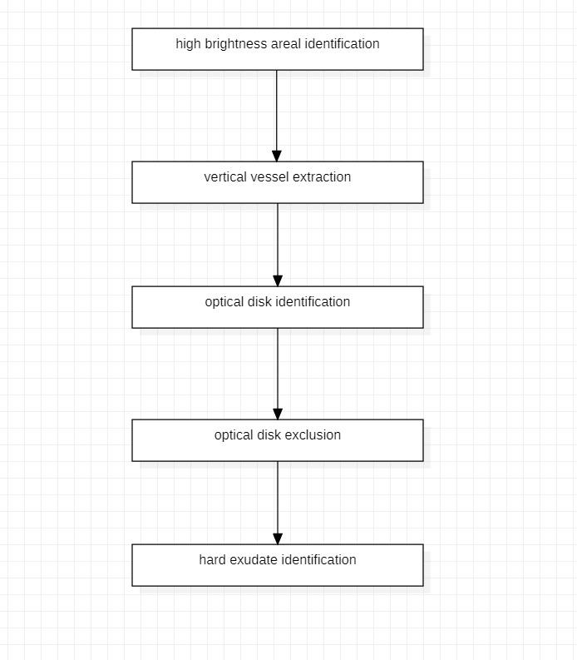

**4.1. ALGORITHM**

Hard Exudates presented in the DR affected fundus image have been detected using a deep learning model. Assumptions: In all the fundus images of the retina, the hard exudates of an intensity of 1 and the background has an intensity of 0.

**STEP 1**: Resize all the fundus images to 256x256 resolution.

**STEP 2:** Extract image patches of size 32x32 from the ground truth images, in which the pixel of interest is located at position (17, 17). Since no padding was used on the ground truth images, all the pixels are not evaluated. The original images are evaluated from (16, 16) to (240,240).

**STEP 3:** The image patches are evaluated on an 8 layer convolution neural network using a kernel of size 2x2. The neural network classifies whether the central pixel of each image patch belongs to a hard exudate or background.

**STEP 4:** After every second convolution layer, Maxpool is used to half the size of the feature map.

**STEP 5:** Batch normalization is also used in each convolution layer to increase the speed of the training.

**STEP 6:** Overfitting is prevented by making use of Drop out.

**STEP 7:** Out of 200000 image patches, 5 sets of 40000 were each trained for 500 epochs one by one. When the network trained all 40000 image patches of one set for 500 epochs, it is called a streak. The current network is trained for 3 complete streaks which means the network is trained for 1500 epochs.

**STEP 8:** After training, the images are dissolved into 50176 patches which is then predicted by the network whether the central pixel belongs to a hard exudate or background.

**STEP 9:** These image patches are then reshaped into images of size 224x224 since padding was not initially used. Hence, images with hard exudates are detected.

**5. RESULTS**

After training, we have found our accuracy to be 99.74%.

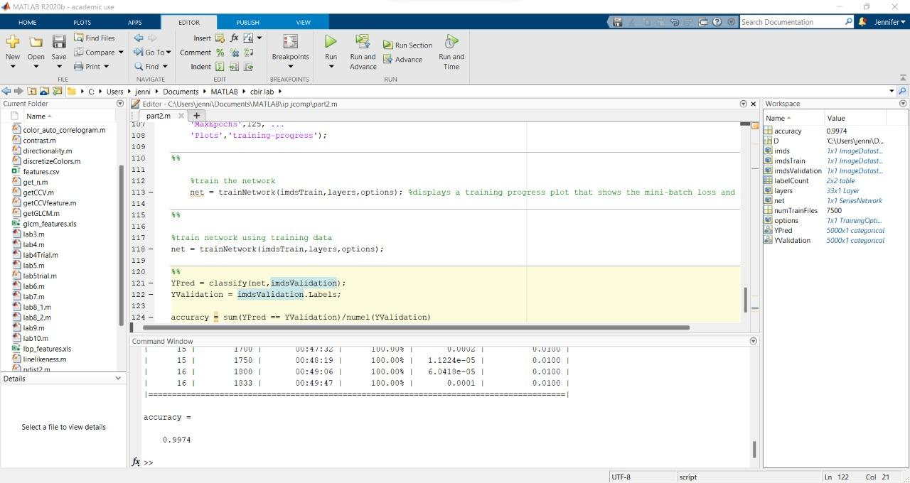

Fig 5.1 Accuracy

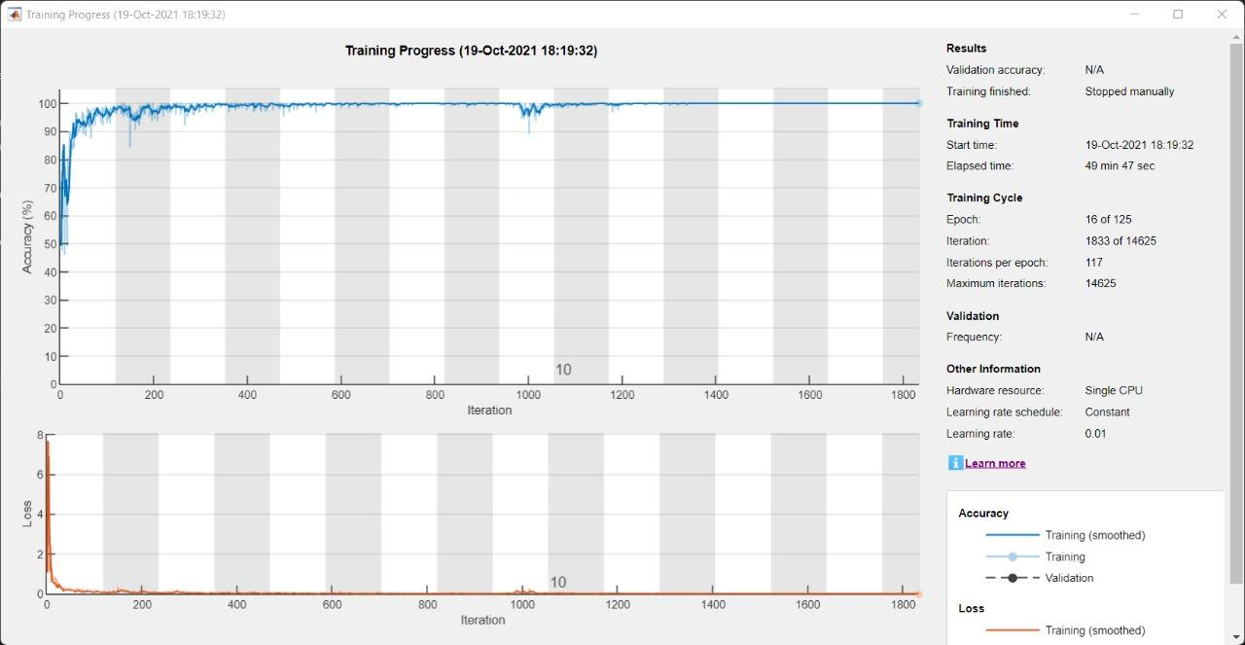

Fig 5.2 Training Process

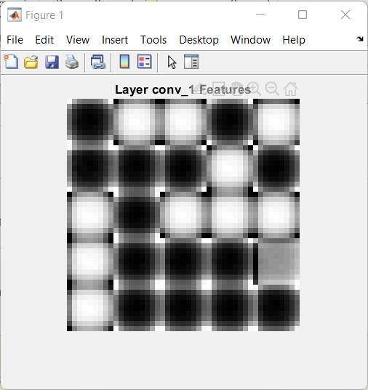

Fig 5.3 First Convolution Layer

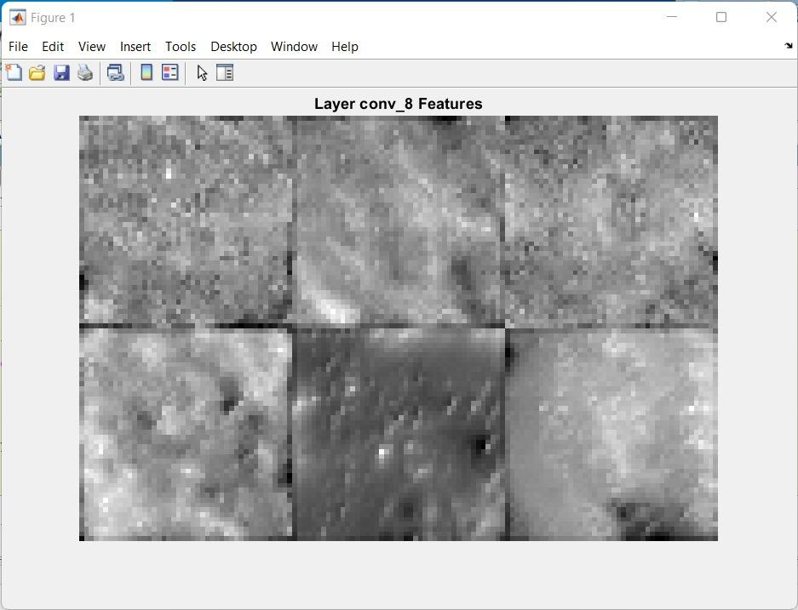

Fig 5.4 Last Convolution Layer

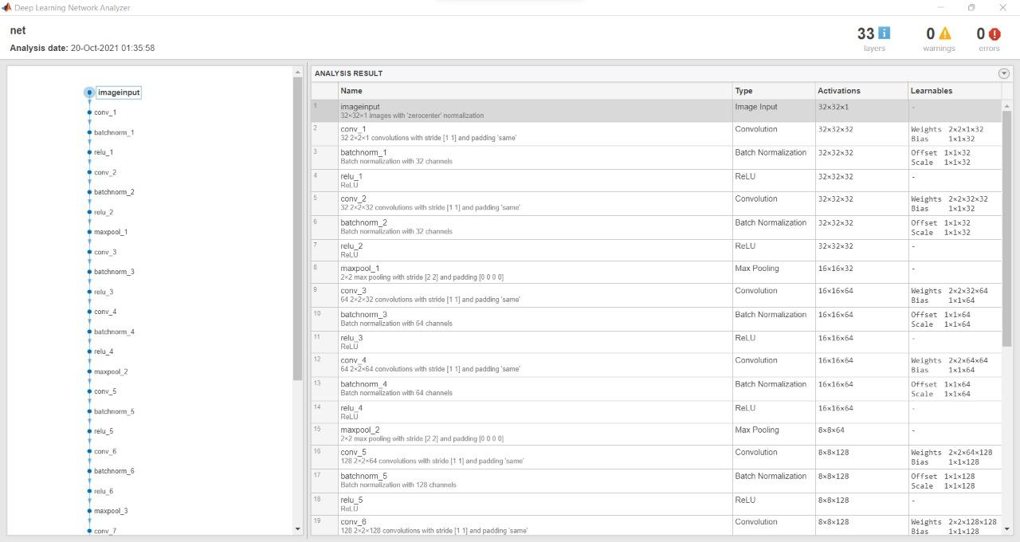

5.5 Network Analysis

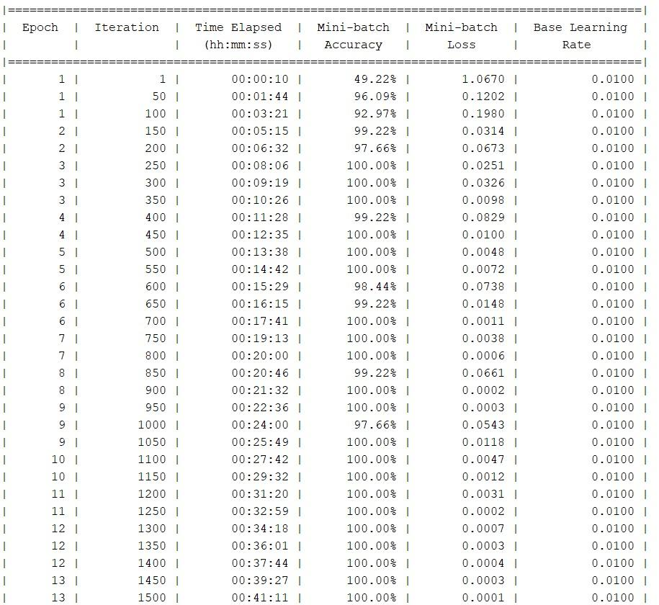

Fig 5.6.1 Epoch Training

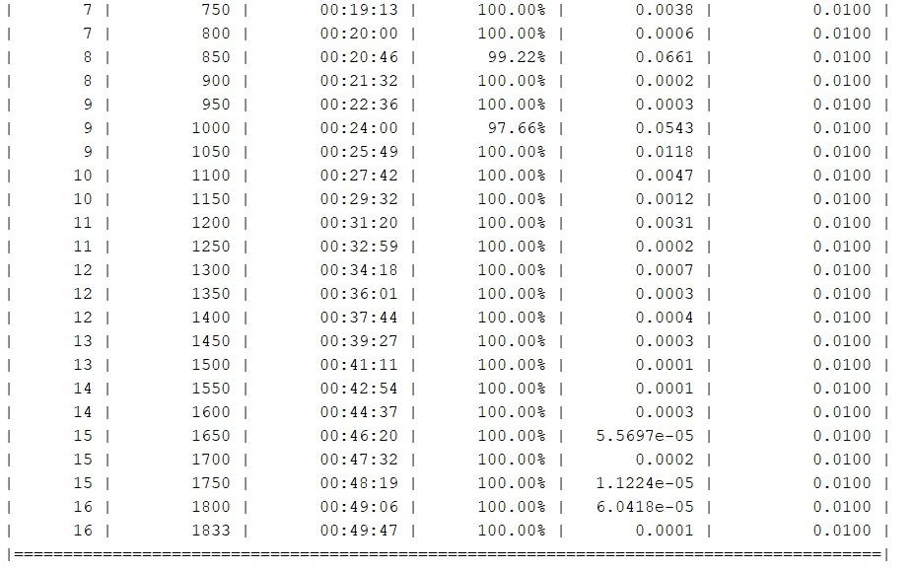

Fig 5.6.2 Epoch Training

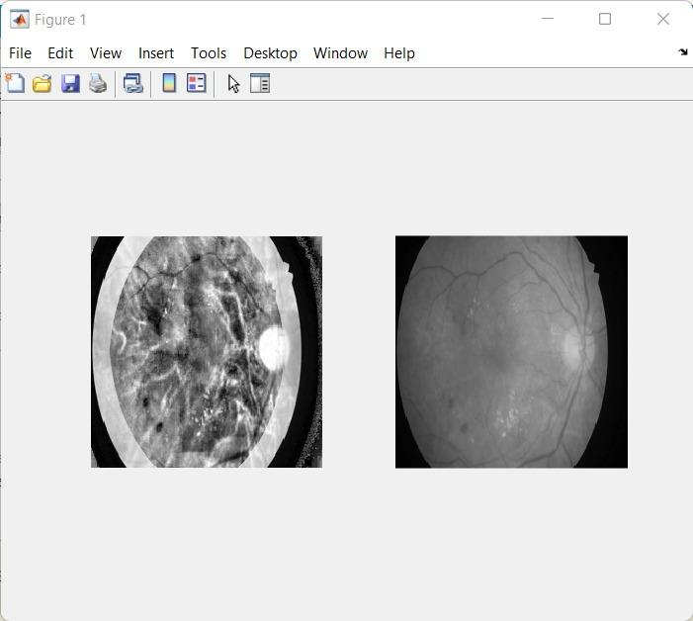

5.7 reconstruction of the image patches

**6. CONCLUSIONS AND FUTURE WORK**

Hard Exudates that are present in the DR impacted fundus image have been identified using a deep learning model created in this work. In case of Diabetic retinopathy illness, detection of hard exudates is important to identify the presence of illness in an automated way.. The introduced model detects the hard exudates with an accuracy 99.7 In future we likewise need to detect Soft exudates, hemorrhage and microaneurysms. Furthermore, using the divided images we need to grade the seriousness of the presence of DR. We need to build the accuracy of the model for that we are proposing 2 approaches. First methodology is to change the size of the image patch. Then, at that point, we can track down the effect of image patch on the accuracy of prediction. Second methodology is to use a troupe of convolutional neural networks for the first and last 16 pixels of each row and column that were not predicted. We need to defeat this trouble by zero padding the image before predicting. This project has a limitation when it comes to detecting thehard exudates. Since patches are created without padding, the outer borders of 16 pixels of each input image are not evaluated. This leaves out the possibility of detecting hard exudates in this border. This is a drawback because evaluating the border pixels increases the chance of detecting the hard exudates which in turn increases the accuracy.

Another limit that we faced was the time taken to train the neural network. This was largely due to the large size of the image data set. Hence, only a part of the original dataset was used.

**REFERENCES**

1. Benzamin, Avula, and Chandan Chakraborty. "Detection of hard exudates in retinal fundus images using deep learning." 2018 Joint 7th International Conference on Informatics, Electronics & Vision (ICIEV) and 2018 2nd International Conference on Imaging, Vision & Pattern Recognition (icIVPR). IEEE, 2018.
2. Sánchez, Clara I., et al. "A novel automatic image processing algorithm for detection of hard exudates based on retinal image analysis." Medical engineering & physics 30.3 (2008): 350-357.
3. <https://www.nei.nih.gov/learn-about-eye-health/eye-conditions-and-diseases/diabetic-retinopathy>
4. <https://irisvision.com/different-types-of-diabetic-retinopathy/>
5. Diabetic retinopathy: current understanding, mechanisms, and treatment strategies Elia J. Duh,1 Jennifer K. Sun,2 Alan W. Stitt3 2017 Jul 20; 2(14): e93751.
6. <https://www.business-standard.com/article/news-ani/prevalence-of-diabetic-retinopathy-in-india-is-16-9-survey-119101000997_1.html>
7. A. Ahmad, A. B. Mansoor, R. Mumtaz, M. Khan and S. H. Mirza, "Image processing and classification in diabetic retinopathy: A review," 2014 5th European Workshop on Visual Information Processing (EUVIP), Paris, 2014, pp.

##### [Diabetic Retinal Fundus Images: Preprocessing and Feature Extraction for Early Detection of Diabetic Retinopath](https://biomedpharmajournal.org/vol10no2/diabetic-retinal-fundus-images-preprocessing-and-feature-extraction-for-early-detection-of-diabetic-retinopathy/)y Dilip Singh Sisodia, Shruti Nair and Pooja Khobragade National Institute of Technology, Raipur.

1. M. Merlin and B. Priestly Shan, “Robust and efficient segmentation of blood vessel in retinal images using gray-level textures features and fuzzy SVM,” Biome.
2. A review on exudates detection methods for diabetic retinopathy Shilpa Joshi⁎ , P.T. Karule Y.C.C.E., Hingna, Nagpur 441110, India
3. <https://www.verywellhealth.com/retina-anatomy-3421686>
4. Xiang Chen, Wei Bu, Xiangqian Wu, Baisheng Dai and Yan Teng, "A novel method for automatic Hard Exudates detection in color retinal images," 2012 International Conference on Machine Learning and Cybernetics, Xian, 2012, pp. 1175-1181
5. Detection of Hard Exudates in Colored Retinal Fundus Images Using the Support Vector Machine Classifier Arjun Narang Department of Electronics and Instrumentation Birla Institute of Technology and Science Pilani, India Gautam Narang, Soumya Singh Department of Electrical and Electronics Engineering Bharati Vidyapeeth’s College of Engineering New Delhi, India.
6. AUTOMATIC RETINA EXUDATES SEGMENTATION WITHOUT A MANUALLY LABELLED TRAINING SET L. Giancardo*t F. Meriaudeau* T.P. Karnowski Ty. Li+ K. W. Tobin Jr. t E. Chaum, MD+ * University of Burgundy t Oak: Ridge National Laboratory + University of Tennessee Health Science Center.
7. Detection and classification of exudates using k-means clustering in color retinal images Dr. G. G. Rajput Associate Professor Dept. of computer science, GUG Gulbarga, India ggrajput@yahoo.co.in Preethi N. Patil Dept. of computer science, GUG Gulbarga, India [Preethip15@gmail.com](mailto:Preethip15@gmail.com)
8. Herbert Franz Jelinek, Ramon Pires, Rafael Padilha, Siome Goldenstein, Jacques Wainer, Terry Bossomaier, and Anderson Rocha, “Data fusion for multi-lesion diabetic retinopathy detection,” in Computer-Based Medical Systems (CBMS), 2012 25th International Symposium on. IEEE, 2012, pp. 1–4.
9. Detection and classification of retinal lesions for grading of diabetic retinopathy M. Usman Akram a,n , Shehzad Khalid b , Anam Tariq a , Shoab A. Khan a , Farooque Azam a a Department of Computer Engineering, College of Electrical & Mechanical Engineering, National University of Sciences & Technology, Islamabad, Pakistan b Department of Computer & Software Engineering, Bahria University, Islamabad, Pakistan.
10. Automated detection and quantification of retinal exudates Russell Phillips l, John Forrester l, Peter Sharp 2 1 Department of Ophthalmology, Medical School, University of Aberdeen, Foresterhill, Aberdeen, AB9 2ZD, Scotland 2 Department of Biomedical Physics, University of Aberdeen, Foresterhill, Aberdeen, AB9 2ZD Scotland Received: 19 December 1991 / Accepted: 21 September 1992
11. Support vector machine and deep-learning object detection for localisation of hard exudates Veronika Kurilova, Jozef Goga, Milos Oravec, Jarmila Pavlovicova, Slavomir Kajan.
12. Ensemble of Deep Convolutional Neural Networks for Automatic Pavement Crack Detection and Measurement Zhun Fan 1,2 , Chong Li 1,2,3,*, Ying Chen 1,2, Paola Di Mascio 3 , Xiaopeng Chen 4 , Guijie Zhu 1,2 and Giuseppe Loprencipe 3
13. Diabetic Retinopathy Detection using Image Processing (GUI) R.Subhashini, T.N.R.Nithin, U.M.S.Koushik
14. Detection of Diabetic Retinopathy Using Bichannel Convolutional Neural Network,, Shu-I Pao,1 Hong-Zin Lin,2,3 Ke-Hung Chien,1,4 Ming-Cheng Tai,1,4 Jiann-Torng Chen,1 and Gen-Min Lin.