The title

First Author1 & Ernst-August Doelle1,2

1 Wilhelm-Wundt-University

2 Konstanz Business School

Author note

Add complete departmental affiliations for each author here. Each new line herein must be indented, like this line.

Enter author note here.

The authors made the following contributions. First Author: Conceptualization, Writing - Original Draft Preparation, Writing - Review & Editing; Ernst-August Doelle: Writing - Review & Editing, Supervision.

Correspondence concerning this article should be addressed to First Author, Postal address. E-mail: [my@email.com](mailto:my@email.com)

Abstract

One or two sentences providing a **basic introduction** to the field, comprehensible to a scientist in any discipline. Two to three sentences of **more detailed background**, comprehensible to scientists in related disciplines. One sentence clearly stating the **general problem** being addressed by this particular study. One sentence summarizing the main result (with the words “**here we show**” or their equivalent). Two or three sentences explaining what the **main result** reveals in direct comparison to what was thought to be the case previously, or how the main result adds to previous knowledge. One or two sentences to put the results into a more **general context**. Two or three sentences to provide a **broader perspective**, readily comprehensible to a scientist in any discipline.

*Keywords:* keywords

*Word count:* X

The title

# Introduction

Comparing proportions is sometimes very hard! But, even infants seem to be able to do it a little bit. The purpose of this science project was better understand how well people compare proportions when the proportions are presented in different formats. The purpose of this class assignment is to take the R-code and plots we’ve been generation over the last several weeks and put it all together into poster formal.

## Research Objectives

1. Does average performance vary across format type?
2. Does average performance vary across numerator congruency status?
3. Does numerator congruency vary across format type? (i.e., is there an interaction)

# Methods

## Participants

A total of 99 adults participated in the study.

## Methods

First, participants were introduced to a story about a magic ball and that the outcome (i.e, blue or orange) depended on the proportions. They were then asked to compare the proportions of different images.

In other words, participants were shown two images of the same kind at the same time and asked to decide which had a higher proportion of the shape (or dots) colored in blue.

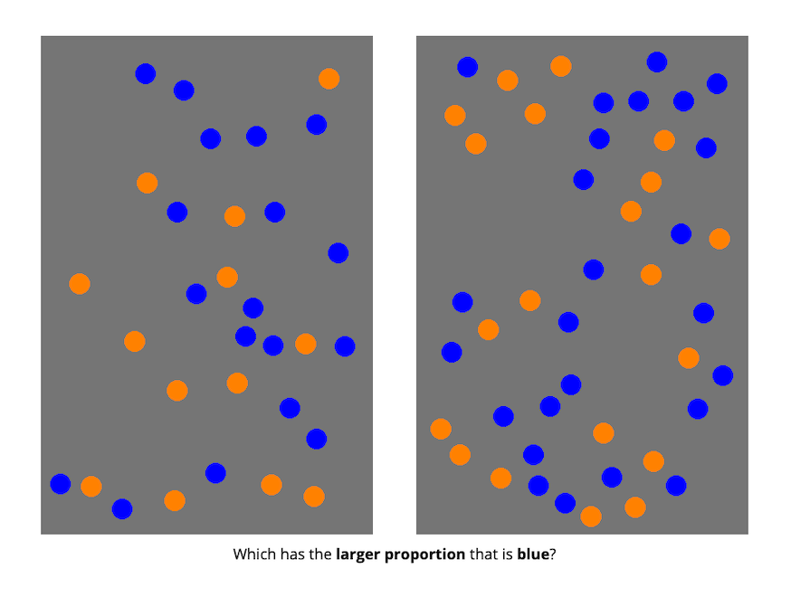

Conditions

There were four different conditions that changed what kinds of images the participants saw:

• divided blobs: blue and orange were entirely separate

• integrated blob: one blob, divided to be part blue and part orange

• separated dots: blue and orange dots were on opposite sides of the image

• integrated dots: blue and orange dots were intermixed

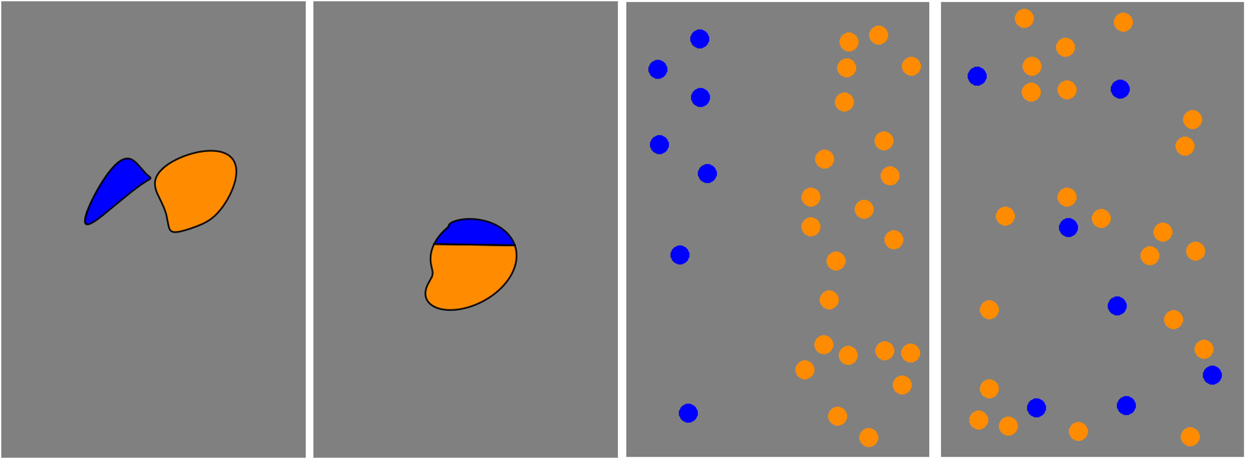

## Data analysis

We used R (Version 4.3.0; R Core Team, 2023) and the R-packages *dplyr* (Version 1.1.4; Wickham, François, Henry, Müller, & Vaughan, 2023), *forcats* (Version 1.0.0; Wickham, 2023a), *ggdist* (Version 3.3.2; Kay, 2024), *ggplot2* (Version 3.5.1; Wickham, 2016), *lubridate* (Version 1.9.3; Grolemund & Wickham, 2011), *papaja* (Version 0.1.3; Aust & Barth, 2024), *purrr* (Version 1.0.2; Wickham & Henry, 2023), *readr* (Version 2.1.5; Wickham, Hester, & Bryan, 2024), *stringr* (Version 1.5.1; Wickham, 2023b), *tibble* (Version 3.2.1; Müller & Wickham, 2023), *tidyr* (Version 1.3.1; Wickham, Vaughan, & Girlich, 2024), *tidyverse* (Version 2.0.0; Wickham et al., 2019) and *tinylabels* (Version 0.2.4; Barth, 2023) for all our analyses.

# Results

1. Does average performance vary across format type, ignoring all other aspects of the stimuli?

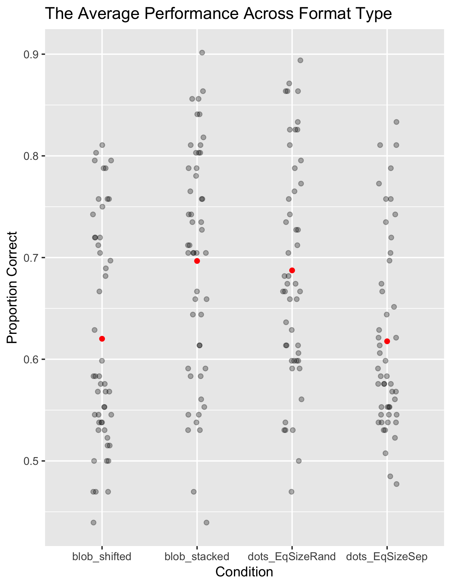

*Figure* 1. The plot shows the average performance for each condition with red dots, while grey dots show how individual responses are distributed around these averages. The average accuracy (proportion correct), varies slightly across different format conditions

1. How are reaction time and accuracy related? 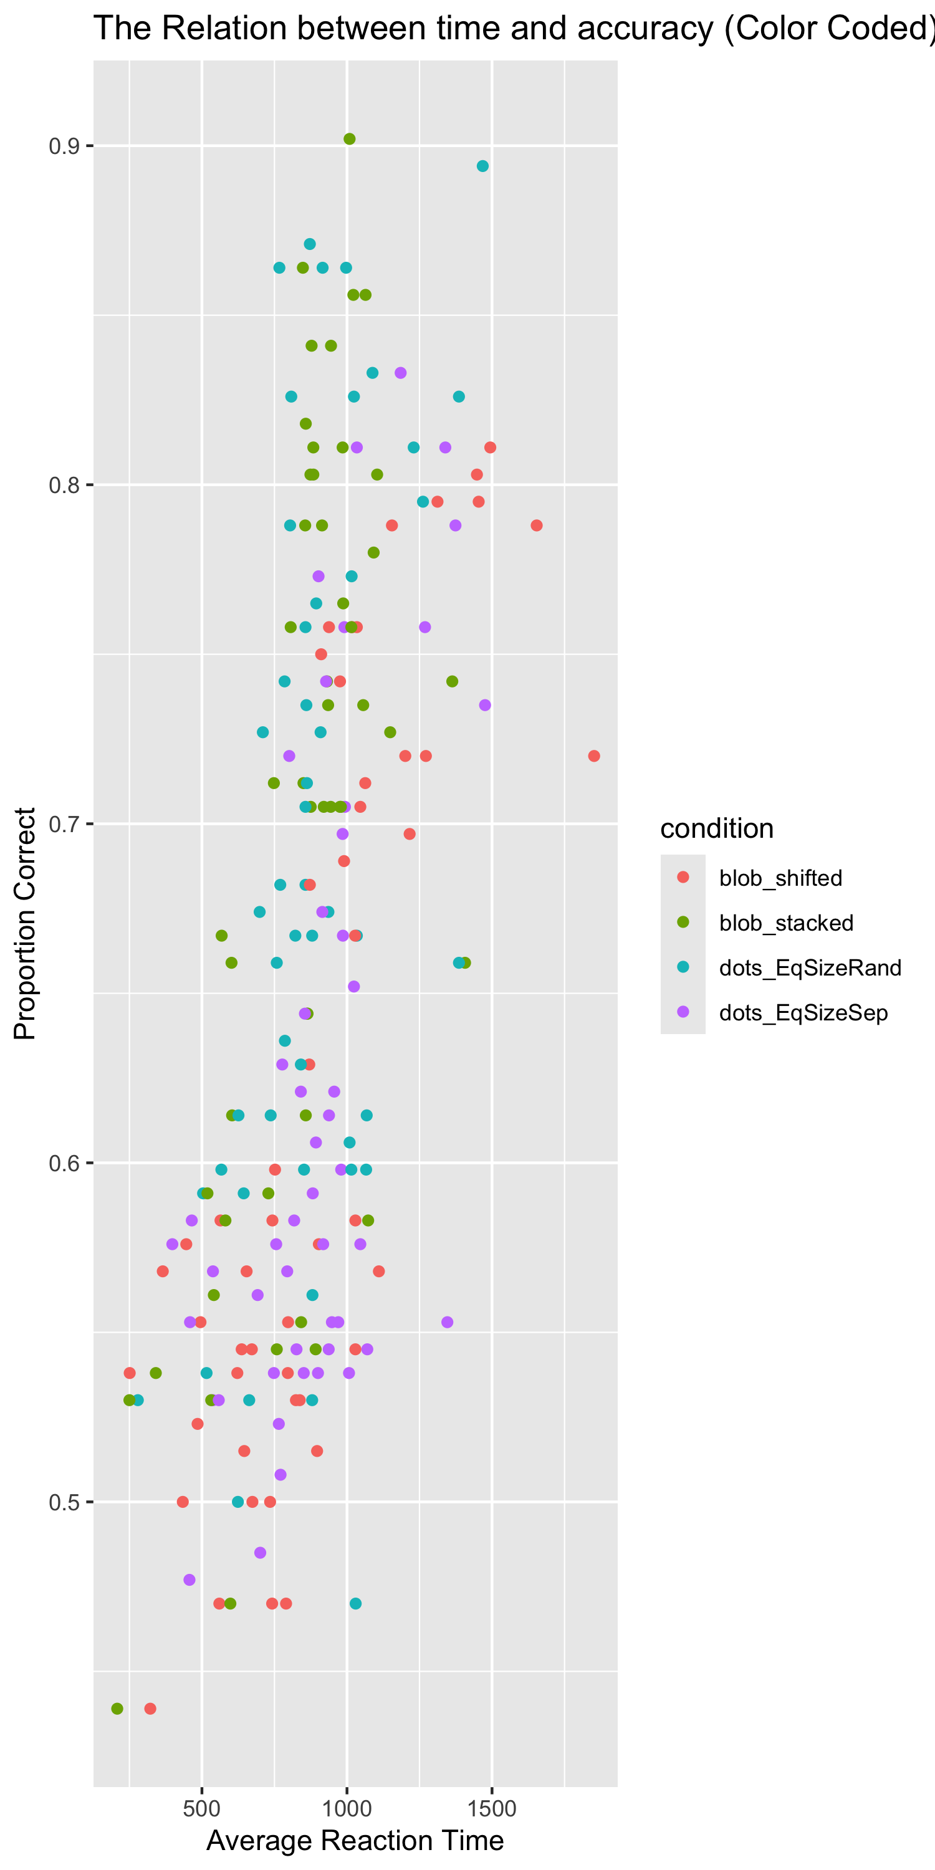
2. How does numerator congruency interact with format type? 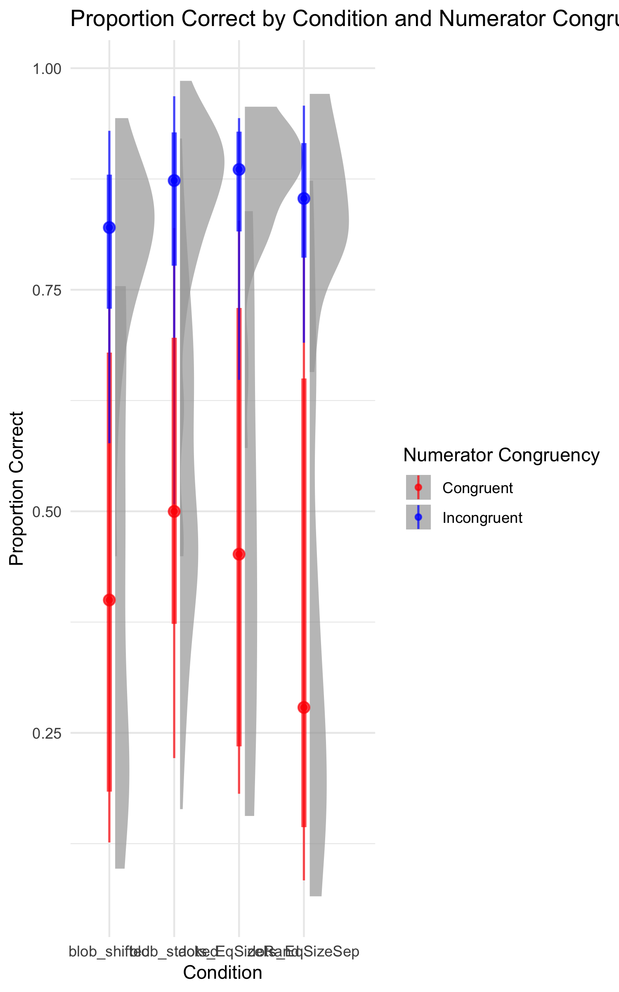

# Discussion

## Interpretation

**Average Performance across format type:** The red dots show the average performance for each condition, while the grey dots show how individual responses vary. Some conditions have responses that are close to the average, while others show more spread, meaning participants’ performance was less consistent.

**The Correlation between reaction time and accuracy:** This plot shows that people are usually more accurate when they take longer to respond. The different colors represent different conditions, and while the trend generally shows better accuracy with more time, there is still some variation between the conditions.

**How numerator congruency interacts with format types:** The plot compares performance on red (congruent) and blue (incongruent) trials. People tend to be less accurate on red trials compared to blue ones. The shaded areas show how much responses vary within each condition, with some conditions showing more spread than others.

## Conclusion

The tedious part of the assignment was dealing with the formatting and getting everything to look right on the poster. It took a lot of time to make sure each section was in the correct place and that the plots were accurate and displayed clearly. Because this was a new file, I had to re-summarize the prodtask data set and then graph it, which introduced some errors.

The most satisfying part was having a template to guide me, so I didn’t have to start from 0. It saved me time and made it easier to focus on putting the content together. It also felt great to see all my work come together in the end. Seeing the finished poster with everything in place was rewarding and gave me a sense of accomplishment.

# References

Aust, F., & Barth, M. (2024). *papaja: Prepare reproducible APA journal articles with R Markdown*. <https://doi.org/10.32614/CRAN.package.papaja>

Barth, M. (2023). *tinylabels: Lightweight variable labels*. Retrieved from <https://cran.r-project.org/package=tinylabels>

Grolemund, G., & Wickham, H. (2011). Dates and times made easy with lubridate. *Journal of Statistical Software*, *40*(3), 1–25. Retrieved from <https://www.jstatsoft.org/v40/i03/>

Kay, M. (2024). ggdist: Visualizations of distributions and uncertainty in the grammar of graphics. *IEEE Transactions on Visualization and Computer Graphics*, *30*(1), 414–424. <https://doi.org/10.1109/TVCG.2023.3327195>

Müller, K., & Wickham, H. (2023). *Tibble: Simple data frames*. Retrieved from <https://CRAN.R-project.org/package=tibble>

R Core Team. (2023). *R: A language and environment for statistical computing*. Vienna, Austria: R Foundation for Statistical Computing. Retrieved from <https://www.R-project.org/>

Wickham, H. (2016). *ggplot2: Elegant graphics for data analysis*. Springer-Verlag New York. Retrieved from <https://ggplot2.tidyverse.org>

Wickham, H. (2023a). *Forcats: Tools for working with categorical variables (factors)*. Retrieved from <https://CRAN.R-project.org/package=forcats>

Wickham, H. (2023b). *Stringr: Simple, consistent wrappers for common string operations*. Retrieved from <https://CRAN.R-project.org/package=stringr>

Wickham, H., Averick, M., Bryan, J., Chang, W., McGowan, L. D., François, R., … Yutani, H. (2019). Welcome to the tidyverse. *Journal of Open Source Software*, *4*(43), 1686. <https://doi.org/10.21105/joss.01686>

Wickham, H., François, R., Henry, L., Müller, K., & Vaughan, D. (2023). *Dplyr: A grammar of data manipulation*. Retrieved from <https://CRAN.R-project.org/package=dplyr>

Wickham, H., & Henry, L. (2023). *Purrr: Functional programming tools*. Retrieved from <https://CRAN.R-project.org/package=purrr>

Wickham, H., Hester, J., & Bryan, J. (2024). *Readr: Read rectangular text data*. Retrieved from <https://CRAN.R-project.org/package=readr>

Wickham, H., Vaughan, D., & Girlich, M. (2024). *Tidyr: Tidy messy data*. Retrieved from <https://CRAN.R-project.org/package=tidyr>