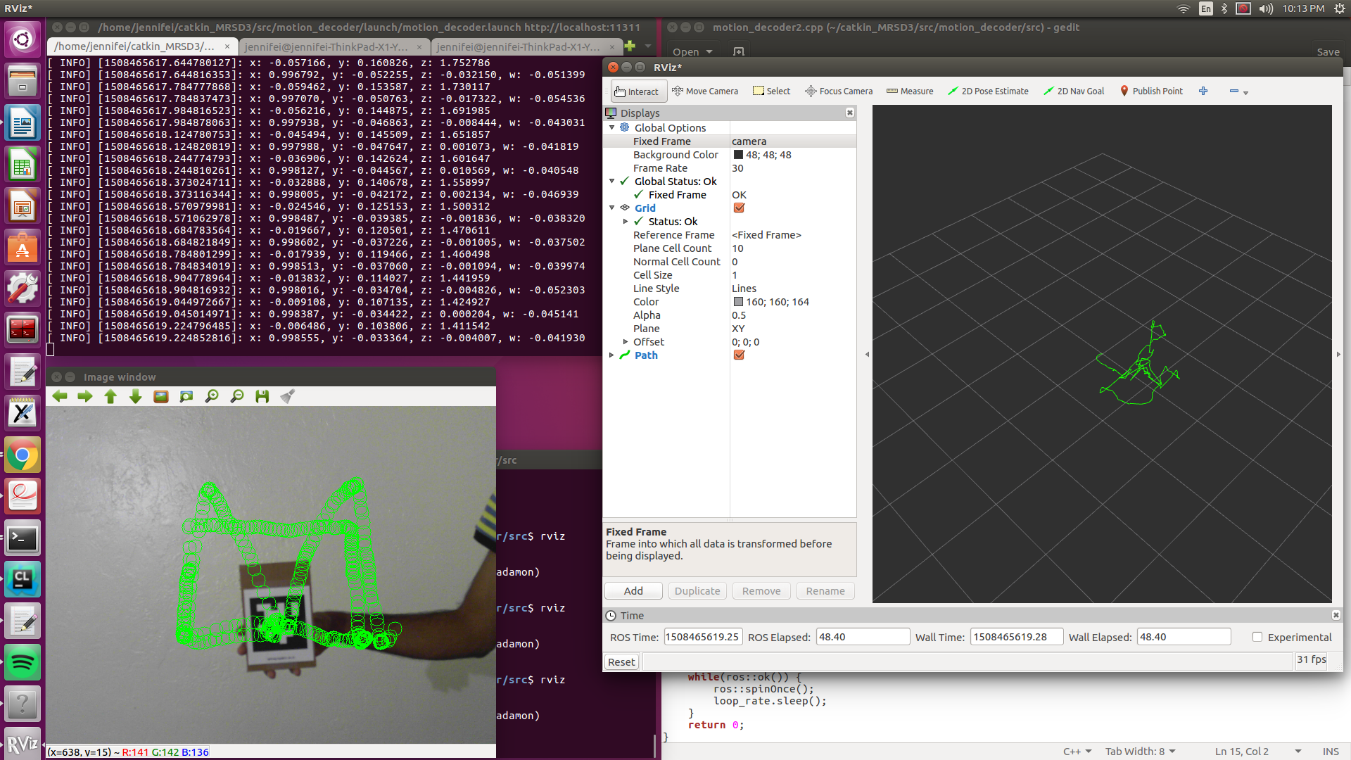
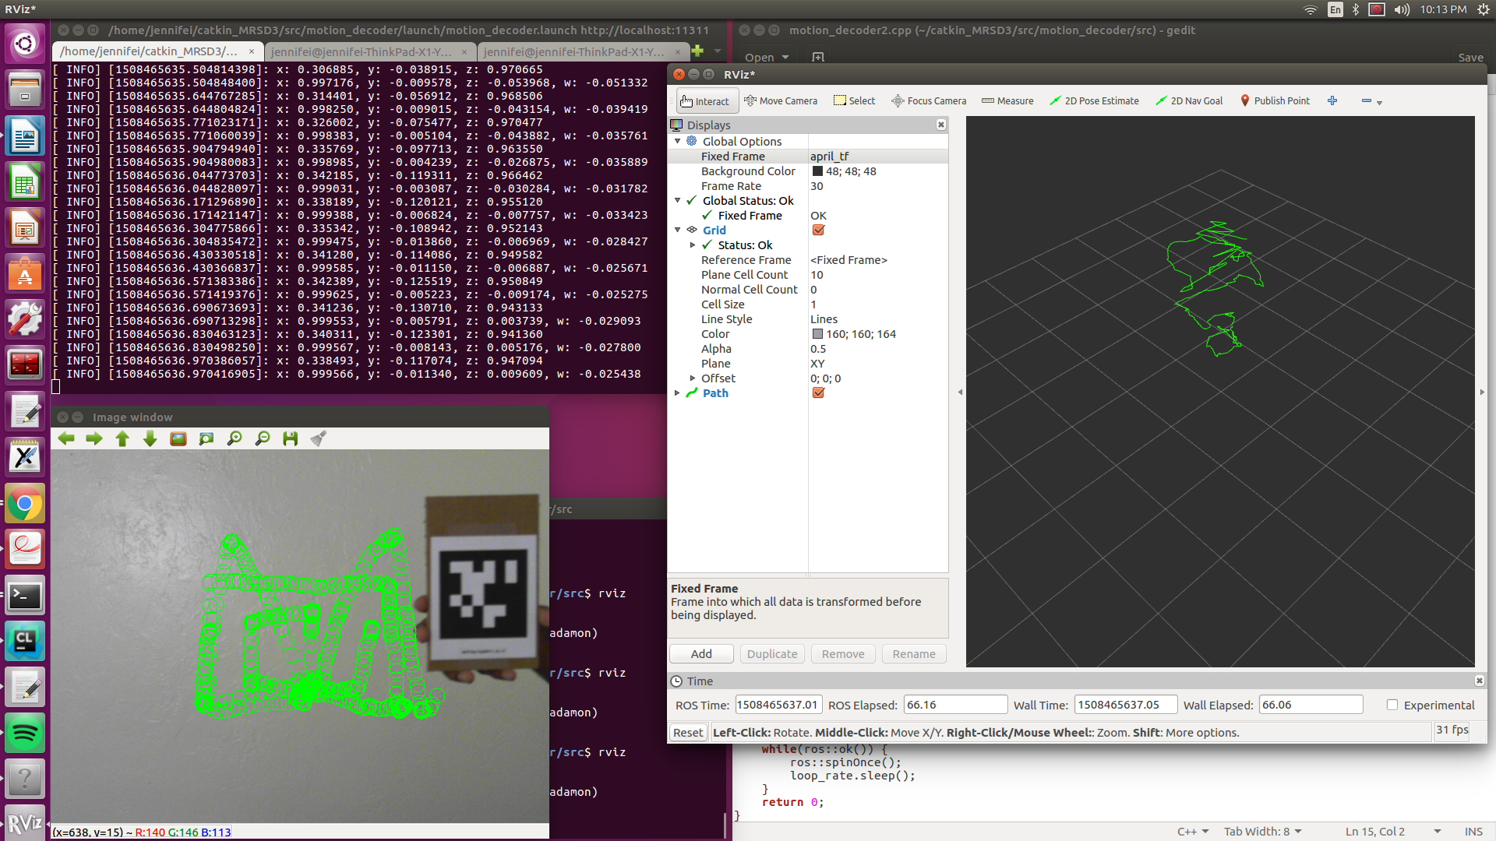

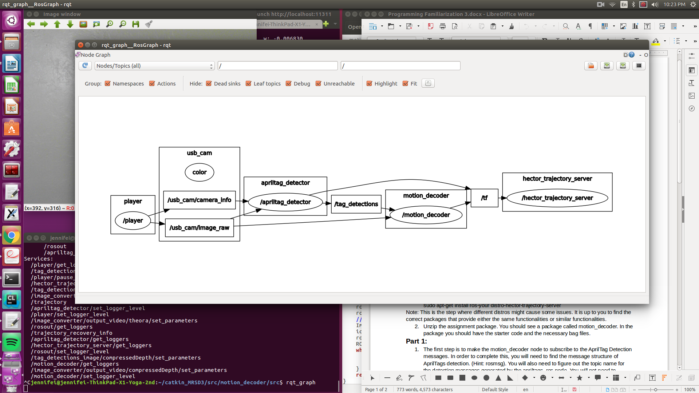

2.) The pose feature could be useful for tracking pedestrian paths around CaBot, or we could possibly use april tags for localization.

3.) This assignment was probably the most useful task we’ve done so far, since we were able to use real data that could be collected easily and analyze it for a real situation. The difficulty was definitely manageable since there was a lot of coding solely based off of the ROS tutorials. I think the longest part of the assignment was figuring out what the assignment actually wanted from us, since some parts were not completely clear. Part 3 was especially unclear with the launch file calling order. There was also a “.” at the end of one of the bag files which took a long time to debug and figure out that my code was not the problem.

