- Build beta cell network:
Average beta cell diameter – 10 $μ$m
- https://www.ncbi.nlm.nih.gov/pmc/articles/PMC5440564/#:~:text=Beta%20cells%20have%20an%20average,Marchetti%20and%20Ferrannini%2C%202015).

- Fill 3D grid with points size [-radius, radius].
Remove any points not in the islet volume \sqrt((x-0)^2+(y-0)^2+(z-0)^2)
Randomly choose %percent beta number of

https://royalsocietypublishing.org/doi/abs/10.1098/rsta.2008.0110?casa_token=VhTF9yYlqpwAAAAA%3AY_TP71x8-ncgAXnCnHvT6imnsti8bgLArXkJOWmjDDOyvb1Dj1p9oPiMdKd-qFak6CJ9_mA_Aj0TC0k

- Connect cells with a distribution of edges
[Zhang et al. 2008] says that there are 217 +/- 46. If we assume a normal distribution, and assume 46 is 1 STD, we can repeat Zhang’s calculations and assume the distribution of cell-to-cell connections for a given cell is $N(6.38, 1.35)$.

- Distribution of total conductance

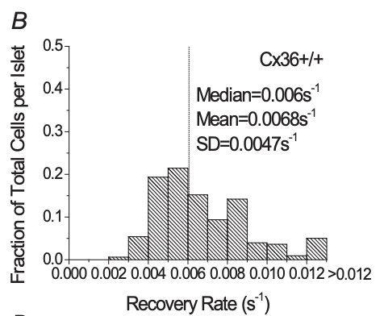
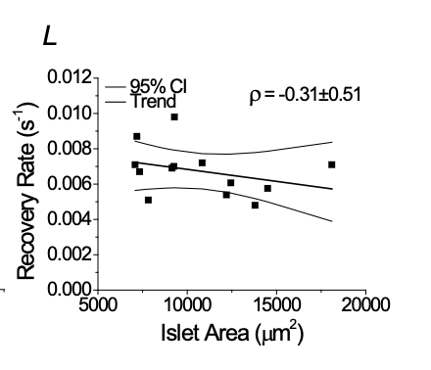
Distribution taken from Fluorescence Recovery Rate after Photobleaching.
The average conductance is 1.22 ns [Zhang et al. 2008]. Therefore, we will scale: $Cond. = Recovery Rate*203$

