Random Ramsey Colorings and SAT Search
Expected counts, sampled probability thresholds, and limits of random search
Revised research report • 28 September 2026

Abstract
We study independent, equally likely red–blue edge colorings of complete graphs and count monochromatic cliques of orders 3, 4, and 5. Linearity of expectation gives E[Xₙ,ₖ] = C(n,k)2^(1−C(k,2)) exactly. A new, seeded Monte Carlo run compares sampled means and extrema with this formula and estimates the smallest tested order at which a coloring contains a monochromatic clique with probability at least 0.9. The sampled crossings are n = 5, 9, and 15 for k = 3, 4, and 5, respectively. An exhaustive check shows that 12 of the 1,024 colorings of K₅ avoid a monochromatic triangle. These observations illustrate typical random colorings; sample minima, failure to find a coloring, and high empirical probabilities do not establish worst-case Ramsey numbers. We provide code, seed rules, and machine-readable summary output for the new run. In a connected pilot extension, a SAT encoding found verified K₄-avoiding colorings through n = 17 within a 0.5-second allowance, whereas uniform random sampling rarely did at the larger tested sizes. This pilot requires longer, repeated benchmarking before a general performance claim.

1 Introduction and research question
The complete graph Kₙ has n vertices and an edge between every pair. Let Xₙ,ₖ count the k-vertex subsets whose induced edges are all red or all blue. The diagonal Ramsey number R(k,k) is the least n for which every two-coloring of Kₙ has Xₙ,ₖ > 0. We ask how the typical count and the probability P(Xₙ,ₖ > 0) develop with n, and what finite random search can establish. The University of Maryland project brief requests sampled minima, maxima, averages, probability crossings, and searches for avoiding colorings [1, 2].

2 Exact baseline and inference
For each k-subset S, let I(S) be one if all m = C(k,2) edges within S share a color. Of the 2^m equally likely edge assignments, precisely two are monochromatic. Thus P(I(S)=1) = 2/2^m = 2^(1−m). Since Xₙ,ₖ = ΣS I(S), linearity of expectation gives E[Xₙ,ₖ] = C(n,k)2^(1−C(k,2)). This does not require the clique indicators to be independent: overlapping subsets share edges.
In particular E[Xₙ,₃] = C(n,3)/4, E[Xₙ,₄] = C(n,4)/32, and E[Xₙ,₅] = C(n,5)/512. The leading coefficients as n grows are 1/24, 1/768, and 1/61,440. These are exact algebraic results, so a high R² from fitting the means would only measure agreement with a known baseline; it would not independently prove a new law. More variable observed K₄ or K₅ counts can reflect rare, clustered cliques and shared edges; an independent-clique binomial model would be inappropriate.

3 Reproducible methods
For each (n,k), the supplied Python program constructs an index of the C(n,k) candidate cliques. Each trial draws an independent fair bit for each of the C(n,2) edges, checks whether every edge of each candidate clique has the same bit, and records the count. Growth grids are n = 5, 10, 20, 40, 60, 80, 100 for k = 3; n = 5, 10, 20, 30, 40 for k = 4; and n = 5, 10, 15, 20, 25, 30 for k = 5, with 400 trials per point. Dedicated threshold grids use 10,000 trials for k = 3 at n = 4–6; 5,000 for k = 4 at n = 8–13; and 1,500 for k = 5 at n = 13–17. A separate pseudorandom stream per point uses NumPy default_rng with seed 20260928 + 1000k + n for growth and 20260928 + 100000 + 1000k + n for threshold grids. All grid points complete in this rerun; there is no partial last batch.
The reported minimum and maximum are only the smallest and largest counts in a specified sample. Threshold probabilities are presence/trials. For illustration, a binomial standard error for an estimated probability p̂ from T independent colorings is √[p̂(1−p̂)/T]. Independence holds between independently generated colorings, although clique indicators within one coloring are dependent. Fixed grids and trial counts replace the older draft’s machine-dependent time stop; the older source and trial-level data were unavailable, so its numbers cannot be reproduced from this package.

4 Results
Figure 1 compares new sample means with the exact expectation. The close agreement is a useful implementation check and is not a discovery about the unknown Ramsey numbers.
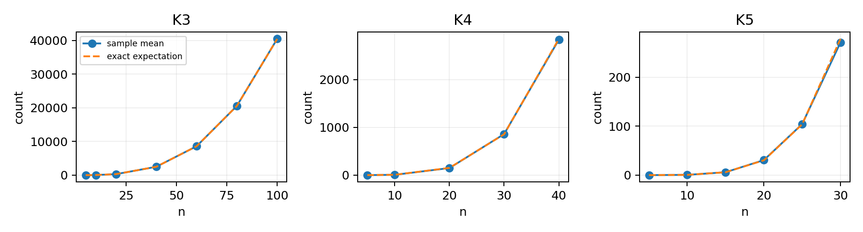
Figure 1. Sampled mean clique counts (solid markers) and exact expected counts (dashed lines); 400 independent colorings at each point.
k | n | Trials | Sample min–max | Mean | Exact E[X] | Mean/E[X]
3 | 5 | 400 | 1–7 | 2.447 | 2.500 | 0.979
3 | 20 | 400 | 250–334 | 283.353 | 285.000 | 0.994
3 | 100 | 400 | 39944–40942 | 40437.940 | 40425.000 | 1.000
4 | 5 | 400 | 0–2 | 0.115 | 0.156 | 0.736
4 | 20 | 400 | 87–275 | 147.830 | 151.406 | 0.976
4 | 40 | 400 | 2283–3477 | 2839.365 | 2855.938 | 0.994
5 | 5 | 400 | 0–1 | 0.003 | 0.002 | 1.280
5 | 15 | 400 | 0–60 | 5.920 | 5.865 | 1.009
5 | 30 | 400 | 116–596 | 271.175 | 278.332 | 0.974
Table 1. Selected growth grid results. The full grid is in results.json. Ratios near one support agreement of the sample means with the exact expectation; at k = 5, n = 5, only about 0.78 events are expected across 400 trials, so a ratio from one batch is intrinsically unstable.
k | n | Present / trials | Estimated P(X > 0) | Approx. SE
3 | 4 | 7182 / 10000 | 0.7182 | 0.0045
3 | 5 | 9885 / 10000 | 0.9885 | 0.0011
4 | 8 | 3967 / 5000 | 0.7934 | 0.0057
4 | 9 | 4708 / 5000 | 0.9416 | 0.0033
5 | 14 | 1271 / 1500 | 0.8473 | 0.0093
5 | 15 | 1380 / 1500 | 0.9200 | 0.0070
Table 2. Sample estimates on both sides of each observed 0.9 crossing. The standard error quantifies Monte Carlo sampling at a fixed n; it does not account for code defects or selection of a wider search grid. The k = 5 estimate at n = 15 is 0.9200 ± 0.0070 (one approximate standard error), separated from 0.9 within this sample.

5 Avoiding colorings and Ramsey bounds
A found zero-count coloring at n proves R(k,k) > n once the coloring is recorded and its edges are independently checked. The current package records counts rather than full edge assignments, so its random zero observations are diagnostic only; a publishable lower-bound witness would require an archived adjacency matrix and independent verification. Conversely, seeing no zero in T independent draws gives neither a proof of nonexistence nor an upper bound on R(k,k). If the true zero probability is q, the chance of missing every zero is (1−q)^T.
For k = 3, exhaustive enumeration of all 2^10 colorings of K₅ yields exactly 12 zero-count colorings, giving P(X₅,₃ = 0) = 12/1024 = 1.171875%; the rerun observed 115/10,000 = 1.15%. The 400-trial growth sample happened to observe no zero at n = 5, illustrating why a sample minimum depends on trial count. The classical exact values R(3,3) = 6 and R(4,4) = 18, and the best cited bounds for R(5,5), belong to the Ramsey literature [3, 4], not to these simulations. The earlier report’s claimed largest witnessed n = 12 for k = 4 is an unarchived observation, not a determined extremal boundary.

6 Discussion and limitations
The observed 90% crossings sit below the corresponding guaranteed thresholds: 5 < 6 and 9 < 18; for k = 5, 15 is below the published lower bound 43 ≤ R(5,5) ≤ 46 [3, 4]. A claim that the gap systematically widens with k needs more than three tested clique orders. The old draft listed k = 6 and k = 7 probability runs but supplied no executable source, raw records, precise trial counts, or seed; they are excluded from the new results. We also cannot infer an empirical polynomial leading coefficient reliably from a short, noisy k = 5 grid. The exact expectation already determines it.
This is a reproducible demonstration of a known probabilistic calculation, not a new Ramsey bound or a new theorem. A research submission seeking a novel contribution could extend it with rigorously verified avoiding witnesses, variance or concentration analysis accounting for overlapping cliques, carefully designed importance sampling, or a complete exhaustive calculation at a tractable n. Any such contribution needs its own evidence and appropriate comparison with prior work.

7 Pilot extension: random sampling versus SAT
The original project asks how many monochromatic cliques appear in random colorings and how rarely a coloring avoids them [1, 2]. A connected extension asks whether a targeted satisfiability search can find an avoiding coloring after uniform random sampling becomes ineffective. This combines the random-coloring experiment in Project One with the SAT formulation suggested in Project Three [1]. The SAT encoding itself is established in prior work [6]; the comparison is an empirical extension, not a new Ramsey theorem.
For each edge e of Kₙ, let Boolean xₑ specify its color. Every four-vertex set S has six induced edges. Add one clause requiring at least one blue edge in S and a second requiring at least one red edge in S. Their conjunction forbids a monochromatic K₄. The resulting formula has C(n,2) variables and 2C(n,4) clauses. A SAT model gives an edge coloring; an independent bitset routine checks every saved coloring for monochromatic K₄. A timeout is unresolved, whereas a verified model certifies only that an avoiding coloring exists at that n. The benchmark uses PySAT Minisat22 [7].
A bounded pilot compared one SAT solve with three separately seeded uniform-random searches at each n = 10–17, each limited to 0.5 seconds. The SAT search found and independently verified a coloring at every n. Uniform random search succeeded in all three runs at n = 10 and 11, one of three at n = 12, and none of three at n = 13–17. The SAT wall times were approximately 0.10–0.14 seconds including process startup and formula construction. These are pilot observations on one execution environment, not stable performance estimates. Random search’s failure at n = 13–17 is not evidence that no avoiding coloring exists; the SAT output directly demonstrates existence.
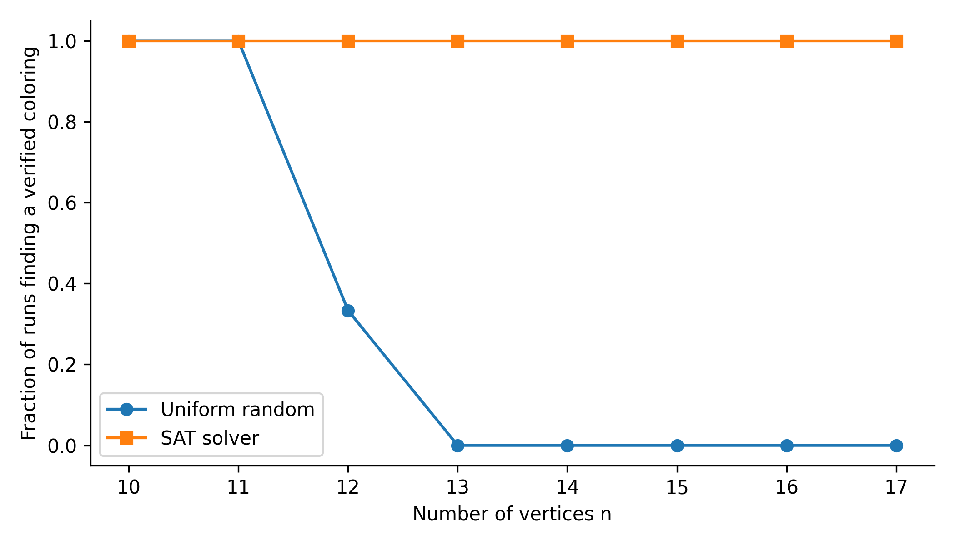
Figure 2. Fraction of pilot runs yielding a verified K₄-avoiding coloring before the 0.5-second limit. SAT has one deterministic run per n (0 or 1); random sampling has three independent runs per n. The SAT line should not be interpreted as an estimated probability over random solver seeds.
This pilot motivates a larger preregistered benchmark: repeated random seeds, several time budgets, recorded machine and software versions, and comparisons to relevant prior search algorithms. A fair conclusion would concern success under specified budgets. Because SAT encodings and K₄-avoiding colorings through n = 17 are already known, neither this pilot nor reproducing those colorings is a novel bound [3, 6].

References
[1] W. Gasarch, “HS PROJ 2026 New Ramsey,” University of Maryland, 2026. https://www.cs.umd.edu/~gasarch/HSPROJ26/NRAMSEY/nramsey.html
[2] W. Gasarch, “Final TO DO for New Ramsey,” University of Maryland, 2026. https://www.cs.umd.edu/~gasarch/HSPROJ26/NRAMSEY/final-todo.pdf
[3] S. P. Radziszowski, “Small Ramsey Numbers,” Electronic Journal of Combinatorics, Dynamic Survey DS1, version April 24, 2026. https://www.combinatorics.org/ojs/index.php/eljc/article/view/DS1
[4] V. Angeltveit and B. D. McKay, “R(5,5) ≤ 46,” 2024 preprint; subsequent published version, 2026. https://arxiv.org/abs/2409.15709
[5] NumPy Developers, “Random Generator,” documentation. https://numpy.org/doc/stable/reference/random/generator.html
[6] B. Molnár, F. Molnár, M. Varga, Z. Toroczkai, and M. Ercsey-Ravasz, “A continuous-time MaxSAT solver with high analog performance,” Nature Communications 9, 4864 (2018). https://doi.org/10.1038/s41467-018-07327-2
[7] A. Ignatiev, A. Morgado, and J. Marques-Silva, “PySAT: A Python Toolkit for Prototyping with SAT Oracles,” SAT 2018. https://pysathq.github.io/

