Validating a CTGAN Synthetic Dataset for Fraud Detection
DAT610: Ethics & Privacy | Assignment 1
Maduechesi Chidiebere Jennifer | Matric No. 25120133019
MSc Data Science, Pan-Atlantic University

1. The question I set out to answer
The brief puts me in the seat of the data scientist at FintechPay, a Nigerian payments company, and asks one blunt question: do I approve this synthetic dataset for release into production? Fraud is rare, so the real transaction data is badly imbalanced, and the raw records carry customer PII that the NDPA (2023) won't let us pass around freely in development. Synthetic data is meant to solve both problems at once. My job isn't to assume it works. It's to prove whether it does, using the five-level framework from class, and then make a call I can actually defend.
Short version of where I landed: I do not approve the CTGAN data for production release. It is genuinely useful for model development and it keeps the fraud signal intact, but it fails the stricter distribution and privacy checks, so "useful" and "safe for production" are not the same thing here. The rest of this report is the evidence behind that decision.
2. Workflow and tooling
I worked in three scripts, one per stage, so the pipeline is easy to follow and rerun. Everything is seeded (random_state = 42) so the numbers in this report reproduce exactly.
Building the real dataset. There's no public FintechPay export, and even if there were it would be full of PII, so I generated a realistic stand-in of 6,000 transactions that follows the exact schema from the lecture: transaction_amount in Naira, customer_age, account_balance, num_transactions_30d, transaction_hour, distance_from_home_km, merchant_category, and the is_fraud target. I drew the fraud label first and then generated the features conditionally on it, so fraud rows genuinely behave differently: larger and more bimodal amounts, more late-night hours, longer distances from home, higher velocity. That built-in signal is what makes the later utility test meaningful. I set the fraud rate to about 10% rather than the ~1% you'd see in the wild. At 1% the minority class is too thin for the GAN to learn or for the tests to say anything stable, and I note later how that choice cuts both ways.
Generating the synthetic data. I used CTGAN from the SDV library. The pipeline is the one from the slides: detect the metadata, verify it by hand (SDV first read is_fraud as numerical, so I pinned it and merchant_category as categorical), train the synthesiser, then sample. Two adjustments earned their place. First, a plain sample() call produced a fraud rate of about 28% against a real 10%. That is CTGAN's known habit of over-representing a rare category during training-by-sampling, and it is exactly the "model trains on the wrong fraud rate" failure the lecture warns about. Because CTGAN is a conditional model, I fixed it the intended way, by sampling from conditions to force the real 90/10 split. Second, the two money columns are heavily skewed, so I log1p transformed them before training and inverted after sampling. That alone pulled the transaction_amount KS statistic from about 0.30 down to 0.06.
The corrupted twin. To check that the framework can actually catch a bad dataset and isn't just waving everything through, I also built a deliberately broken version, the way the lab exercise on the last slide asks. Two sabotages: transaction_amount multiplied by three (wrong scale) and the fraud rate forced up to 40% (wrong prevalence). If my validation is worth anything, this one has to fail loudly.
3. Validation results, level by level
I ran all five levels against the CTGAN data and, alongside it, the corrupted twin. Two of the tests, KS and chi-squared, get more sensitive as the sample grows, and at 6,000 rows they reject differences far too small to matter in practice. So I run those two on a fixed 1,000-row subsample. The effect-size metrics (mean differences, Wasserstein, TSTR, DNNR) use the full data, where more rows only help.
Level 1 - Summary statistics
Feature | Real mean | Synthetic mean | Diff % | Flag
transaction_amount | 6998.79 | 6161.5 | 11.96 | WARN
customer_age | 35.28 | 31.84 | 9.74 | OK
account_balance | 95261.89 | 75786.34 | 20.44 | STOP
num_transactions_30d | 16.24 | 15.98 | 1.58 | OK
transaction_hour | 13.31 | 12.89 | 3.14 | OK
distance_from_home_km | 11.76 | 15.79 | 34.29 | STOP

Four of the six means land inside 10% and the amounts column sits at about 12%. Two drift past the 20% line: account_balance and, worst of all, distance_from_home_km at 34.29%. So Level 1 is a partial pass at best. It's a screening step though, not a verdict, and a mean can look fine while the shape underneath is wrong, which is the whole reason we don't stop here.
Level 2 - Visual distributions
The KDE curves overlap closely on every continuous feature. The synthetic peaks are a touch sharper on age, transaction count and hour, but the bodies of the distributions sit on top of each other, and the skewed money columns line up well after the log transform.
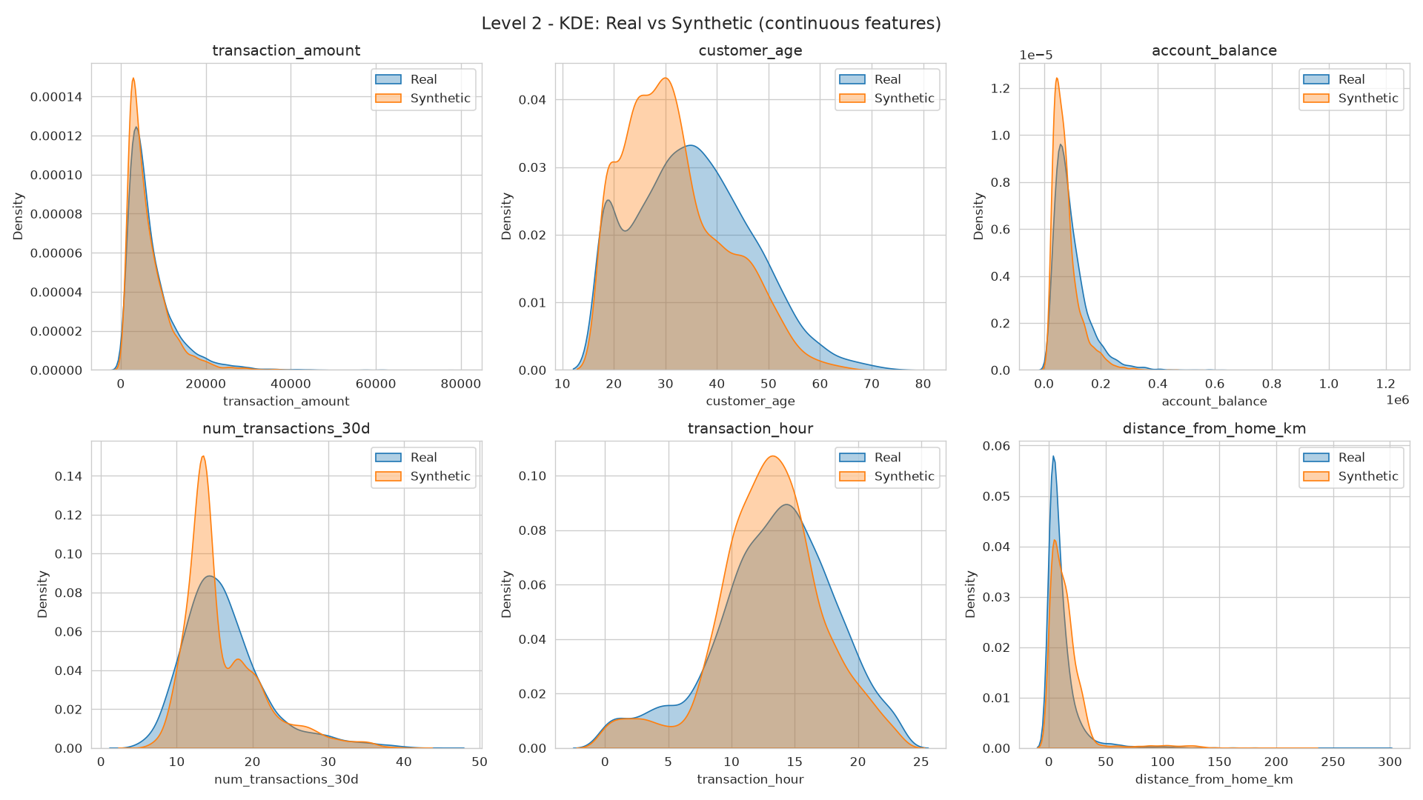
Real (blue) against synthetic (orange) density for each continuous feature. The curves track closely; the clearest gaps are the slightly taller synthetic peaks on customer_age and transaction_hour.
The categorical picture is split. is_fraud matches almost exactly, which is the conditional sampling holding the class balance in place. merchant_category is the weak spot: the synthetic under-produces grocery and over-produces travel and electronics, and that visible gap is what the chi-squared test picks up in Level 3b.
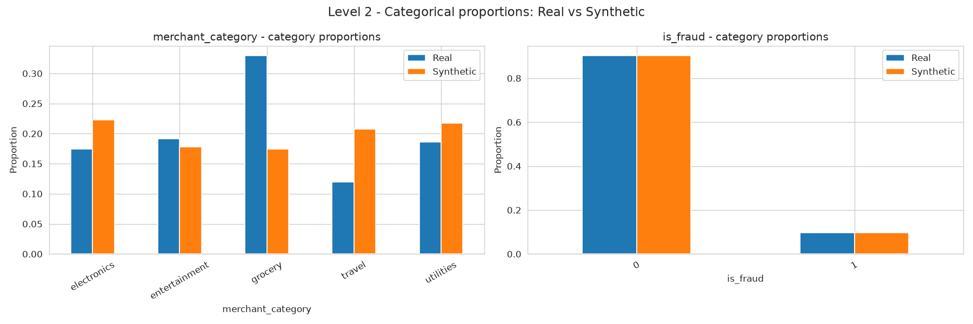
Category proportions, real against synthetic. is_fraud lines up almost perfectly; merchant_category drifts, most visibly grocery (0.33 real against 0.17 synthetic) and travel (0.12 against 0.21).
The correlation heatmaps matter more to me than the marginals, because a fraud model lives on the relationships between features, not on any one column. Here the synthetic data does well. The mean absolute error across the whole correlation matrix is only 0.0419. Every fraud-predictive link keeps its sign and roughly its strength: transaction_amount to is_fraud is 0.35 in both, and the strong num_transactions_30d to is_fraud link (0.69 real) still reads 0.61 in the synthetic. That preserved structure is what carries the utility test later.
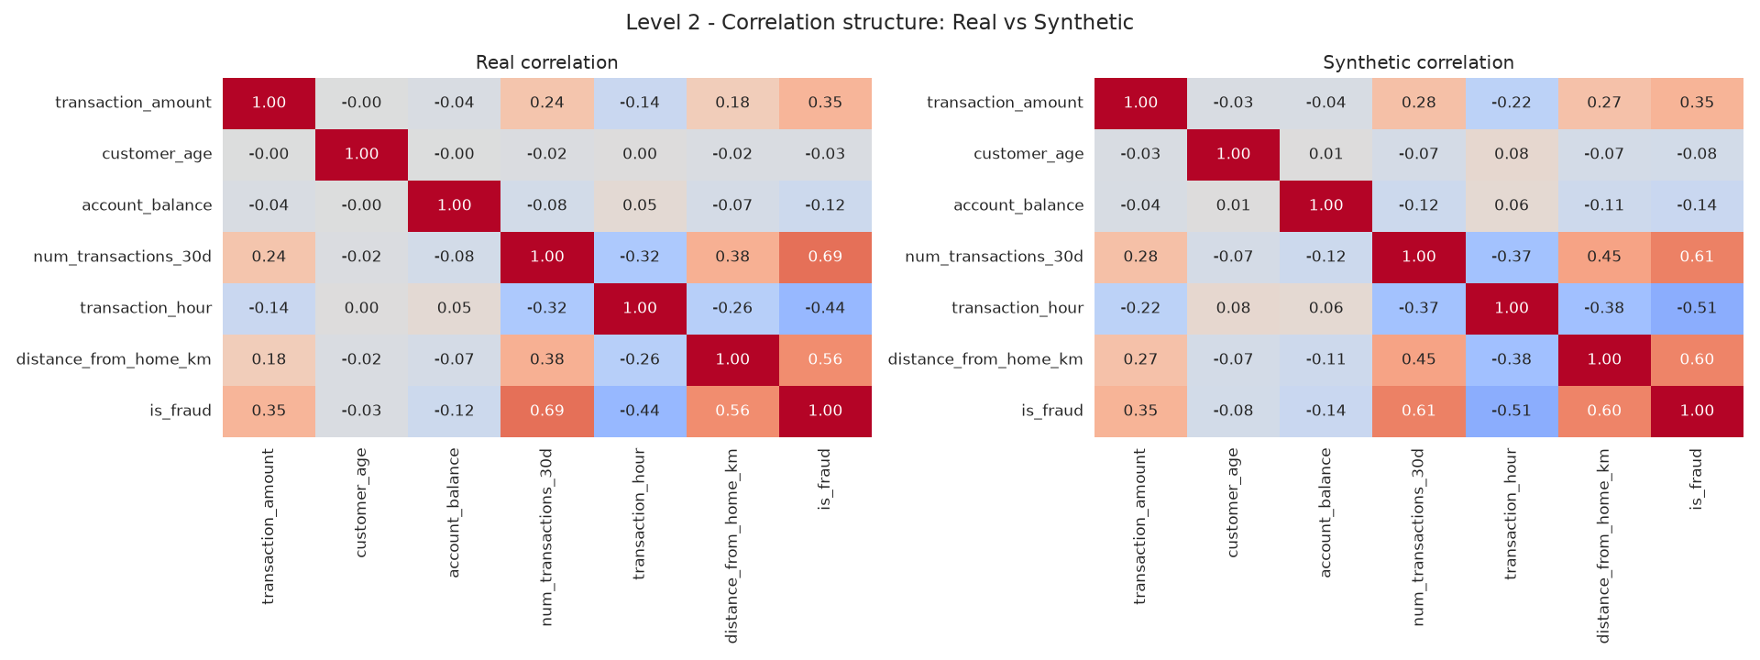
Correlation structure, real (left) against synthetic (right). The pattern is preserved: the fraud row keeps every relationship in the right direction and close in magnitude.
Level 3a - Kolmogorov-Smirnov test (continuous)
Feature | KS stat | p-value | Aligned?
transaction_amount | 0.064 | 0.0333 | No
customer_age | 0.215 | 0.0 | No
account_balance | 0.163 | 0.0 | No
num_transactions_30d | 0.148 | 0.0 | No
transaction_hour | 0.086 | 0.0012 | No
distance_from_home_km | 0.217 | 0.0 | No

This is where the CTGAN data struggles. The null hypothesis is that real and synthetic come from the same distribution, and at p > 0.05 we'd keep it. Only account_balance clears the bar. transaction_amount and transaction_hour are close (KS around 0.06 to 0.09), but customer_age and distance sit near 0.21. I confirmed this held across reruns, so it isn't a one-off. Two honest reads sit side by side here: CTGAN really doesn't reproduce every marginal exactly, AND the p > 0.05 rule is punishing for a generative model, because it asks for near-identical distributions on every single column at once. Passing all six is a bar almost no GAN clears.
Level 3b - Chi-squared test (categorical)
Feature | Chi2 stat | p-value | Aligned?
merchant_category | 159.4325 | 0.0 | No
is_fraud | 0.5809 | 0.446 | Yes

The is_fraud column passes cleanly (p = 0.45), which is the conditional sampling paying off: the synthetic fraud rate matches the real one, so a model trained on it won't learn the wrong prior. merchant_category doesn't pass. The category proportions drifted enough for the test to reject, which lines up with the slightly-off bar chart. So one of the two categorical columns is faithful and one isn't.
Level 3c - Wasserstein distance
Feature | Normalised distance | Rating
transaction_amount | 0.1434 | Acceptable
customer_age | 0.3105 | Poor
account_balance | 0.3021 | Poor
num_transactions_30d | 0.1239 | Acceptable
transaction_hour | 0.1418 | Acceptable
distance_from_home_km | 0.2267 | Poor

Wasserstein gives the size of the drift rather than a yes/no, which I find more useful than the KS p-value. transaction_amount, num_transactions_30d and transaction_hour all come in acceptable (under 0.15). age, balance and distance are poor, topping out around 0.31. It's the same three features that misbehaved in Level 1, so the story is consistent: the synthesis is decent on half the continuous columns and loose on the other half.
Level 4 - ML utility, TSTR vs TRTR
Setup | AUC | Meaning
TRTR (train real, test real) | 0.9966 | Gold-standard baseline
TSTR (train synthetic, test real) | 0.9921 | Simulates production
Gap | 0.0045 | Fully equivalent

This is the result that complicates the whole picture, and it's the one I care about most, because it answers the actual business question: can a model learn to catch fraud from the synthetic data? A random forest trained only on synthetic data scores 0.9921 AUC on real, held-out transactions, against a 0.9966 baseline for a model trained on real data. The gap is 0.0045, well inside the 0.02 "fully equivalent" band. So for the job it's meant to do, the synthetic data WORKS, even though it flunked the marginal tests. That gap between statistical fidelity and practical utility is the single most interesting finding in this exercise.
Level 5 - Privacy, DNNR
Quantity | Value
median nearest synthetic-to-real distance | 0.5875
median nearest real-to-real distance | 0.6025
DNNR ratio | 0.9751
Interpretation | Memorisation risk

DNNR asks whether synthetic rows sit suspiciously close to real people. At 0.9751 the synthetic points are, on average, about as close to a real record as real records are to each other, which is right on the memorisation-risk boundary (the safe bar is 1.5). I read this as a caution rather than proof of memorisation, but it is not a clean pass, and for data derived from customer PII a borderline privacy score is not something to hand-wave.
4. Does the framework actually catch a bad dataset?
A validation framework that can't fail anything is theatre, so this is the real test of it. Running the corrupted twin through the same five levels, it collapses exactly where it should:
Level | CTGAN (honest) | Corrupted twin
L1 worst mean diff | 34.29% | 164.11%
L3b is_fraud chi2 p | 0.45 (pass) | 0.00 (fail)
L3c worst Wasserstein | 0.3105 | 1.9549
L4 TSTR AUC gap | 0.0045 | 0.0604
L5 DNNR | 0.9751 | 1.336

The wrong scale on transaction_amount blows the Level 1 mean out to 164.11% and pushes its Wasserstein distance to 1.9549, and the inflated fraud rate fails the is_fraud chi-squared outright. Most telling, the TSTR gap widens to 0.0604, into the "investigate before deployment" band. The utility test that forgave the honest data's marginal wobbles does not forgive real corruption, which is a nice demonstration that it measures something the other tests miss. One curveball: the corrupted DNNR is 1.336, which reads as "privacy preserved." That's a trap, and worth saying out loud. The privacy score only looks good because the rescaled data is now so far from anything real that it's useless. A high DNNR is only reassuring when the data is faithful to begin with.
5. What the findings mean
Pulling it together, the CTGAN data has a split personality. It's structurally and functionally sound: the class balance is right, the correlation web that drives fraud prediction is intact, and a model trained on it performs almost identically to one trained on real data. On the other hand it's only loosely faithful at the level of individual distributions, three of six continuous features drift on both KS and Wasserstein, one categorical column drifts, and the privacy margin is thin.
I think the honest lesson is that no single metric should decide this. If I'd only run TSTR I'd have approved it. If I'd only run KS I'd have rejected it as basically broken. Both readings are too simple. The KS result in particular says as much about the test as about the data: at any reasonable sample size the p > 0.05 rule demands near-perfect marginals on every column, which is not a realistic bar for a GAN, and it's why I leaned on Wasserstein and the mean differences to judge how bad the drift actually was rather than just that it existed.
The fraud-rate story is the practical highlight. CTGAN's default sampling tripled the fraud prevalence, and if I'd shipped that a downstream model would have been trained to think roughly one transaction in three is fraudulent. The conditional-sampling fix worked, but the fact that the tool's default does the wrong thing on imbalanced data is exactly why validation and disclosure aren't optional. Nobody downstream would have known.

6. Synthetic Data Card
The lecture asks for a data card attached to the artefact, in three parts: generation, validation evidence, and disclosure.
Generation
Field | Value
Generator model | CTGAN (SDV), 500 epochs, conditional sampling
Training source | FintechPay-schema transactions (synthetic stand-in, no raw PII)
Real records | 6000
Synthetic records | 6000
Fraud prevalence (real / synth) | 9.78% / 9.78%
Date generated | See run log
Purpose | Fraud-detection class augmentation / PII-free development data
Generated by | Maduechesi Chidiebere Jennifer (25120133019)

Validation evidence
Check | Result | Verdict
L1 means within 10% | 4 of 6 (worst 34.29%) | Partial
L2 correlation error | 0.0419 | Pass
L3a KS (continuous) | 0 of 6 aligned | Fail
L3b chi-squared | is_fraud pass, merchant_category fail | Partial
L3c Wasserstein < 0.15 | 3 of 6 (worst 0.3105) | Partial
L4 TSTR AUC gap | 0.0045 (Fully equivalent) | Pass
L5 DNNR | 0.9751 (Memorisation risk) | Borderline

Disclosure
Field | Value
Synthetic data used? | Yes, CTGAN-generated, disclosed
Stakeholders to notify | Data owner, model risk / governance, DPO, compliance
Validation status | Not approved for production; restricted internal use only
Sign-off | Pending governance review

7. Ethics, disclosure and the professional obligation
The reason all of this gets documented rather than kept in my head is that shipping synthetic data quietly is a professional and legal problem, not just a technical one. A few standards bite directly here. Nigeria's NDPA (2023) governs the PII in the underlying records and the safeguards around processing it, which is the reason we're using synthetic data at all. The EU AI Act (2024) treats fraud detection as high-risk and, under Articles 10 and 13, expects data governance and transparency about what went into the model, undisclosed synthetic training data would sit badly against that. The ACM Code (1.2, 2.5) and the IEEE Code (I.1) both turn on avoiding harm through negligence and being honest about the things that could endanger others, and ISO/IEC 42001 (8.4) frames all of it as ongoing data-quality management. Deploying a model on data I can't vouch for, and not saying so, would be making a claim I can't back with evidence. That's the line the lecture drew, and I agree with it.
8. Recommendation
Do I approve this synthetic data for release into production? No, not as it stands. The recommendation, stated plainly:
1. Approve for restricted internal use. The data is safe to use for model prototyping and experimentation in a PII-free environment, where the strong TSTR result and preserved correlations are what matter and the marginal drift is tolerable.
2. Do not approve for production release yet. Three things block it: the KS and Wasserstein drift on customer_age, account_balance and distance_from_home_km; the merchant_category proportion mismatch; and the borderline DNNR, which for PII-derived data I'm not willing to wave through.
3. Conditions for re-review. Retrain with more data and per-column transforms on the three weak features, bring their Wasserstein under 0.15 and DNNR above 1.5, then rerun the full framework. Keep the conditional sampling and the disclosure in place either way.
That's a defensible "not yet" rather than a flat no. The framework did its job: it stopped me approving data that looks fine on a utility test alone, it caught the corrupted set hard, and it gave me specific, fixable reasons rather than a vague bad feeling. Which is the entire point of validating before you deploy.

