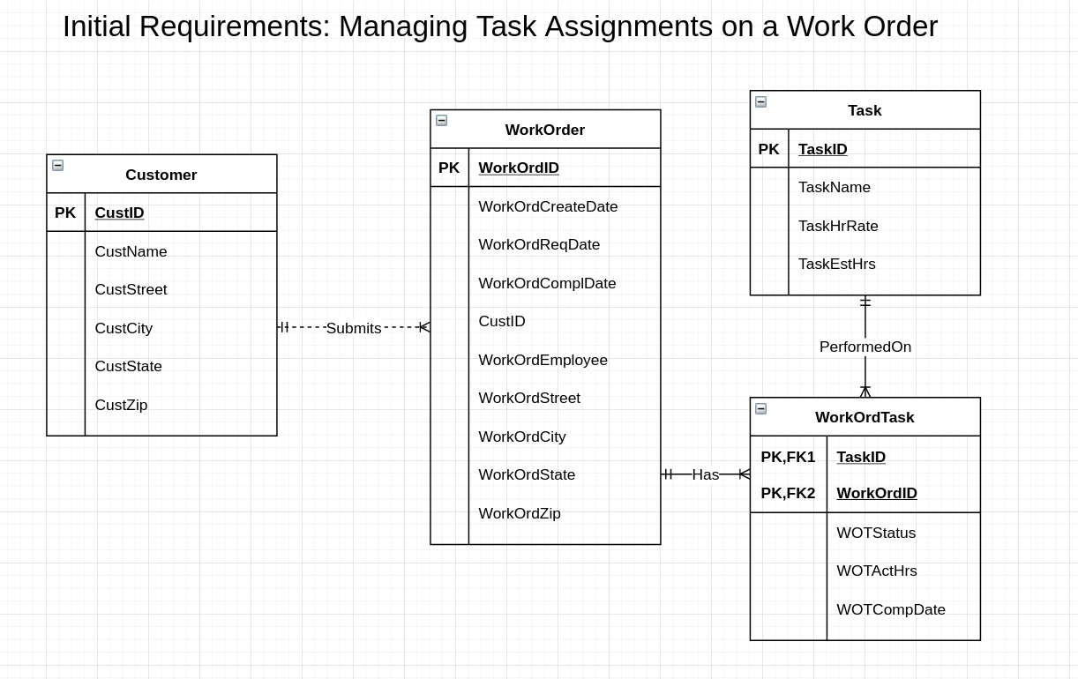

**Transformations based on new requirements (see ERD below):**

1. Added a Material entity to allow company to track list of materials.
2. Added a WorkOrdMaterial Entity for the M-N relationship since each Work Order uses collection of materials and materials could conceivably be used in multiple work orders (requirements does not specify one way or the other)
3. Moved estimated hours from Task entity to WorkOrdTask entity since estimated hours depends on both task and work order

