**Pressure-Equilibrium Phase Composition for Isobutane-Carbon Dioxide System**

Presented to : Professor Phillip Servio

Prepared by  
Ngan Jennifer Tram Su [260923530]

CHEE 390 – Computational Methods in Chemical Engineering  
Department of Chemical Engineering  
McGill University

2021.12.7

Table of Contents

Nomenclature 3

1 Objective 3

2 Flowchart 5

3 Results 7

4 Discussion 10

**4.1 Interaction Parameters 10**

**4.2 Program Considerations 11**

4.2.1 Initial Guess Using Wilson’s Equation 11

4.2.2 Zero Order Continuation 13

4.2.2 Mass Limitations 14

4.2.3 Verifying the Existence of Phases 15

5 Conclusion 16

6 References 17

# Nomenclature

|  |  |
| --- | --- |
| , | Critical temperature and pressure of the species |
|  | System temperature and pressure |
|  | Interaction parameter between the and species |
|  | Vapour fraction |
|  | Asymptotic vapour fraction |
|  | Mixing parameters of the pure species that account for attractive forces and particle volume, respectively |
|  | Acentric factor of the species |
|  | Mixture mixing parameters |
|  | Correction factor for the mixing parameter |
|  | Equilibrium constant for the species |
|  | Fugacity of the liquid and vapour phase, respectively |
|  | Compositions for the species in the liquid phase, vapour phase, and feed, respectively |
|  | Compressibility factor |

# 1 Objective

Unlike single-component vapour-liquid equilibrium (VLE) systems, the behaviour of a multi-component system involves additional non-ideal interactions between each species. Accounted for by interaction parameters, the Peng-Robinson equation of state was used to determine the state of a system at a fixed temperature and pressure, where the equilibrium ratio consequently follows. The objective of this report was to perform a two-phase flash calculation to determine the behaviour of an isobutane-carbon dioxide system at VLE.

# 2 Flowchart

Within the main program, the flash program takes in a guess equilibrium constant to determine the state of the system at the next pressure. The path which it takes is outlined in Figure 1 and Figure 2.

Figure Two Phase Flash Block Diagram [1/2]

Figure Two Phase Flash Block Diagram [2/2]

# 3 Results

The phase composition diagrams were produced through zero-order continuation, where the initial guess for the equilibrium constants were determined through the Wilson equation (1).

|  |  |
| --- | --- |
|  | (1) |

Thermodynamically, equilibrium is achieved when the change in Gibb’s energy is minimized; the system has no tendency towards any phase. For each pressure, the flash calculation iterates until the ratio of the fugacity of each phase for each species converge to unity. To determine the fugacities, the Peng-Robinson equation of state was used.

The Peng-Robinson equation of state (2) was proposed as a model that provided an improved estimation of a system’s equilibrium ratios.

|  |  |
| --- | --- |
|  | (2) |

When rearranged, the equation of state can be expressed as a third order polynomial in terms of the compressibility factor.

|  |  |
| --- | --- |
|  | (3) |
|  |  |
|  |  |
|  |  |

For a binary system, the roots of equation (3) must be solved twice, once for each phase. Being a cubic equation of state, this yields three roots. For the vapour composition, the largest real root is taken, while the smallest real root is taken for the liquid. From the compressibility factor, the fugacity of each species in each phase can be determined.

|  |  |
| --- | --- |
|  | (4) |

Where the species is kept constant relative to the species.

Indeed, the ratio of the fugacities will not equal unity in the first iteration. And so, to converge to the equilibrium compositions, the equilibrium constant is adjusted by this ratio to be used as the new guess for the next iteration (5).

|  |  |
| --- | --- |
|  | (5) |

The flash calculation was performed at two fixed temperatures: 100 and 220 converted to units of Kelvin. Varying the pressure and feed fractions, the following phase composition diagrams were obtained (Figure 3).

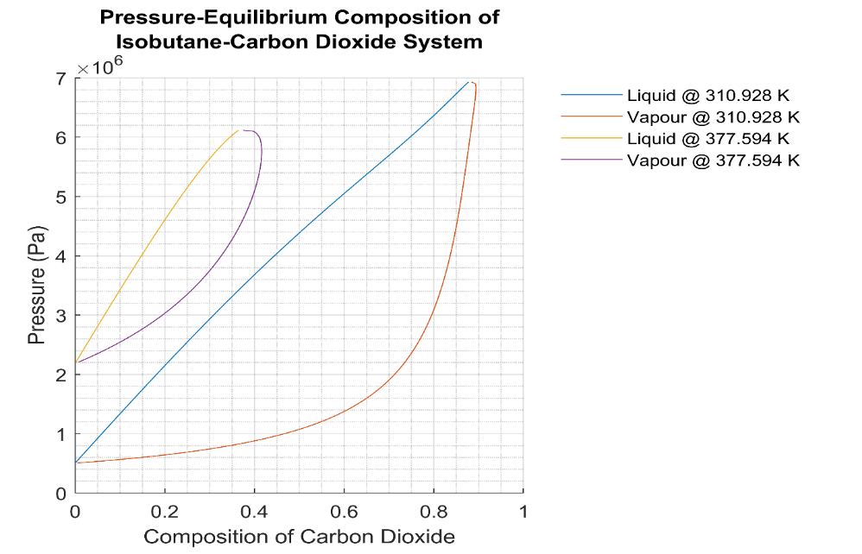

Figure 3 Pressure-Equilibrium Composition of Isobutane-Carbon Dioxide System

The ends of the curves don’t touch, however, this is expected due to floating point error, as well as the pressure values at either end do not perfectly match the vapour pressures of isobutane and carbon dioxide.

# 4 Discussion

## 4.1 Interaction Parameters

Interaction parameters are empirically determined coefficients that account for the non-ideal behaviour between species of a multicomponent system. These are a set of correction terms specific to the attractive mixing parameter for mixtures [1]. Their expressions and magnitudes vary with the equation of state. In this report, the Peng-Robinson EOS uses relations (6) and (7), part of the Van der Waals mixing rules.

|  |  |
| --- | --- |
|  | (6) |
|  | (7) |

Demonstrated in Figure 4, the addition of interaction parameters is necessary as it provides a more accurate fit of the phase compositions to experimental data, otherwise, significant deviations are observed. As well, the use of these interaction parameters avoids the need to use more complex mixing rules [1].

Figure 4 Pressure-Equilibrium Phase Composition Diagram for Isobutane-Carbon Dioxide System

## 4.2 Program Considerations

### 4.2.1 Initial Guess Using Wilson’s Equation

To create Figure 3, the flash calculation requires an appropriate initial guess for the equilibrium constants. This guess was determined through equation (1), from which the program converges to the actual values. Wilson’s correlation is an empirical model that has no dependency on composition and is only valid at low pressures [2].

Figure 3 is traced by taking small step sizes in pressure and feed fractions. Within the VLE region, changes in pressure at a constant temperature result in a change in composition as vapour condensates to liquid. For small changes in pressure, there is a small change in composition. Therefore, the reference pressure at which the Wilson equation is used must be appropriately close to a pressure at which the system may exist in equilibrium. Otherwise, if the two states are too far apart, the flash calculation may not converge at all.

The vapour pressure of isobutane at is around . When the Wilson equation is used at this pressure, Figure 3 is produced as expected. However, when the pressure is lowered to , the flash calculation diverges and produces Figure 5.

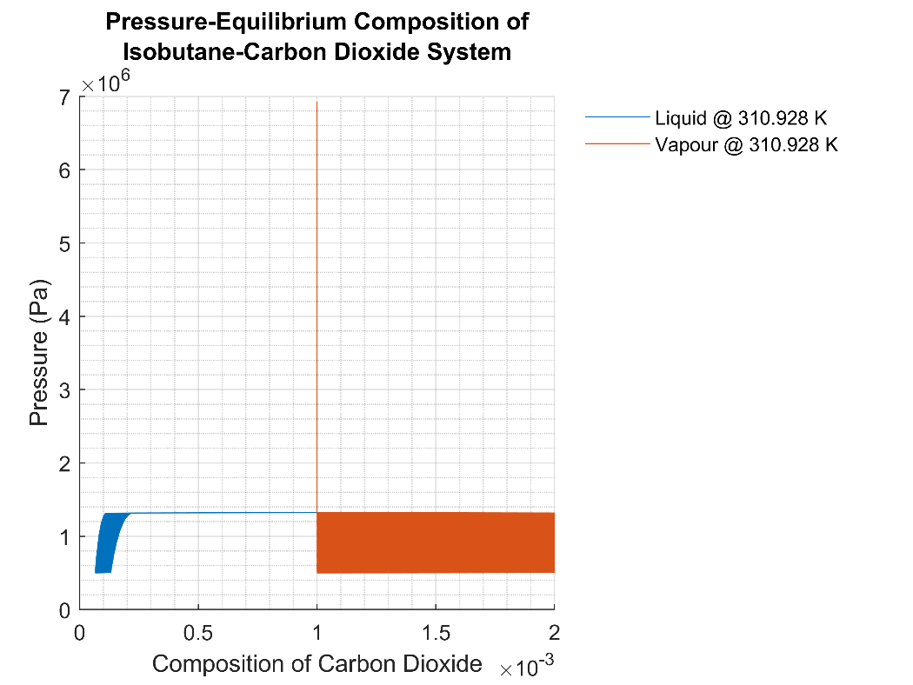

Figure 5 Phase Composition Diagram at with the Initial Guess Produced at

To mitigate this divergence, the program includes a while loop which pushes the reference pressure up until it is sufficiently close to isobutane’s vapour pressure. In each iteration, Wilson’s equation is called to produce an initial guess. This value is not saved until the sufficient pressure is met, at which point the program switches to zero-order continuation to produce the remainder of the curves.

Values above this vapour pressure also displayed divergence. At a pressure of , Figure 6 was produced.

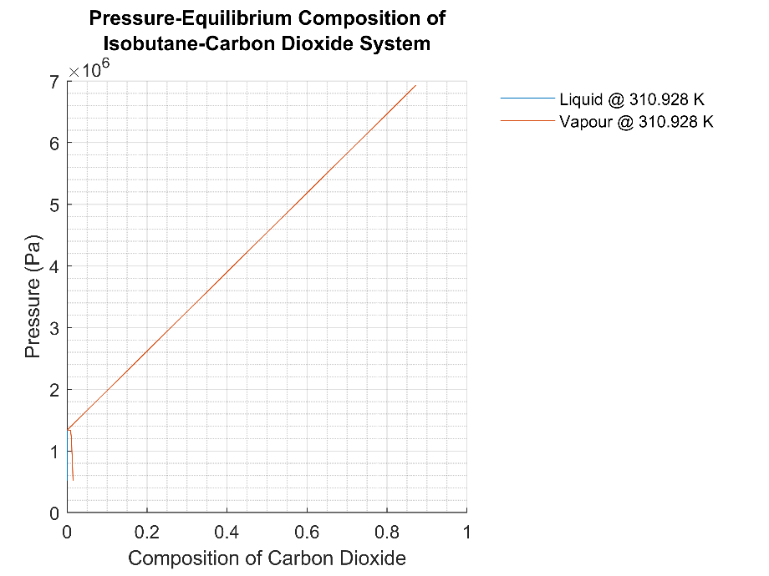

Figure 6 Phase Composition Diagram at with the Initial Guess Produced at

At this pressure, it is possible that the initial feed fraction is not sufficiently high enough for the program to converge to equilibrium. Although later discussed in Section 4.2.2 Mass Limitations, this is mitigated by increasing the feed fraction whenever the system lands in the liquid region.

### 4.2.2 Zero Order Continuation

Each iteration in the main program outputs the equilibrium constant of the system at the previous pressure. Through zero-order continuation, this constant was used as the guess for the next iteration at a higher pressure. However, as the system approaches the critical point of the second species, the compositions for the vapour phase encounter a turning point and curve back.

The program mainly uses the built-in function *roots* to solve for the compressibility factors. Near the critical point, as the compositions begin to approach each other, the roots of equation (3) begin to approach each other. When the roots are in proximity, floating point errors begin to introduce significant effects. The *roots* function, which uses the Cardano algorithm, becomes unstable. It involves the product and square roots of constants, which when sufficiently small, may cause these operations to blow up. This was also observed during the development of the program, where imaginary values were returned when solving for the compressibility factors. Therefore, when the system pressure reaches 90% of the critical pressure, or whenever the compressibility factors were found to be imaginary, the program switches to the bisection root solving method. It is a more stable method, as it only requires the presence of a sign change and is thus used to obtain the upper portion of the curves.

### 4.2.2 Mass Limitations

The phase composition curves cannot be fully obtained through a single feed fraction. For a fixed feed, the equilibrium compositions are read through the tie line that intersects the curves at a desired pressure. As pressure increases, the distance between the feed fraction and liquid curve decreases. Through the lever rule, this corresponds to a decrease in vapour fraction that approaches 0, beyond which the system is no longer in equilibrium. This was accounted for by increasing the feed fraction[1] whenever the vapour fraction became less than 20%.

Other mass limitations occur when the system “escapes” the VLE region. Generally, this is unlikely to occur, however, these cases occurred during the program’s development and were added as a failsafe. The flash calculation outputs the vapour fraction of the system for each iteration. With the given feed fraction and pressure, a vapour fraction of 0 indicates that the system is in the liquid region. This may occur when the increase in pressure happens to shoot above the bubble point pressure. To account for this, the feed fraction was increased as an attempt to bring the system back into the VLE region. Similarly, a vapour fraction of 1 indicates that the system is in the vapour region, which may occur when the increase in feed fraction brings the system past the dew point composition. To bring the system back to VLE, the feed fraction was decreased.

### 4.2.3 Verifying the Existence of Phases

The existence of one or two phases can be deduced from the objective function for vapour pressure (8). When the vapour fraction is between 0 and 1, there must be two phases present (otherwise no fraction exists). At 0, the system is liquid, while at 1, the system is vapour.

|  |  |
| --- | --- |
|  | () |

The behaviour of this function may be examined when looking at its asymptotes.

Equilibrium may only be present if the following conditions are met for n species:

Where approaches negative infinity for and positive infinity for . Under these conditions, two phases may only exist if is negative. This indicates a sign change between 0 and 1, where the root corresponds to the vapour fraction of the system. Otherwise, there can only be one phase present.

# 5 Conclusion

Models of multicomponent systems must consider the non-ideal interactions between molecules of different species. Several empirical models exist and make use of interaction parameters that fit the model closer to experimental data. For this investigation, the Peng-Robinson equation was used. Through zero-order continuation, successive estimations of the equilibrium constants were produced, where the initial guess was provided by Wilson’s equation. However, this equation assumes that the intensive variables inputted correspond to a system which exists at equilibrium. As such, appropriate initial guesses are crucial as to ensure the convergence of the flash calculation. In each iteration, the state of the system (or rather, the number of phases present) was determined through the residual equation (8), where the difference of the sum of the compositions in each phase must equal zero. Mass limitations also prevented the program from obtaining the full curves. This was mitigated by adjusting the feed fractions whenever the vapour fraction fell below 0.2, or whenever the system falls in the liquid or vapour region. The top portion of the curves were obtained using the bisection method instead of the built-in *roots* method due to its stability. With all these program considerations, the final phase composition diagram at two temperatures was reproduced.

# 6 References

[1] Whitson. (n.d.). *Binary Interaction Parameters - whitson wiki*. Whitson Wiki. https://wiki.whitson.com/eos/bips/

[2] Adewumi, M. (n.d.). *Do We Really Know Ki? | PNG 520: Phase Behavior of Natural Gas and Condensate Fluids*. PennState Education. https://www.e-education.psu.edu/png520/m13_p4.html

1. Relative to species 1 (carbon-dioxide). Equally, the feed fraction for species 2 was decreased to maintain their sum of unity.