**Step 3**

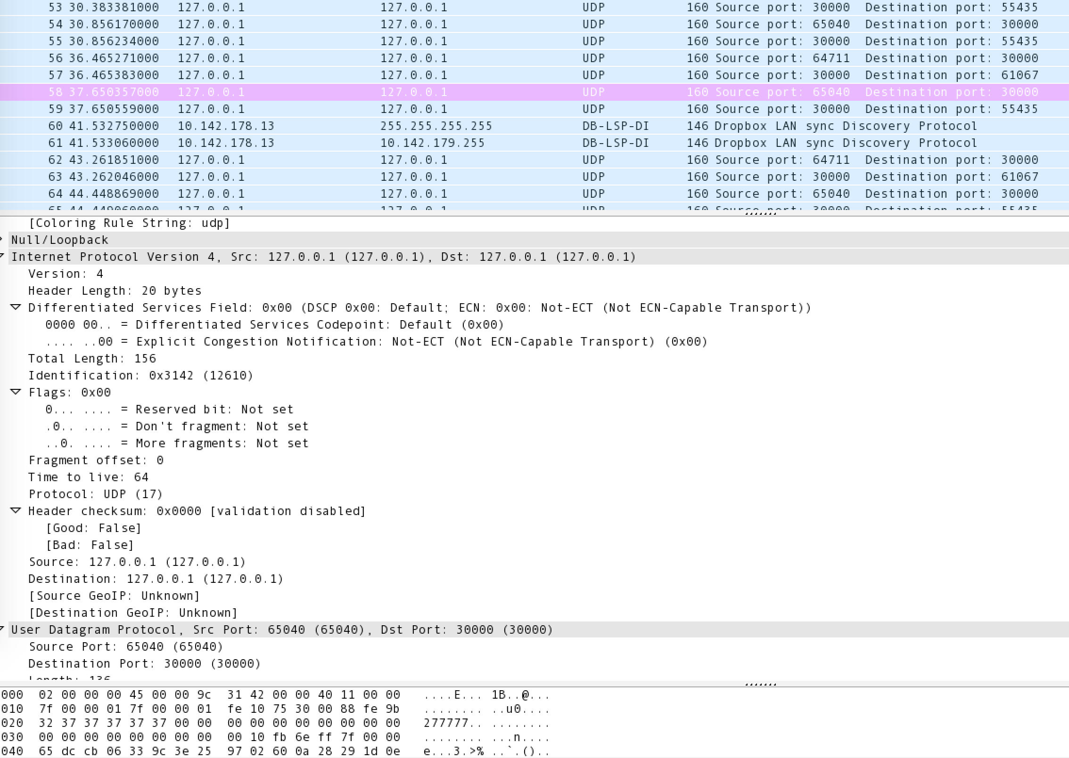

1. I ran the program on address 127.0.0.1 (loopback). But from other packets that went through, I know my IP is **10.142.178.13**
2. **UDP (17)**
3. **20 bytes** in IP header. Total length = 150 bytes, so $156-20=136$ **bytes** payload.
4. Data **not fragmented**, because the “More fragments” field is 0.

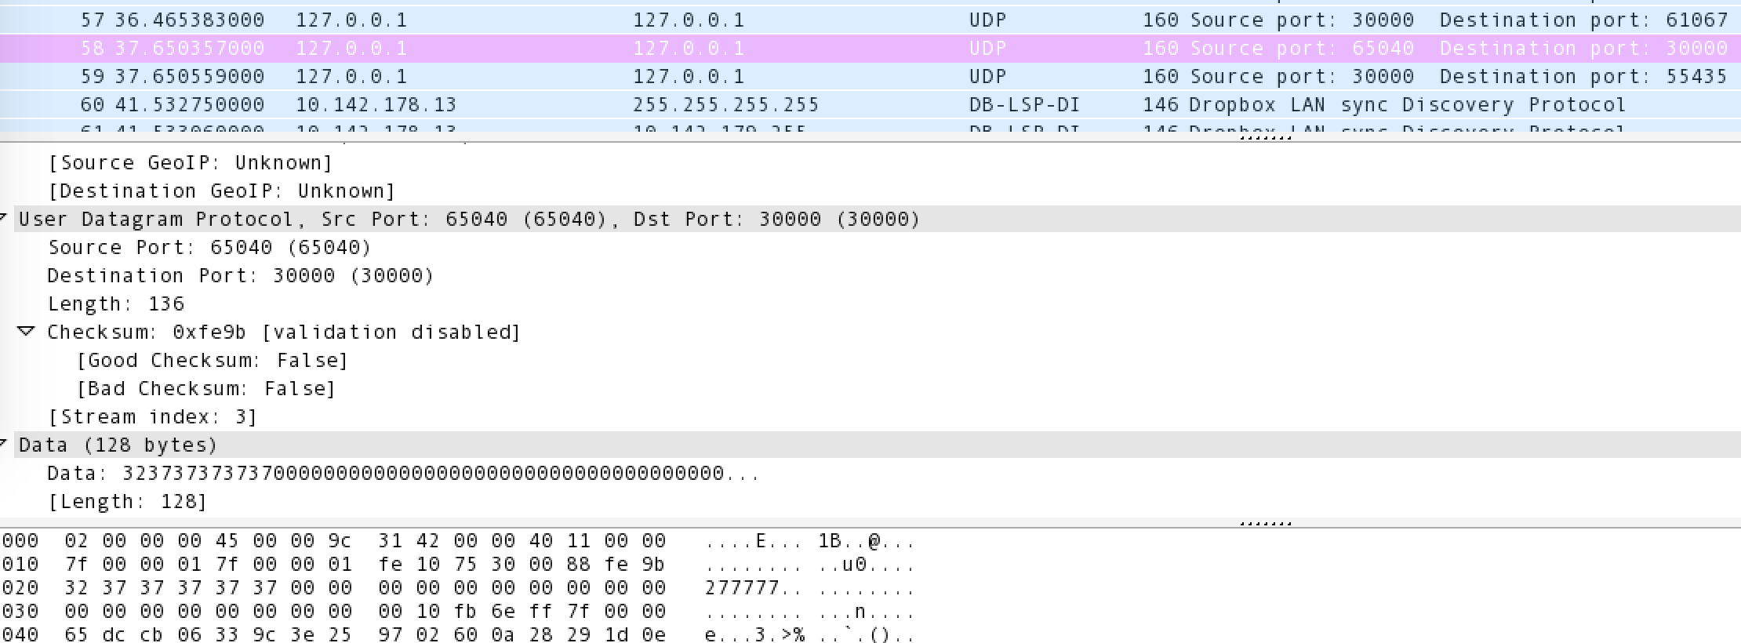

1. Source Port – 2 bytes – 65040(sender port)

Destination Port – 2 bytes – 30000(router port)

Length – 2 bytes – 136(8 bytes header + 128 bytes data)

Checksum – 2 bytes – 0xfe9b [validation disabled]