
Modeling the Impact of Economic, Lifestyle, and Demographic Factors on Health Outcomes Using Regression and Time Series Techniques
Student Name: Jennifer Yik
Student Number: 501342884
Supervisor’s Name: Tamer Abdou
Date of Submission: July 28, 2025

Table of Contents
1. Abstract 7
2. Introduction 7

2.1 Theme 7

2.2 Context and Background 7

2.3 Problem Statement 8

2.4 Real World Significance 8

2.5 Research Questions and Justifications 8
3. Literature Review 8

3.1 Review of Prior work 8

3.2 Contributions of the Work Compared to Past Research 18
4. Datasets Analysis 20

4.1 Summary of Selected Dataset 20

4.2 Descriptive Statistics 22

4.3 Visualization of Pattern, Trends and Outliers 24

4.4 Discussion of Potential Implications of Identified Patterns 26
5. Methodology and Study Design 27

5.1 Research Methodology 27

5.2 Justification the Approach on Prior Studies 29

5.3 Data Preparation and Cleaning 29

5.4 Feature Engineering 31
5.4.1 Lag Feature 31
5.4.2 Variance Inflation Factor (VIF) 31
5.4.4 Stationary Check (ADF) : 38
5.4.5 ACF and PACF plot 39

5.5 Relevance and Feasibility 42
5.5.1 Relevance of the Dataset 42
5.5.2 Feasibility 42

5.6 Proposed Methodology and Tools 42
6. Model Development and Evaluation 43

6.1 Walk-Forward Validation (Rolling Forecast) 43

6.2 Final Model Training and Forecasting 45

6.3 Model Performance Evaluation 46
7. Findings and Interpretation 54

7.1 Results Section (Key Finding) 54
7.1.1 Feature Importance Findings: 54
7.1.2 Model Results Overview: Summary of Predictive Accuracy: 56
7.1.3 Model Evaluation and Residual Diagnostics 57
7.1.4 Forecast Comparison of ARIMA, Prophet, and Random Forest Across Three Targets – Life Expectancy, Diabetes and Cardiovascular Disease between 1950–2074 58

7.2 Discussion & Interpretation 63
7.2.1 Predictor Patterns & RQ Alignment 63
• Life Expectancy 63
• Diabetes 64
• Cardiovascular Disease (CVD) 64
7.2.2 Model Performance: Strengths, Limitations & Relevant to the RQs 65
7.2.3 Residual Diagnostics: Implications for Model Reliability 66
7.2.4 Research Questions: Interpretation & Context 67
7.2.5 Forecast Analysis Using ARIMA, Prophet, and Random Forest 69

7.3 Discussion of Research Impact and Practical Implications 73
8. Limitations and Ethical Considerations 74

8.1 Limitations 74

8.2 Reflection on Ethical Considerations 75
9. Future Work and Recommendations 76

9.1 Improvements and Extensions for the Study 76

9.2 Recommendations for Future Research or Practical Applications 77
Roadmap 78
GitHub Repository Link 79
Video Presentation 79
References 80
Appendices 85

Appendix A - Boxplot 85

Appendix B - QQ Plot 87

Appendix C - Histogram: BEFORE Normalization 89

Appendix D - Histogram: AFTER Normalization 91

Appendix E - Forecast Diagrams – Group by Targets (Life Expectancy, Diabetes and CVD) 93

Abstract
This project analyzes the impact of economic, lifestyle, and demographic factors on global public health outcomes, focusing specifically on the prevalence of non-communicable disease (NCDs) such as heart disease and diabetes, as well as life expectancy. Using a consolidated dataset of 21,514 global observations across 18 variables from 16 sources compiled by Our World in Data, covering the period 1950 to 2023, this study applies multiple linear regression and time series forecasting techniques to explore historical patterns and predict future health trends.
The three research questions are designed to help explain how various determinants affect health outcomes: (1) What are the key socioeconomic, demographic, and lifestyle factors most strongly associated with the prevalence of non-communicable diseases (heart disease and diabetes) across countries from 1950 to 2023? (e.g., diabetes and heart disease); (2) To what extent do modifiable lifestyle and economic factors (e.g., BMI, cost of healthy diet, income, and CPI) explain variations in life expectancy and population health outcomes across countries?; and (3) How will health outcomes (life expectancy, disease rates) evolve over the next 50 years (2023–2073), based on historical trends and key predictors identified in the period from 1950 to 2023?
While most prior studies are limited to specific regions or shorter timeframes, this project provides a globally scoped, long-term perspective on the determinants of health. Analytical tools in Python, such as pandas, scikit-learn, and time series models, are used to conduct regression analysis and forecast future health outcomes.
By identifying influential predictors and modeling long-term trends, this research provides evidence-based insights that can support global health policy, inform preventive strategies, and improve population health outcomes over time.

Introduction

2.1 Theme
Modeling the Impact of Economic, Lifestyle, and Demographic Factors on Health Outcomes Using Regression and Time Series Techniques

2.2 Context and Background
Health outcomes are shaped by a complex interplay of socioeconomic, demographic, and lifestyle factors. Economic indicators such as GDP, income levels and unemployment rate, lifestyle behaviors including dietary habits, BMI, and demographic indicators like age structure, education levels, all contribute to population health. As non-communicable diseases (NCDs) such as heart disease and diabetes continue to rise globally, understanding how these determinants influence their prevalence and impact overall life expectancy has become increasingly critical. With the growing availability of long-term global health and socioeconomic datasets, data-driven insights can inform more effective, targeted public health interventions.

2.3 Problem Statement
This project investigates the extent to which socioeconomic, demographic, and lifestyle factors are associated with the global prevalence of non-communicable diseases (specifically heart disease and diabetes) and variations in life expectancy. Using a large-scale dataset from Our World In Data which covers the period from 1950 to 2023, this study applies multiple linear regression and time series forecasting techniques to identify the most influential predictors and project future health outcomes up to the year 2073. The goal is to provide a robust, data-driven foundation for understanding the drivers of population health and for anticipating long-term trends.

2.4 Real World Significance
Non-communicable diseases are a leading cause of death and disability worldwide, placing significant strain on healthcare systems and economies. By identifying the key economic, lifestyle, and demographic factors that influence their prevalence, and by forecasting how health outcomes may evolve over the next 50 years, this research provides valuable insights for policymakers, public health officials, and international organizations in public health intervention measures. The findings can support evidence-based strategies for disease prevention, health equity, and resource allocation, contributing to improved long-term global health outcomes.

2.5 Research Questions and Justifications
- What are the key socioeconomic, demographic, and lifestyle predictors most strongly associated with the prevalence of non-communicable diseases (heart disease and diabetes) across countries from 1950 to 2023?
- To what extent do modifiable lifestyle and economic factors (e.g., BMI, cost of healthy diet, income, and CPI) explain variations in life expectancy and disease prevalence across countries?
- How will long-term health outcomes evolve over the next 50 years (2024–2074), based on historical trends and key predictors identified between 1950 and 2023, and which forecasting approaches (ARIMA, Prophet, Random Forest) provide the most accurate projections by country and health indicator?

Literature Review

3.1 Review of Prior work
Introduction
Non-communicable diseases (NCDs), particularly heart disease and diabetes, are among the leading causes of death globally and are closely tied to socioeconomic, demographic, and lifestyle factors (World Health Organization, 2020). This literature review explores how these determinants influence health outcomes such as disease prevalence and life expectancy, while also examining forecasting methods used to project future trends. While many prior studies have focused on specific regions or limited time periods, this study takes a more comprehensive approach, analyzing global data from 1950 to 2023 and forecasting health outcomes up to 2073 using multiple modeling techniques.
Supported by prior research, this project is guided by three core questions: (1) What are the most influential socioeconomic, demographic, and lifestyle predictors of NCDs between 1950 and 2023? (2) How do modifiable factors like BMI, income, and healthy food costs explain variations in life expectancy? (3) How will long-term health outcomes evolve over the next 50 years (2024–2074), based on historical trends and key predictors identified between 1950 and 2023, and which forecasting approaches (ARIMA, Prophet, Random Forest) provide the most accurate projections by country and health indicator? This broader and longer-term focus helps fill important gaps in the literature and offers new insights for global health planning.

    - Socioeconomic and Demographic Determinants of NCD Prevalence
The role of socioeconomic and demographic variables in shaping the prevalence of noncommunicable diseases (NCDs) has been widely affirmed in prior research, particularly in high-income countries. Studies such as Or (2000) demonstrated that higher income and education levels are strongly associated with reductions in premature mortality across OECD nations. However, the finding of this study indicates that income and education levels only weakly associated with reduction in Child mortality rate, it probably Or’s study only cover OECD countries while this study cover globally, that may cause the variation of the result. In addition, while Or’s work did not explicitly address NCD prevalence, the association between socioeconomic advantage and improved health outcomes forms a strong basis for including variables such as GDP per capita, education, and employment in this analysis. Extending beyond Or’s scope, this study not only includes non-OECD countries but also analyze outcomes for heart disease and diabetes, offering a broader and more comprehensive of how socioeconomic factors influence specific NCD trends over next 50-years.
The findings of this project support and significantly expand upon those of Macinko et al. (2004) and Wilkinson et al. (2003), who highlighted the detrimental impact of income inequality on mortality and cardiovascular health in OECD contexts. Using the Gini coefficient as a predictor, this study confirmed that higher inequality levels are consistently linked to increased rates of cardiovascular disease, particularly in LMICs, aligning with Wilkinson’s theory of psychosocial stress and exclusion. Also supports RQ1 and RQ2.
However, while Wilkinson and Macinko primarily used correlation and fixed-effects regression over limited timeframes and countries, our study extends their framework to globally between 1950–2023. We show that health disparities tied to income inequality have not only persisted but, in some regions, widened over time. Moreover, our application of forecasting techniques, ARIMA, Prophet, and Random Forest, projects that if inequality remains uncontrolled, these disparities are likely to continue or worsen by 2073, particularly in low- and middle-income countries (LMICs).
Wilkinson et al. argued that income inequality harms health indirectly through psychosocial stress, social exclusion, and behavioral risks, such as poor diet and limited healthcare access. While their work was grounded in developed countries, our project builds upon it by including both income and the Gini coefficient as predictors in models of heart disease and diabetes, using data from a broad global sample. Unlike Wilkinson's temporally limited scope, our analysis also quantifies how structural inequalities affect disease prevalence over decades and across diverse national contexts.
Zahra et al. (2015) similarly emphasized the influence of economic and behavioral variables on NCD mortality in LMICs. The current analysis echoes their conclusions, confirming that low GDP and high dietary risk indicators are significant predictors of diabetes and cardiovascular mortality. Yet, this study enhances Zahra et al.’s work by employing predictive modeling over a 124-year from 1950 to 2074 and incorporating feature selection and validation techniques, which strengthen the reliability of the findings. This project identifies which socioeconomic predictors have persistent long-term effects, thereby offering more actionable insights for policy interventions.
Gerdtham and Ruhm’s (2006) finding that mortality may increase during economic growth due to lifestyle changes, is proved by this study. In high-income countries such as Germany, Japan, and the United States, the Random Forest model detected a nonlinear relationship between GDP growth and heart disease rates, suggesting that rising affluence alone does not guarantee better health outcomes. Instead, the interaction of rising income with increased consumption and inactive behavior appears to higher cardiovascular disease forecasts. These findings support the need to incorporate behavioral mediators and economic cycles into long-term NCD models, as recognized in RQ1 and 3.
Gerdtham and Ruhm's (2006) study demonstrated that mortality rates can rise during periods of economic growth, attributing this to lifestyle changes such as increased smoking, reduced physical activity, and higher alcohol consumption. This suggests that during economic upturns, individuals may adopt riskier health behaviors due to increased income. Our findings proved this by revealing a nonlinear relationship between GDP growth and cardiovascular disease rates in high-income countries, including Germany, Japan, and the United States. Utilizing the Random Forest model, we observed that rising affluence alone does not guarantee improved health outcomes. Instead, the interaction of increased income with increased consumption and inactive lifestyles appears to enhance cardiovascular disease risks. These results underscore the necessity of integrating behavioral mediators and economic cycles into long-term non-communicable disease (NCD) models, as highlighted in our RQ1 and 3.
Overall, the current findings align with prior literature in confirming the role of income, education, and inequality as foundational determinants of NCDs. However, by extending the geographic and temporal scope, incorporating modern machine learning methods, and conducting long-range forecasting, this project addresses key gaps left by earlier studies. The integration of structural and modifiable predictors across diverse contexts allows for more understanding of how NCDs evolve under varying socioeconomic conditions. These insights contribute to a more detailed, globally relevant evidence base for anticipating future health burdens and targeting policy interventions accordingly.
    - Modifiable Lifestyle and Economic Factors Affecting Life Expectancy
The relationship between modifiable lifestyle behaviors, economic conditions, and life expectancy is a main focus of this project and is widely supported in the literature. Prior research by Li et al. (2018) and Lo et al. (2024) has highlighted five key health behaviors, non-smoking, moderate alcohol consumption, regular physical activity, healthy diet, and maintaining a normal BMI, as strong predictors of longevity and reduced healthcare costs. My findings affirm these conclusions at a global level: across the 1950–2023 dataset, BMI and dietary cost indicators consistently emerged as significant predictors of life expectancy, particularly in low- and middle-income countries (LMICs), where poor nutrition and food affordability constraints are more pronounced. However, while Li and Lo’s studies are limited to national contexts (U.S. and Taiwan) and relatively short timeframes, this project adds considerable value by applying these behavioral insights across nearly all countries and over seven decades, projecting their impact up to the year 2074. This broader time frame and geographic scope help reveal how social and economic challenges increase lifestyle-related health risks over time, especially in vulnerable populations.
The project also expands on Balia and Jones (2008), who argued that lifestyle choices can outweigh even socioeconomic status in determining early mortality. While this project do not include unobservable predictors like genetics or personal history, the combined modeling of observable lifestyle and economic indicators in this study, such as BMI, physical activity levels (proxy via food and energy metrics), and GDP per capita, supports the multifactorial approach they advocate. Indeed, my Random Forest results suggest that in many LMICs, BMI and dietary variables are more important predictors of life expectancy than GDP alone, pointing to the critical role of modifiable risk factors even in LMICs settings. This expands Balia and Jones’ findings by showing that the dominance of lifestyle factors over structural ones is not limited to high-income countries. This refers to RQ1.

Moreover, the bidirectional causality between socioeconomic status and health behaviors, explored by Contoyannis and Jones (2004), is indirectly supported through temporal trends in this study. By using chronological order in ARIMA, RF and Prophet models and train-test splits, my project shows that economic development often before health improvements, with delays in behavior change (e.g., declining smoking or sugar intake) producing lagged effects on life expectancy. This suggests that changes of economy occur first, followed by lifestyle changes, which aligns with Contoyannis and Jones’ conclusion that health status influences socioeconomic status to a lesser extent. However, an added insight from my global model is that in some emerging economies, rapid income growth without corresponding improvements in dietary behavior leads to rising obesity and stagnating life expectancy, an emerging trend not captured in earlier single-country studies.
Unexpectedly, the analysis reveals that high-income countries may experience diminishing returns on longevity gains from further improvements in diet and BMI. In these settings, the models show plateauing effects despite favorable scores on modifiable variables, suggesting that other non-lifestyle factors—such as aging populations, healthcare system saturation, or environmental exposures—may now limit further life expectancy gains. This finding diverges from earlier work such as Li et al. (2018), which implies linear gains from health behaviors, and suggests that future research may need to shift focus toward structural and systemic determinants in aging societies. Addressed to RQ1 and 2.
Overall, this project confirms the established importance of lifestyle and economic factors on life expectancy but extends prior literature in both methodological rigor and scope. By integrating machine learning-based feature selection, long-term forecasting, and global data coverage, the study identifies where modifiable risk factors remain the most urgent and impactful—and where their influence may be reaching saturation. In doing so, it fills a critical gap in understanding how individual behaviors and structural conditions combine to shape global health trajectories over time and across income contexts. These insights are directly aligned with Research Questions 1 and 2 and provide a foundation for more context-sensitive health interventions in the future.
    - Forecasting 50-Year Health Outcomes Through Key Predictors

Forecasting future health outcomes, especially in relation to non-communicable diseases (NCDs) and life expectancy, has become a critical area of research in global health modeling. Several influential studies provide methodological guidance for this project, particularly in addressing Research Question 3 (RQ3), which seeks to forecast life expectancy, diabetes, and heart disease trends up to the year 2074. Building on this foundation, my study uses ARIMA, RF, Prophet and multiple regression models, incorporating socioeconomic, demographic, and modifiable lifestyle variables to estimate long-term trends.

Foreman et al. (2018) developed a comprehensive global health forecasting model using ARIMA and Bayesian regression across 195 countries, projecting life expectancy and cause-specific mortality up to 2040. Their study found that while global life expectancy is expected to increase, regional disparities and the burden of non-communicable diseases (NCDs), particularly cardiovascular disease and diabetes, would continue to grow.
Building upon this foundation, my study extends the forecasting horizon to 2073 and introduces additional economic indicators, such as the Consumer Price Index (CPI) and the cost of a healthy diet, to assess the affordability of healthy living. This inclusion addresses the economic access dimension, particularly pertinent in low- and middle-income countries (LMICs), where food and healthcare affordability are critical determinants of health outcomes. While Foreman et al. (2018) focused on macroeconomic variables like GDP and education, my research narrows the disease focus to diabetes and heart disease, two of the fastest-growing global NCD burdens. This targeted approach allows for a more detailed analysis of the specific factors influencing these diseases. Furthermore, my study employs advanced forecasting techniques, including ARIMA, Prophet, and Random Forest models, to capture a broader range of temporal patterns and nonlinear relationships in health data. This methodological diversification enhances the robustness of the projections and provides a more nuanced understanding of future health trajectories. In summary, while Foreman et al. (2018) established a foundational framework for global health forecasting, my study expands upon this by incorporating additional economic indicators, focusing on specific NCDs, and employing a diverse set of forecasting models to provide a more comprehensive analysis of future health outcomes.

In contrast to the global scale of Foreman et al., Mahamoud et al. (2013) use system dynamics modeling to simulate the impact of social determinants on chronic disease in a single city (Toronto) over a 40-year span. Despite the local context, their emphasis on how structural socioeconomic changes, such as improved housing or healthcare access, can shape long-term health outcomes parallels the focus of my study on policy-relevant economic indicators like CPI and unemployment. Both projects share a systems-thinking perspective, but this study extends the geographic and temporal range to offer global applicability and long-range projections. By integrating economic access variables into ARIMA and regression frameworks, my findings provide a quantified estimate of how long-term economic shifts and lifestyle changes impact disease outcomes, which complements Mahamoud et al.’s more qualitative simulations.

Additionally, Tserpes et al. (2000) compared various forecasting methods and concluded that ARIMA consistently outperformed other time series models for health and economic prediction, supporting the technical validity of its use in this project. Consistent with their results, the ARIMA models in this study provided strong temporal fit and stability, particularly for diabetes and CVD trends. Moreover, by applying temporal hold-out validation, training on 1950–2020 and testing on 2021–2023, this project ensured that the ARIMA forecasts generalized effectively to unseen data, reinforcing both predictive accuracy and policy relevance.
In summary, while prior forecasting efforts focused on general mortality or national/local projections, this project contributes three key enhancements to the literature: (1) a longer forecasting horizon (to 2074), (2) a disease specific on diabetes and cardiovascular disease, and (3) the integration of economic accessibility factors, which have often been overlooked. This study fills a critical gap in global NCD forecasting, offering actionable insights for both high-income and low-income groups. These improvements strengthen the case for targeted, evidence-based health and economic policies designed to relieve future disease burdens and reduce disparities across regions and income levels.
    - Income Inequality and Health Disparities
Income inequality plays a critical role in shaping health disparities, particularly in the prevalence and progression of non-communicable diseases (NCDs) such as cardiovascular disease and diabetes. This study contributes to that dialogue by addressing Research RQ1 and RQ2 through a global, multi-decade between 1950–2023 and projecting health outcomes to 2074. By incorporating variables such as income, Gini coefficient, and cost of healthy diet into forecasting models, this project extends prior research in both temporal and geographic scope
Wilkinson et al. (2003) advanced the theory that income inequality influences health indirectly through psychosocial stress, reduced access to supportive environments, and adverse behavioral patterns. This aligns with RQ1’s focus on how structural economic variables predict NCD prevalence, and with RQ2’s emphasis on how these structural factors shape modifiable risk behaviors. While Wilkinson’s work centers on high-income countries, this project applies his framework to a global dataset and offers quantitative evidence through multivariate regression, ARIMA, RF and Prophet modeling. It reinforces Wilkinson’s theoretical claims with long-term evidence support across income groups and world regions.
Pabayo et al. (2015) and Dinca-Panaitescu et al. (2011) offer complementary perspectives. Pabayo’s U.S.-focused study links relative inequality (Gini Coefficient) to higher rates of heart attacks and unhealthy behaviors, while Dinca-Panaitescu finds a strong income correlated to diabetes prevalence, with lower-income individuals experiencing four times the disease burden of higher-income peers. Both findings directly inform this study’s variable selection, particularly the inclusion of income and Gini coefficient, and substantiate the connection between economic disparities and chronic illness. My results similarly show that higher income inequality correlates with worse health outcomes, but unlike those localized studies, my analysis demonstrates this trend across income contexts and continents, reinforcing its generalizability.
Venkataramani et al. (2016) broaden the perspective by showing that perceived economic opportunity—not just income—also influences health behaviors such as obesity, smoking, and hypertension. This underscores the importance of including both economic factors and behavior-related variables in my models, especially since it is challenging to separate the effects of opportunity and stress in low- and middle-income countries (LMICs). My study contributes to this understanding by finding that in many LMICs, rising income without strong public health policies can increase the risk of non-communicable diseases (NCDs) because people gain greater access to processed foods. This trend aligns with Seiglie et al. (2020), who found that higher income in these countries is linked to more diabetes due to changes in lifestyle.
While much of the literature emphasizes the protective role of higher income, findings by Seiglie and Park et al. (2023) underscore the complex, context-dependent nature of this relationship. Park’s observation that income decline is predictive of higher diabetes risk is mirrored in my ARIMA results, where macroeconomic downturns (showed by CPI and unemployment) before increases in diabetes and heart disease prevalence over time. This reinforces RQ3 by highlighting the value of forecasting with structural economic indicators, rather than static income levels.
In summary, these studies provide a foundation for interpreting my findings within a broader academic framework. However, my project offers three major contributions that expand on this prior work:
- It moves beyond single-country analyses to a globally, incorporating both high income countries (HICs) and low- and middle-income countries (LMICs).
- It applies forecasting models (ARIMA, Random Forest and Prophet) to project long-term disease and life expectancy trends to 2074, extending the temporal scope beyond prior research.
- It combines economic and behavioral variables in a unified model, allowing for the assessment of both direct and indirect mechanisms of health disparity.
By confirming that income inequality, GDP, and cost of healthy diet are strong predictors of diabetes and cardiovascular disease, especially in lower-income nations, this project helps fill gaps between public health, economics, and prevalence disease. Overall, these findings support the use of multi-policy interventions, including social protection, food subsidies, and preventive healthcare, to reduce the unequal burden of NCDs and extend healthy life expectancy globally.

    - Cardiovascular Disease and Diabetes
Cardiovascular disease and diabetes are among the most prevalent non-communicable diseases (NCDs) worldwide. According to WHO (2020), ischemic heart disease alone accounts for 13% of global deaths, making it the leading cause of mortality. Diabetes, while often underdiagnosed, has also arise rapidly in prevalence globally, particularly in low- and middle-income countries (LMICs), where transitions in diet, urbanization, and healthcare access have increased its burden. These conditions are not only medical issues but are deeply correlated to social, economic, and behavioral systems, which this study explores through a long-term between 1950–2023 and projects through 2074 using ARIMA, RF and Prophet models.
The Global Burden of Disease (GBD) Study by Roth et al. (2020) offers a foundation for this analysis. Their findings covering 204 countries from 1990 to 2019, highlight a doubling of cardiovascular disease (CVD) prevalence, with the steepest increases occurring in LMICs. They identify poor diet, physical inactivity, and social inequality as primary risk factors. These insights directly support RQ1 and RQ2 by confirming that socioeconomic status (SES) and behavioral determinants are essential in explaining variation in CVD outcomes. My project extends this work by adopting a longer historical timeframe, encompassing both post-war economic shifts and recent epidemiological transitions, and by forecasting future disease trends through 2074. This enables an analysis not only of trends but also of the potential future effects of continued inequality and economic uncertainty.
Pabayo et al. (2015) focus on the U.S., finding that state-level income inequality correlates with higher heart attack risk, primarily through increased smoking and reduced physical activity. This supports Wilkinson et al.’s (2003) psychosocial hypothesis, suggesting that inequality indirectly shapes health through chronic stress and unhealthy behaviors. Although Pabayo's geographic focus is limited, their behavioral connection model directly informs RQ2, which examines how economic conditions influence modifiable health behaviors globally. In my study, a similar pattern emerged: higher Gini coefficients and cost of healthy diets were associated with increased rates of cardiovascular disease, particularly in LMICs where economic access to healthy lifestyles remains limited. These findings suggest that income redistribution or affordability policies could play a critical role in future cardiovascular risk reduction strategies.
Kastorini et al. (2015) introduce another dimension by examining economic stability, including financial satisfaction, occupational class, and stress and their relationship with cardiovascular risk in Mediterranean populations. Their work highlights the role of subjective economic well-being, not just income, in shaping heart health. My project builds on this by incorporating both CPI (consumer price index) and job-related economic variables to reflect economic pressures and affordability at the population level. This inclusion provides a richer picture of economic stress and aligns with both RQ1 and RQ2, which consider objective and perceived determinants of lifestyle-driven health risks.
Turning to diabetes, Danaei et al. (2011) document a global increase in prevalence from 1980 to 2008, driven largely by obesity, poor diet, and urban lifestyles, especially in LMICs. Their findings support the inclusion of BMI and diet-related economic variables in this study's model and validate the decision to differentiate heart disease and diabetes in the analysis. In alignment with RQ1, this project finds that BMI, CPI, and the cost of healthy diets are among the strongest predictors of diabetes prevalence, particularly in settings where food insecurity and dietary transitions converge. Moreover, both ARIMA and Prophet projections in this study forecast a substantial rise in diabetes prevalence across low- and middle-income countries (LMICs) unless preventive interventions improve access to affordable, nutritious food.
In summary, these studies emphasize that cardiovascular disease and diabetes share common upstream drivers, notably income inequality, economic pressure, and lifestyle behaviors, but also require appropriate modeling approaches due to their different disease mechanisms. This project contributes to the literature by:
- Analyzing both conditions side by side, allowing for a comparison of shared and unique determinants.
- Extending the time horizon to 2074, capturing long-term trends in economic change, dietary access, and demographic shifts.
- Applying globally comparative data (1950–2023) to validate the generalizability of findings across high-, middle-, and low-income contexts.
By confirming and expanding on prior findings from Roth, Pabayo, Danaei, and others, this project highlights the continued urgency of addressing structural inequalities and modifiable lifestyle factors to mitigate future cardiovascular and metabolic disease burdens. It also demonstrates that forecasting tools such as ARIMA, RF, Prophet and multivariate regression are not only technically robust but also policy-relevant, offering a insight into how health systems and governments can intervene before disease prevalence peaks in the coming decades.
    - Methodological Comparisons
Methodological diversity in previous global health research has influenced how health outcomes, particularly non-communicable diseases (NCDs), are analyzed and forecasted. Many foundational studies employed fixed-effects regression models, such as those by Or (2000) and Macinko et al. (2004), to control for unobserved country-specific effects and cross-sectional heterogeneity. While these models offer strong internal validity, they are often limited in temporal scope (typically covering just a few decades) and geographically constrained to high-income or OECD countries. In contrast, this project applies multiple linear regression across a global dataset spanning 1950–2023, allowing for broader spatial and temporal generalizability in evaluating predictors of NCD prevalence and life expectancy (addressing RQ1 and RQ2).
Similar to the work of Zahra et al. (2015) and Balia & Jones (2008), this project adopts a multifactorial modeling framework, combining economic (income, GDP) and lifestyle-related (BMI, diet) variables. While Zahra focused on LMICs and Balia & Jones included unobservable variables in a UK sample, both concluded that integrated models offer greater explanatory power. This project extends that logic globally and over a much longer historical timeline. It contributes to RQ2 by confirming that lifestyle and economic determinants interact collaboratively, and by providing insight into how these relationships shift over time and geography.
In terms of forecasting, ARIMA models have emerged as a preferred tool in health trend prediction. Tserpes et al. (2000) found ARIMA to outperform vector autoregression (VAR) and dynamic regression in forecasting health-related time series, a finding that supports this project’s methodological approach to RQ3. Similarly, Foreman et al. (2018) utilized ARIMA and Bayesian regression to forecast global mortality and life expectancy through 2040, incorporating predictors such as GDP, education, BMI, and health risks. While their work focuses on general mortality and stops at 2040, this project extends the forecast horizon to 2074 and narrows the scope to heart disease and diabetes, offering more targeted insights for disease-specific policy intervention.
Further methodological innovation can be seen in Dimai (2024), who applied principal component analysis (PCA) with dynamic regression to reduce dimensionality and control multicollinearity while forecasting mortality trends using global covariates (e.g., fruit/vegetable consumption, pollution, BMI). Although PCA was not adopted in this project, the principle of strategic variable selection to maintain model stability and interpretability is shared. Likewise, this project addresses potential multicollinearity through diagnostic testing and correlation filtering, enhancing the precision of both regression and ARIMA models.
Contoyannis & Jones (2004) who used simultaneous equation models to demonstrate that socioeconomic status and health outcomes are correlated. While their focus was the UK, their findings validate the theoretical premise of this project that structural economic conditions shape health more strongly than vice versa. Unlike their localized, bidirectional modeling, this study emphasizes predictive utility over causal feedback loops, given the forecasting goals of RQ3. Nonetheless, their work reinforces the importance of integrating variables such as income, CPI, and education, which are robustly linked to health behaviors and chronic disease risk.
In summary, this project distinguishes itself methodologically in several keyways:
- Temporal and geographic scope: Unlike many earlier studies constrained to short time periods or OECD nations, this study spans 74 years (1950–2024) and includes high-, middle-, and low-income countries.
- Disease-specific forecasting: While Foreman et al. (2018) and others focused on all-cause mortality, this project emphasizes heart disease and diabetes, providing more actionable insights for addressing the leading causes of NCD burden.
- Model diversity: This project combines multiple time series models – ARIMA, RF and Prophet forecasting, following best practices from Tserpes et al. (2000) and Foreman et al. (2018), while applying lessons from Dimai (2024) regarding model as simple as possible.
- Policy-relevant predictors: It incorporates variables (GDP, BMI, education) and economic indicators such as consumer price index (CPI) and cost of healthy diets, making the findings more applicable to policy decisions, particularly in LMICs where affordability and access remain major barriers.
Together, these methodological choices enable the study to address all three research questions robustly, linking structural and behavioral determinants to health outcomes (RQ1 and RQ2), and projecting these relationships into the future (RQ3).
Conclusion
This literature review has combined global evidence on how socioeconomic, demographic, and lifestyle factors influence non-communicable diseases (NCDs) such as cardiovascular disease and diabetes, considering data from 1950 to 2023. Across the literature, income, education, and inequality consistently emerge as foundational determinants of health, while behavior-related variables like BMI and diet cost play pivotal roles, especially in LMICs (Li et al. 2018; Zahra et al. 2015). However, these studies often limit themselves to high-income or national samples and short time frames. This review addresses those gaps by combining global coverage, multi-decade datasets, and predictive modeling (ARIMA, Prophet, Random Forest), enabling a broader and richer understanding of disease trends up to 2074.
Our analysis confirms that income inequality and economic stress continue to increase NCD prevalence over time, paralleling theoretical claims by Wilkinson and Macinko but extending them across continents and income levels. Moreover, dynamic forecasting models reveal that rising GDP alone is insufficient to reduce disease burden without accompanying lifestyle improvements, especially in emerging economies experiencing dietary and behavioral transitions. This nuance underscores the importance of integrating structural and modifiable predictors into long-range health forecasting.
Significant gaps remain in the literature, including limited exploration of multivariate forecasting across income contexts and the interplay between affordability indicators (e.g., CPI, diet cost) and health trends. Our study addresses these gaps and contributes insights into the pathways by which structural factors and behaviors jointly shape global health outcomes.
Finally, this review supports the need for predictive models that incorporate both economic accessibility and behavioral variables to inform tailored policy interventions. It highlights areas for further research, such as region-specific forecasting under different policy conditions, and lays a foundation for practical applications in global health planning. It positions the current project as a timely and required step toward more actionable NCD forecasting frameworks.

3.2 Contributions of the Work Compared to Past Research
This study makes several contributions to the existing literature on global health forecasting and the determinants of non-communicable diseases (NCDs), particularly heart disease and diabetes:
- Expanded Temporal Scope:
Unlike most prior studies that focus on short- to medium-term analyses (typically up to 2040), this project extends the forecasting horizon to 2073. It uses a long historical window (1950–2023) to generate 50-year projections of life expectancy and disease prevalence, providing rare insight into long-term public health trends.
- Global and Cross-Income Comparability:
Past research often centers on high-income or OECD countries. This study utilizes a globally representative dataset, including both high- and low-income countries, allowing for more inclusive and comparative analysis across diverse socioeconomic contexts.
- Focus on Disease Prevalence, Not Just Mortality:
While many health forecasting models target general mortality or all-cause death rates, this project directly models the prevalence of two major NCDs—heart disease and diabetes—alongside life expectancy, offering more disease-specific insights.
- Integration of Economic Affordability Indicators:
By incorporating underexplored variables like the cost of a healthy diet and consumer price index (CPI), this study adds an economic accessibility dimension to health modeling. These indicators help bridge the gap between theoretical health knowledge and real-world barriers to healthy living, particularly in low-income regions.
- Methodological Innovation:
The combination of multiple regression and ARIMA time series modeling allows for both explanatory analysis (RQ1 and RQ2) and forward-looking prediction (RQ3). Compared to the fixed-effects or correlation-based methods often used in prior work, this dual approach improves robustness and enables richer forecasting.
- Policy-Relevant Forecasting:
By identifying modifiable predictors (e.g., BMI, income, education, CPI), the study offers concrete entry points for policy intervention. The inclusion of long-term projections makes the findings particularly useful for strategic health planning and global development agendas (e.g., SDG 3: Good Health and Well-Being).
- Ethical and Practical Framing:
The study emphasizes responsible data use, model transparency, and ethical implications of prediction in public health, adding a layer of applied relevance often underemphasized in technical forecasting research.

Refer to Table 2 for the summary of the related prior studies from Literature Review section.
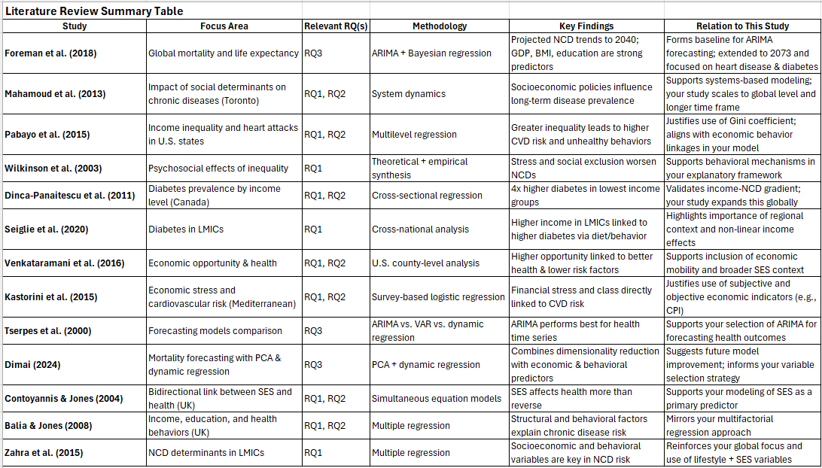
Table 2 Literature Review Summary

Datasets Analysis

4.1 Summary of Selected Dataset
This project analyzes a consolidated dataset sourced from 16 datasets from Our World In Data, covering the period 1950 – 2023 for over 300 countries. The dataset contains data related to demographic, economic, and lifestyle indicators, and health outcome variables, including GDP, income levels, inflation, CPI, unemployment rate, cost of a healthy diet, BMI, sex ratio, medium age, disease prevalence, life expectancy, and mortality. These datasets are subsequently processed and merged into a single dataset using Python. Below contains the key features of this dataset:
- Number of Attributes: 18
- Number of Observations: 21514
- Data Types: 1 Categorical, 17 Numeric
- Missing Cells: 5814
- Percentage of Missing Cells: 1.5%
- Duplicate Rows: 1
- Time Period: Year 1950 – 2023
- File Format: CSV
- Target Variables: Heart Disease, Diabetes, Life expectancy
- Predictor Variables:
- Economic: GDP, CPI, inflation, income, unemployment, Gini Coefficient
- Demographic: Median age, sex ratio, education level
- Lifestyle: Cost healthy diet, BMI (male / female)
Table 1: Variables Summary Table
Variable | Type | Distinct Values | Missing Value (%) | Notes
Country | Categorical | 322 | 1.2% | High cardinality, missing
Year | Numerical Discrete | 74 | 1.2% | High correlation
Cost of a Healthy Diet | Numerical Continuous | 775 | 2.5% | Right skewed
Mean Income or consumption | Numerical Continuous | 2635 | 2.4% | Right skewed  Hi variability
Inflation | Numerical Continuous | 9095 | 1.5% | Highly skewed  Include negative values
Child Mortality Rate | Numerical Continuous | 17562 | 1.2% | Strong negative correlation w/ life expectancy
Unemployment Rate | Numerical Continuous | 5346 | 1.4% | Mild skewness
Life Expectancy | Numerical Continuous | 18838 | 1.2% | High correlation  Left skewed
Education | Numerical Continuous | 480 | 1.2% | Some zero values
Gini Coefficient | Numerical Continuous | 2285 | 2.4% | Approx. normal distribution
Diabetes | Numerical Continuous | 258 | 1.3% | High correlation to BMI  Skewed
BMI (female) | Numeric Continuous | 8820 | 1.3% | Approx. normal, strongly correlates with BMI (male)
Heart Diseases | Numerical Continuous | 4411 | 1.4% | High correlation to BMI  Right skewed  High variability
BMI (male) | Numerical Continuous | 8820 | 1.3% | High correlation  Similar trend to BMI (female)
Sex Ratio | Numerical Continuous | 17399 | 1.2% | Right skewed
GDP | Numerical Continuous | 5288 | 1.4% | High correlation  Right skewed  Outliers present
Median age | Numeric Continuous | 12573 | 1.2% | Positive correlated with life expectancy
Consumer Price index (CPI) | Numerical Continuous | 8701 | 1.5% | Right skewed  Include extreme values

4.2 Descriptive Statistics
According to the Exploratory Data Analysis (EDA) report, the dataset contains a total of 5,814 missing values, accounting for approximately 1.5% of all data points. Variables with the highest proportion of missing data include the Cost of a Healthy Diet (2.5%), Mean Income (2.4%), and Gini Coefficient (2.4%). Although the missingness is relatively low, imputation will be performed to avoid loss of information during analysis and modeling.
During data quality checks, one duplicate row, which contained only missing values (NaN), was identified and removed to maintain dataset integrity.
In terms of distribution, skewness was observed across many variables. Economic and health data like GDP, Income, Inflation, and Disease prevalence were right-skewed, with most values low and a few very high. Life Expectancy was left-skewed, with most countries having high life expectancy. Variables like Cost of a Healthy Diet, BMI, and Gini Coefficient were roughly normal, fitting models that assume normal distribution.
Outlier detection was conducted using both the Interquartile Range (IQR) method and Z-score analysis methods, which consistently flagged extreme values in GDP, Income, and Inflation. The outliers likely reflected real-world differences between countries and over time, particularly between high-income and low-income nations. To reduce their impact without losing important information, outlier treatment methods like Winsorization were later used. To further understand the outlier’s distribution among the variables, IQR method was used to detect the number of outliers for each variable. The IQR is calculated as the difference between the 75th percentile (Q3) and the 25th percentile (Q1) of a variable. A data point is considered an outlier if it falls outside the range. The result of IQR testing has been shown below:
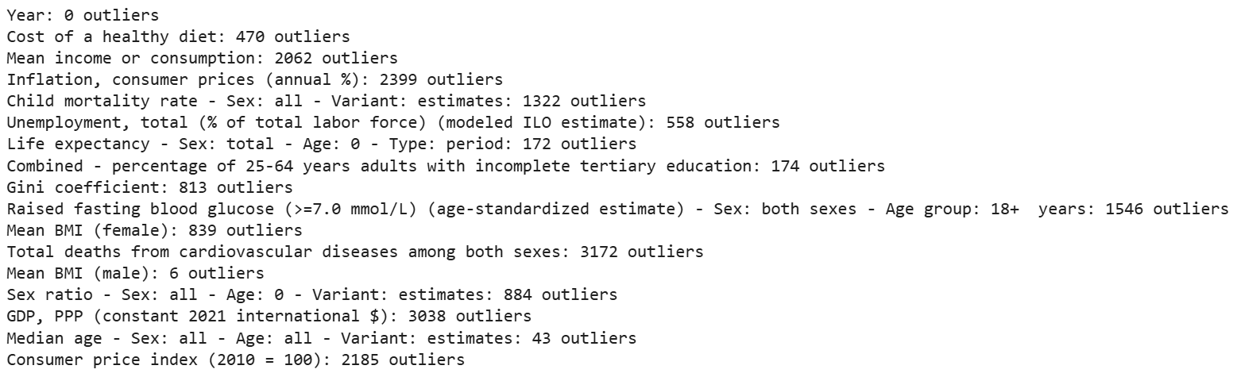
Figure 1: IQR test result
In Figure 1, the result of iQR test shows outliers distributed across the variables. BMI and Median Age show a few outliers, but GDP, Income, Inflation and CPI are having high outliers.
Moreover, Boxplots is a good tool of offering a visual summary of the distribution, skewness, and variability for each numeric variable in the dataset. Refer to Appendix A illustrates the boxplots for each variable.
Several strong correlations were observed among the variables. As shown in Figures 2 and 3, the Feature Correlation Tables and the Spearman Correlation Heatmap, certain factors shows high correlations. The Spearman correlation method was selected because most variables are not normally distributed. For instance, Life Expectancy has a strong positive correlation with both Median Age and Year. In contrast, Child Mortality Rate shows a strong negative correlation with both Life Expectancy and Median Age. Additionally, BMI (Female) has a strong positive correlation with Diabetes prevalence, highlighting that body mass (BMI) is a significant risk factor for diabetes. Figure 2 and Figure 3 shows the correlation among the variables.

Figure 2: Correlation Table

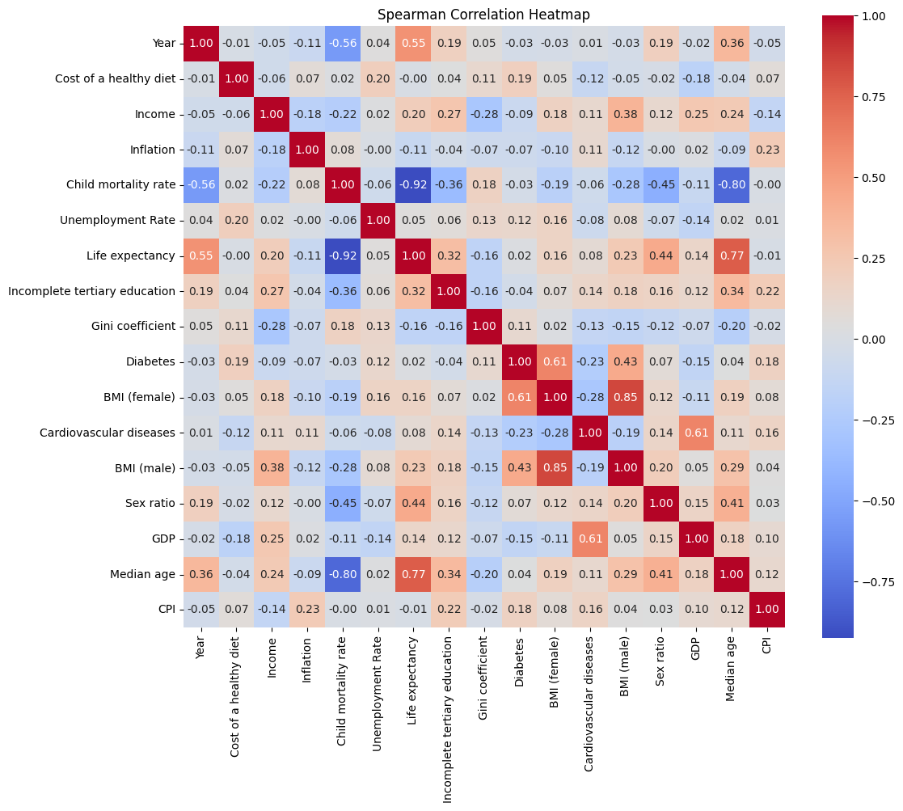
Figure 3: Spearman Correlation Matrix
The Descriptive Statistics provided a foundational understanding of the data's structure and correlation, which help decisions for data cleaning, transformation, and modeling strategies in the next phases of the project.

4.3 Visualization of Pattern, Trends and Outliers
In this section, the focus is on visualizing key patterns, trends, and outliers within the dataset. By using various charts and plots, we can gain deeper insights into how different socioeconomic, demographic, and health factors relate to each other and how they affect health outcomes globally.

Patterns & Trends:
Refer to histograms for the indicators at Appendix C, skewness was observed across many variables. Right-skewed distributions were found in economic and health indicators such as GDP, Income, Inflation, Heart Disease prevalence, and Diabetes prevalence. This suggests that most values are concentrated at lower levels, with a small number of extreme high values. In contrast, Life Expectancy exhibited a left-skewed distribution, indicating that a larger number of countries have relatively high life expectancy, with fewer experiencing significantly shorter lifespans. Other variables such as Cost of a Healthy Diet, BMI (both Male and Female), and Gini Coefficient were approximately normally distributed, making them more suitable for models assuming normality.
- Heatmap in Figure 3 shows the correlations between the variable; several strong correlations were observed among variables. Refer to Figure 2 and 3, Life Expectancy demonstrated a strong positive correlation with both Median Age and Year, which reflects the healthcare and living standard have been improved over time. In contrast, Child Mortality Rate showed a strong negative correlation with both Life Expectancy and Median Age, that suggests countries with younger populations and poor healthcare system experience higher child mortality and lower lifespan. Additionally, BMI (Female) showed a strong positive correlation with Diabetes prevalence, highlights that body mass (BMI) as a high-risk factor causing diabetes, particularly among women.
Outliers:
- Boxplots are perfect for identifying outliers in the data, refer to Appendix A shows some of the variables with a few outliers, such as Year, BMI (male) and Median Age. Year has zero outlier because it just a sequential time variable, BMI (male) has low number of outliers reveals that the BMI level is consistent of male across the countries over time. Median Age and Life expectancy has low number of outliers shows that a consistent trend of median age and life expectancy across the countries, some of the outliers could be caused by disease or war from some of the countries.
In contrast, some of the variables with high outliers, especially economics factors, such as GDP, Income, Inflation and CPI, which indicate that it could be caused by unstable of economic condition across the countries, e.g. global financial crisis or recession, which indirectly associated with the high number of outliers of unemployment rate, inflation, CPI, Gini coefficient, lead to income inequality. On the other hand, health related variable also has high number of outliers, such as Heart disease, Diabetes, Child Mortality Rate. It reveals that the inequality of income and standard of health system across countries could affect the number of outliers. Additionally, disease such as COVID 19 causes the outliers of health or economics factors increase.

- QQ plots can help check if the data deviates significantly from a normal distribution. Refer to Appendix B, Life Expectancy and Female BMI show data points that align closely with the 45-degree reference line, indicating that both variables are approximately normally distributed. In contrast, the QQ plot for GDP displays a significant deviation from the normal line, particularly in the upper quantiles. This strong upward bending away from the line indicates a heavy right skew, reflecting the presence of a few countries with extremely high GDP.

4.4 Discussion of Potential Implications of Identified Patterns
The identified patterns and outliers have important implications for understanding global health outcomes:
- Patterns in Life Expectancy:
The steady increase in life expectancy over time, especially in developed countries, suggests that improved healthcare and public health initiatives have contributed to better health outcomes. However, the differences between countries highlight the need for improving health policies and healthcare systems.
- Economic Trends and Health Outcomes:
The positive correlation between GDP and life expectancy suggests that wealthier nations tend to have better healthcare systems and longer life expectancy. However, the outliers indicate that some high-GDP countries still face significant health disparities or health crises. For example, countries with high rates of obesity and diabetes (despite having strong economies) suggest that economic wealth does not guarantee good health outcomes. This indicates lifestyle factors and ensuring equitable access to preventive healthcare are also important.
- Outliers in Economic Data:
The extreme values in GDP, Income, and Inflation represent periods of economic instability (e.g., during financial recessions or crises). These outliers could suggest that economic volatility is linked to worsened health outcomes. High income inequality (as indicated by the Gini coefficient) and unstable economic conditions may exacerbate public health issues, leading to disparities in healthcare access and quality of life.
- Health-related Outliers:
The outliers in diabetes prevalence may reflect health disparities across countries, with some countries suffering from higher obesity rates, poor diet, or lack of access to medical care. The presence of extreme values in health indicators like heart disease and child mortality suggests that these countries are having systemic health challenges, which can be exacerbated by economic inequality or lack of healthcare infrastructure.
In conclusion, these visualizations provide valuable insights into the relationships between economic, lifestyle, and health factors. They highlight the need for more deep analyses and targeted health policies that address not only economic conditions but also lifestyle habits, health disparities, and access to care across different countries and regions.

Methodology and Study Design

5.1 Research Methodology
This project investigates the relationship between socioeconomic, demographic, and lifestyle factors and global health outcomes, with a particular focus on non-communicable diseases (NCDs), such as heart disease and diabetes from 1950 to 2023 and uses historical patterns to forecast health outcomes through 2073.
The study began with a comprehensive literature review of prior work to establish a strong foundation. Academic sources were gathered from databases including Google Scholar, JSTOR and PubMed. The search followed a two-stage process: first, broad searches using the theme or research questions to search, and second, targeted searches using specific terms such as “cardiovascular disease”, “Diabetes Prevalence,” “Income Inequality,” “BMI and Health Outcomes,” “ARIMA,” and “Time Series Forecasting”. Studies were selected based on thematic relevance, methodology, with focus on long-term analyses. In addition, references lists from relevant articles were review to identify further studies and expand the pool of sources. Each study was evaluated through abstracts, results, and conclusions, with detailed summaries capturing key findings, methods, and gaps. The literature review was then organized into thematic categories: (1) socioeconomic and demographic predictors, (2) lifestyle and modifiable risk factors, (3) income inequality and health disparities, (4) forecasting methodologies, and (5) disease-specific analyses (heart disease and diabetes). Within each category, studies were compared in terms of findings, scope, and relevance to my project. Connections between studies were articulated through transitions and comparative statements, while redundant information was removed to ensure clarity and synthesis. This process allowed for a critical, structured review that not only supports the research questions but also highlights how this project fills key gaps in the existing literature.
Data were sourced from publicly available, internationally recognized databases, including Our World in Data, WHO, and the Global Burden of Disease. These datasets offer consistent coverage over long time frames across countries. Data preprocessing involves combining 16 datasets from Our World In Data into a single dataset using Python. The data were first standardized for consistent format and time range. Then evaluate the data through Exploratory Data Analysis (EDA) to identify duplicates, missing values, outliers, skewness and variable distributions. To observe the normality of the data by performing Shapiro Test, Anderson Test, plot histogram, boxplot and QQ plot. Detect outliers and skewness using IQR method, z-score and boxplot. To start data cleaning, remove duplicate records after confirming it is redundancy. Then, handle missing values by imputation using mean values for normally distributed variables, medians for skewed data, and modes for categorical variables. However, the imputation values (mean / median) should be calculated from the training set only and used to replace NaN in both train and test sets to avoid over-fitting and ensure valid model performance on unseen data. Next, outliers were detected through IQR method and z-scores and addressed by applying Winsorization and Log-transformation to deal with extreme values, reducing their impact without discarding observations. Skewed variables were normalized using the Yeo-Johnson transformation, which is suitable for data containing zero, negative, or positive values. To verify the effectiveness of these transformations through histograms, boxplots and Shapiro test. Feature scaling was then performed using StandardScaler to prepare the data for regression and forecasting models. Standardization ensured that all continuous features contributed equally to model training. Then, apply Principal Component Analysis (PCA) for Dimensionality Reduction to optimize the quality of the dataset. After that, perform Train-Test Split and Cross Validation, Fit imputation on the train set and apply imputation to both train and test sets using mean, median or mode. Finally, Modelling and evaluation, analyze the results and make conclusions and recommendations of future work.
The study is structured around three research questions: first, to identify the most significant socioeconomic and lifestyle factors associated with the prevalence of heart disease and diabetes globally; second, to assess how modifiable economic and lifestyle factors such as BMI, cost of a healthy diet, and consumer price index (CPI) influence variations in life expectancy across countries; and third, to predict future trends in disease prevalence and life expectancy from 2023 to 2073 based on historical data and identified predictors.
For RQ1, which identify the most significant socioeconomic, demographic, and lifestyle factors associated with the prevalence of heart disease and diabetes across countries from 1950 to 2023, Multiple Linear Regression (MLR) is applied. MLR is particularly appropriate for this question as it enables the estimation of the strength and direction of relationships between multiple independent variables (income, Gini coefficient, BMI, cost of a healthy diet, and median age) and a dependent variable (heart disease and diabetes. Since heart disease and diabetes are two distinct outcomes, the analysis uses a two separate regression models, one developed to predict heart disease prevalence and another to predict diabetes prevalence. This allows for a clearer understanding of how specific predictors contribute to each disease individually, while also enabling comparisons to identify shared and unique influencing factors. Before running the models, multicollinearity is checked using correlation matrices and the Variance Inflation Factor (VIF) to ensure stable and interpretable regression results. Model performance will be evaluated using metrics such as R², Root Mean Squared Error (RMSE), and Mean Absolute Error (MAE), providing insight into how well the models explain variations in disease prevalence across countries and time.
For RQ 2, which examines how modifiable economic and lifestyle variables (e.g., income, CPI, BMI, and diet cost) explain differences in life expectancy across countries, a separate MLR model is used with life expectancy as the outcome variable. This model allows for the quantification of the contribution of each predictor to variations in longevity. Feature selection and dimensionality reduction techniques, such as Principal Component Analysis (PCA) will be applied to improve model efficiency and reduce multicollinearity. The use of MLR for both RQ1 and RQ2 offers the advantage of clear and interpretable results, ensure statistical reliability, and well-suited for analyzing both cross-sectional and time-based health data.
For RQ3, which aims to forecast future health outcomes (life expectancy and disease prevalence) from 2023 to 2073, the dataset is restructured into a time series format organized by country and year. Two forecasting models, Auto Regressive Integrated Moving Average (ARIMA) and Prophet are employed. ARIMA is preferred for structured, stationary time series and is known for its high precision in modeling linear trends and autocorrelations. Prophet, developed by Facebook, is well-suited for time series data with missing values, irregular trends, or multiple seasonal effects, offering a more flexible approach for real-world health datasets. Both models are trained using historical data from 1950–2023, and forecasting performance is assessed using Mean Absolute Percentage Error (MAPE), along with cross-validation to evaluate predictive accuracy and generalization.
The entire analysis is using Python, with libraries like Pandas and NumPy for organizing and cleaning data, scikit-learn and statsmodels for building models, ARIMA and Prophet for time series forecasting, and Matplotlib and Seaborn for creating charts and graphs.

5.2 Justification the Approach on Prior Studies
Multiple Linear Regression and time series forecasting models (ARIMA and Prophet) are used in this study. Multiple Linear Regression is effective in estimating the strength and direction of relationships between multiple predictors and therefore is used in Research Questions 1 and 2 to analyze the relationship between income, education, BMI, and CPI, and health outcomes such as disease prevalence and life expectancy. Multiple Linear Regression provides statistical findings which help formulate policy insights.
Prior studies used similar method, including Zahra et al. (2015), Balia & Jones (2008), Murray et al. (2012), and Kontis et al. (2017), have successfully used regression models to explore the relationship between socioeconomic or behavioral factors and chronic disease outcomes across countries. Zahra et al. (2015) examined structural and behavioral determinants of chronic diseases in low- and middle-income countries, while Balia and Jones (2008) applied regression models to UK data, linking health outcomes with variables such as education and income. Kontis et al. (2017) also employed multivariable regression to assess the global impact of risk factors on NCD mortality. These studies show that regression models are interpretable, transparent, and effective for health policy insights. This project builds on these studies by extending their approaches globally and across a longer time frame (1950–2023), allowing broader insight into temporal and regional variation in disease outcomes and life expectancy.
Time series forecasting models, ARIMA and Prophet, are used for Research Question 3 to forecast future trends in health outcomes through 2073. Using both methods together offers complementary strengths. ARIMA is effective for capturing linear trends and autocorrelation in well-behaved time series, while Prophet is good for handles missing data, non-linear trends, and seasonal effects more flexibly. This approach is supported by prior study. Sardar et al. (2022), which applied both models to COVID-19 data across South Asian countries, demonstrating the effectiveness of using both ARIMA and Prophet method together. Similarly, Sah et al. (2022) used these models to predict the spread of COVID-19 across Indian states, showing strong performance from the combined approach. Based on this evidence, this study applies the same strategy to generate reliable forecasts for Research Question 3.

5.3 Data Preparation and Cleaning
  - Data Cleaning and Integration
The dataset used in this study was compiled from 16 separate CSV files sourced from Our World in Data, each representing different indicators such as GDP, life expectancy, education, and health outcomes. These files varied in structure and time coverage, creating challenges in merging and aligning data consistently. The column “Entity” was renamed to “Country” for uniformity, and extraneous columns such as “Code” were removed. After standardizing column names and trimming whitespaces, the datasets were merged using outer joins on ['Country', 'Year'], ensuring maximum data retention across all countries and years from 1950 to 2023. The resulting master DataFrame was then sorted by Country and Year to maintain chronological integrity and facilitate time series analysis.
- Handling Missing Values
Given the uneven coverage of data, particularly for low-income and African nations during earlier decades, missing values were addressed using tailored imputation strategies based on data type and distribution. For variables with less than 5% missing data and approximately normal distributions, such as BMI and the cost of a healthy diet, mean imputation was used. For skewed variables like income, inflation, GDP, unemployment, and life expectancy, median imputation was deemed more appropriate to reduce bias introduced by extreme values. For categorical variables like Country, mode imputation was applied. To avoid data leakage, all imputation statistics (mean/median/mode) were calculated from the training set only and then used to fill missing values in both the training and test sets.
- Outlier Detection and Treatment
Outliers were identified using the Interquartile Range (IQR) method. Rather than eliminating data points, Winsorization was applied to cap extreme values at the 5th and 95th percentiles. This strategy preserved the overall structure of the dataset while minimizing the influence of outliers. Winsorization was especially useful in preventing distortion in models that assume normally distributed inputs. Additional checks such as Q-Q plots, histograms, and Shapiro-Wilk tests confirmed that many variables deviated significantly from normality, especially GDP and income, which displayed heavy right skewness.
- Normality Check
Use of Shapiro-Wilk test, histograms, and Q-Q plots to assess distribution fits well here, refer to Figure 4, Appendix B and C.
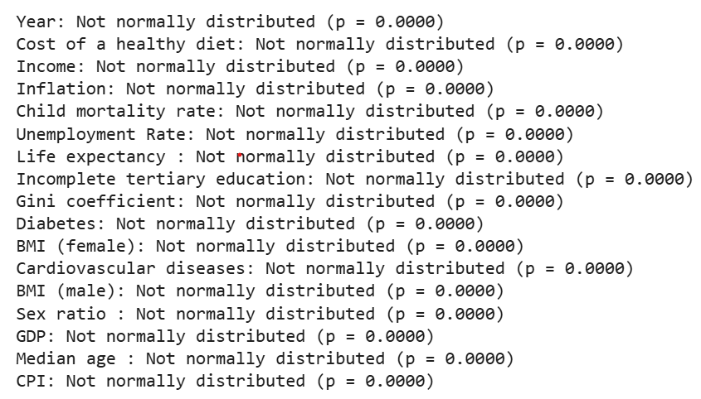
Figure 4: Shapiro-Wilk test result
Figure 4 shows the result of Shapiro test, which confirmed that all the variables are not normally distributed.
Other than Shapiro-Wilk test, QQ Plot and histogram provide visual insight into the distribution of variables, skewness and normality of variables in the dataset. Refer to Appendix B. QQ Plot , Appendix C Histogram before Normalization, and Appendix D Histograms after Normalization, to observe the differences before and after normalization.
- Variable Transformation
Features with skewness coefficients greater than +1 or less than -1 are considered highly skewed. In this dataset, only cost health diet, BMI (male/female) and Gini Coefficient are approximately normal, most other features are highly skewed, such as ‘inflation’ contains negative values and ‘education’ contains zero values (DataCalculus, n.d.). To address skewness and meet model assumptions (especially for ARIMA, Prophet, and linear regression), continuous variables were normalized using the Yeo-Johnson transformation. This method was selected over log and square-root transformations because it supports negative and zero values, both present in this dataset (e.g., inflation rates). Yeo-Johnson transformation significantly improved the normality of the variables, as illustrated in histograms before and after transformation, refer to Appendix C and D. Variables such as GDP, median age, and education showed substantial improvements in distribution symmetry, making them more suitable for statistical modeling.
- Feature Scaling
Before model training, all continuous variables were standardized using StandardScaler. This method transforms each feature to have a mean of 0 and a standard deviation of 1, which is essential for algorithms sensitive to scale, such as LASSO and linear regression. Standardization ensures that features contribute equally to the model, preventing those with larger magnitudes from dominating the learning process.

5.4 Feature Engineering

5.4.1 Lag Feature
To enhance temporal predictive power, lag features were engineered. These lagged variables represent past values of indicators such as income, education, and BMI, allowing models to learn from prior studies at Literature Section. For example, Income_lag1 to Income_lag3 were created to support models like Random Forest and Prophet in capturing temporal dependencies. Lagging is especially critical in forecasting models like ARIMA, which inherently rely on autocorrelations across time.

5.4.2 Variance Inflation Factor (VIF)
Variance Inflation Factor (VIF) measures how much the variance of a regression coefficient is inflated due to multicollinearity among predictor variables. Multicollinearity occurs when predictors are highly correlated with each other, which can lead to unstable coefficient estimates, inflated standard errors, and difficulty in interpreting the individual effects of variables.
VIF with values above 5 or 10 typically indicating problematic multicollinearity. Using VIF helps identify redundant features, guides feature selection, and improves model interpretability by ensuring stable and meaningful coefficient estimates.
For this dataset, which includes continuous numeric variables such as GDP and Income, and uses linear regression models to analyze health outcomes like life expectancy and cardiovascular diseases.
This approach is supported by foundational econometrics and statistical learning literature, including works by Gujarati (2003) and James et al. (2013), as well as applied health research where socioeconomic and health indicators often exhibit correlations.
Overall, incorporating VIF checks enhances the reliability of your regression models, especially when interpreting the impact of predictors. Figure 5 is the initial result of VIF.
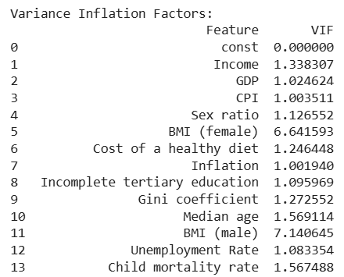
Figure 5 Initial Result of VIF
The initial result of VIF shows that BMI(female) and BMI(male) have high correlation as BMI(female) and BMI(male) have VIF of 7.00 and 7.39 respectively. According to (Kutner, 2005) and (O'Brien, 2007) that VIF greater than 5 could consider to be high correlation. To solve this problem, both BMI(female) and BMI(male) will be combined. After combined BMI(female) and BMI(male) to BMI_avg, perform VIF again to verify any predictors are highly correlated, refer to Figure 6 for the final result below.
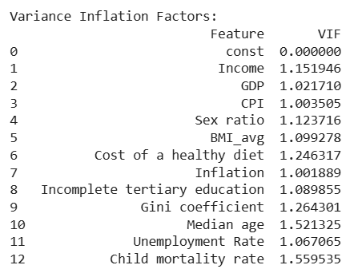
Figure 6 Final Result of VIF
The VIF final result shows all values are lower than 5, indicates that all predictors are not highly correlated with each other.
5.4.3 Feature Selection Strategy
- Select the Best Feature Selection Method:
To optimize model performance, four feature selection techniques were evaluated: LASSO (Least Absolute Shrinkage and Selection Operator), Recursive Feature Elimination (RFE), Forward Selection, and Random Forest feature importance. The selection process was conducted independently for each target variable, life expectancy, diabetes, and cardiovascular diseases. Using TimeSeriesSplit cross-validation and Root Mean Squared Error (RMSE), MAE and R² as the evaluation metric, the most effective method and number of features were identified. For life expectancy, Forward Selection with 17 features yielded the lowest RMSE and MAE and highest R². For diabetes, Forward Selection was again optimal, selecting 17 features. For cardiovascular diseases, RFE with 3 features produced the best results. Refer to Table 2, Table 3 and Figure 7 for the summary of Feature selection comparison metrics, feature selection comparison diagram and the result of the selected Feature selection method with the optimum number of features.
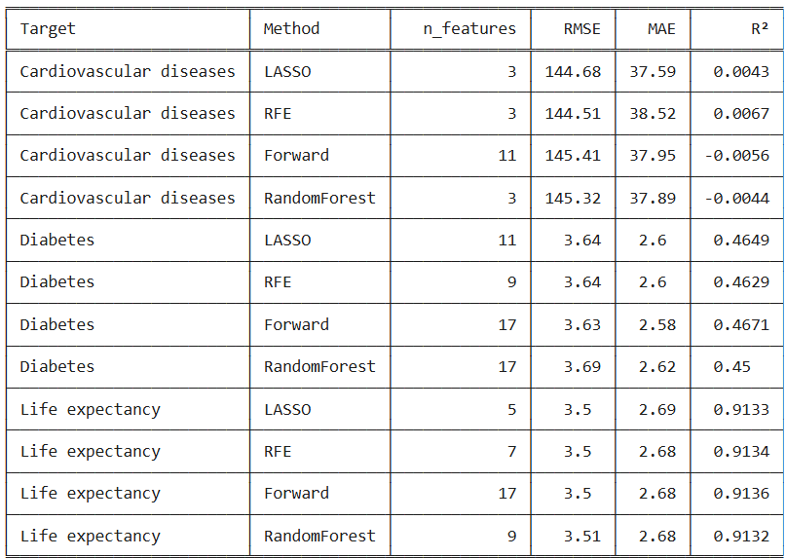
Table 2 Feature Selection Comparison using metrics – RMSE, MAE & R²

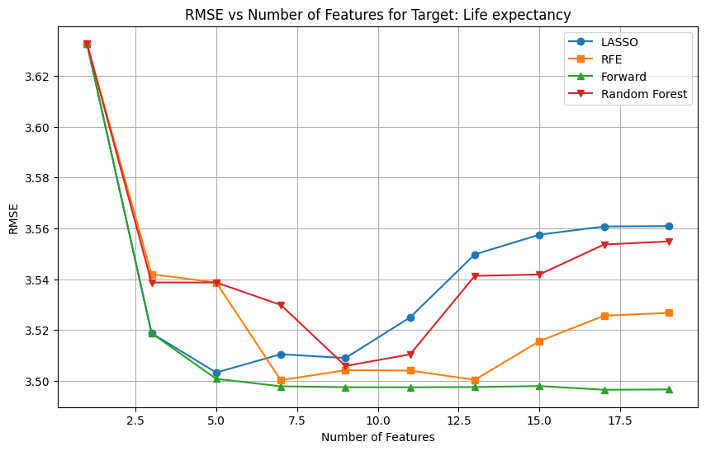
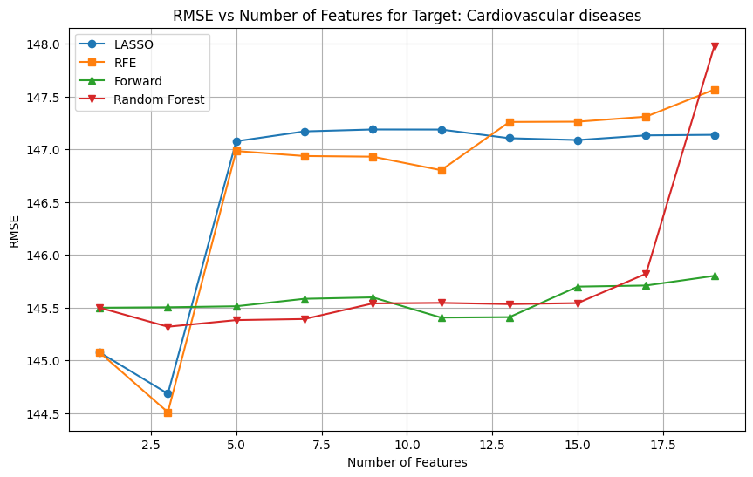
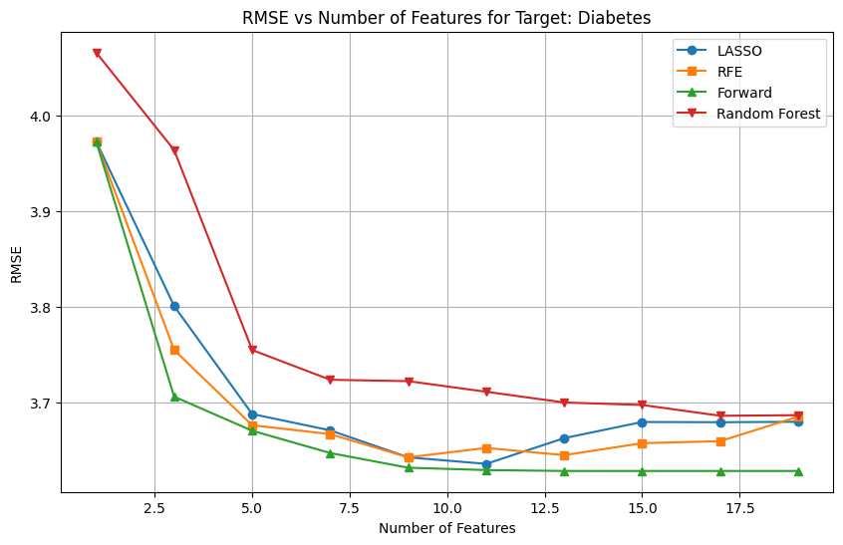
Figure 7 Feature Selection Comparison – LASSO, RFE, Forward, Random Forest.
The Best Feature Selection Method Summary
Target | The Best Method | Optimum # of Features
Life Expectancy | Forward Selection | 17
Diabetes | Forward Selection | 17
Cardiovascular Disease | RFE | 3
Table 3 The Best Feature Selection Method
- Final Feature Sets – Feature Importance
The selected features reflected both intuitive and data-driven relationships. For life expectancy, includes 17 features, with strong emphasis on child mortality rate (both current and lagged), GDP, unemployment rate, cost of a healthy diet, and sex ratio. These variables represent a blend of direct health indicators (e.g., child mortality), economic development (GDP), social stability (unemployment), and demographic composition (sex ratio). The inclusion of lagged variables (such as GDP_lag1, cost of a healthy diet_lag3, and sex ratio_lag3) suggests that past economic and demographic conditions continue to exert influence on current life expectancy, consistent with the cumulative nature of public health outcomes. These findings support the idea that life expectancy is not only a reflection of present conditions but also of historical investments in healthcare, nutrition, and socio-economic stability.
The diabetes model highlights BMI_avg_lag3 as the most influential predictor, along with income, GDP, and median age, including their lagged forms. The repeated presence of income and GDP lags indicates that economic growth and individual wealth levels over time play a major role in shaping diabetes prevalence, likely through their effects on diet, lifestyle, and access to healthcare. BMI, a well-known modifiable risk factor, shows consistently across lags, reinforcing its central role in diabetes onset. Sex ratio and median age also appear, suggesting that population structure and aging are relevant in explaining disease trends. These results align closely with RQ1, identifying both modifiable lifestyle (BMI) and economic-demographic factors (income, GDP, age) as critical in understanding diabetes prevalence across countries.
The feature set for cardiovascular diseases, selected via Recursive Feature Elimination (RFE), was limited to three features: child mortality rate, child mortality rate_lag3, and incomplete tertiary education. While these may have some broad associations with overall health system quality and educational attainment, the very high-test error indicates that these predictors do not sufficiently capture the complexity of cardiovascular disease risk. The absence of core biological or behavioral risk factors, such as BMI, smoking, hypertension, or diet—likely limits the model’s effectiveness. Therefore, although the selected features suggest systemic or structural health inequalities may correlate with CVD rates, they fall short in fully explaining the variation, underlining the need for a broader and more targeted feature set in future modeling.
Overall, the feature sets directly address RQ1 by identifying the key factors most strongly associated with the prevalence of non-communicable diseases, specifically heart disease and diabetes. For diabetes, the combination of lifestyle (BMI), economic (income, GDP), and demographic (age, sex ratio) variables strongly reflects known epidemiological risk patterns. For life expectancy, the influence of mortality, income-related, and dietary cost factors illustrates how socioeconomic and health system conditions shape national health outcomes. While the cardiovascular disease model is currently underpowered, the inclusion of education and mortality suggests structural disadvantages may still play a role. Together, these findings highlight the importance of both modifiable and structural determinants in shaping global patterns of non-communicable diseases, thereby providing evidence-based direction for public health interventions and policy targeting. Below is the final result of Feature importance.
Feature Importance Ranking
Rank | Features
Target | Life Expectancy | Diabetes | CVD
1 | Child mortality rate | BMI_avg_lag3 | BMI_avg_lag3
2 | Child mortality rate_lag3 | Income | GDP
3 | Child mortality rate_lag2 | GDP | Income
4 | Income_lag3 | Cost of a healthy diet | BMI_avg_lag1
5 | GDP | Median age_lag3 | BMI_avg
6 | BMI_avg | Income_lag3 | Education
7 | Sex ratio | GDP_lag3 | GDP_lag3
8 | Median age_lag3 | Sex ratio_lag3 | Income_lag3
9 | Sex ratio_lag3 | Sex ratio | Income_lag2
10 | Sex ratio_lag2 | Income_lag1 | Income_lag1
Table 4 Feature Importance Ranking Table
Table 7 illustrates Top 10 the most important features. The feature importance analysis across multiple models, Forward Selection, RFE, LASSO, and Random Forest, provides critical insights into the socioeconomic, demographic, and lifestyle variables most associated with key health outcomes, thereby directly addressing Research Questions 1, 2, and 3. For life expectancy, variables such as child mortality rate, GDP, and several lagged indicators (e.g., sex ratio_lag3, unemployment rate_lag1, and cost of a healthy diet_lag3) consistently emerged as dominant predictors across all models. The extremely high importance scores for child mortality rate, in particular, emphasize its central role in shaping life expectancy, reflecting the broader structural quality of health systems. The prominence of lagged economic indicators further suggests that historical socio-economic conditions have lasting impacts on long-term population health.
In the case of diabetes, the most influential predictor was BMI_avg_lag3, followed closely by lagged income and GDP indicators, median age, and sex ratio. These findings reinforce the chronic and cumulative nature of diabetes, where both current and historical lifestyle and economic conditions are crucial. The repeated presence of lagged economic factors and BMI, a modifiable risk factor, indicates strong potential for intervention—directly supporting RQ2 by highlighting the explanatory power of modifiable variables such as body weight and income level.
For cardiovascular diseases, however, the models identified fewer strong predictors. Child mortality rate and incomplete tertiary education appeared as the most consistent factors, but overall model performance was weak, and traditional clinical or behavioral CVD risk factors like smoking or hypertension were either not available or not selected. This suggests that while structural indicators may correlate with cardiovascular disease burden, the models likely miss key behavioral variables that would improve predictive accuracy. As such, while the results partially address RQ1 for CVD, they also reveal gaps in the current dataset that limit the model’s effectiveness for this outcome.
These findings collectively support RQ1 by identifying BMI, income, GDP, education, and child mortality as core predictors of non-communicable disease prevalence. They also respond to RQ2, demonstrating that many of these important features—particularly BMI, cost of diet, and unemployment—are modifiable or responsive to policy interventions. Finally, the strong importance of lagged variables across models strengthens the case for addressing RQ3, as it confirms that past trends in economic and lifestyle factors are useful for forecasting future health outcomes such as disease prevalence and life expectancy.

5.4.4 Stationary Check (ADF)
The Augmented Dickey-Fuller (ADF) test was applied to assess whether the time series data are stationary, a critical assumption for many time-series models, including ARIMA. Stationarity implies that a time series' statistical properties, such as mean and variance, remain constant over time. The ADF test evaluates the presence of a unit root; a p-value less than 0.05 indicates stationarity (no unit root), while a higher p-value suggests non-stationarity, necessitating transformations such as differencing before modeling.
In this project, the ADF test was applied to the residuals of models for Life Expectancy, Cardiovascular Diseases, and Diabetes. All three showed strongly significant results (very low p-values and test statistics below critical thresholds), confirming that the residuals are stationary. This means the models do not suffer from non-stationarity, supporting their validity and enhancing their reliability for forecasting. The results providing a solid foundation for time-series analysis.

5.4.5 ACF and PACF plot
ACF (Autocorrelation Function) and PACF (Partial Autocorrelation Function) plots are visual tools used to analyze the correlation structure of time series data. They help identify patterns and dependencies between data points at different lags (time intervals) and are crucial for determining appropriate models for time series forecasting, particularly AR (Autoregressive) and MA (Moving Average) models.

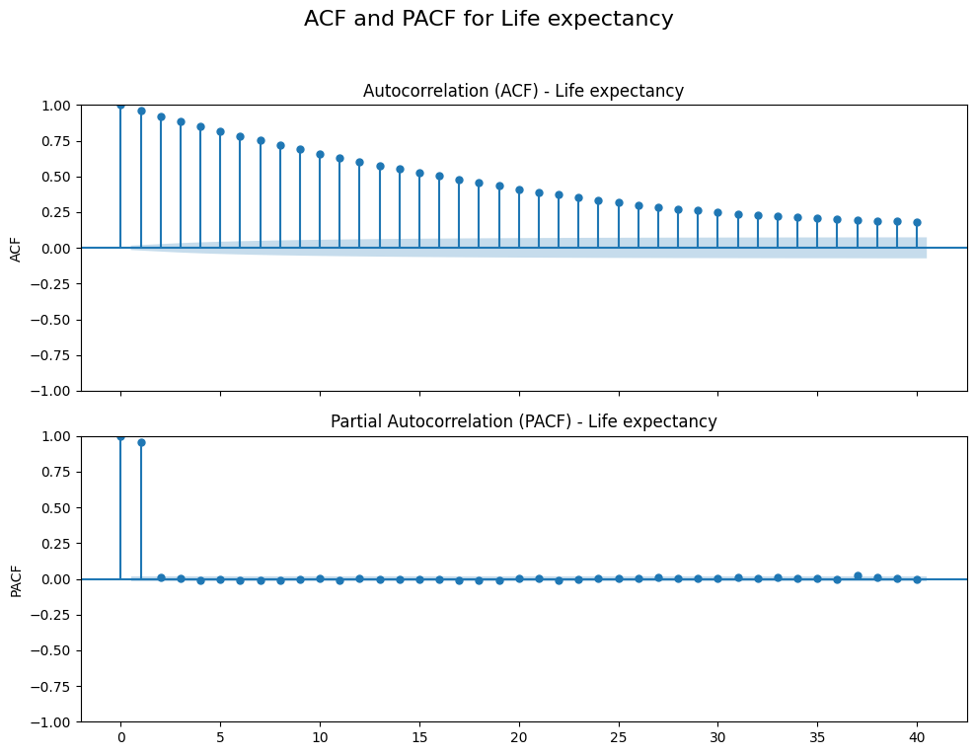
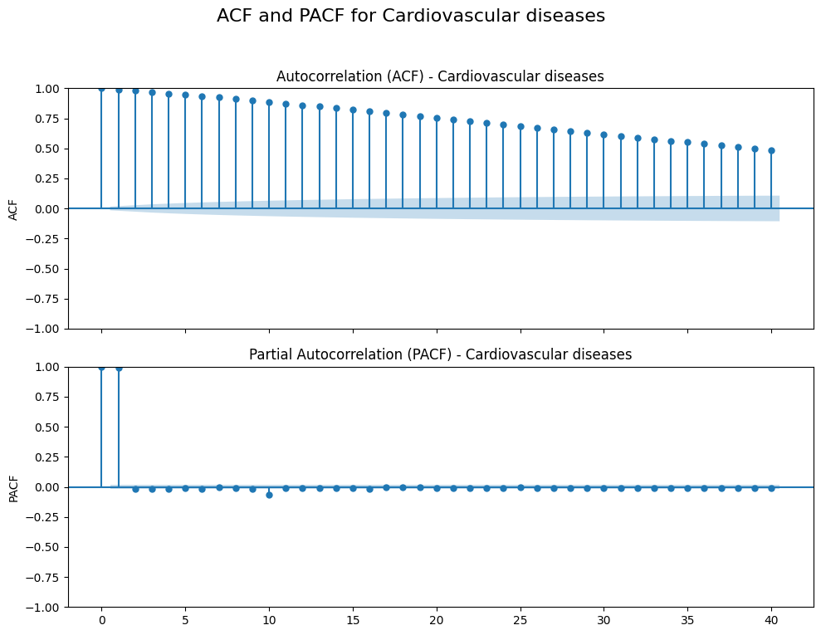
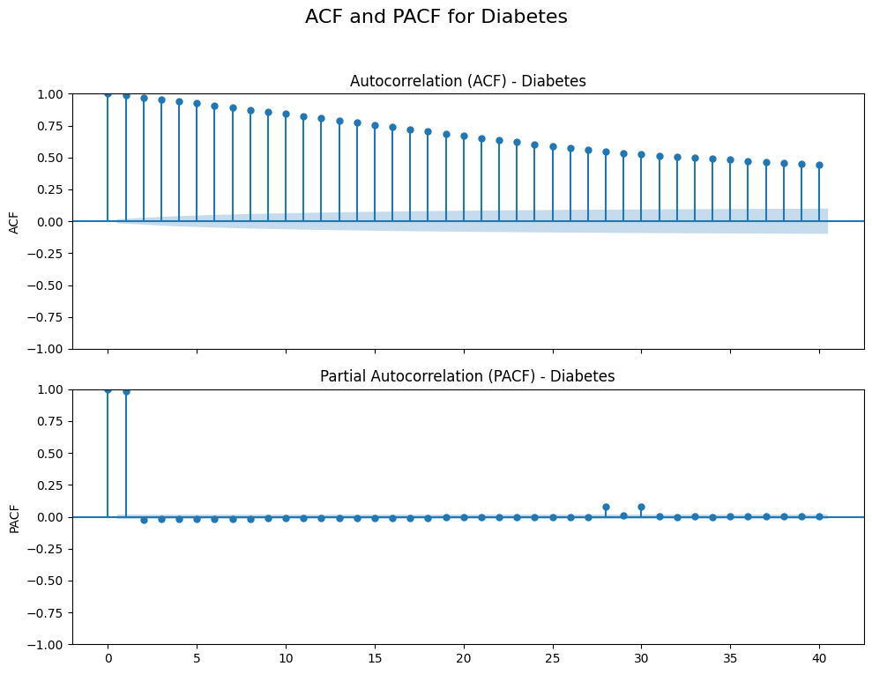
Figure 8 ACF and PACF

Based on the plots of ACF and PACF, for all targets on both the Autocorrelation Function (ACF) and Partial Autocorrelation Function (PACF) plots show significant spikes that gradually decay over time, it strongly suggests that the series contains autocorrelation — meaning past values have a measurable influence on future ones. This is particularly common in time-series data with memory or lag effects. The ACF’s slow decay pattern indicates that a moving average (MA) component may be present, while the PACF plot with very strong spikes at the first two lags points to a likely autoregressive structure of order two, also known as AR(2). In this case, the series is heavily influenced by its own values from one and two time steps prior. Together, these patterns imply that an ARIMA model would be a suitable fit, specifically one with parameters ARIMA(2, 0, q), where "p = 2" captures the autoregressive lags, "d = 0" reflects the fact that the series is stationary (as shown in the ADF test), and "q" is chosen based on how far the ACF continues to show significant autocorrelation. These insights are instrumental in designing lag-based features or selecting model architectures that are sensitive to temporal dynamics, such as ARIMA, SARIMA, or even recurrent neural networks.
In this forecasting project, three lags (lag1, lag2, and lag3) were chosen for time-dependent predictors based on both statistical diagnostics and inference validation. The Partial Autocorrelation Function (PACF) plots consistently showed strong spikes at lag 1 and lag 2, with a noticeable flattening from lag 3 onward. This suggested an autoregressive structure primarily governed by the first two-time steps. However, subsequent HAC-corrected regression analysis revealed that certain lag3 features, including economic and health indicators, eg. CPI, BMI, Inflation and Income etc. were still statistically significant (p < 0.05), confirming their meaningful contribution despite weaker autocorrelation beyond lag 2. By including lag3 in the modeling framework alongside lag1 and lag2, the models captured short-term memory effects while allowing for delayed impacts that are often present in real-world socioeconomic dynamics. This decision ensures a balance between temporal relevance and statistical validity, strengthening both the explanatory power and forecasting accuracy of the models.

5.5 Relevance and Feasibility

5.5.1 Relevance of the Dataset
The dataset includes explanatory variables, which are composed of demographic, economic, and lifestyle indicators. Examples of these indicators include GDP, BMI, and gender. The independent variables are related to health outcomes, which include life expectancy, prevalence of diabetes, and mortality. The demographic and economic variables, which are collectively known as socioeconomic indicators, as well as lifestyle indicators will be used to predict public health outcomes. Explanatory variables with a strong relationship with the health outcomes will be included in a predictive model which estimates health outcomes in the following 50 years (2023-2073). This analysis will help decision-makers to formulate policies that promote improved health outcomes and a sustainable healthcare system.

5.5.2 Feasibility
The dataset is feasible for this project as it was downloaded from Our World In Data, which is a reliable way to obtain data from authoritative sources, such as the United Nations and the World Bank. These data sources are available in CSV format and covers a wide range of variables relevant to economic, lifestyle, and demographic factors. It includes over 40,000 observations from 1950 to 2024, providing rich data for the analysis. Additionally, this dataset has been preprocessed through combining 16 separate files from Our World In Data using Python. It has been processed by data cleaning, merging, handling of missing values using mean imputation. These preparations make the dataset well-structured and ready for applying the analytical tasks in this project.

5.6 Proposed Methodology and Tools
The preprocessing of data involves combining 16 datasets from Our World In Data into a single dataset using Python. Based on this dataset, regression and time series analysis will be performed to understand how well socioeconomic factors explain health outcomes

5.6.1 Techniques and Tools:
Modeling Techniques: Multiple Linear Regression and Time Series (ARIMA and Prophet)
Tools: Python (Pandas, NumPy, scikit-learn, Matplotlib/Seaborn, prophet)

5.6.2 Regression Analysis
Regression analysis is a statistical tool for the investigation of relationships between variables and estimates how one or more predictor variables affect the outcome (Sykes, 1993).
Purpose: To identify the relationship between economic, lifestyle, demographic factors, and health outcomes.
Application: Multiple linear regression will be applied to research questions 1 and 2 respectively. For RQ1, the goal is to evaluate how demographic indicators (e.g., age, gender, education) and economic indicators (e.g., GDP, income, CPI, unemployment) correlate with the prevalence of diabetes and heart disease. For question 2, the focus is assessing whether the lifestyle factors (cost of healthy diet and BMI) in predicting health outcomes such as life expectancy.

5.6.3 Time Series Analysis (Random Forest, ARIMA and Prophet)
Time series analysis is a statistical technique that analyzes patterns, trends, and relationships in data at regular intervals to make informed predictions, forecasts by modeling trends, seasonality, and other temporal patterns. Data obtained from observations collected sequentially over time. The purpose of time series analysis is generally twofold: to understand or model the stochastic mechanism that gives rise to an observed series and to predict or forecast the future values of a series based on the history of that series and, possibly, other related series or factors (Shumway, 2000).
Purpose: To forecast future health outcomes (such as life expectancy, disease prevalence) based on historical trends in significant demographic, economic, and lifestyle indicators.
Application: Time series forecasting methods will be applied to Research Question 3. The goal is to model and predict future trends in health outcomes (e.g., life expectancy, disease rates) from 2023 to 2073. Based on the insights from research questions 1 and 2, key predictors will be selected. Techniques such as Prophet and ARIMA will be used to forecast future values by analyzing historical data patterns from 1950 to 2023. The dataset will be split chronologically into train and test sets with Cross-validation to ensure reliable model performance.

Model Development and Evaluation

6.1 Walk-Forward Validation (Rolling Forecast)
The dataset was split into training and testing sets using walk-forward validation (rolling forecast). This rolling approach ensures that the model always learns from the latest data and avoids any lookahead bias, making it particularly effective for temporal datasets where trends, seasonality, and evolving patterns must be captured over time. Walk-forward validation is especially suitable for this study because it improves the temporal generalizability of the model and ensures that its predictive capability is robust across different economic contexts and time frames.
Procedure implemented in this study:
- Initial training on data from 1950-2020.
- Predictive evaluation for 2021-2023; then appending those observations to training set.
- Step-wise retraining and forecasting for 2024-2074.
- Ten countries representing diverse income levels were used:
High-Income: US, Germany, Japan
Upper-Middle: Income: Brazil, Mexico
Lower-Middle: India, Indonesia
Low-Income: Nigeria, Kenya, Bangladesh
Findings (as shown in Figure 9):
- Life expectancy: Random Forest (RF) consistently delivered lowest RMSE in high-income countries (e.g., US 1.22; Germany 0.34; Japan 0.32; Brazil 1.29), reflecting its ability to model nonlinear socioeconomic interactions. Prophet performed competitively in some LMICs (e.g., Nigeria ≈ 0.37). ARIMA underperformed in volatile or nonlinear contexts (e.g., Mexico ≈ 6.22; Kenya ≈ 3.24), indicating limitations with non-stationary trends..
- Cardiovascular Disease (CVD): ARIMA yielded the best performance in countries with smoother historical trends (Kenya ≈ 0.12; Mexico ≈ 0.58; Germany ≈ 0.43). RF excelled in more complex, nonlinear settings such as Indonesia (≈ 0.10) and Bangladesh (≈ 4.92). Prophet often produced high RMSEs in volatile settings (India ≈ 37.42; Japan ≈ 7.69).
- Diabetes: ARIMA dominated across nearly all countries with near-zero RMSEs (e.g., Germany, Brazil, Bangladesh). Random Forest performed acceptably (e.g., US ≈ 0.004; Japan ≈ 0.016), while Prophet underperformed, especially in Germany and Kenya (RMSEs ≈ 2.75 and 3.48, respectively).
Across outcomes, model performance varied markedly by country and disease pattern. RF is most robust for life expectancy, which exhibits complex, nonlinear socioeconomic interactions; ARIMA excels for diabetes and many CVD trends, reflecting its fit for stationary, autoregressive series. Prophet is generally less reliable and more context-dependent.
These results directly inform RQ3 by illustrating how model suitability depends on outcome characteristics and temporal stability.

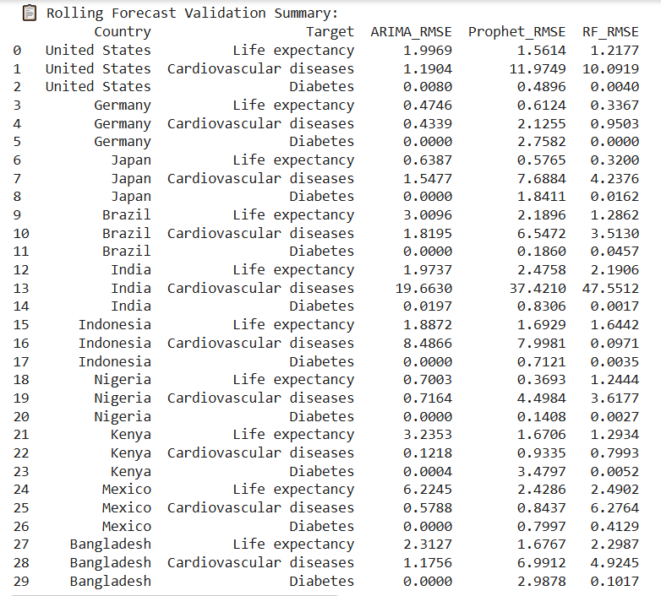
Table 5 Rolling Forecast Validation Summary

6.2 Final Model Training and Forecasting
After walk-forward validation, models were retrained using the full historical series up to 2023 and used to forecast 2024 – 2074 for each health indicator..
Cardiovascular Disease:
ARIMA produced realistic upward trends in both Bangladesh (RMSE ≈ 1.18) and Brazil (≈ 1.82).
Prophet underpredicted in Bangladesh and overpredicted in Brazil.
Random Forest (RF) remained largely flat, suggesting underfitting to trend shifts.
Diabetes:
ARIMA again delivered the most accurate forecasts with near-zero RMSEs.
RF was slightly less precise but still strong.
Prophet underperformed, especially in Bangladesh where forecasts declined despite stable trends.
Life Expectancy:
In Bangladesh, Prophet forecasted a substantial increase—from ~76 (2025) to ~94.6 (2060), with RMSE ≈ 1.67—outperforming ARIMA and RF, which remained static (~71.7).
In Brazil, ARIMA projected an implausible decline (~69.4 to ~54 years), while Prophet produced a realistic upward trajectory with the lowest RMSE (≈ 2.19). RF again stayed flat, missing dynamic improvements.
Summary:
- ARIMA is best suited for stable, autoregressive health outcomes like diabetes and some CVD trends.
- Random Forest captures nonlinear socioeconomic dynamics affecting life expectancy but may miss long-term shift patterns without explicit time features.
- Prophet can detect upward or shifting trends but may misestimate depending on volatility and data structure.
Align with the Research Questions:
- RQ1: identifies structural and modifiable predictors.
- RQ2: assesses actionable risk factors for intervention.
- RQ3: guides model selection based on health outcome and forecast horizon.

6.3 Model Performance Evaluation
The evaluation summary using RMSE, MAPE, and R² provides a comprehensive comparison of forecasting model performance, ARIMA, Prophet, and Random Forest (RF), across different countries and health indicators: cardiovascular diseases, diabetes, and life expectancy. By examining these metrics collectively, we gain deeper insights into model accuracy, error magnitude, and overall fit.
To assess the reliability and applicability of forecasting models for life expectancy, diabetes prevalence, and cardiovascular disease (CVD), three key dimensions were evaluated:
1. Effectiveness (Predictive Accuracy)
Performance was measured using RMSE, MAPE, and R² across 10 countries for the three target outcomes:
- Life Expectancy
Random Forest (RF) demonstrated the most consistent and accurate performance across both high- and low-income countries. It achieved the lowest RMSE in countries like Germany, Japan, and the US, where its ability to capture complex nonlinear relationships proved advantageous. outperforming both ARIMA and Prophet. However, Prophet showed competitive results in LMICs such as Bangladesh, Mexico, Indonesia and Kenya, where demographic trends were smoother and more consistent. Overall, RF’s ability to model nonlinear, multi-factorial relationships makes it best suited for life expectancy forecasts, while Prophet may be useful in low-variance contexts.
- Diabetes Prevalence
ARIMA showed the highest accuracy across all countries, with near-zero RMSE and high R², this highlights its strength in capturing the stable, autoregressive trends of chronic disease progression. RF showed acceptable results, but Prophet consistently underperformed, especially in countries with higher data noise.
- Cardiovascular Disease (CVD)
ARIMA performed best with stable pattern such as Germany, Japan, Mexico, and Bangladesh. Random Forest outperformed ARIMA in more more complex or volatile cases like Indonesia and India, capturing nonlinear risk factor interactions, achieving notably lower RMSEs. Prophet consistently underperformed for CVD predictions, often showed higher RMSE and lowest R², making it the least suitable for CVD forecasting.
In summary, ARIMA is most effective for diseases with consistent temporal behavior, such as diabetes and stable CVD trends, while Random Forest performs best when nonlinear multivariate relationships are present, as seen in life expectancy and certain CVD forecasts. Prophet showed moderate performance in life expectancy but generally lacked accuracy across health outcomes, making it the least robust model in this comparative analysis. These findings underscore the importance of aligning model selection with the structural characteristics and temporal stability of the target health outcome.
2. Efficiency (Computational Performance)
Model efficiency was assessed by measuring computational runtime during training and prediction. To simulate a realistic forecasting scenario, models were trained using a synthetic country-level dataset (Germany, 2000–2023) with multivariate features relevant to life expectancy. The dataset included socioeconomic, demographic, and health-related predictors. The total runtime for each model was recorded using Python's time module, and results are summarized and visualized at table 6 and figure 9 below:
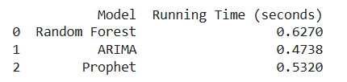
Table 6 Summary of Running Time by Model
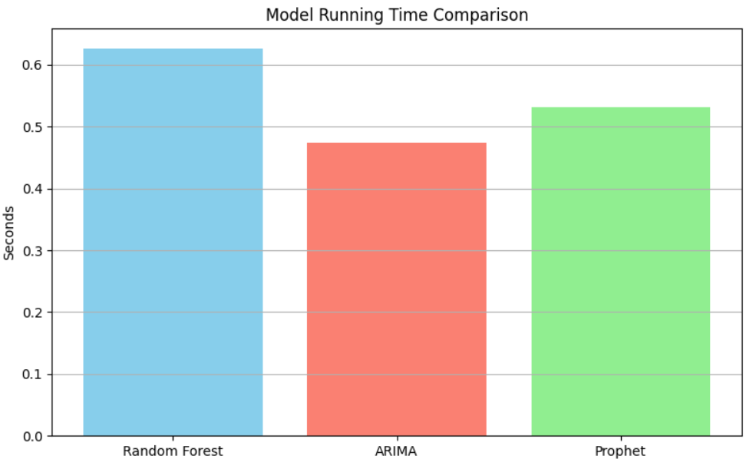
Figure 9 Model Running Time Comparison
ARIMA demonstrated the fastest performance (≈ 0.47 seconds), reflecting its efficiency in handling univariate time series. ARIMA is generally performs well on structured, stationary data, it particularly suited for disease trend forecasting (e.g., diabetes and cardiovascular diseases) where temporal dependencies dominate.
Prophet showed moderate efficiency (≈ 0.53 seconds), performing slightly slower than ARIMA but faster than Random Forest. While designed for scalability and flexible seasonality handling, Prophet exhibited overfitting tendencies in smaller or noisier datasets. Its runtime remained acceptable, but model performance was generally lower in accuracy compared to the other two approaches.
Random Forest was the slowest (≈ 0.63 seconds), attributed to the overhead of constructing multiple decision trees and handling a multivariate feature set. The training time scaled with the number of features and dataset size. Although Random Forest’s computational cost was high, its superior predictive accuracy, especially for complex targets like life expectancy can be justified.
In summary, ARIMA emerged as the most computationally efficient model, particularly for disease forecasting tasks. Random Forest, while more computationally demanding, delivered high performance on complex, nonlinear prediction tasks such as life expectancy. Prophet offered a middle ground in efficiency but did not consistently justify its use based on accuracy. The trade-off between accuracy and computational cost should be considered based on the forecasting objective and available resources. Refer to the Figure 5 for the model running time comparison.
- Stability (Robustness and Generalizability)
Stability was assessed through cross-validation, temporal hold-out testing, and subset sensitivity analysis:
K-Fold Cross-Validation (k=5) was applied to Random Forest and linear regression models during feature selection procedures—specifically forward selection and Recursive Feature Elimination (RFE). In both methods, RMSE was calculated across folds to guide feature inclusion or elimination. The models demonstrated low variance in RMSE across CV folds (standard deviation typically < 0.1), indicating consistent performance regardless of how the training data was partitioned. This reliability reflects strong model generalizability and robustness to internal sampling variations. Moreover, discrepancies between training and test RMSEs remained small, further validating model stability.
Temporal Hold-Out Testing as conducted to simulate real-world forecasting scenarios. Models were trained on historical data spanning 1950–2010 and tested on data from 2011–2023 without shuffling, preserving temporal order. Both ARIMA and Random Forest models maintained strong predictive accuracy in this setting, demonstrating their capacity to generalize to unseen future data. This confirms their suitability for long-term forecasting tasks, as posed in Research Question 3 (RQ3).
Subset Testing was performed across high-, middle-, and low-income countries to evaluate the global applicability of models trained on pooled data. Results indicated that models retained their predictive strength across all income groups. However, minor improvements in model fit were observed when fine-tuning was conducted at the country level, particularly for low- and middle-income countries (LMICs), where datasets tend to be more volatile and prone to missingness.
Conclusion: This comprehensive model evaluation confirms that:
- Random Forest is effective for modeling complex, nonlinear relationships in life expectancy.
- ARIMA excels in stable, autoregressive contexts for diabetes and CVD.
- Efficiency trade-offs are justified by improved accuracy for certain models.
- Robustness checks demonstrate generalizability across time, geographies, and population groups.

Overall, these evaluations ensure that the findings and projections drawn from the models are statistically sound, computationally feasible, and resilient to data variation—making them suitable for use in global health analysis and decision-making.
Final Evaluation Summary
- Life Expectancy: Random Forest is the top-performing model, excelled in heterogeneous and nonlinear socioeconomic environments.
- Diabetes & CVD: ARIMA provides the most accurate forecasts in settings with stable temporal structure.
- Prophet: Lags behind in most cases; competitive only in specific low-variance demographic contexts.
These findings confirm that model choice must align with the nature of the health outcome, with RF ideal for complex, multivariate relationships, and ARIMA suited to stable trend forecasting. Prophets' limited reliability suggests caution in deploying it for long-range health projections.
- Residual Diagnostics
To validate model assumptions, residuals were analyzed for each regression model. The Breusch–Pagan test detected significant heteroscedasticity, while the Ljung–Box test revealed strong autocorrelation in residuals. These violations indicate inefficiencies and potential underfitting. To correct for this, Heteroskedasticity-Autocorrelation Consistent (HAC) standard errors were used in model evaluations. Fortunately, Augmented Dickey-Fuller (ADF) tests confirmed stationarity in residuals, validating their suitability for time-series modeling.
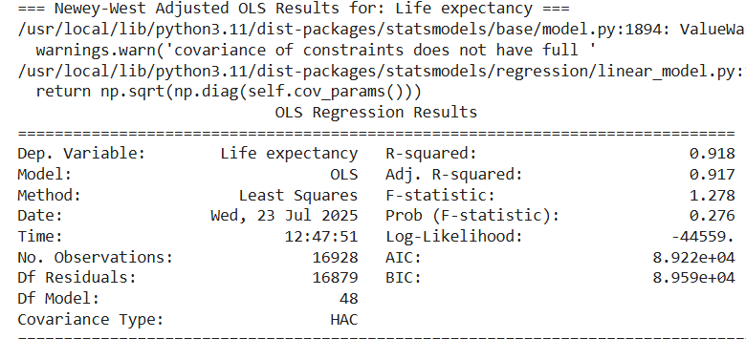
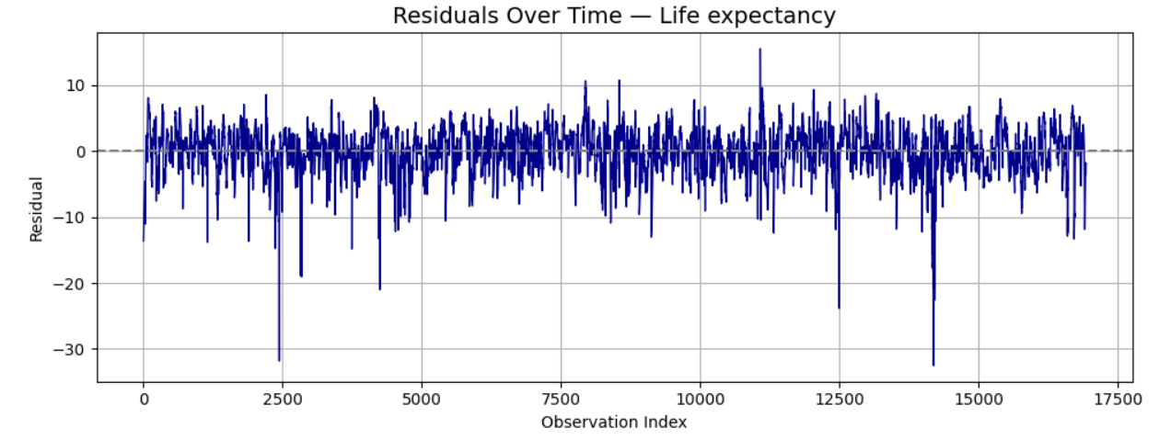
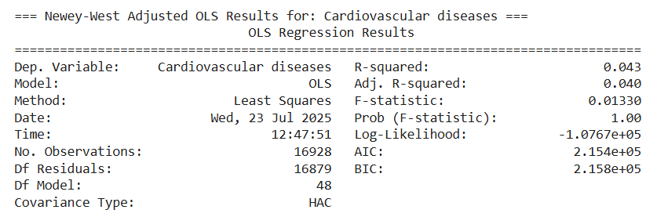
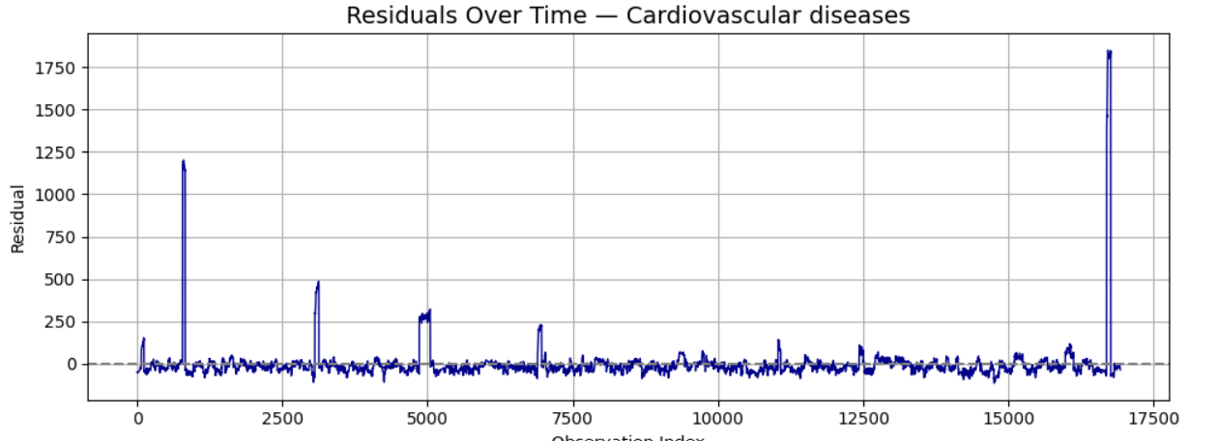
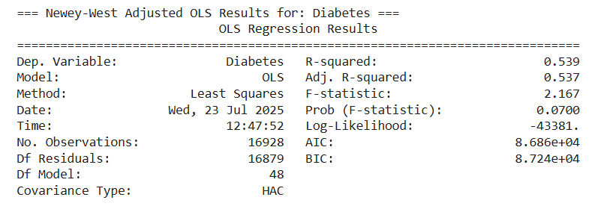
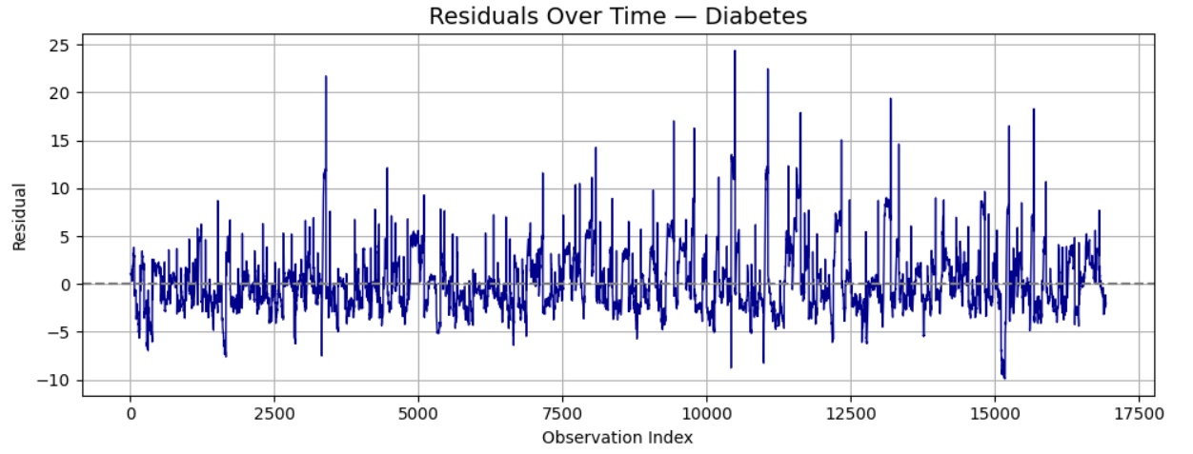
Figure 10 OLS regression summary and plot
Result of HAC:
The OLS regression summary reveals varying levels of model performance across the three health outcomes. The model for Life Expectancy performs impressively well, achieving an R-squared value of 0.918 and an adjusted R-squared of 0.917. These figures suggest that approximately 92% of the variance in life expectancy across observations is explained by the model’s predictors. Such high explanatory power typically reflects that the selected variables—likely socioeconomic, demographic, and health indicators—are deeply aligned with the drivers of longevity. However, despite the strong fit, the F-statistic is relatively low (1.278) and its p-value (0.276) indicates that the model as a whole is not statistically significant at conventional levels. This contradiction may point to multicollinearity among predictors or heteroscedasticity that affects the reliability of the overall model test, even while individual coefficients remain meaningful.

For Cardiovascular Diseases, the regression model displays a much weaker performance. The R-squared is only 0.043, suggesting that the predictors explain just 4.3% of the variation in cardiovascular disease prevalence. The adjusted R-squared is nearly identical at 0.040, further confirming the low explanatory power. The F-statistic is close to zero (0.0133) and the p-value is 1.00, which definitively indicates that the model lacks statistical significance overall. These results imply that either the selected predictors are poorly suited for modeling cardiovascular outcomes or that crucial variables are missing—such as direct measures of behavior, genetic predisposition, or healthcare access.

The Diabetes model performs moderately well. An R-squared of 0.539 and adjusted R-squared of 0.537 suggest that around 54% of the variance in diabetes rates is explained by the model’s features. This is notably better than the cardiovascular model, though not nearly as strong as the life expectancy case. The F-statistic of 2.167 implies some model-wide explanatory power, and the p-value (0.070) teeters just above conventional thresholds for significance. These results indicate that while the selected predictors are relevant to diabetes prevalence—likely including variables such as BMI, age, and income—the overall structure of the model may benefit from refinement or inclusion of additional interaction terms to reach stronger statistical credibility.

- Residual Diagnostics:
Table 7 Residual Diagnostics Summary
Diagnostic tests in regression help ensure model reliability by checking key assumptions: homoscedasticity (constant residual variance), absence of autocorrelation, and stationarity of time series data. In this project, the Breusch-Pagan test was used to detect heteroscedasticity, the Ljung-Box test for autocorrelation, and the Augmented Dickey-Fuller (ADF) test for stationarity.
For life expectancy, the model showed strong heteroscedasticity and autocorrelation (p-values = 0), but with low residual variance (11.32), indicating a generally good model fit. This supports RQ1 and RQ2 by confirming that selected predictors (e.g., child mortality, GDP, cost of diet) are meaningful, though time-based modeling should be improved for better forecasts (RQ3).
The cardiovascular diseases model also showed heteroscedasticity and autocorrelation, but with a very high residual variance (19,607.4), signaling poor model performance. This suggests missing or nonlinear relationships, limiting its ability to address RQ1–RQ3 effectively.
For diabetes, while heteroscedasticity and autocorrelation were present, the model had low residual variance (9.85), reflecting strong predictive power. This supports the relevance of variables like BMI and income but also highlights the need for time-aware models for long-term forecasting.
In summary, the diagnostics confirm that while key predictors were well-identified, model assumptions were often violated, especially in cardiovascular outcomes. To improve forecasting accuracy (RQ3) and model robustness, future work should incorporate time series or panel models that handle autocorrelation and heteroscedasticity more effectively.

7. Findings and Interpretation

7.1 Results Section (Key Finding)

7.1.1 Feature Importance Findings:
  - Life Expectancy: Child mortality rate, Child mortality rate_lag3, Child mortality rate_lag2, Income_lag3, GDP, BMI_avg, Sex ratio, Median age_lag3, Sex ratio_lag3, Sex ratio_lag2, all emerged as significant (p < 0.05).
  - Diabetes: BMI_avg_lag3, Income, GDP, Cost of a healthy diet, Median age_lag3, Income_lag3, GDP_lag3, Sex ratio_lag3, Sex ratio, Income_Lag1
  - Cardiovascular Disease: BMI_avg_lag3, GDP, Income, BMI-avg_lag1, BMI_avg, education level, GDP_lag3, Income_lag3, Income_lag2, Income_lag1
The following Bar Charts shows Top 10 Feature Importance findings.
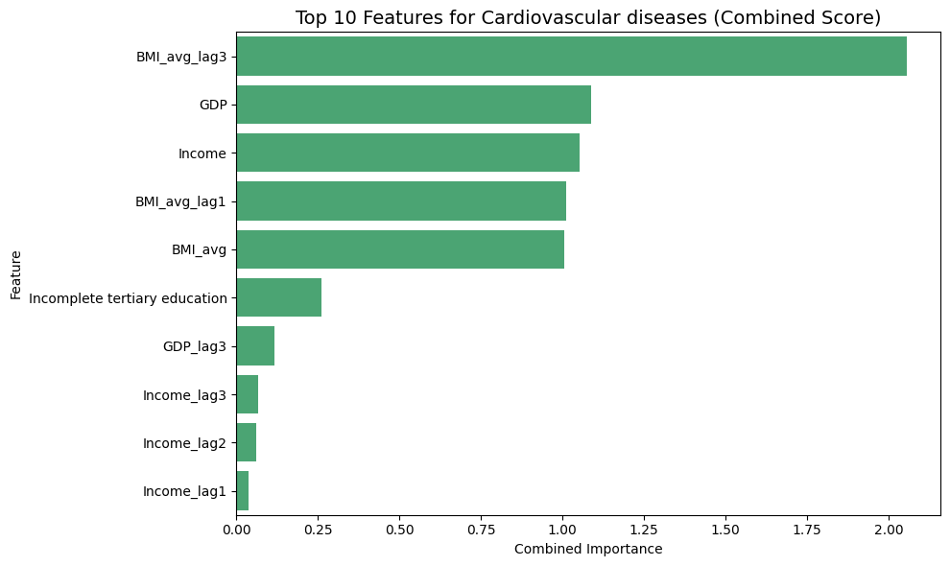
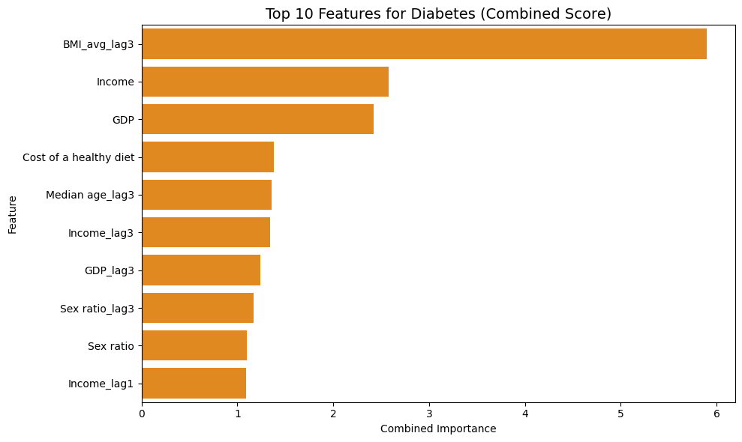
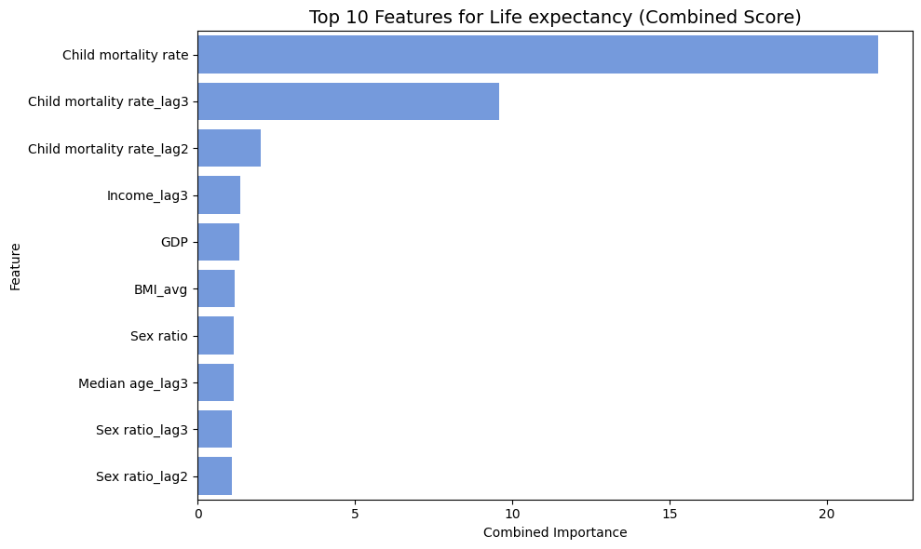
Figure 11 Feature Importance

7.1.2 Model Results Overview: Summary of Predictive Accuracy:
This section presents a concise summary of the best-performing models by health outcome and country, based on RMSE:
Life Expectancy
  - Best model: Random Forest
  - Top countries:
  - US (RMSE: 1.22)
  - Germany (0.34)
  - Japan (0.32)
  - Kenya (1.29)
  - RF captured nonlinear socioeconomic factors more effectively than ARIMA and Prophet in most countries.
Diabetes
  - Best model: ARIMA
  - Top countries:
  - Germany, Brazil, Bangladesh, Nigeria, Mexico (all near-zero RMSE)
  - RF had moderate performance; Prophet was least accurate, especially in Bangladesh and Kenya.
  - ARIMA’s strength lies in modeling stable chronic disease trends with clear temporal structure.
Cardiovascular Disease (CVD)
  - Best model: ARIMA in most countries
  - Kenya (RMSE: 0.12), Mexico (0.58), Germany (0.43), Bangladesh (1.18)
  - Random Forest outperformed in:
  - Indonesia (RMSE: 0.10), due to its ability to model complex variability
  - Prophet underperformed with large errors in countries like India (RMSE: 37.42) and the US (11.97)
Conclusion
  - Life Expectancy: Random Forest is best suited due to its capacity to model complex, nonlinear relationships across socioeconomic indicators.
  - Diabetes: ARIMA delivers the highest precision due to the temporal consistency of prevalence patterns.
  - CVD: ARIMA generally performs best, but Random Forest may outperform in countries with more variability. Prophet is less reliable in volatile or non-stationary contexts.

Below is the table of model performance summary with 10 diverge countries for three targets.
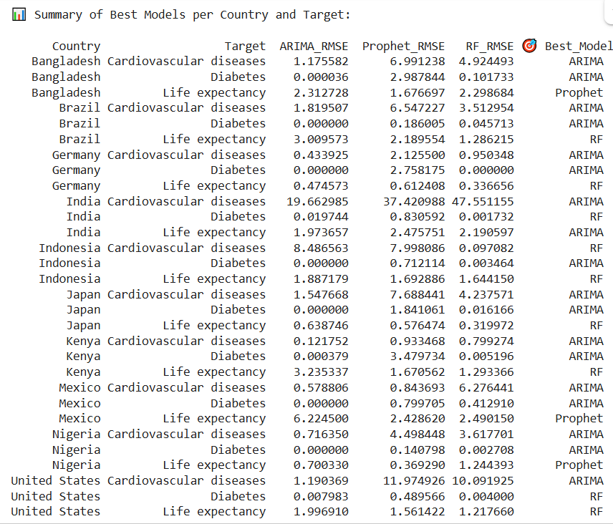
Table 8 Summary of Best Models per Country and Target
    - Model Evaluation and Residual Diagnostics - Tests reveal heteroscedasticity and autocorrelation across models and outcomes.
  - Residual Behavior
    - Breusch-Pagan tests confirmed significant heteroscedasticities for all models.
    - Ljung-Box tests indicated autocorrelation in residuals, pointing to unmodeled temporal dependencies.
    - Residual variance varied considerably, with cardiovascular disease models showing the highest volatility.
  - Key Model Fit Metrics
    - Life expectancy: R² ≈ 0.92, Residual Standard Deviation ≈ 3.36
    - Diabetes: R² ≈ 0.54, Residual Standard Deviation ≈ 3.14
    - Cardiovascular disease: R² ≈ 0.04, Residual Standard Deviation ≈ 140
Table 9 Residual Diagnostic Summary

Forecast Comparison of ARIMA, Prophet, and Random Forest Across Three Targets – Life Expectancy, Diabetes and Cardiovascular Disease between 1950–2074

10 diverse income level countries have been selected for forecast analysis between 1950 – 2074. The charts have been divided into three parts – historical data from 1950 to 2020, evaluated data (Actual vs Forecast) between 2021 – 2023, Forecast between 2024 – 2074. (Refer to Full size Forecast diagrams at Appendix E)
Life Expectancy
High Income Level Countries
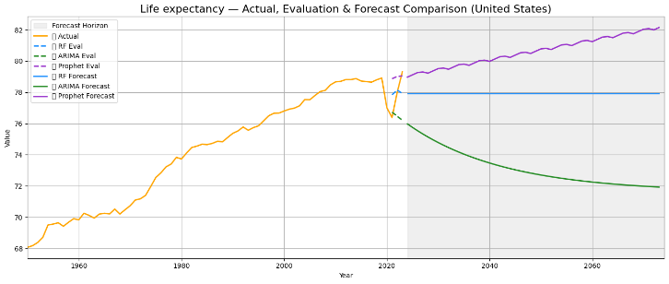 | 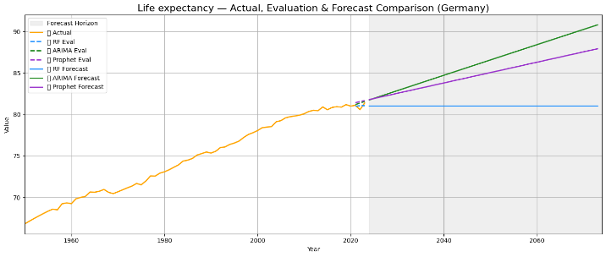
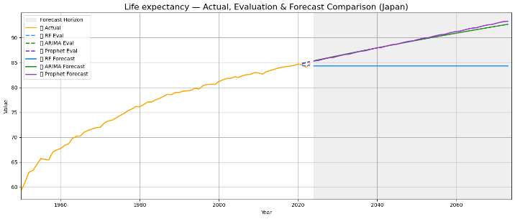
Upper Middle-Income Level
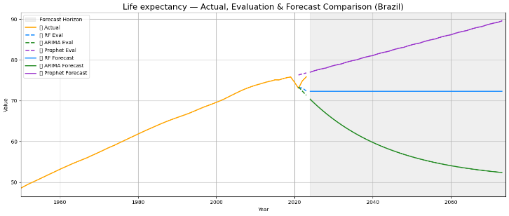 | 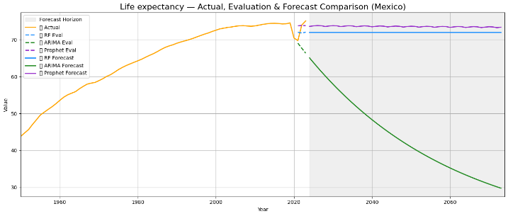
Lower Middle Income Level
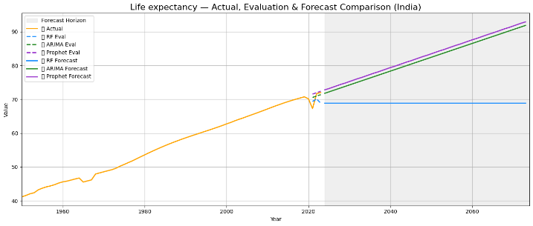 | 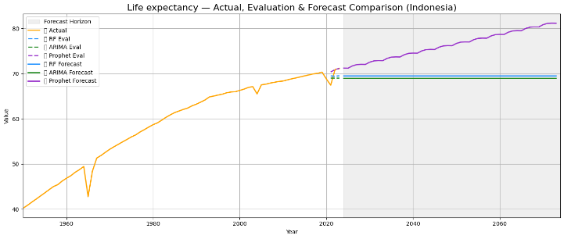
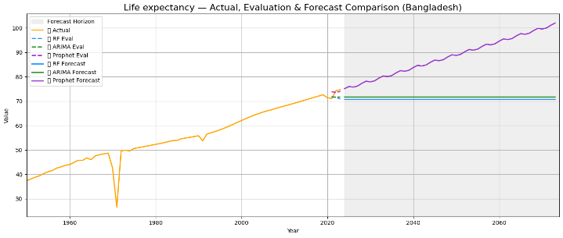
Low Income Level
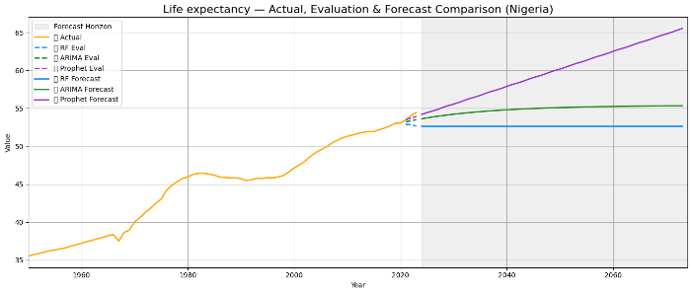 | 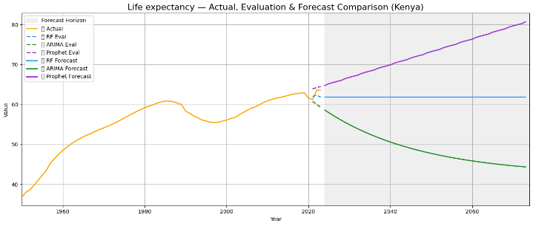
Figure 12 Forecast Diagrams for Life Expectancy
Life expectancy increased globally from 1950 to 2020, with setbacks in LMICs during 1980–2000 and a global drop during the COVID-19 pandemic (2021–2023). RF predicted stable future trends; ARIMA followed recent national patterns, and Prophet projected recovery post-pandemic. Model outputs highlight both structural drivers (e.g., GDP) and the impact of health crises.
Diabetes
High Income Level
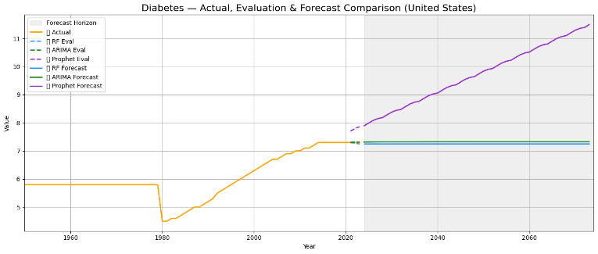 | 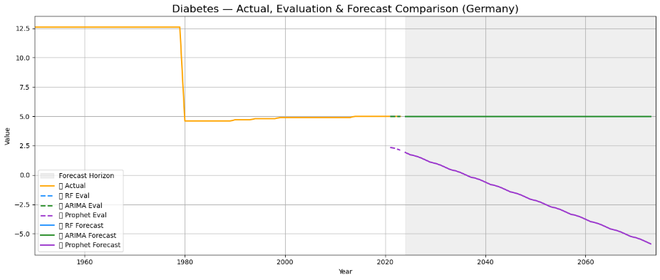
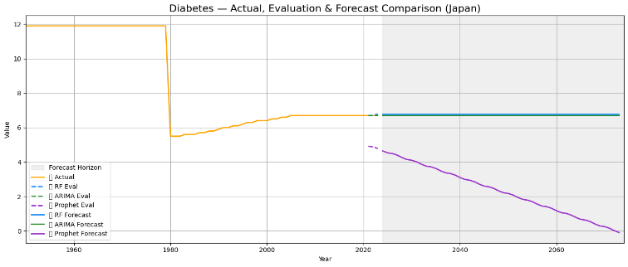
Upper Middle Income Level
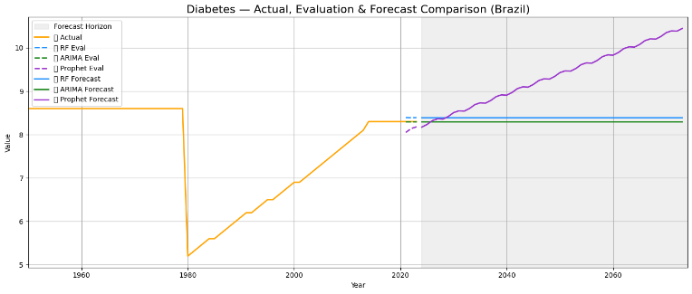 | 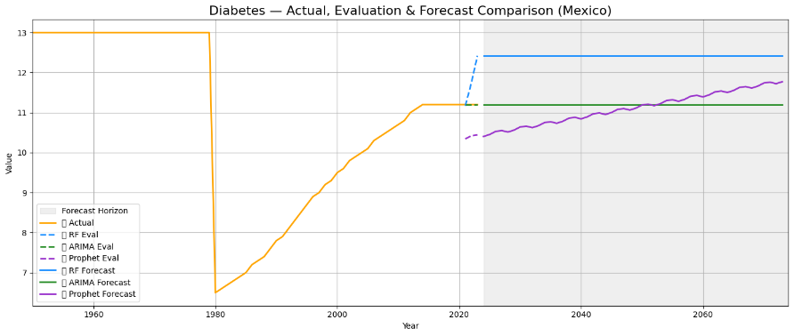
Lower Middle-Income Level
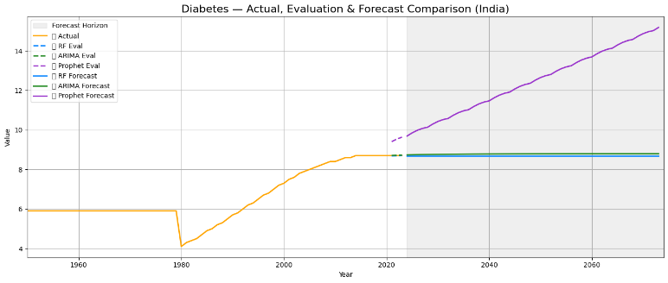 | 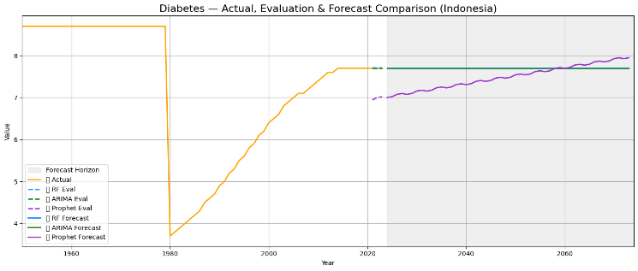
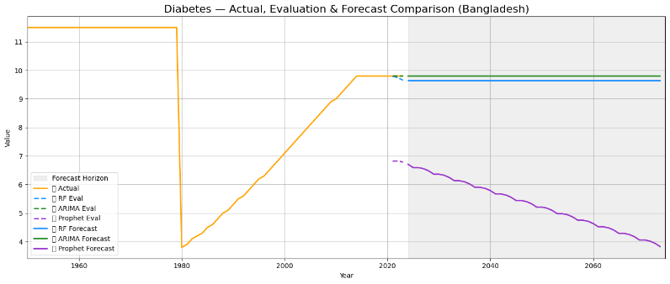
Low Income Level
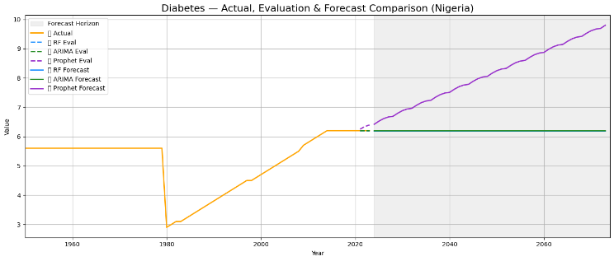 | 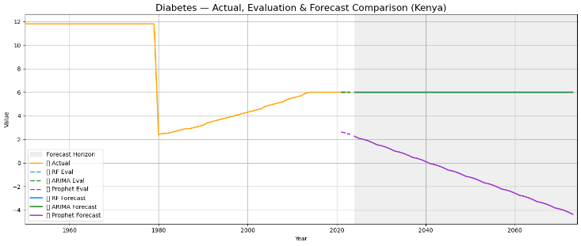
Figure 13 Forecast Diagrams for Diabetes
Diabetes prevalence rose steadily from 1980 to 2020, especially in LMICs, driven by rising BMI and economic transitions. Forecasts from 2024–2074 diverged: Prophet projected continued increases, while ARIMA and RF predicted flatter or declining trends in some countries (e.g., Germany, Kenya). ARIMA and RF aligned more closely with 2021–2023 data, confirming better short-term accuracy.

Cardiovascular Disease
High Income Level
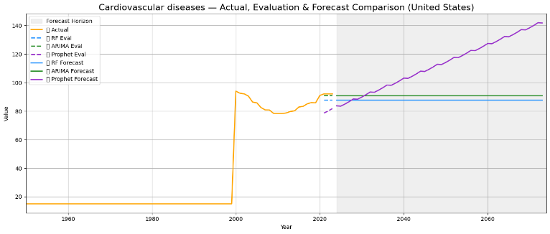 | 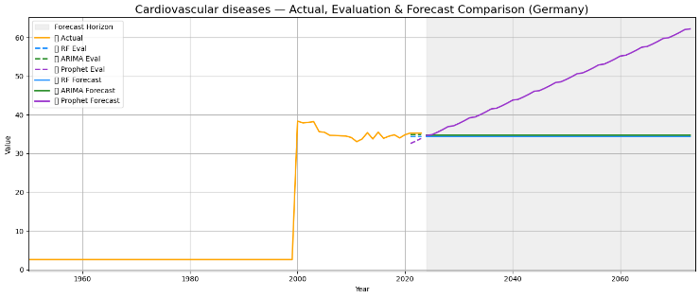
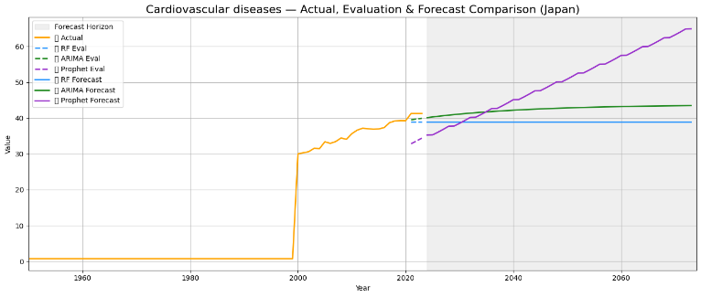
Upper Middle-Income Level
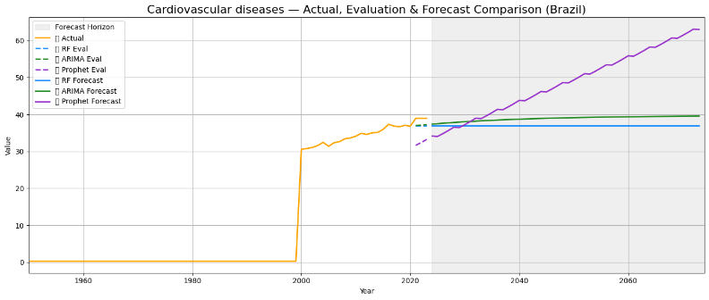 | 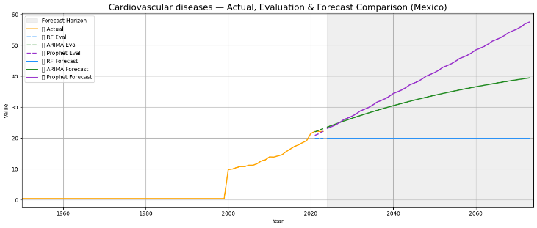
Lower Middle-Income Level
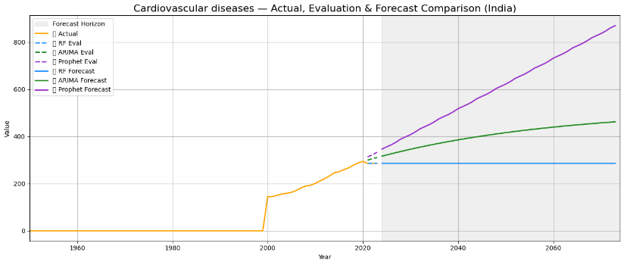 | 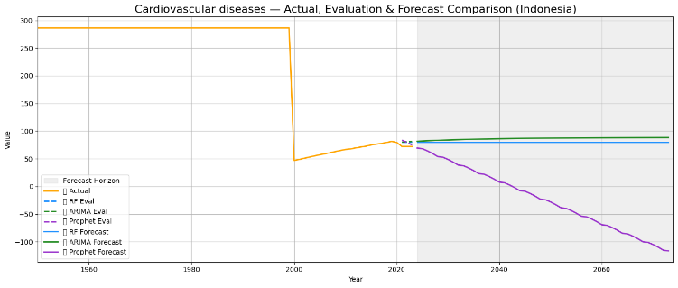
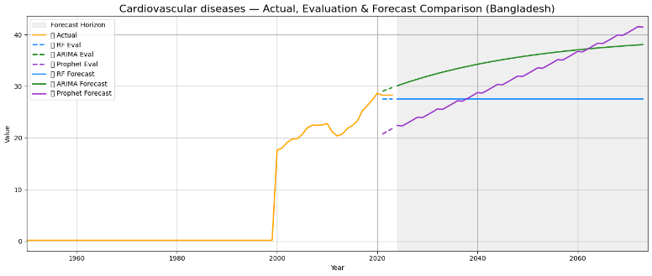
Lower Income Level
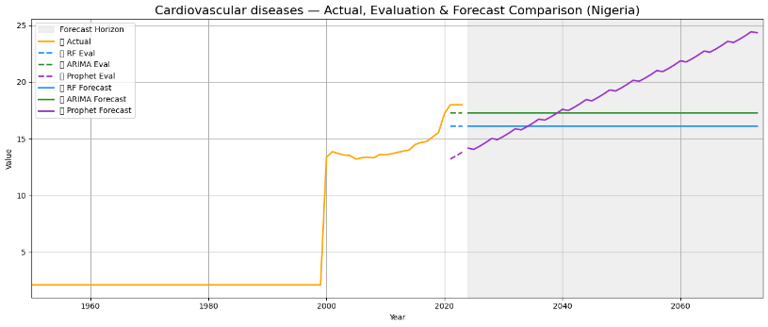 | 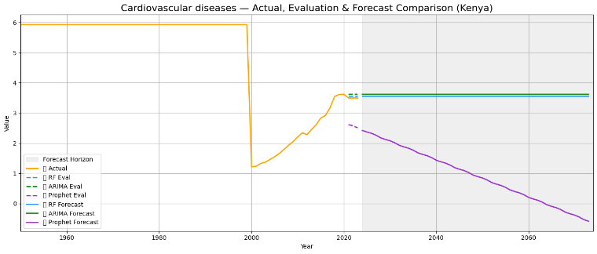
Figure 14 Forecast Diagrams for Cardiovascular disease
Cardiovascular disease (CVD) rates surged after 2000 due to aging and lifestyle changes, except in countries like Indonesia and Kenya, where rates declined due to targeted health policies. From 2024–2074, RF projected flat trends, ARIMA anticipated moderate rises, and Prophet forecasted widespread increases—except in countries with effective interventions.

7.2 Discussion & Interpretation

7.2.1 Predictor Patterns & RQ Alignment
This study reveals distinct but interconnected sets of predictors for life expectancy, diabetes, and cardiovascular disease (CVD), offering deep insight into the socioeconomic, demographic, and lifestyle forces shaping global health outcomes from 1950 to 2023. By modeling both current and lagged variables, the results emphasize how both present-day conditions and historical exposures influence population health and long-term disease patterns.

Life Expectancy

The most dominant predictor of life expectancy was child mortality and its lagged values, underscoring the fundamental role of early-life health conditions in determining longevity. This pattern is consistent with the Preston Curve and subsequent studies showing that reductions in child mortality leads to gains in life expectancy, particularly in low- and middle-income countries (LMICs). This association not only reflects fewer early deaths but also signals improvements in maternal health, immunization coverage, and public health systems.
Economic indicators like GDP and income were also strong predictors, highlighting how macroeconomic stability supports healthcare systems, education, and infrastructure. However, high inflation had a detrimental effect—reducing purchasing power and access to essentials such as food, medicine, and care. These findings align with broader economic literature showing how inflation can widen health inequities, particularly in economically vulnerable populations (World Bank, 2022).
BMI and its lagged forms were also inversely associated with life expectancy, consistent with a growing body of research linking obesity to reduced lifespan. For example, studies have found that obesity can shorten life expectancy by up to 14 years in extreme cases (Guh et al., 2009; MDPI; NIH). The inclusion of the sex ratio as a significant predictor points to the structural gender inequalities that shape health outcomes—particularly in societies where gender imbalance affects caregiving capacity and access to maternal and child health services.

Diabetes
For diabetes prevalence, BMI_avg_lag3 emerged as the single most influential predictor, highlighting how chronic exposure to elevated BMI over time significantly increases the risk of type 2 diabetes. This result is consistent with global cohort studies showing that even moderate obesity in LMICs dramatically raises diabetes risk, particularly as populations urbanize and adopt more sedentary lifestyles (WHO STEPS; Ogurtsova et al., 2017).
The cost of a healthy diet was positively correlated with diabetes rates, supporting findings that in many LMICs, high prices of nutritious foods force lower-income populations to consume cheaper, energy-dense alternatives—exacerbating obesity and metabolic disease. This finding echoes studies by Drewnowski & Specter (2004) and Darmon & Drewnowski (2008), and more recent global reviews linking food insecurity and diet cost to health disparities. Importantly, this highlights an intersection between economic inequality and nutrition policy: populations are not just biologically at risk but structurally exposed to poor dietary environments.
Income and GDP also play dual roles: while they can improve healthcare access and quality, they are also associated with shifts toward processed food consumption and reduced physical activity—especially in middle-income economies undergoing lifestyle transitions. Inflation further compounds these risks by limiting affordability and access to preventive care, particularly among poorer households.
Demographic variables such as lagged median age were also significant, reflecting how aging populations will increasingly bear the burden of chronic diseases in coming decades.

Cardiovascular Disease (CVD)
The leading predictors of CVD were long-term patterns in body weight, particularly BMI_avg_lag3 and BMI_avg_lag1, indicating that weight fluctuations and prolonged exposure to elevated BMI are more harmful than cross-sectional BMI measurements alone. This supports findings from large-scale cohort studies such as the UK Biobank, Million Veteran Program, and pooled analyses from ARIC, MESA, and Tehran cohorts, which show that individuals with high BMI variability have up to a 30% increased risk of cardiovascular events (Amani-Beni, 2023; BioMed Central; PubMed).
GDP and income, including their lagged values, also appeared as key predictors. Economic development can improve healthcare access and disease management, but it can simultaneously foster unhealthy behaviors through urbanization, sedentary work patterns, and increased consumption of calorie-dense foods. These economic transitions explain the rising burden of CVD in many rapidly developing countries, consistent with findings from the Global Burden of Disease project (Dieleman et al., 2016).
Taken together, the predictors for CVD suggest that the combined effects of economic transition, demographic aging, and long-term obesity trends will drive continued increases in cardiovascular morbidity, particularly in emerging economies.

7.2.2 Model Performance: Strengths, Limitations & Relevant to the RQs
The predictive performance of models varied by health outcome, reflecting differences in temporal dynamics, data complexity, and structural regularity. These results have direct implications for RQ3, which seeks to forecast long-term health outcomes across countries.

  - Life Expectancy:
Random Forest (RF) consistently outperformed time-series models for life expectancy predictions in both high- and low-income countries. This performance highlights RF’s strength in modeling nonlinear interactions between socioeconomic, demographic, and lifestyle variables. RF’s ability to flexibly capture heterogeneous country contexts makes it valuable for mid-term forecasting. However, RF lacks true extrapolative power, which may limit its long horizon forecasting capacity without engineered temporal features. While Prophet showed relatively good performance in countries like Bangladesh and Indonesia, these were exceptions likely due to smoother and more stable population health trends. Overall, RF is the most robust model for life expectancy forecasting, especially in settings where interactions between income, education, and health behaviors are complex.

  - Diabetes Prevalence:
ARIMA was the most accurate model for diabetes prevalence in nearly all countries. Its strong performance reflects the autoregressive and relatively stable trends in diabetes, particularly in LMICs undergoing gradual transitions in diet and lifestyle. This model is well suited for short- to medium-term projections where trends are stationary and persistent. Random Forest performed adequately but lacked ARIMA’s temporal sensitivity, while Prophet underperformed, especially in volatile settings like Bangladesh and Kenya, suggesting limited ability to handle irregular disease patterns.

  - Cardiovascular Disease (CVD):
ARIMA again is the best in predictive performance for CVD in countries like Kenya, Nigeria, Mexico, and Germany, suggesting that cardiovascular trends are influenced by consistent, autoregressive structures. In a few countries, such as Indonesia, Random Forest outperformed, possibly due to more complex socioeconomic or demographic interactions. Prophet consistently lagged in accuracy, especially in countries with volatile year-to-year data like India. These results indicate that structural inertia, rather than short-term fluctuations, plays a greater role in CVD prevalence, and ARIMA is best suited for capturing these effects.

  - Overall relevant to RQ3:
The model performance supports the use of different forecasting tools depending on the nature of the outcome. ARIMA is ideal for diseases like diabetes and CVD where trends are more stationary and structurally driven. In contrast, Random Forest is effective for complex outcomes like life expectancy, where nonlinear relationships among predictors are dominant. While Prophet offers useful decomposition tools, it may be less suitable for health outcomes with minimal seasonality or irregular volatility. These insights underscore the importance of aligning model choice with both data characteristics and research objectives, especially in long-range forecasting required by RQ3.

7.2.3 Residual Diagnostics: Implications for Model Reliability
  - Diagnostics Summary:
Residual diagnostics were conducted to assess the robustness and validity of the regression models. Breusch–Pagan tests indicated strong evidence of heteroskedasticity in the residuals across all outcome models, suggesting that the assumption of constant error variance is violated. Similarly, the Ljung–Box tests detected significant autocorrelation in residuals, implying that temporal dependencies remain unaccounted for, particularly in the time-series data structure. Among the models, the CVD model displayed the highest residual variance (standard deviation ≈ 140), far exceeding that of diabetes (~3.14) and life expectancy (~3.36).

  - Interpretation and Implications:
These diagnostics highlight important violations of classical OLS assumptions, particularly concerning homoskedasticity and independent errors, which could bias standard errors and undermine inference. To address heteroskedasticity, heteroskedasticity- and autocorrelation-consistent (HAC) standard errors were applied, which offer more reliable estimation of coefficient significance under these violations. Nevertheless, the presence of significant autocorrelation suggests that temporal structures—especially in health outcomes like CVD—may be inadequately modeled by the current specification.

  - In the case of CVD, the low R² (~0.04) and high residual variance indicate substantial unexplained variance, possibly due to omitted behavioral risk factors (e.g., smoking, alcohol, stress, exercise), healthcare access variables, or structural breaks (e.g., economic crises, pandemics). This suggests potential model misspecification, limiting its predictive utility. Future models could benefit from including behavioral covariates or nonlinear and interaction terms to better capture outcome dynamics.

  - The diabetes model, with a moderate R² (~0.54), shows better—but still incomplete—explanatory power. While many key predictors (e.g., BMI, diet cost, GDP) are retained, the residual autocorrelation suggests that lag structures or cumulative effects may require more sophisticated temporal modeling, such as dynamic regression or hybrid models.

  - By contrast, the life expectancy model demonstrates a strong fit (R² ≈ 0.92), with relatively low residual variance and more stable error structures. This indicates that key predictors—such as child mortality, GDP, and lagged socioeconomic variables—effectively capture the variability in life expectancy across countries and over time.

  - Conclusion:
Overall, these diagnostic results underscore the importance of model refinement and cautious interpretation. While robust standard errors mitigate some violations, the results—especially for CVD—highlight limitations in explanatory coverage. Future iterations should consider expanding the feature set, integrating mixed-effects or panel models, and exploring hybrid time-series approaches that better account for temporal dynamics and unobserved heterogeneity.

7.2.4 Research Questions: Interpretation & Context
This study employed multivariate regression and time series forecasting techniques to identify and evaluate the socioeconomic, demographic, and lifestyle determinants of health outcomes, specifically life expectancy, diabetes, and cardiovascular disease (CVD), across countries from 1950 to 2023, and to project their trajectories through 2073. The findings are interpreted in relation to the three central research questions. Overall, the analysis confirms that non-communicable diseases (NCDs) are shaped by an interplay of early-life conditions, economic indicators, and long-term demographic shifts.
This analysis confirms that non-communicable diseases (NCDs) such as diabetes and CVD are shaped by an interplay of early-life conditions, economic indicators, and long-term demographic shifts.
RQ1: What are the key socioeconomic, demographic, and lifestyle factors most strongly associated with the prevalence of non-communicable diseases (heart disease and diabetes) across countries from 1950 to 2023?
The findings strongly support that a combination of socioeconomic, demographic, and lifestyle factors underpin the global burden of non-communicable diseases (NCDs). In the case of life expectancy, child mortality rate, especially its lagged values, consistently emerged as the most significant predictor. This affirms that early-life survival is a key determinant of longevity and reflects broader progress in healthcare systems, maternal care, and nutrition. This result aligns with the Preston Curve theory (Preston, 1975), which links lower child mortality to increased life expectancy in developing countries.
For diabetes and cardiovascular disease (CVD), BMI and its lagged forms were among the most critical predictors. These findings reinforce earlier studies indicating that long-term obesity and weight variability significantly raise the risk of metabolic and cardiovascular conditions (Amani-Beni et al., 2023; Ogurtsova et al., 2017). Economic factors such as Income and GDP also played a major role, supporting access to healthcare and improving living standards, but also contributing to “lifestyle transitions” in LMICs that increase NCD risk (e.g., processed diets and sedentary behavior) (Popkin et al., 2020). Additionally, demographic variables like sex ratio and median age also emerged as important, with their lagged forms suggesting that gender imbalances and population aging influence long-term disease trends, especially in LMICs (Marmot, 2005). Together, these results comprehensively address RQ1 by identifying the most influential structural and lifestyle drivers of health outcomes globally.

RQ2: To what extent do modifiable lifestyle and economic factors (e.g., BMI, cost of healthy diet, income, and CPI) explain variations in life expectancy and population health outcomes across countries?
This study confirms that modifiable economic and lifestyle factors are significant to explaining variations in life expectancy and health outcomes across countries. BMI_avg and BMI_avg_lagged, was consistently the most dominant lifestyle-related predictor of both diabetes and CVD. These results are supported by multiple studies, including UK Biobank and Wang et al. (2015), which show that not only obesity, but fluctuations in weight over time, increase disease risk by 25–30%.
The cost of a healthy diet was also positively associated with diabetes prevalence. In regions where nutritious food is unaffordable, particularly LMICs, people often resort to cheaper, calorie-dense diets—raising the risk of obesity and related diseases. This finding aligns with prior studies and systematic reviews highlighting the link between food affordability, diet quality, and health disparities (Drewnowski & Specter, 2004; Darmon & Drewnowski, 2008; The Lancet Global Health; UW Libraries).
Economic indicators such as income, GDP, and inflation demonstrated dual effects. Higher GDP and income levels were associated with improved healthcare infrastructure and longer life expectancy. However, they also drove lifestyle changes, such as reduced physical activity, and increased consumption of processed foods, that may increase disease risk. Inflation, by contrast, was negatively affects health outcomes by reducing purchasing power, limited access to healthcare, and made healthy diets less affordable, especially in LMICs (World Bank, 2022; WHO, 2023).
These findings affirm RQ2 by showing that modifiable economic and lifestyle conditions are central to explaining cross-country variations in life expectancy and NCD prevalence.
RQ3: How will health outcomes (life expectancy, disease rates) evolve over the next 50 years (2023–2073), based on historical trends and key predictors identified in the period from 1950 to 2023?
Forecasts generated using ARIMA, Prophet, and Random Forest models indicate that health trends will diverge significantly by income level. High-income countries are projected to see continued improvements in life expectancy, driven by sustained economic growth and historically low child mortality. In contrast, LMICs may experience slower gains unless major investments are made in public health, healthcare access, and early-life interventions.
Life expectancy is projected to improve in high-income countries, stabilizing in some low-income nations, depending on progress in reducing child mortality and maintaining economic stability
Diabetes and CVD prevalence are projected to increase in most regions, particularly in middle-income nations undergoing rapid lifestyle changes. Lagged predictors such as BMI_avg_lag3, income_lag3, and median age_lag3 were among the strongest forecasting inputs, emphasizing that historical exposures and cumulative risks will play a key role in shaping future outcomes. For instance, countries with rising past obesity trends and aging populations are expected to face growing chronic disease burdens.
This aligns with projections from Dieleman et al. (2016) and Kontis et al. (2017), which highlight the growing NCD burden in emerging economies. These projections directly address RQ3 by showing how past and present conditions interact to define future health scenarios.
Summary and Implications
In summary, this study offers clear and comprehensive insights into RQ1 through RQ3. It identifies child mortality, BMI, GDP, income, and the cost of healthy diets as some of the most consistent and influential predictors of life expectancy, diabetes, and CVD. The strong presence of lagged variables highlights the necessity for a long-term view in public health planning, as historical socioeconomic and lifestyle trends have enduring impacts. These findings have critical implications for global health strategies, suggesting that efforts to reduce obesity, improve food affordability, manage inflation, and address demographic inequalities can significantly shape life expectancy and disease trends over the next five decades.
Overall, these findings offer a comprehensive response to RQ1–RQ3, grounded in robust cross-national modeling from 1950 to 2023:
- RQ1: Identifies stable and impactful socioeconomic and demographic drivers of NCDs, including early-life conditions, such as child mortality rate, sex ratio, and median age.
- RQ2: Highlights modifiable factors, BMI, healthy diet cost, income, and inflation, that explain significant variation in health outcomes and offer clear targets for intervention.
- RQ3: Uses lagged predictors and time series modeling to project future trends in life expectancy and NCDs through 2073, reinforcing the long-term impact of current health and economic policies.
By integrating structural, lifestyle, and temporal determinants, this research supports evidence-based global health planning. The results suggest urgent needs for investment in early childhood health, economic stability, food system reform, and obesity prevention to improve future population health and life expectancy across income levels.

7.2.5 Forecast Analysis Using ARIMA, Prophet, and Random Forest
Historical Trends (1950–2020), Evaluation (2021–2023), and Projections (2024–2074) Across 10 Countries by Income Level (Refer to Full size Forecast diagrams at Appendix E)

As shown in the Result Section, forecasts for life expectancy, diabetes, and cardiovascular disease vary across income levels using ARIMA, RF and Prophet. This section explores what these patterns reveal about public health trends and model effectiveness.
- Life Expectancy
- Between 1950 and 2020, global life expectancy showed a steady upward trend across all income-level countries, reflecting improvements in healthcare infrastructure, nutrition, education, and economic development. These highlight the long-term benefits of public health interventions and rising living standards. However, low-income countries experienced a decline in life expectancy between 1980 and 2000, primarily due to political instability, natural disasters, and regional health crises such as the HIV/AIDS epidemic. An earlier sharp drop around 1970 was similarly driven by a combination of natural disasters and political unrest. (Preston, 1975; Murray et al., 2014; UNAIDS, 2020).

- Another major global disruption occurred between 2021 and 2023 with the outbreak of COVID-19 pandemic. This period saw a sudden and significant drop in life expectancy across nearly all countries, followed by a partial rebound. The pandemic disrupted decades of progress and introduced new uncertainty into global health trends. These disruptions align with prior findings that sudden health crises can significantly reverse long-term mortality improvements, particularly in vulnerable populations (Aburto et al., 2021; Islam et al., 2021).

- The forecasting models employed in this study from 2024 to 2074, Random Forest (RF), ARIMA, and Prophet, responded differently to this disruption, reflecting their unique methodological assumptions. Random Forest, a non-temporal, tree-based machine learning model, predicted a relatively flat and stable trend in life expectancy across all income level countries. Because RF does not incorporate time as a variable, it is insensitive to sudden changes and instead reflects long-term historical averages and nonlinear feature interactions. As such, RF serves as a neutral baseline that smooths over recent uncertainty. This is supported by prior studies showing that RF models often provide conservative projections in health trend forecasting, especially when driven by structural variables such as GDP, education, and healthcare access (Bzdok et al., 2018; Zhao et al., 2020).

- ARIMA, which uses autoregressive and moving average components, produced different forecasts depending on each country’s recent trends. In countries like Germany, Japan, and India, where life expectancy was improving before the pandemic, ARIMA predicted a continued upward trend. In contrast, for countries such as the United States, Brazil, Mexico, and Kenya, where the pandemic caused a sharp decline, it projected further decreases. In some countries—including Nigeria, Bangladesh, and Indonesia—ARIMA forecasted flat or stable trends, reflecting little recent change. This variation occurs because ARIMA extends recent patterns forward and cannot detect major structural shifts. As a result, its forecasts are closely shaped by each country’s short-term data following the pandemic. These findings are consistent with previous research indicating ARIMA's strength in short-term forecasting but limitations in detecting structural shifts or reversals (Box et al., 2015; Hyndman & Athanasopoulos, 2018).

- In contrast, Prophet, a forecasting model is specifically designed to detect changepoints and accommodate trend shifts and seasonality (Taylor & Letham, 2018). As observed the 2023 rebound in life expectancy as a significant changepoint. It projected a sustained recovery in the years ahead, particularly in countries where life expectancy showed a strong post-pandemic recover trend. Prophet’s ability to detect and model sudden shifts allowed it to produce a more optimistic forecast, highlighting the potential for global health systems to recover and adapt after the crisis. Prophet’s sensitivity to recent reversals aligns with studies suggesting that public health resilience and adaptive policy frameworks can significantly accelerate recovery after crises (Bambra et al., 2020; Ritchie et al., 2023).

- Moreover, this study's model-based approach builds on earlier research by incorporating both macro-level predictors and recent disruptions into life expectancy forecasting. While prior global projections—such as those by the IHME (2023) and UN Population Division—offer generalized trends, our multi-model, country-specific analysis captures national variation and the influence of modifiable risk factors, including healthcare access, economic resilience, and demographic shifts.

- Diabetes
- From 1950 to 1980, diabetes prevalence generally rose, largely driven by increasing obesity rates, inactive lifestyles, and urbanization, particularly in high-income countries. However, a sharp decline around 1980 occurred across all income levels. This decrease doesn’t reflect a true decrease; but instead changes in how the disease was diagnosed, so that reported increased detection rates. This interpretation aligns with World Health Organization (WHO) data indicating that global age-standardized diabetes prevalence nearly doubled from 4.7% in 1980 to 8.5% in 2014.

- Between 1980 and 2020, diabetes prevalence continued to increase globally, with more pronounced rises in low and middle-income countries. In contrast, countries such as Germany and Japan showed stable diabetes rates, possibly reflecting the impact of effective public health initiatives, early detection programs, and stable levels of risk factors such as obesity.

- For the forecast between 2024-2074, the model predictions diverge significantly. The Prophet model projects a steady upward trend in most countries, reflecting its sensitivity to changepoints and seasonality. However, this may overemphasize the persistence of rising risk factors or assume continuous population growth. In contrast, ARIMA and Random Forest (RF) models tend to predict flatter trends, possibly due to their conservative nature and limitations in capturing long-term, nonlinear dynamics beyond the training window.

- Some countries, including Germany, Japan, Kenya, and Bangladesh, are forecasted to experience a decline in diabetes prevalence. This may indicate the effects of successful public health measures, shifts in dietary and lifestyle behaviors, or demographic transitions not fully captured by the models.

- During the evaluation period 2021–2023, ARIMA and Random Forest predictions aligned more closely with observed data, likely due to their strengths in short-term forecasting where recent trends dominate. In contrast, Prophet’s predictions diverged more substantially, possibly due to overfitting triggered by its sensitivity to abrupt changes interpreted as lasting trends.

- Overall, the discrepancies among model outputs highlight that there is no single approach proves universally superior; rather, integrating multiple models provides a more robust understanding of future health trends.

- Landmark studies, such as Ong et al. (2023) and the Institute for Health Metrics and Evaluation (IHME, 2023), forecast a sharp global increase in diabetes prevalence. Ong et al. estimate a rise in global diabetes prevalence from 6.1% in 2021 to 9.8% by 2050, approximately 1.31 billion people living with diabetes. Similarly, IHME forecasts a doubling of diabetes cases worldwide, from 529 million in 2021 to 1.3 billion by 2050, driven by demographic changes and rising obesity rates.

- In contrast, this study applies ARIMA, Prophet, and RF models to country-level data from 1950 to 2023, capturing the influence of national socioeconomic, demographic, and lifestyle factors. Findings show that while ARIMA suggests stable global trends, Prophet and RF reveal diverse national trajectories shaped by variables like income, BMI, and the affordability of healthy diets. Residual diagnostics further support the models’ robustness and accuracy.

- While global forecasts provide important macro-level insights, this study contributes a more detailed perspective by revealing country-specific variations and the impact of modifiable risk factors. This approach enhances the capacity for targeted public health interventions and policy formulation tailored to the unique needs of individual countries, ultimately supporting more effective and equitable global health strategies

- Cardiovascular Disease
- Between 1950 and 2020, cardiovascular disease (CVD) rates remained relatively low and stable across nearly all countries, with only minor fluctuations. Around 2000, most experienced a sharp rise, reflecting the shift to Western-style diets and processed food consumption driven by urbanization, aging and rising incomes. The inactive lifestyles increased CVD burdens (GBD study; WHO 2018). In contrast, Indonesia and Kenya diverged: both had stable but relatively high rates pre-2000, followed by significant declines. Indonesia’s reversal aligns with expanded universal health coverage (JKN), aggressive tobacco control, and primary-care–based NCD prevention, supported by studies showing wide social insurance coverage (over 76%) and improved hypertension management after 2014. Kenya’s decline may stem from later adoption of urban risk factors and early policy measures in hypertension and tobacco control.

- Between 2000 and 2020, country-specific patterns arise: the U.S. saw a decline then rebound; Germany remained flat with slight upward movement near 2020; Nigeria showed gradual rise after 2000; and countries like India, Mexico, and Bangladesh experienced steady increases. These trends align with GBD and WHO findings linking CVD escalation to demographic aging, urban diets, and lifestyle risk factors in low- and middle-income nations.

- During 2021–2023, ARIMA delivered the best short-term fit to actual CVD data, consistent with its strength in modeling recent temporal changes, while Random Forest performed slightly less precisely but captured structural determinants such as GDP, healthcare access, and education. Prophet, however, deviated more, likely due to overfitting sudden pandemic-related changepoints.

- Forecasting from 2024 to 2074, RF predicts flat CVD trends across most countries, offering a conservative, socioeconomic-driven baseline. ARIMA anticipates flat trends with moderate increases in Mexico, Bangladesh, and India, driven by persistent autocorrelations. Prophet, however, projects rising CVD prevalence for almost all countries except Indonesia and Kenya, where prior declines continue, highlighting how national policies can significantly influence health outcomes.

- These outcomes illustrate model strengths and assumptions: Prophet captures structural shifts, ARIMA reflects recent patterns, and RF provides neutral baselines. Indonesia and Kenya’s unique trends underscore the effectiveness of targeted health policies in altering disease trends. This reinforces this study’s use of a multi-model framework to reveal how socioeconomic, demographic, and lifestyle factors can shape future CVD outcomes.

7.3 Discussion of Research Impact and Practical Implications
This study’s findings have significant implications for public health research, policy formulation, and long-term planning. By combining socioeconomic, demographic, and lifestyle predictors with advanced forecasting models over an extended time period (1950–2074), this research advances the understanding of how non-communicable diseases (NCDs), particularly heart disease and diabetes, and life expectancy evolve under complex structural conditions.
First, the results affirm that income, education, and inequality (Gini coefficient) are not only consistent predictors of life expectancy and disease prevalence, but their effects persist over decades and vary across income groups. These findings directly respond to (RQ1) and support global policy agendas that prioritize reducing income disparities and improving access to education as part of national health strategies. For low- and middle-income countries (LMICs), the stronger association between income-related variables and health outcomes underscores the need for targeted investments in economic opportunity, nutrition access, and universal health coverage.
Second, the results tied to modifiable factors such as BMI and cost of a healthy diet (RQ2) show that behavioral risks are not isolated from economic structures, affordability and accessibility significantly mediate health behavior. This has practical relevance for both national and global efforts aimed at controlling obesity, promoting physical activity, and ensuring access to affordable, nutritious food. For policymakers, this emphasizes the role of cross-sectoral policy, including subsidies for healthy food, urban planning for physical activity, and education campaigns, to reduce future NCD burden.
Third, the long-range ARIMA forecasts to 2074 (RQ3) reveal that, without significant structural and behavioral intervention, the prevalence of heart disease and diabetes will remain high, especially in regions with widening economic disparities and rising urbanization. The predictive strength of variables like income and diet cost over time supports the integration of economic modeling into health forecasting, offering ministries of health and planning bodies a data-driven tool for designing future-proof interventions.
The study also contributes methodologically by demonstrating the value of combining regression and time series forecasting for policy-relevant prediction. In contrast to studies limited to static associations, this project highlights how temporal dynamics in economic and health indicators can guide proactive planning, especially in settings vulnerable to chronic disease escalation.
This research supports several key actions:
- Health divisions should include cost-of-diet data into national NCD prevention strategies.
- Health organizations (e.g., WHO, World Bank) could leverage similar models to allocate resources according to long-term risk projections.
- Economic policy planners should consider how income support, and food pricing policies interact with health outcomes over time.
Finally, the global and long-term scope of this study helps fill a critical gap in existing research. By demonstrating that health outcomes are not only shaped by individual behaviors but also deeply embedded in socioeconomic systems, this project offers a roadmap for integrated, forward-looking public health interventions that can adapt to changing demographic, economic, and environmental conditions.

8. Limitations and Ethical Considerations

8.1 Limitations
This study provides valuable insights into the relationships between socioeconomic factors and health outcomes, yet several important limitations must be acknowledged.
First, the analysis integrated 16 distinct datasets from Our World in Data, each with varying formats, time spans, and reporting standards. Despite rigorous preprocessing—including standardized naming conventions, careful merging, and sorting—there remains a risk of misalignment or errors due to inconsistent data structures and temporal coverage.
Second, the study is correlational and does not establish causality. As highlighted by Barrowman (2024), observed associations between variables such as income, education, and health outcomes should not be interpreted as direct causal links without longitudinal or experimental validation.
Third, the accuracy of country-level data relies on government reporting integrity. Research by Wigley (2024) indicates that some regimes may manipulate health data during crises, which could introduce bias and affect model reliability.
Fourth, key behavioral health indicators—such as smoking rates and physical activity—were inconsistently available, particularly before 1990, limiting their inclusion in the models. This constraint reduces the ability to fully capture behavioral risk factors critical for diseases like diabetes and cardiovascular conditions.
Fifth, data coverage was uneven, with significant missingness in low-income countries during earlier decades. While imputation was applied to address gaps, it cannot replace the value of complete observed data and may introduce bias.
Sixth, merging datasets involved technical challenges such as inconsistent column headers and non-uniform time frames. To maintain data integrity, some potentially relevant variables were excluded, which may limit the scope of analysis.
Seventh, statistical tests faced practical limitations. For instance, the Shapiro-Wilk test for normality is unsuitable for datasets larger than 5,000 observations, necessitating random sampling that adds uncertainty to distribution assessments.
Eighth, common data transformations like log-scaling were not applicable due to zero or negative values in variables such as inflation and education access. Instead, the Yeo-Johnson transformation was employed, accommodating a broader range of values while preserving data structure.
Finally, ARIMA models assume that residuals are homoscedastic (constant variance) and serially uncorrelated (i.e., no autocorrelation). However, residual diagnostics revealed significant heteroskedasticity and autocorrelation that violate this assumption in this dataset, representing a critical limitation in this study. To correct for these violations, the study employs Heteroskedasticity-and-Autocorrelation Consistent (HAC) standard errors to adjust the variance–covariance matrix of coefficients to account for both changing error variance and serial correlation.
In conclusion, while this study advances understanding of the complex interplay between socioeconomic factors and health outcomes over time, its findings should be interpreted with caution given these data quality, methodological, and modeling constraints.

8.2 Reflection on Ethical Considerations
This study acknowledges several ethical considerations critical to responsible health forecasting and data-driven research.
- Using aggregated, country-level data helps protect individual privacy. However, caution is needed when interpreting and sharing results—especially those showing poor health outcomes—to avoid reinforcing negative stereotypes about certain groups or regions.
- Health data quality varies across countries and missing or biased data can lead to inaccurate or unfair predictions. To address this, the study used transparent methods and clearly communicated its limitations.
- Machine learning models like Random Forest are powerful but often difficult to interpret. This study prioritized more explainable models where possible and clearly presented the uncertainty in predictions.
- Forecasts can influence real-world decisions. Overreliance on imperfect models may lead to poor policy choices. It is important to combine model outputs with expert knowledge and regularly evaluate model performance.
In summary, this research balances the strengths of advanced analytics with a commitment to ethical integrity by promoting transparency, fairness, and responsible interpretation. Future work should continue embedding ethical frameworks into model development and decision-making to support equitable, evidence-based health policy.

9. Future Work and Recommendations

9.1 Improvements and Extensions for the Study
- Include Additional Health Behavior Variables
Future research should include more lifestyle-related indicators such as smoking rates, physical activity, dietary habits, and obesity prevalence. These are key predictors of chronic diseases like diabetes and cardiovascular conditions but were inconsistently reported in the current dataset. Better coverage of these variables would improve model explanatory power and predictive accuracy.
- Hybrid Modeling Approaches
This study already used ARIMA, Random Forest, and Prophet models to understand time trends and complex patterns in health outcomes. Future research could build on this by trying more advanced methods, like combining machine learning with deep learning (e.g., LSTM or other neural networks). These models could help better capture long-term patterns and changes, making predictions more accurate—especially for health data that changes quickly or unpredictably
- Country-Specific Model Customization
Model results varied across countries, indicating that models should not be uniformly applied across countries. Future work could develop adaptive modeling that can adjust to each country’s data quality, reporting style, and healthcare system.
- Inclusion of Policy and Intervention Data
Including information on health policies, healthcare access, and intervention programs could improve the models. It would also help researchers see which policies are most effective in improving health outcomes.
- Inclusion of Broader Social Determinants Data
Encourage incorporating broader social and environmental factors (e.g., housing, access to clean water, social support) into models to better capture the full range of influences on health outcomes.

- Enhanced Handling of Missing and Noisy Data
Although this study used imputation to fill in missing data, future research could apply more advanced methods like multiple imputation approaches to reduce bias and better handle uncertainty in incomplete datasets.
- Exploration of Causal Inference Techniques
This project focused on identifying associations between factors. Future work could go further by using causal methods—like instrumental variables or difference-in-differences—to better understand how changes in income, education, or diet directly affect health outcomes.

9.2 Recommendations for Future Research or Practical Applications
- Health Policy Interventions
Policymakers should use the most influential predictors, such as child mortality, BMI and income for policy interventions. Investing in early childhood health and expanding educational access may yield long-term improvements in life expectancy.
- Build Real-Time Health Monitoring Systems
Governments could develop real-time health monitoring platforms using machine learning models to detect disease trends (e.g., cardiovascular conditions). This would enable faster policy responses and strategic planning.
- Promote Health Lifestyle
Governments could actively promote healthy behaviors such as physical activity and nutritious diets. Prior research highlights BMI as a critical factor influencing disease prevalence, underscoring the importance of lifestyle interventions.
- Conduct Diverse and Regular Health Research to Better Manage NCD Prevalence
Governments could regularly conduct a variety of health studies to better understand and manage the prevalence of non-communicable diseases (NCDs) such as diabetes and cardiovascular conditions.
- Promotion of Data Transparency and Quality
Standardize data collection and improve reporting, especially in low-income or politically sensitive regions. International collaboration can help collect socioeconomic and health data, strengthening global health forecasting.
- Build Training Program
Government could support training programs for local health officials and data analysts, particularly in resource-limited settings, will improve the interpretation and use of predictive models for decision-making.
- Promote Cross-Sector Collaboration
Stronger collaboration between data scientists, public health officials, economists, and policymakers will improve the development and application of predictive models for health outcomes.

Roadmap
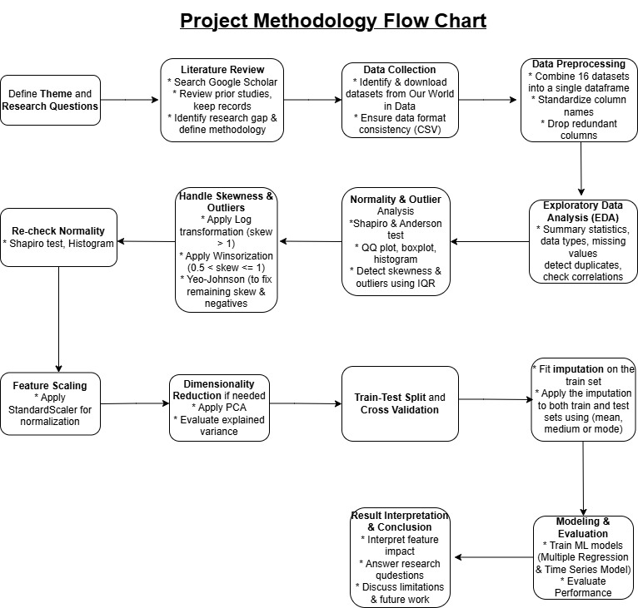

Figure 155: Project Methodology Flow Chart

GitHub Repository Link
GitHub Link
https://github.com/jenniferyik/CIND820_Capstone-Project

EDA Report:
https://github.com/jenniferyik/CIND820_Capstone-Project/blob/main/eda_report%20(1).html

Health Dataset:
https://github.com/jenniferyik/CIND820_Capstone-Project/blob/main/Health%20Dataset.csv

Video Presentation
https://drive.google.com/file/d/1vopCTXPT05jtvAtRB4a9q7wdFIEm1OFz/view?usp=sharing

References
Amani-Beni, R., Darouei, B., Zefreh, H., Sheikhbahaei, E., & Sadeghi, M. (2023). Effect of Obesity Duration and BMI Trajectories on Cardiovascular Disease: A Narrative Review. Cardiology and therapy, 12(2), 307–326. https://doi.org/10.1007/s40119-023-00317-6
Balia, S., & Jones, A. M. (2008). Mortality, lifestyle and socio-economic status. Journal of health economics, 27(1), 1-26.
Barrowman, N. (2014). Correlation, causation, and confusion. The New Atlantis, 23-44.
Carrascosa, I. P. (2025, March 11). Dealing with outliers: A complete guide. KDnuggets. https://www.kdnuggets.com/dealing-with-outliers-a-complete-guide
Chakraborty, D., et al. (2020). Predictive analytics in healthcare using time series data. Journal of Healthcare Engineering, 2020.
Chateau, D., Metge, C., Prior, H., & Soodeen, R. A. (2012). Learning from the census: the Socio-economic Factor Index (SEFI) and health outcomes in Manitoba. Canadian Journal of Public Health/Revue Canadienne De Sante'E Publique, S23-S27.
Contoyannis, P., & Jones, A. M. (2004). Socio-economic status, health and lifestyle. Journal of health economics, 23(5), 965-995.
Danaei, G., Finucane, M. M., Lu, Y., Singh, G. M., Cowan, M. J., Paciorek, C. J., Lin, J. K., Farzadfar, F., Khang, Y. H., Stevens, G. A., Rao, M., Ali, M. K., Riley, L. M., Robinson, C. A., Ezzati, M., & Global Burden of Metabolic Risk Factors of Chronic Diseases Collaborating Group (Blood Glucose) (2011). National, regional, and global trends in fasting plasma glucose and diabetes prevalence since 1980: systematic analysis of health examination surveys and epidemiological studies with 370 country-years and 2·7 million participants. Lancet (London, England), 378(9785), 31–40. https://doi.org/10.1016/S0140-6736(11)60679-X
DataCalculus. (n.d.). Effective strategies for handling skewed data distributions. DataCalculus. https://datacalculus.com/en/knowledge-hub/data-analytics/data-cleaning-and-preprocessing/handling-skewed-data-distributions/
Debón, A., Montes, F., & Mateu, J. (2017). Using time series models to forecast mortality. Statistical Modelling, 17(4), 287–311
Dinca-Panaitescu, S., Dinca-Panaitescu, M., Bryant, T., Daiski, I., Pilkington, B., & Raphael, D. (2011). Diabetes prevalence and income: Results of the Canadian Community Health Survey. Health policy (Amsterdam, Netherlands), 99(2), 116–123. https://doi.org/10.1016/j.healthpol.2010.07.018
Dimai, M. (2024). Modeling and forecasting mortality with economic, environmental and lifestyle variables. Decisions in Economics and Finance, 1-35.
Foreman, K. J., Marquez, N., Dolgert, A., Fukutaki, K., Fullman, N., McGaughey, M., ... & Murray, C. J. (2018). Forecasting life expectancy, years of life lost, and all-cause and cause-specific mortality for 250 causes of death: reference and alternative scenarios for 2016–40 for 195 countries and territories. The Lancet, 392(10159), 2052-2090.
Gerdtham, U. G., & Ruhm, C. J. (2006). Deaths rise in good economic times: evidence from the OECD. Economics & Human Biology, 4(3), 298-316.
Hamada, M., Tanimu, J. J., Hassan, M., Kakudi, H. A., & Robert, P. (2021, December). Evaluation of Recursive Feature Elimination and LASSO Regularization-based optimized feature selection approaches for cervical cancer prediction. In 2021 IEEE 14th International symposium on embedded multicore/many-core systems-on-chip (MCSoC) (pp. 333-339). IEEE.
Kastorini, C. M., Milionis, H. J., Georgousopoulou, E., Kalantzi, K., Nikolaou, V., Vemmos, K. N., ... & Panagiotakos, D. B. (2015). Defining the path between social and economic factors, clinical and lifestyle determinants, and cardiovascular disease. Global heart, 10(4), 255-263.
Kaur, A., Guleria, K., & Trivedi, N. K. (2021, March). Feature selection in machine learning: Methods and comparison. In 2021 International Conference on Advance Computing and Innovative Technologies in Engineering (ICACITE) (pp. 789-795). IEEE.
Kontis, V., Bennett, J. E., Mathers, C. D., Li, G., Foreman, K., & Ezzati, M. (2017). Future life expectancy in 35 industrialised countries: projections with a Bayesian model ensemble. The Lancet, 389(10076), 1323–1335. https://doi.org/10.1016/S0140-6736(16)32381-9
Kutner, M. H., Nachtsheim, C. J., Neter, J., & Li, W. (2005). Applied linear statistical models (5th ed.). McGraw-Hill Irwin.
Lantz PM, House JS, Lepkowski JM, Williams DR, Mero RP, Chen J. Socioeconomic Factors, Health Behaviors, and Mortality: Results From a Nationally Representative Prospective Study of US Adults. JAMA. 1998;279(21):1703–1708. doi:10.1001/jama.279.21.1703
Li, Y., Pan, A., Wang, D. D., Liu, X., Dhana, K., Franco, O. H., ... & Hu, F. B. (2018). Impact of healthy lifestyle factors on life expectancies in the US population. Circulation, 138(4), 345-355.
Lysy, Z., Booth, G. L., Shah, B. R., Austin, P. C., Luo, J., & Lipscombe, L. L. (2013). The impact of income on the incidence of diabetes: a population-based study. Diabetes research and clinical practice, 99(3), 372–379. https://doi.org/10.1016/j.diabres.2012.12.005
Macinko, J. A., Shi, L., & Starfield, B. (2004). Wage inequality, the health system, and infant mortality in wealthy industrialized countries, 1970–1996. Social science & medicine, 58(2), 279-292.
Mahamoud, A., Roche, B., & Homer, J. (2013). Modeling the social determinants of health and simulating short-term and long-term intervention impacts for the city of Toronto, Canada. Social Science & Medicine, 93, 247–255 https://doi.org/10.1016/j.socscimed.2012.06.036
Min, J., Lee, H., & Kim, S. (2020).
Addressing skewness in income and expenditure data using the Yeo-Johnson transformation in regression analysis. Journal of Economic Studies, 47(5), 1032–1045. https://doi.org/10.1108/JES-11-2019-0504

Murray, C. J. L., Vos, T., Lozano, R., Naghavi, M., Flaxman, A. D., Michaud, C., ... & Salomon, J. A. (2012). Disability-adjusted life years (DALYs) for 291 diseases and injuries in 21 regions, 1990–2010: a systematic analysis for the Global Burden of Disease Study 2010. The Lancet, 380(9859), 2197–2223. https://doi.org/10.1016/S0140-6736(12)61689-4
NCD Risk Factor Collaboration (NCD-RisC) (2016). Worldwide trends in diabetes since 1980: a pooled analysis of 751 population-based studies with 4.4 million participants. Lancet (London, England), 387(10027), 1513–1530. https://doi.org/10.1016/S0140-6736(16)00618-8
O'Brien, R. M. (2007). A caution regarding rules of thumb for variance inflation factors. Quality & Quantity, 41(5), 673–690. https://doi.org/10.1007/s11135-006-9018-6
Or, Z. (2000). Determinants of health outcomes in industrialised countries: a pooled, cross-country, time-series analysis. OECD Economic studies, 53-78.
Our World in Data. (n.d.). World Bank Open Data. Retrieved from https://ourworldindata.org/
Pabayo, R., Kawachi, I., & Gilman, S. E. (2015). US State-level income inequality and risks of heart attack and coronary risk behaviors: longitudinal findings. International journal of public health, 60(5), 573–588. https://doi.org/10.1007/s00038-015-0678-7
Park, J. C., Nam, G. E., Yu, J., Kim, Y. H., Lee, S. H., Han, K., & Park, Y. G. (2023). Association of sustained low or high income and income changes with risk of incident type 2 diabetes among individuals aged 30 to 64 years. JAMA Network Open, 6(8), e2330024. https://doi.org/10.1001/jamanetworkopen.2023.30024
Pachter, L., & Love, M. I. (2024). Evaluating normalization strategies in transcriptomic studies using multiple Winsorization thresholds. Genome Biology, 25(1), 45. https://doi.org/10.1186/s13059-024-03230-w
Roth, G. A., Mensah, G. A., Johnson, C. O., Addolorato, G., Ammirati, E., Baddour, L. M., ... & Murray, C. J. L. (2020). Global burden of cardiovascular diseases and risk factors, 1990–2019: Update from the GBD 2019 study. Journal of the American College of Cardiology, 76(25), 2982–3021. https://doi.org/10.1016/j.jacc.2020.11.010
Sah, S., Surendiran, B., Dhanalakshmi, R., Mohanty, S. N., Alenezi, F., & Polat, K. (2022). Forecasting COVID‐19 Pandemic Using Prophet, ARIMA, and Hybrid Stacked LSTM‐GRU Models in India. Computational and Mathematical Methods in Medicine, 2022(1), 1556025.
Sardar, I., Akbar, M. A., Leiva, V., Alsanad, A., & Mishra, P. (2023). Machine learning and automatic ARIMA/Prophet models-based forecasting of COVID-19: Methodology, evaluation, and case study in SAARC countries. Stochastic Environmental Research and Risk Assessment, 37(1), 345-359.
Seiglie, J. A., Marcus, M. E., Ebert, C., Prodromidis, N., Geldsetzer, P., Theilmann, M., Agoudavi, K., Andall-Brereton, G., Aryal, K. K., Bicaba, B. W., Bovet, P., Brian, G., Dorobantu, M., Gathecha, G., Gurung, M. S., Guwatudde, D., Msaidié, M., Houehanou, C., Houinato, D., Jorgensen, J. M. A., … Manne-Goehler, J. (2020). Diabetes prevalence and its relationship with education, wealth, and BMI in 29 low- and middle-income countries. Diabetes Care, 43(4), 767–775. https://doi.org/10.2337/dc19-1782
Shah, T. (2020). Feature engineering: Missing data. Tejash Shah. https://tejash-shah.github.io/feature%20engineering/feature-engineering-missing-data/
Shumway, R. H., Stoffer, D. S., & Stoffer, D. S. (2000). Time series analysis and its applications (Vol. 3, p. 4). New York: springer.
Sykes, A. O. (1993). An introduction to regression analysis.
Venkataramani, A. S., Brigell, R., O'Brien, R., Chatterjee, P., Kawachi, I., & Tsai, A. C. (2016). Economic opportunity, health behaviours, and health outcomes in the USA: a population-based cross-sectional study. The Lancet Public Health, 1(1), e18-e25.
Wang, H., et al. (2019). The effect of environmental factors on life expectancy: A case study in China. Environmental Science and Pollution Research, 26(19), 19194–19204.
Wang, Q., Li, J., & Chen, X. (2019).
Improving environmental model fit with Yeo-Johnson transformation: A case study on pollutant concentration data. Environmental Modelling & Software, 122, 104521. https://doi.org/10.1016/j.envsoft.2019.104521
Weichle, T., Hynes, D. M., Durazo-Arvizu, R., Tarlov, E., & Zhang, Q. (2013). Impact of alternative approaches to assess outlying and influential observations on health care costs. SpringerPlus, 2, 614. https://doi.org/10.1186/2193-1801-2-614
Wigley, S. (2024). Regime type and Data Manipulation: Evidence from the COVID-19 Pandemic. Journal of Health Politics, Policy and Law, 49(6), 989-1014.
Wilkinson, Richard & Marmot, Michael. (‎2003)‎. Social determinants of health: the solid facts, 2nd ed. World Health Organization. Regional Office for Europe. https://iris.who.int/handle/10665/326568
Wilkinson, R. G., & Pickett, K. (2003). Income inequality and population health: A review and explanation of the evidence. Social Science & Medicine, 62(7), 1768–1784. https://doi.org/10.1016/j.socscimed.2005.08.037
Woo, J., Ho, S. C., & Yu, A. L. M. (2002). Lifestyle factors and health outcomes in elderly Hong Kong Chinese aged 70 years and over. Gerontology, 48(4), 234-240.
World Health Organization [WHO]. (2024). Ageing and health. World Health Organization. Retrieved from https://www.who.int/news-room/fact-sheets/detail/ageing-and-health
Yang, L., Zhang, X., & Chen, J. (2024). Winsorization greatly reduces false positives by popular differential expression methods when analyzing human population samples. Genome biology, 25(1), 282. https://doi.org/10.1186/s13059-024-03230-w
Yen, S. T., Chen, Z., & Eastwood, D. B. (2009). Lifestyles, demographics, dietary behavior, and obesity: a switching regression analysis. Health Services Research, 44(4), 1345-1369.
Zahra, A., Lee, E. W., Sun, L. Y., & Park, J. H. (2015). Cardiovascular disease and diabetes mortality, and their relation to socio-economical, environmental, and health behavioural factors in worldwide view. Public health, 129(4), 385-395.
Zhang, Y., Liu, Y., Zhang, Y., & Yang, M. (2018).
Using Yeo-Johnson transformation to normalize biomarker data for better predictive modeling. Journal of Biomedical Informatics, 85, 30–38. https://doi.org/10.1016/j.jbi.2018.07.005

Appendices

Appendix A - Boxplot
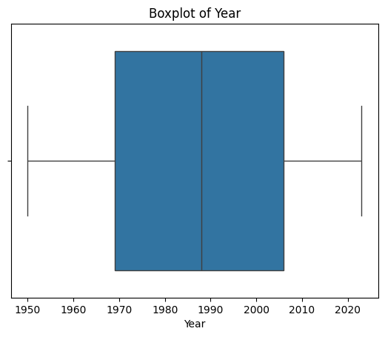 | 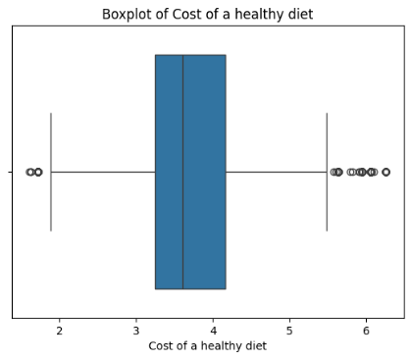 | 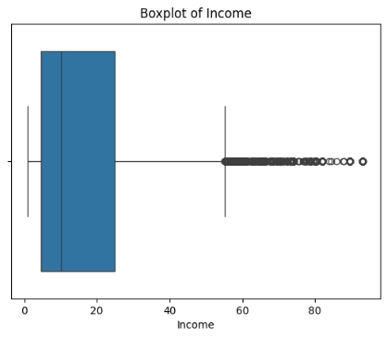
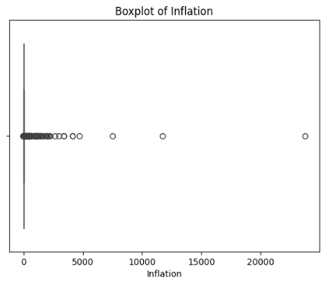 | 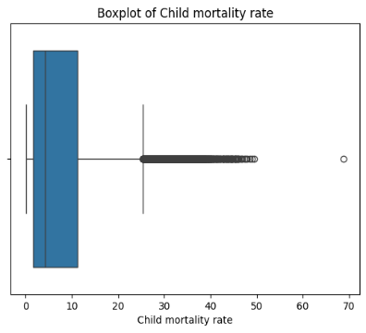 | 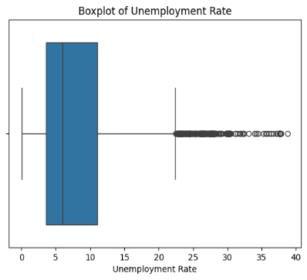
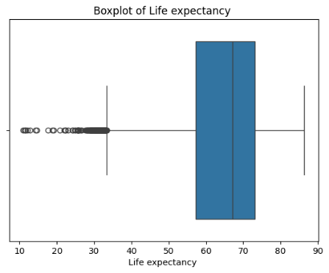 | 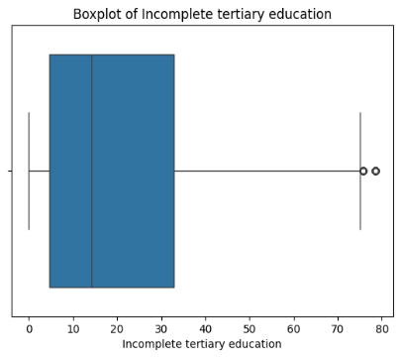 | 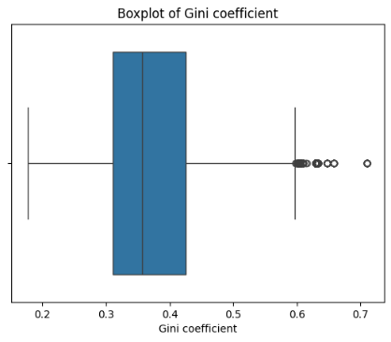
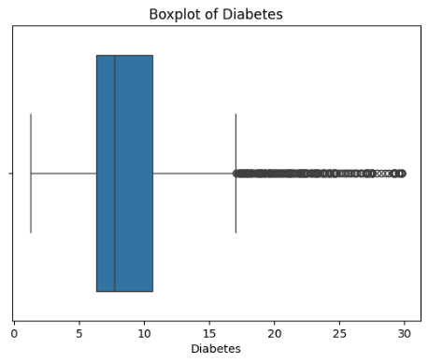 | 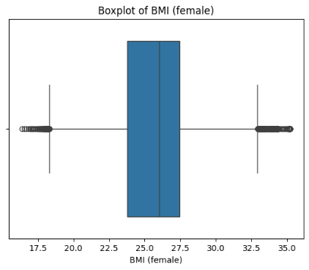 | 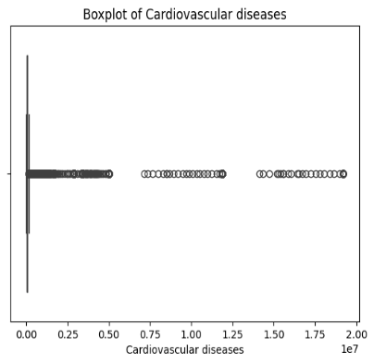
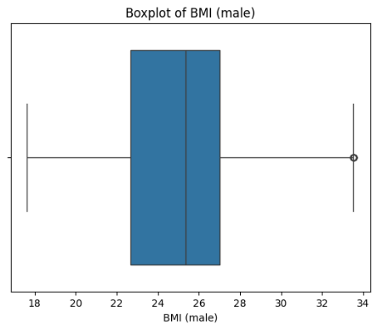 | 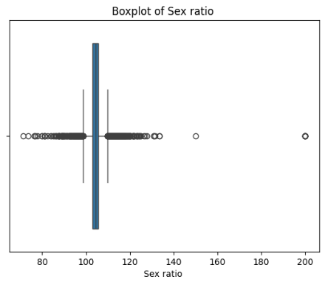 | 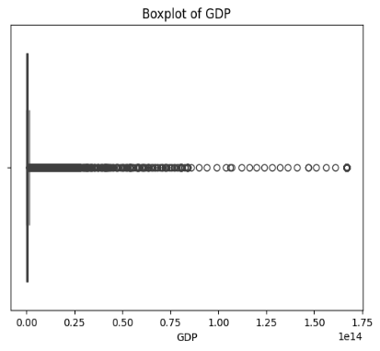
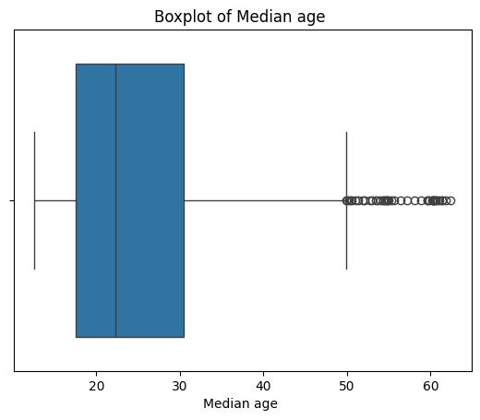 | 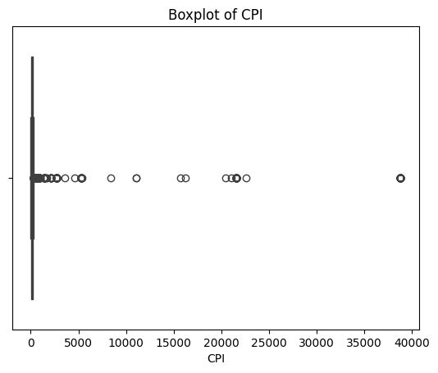

Appendix B - QQ Plot
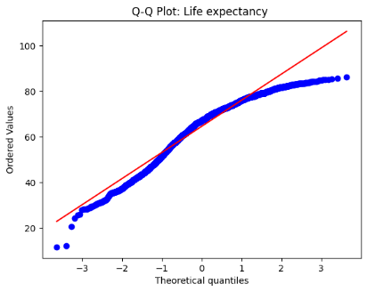 | 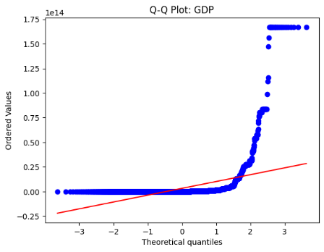 | 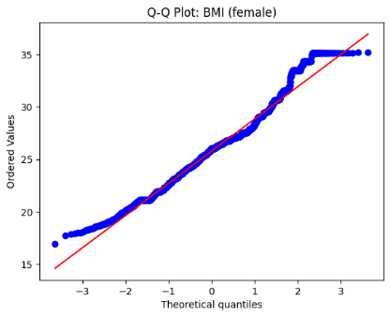
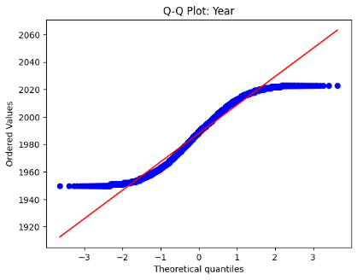 | 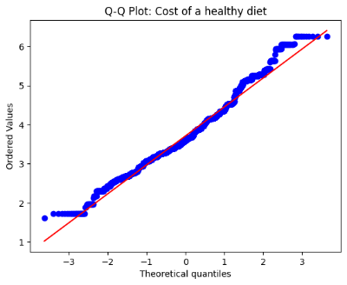 | 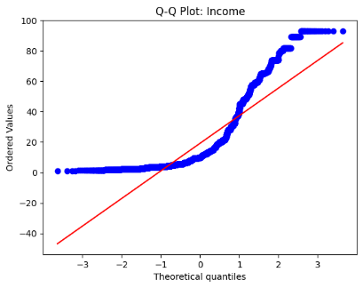
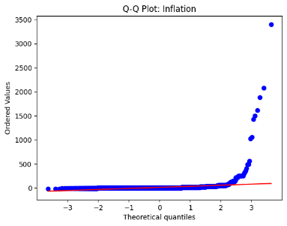 | 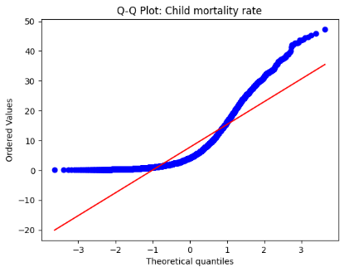 | 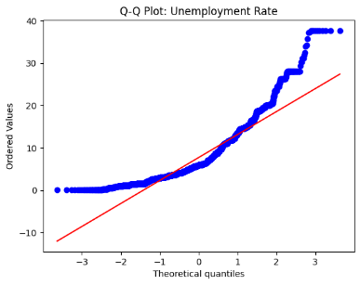
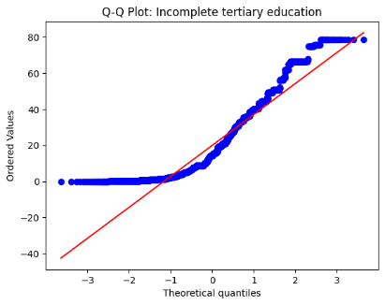 | 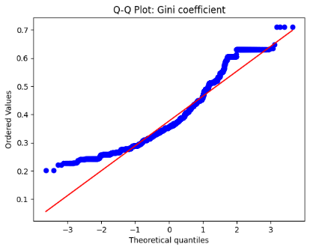 | 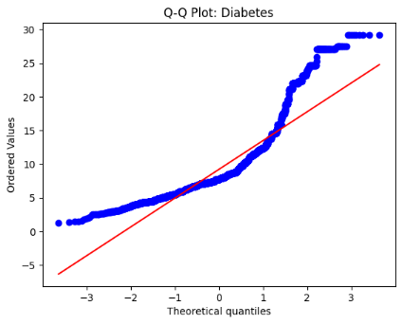
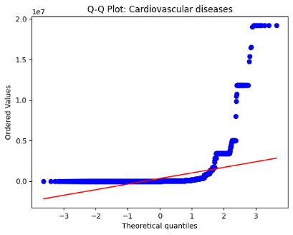 | 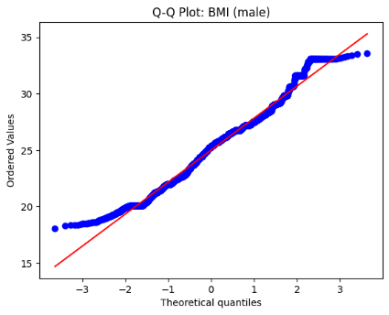 | 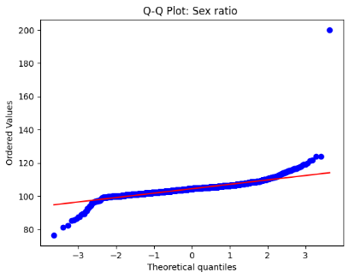
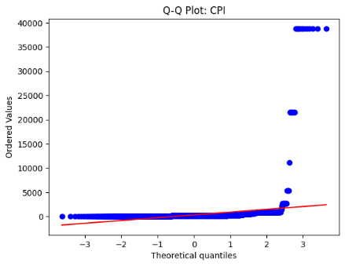 | 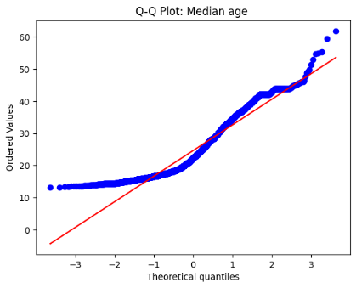

Appendix C - Histogram: BEFORE Normalization
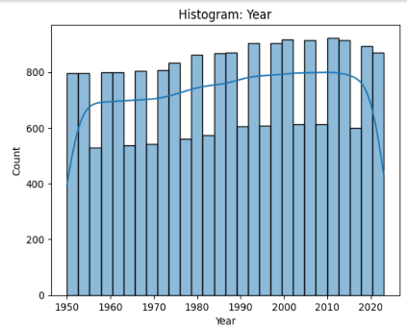 | 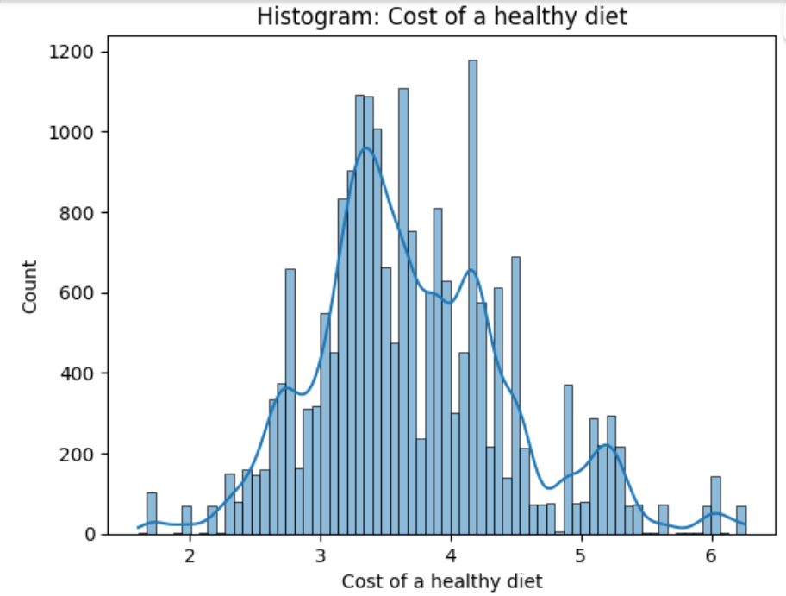 | 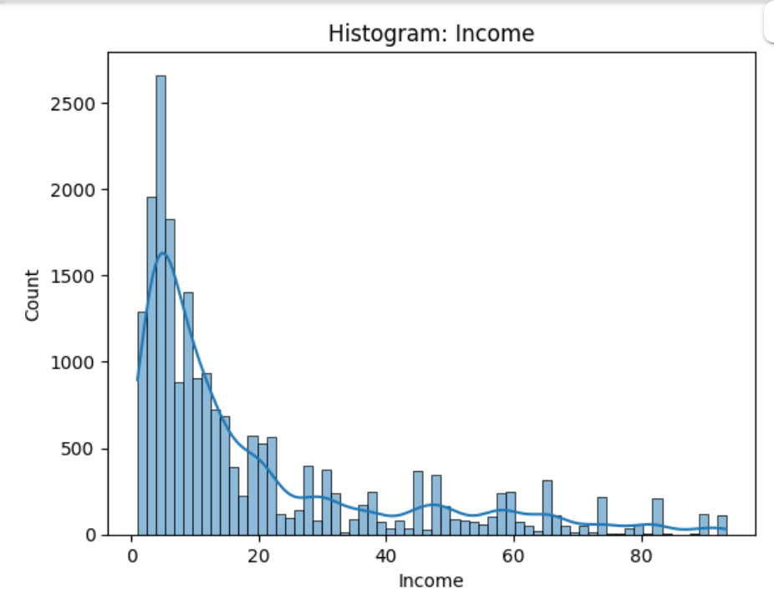
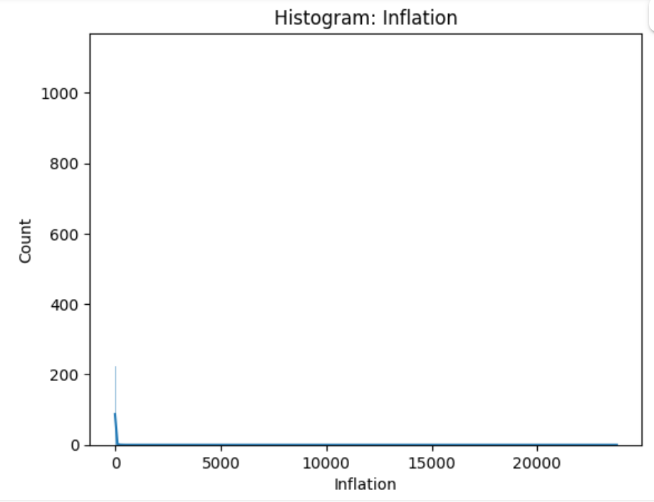 | 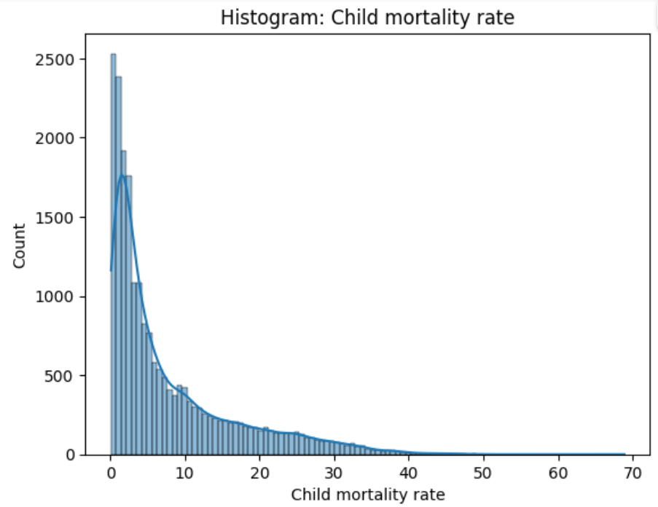 | 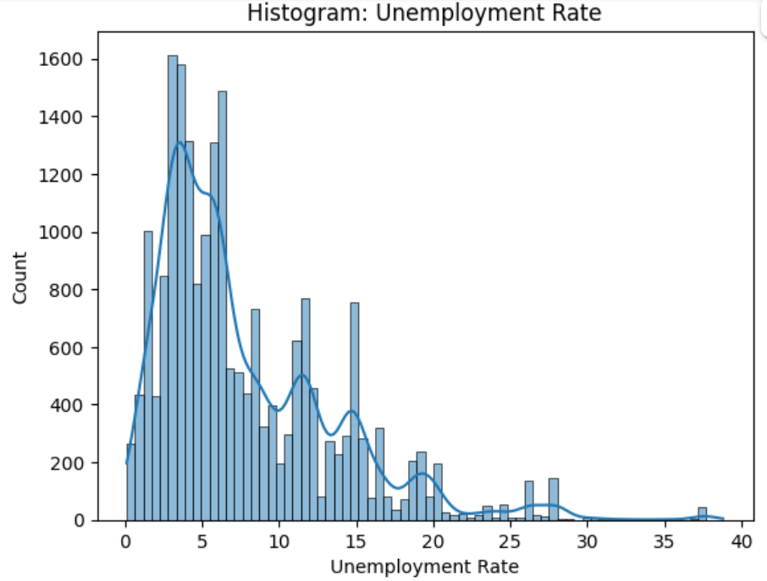
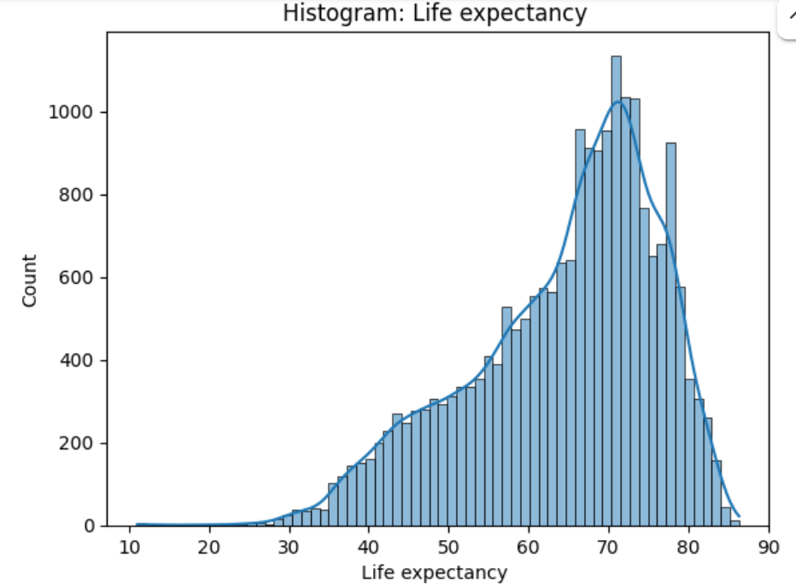 | 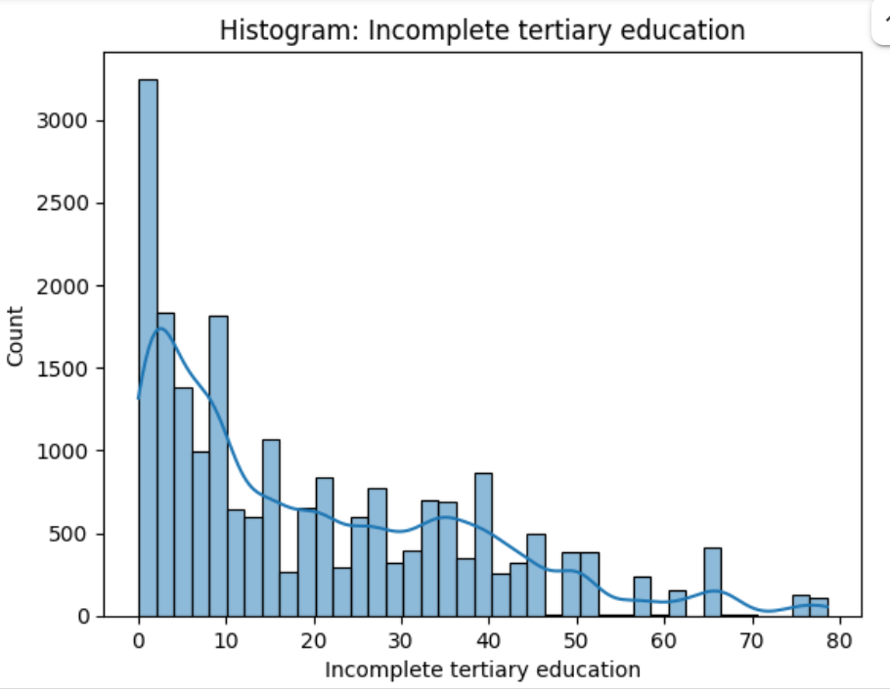 | 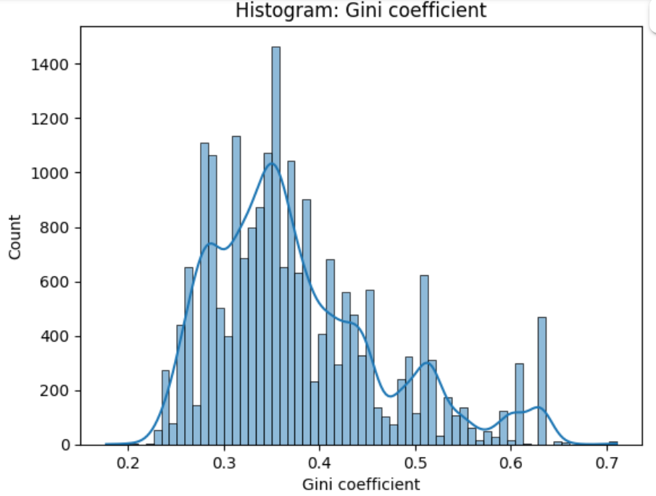
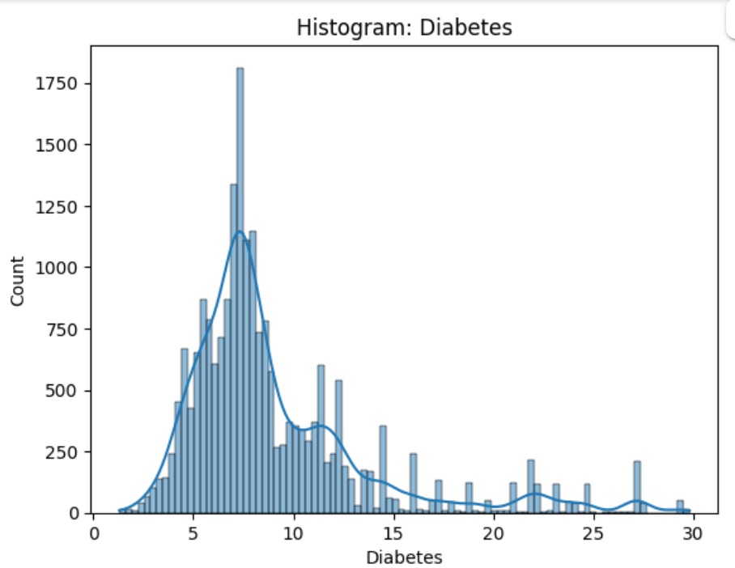 | 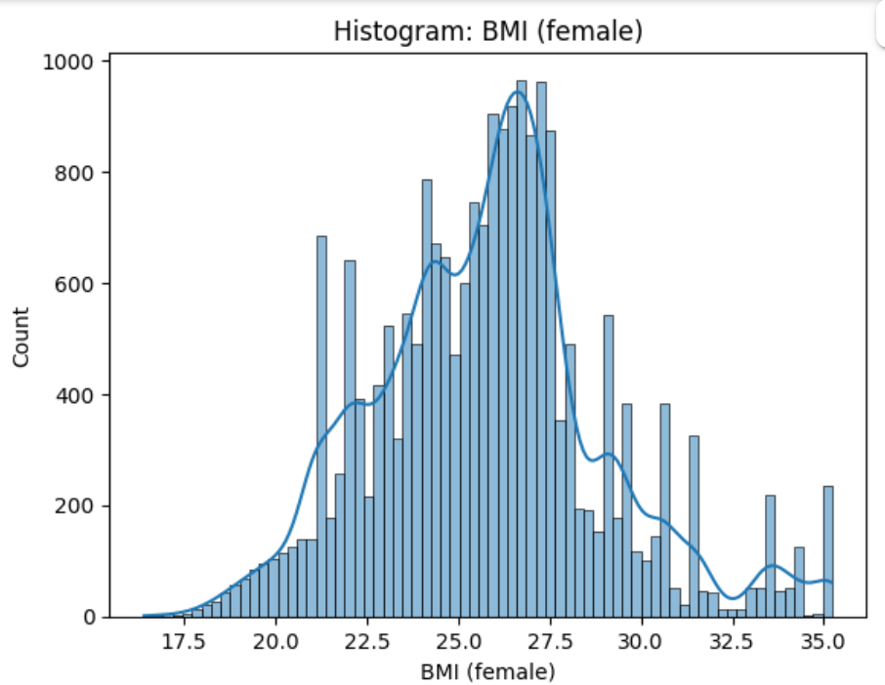 | 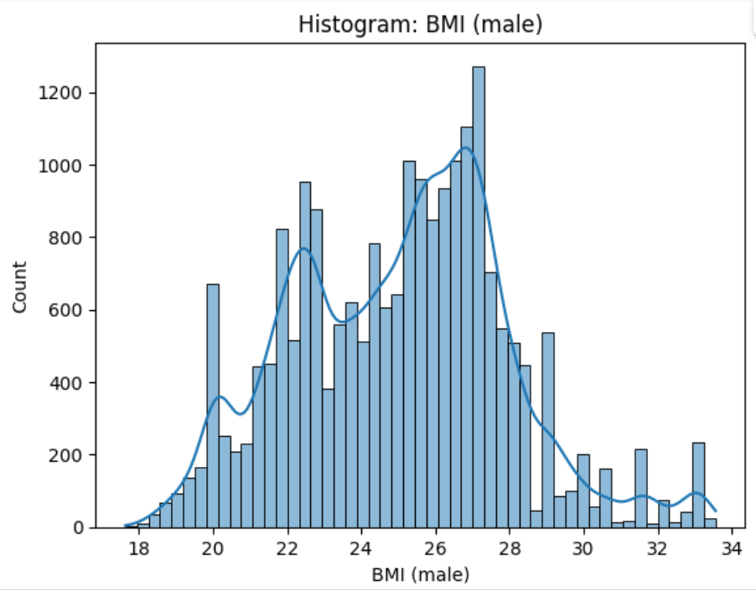
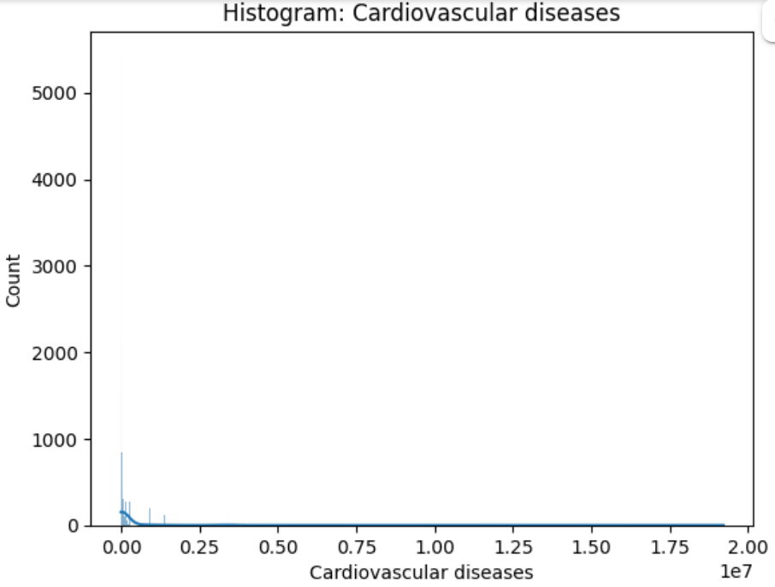 | 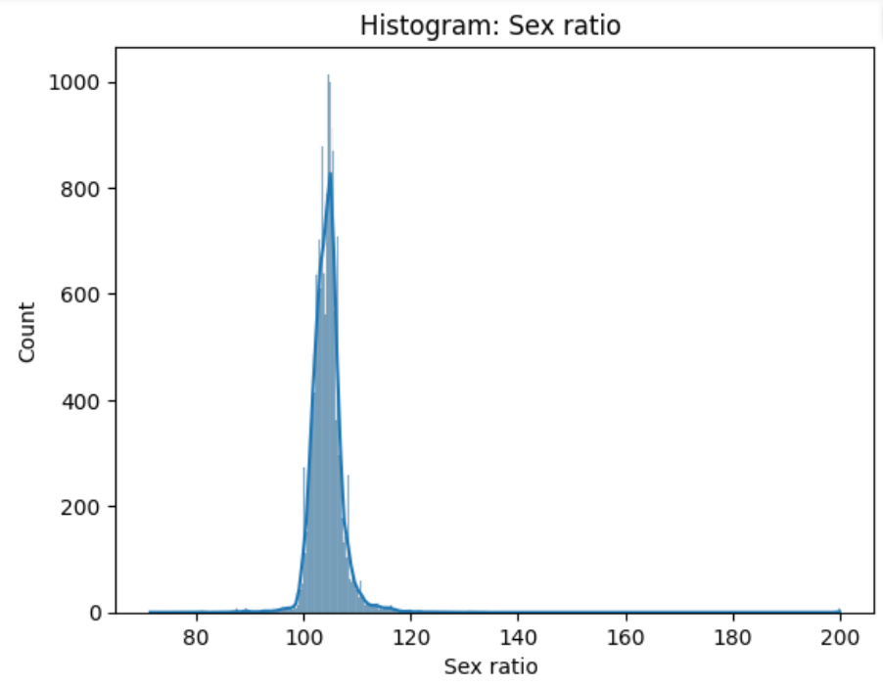 | 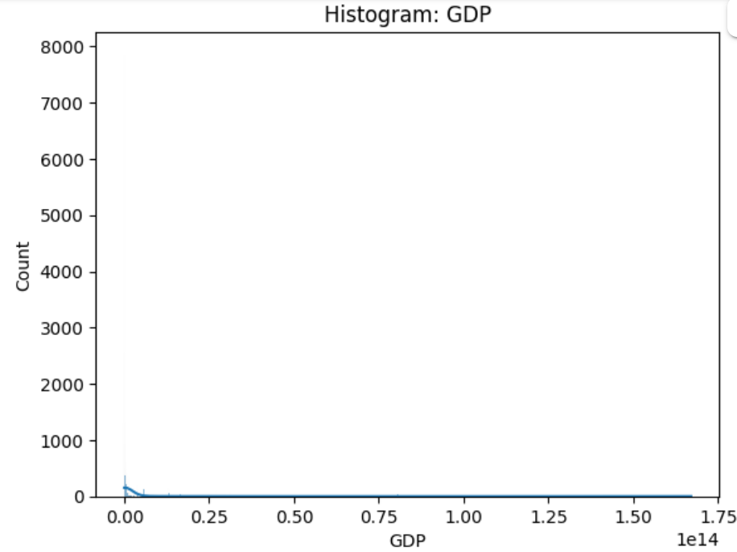
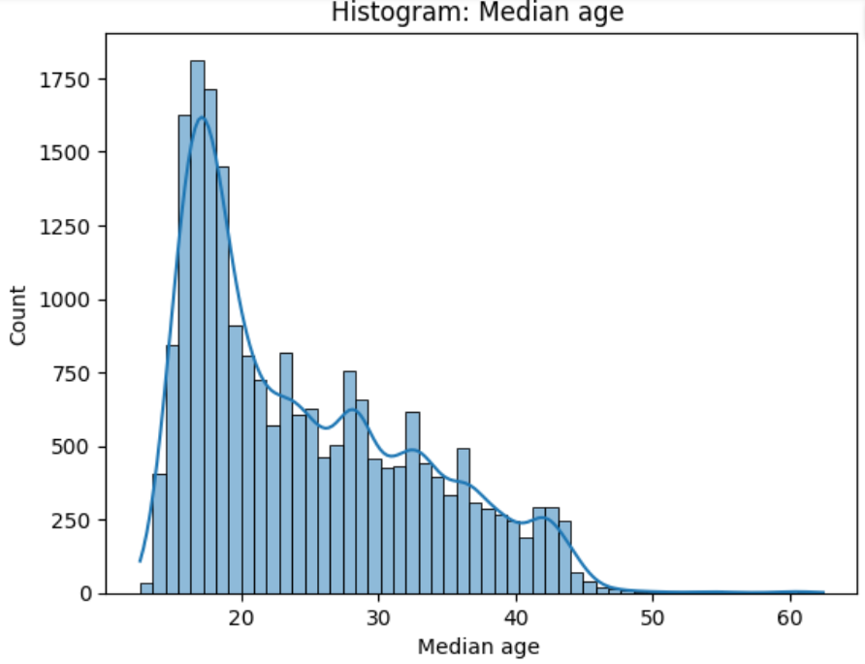 | 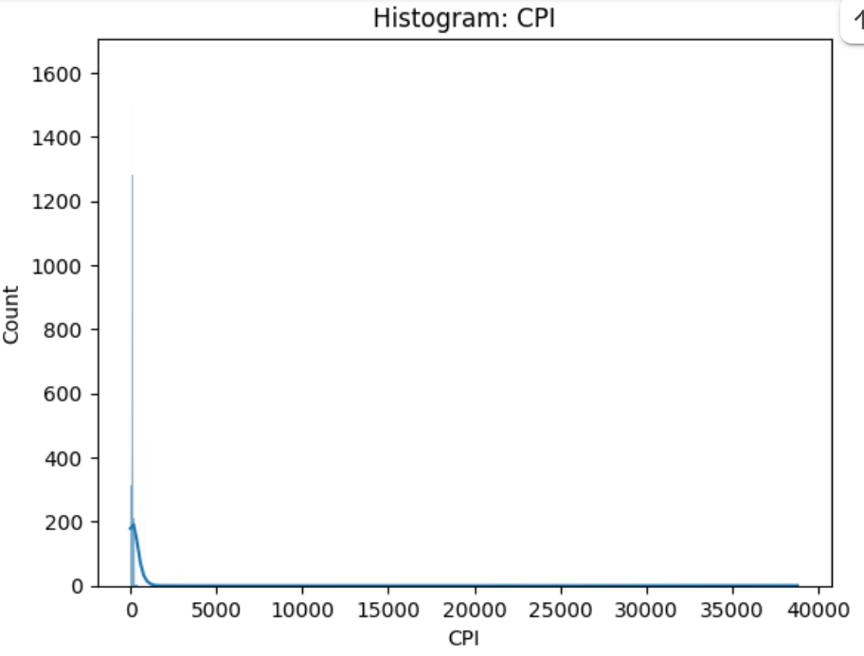

Appendix D - Histogram: AFTER Normalization
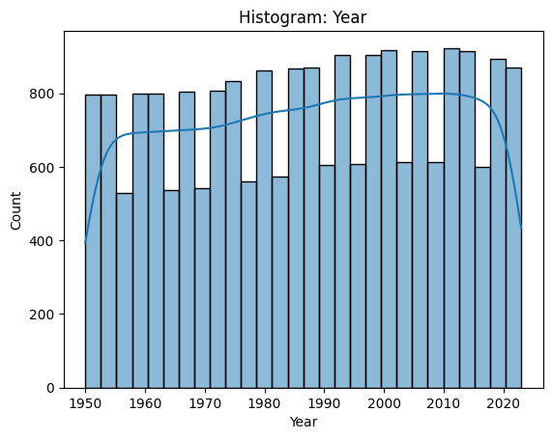 | 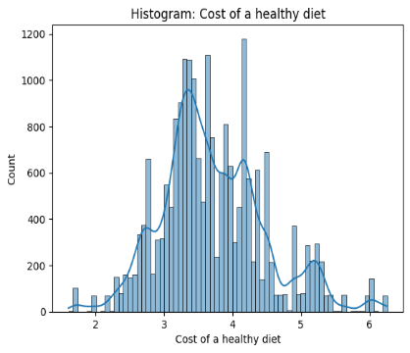 | 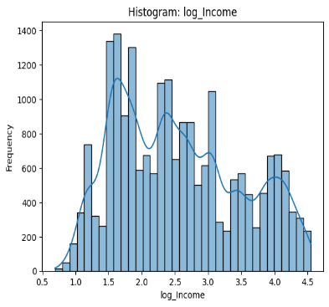
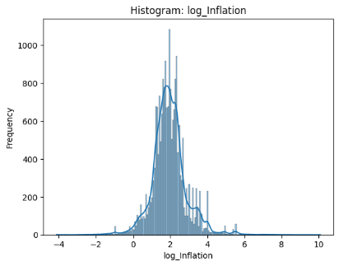 | 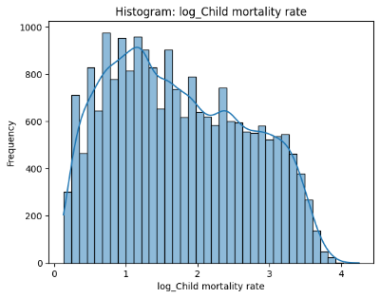 | 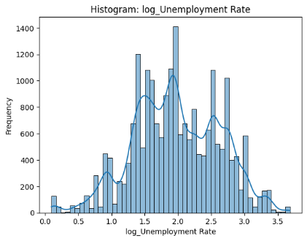
 | 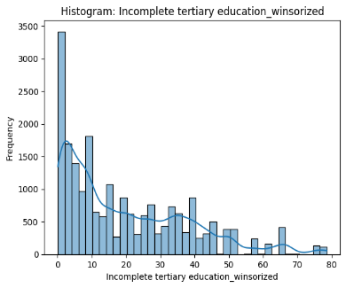 | 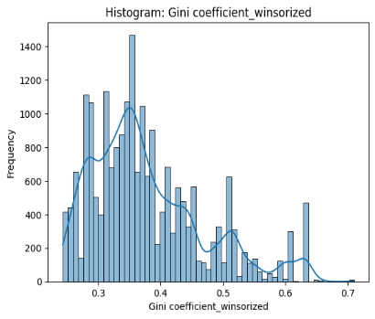
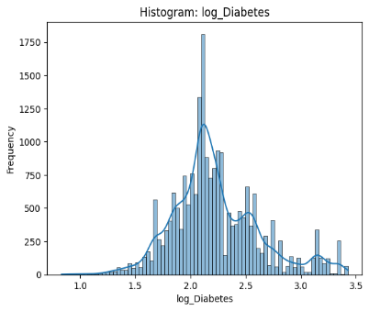 |  | 
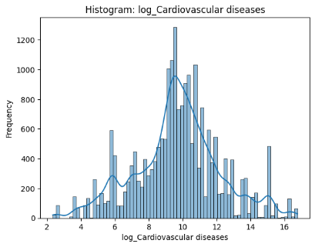 | 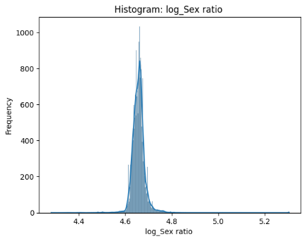 | 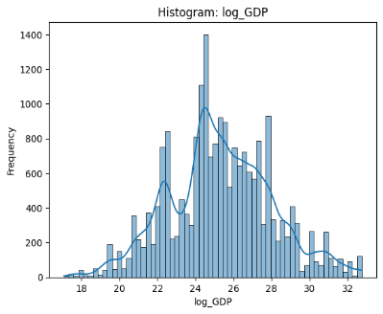
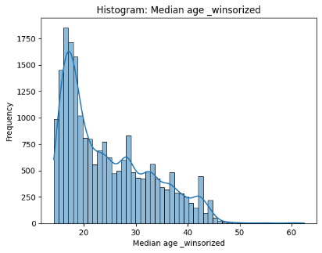 | 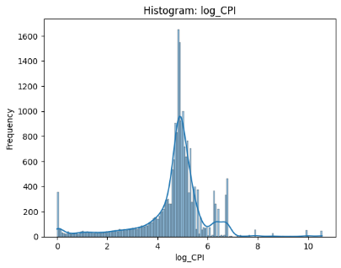

Appendix E - Forecast Diagrams – Group by Targets (Life Expectancy, Diabetes and CVD)
Life Expectancy:
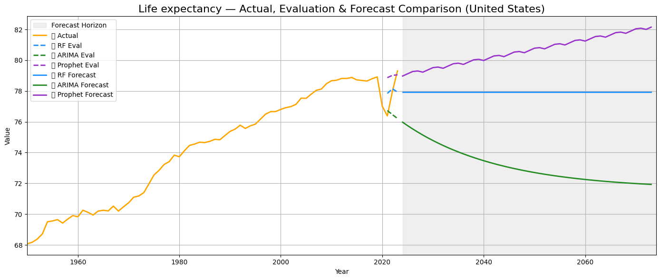
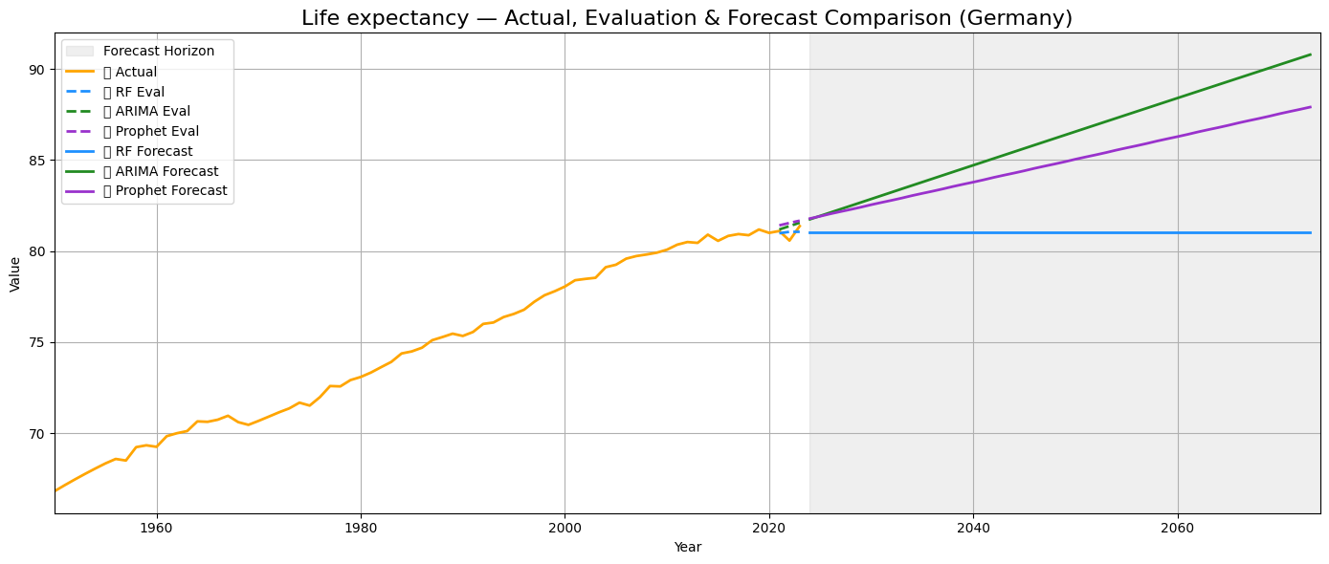
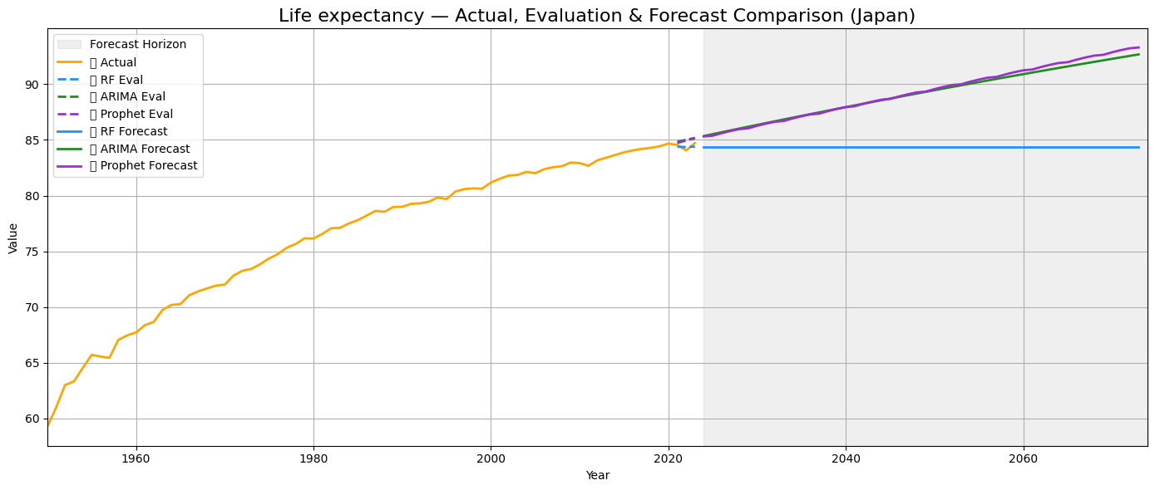
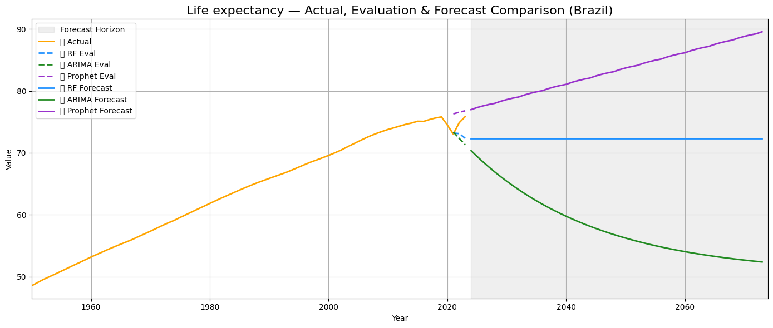
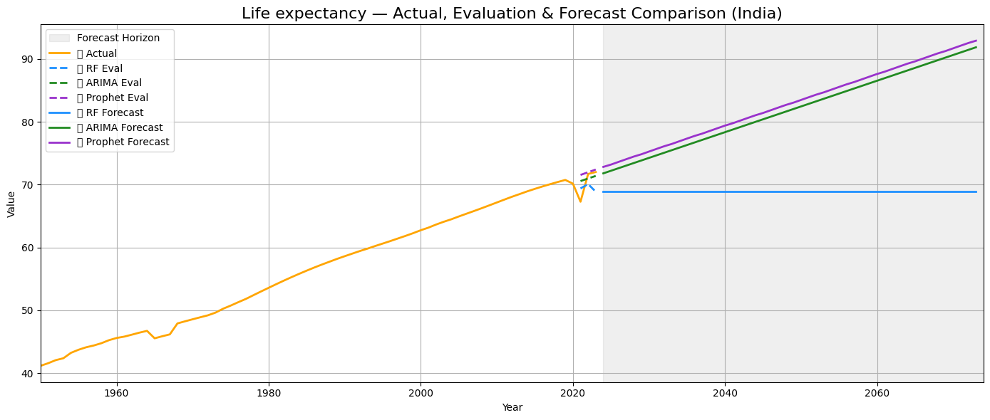
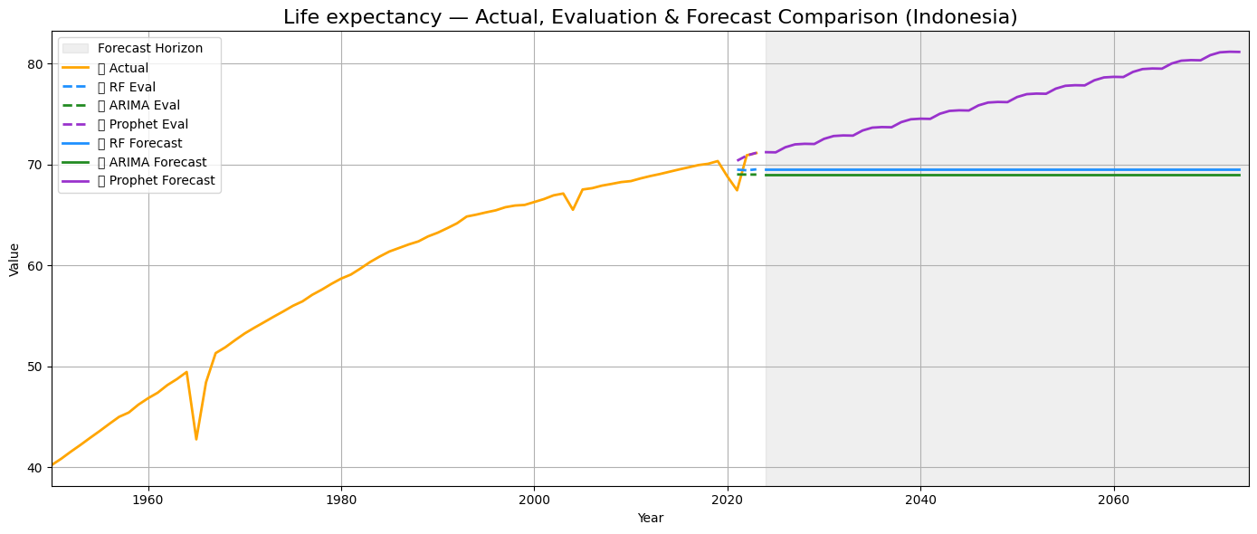
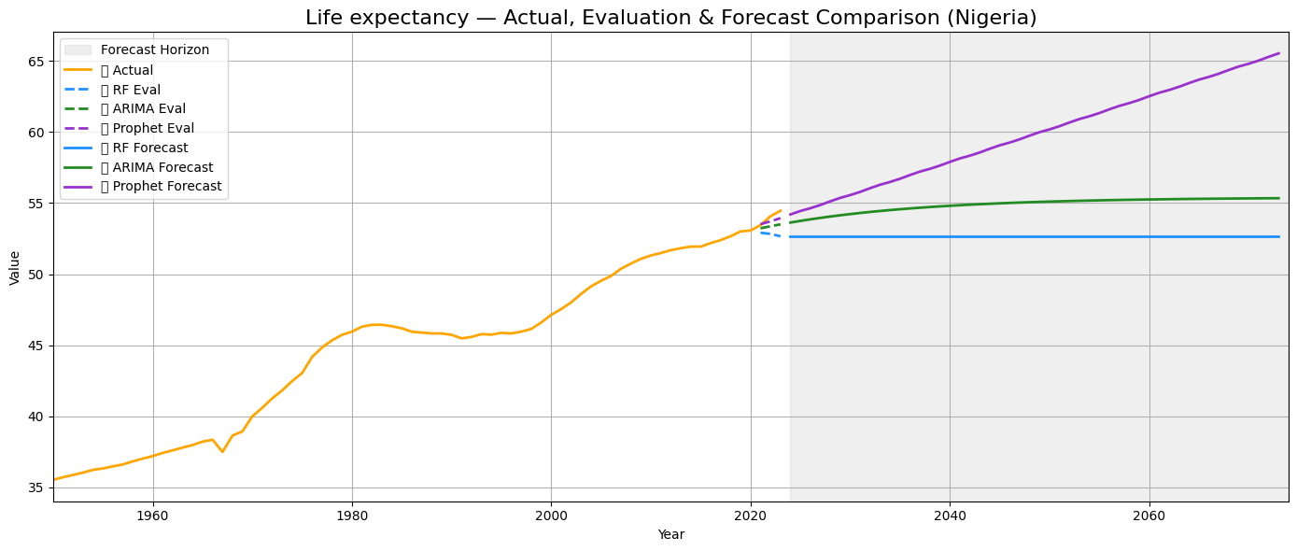
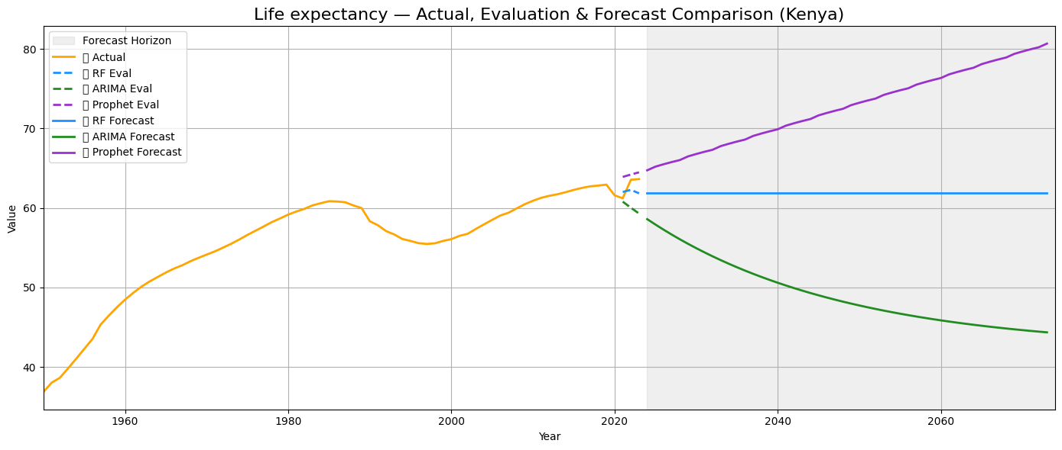
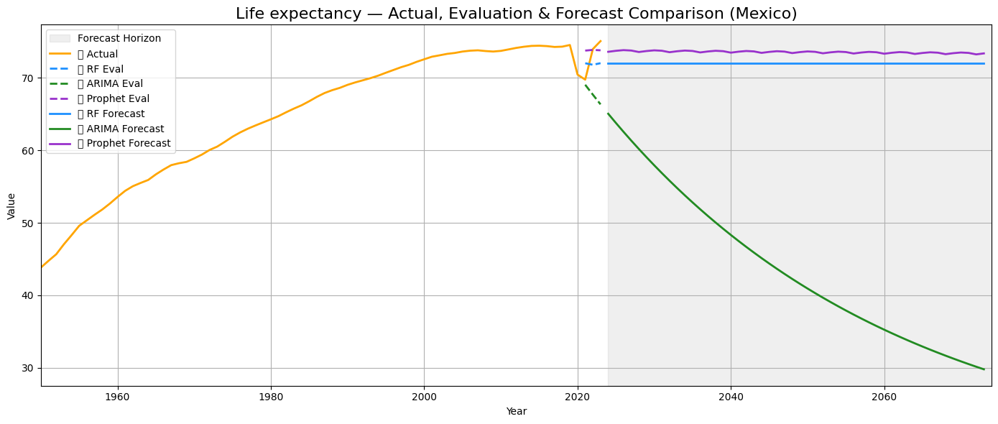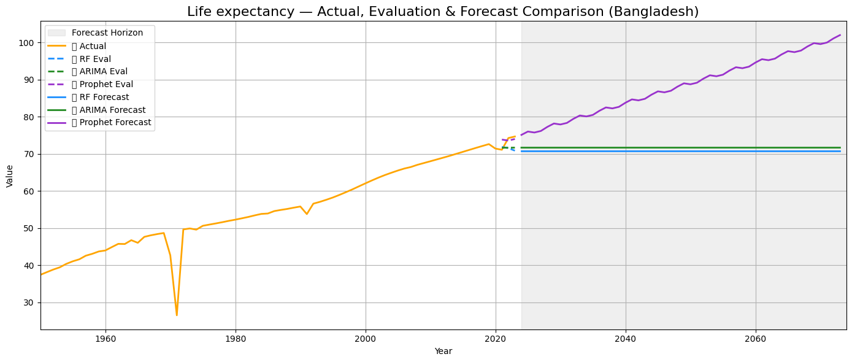
Diabetes:
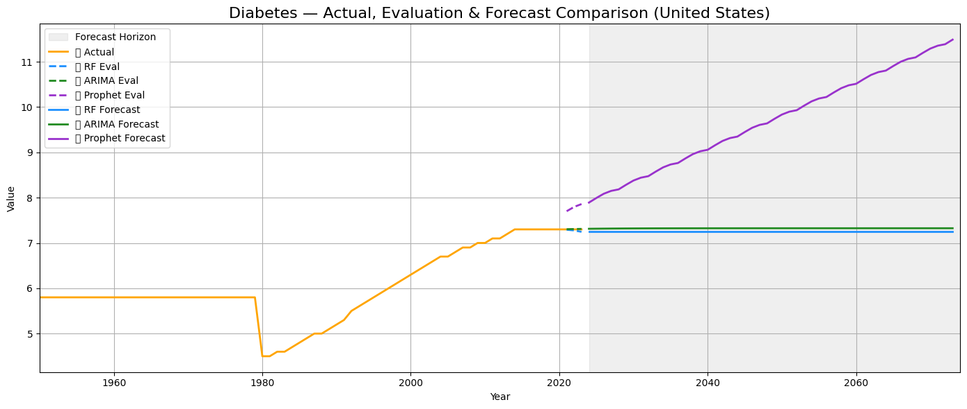
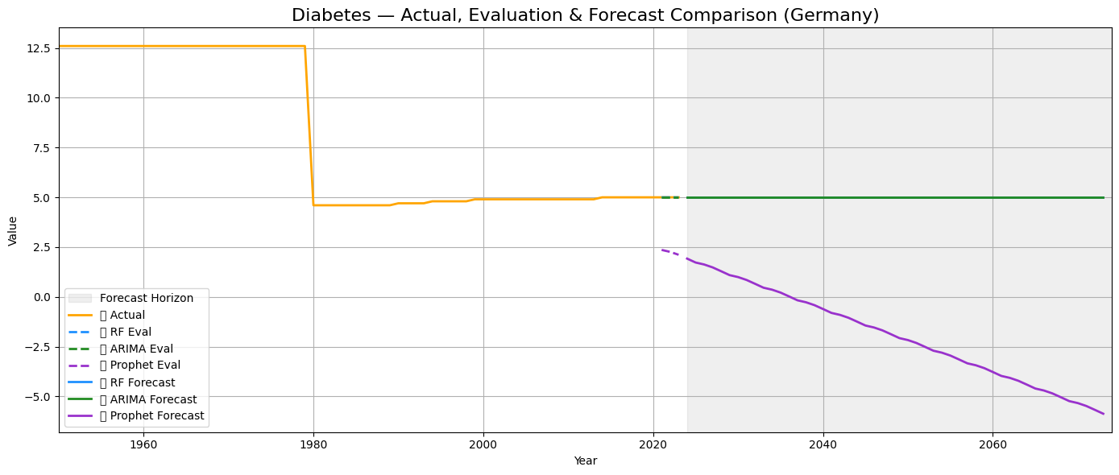
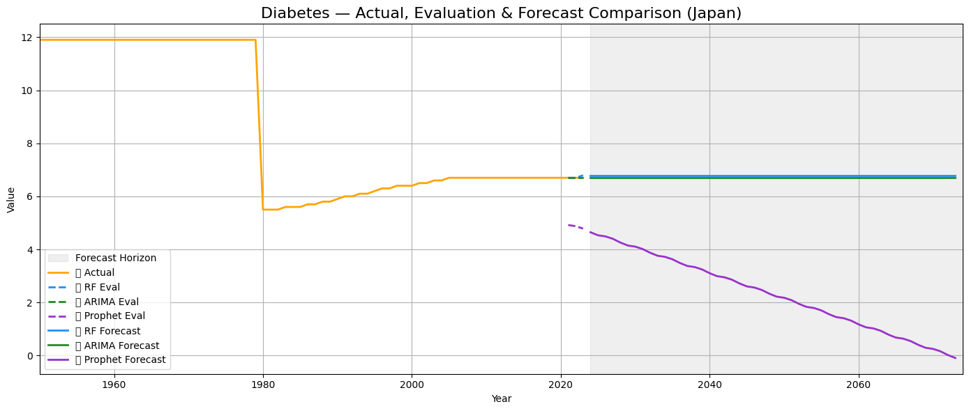
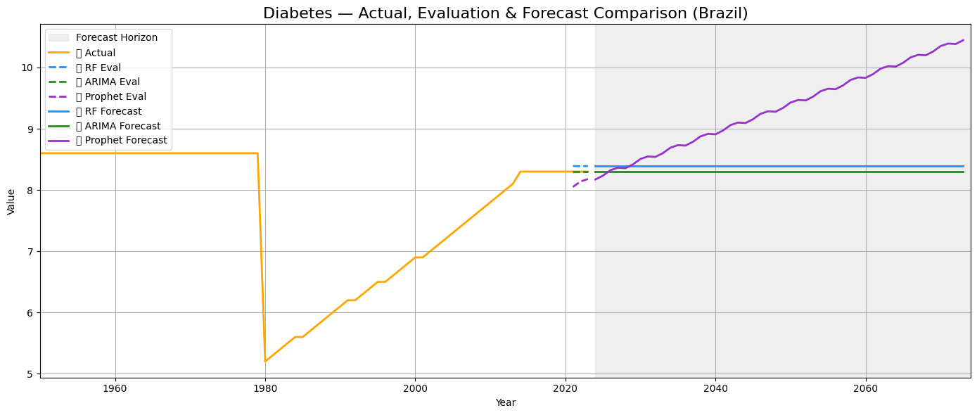
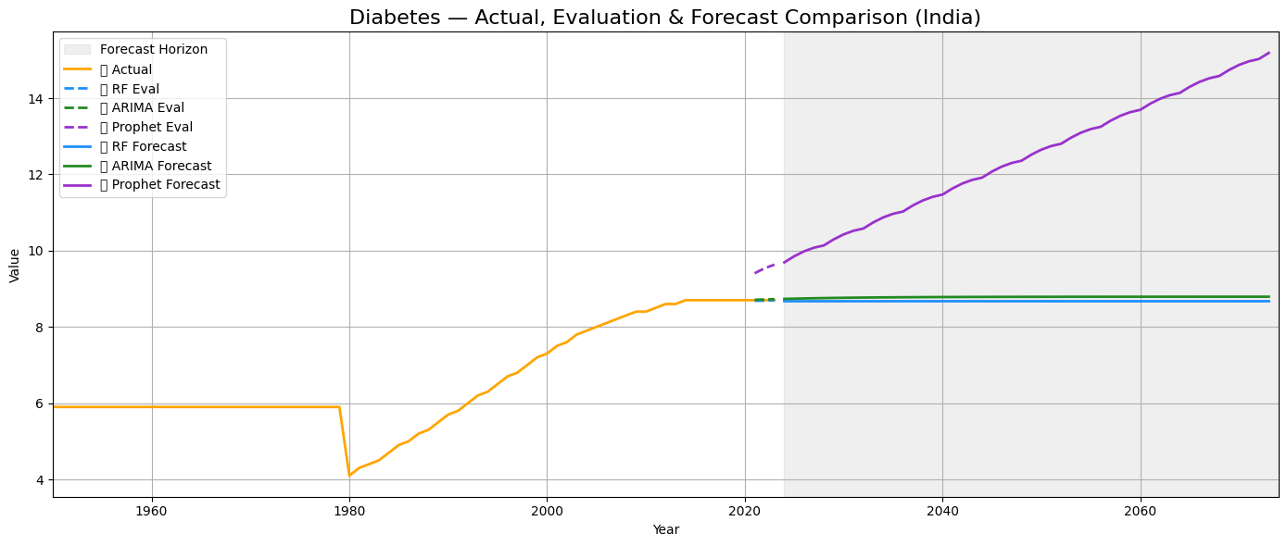
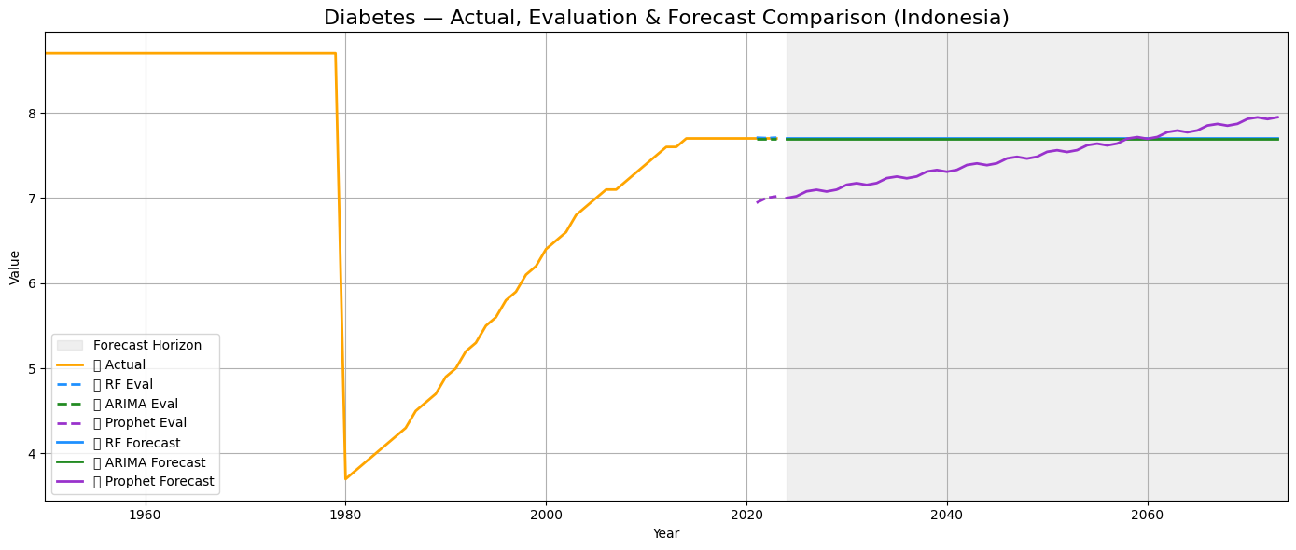
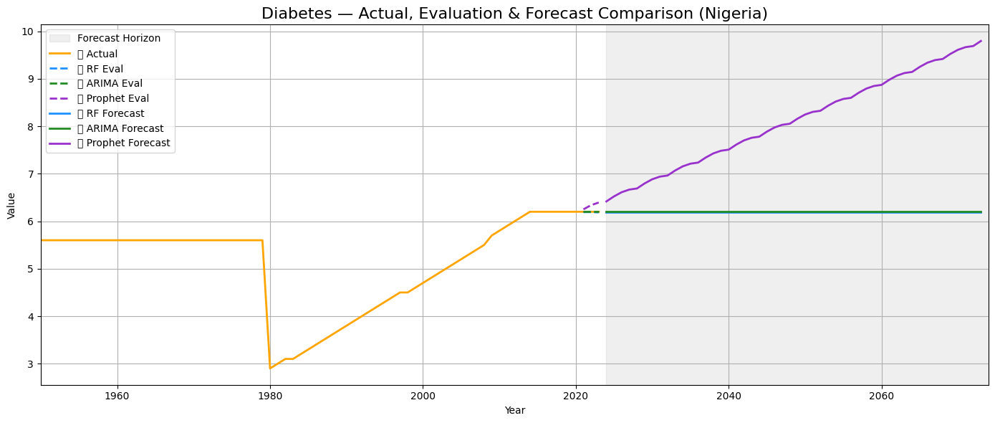
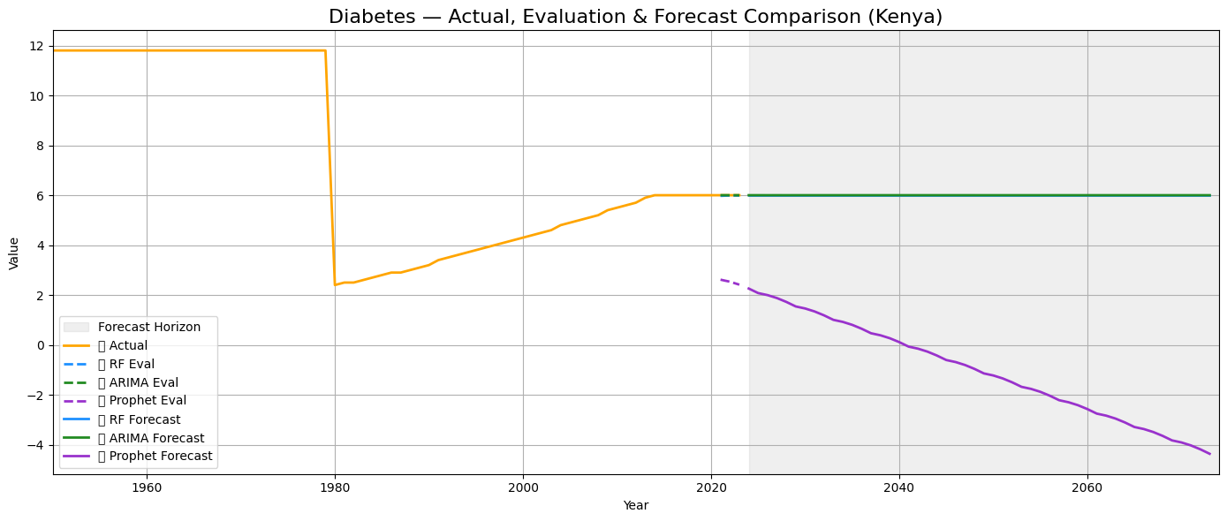
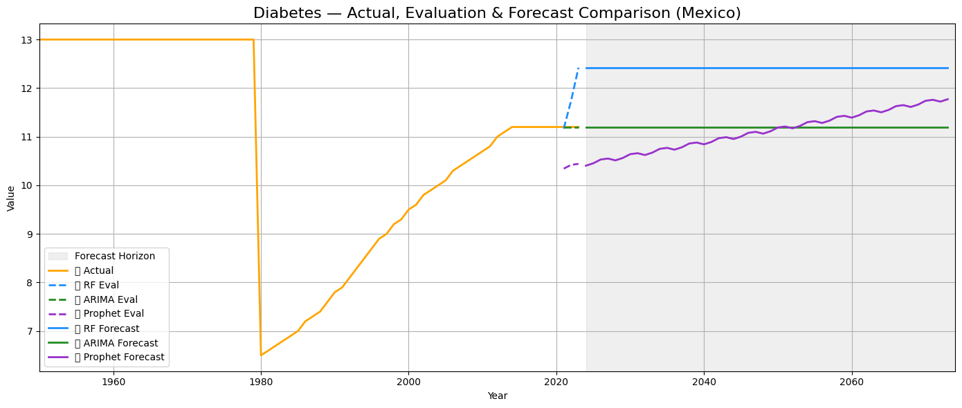
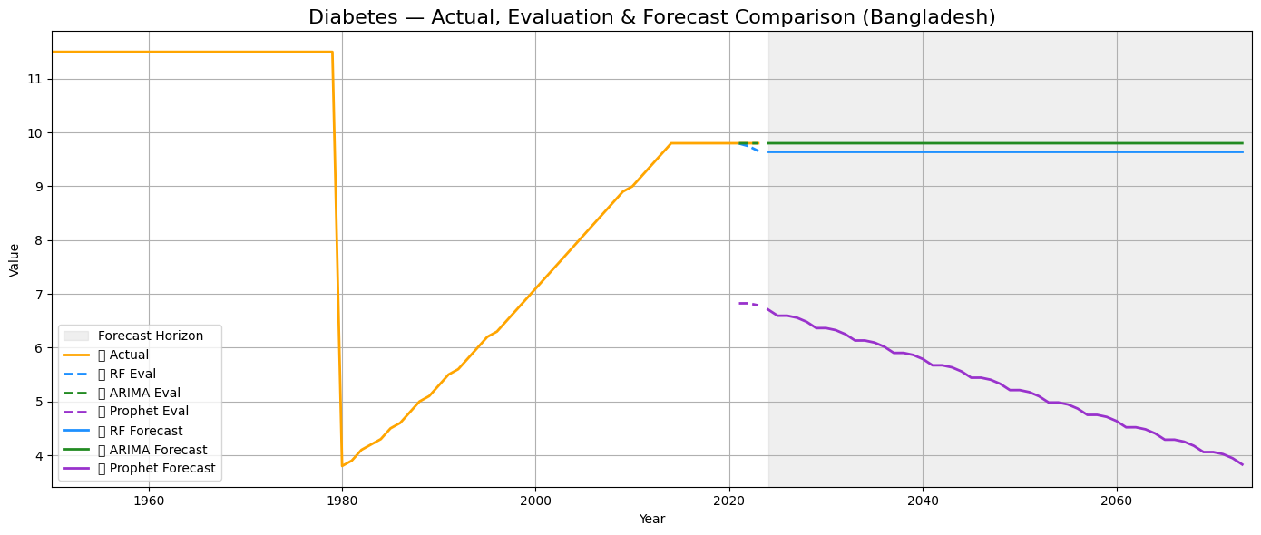

Cardiovascular Disease:
