
Modeling the Impact of Economic, Lifestyle, and Demographic Factors on Health Outcomes Using Regression and Time Series Techniques
Student Name: Jennifer Yik
Student Number: 501342884
Supervisor’s Name: Tamer Abdou
Date of Submission: June 23, 2025

Table of Contents
Problem Statement and Context 3

Abstract 3

Theme 3

Context and Background 3

Problem Statement 4

Real World Significance 4
Research Questions and Justifications 4
Literature Review 5
Datasets Description 13

Summary of Selected Dataset 13

Descriptive Statistics 15

Explanation of Constraints and Preprocessing Steps 18
Constraints 18
Preprocess Dataset 18

Relevance of the Dataset 20

Feasibility 20

Limitations 21
Project Approach 21
1. Research Methodology 21
2. Justification the Approach on Prior Studies 23
3. Proposed Methodology and Tools 24
4. Techniques and Tools 24
Visual Representation 26
GitHub Repository Link 27
References 27
Appendices 31

Appendix A. Bloxplot 31

Appendix B. QQ Plot 33

Appendix C. Histogram: BEFORE Normalization 35

Appendix D. Histogram: AFTER Normalization 37

Problem Statement and Context

Abstract
This project analyzes the impact of economic, lifestyle, and demographic factors on global public health outcomes, focusing specifically on the prevalence of non-communicable disease (NCDs) such as heart disease and diabetes, as well as life expectancy. Using a consolidated dataset of 21,514 global observations across 18 variables from 16 sources compiled by Our World in Data, covering the period 1950 to 2023, this study applies multiple linear regression and time series forecasting techniques to explore historical patterns and predict future health trends.
The three research questions are designed to help explain how various determinants affect health outcomes: (1) What are the key socioeconomic, demographic, and lifestyle factors most strongly associated with the prevalence of non-communicable diseases (heart disease and diabetes) across countries from 1950 to 2023? (e.g., diabetes and heart disease); (2) To what extent do modifiable lifestyle and economic factors (e.g., BMI, cost of healthy diet, income, and CPI) explain variations in life expectancy and population health outcomes across countries?; and (3) How will health outcomes (life expectancy, disease rates) evolve over the next 50 years (2023–2073), based on historical trends and key predictors identified in the period from 1950 to 2023?
While most prior studies are limited to specific regions or shorter timeframes, this project provides a globally scoped, long-term perspective on the determinants of health. Analytical tools in Python, such as pandas, scikit-learn, and time series models, are used to conduct regression analysis and forecast future health outcomes.
By identifying influential predictors and modeling long-term trends, this research provides evidence-based insights that can support global health policy, inform preventive strategies, and improve population health outcomes over time.

Theme
Modeling the Impact of Economic, Lifestyle, and Demographic Factors on Health Outcomes Using Regression and Time Series Techniques

Context and Background
Health outcomes are shaped by a complex interplay of socioeconomic, demographic, and lifestyle factors. Economic indicators such as GDP, income levels and unemployment rate, lifestyle behaviors including dietary habits, BMI, and demographic indicators like age structure, education levels, all contribute to population health. As non-communicable diseases (NCDs) such as heart disease and diabetes continue to rise globally, understanding how these determinants influence their prevalence and impact overall life expectancy has become increasingly critical. With the growing availability of long-term global health and socioeconomic datasets, data-driven insights can inform more effective, targeted public health interventions.

Problem Statement
This project investigates the extent to which socioeconomic, demographic, and lifestyle factors are associated with the global prevalence of non-communicable diseases (specifically heart disease and diabetes) and variations in life expectancy. Using a large-scale dataset from Our World In Data which covers the period from 1950 to 2023, this study applies multiple linear regression and time series forecasting techniques to identify the most influential predictors and project future health outcomes up to the year 2073. The goal is to provide a robust, data-driven foundation for understanding the drivers of population health and for anticipating long-term trends.

Real World Significance
Non-communicable diseases are a leading cause of death and disability worldwide, placing significant strain on healthcare systems and economies. By identifying the key economic, lifestyle, and demographic factors that influence their prevalence, and by forecasting how health outcomes may evolve over the next 50 years, this research provides valuable insights for policymakers, public health officials, and international organizations in public health intervention measures. The findings can support evidence-based strategies for disease prevention, health equity, and resource allocation, contributing to improved long-term global health outcomes.

Research Questions and Justifications
- What are the key socioeconomic, demographic, and lifestyle factors most strongly associated with the prevalence of non-communicable diseases (heart disease and diabetes) across countries from 1950 to 2023?
Chateau et al. (2012) creates a composite of measures related to socioeconomic status to assess health outcomes and find that area-based socio-economic measure (ABSM) is strongly correlated with health outcomes in Manitoba. In this project, I will assess the relationship between socioeconomic indicators (demographic and economic variables) and health outcomes. Understanding these relationships will help inform decision-makers to implement socioeconomic policies that help advance health outcomes.
- To what extent do modifiable lifestyle and economic factors (e.g., BMI, cost of healthy diet, income, and CPI) explain variations in life expectancy and population health outcomes across countries?
Woo et al. (2002) find that the risk of mortality is reduced among Hong Kong Chinese elderly aged 70 years and over with increased physical activities, daily fish intake, moderate alcohol consumption, and avoidance of smoking. This shows lifestyle factors may help predict health outcomes and life expectancy. This research question aims at understanding if lifestyle factors, including the cost of healthy diet and BMI, help explain health outcomes and life expectancy. A strong relationship between lifestyle factors and health outcomes helps policymakers to determine strategies to promote behavioural changes that improve health outcomes.
- How will health outcomes (life expectancy, disease rates) evolve over the next 50 years (2023–2073), based on historical trends and key predictors identified in the period from 1950 to 2023?
This project analyzes the relationship between socioeconomic and lifestyle factors and health outcomes. Explanatory socioeconomic variables that have a strong correlation with health outcome variables, where p-value ≤ 0.05, will be included in the predictive model that estimates future health outcomes in the following 50 years, from 2023 to 2073. The aim of the predictive model is to help policymakers to proactively plan for intervention strategies that promote a positive health outcome.

Literature Review
Introduction
Non-communicable diseases (NCDs), particularly heart disease and diabetes, are among the leading causes of death globally and are closely tied to socioeconomic, demographic, and lifestyle factors, according to WHO’s report (World Health Organization, 2020). This literature review explores how these determinants affect health outcomes, particularly disease prevalence and life expectancy, while also examining forecasting methods for future trends. While many prior studies focused on specific regions or shorter time frames, this project takes a broader view by analyzing global data from 1950 to 2023, projecting outcomes to 2073.
Specifically, the prior studies support the project’s three research questions: (1) identifying the most influential socioeconomic, demographic, and lifestyle predictors of NCDs between 1950 and 2023; (2) examining how modifiable factors such as BMI, income, and the cost of healthy food explain variation in life expectancy; and (3) projecting health outcomes (life expectancy, disease rates) over the next 50 years using historical trends and key predictors.
1. Socioeconomic and Demographic Determinants of NCD Prevalence
Several studies confirm that socioeconomic status, including income, education, and employment, is widely recognized as fundamental determinants of population health.
Or (2000) uses fixed-effects models across OECD countries for the period 1970-1992 and finds that higher income and education levels were strongly associated with lower premature mortality rate. Although Or's work focuses on factors associated to mortality in high-income countries and does not consider the prevalence of NCD, his study supports the inclusion of economic and educational indicators in explaining disease outcomes Research Question 1 (RQ1). In this project, the scope of the study will extend beyond OECD countries by including all countries. In addition, heart disease and diabetes will be examined as separate but related health outcomes by making a 50-year projection following 2023.
Another study that complements this project’s focus on non-medical determinants is Macinko et al. (2004), who conduct a pooled, cross-sectional, time-series analysis to explore the relationship between income inequality and infant mortality in 19 OECD countries over the period 1970–1996 by using Pearson correlation and fixed-effects multivariate regression. This supports the use of the Gini coefficient and other inequality metrics in this project’s models, particularly in explaining differences in NCD outcomes across income levels. This study supports Research Questions 1 and 2.
Wilkinson et al. (2003) advanced the conceptual framework showing that income inequality affects health indirectly through psychosocial stress, social exclusion, and behavioral risks, including chronic stress, poor diet, and reduced access to healthcare. Wilkinson’s study concluded that economic disparities significantly affect cardiovascular health, increasing the risk of heart disease, especially among lower-income populations. This aligns closely with the focus of this project, which includes both income levels and the Gini coefficient as the predictors in analyzing the prevalence of heart disease and diabetes. Whereas Wilkinson’s analysis focused on stress and psychosocial explanations in developed countries, this project expands the scope by using a global dataset (1950–2023) and applies multiple regression and ARIMA time series, to investigate how structural inequalities contribute to chronic disease burden over time. These insights directly support RQ1, which aims to identify socioeconomic predictors of NCDs, and Research Question 2 (RQ2), which investigates the role of modifiable economic factors in explaining health disparities. By quantifying the effects of inequality over decades and across countries, this project extends Wilkinson et al.'s theoretical insights into an empirical, globally comparative framework.
Zahra et al. (2015) expanded this analysis to LMICs, using regressing models to explore how economic and behavioral factors, including income, obesity, and health behaviors, influence mortality rates from cardiovascular disease and diabetes in low- and middle-income countries (LMICs), and using Correlation test and linear regression were employed in his study Their study supports the inclusion of modifiable and structural factors such as GDP and diet in global health models, providing a strong foundation for both RQ1 and RQ2. This project builds upon Zahra et al.'s findings by using a broader timespan (1950–2023) and predicting long-term trends (to 2073), helping to forecast how these patterns might evolve in the future.
Gerdtham and Ruhm (2006) added nuance by introduced a counterintuitive but valuable insight: mortality may rise during economic growth due to behavioral changes like increased consumption of unhealthy foods. By showing that a 1% drop in unemployment led to a 0.4% increase in mortality in OECD countries, their findings highlight the complex macroeconomic-health linkage. This supports the inclusion of unemployment and income as economic factors in this project and reinforces the time-sensitive nature of health outcomes, relevant to both research question1 and 3.
2. Modifiable Lifestyle and Economic Factors Affecting Life Expectancy
Modifiable behaviors and economic conditions are well-established predictors of longevity. This section explores the prior studies of how behavioral factors, especially diet, physical activity, and BMI, interact with economic access to influence life expectancy.
Li et al. (2018) conduct a large-scale U.S. based study from 1980 to 2014, identifying five key lifestyle behaviors, including non-smoking, moderate alcohol intake, regular exercise, healthy diet, and normal BMI, as critical determinants of life expectancy and premature mortality. The authors concluded that adopting a healthy lifestyle could substantially reduce premature mortality and prolong life expectancy in US adults. Although limited to a single country and a shorter timeframe, the study’s emphasis on behavioral factors aligns directly with RQ2 of this project, which seeks to understand the extent to which modifiable lifestyle and economic variables, such as BMI and healthy diet cost, explain variations in health outcomes globally.
Similarly, Lo et al. (2024) analyzes five healthy lifestyle behaviours to investigate how healthy habits impact on life expectancy, including the absence of smoking, moderate consumption of alcohol, regular physical activity, adequate intake of vegetables, and maintaining a healthy weight, affect life expectancy and lifetime healthcare costs among Taiwanese adults. The authors find that adhering to all five healthy behaviours is associated with increased life expectancy and a reduction in annual healthcare spending. This article provides strong evidence to RQ2 which explores the impact of lifestyle related factors, such as cost of healthy diet and BMI, on health outcomes.

Balia and Jones (2008) further analyze not only observable socioeconomic factors like income and education, but also unobservable influences such as habits, personal history, and genetics. Their study, conducted in the UK, finds that lifestyle factors have a stronger correlation with early death than socioeconomic status alone. Although my project will not include unobservable factors used by Balia and Jones, their research supports the multifactor approach used in my project, as I will combine economic and lifestyle variables rather than isolating them, which strengthens the logic behind RQ1. Additionally, their findings of the factors dominate the impact with mortality that provided support to the answer for RQ1.
Contoyannis and Jones (2004) examine the bidirectional relationship between socio-economic status and health behaviors and outcomes in the UK using simultaneous equation modeling. Their findings indicate that socio-economic status has a strong effect on health and lifestyle choices (e.g. smoking, exercise) but health impacts socio-economic status but to a lesser extent. This suggests that health disparities are largely driven by socio-economic factors, rather than health status alone. While their study focused on general health outcomes in a single country, their findings support the premise that social determinants play a central role in shaping health, which reinforce both RQ1 (predictors of NCDs) and RQ2 (modifiable factors and life expectancy).
3. Forecasting 50-Year Health Outcomes Through Key Predictors

Recent studies have employed time series and simulation models to project future health outcomes such as life expectancy and the prevalence of NCDs. The methodologies used in prior studies guide the approach used to address RQ3 in this study, which focuses on predicting global health trends up to 2073 using socioeconomic, demographic, and lifestyle variables.

Foreman et al. (2018) developed a comprehensive global health forecasting model using ARIMA and Bayesian regression to project life expectancy, all-cause mortality, and cause-specific deaths, including non-communicable diseases (NCDs) like heart disease and diabetes across 195 countries from 2016 to 2040. Their model incorporated key socioeconomic and lifestyle predictors such as GDP per capita, education, fertility, smoking, high BMI, air pollution, and high blood pressure. Their findings show a rise in global life expectancy along with persistent regional disparities, with NCDs increasingly dominating global mortality patterns. This study aligns directly with RQ3, which aims to forecast future health outcomes (1950–2073) using economic, demographic, and behavioral indicators. Both Foreman et al. and my study share core variables, including GDP, education, BMI, and age, in modeling long-term health outcomes. However, this project extends Foreman et al.’s framework by expanding the forecasting horizon from 2040 to 2073, focusing specifically on heart disease and diabetes rather than general mortality; and including additional economic indicators such as consumer price index (CPI) and the cost of a healthy diet to better account for affordability and access, especially in low-income countries. While Foreman et al. emphasized the predictive power of macroeconomic and lifestyle variables using ARIMA, this project similarly employs ARIMA and multiple regression models but integrates a broader temporal scope and a focused lens on specific diseases, including heart disease and diabetes. By adapting their methodology, this project contributes to the literature by filling a gap in long-range health forecasting by incorporating specific determinants of NCDs rather than mortality. Foreman et al.’s (2018) findings not only guide the development of a predictive model in this project but also in identifying key policy interventions across regions and generations.

Mahamoud et al. (2013) used system dynamics modeling to simulate how changes in social determinants, such as income, housing, and healthcare access, could influence chronic disease prevalence and mortality in Toronto between 2006 and 2046. Their results highlight the long-term effects of policy interventions and structural changes on reducing health disparities and improving outcomes in urban populations. While the study is localized and focused on a single city, it is relevant to a key theme in RQ3, which is the predictive value of socioeconomic variables for long-term health planning.
Tserpes et al. (2000) compared forecasting models and found that ARIMA provided the most accurate results for health and economic time series, which supports Research Question 3.
Similarly to my study, Mahamoud et al. (2013) apply forecasting principles to a global scale and extending the projection horizon to 2073. However, unlike their localized, scenario-based system dynamics framework, this study employs ARIMA time series models and regression to quantify and predict how income, CPI, BMI, and the cost of a healthy diet influence future trends in heart disease, diabetes, and life expectancy. Both Mahamoud et al. (2013) and my study share a systems perspective, analyzing the relationship of determinants and outcomes, although differ in scope, methods, and temporal range. By incorporating global datasets and expanding the forecast window, this research addresses the geographical and temporal limitations of Mahamoud et al.’s (2013) work, while reinforcing the value of long-term modeling for proactive public health policy. It supports the role of economic and demographic indicators in projecting disease trends and contributes to the design of evidence-based interventions across diverse socioeconomic contexts.
4. Income Inequality and Health Disparities
Income inequality has consistently been shown to influence both the prevalence and severity of non-communicable diseases (NCDs), including heart disease and diabetes. This section examines how economic disparities impact health outcomes, aligning with RQ1 (predictors of NCDs) and RQ2 (modifiable economic factors impacting life expectancy).
Wilkinson et al. (2003) argue that the effects of income inequality are largely indirect through heightened stress, social exclusion, and diminished access to health-supporting environments. These psychosocial factors increase chances to cause the chronic illnesses such as cardiovascular disease and diabetes. While their study is focused on developed countries, it aligns closely with RQ1, which explores how economic factors predict NCD prevalence globally and informs RQ2 by highlighting the behavioral link between inequality and poor health indirectly.
In comparison, Pabayo et al. (2015) examine the impact of income inequality rather than individual income levels, and on heart attack instead of diabetes incidence across U.S. states. The study finds that greater income inequality is associated with higher rates of heart attack and unhealthy lifestyle behaviors, such as smoking, poor diet. This supports the project's focus on linking economic disparities not only to disease outcomes but also to intermediary risk behaviors, connecting directly to both RQ1 and RQ2. It also strengthens the rationale for including the Gini coefficient in the project’s analysis. While both studies focus on North America and specific diseases (diabetes and heart attacks), they complement each other by addressing different dimensions of economic inequality: absolute income level (Dinca-Panaitescu) and relative inequality (Pabayo). This project expands their scope by using a global dataset (1950–2023) rather than a single-country focus, analyzing two NCDs (heart disease and diabetes) simultaneously and projecting outcomes to 2073 using ARIMA models and multivariate regression.
Venkataramani et al. (2016) examine the relationship between economic opportunity and various health outcomes across U.S. counties. Venkataramani found that higher economic opportunity is associated with improved health behaviors (smoking, obesity, hypertension, and diabetes) and reduced mortality rates. This supports the idea that not just income levels, but also the perceived opportunity to improve one's socioeconomic position, plays a key role in shaping health behaviors and outcomes. These insights inform RQ1 by reinforcing the inclusion of broader socioeconomic context (like opportunity and mobility) in explaining NCD prevalence and support RQ2 by demonstrating how structural economic factors influence modifiable health behaviors at the population level.
Dinca-Panaitescu et al. (2011) conduct an analysis of the relationship between income and the prevalence of type 2 diabetes in Canada and find that the prevalence of type 2 diabetes in the lowest income group is 4.14 times higher than in the highest income group. The study concludes that prevalence of diabetes decreases steadily as income goes up. This linear relationship between income and disease risk underscores how socioeconomic status (SES) directly contributes to chronic disease prevalence. While focused on diabetes in a high-income country, the findings validate this project’s global exploration of income as a predictor of NCDs and provide a strong rationale for including income as a key independent variable in both the regression and time series models.
Dinca-Panaitescu et al. (2011) and Lysy et al. (2013) reinforce the income-health gradient, showing that individuals in lower-income groups have up to four times higher diabetes prevalence than those in wealthier groups. These findings offer direct support for RQ2, which focuses on how economic and modifiable lifestyle factors (e.g., BMI, diet cost) impact health outcomes and life expectancy.
In contrast, Seiglie et al. (2020) find that in LMICs, higher income and education are associated with greater diabetes risk due to increased consumption of processed foods and sedentary behavior. This complexity highlights the importance of contextual analysis and supports the inclusion of both income level and health behavior in this project.
Park et al. (2023) further find that sustained low income or income decreases are predictive of higher Type 2 Diabetes (T2D) incidence. This aligns with RQ3, reinforcing the utility of long-term trend forecasting using variables like income, CPI, and BMI over decades.
These studies highlight how income inequality and economic conditions operate at different levels, from psychosocial mechanisms (Wilkinson) to economic opportunity (Venkataramani) and regional disparities in disease risk (Pabayo). Each study provides a complementary piece of evidence that supports the decision to this project, include income, inequality, and behavioral mediators in the global analysis of NCDs and life expectancy. By applying these findings across a wider time frame (1950–2023) and global scope, this project bridges gaps in the literature and provides a more comprehensive understanding of how modifiable economic inequalities shape long-term health outcomes.
5. Heart Disease and Diabetes
Heart disease and diabetes are in the top ten prevalence disease causes mortality according to the report from WHO (World Health Organization, 2020). Particularly heart disease is consistently the leading global cause of death, with ischemic heart disease alone accounting for 13% of global deaths.
An article from the Global Burden of Disease Study 2019 (Roth et al., 2020) offers a comprehensive analysis of the global burden of cardiovascular diseases trends across 204 countries from 1990 to 2019, indicates that cardiovascular disease prevalence has nearly doubled during this period, with a rise in low- and middle-income countries. Importantly, they identify social inequality, poor diet, and physical inactivity as key global risk factors. This study directly supports the research questions 1 and 2 by confirming that socioeconomic and lifestyle factors are major contributors to heart disease at the population level. Their findings also reinforce the decision to analyze both high-income and low-income countries in this project from a long-term perspective (1950-2023), and their emphasis on inequality sets the foundation for incorporating structural predictors into the model of this capstone project.
In another article, Pabayo et al. (2015) focus more narrowly on the U.S. context, demonstrating that income inequality at the state level is positively associated with increased heart attack risk. Their study links higher inequality to higher engagement in unhealthy behaviors such as smoking and physical inactivity, which echoes Wilkinson et al.'s (2003) psychosocial theory. While their analysis is geographically limited, it reinforces your RQ2 by supporting the idea that economic disparities indirectly shape modifiable lifestyle behaviors. Pabayo et al.’s (2015) use of heart attacks as the outcome variable aligns with this project’s focus on heart disease and offers practical implications, suggesting that reducing inequality could serve as a population-level intervention to lower cardiovascular risk.
Meanwhile, Kastorini et al. (2015) provide an important analysis from a Mediterranean population, showing that occupational class, financial stress, and perceived economic satisfaction are directly associated with cardiovascular risk. Their study emphasizes how social status influences health not only through income but also via perceived stability and stress, further supporting this project’s inclusion of multidimensional economic indicators such as CPI, job type, and subjective financial well-being. This aligns with RQ1 and RQ2, illustrating how economic experiences at both the objective and subjective levels affect lifestyle decisions like diet and exercise, which in turn shape disease risk.
Danaei et al. (2011) demonstrated a global surge in diabetes prevalence from 1980 to 2008, particularly in low- and middle-income countries, closely tied to increased obesity rates and changing lifestyle behaviors. This links clearly to RQ1, as it shows that socioeconomic context including food access, urbanization, and physical inactivity is key in explaining diabetes trends.
These studies collectively highlight that structural economic conditions, both objective (income, inequality) and perceived (economic satisfaction, job type), are deeply intertwined with behavioral risk factors that influence cardiovascular disease. This project extends the analysis across global contexts based on a longer time series (1950–2023) and advanced forecasting (to 2073). Additionally, by focusing on both heart disease and diabetes, this project explores the shared and distinct pathways through which these determinants affect NCDs.
6. Methodological Comparisons
Most prior research have employed fixed-effects regression models (Or, 2000; Macinko, 2004) to handle cross-country heterogeneity and unobserved variables in health outcomes. These methods provide strong internal validity within panel data but are typically limited to shorter time frames or to OECD countries. In contrast, this project adopts a multiple regression approach over a global dataset spanning 1950-2023, addressing Research Questions 1 and 2 by examining how socioeconomic and demographic factors such as income, education, CPI, and BMI explain differences in disease prevalence and life expectancy across a broader time and spatial context.
Several studies, including Zahra et al. (2015) and Balia & Jones (2008) applied multiple regression models to analyze the relationship between structural factors like income and education and modifiable behaviors like BMI and smoking in relation to chronic disease. While Zahra et al. (2015) focus on low- and middle-income countries (LMICs) and Balia & Jones (2008) examine UK data, both demonstrate that combining socioeconomic and lifestyle variables provides a stronger explanatory framework for NCD risk. This project mirrors their multifactorial approach but extends it globally, providing additional insight into RQ2: the degree to which modifiable lifestyle and economic factors explain variations in life expectancy.
In terms of forecasting methods, Tserpes et al. (2000) conduct a comparative study of ARIMA, dynamic regression and vector autoregressions, and conclude that ARIMA provided the most accurate and least biased forecasts for health-related time series. The authors’ findings reinforce ARIMA’s robustness in modeling real world phenomena by environmental and economic factors.
Others, such as Dimai (2024), employs principal component analysis (PCA) combined with dynamic regression methods to forecast mortality trends. Modeling age-specific death rates across multiple populations, the author incorporates key economic, environmental, and lifestyle covariates, like fruit and vegetable consumption, air pollution, income, and BMI, derived from accessible global datasets. This approach allows tracking latent mortality drivers while reducing dimensionality and addressing multicollinearity.
Similarly, Foreman et al. (2018) use ARIMA models and Bayesian regression to forecast mortality and life expectancy across 195 countries through 2040, using predictors like GDP, BMI, education, and health risks factors, and found that non-communicable diseases such as diabetes and heart disease would dominate global health burdens by 2040. While Foreman’s (2018) model is more comprehensive in forecasting general mortality, this project narrows its focus to cardiometabolic diseases (heart disease and diabetes), and pushes the forecast horizon to 2073, extending the value of predictive insights for policymakers. These contributions speak directly to RQ3, which forecasts how health outcomes will evolve over the next 50 years using long-term historical predictors.
Contoyannis & Jones (2004) employed simultaneous equation models to explore the bidirectional relationship between socioeconomic status and health outcomes in the UK, revealing that socioeconomic conditions more strongly influence health than the reverse. The authors’ methodology enables the capture of reciprocal causality and time-sensitive dynamics between income, education, health behaviors, and outcomes. While their study is geographically limited to the UK and focuses on general health, it provides valuable insights for this project. Specifically, their findings support the theoretical justification for treating health as both a consequence and a contributor to economic status, relevant to Research Questions 1 and 2, which examine how socioeconomic and lifestyle factors (e.g., income, CPI, BMI) affect NCD prevalence and life expectancy across countries.
Compared to Contoyannis and Jones' (2004) localized, complex econometric approach, this project adopts a global, long-term design, using multiple regression and ARIMA time series modeling to assess and forecast the relationship between health outcomes (heart disease, diabetes, life expectancy) and social determinants over the period 1950–2073. This approach prioritizes temporal and geographic breadth over bidirectional modeling, focusing on predictive capacity (particularly for RQ3) and enabling international comparisons. Nevertheless, the insight from Contoyannis and Jones (2004), that health is deeply intertwined with structural socioeconomic dynamics, reinforces the importance of selecting robust, policy-relevant predictors in modeling chronic disease burdens over time.
This project advances the field by using both multiple regression and ARIMA forecasting on a global dataset (1950–2023), projecting to 2073. It follows Foreman et al. (2018) in using time-series predictors (GDP, BMI, education), but adds new variables such as CPI and healthy diet cost. It also incorporates insights from Dimai (2024) by addressing multicollinearity through careful variable selection.

Conclusion
By reviewing prior research, there has been a clearer understanding of the existing work in this field. Drawing on earlier studies, particularly their analytical focus, methodologies, and findings has enhanced the foundation and direction of this project.
Previous studies have laid a strong groundwork, especially in identifying key determinants such as income, education, unemployment, and diet. However, much of the literature is geographically concentrated in high-income or OECD countries and often centers on mortality as the primary health outcome. Methodologically, most studies rely on fixed-effects regression or basic correlation analyses, with relatively few utilizing long-term time series data for forecasting future trends.
This project addresses these limitations by adopting a hybrid approach that integrates multiple regression and time series analysis (including ARIMA models) to examine disease prevalence, not just mortality, across a globally diverse sample of countries. By covering data from 1950 to 2023 and projecting trends to 2073, this study aims to offer a more comprehensive and forward-looking understanding of global health patterns, which help inform policymaking.

Datasets Description

Summary of Selected Dataset
This project analyzes a consolidated dataset sourced from 16 datasets from Our World In Data, covering the period 1950 – 2023 for over 300 countries. The dataset contains data related to demographic, economic, and lifestyle indicators, and health outcome variables, including GDP, income levels, inflation, CPI, unemployment rate, cost of a healthy diet, BMI, sex ratio, medium age, disease prevalence, life expectancy, and mortality. These datasets are subsequently processed and merged into a single dataset using Python. Below contains the key features of this dataset:
- Number of Attributes: 18
- Number of Observations: 21514
- Data Types: 1 Categorical, 17 Numeric
- Missing Cells: 5814
- Percentage of Missing Cells: 1.5%
- Duplicate Rows: 1
- Time Period: Year 1950 – 2023
- File Format: CSV
- Target Variables: Heart Disease, Diabetes, Life expectancy
- Predictor Variables:
- Economic: GDP, CPI, inflation, income, unemployment, Gini Coefficient
- Demographic: Median age, sex ratio, education level
- Lifestyle: Cost healthy diet, BMI (male / female)
Table 1: Variables Summary Table
Variable | Type | Distinct Values | Missing Value (%) | Notes
Country | Categorical | 322 | 1.2% | High cardinality, missing
Year | Numerical Discrete | 74 | 1.2% | High correlation
Cost of a Healthy Diet | Numerical Continuous | 775 | 2.5% | Right skewed
Mean Income or consumption | Numerical Continuous | 2635 | 2.4% | Right skewed  Hi variability
Inflation | Numerical Continuous | 9095 | 1.5% | Highly skewed  Include negative values
Child Mortality Rate | Numerical Continuous | 17562 | 1.2% | Strong negative correlation w/ life expectancy
Unemployment Rate | Numerical Continuous | 5346 | 1.4% | Mild skewness
Life Expectancy | Numerical Continuous | 18838 | 1.2% | High correlation  Left skewed
Education | Numerical Continuous | 480 | 1.2% | Some zero values
Gini Coefficient | Numerical Continuous | 2285 | 2.4% | Approx. normal distribution
Diabetes | Numerical Continuous | 258 | 1.3% | High correlation to BMI  Skewed
BMI (female) | Numeric Continuous | 8820 | 1.3% | Approx. normal, strongly correlates with BMI (male)
Heart Diseases | Numerical Continuous | 4411 | 1.4% | High correlation to BMI  Right skewed  High variability
BMI (male) | Numerical Continuous | 8820 | 1.3% | High correlation  Similar trend to BMI (female)
Sex Ratio | Numerical Continuous | 17399 | 1.2% | Right skewed
GDP | Numerical Continuous | 5288 | 1.4% | High correlation  Right skewed  Outliers present
Median age | Numeric Continuous | 12573 | 1.2% | Positive correlated with life expectancy
Consumer Price index (CPI) | Numerical Continuous | 8701 | 1.5% | Right skewed  Include extreme values

Descriptive Statistics
According to the Exploratory Data Analysis (EDA) report, the dataset contains a total of 5,814 missing values, accounting for approximately 1.5% of all data points. Variables with the highest proportion of missing data include the Cost of a Healthy Diet (2.5%), Mean Income (2.4%), and Gini Coefficient (2.4%). Although the missingness is relatively low, imputation will be performed to avoid loss of information during analysis and modeling.
During data quality checks, one duplicate row, which contained only missing values (NaN), was identified and removed to maintain dataset integrity.
In terms of distribution, skewness was observed across many variables. Right-skewed distributions were found in economic and health indicators such as GDP, Income, Inflation, Heart Disease prevalence, and Diabetes prevalence. This suggests that most values are concentrated at lower levels, with a small number of extreme high values. In contrast, Life Expectancy exhibited a left-skewed distribution, indicating that a larger number of countries have relatively high life expectancy, with fewer experiencing significantly shorter lifespans. Other variables such as Cost of a Healthy Diet, BMI (both Male and Female), and Gini Coefficient were approximately normally distributed, making them more suitable for models assuming normality.
Outlier detection was conducted using both the Interquartile Range (IQR) method and Z-score analysis methods, which consistently flagged extreme values in GDP, Income, and Inflation. The outliers likely reflected real-world differences between countries and over time, particularly between high-income and low-income nations. To reduce their impact without losing important information, outlier treatment methods like Winsorization were later used. To further understand the outlier’s distribution among the variables, IQR method was used to detect the number of outliers for each variable. The IQR is calculated as the difference between the 75th percentile (Q3) and the 25th percentile (Q1) of a variable. A data point is considered an outlier if it falls outside the range. The result of IQR testing has been shown below:
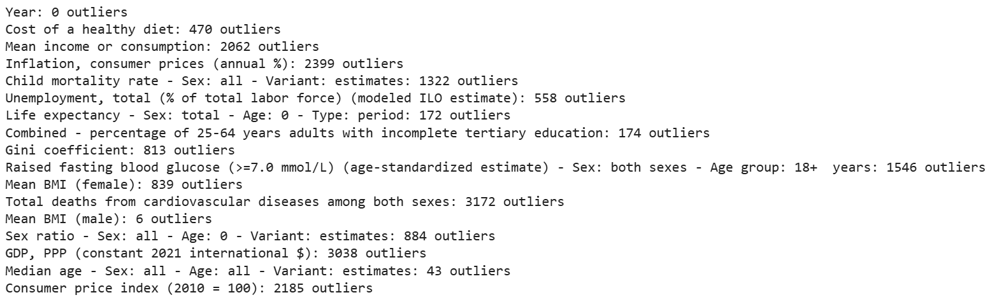
Figure 1: IQR test result
In Figure 1, the result of iQR test shows some of the variables with a few outliers, such as Year, BMI (male) and Median Age. Year has zero outlier because it just a sequential time variable, BMI (male) has low number of outliers reveals that the BMI level is consistent of male across the countries over time. Median Age and Life expectancy has low number of outliers shows that a consistent trend of median age and life expectancy across the countries, some of the outliers could be caused by disease or war from some of the countries.
In contrast, some of the variables with high outliers, especially economics factors, such as GDP, Income, Inflation and CPI, which indicate that it could be caused by unstable of economic condition across the countries, e.g. global financial crisis or recession, which indirectly associated with the high number of outliers of unemployment rate, inflation, CPI, Gini coefficient, lead to income inequality. On the other hand, health related variable also has high number of outliers, such as Heart disease, Diabetes, Child Mortality Rate. It reveals that the inequality of income and standard of health system across countries could affect the number of outliers. Additionally, disease such as COVID 19 causes the outliers of health or economics factors increase.
Moreover, Boxplots is a good tool of offering a visual summary of the distribution, skewness, and variability for each numeric variable in the dataset. Refer to Appendix A illustrates the boxplots for each variable.
For the correlations between the variables, several strong correlations were observed among variables. Refer to Figure 2 and 3, Life Expectancy demonstrated a strong positive correlation with both Median Age and Year, which reflects the healthcare and living standard have been improved over time. In contrast, Child Mortality Rate showed a strong negative correlation with both Life Expectancy and Median Age, that suggests countries with younger populations and poor healthcare system experience higher child mortality and lower lifespan. Additionally, BMI (Female) showed a strong positive correlation with Diabetes prevalence, highlights that body mass (BMI) as a high-risk factor causing diabetes, particularly among women.
Figure 2 and Figure 3 shows the correlation among the variables

Figure 2: Correlation Table
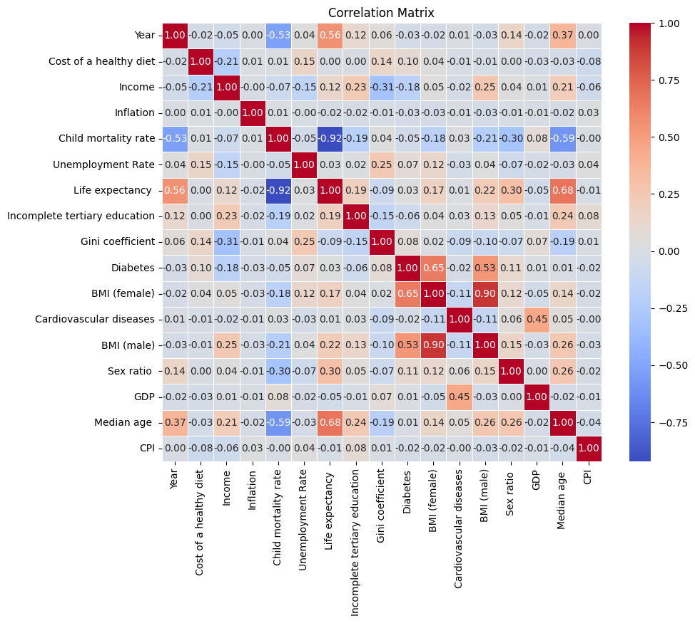
Figure 3: Correlation Matrix
The Descriptive Statistics provided a foundational understanding of the data's structure and correlation, which help decisions for data cleaning, transformation, and modeling strategies in the next phases of the project.

Explanation of Constraints and Preprocessing Steps

Constraints
Limitation for the availability of Indicators: As only indicators from Our World in Data with a consistent time range (1950–2023) were considered. However, many lifestyle-related datasets, such as those on physical activity, obesity prevalence or smoking rates, were only available from 1990 onward or do not allow to be downloaded. As a result, the selection of lifestyle indicators for this study was limited.
The incompleteness for the coverage across regions and years: A significant portion of missing data came from low-income or African countries, especially in the earlier decades (1950s –1970s). This led to gaps in the dataset, requiring imputation methods during preprocessing to maintain accuracy and integrity.
Merging and Format Inconsistencies: The dataset was constructed by combining 16 separate CSV files, each with slightly different formats and time frames. This created merging challenges, such as inconsistent column names (e.g., “Entity” vs. “Country”) and insufficient time frame. As a result, variable selection had to be carefully managed to ensure proper alignment across countries and years.
There is a constraint of conducting Shapiro test with observations fewer than 5000. Since the dataset contains over 21,000 records, random sampling was applied to subsets of the data to assess normality.
For transforming variables, Log-transformation techniques are only applicable for positive values, however, this dataset includes negative and zero values. Therefore, Yeo-Johnson technique was employed, as it can handle both negative and zero value.

Preprocess Dataset
First import necessary libraries and load 16 files. To ensure that all files have been loaded correctly, list the contents of the directory to confirm the presence of all required files. Then assign shorter variable names to each file for easier reference. Next, check the column names in each file. Ensure consistency by renaming the column “Entity” to “Country” in all datasets. Also, remove any leading or trailing whitespace from column headers and drop redundant columns such as "Code", which typically contains country abbreviations.
To merge the 16 files into a single Data Frame. First, create a list containing all the individual data frames. Then, merges them using outer joins on the columns [‘Country’,’Year’] to ensure that no data is lost due to mismatched entries. Merge all data frames again after cleaning. Finally, sort the merged dataset by Country and Year, and fill up the missing value with Nan. Once the data is fully cleaned and consolidated, save the final merged dataset.

Data Cleaning
The following are the steps involved in the data cleaning process to prepare the dataset for modeling.
The process began with the removal of a completely empty duplicate row identified in the dataset.
To handle missing values, imputation methods should be tailored to the distribution of the numerical variable, as recommended by (Shah.,n.d.). For variables with missing values less than 5% and approximately normal distribution, e.g. Cost of healthy diet, BMI (male / female), mean imputation is appropriate to apply. For skewed variables, e.g. Income, Inflation, Child mortality, unemployment, education, Gini Coefficient, Diabetes, heart disease, sex ratio, GDP, median age, CPI and Life expectancy, median imputation is recommended to apply. For categorical variable, e.g. Country, mode imputation is used. However, the imputation values (mean / median) should be calculated from the training set only and used to replace NaN in both train and test sets to avoid over-fitting and ensure valid model performance on unseen data. The method of Complete-case analysis (CCA) and K-Nearest Neighbors (KNN) are NOT suitable for this project because it could lead to biased dataset by discarding valuable data, while KNN is more suitable for datasets with high percentage of missing values.
The next step is handling outliers. According to (Carrascosa, 2025), outliers can be identified using the Interquartile Range (IQR) and Z-score method. After detecting outliers, Winsorization (Capping) is applied because this technique transforms only the most extreme data instead of transforming them all, reducing their influence without discarding observations altering the distribution. To investigate variable distribution, normality tests including the Shapiro-Wilk test, Anderson-Darling test, and Q-Q plots were performed. Results from the Shapiro-Wilk test (Figure 4) confirmed that none of the variables follow a normal distribution.
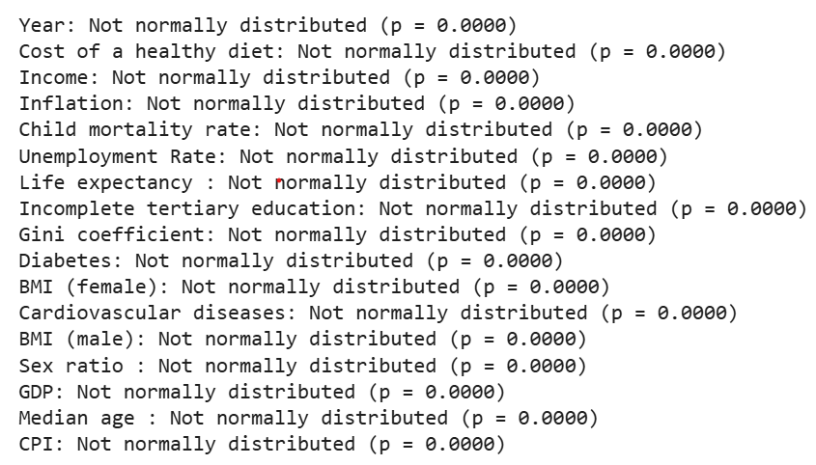
Figure 4: Shapiro-Wilk test result
Figure 4 shows the result of Shapiro test, which confirmed that all the variables are not normally distributed.
Other than Shapiro-Wilk test, QQ Plot and histogram provide visual insight into the distribution of variables, skewness and normality of variables in the dataset. Refer to Appendix B. QQ Plot , Appendix C Histogram before Normalization, and Appendix D Histograms after Normalization, to observe the differences before and after normalization.
in Appendix B, the QQ plots for Life Expectancy and Female BMI show data points that align closely with the 45-degree reference line, indicating that both variables are approximately normally distributed. In contrast, the QQ plot for GDP displays a significant deviation from the normal line, particularly in the upper quantiles. This strong upward bending away from the line indicates a heavy right skew, reflecting the presence of a few countries with extremely high GDP.
The next step involved addressing the skewed data for transformation, as skewed data can bias in model predictions. Features with skewness coefficients greater than +1 or less than -1 are considered highly skewed. In this dataset, only cost health diet, BMI (male/female) and Gini Coefficient are approximately normal, most other features are highly skewed, such as ‘inflation’ contains negative values and ‘education’ contains zero values (DataCalculus, n.d.). Therefore, Yeo-Johnson transformation was applied to this dataset because this technique is effective to handle both positive and negative values, and even zero values. Log transformation and square root transformation are not suitable to apply in this dataset because they only can handle positive skewed data.
The final step in data preparation involved feature scaling using the StandardScaler technique. Standardization was crucial to ensure that all continuous features contributed equally during model training. Standardization adjusted the distribution of each variable to have a mean of zero and a standard deviation of one, which is important for machine learning algorithms sensitive to the scale of input features. These steps helped ensure that the dataset was clean, consistent, accurate and ready for modeling.

Relevance of the Dataset
The dataset includes explanatory variables, which are composed of demographic, economic, and lifestyle indicators. Examples of these indicators include GDP, BMI, and gender. The independent variables are related to health outcomes, which include life expectancy, prevalence of diabetes, and mortality. The demographic and economic variables, which are collectively known as socioeconomic indicators, as well as lifestyle indicators will be used to predict public health outcomes. Explanatory variables with a strong relationship with the health outcomes will be included in a predictive model which estimates health outcomes in the following 50 years (2023-2073). This analysis will help decision-makers to formulate policies that promote improved health outcomes and a sustainable healthcare system.

Feasibility
The dataset is feasible for this project as it was downloaded from Our World In Data, which is a reliable way to obtain data from authoritative sources, such as the United Nations and the World Bank. These data sources are available in CSV format and covers a wide range of variables relevant to economic, lifestyle, and demographic factors. It includes over 40,000 observations from 1950 to 2024, providing rich data for the analysis. Additionally, this dataset has been preprocessed through combining 16 separate files from Our World In Data using Python. It has been processed by data cleaning, merging, handling of missing values using mean imputation. These preparations make the dataset well-structured and ready for applying the analytical tasks in this project.

Limitations
Although the dataset helps predict the correlation between socioeconomic factors and health outcomes, there are a few limitations associated with this study.
First, the preprocessing of data involves 16 datasets from Our World In Data, which are then combined into a single dataset using Python. Despite a rigorous process to match and merge data, there is a risk that errors may be introduced during this process.
Second, this study focuses on the correlation between factors rather than causations. Barrowman (2024) cites Hume to show that while correlations may be observed, there is no certainty as to the causes. In this study, I analyze the relationship between socioeconomic factors and health outcomes; however, the correlations are mere patterns found based on the data, and one should not attempt to draw causal inference from such relationships.
Third, despite the data from Our World In Data are from well-regarded global institutions, such as the United Nations and the World Health Organization, there may be biases in the data. Wigley (2024) finds that regime type is associated with manipulation of data during the COVID-19 pandemic, where the absence of opposition parties in authoritarian states is associated with deliberate undercounting the number of COVID-19 cases. This shows that data used in this study is dependent on the accuracy of reporting by individual states and how these global institutions audit and ensure data accuracy.

Project Approach

Research Methodology

This project investigates the relationship between socioeconomic, demographic, and lifestyle factors and global health outcomes, with a particular focus on non-communicable diseases (NCDs), such as heart disease and diabetes from 1950 to 2023 and uses historical patterns to forecast health outcomes through 2073.
The study began with a comprehensive literature review of prior work to establish a strong foundation. Academic sources were gathered from databases including Google Scholar, JSTOR and PubMed. The search followed a two-stage process: first, broad searches using the theme or research questions to search, and second, targeted searches using specific terms such as “cardiovascular disease”, “Diabetes Prevalence,” “Income Inequality,” “BMI and Health Outcomes,” “ARIMA,” and “Time Series Forecasting”. Studies were selected based on thematic relevance, methodology, with focus on long-term analyses. In addition, references lists from relevant articles were review to identify further studies and expand the pool of sources. Each study was evaluated through abstracts, results, and conclusions, with detailed summaries capturing key findings, methods, and gaps. The literature review was then organized into thematic categories: (1) socioeconomic and demographic predictors, (2) lifestyle and modifiable risk factors, (3) income inequality and health disparities, (4) forecasting methodologies, and (5) disease-specific analyses (heart disease and diabetes). Within each category, studies were compared in terms of findings, scope, and relevance to my project. Connections between studies were articulated through transitions and comparative statements, while redundant information was removed to ensure clarity and synthesis. This process allowed for a critical, structured review that not only supports the research questions but also highlights how this project fills key gaps in the existing literature.
Data were sourced from publicly available, internationally recognized databases, including Our World in Data, WHO, and the Global Burden of Disease. These datasets offer consistent coverage over long time frames across countries. Data preprocessing involves combining 16 datasets from Our World In Data into a single dataset using Python. The data were first standardized for consistent format and time range. Then evaluate the data through Exploratory Data Analysis (EDA) to identify duplicates, missing values, outliers, skewness and variable distributions. To observe the normality of the data by performing Shapiro Test, Anderson Test, plot histogram, boxplot and QQ plot. Detect outliers and skewness using IQR method, z-score and boxplot. To start data cleaning, remove duplicate records after confirming it is redundancy. Then, handle missing values by imputation using mean values for normally distributed variables, medians for skewed data, and modes for categorical variables. However, the imputation values (mean / median) should be calculated from the training set only and used to replace NaN in both train and test sets to avoid over-fitting and ensure valid model performance on unseen data. Next, outliers were detected through IQR method and z-scores and addressed by applying Winsorization and Log-transformation to deal with extreme values, reducing their impact without discarding observations. Skewed variables were normalized using the Yeo-Johnson transformation, which is suitable for data containing zero, negative, or positive values. To verify the effectiveness of these transformations through histograms, boxplots and Shapiro test. Feature scaling was then performed using StandardScaler to prepare the data for regression and forecasting models. Standardization ensured that all continuous features contributed equally to model training. Then, apply Principal Component Analysis (PCA) for Dimensionality Reduction to optimize the quality of the dataset. After that, perform Train-Test Split and Cross Validation, Fit imputation on the train set and apply imputation to both train and test sets using mean, median or mode. Finally, Modelling and evaluation, analyze the results and make conclusions and recommendations of future work.
The study is structured around three research questions: first, to identify the most significant socioeconomic and lifestyle factors associated with the prevalence of heart disease and diabetes globally; second, to assess how modifiable economic and lifestyle factors such as BMI, cost of a healthy diet, and consumer price index (CPI) influence variations in life expectancy across countries; and third, to predict future trends in disease prevalence and life expectancy from 2023 to 2073 based on historical data and identified predictors.
For RQ1, which identify the most significant socioeconomic, demographic, and lifestyle factors associated with the prevalence of heart disease and diabetes across countries from 1950 to 2023, Multiple Linear Regression (MLR) is applied. MLR is particularly appropriate for this question as it enables the estimation of the strength and direction of relationships between multiple independent variables (income, Gini coefficient, BMI, cost of a healthy diet, and median age) and a dependent variable (heart disease and diabetes. Since heart disease and diabetes are two distinct outcomes, the analysis uses a two separate regression models, one developed to predict heart disease prevalence and another to predict diabetes prevalence. This allows for a clearer understanding of how specific predictors contribute to each disease individually, while also enabling comparisons to identify shared and unique influencing factors. Before running the models, multicollinearity is checked using correlation matrices and the Variance Inflation Factor (VIF) to ensure stable and interpretable regression results. Model performance will be evaluated using metrics such as R², Root Mean Squared Error (RMSE), and Mean Absolute Error (MAE), providing insight into how well the models explain variations in disease prevalence across countries and time.
For Research Question 2, which examines how modifiable economic and lifestyle variables (e.g., income, CPI, BMI, and diet cost) explain differences in life expectancy across countries, a separate MLR model is used with life expectancy as the outcome variable. This model allows for the quantification of the contribution of each predictor to variations in longevity. Feature selection and dimensionality reduction techniques, such as Principal Component Analysis (PCA) will be applied to improve model efficiency and reduce multicollinearity. The use of MLR for both RQ1 and RQ2 offers the advantage of clear and interpretable results, ensure statistical reliability, and well-suited for analyzing both cross-sectional and time-based health data.
For Research Question 3, which aims to forecast future health outcomes (life expectancy and disease prevalence) from 2023 to 2073, the dataset is restructured into a time series format organized by country and year. Two forecasting models, Auto Regressive Integrated Moving Average (ARIMA) and Prophet are employed. ARIMA is preferred for structured, stationary time series and is known for its high precision in modeling linear trends and autocorrelations. Prophet, developed by Facebook, is well-suited for time series data with missing values, irregular trends, or multiple seasonal effects, offering a more flexible approach for real-world health datasets. Both models are trained using historical data from 1950–2023, and forecasting performance is assessed using Mean Absolute Percentage Error (MAPE), along with cross-validation to evaluate predictive accuracy and generalization.
The entire analysis is using Python, with libraries like Pandas and NumPy for organizing and cleaning data, scikit-learn and statsmodels for building models, ARIMA and Prophet for time series forecasting, and Matplotlib and Seaborn for creating charts and graphs.

Justification the Approach on Prior Studies

Multiple Linear Regression and time series forecasting models (ARIMA and Prophet) are used in this study. Multiple Linear Regression is effective in estimating the strength and direction of relationships between multiple predictors and therefore is used in Research Questions 1 and 2 to analyze the relationship between income, education, BMI, and CPI, and health outcomes such as disease prevalence and life expectancy. Multiple Linear Regression provides statistical findings which help formulate policy insights.
Prior studies used similar method, including Zahra et al. (2015), Balia & Jones (2008), Murray et al. (2012), and Kontis et al. (2017), have successfully used regression models to explore the relationship between socioeconomic or behavioral factors and chronic disease outcomes across countries. Zahra et al. (2015) examined structural and behavioral determinants of chronic diseases in low- and middle-income countries, while Balia and Jones (2008) applied regression models to UK data, linking health outcomes with variables such as education and income. Kontis et al. (2017) also employed multivariable regression to assess the global impact of risk factors on NCD mortality. These studies show that regression models are interpretable, transparent, and effective for health policy insights. This project builds on these studies by extending their approaches globally and across a longer time frame (1950–2023), allowing broader insight into temporal and regional variation in disease outcomes and life expectancy.
Time series forecasting models, ARIMA and Prophet, are used for Research Question 3 to forecast future trends in health outcomes through 2073. Using both methods together offers complementary strengths. ARIMA is effective for capturing linear trends and autocorrelation in well-behaved time series, while Prophet is good for handles missing data, non-linear trends, and seasonal effects more flexibly. This approach is supported by prior study. Sardar et al. (2022), which applied both models to COVID-19 data across South Asian countries, demonstrating the effectiveness of using both ARIMA and Prophet method together. Similarly, Sah et al. (2022) used these models to predict the spread of COVID-19 across Indian states, showing strong performance from the combined approach. Based on this evidence, this study applies the same strategy to generate reliable forecasts for Research Question 3.

Proposed Methodology and Tools
The preprocessing of data involves combining 16 datasets from Our World In Data into a single dataset using Python. Based on this dataset, regression and time series analysis will be performed to understand how well socioeconomic factors explain health outcomes

Techniques and Tools:
Modeling Techniques: Multiple Linear Regression and Time Series (ARIMA and Prophet)
Tools: Python (Pandas, NumPy, scikit-learn, Matplotlib/Seaborn, prophet)

Regression Analysis
Regression analysis is a statistical tool for the investigation of relationships between variables and estimates how one or more predictor variables affect the outcome (Sykes, 1993).
Purpose: To identify the relationship between economic, lifestyle, demographic factors, and health outcomes.
Application: Multiple linear regression will be applied to research questions 1 and 2 respectively. For RQ1, the goal is to evaluate how demographic indicators (e.g., age, gender, education) and economic indicators (e.g., GDP, income, CPI, unemployment) correlate with the prevalence of diabetes and heart disease. For question 2, the focus is assessing whether the lifestyle factors (cost of healthy diet and BMI) in predicting health outcomes such as life expectancy.

Time Series Analysis (ARIMA and Prophet)
Time series analysis is a statistical technique that analyzes patterns, trends, and relationships in data at regular intervals to make informed predictions, forecasts by modeling trends, seasonality, and other temporal patterns. Data obtained from observations collected sequentially over time. The purpose of time series analysis is generally twofold: to understand or model the stochastic mechanism that gives rise to an observed series and to predict or forecast the future values of a series based on the history of that series and, possibly, other related series or factors (Shumway, 2000).
Purpose: To forecast future health outcomes (such as life expectancy, disease prevalence) based on historical trends in significant demographic, economic, and lifestyle indicators.
Application: Time series forecasting methods will be applied to Research Question 3. The goal is to model and predict future trends in health outcomes (e.g., life expectancy, disease rates) from 2023 to 2073. Based on the insights from research questions 1 and 2, key predictors will be selected. Techniques such as Prophet and ARIMA will be used to forecast future values by analyzing historical data patterns from 1950 to 2023. The dataset will be split chronologically into train and test sets with Cross-validation to ensure reliable model performance.

Visual Representation

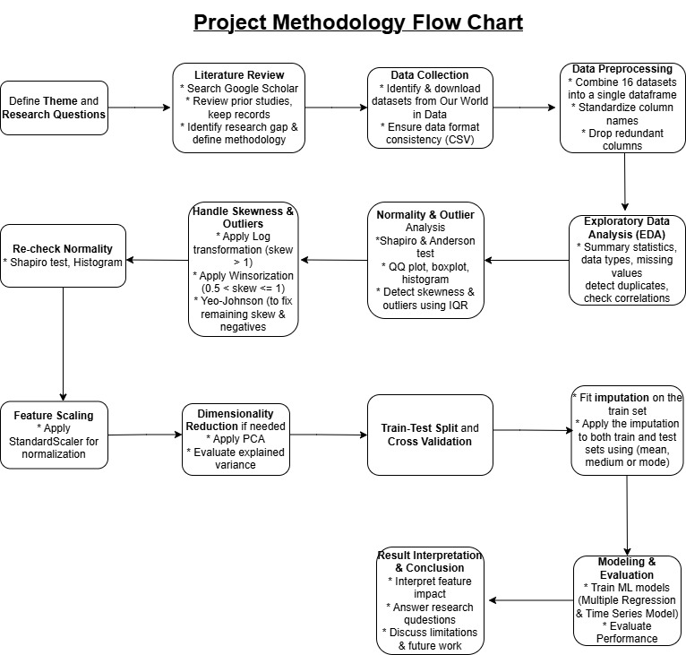

Figure 5: Project Methodology Flow Chart

GitHub Repository Link
EDA Report:
https://github.com/jenniferyik/CIND820_Capstone-Project/blob/main/eda_report%20(1).html

Health Dataset:
https://github.com/jenniferyik/CIND820_Capstone-Project/blob/main/Health%20Dataset.csv

References
Balia, S., & Jones, A. M. (2008). Mortality, lifestyle and socio-economic status. Journal of health economics, 27(1), 1-26.
Barrowman, N. (2014). Correlation, causation, and confusion. The New Atlantis, 23-44.
Carrascosa, I. P. (2025, March 11). Dealing with outliers: A complete guide. KDnuggets. https://www.kdnuggets.com/dealing-with-outliers-a-complete-guide
Chateau, D., Metge, C., Prior, H., & Soodeen, R. A. (2012). Learning from the census: the Socio-economic Factor Index (SEFI) and health outcomes in Manitoba. Canadian Journal of Public Health/Revue Canadienne De Sante'E Publique, S23-S27.
Contoyannis, P., & Jones, A. M. (2004). Socio-economic status, health and lifestyle. Journal of health economics, 23(5), 965-995.
Danaei, G., Finucane, M. M., Lu, Y., Singh, G. M., Cowan, M. J., Paciorek, C. J., Lin, J. K., Farzadfar, F., Khang, Y. H., Stevens, G. A., Rao, M., Ali, M. K., Riley, L. M., Robinson, C. A., Ezzati, M., & Global Burden of Metabolic Risk Factors of Chronic Diseases Collaborating Group (Blood Glucose) (2011). National, regional, and global trends in fasting plasma glucose and diabetes prevalence since 1980: systematic analysis of health examination surveys and epidemiological studies with 370 country-years and 2·7 million participants. Lancet (London, England), 378(9785), 31–40. https://doi.org/10.1016/S0140-6736(11)60679-X
DataCalculus. (n.d.). Effective strategies for handling skewed data distributions. DataCalculus. https://datacalculus.com/en/knowledge-hub/data-analytics/data-cleaning-and-preprocessing/handling-skewed-data-distributions/
Dinca-Panaitescu, S., Dinca-Panaitescu, M., Bryant, T., Daiski, I., Pilkington, B., & Raphael, D. (2011). Diabetes prevalence and income: Results of the Canadian Community Health Survey. Health policy (Amsterdam, Netherlands), 99(2), 116–123. https://doi.org/10.1016/j.healthpol.2010.07.018
Dimai, M. (2024). Modeling and forecasting mortality with economic, environmental and lifestyle variables. Decisions in Economics and Finance, 1-35.
Foreman, K. J., Marquez, N., Dolgert, A., Fukutaki, K., Fullman, N., McGaughey, M., ... & Murray, C. J. (2018). Forecasting life expectancy, years of life lost, and all-cause and cause-specific mortality for 250 causes of death: reference and alternative scenarios for 2016–40 for 195 countries and territories. The Lancet, 392(10159), 2052-2090.
Gerdtham, U. G., & Ruhm, C. J. (2006). Deaths rise in good economic times: evidence from the OECD. Economics & Human Biology, 4(3), 298-316.
Kastorini, C. M., Milionis, H. J., Georgousopoulou, E., Kalantzi, K., Nikolaou, V., Vemmos, K. N., ... & Panagiotakos, D. B. (2015). Defining the path between social and economic factors, clinical and lifestyle determinants, and cardiovascular disease. Global heart, 10(4), 255-263.
Kontis, V., Bennett, J. E., Mathers, C. D., Li, G., Foreman, K., & Ezzati, M. (2017). Future life expectancy in 35 industrialised countries: projections with a Bayesian model ensemble. The Lancet, 389(10076), 1323–1335. https://doi.org/10.1016/S0140-6736(16)32381-9
Kutner, M. H., Nachtsheim, C. J., Neter, J., & Li, W. (2005). Applied linear statistical models (5th ed.). McGraw-Hill Irwin.
Lantz PM, House JS, Lepkowski JM, Williams DR, Mero RP, Chen J. Socioeconomic Factors, Health Behaviors, and Mortality: Results From a Nationally Representative Prospective Study of US Adults. JAMA. 1998;279(21):1703–1708. doi:10.1001/jama.279.21.1703
Li, Y., Pan, A., Wang, D. D., Liu, X., Dhana, K., Franco, O. H., ... & Hu, F. B. (2018). Impact of healthy lifestyle factors on life expectancies in the US population. Circulation, 138(4), 345-355.
Lysy, Z., Booth, G. L., Shah, B. R., Austin, P. C., Luo, J., & Lipscombe, L. L. (2013). The impact of income on the incidence of diabetes: a population-based study. Diabetes research and clinical practice, 99(3), 372–379. https://doi.org/10.1016/j.diabres.2012.12.005
Macinko, J. A., Shi, L., & Starfield, B. (2004). Wage inequality, the health system, and infant mortality in wealthy industrialized countries, 1970–1996. Social science & medicine, 58(2), 279-292.
Mahamoud, A., Roche, B., & Homer, J. (2013). Modeling the social determinants of health and simulating short-term and long-term intervention impacts for the city of Toronto, Canada. Social Science & Medicine, 93, 247–255 https://doi.org/10.1016/j.socscimed.2012.06.036
Murray, C. J. L., Vos, T., Lozano, R., Naghavi, M., Flaxman, A. D., Michaud, C., ... & Salomon, J. A. (2012). Disability-adjusted life years (DALYs) for 291 diseases and injuries in 21 regions, 1990–2010: a systematic analysis for the Global Burden of Disease Study 2010. The Lancet, 380(9859), 2197–2223. https://doi.org/10.1016/S0140-6736(12)61689-4
O'Brien, R. M. (2007). A caution regarding rules of thumb for variance inflation factors. Quality & Quantity, 41(5), 673–690. https://doi.org/10.1007/s11135-006-9018-6
Or, Z. (2000). Determinants of health outcomes in industrialised countries: a pooled, cross-country, time-series analysis. OECD Economic studies, 53-78.
Our World in Data. (n.d.). World Bank Open Data. Retrieved from https://ourworldindata.org/
Pabayo, R., Kawachi, I., & Gilman, S. E. (2015). US State-level income inequality and risks of heart attack and coronary risk behaviors: longitudinal findings. International journal of public health, 60(5), 573–588. https://doi.org/10.1007/s00038-015-0678-7
Park, J. C., Nam, G. E., Yu, J., Kim, Y. H., Lee, S. H., Han, K., & Park, Y. G. (2023). Association of sustained low or high income and income changes with risk of incident type 2 diabetes among individuals aged 30 to 64 years. JAMA Network Open, 6(8), e2330024. https://doi.org/10.1001/jamanetworkopen.2023.30024
Roth, G. A., Mensah, G. A., Johnson, C. O., Addolorato, G., Ammirati, E., Baddour, L. M., ... & Murray, C. J. L. (2020). Global burden of cardiovascular diseases and risk factors, 1990–2019: Update from the GBD 2019 study. Journal of the American College of Cardiology, 76(25), 2982–3021. https://doi.org/10.1016/j.jacc.2020.11.010
Sah, S., Surendiran, B., Dhanalakshmi, R., Mohanty, S. N., Alenezi, F., & Polat, K. (2022). Forecasting COVID‐19 Pandemic Using Prophet, ARIMA, and Hybrid Stacked LSTM‐GRU Models in India. Computational and Mathematical Methods in Medicine, 2022(1), 1556025.
Sardar, I., Akbar, M. A., Leiva, V., Alsanad, A., & Mishra, P. (2023). Machine learning and automatic ARIMA/Prophet models-based forecasting of COVID-19: Methodology, evaluation, and case study in SAARC countries. Stochastic Environmental Research and Risk Assessment, 37(1), 345-359.
Seiglie, J. A., Marcus, M. E., Ebert, C., Prodromidis, N., Geldsetzer, P., Theilmann, M., Agoudavi, K., Andall-Brereton, G., Aryal, K. K., Bicaba, B. W., Bovet, P., Brian, G., Dorobantu, M., Gathecha, G., Gurung, M. S., Guwatudde, D., Msaidié, M., Houehanou, C., Houinato, D., Jorgensen, J. M. A., … Manne-Goehler, J. (2020). Diabetes prevalence and its relationship with education, wealth, and BMI in 29 low- and middle-income countries. Diabetes Care, 43(4), 767–775. https://doi.org/10.2337/dc19-1782
Shah, T. (2020). Feature engineering: Missing data. Tejash Shah. https://tejash-shah.github.io/feature%20engineering/feature-engineering-missing-data/
Shumway, R. H., Stoffer, D. S., & Stoffer, D. S. (2000). Time series analysis and its applications (Vol. 3, p. 4). New York: springer.
Sykes, A. O. (1993). An introduction to regression analysis.
Venkataramani, A. S., Brigell, R., O'Brien, R., Chatterjee, P., Kawachi, I., & Tsai, A. C. (2016). Economic opportunity, health behaviours, and health outcomes in the USA: a population-based cross-sectional study. The Lancet Public Health, 1(1), e18-e25.
Wigley, S. (2024). Regime type and Data Manipulation: Evidence from the COVID-19 Pandemic. Journal of Health Politics, Policy and Law, 49(6), 989-1014.
Wilkinson, Richard & Marmot, Michael. (‎2003)‎. Social determinants of health: the solid facts, 2nd ed. World Health Organization. Regional Office for Europe. https://iris.who.int/handle/10665/326568
Wilkinson, R. G., & Pickett, K. (2003). Income inequality and population health: A review and explanation of the evidence. Social Science & Medicine, 62(7), 1768–1784. https://doi.org/10.1016/j.socscimed.2005.08.037
Woo, J., Ho, S. C., & Yu, A. L. M. (2002). Lifestyle factors and health outcomes in elderly Hong Kong Chinese aged 70 years and over. Gerontology, 48(4), 234-240.
World Health Organization [WHO]. (2024). Ageing and health. World Health Organization. Retrieved from https://www.who.int/news-room/fact-sheets/detail/ageing-and-health
Yen, S. T., Chen, Z., & Eastwood, D. B. (2009). Lifestyles, demographics, dietary behavior, and obesity: a switching regression analysis. Health Services Research, 44(4), 1345-1369.
Zahra, A., Lee, E. W., Sun, L. Y., & Park, J. H. (2015). Cardiovascular disease and diabetes mortality, and their relation to socio-economical, environmental, and health behavioural factors in worldwide view. Public health, 129(4), 385-395.

Appendices

Appendix A. Bloxplot
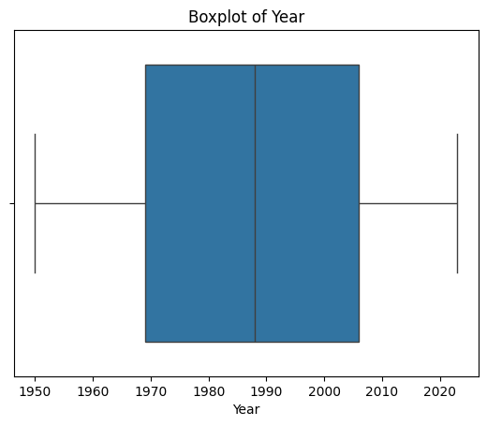 | 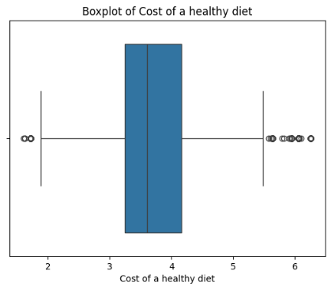 | 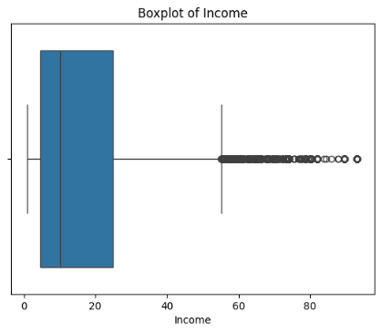
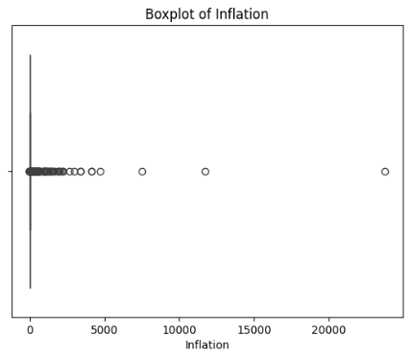 | 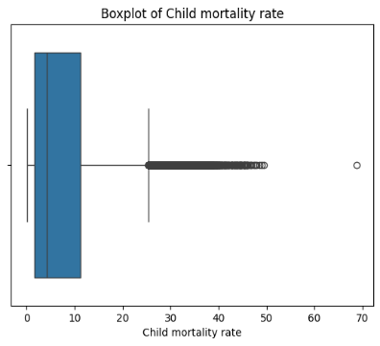 | 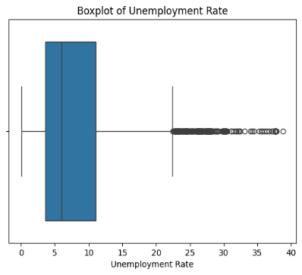
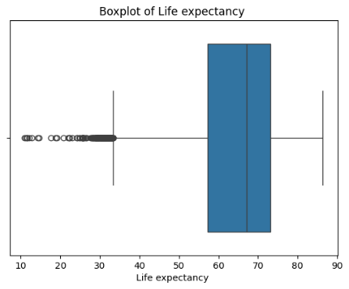 | 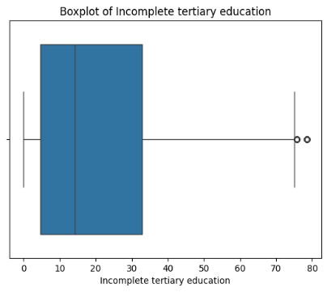 | 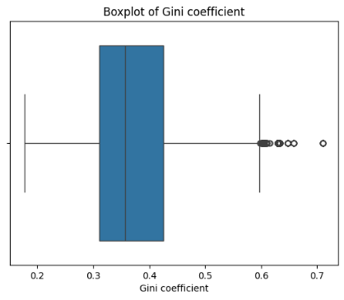
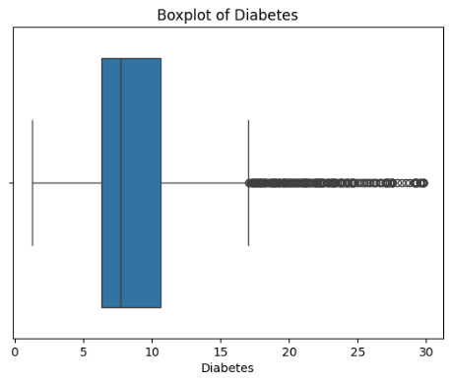 | 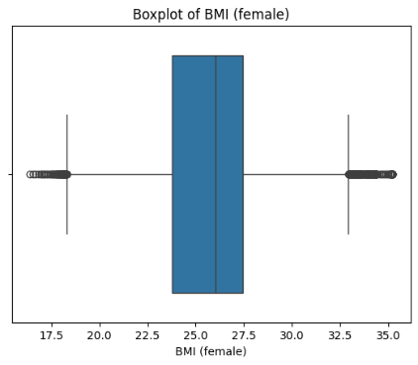 | 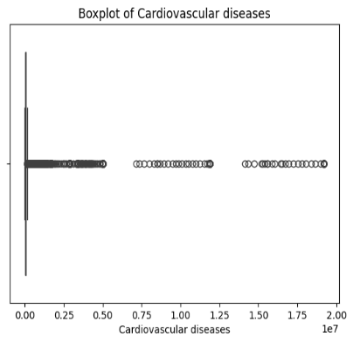
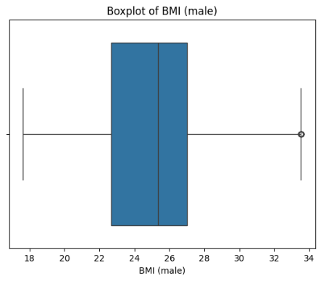 | 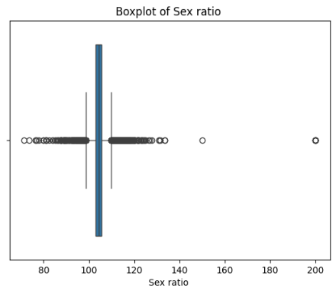 | 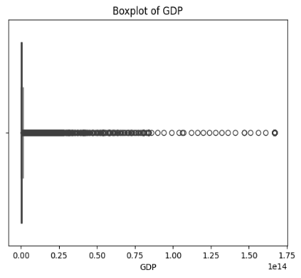
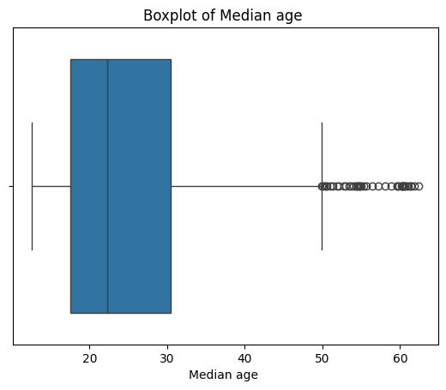 | 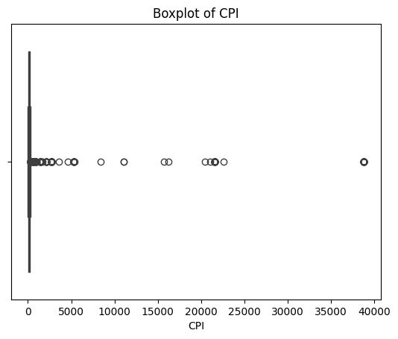

Appendix B. QQ Plot
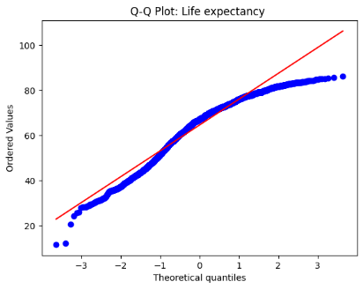 | 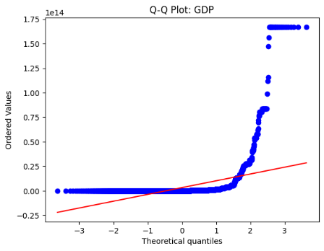 | 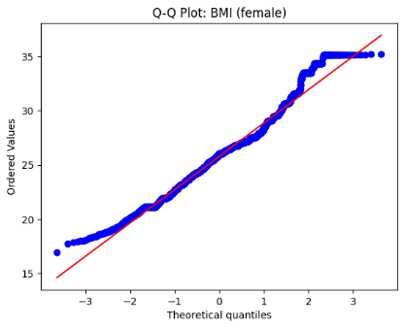
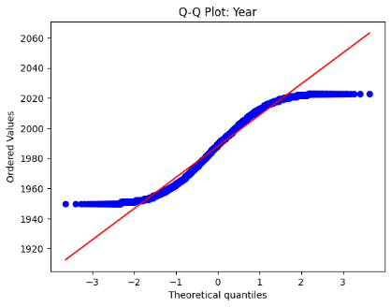 | 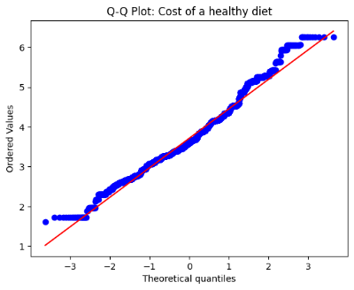 | 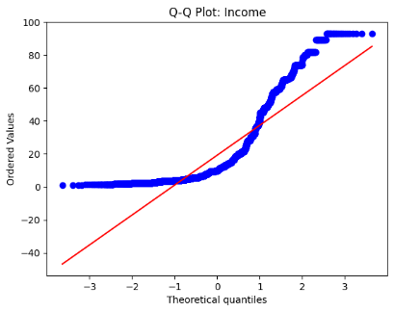
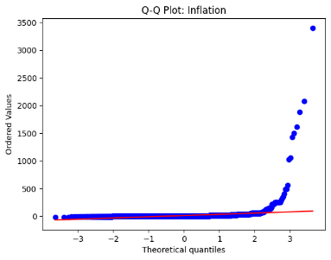 | 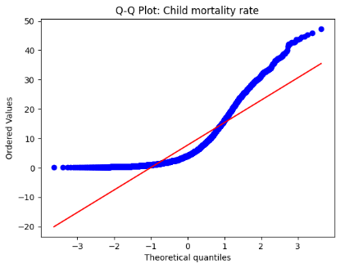 | 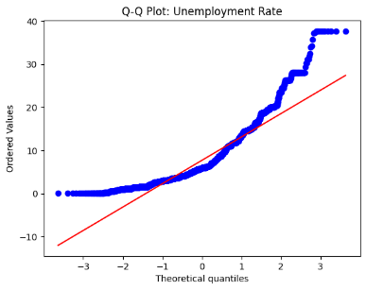
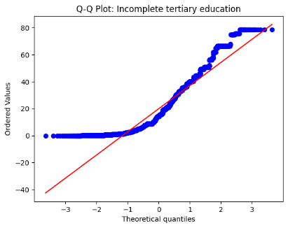 | 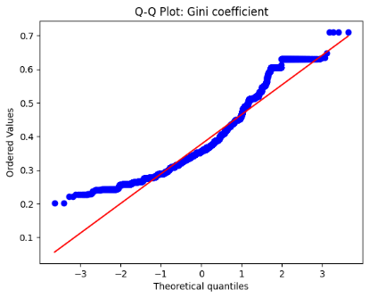 | 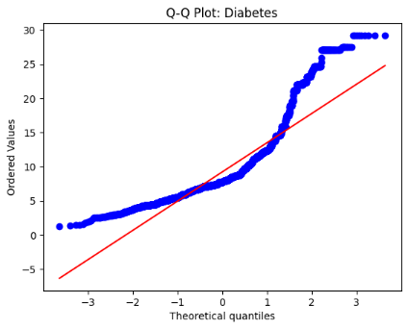
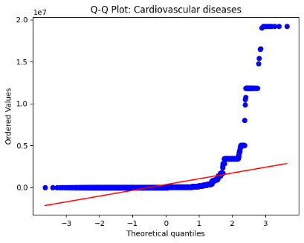 | 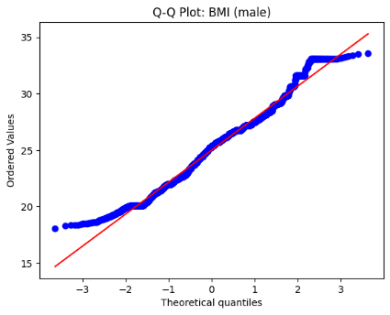 | 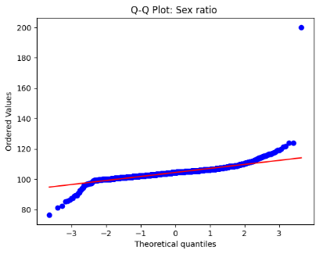
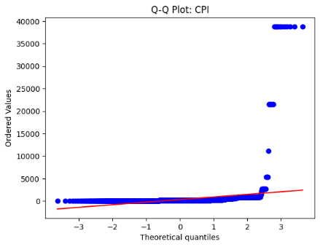 | 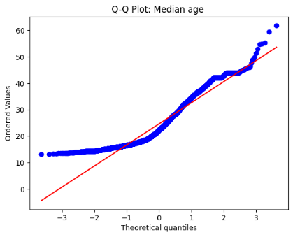

Appendix C. Histogram: BEFORE Normalization
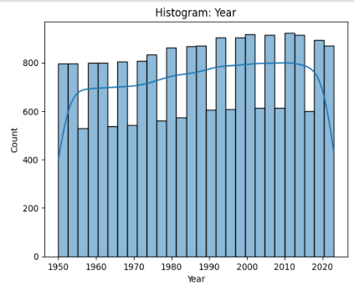 | 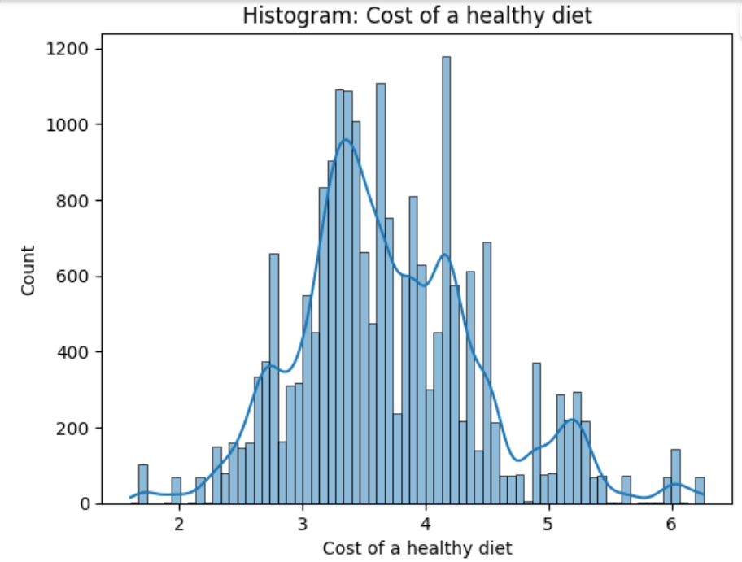 | 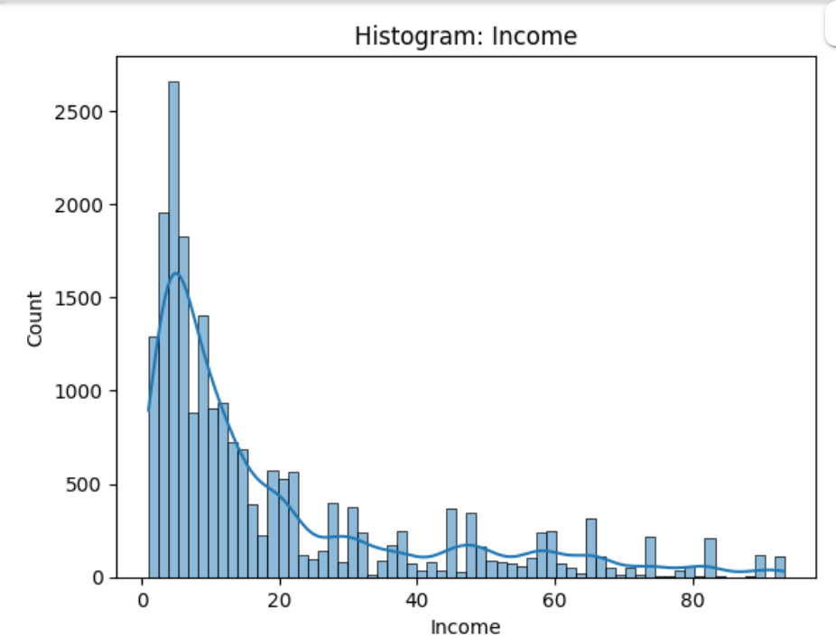
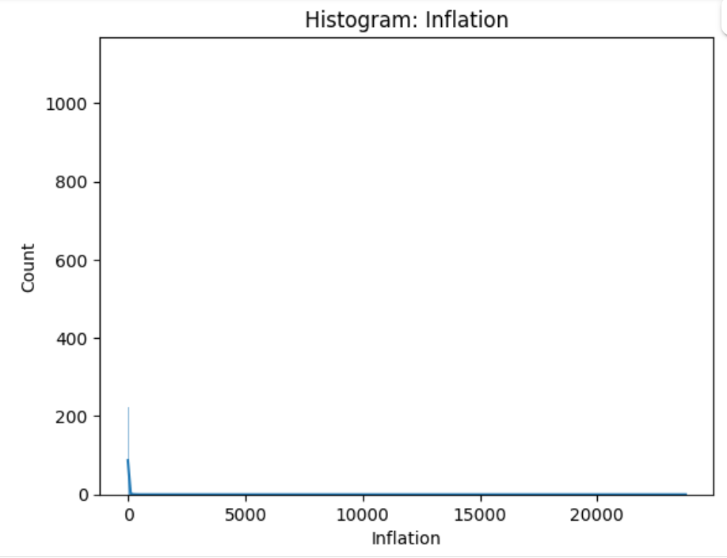 | 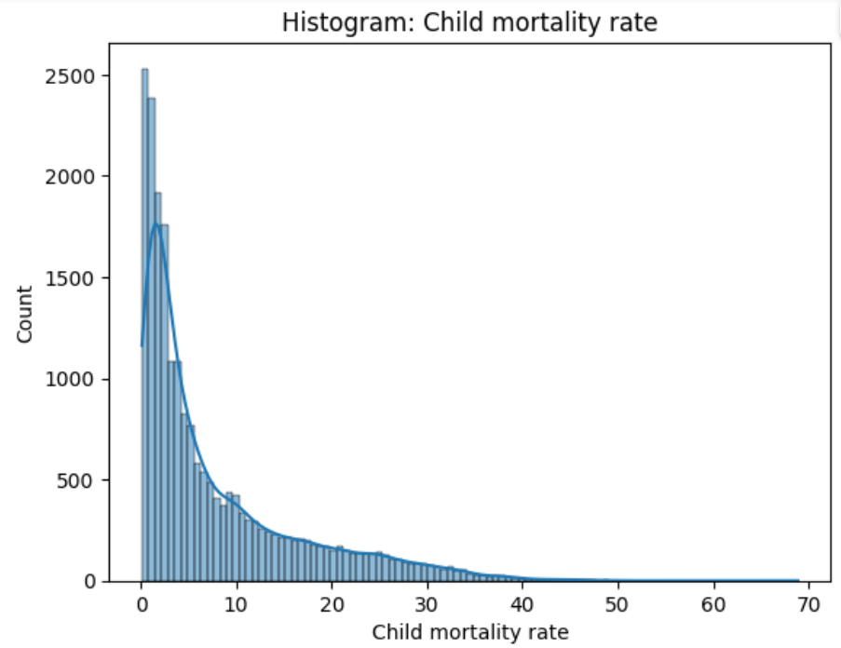 | 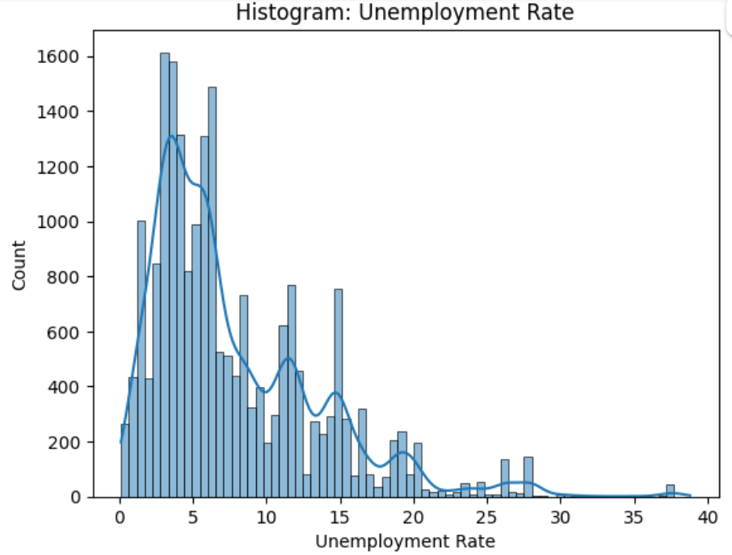
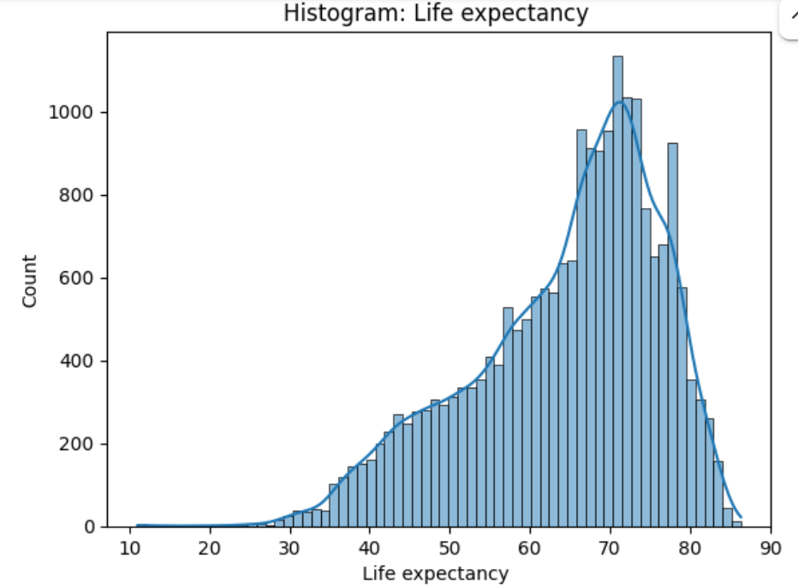 | 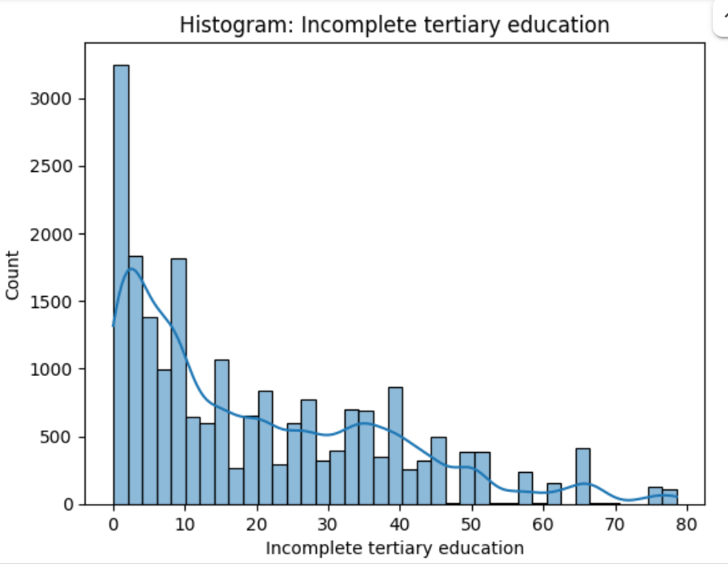 | 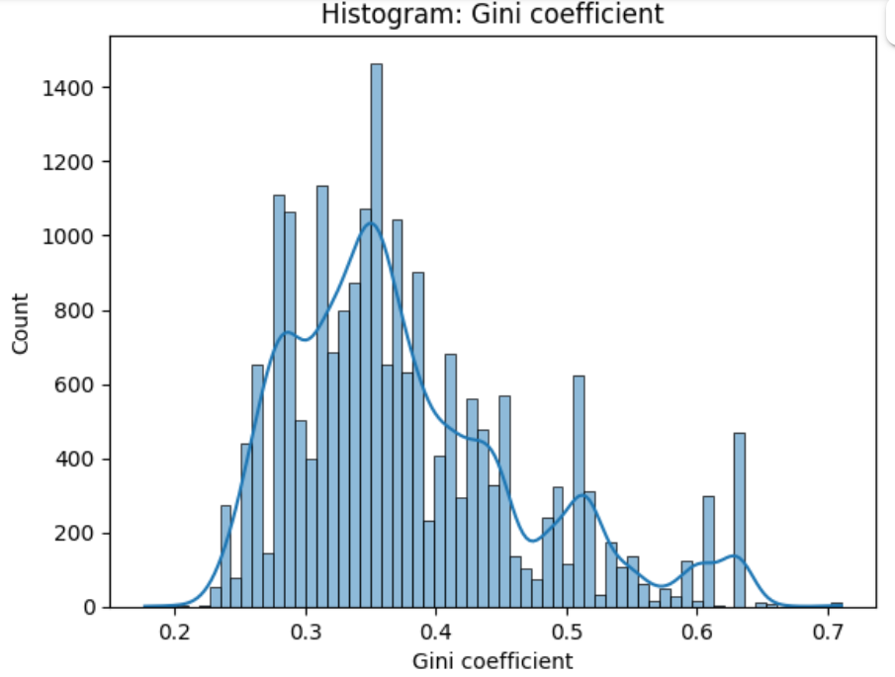
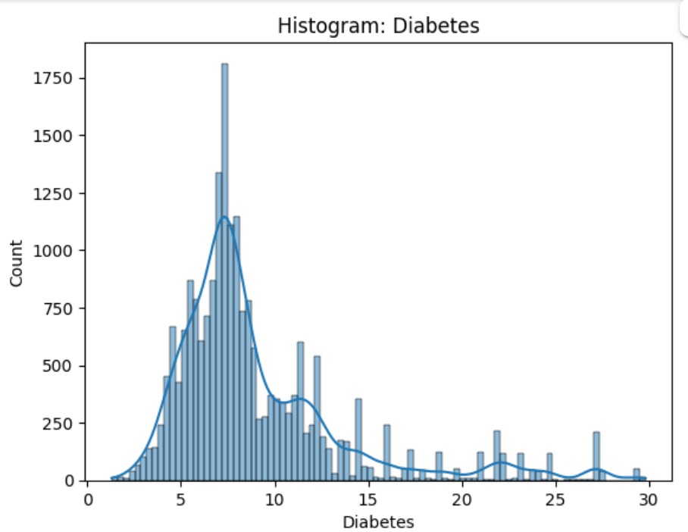 | 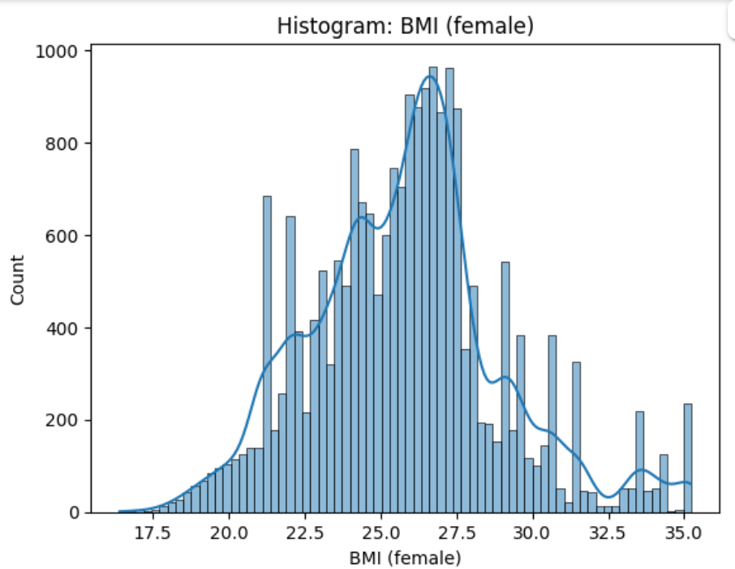 | 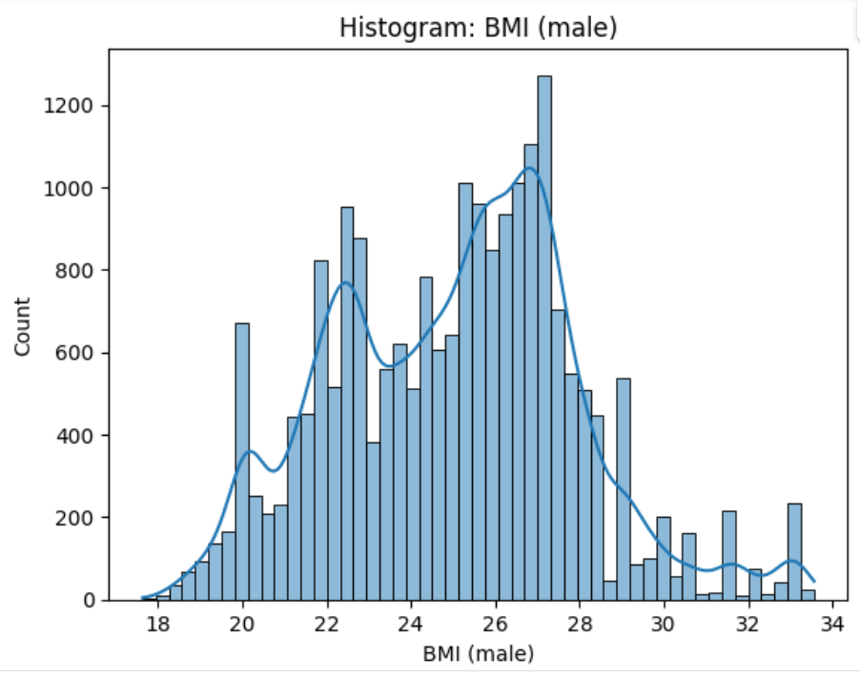
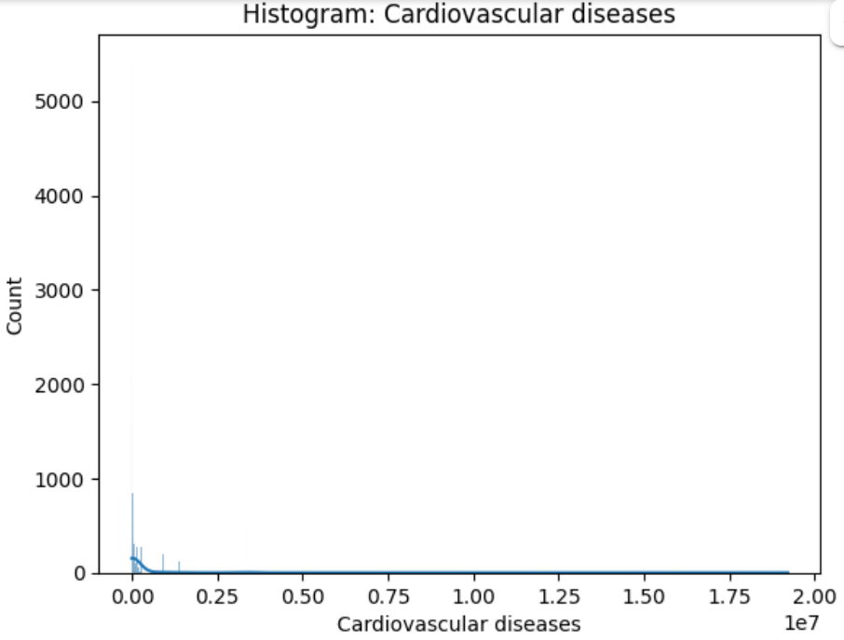 | 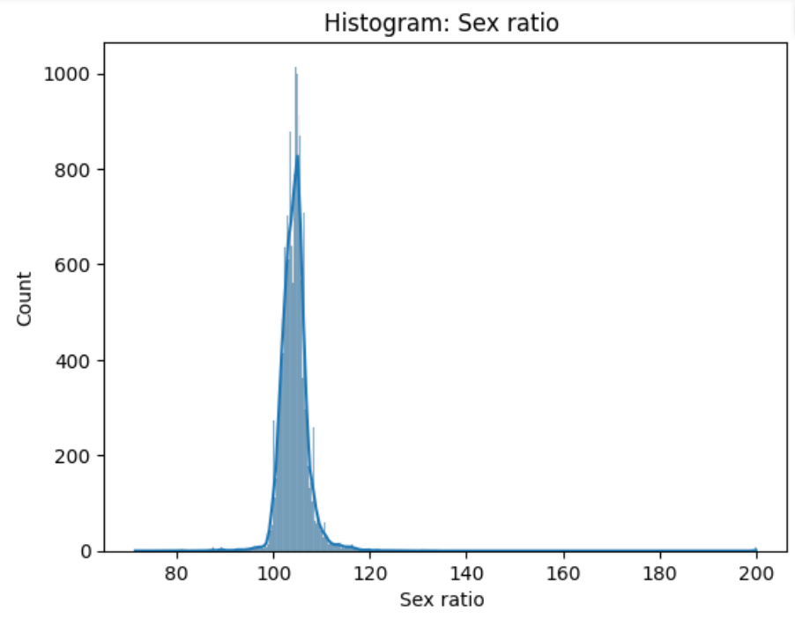 | 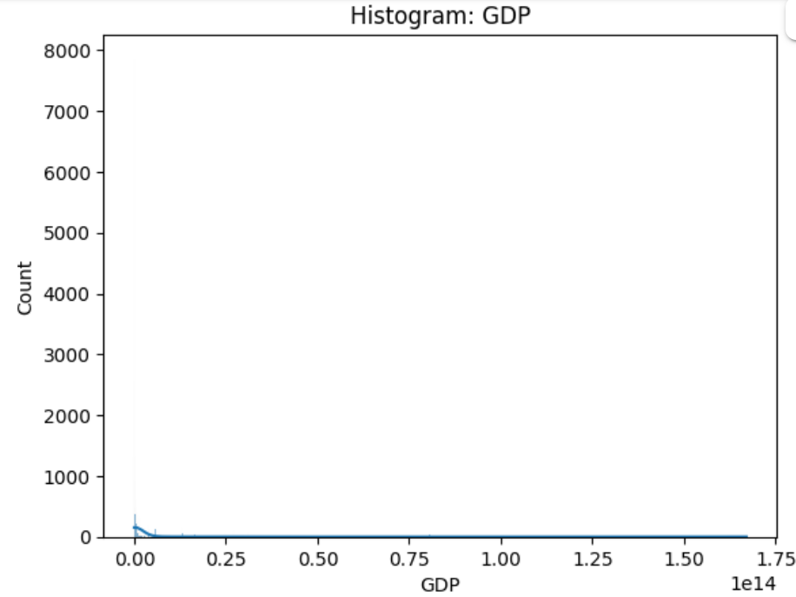
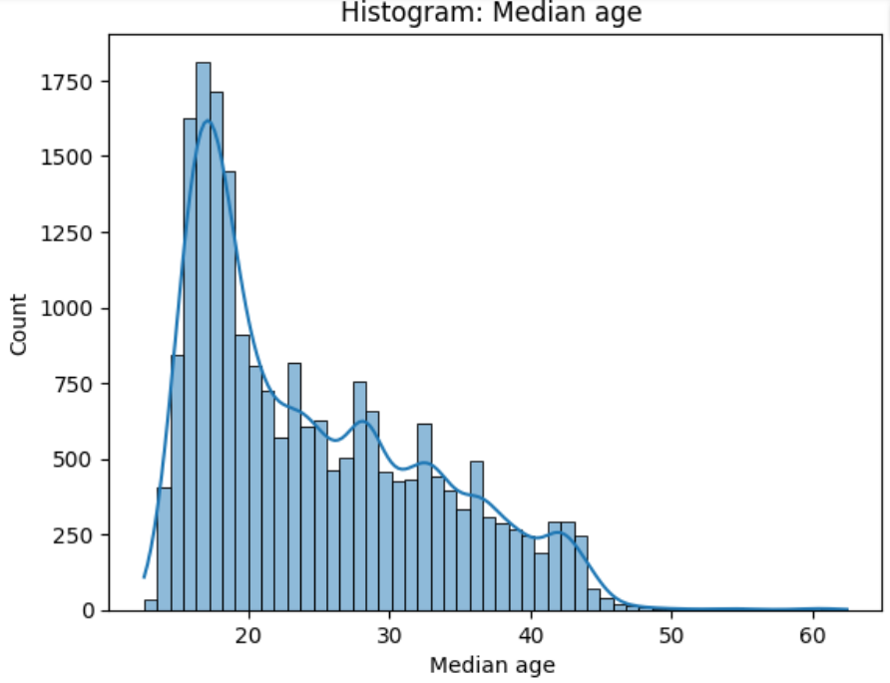 | 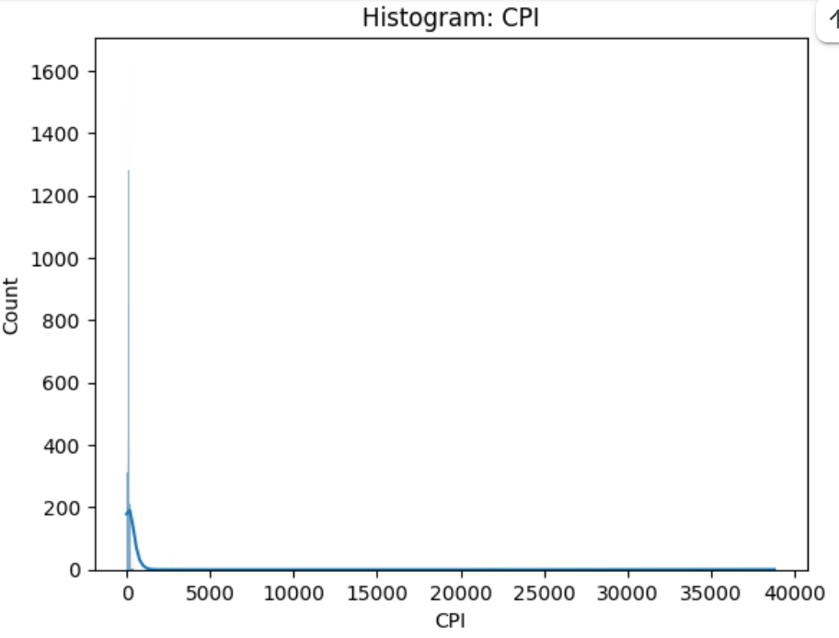

Appendix D. Histogram: AFTER Normalization
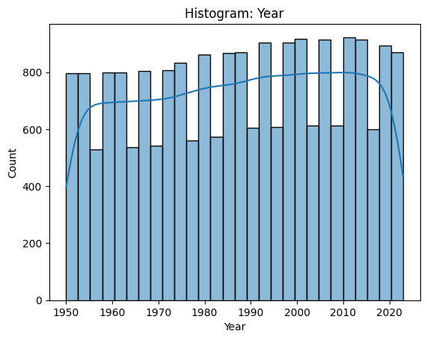 | 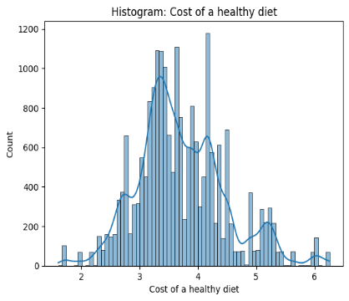 | 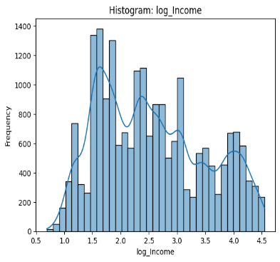
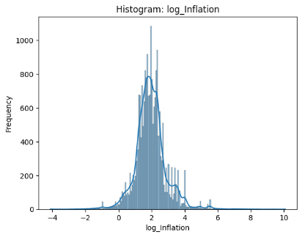 | 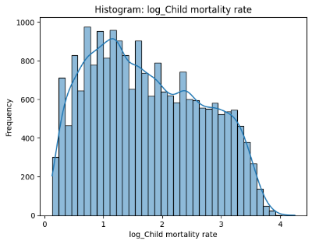 | 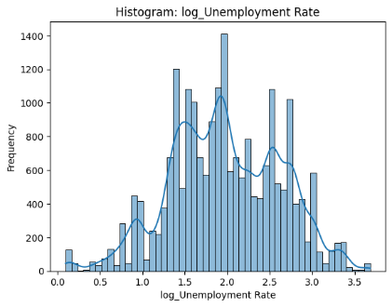
 | 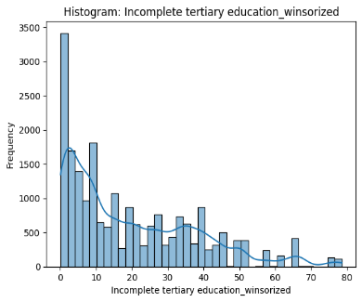 | 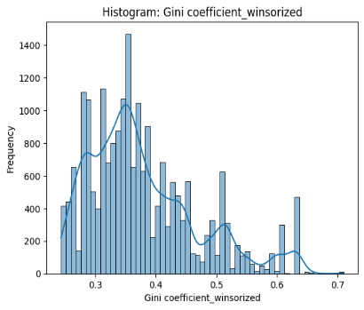
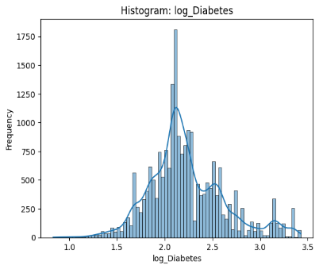 |  | 
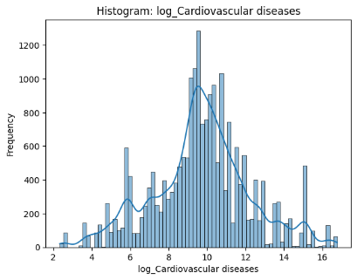 | 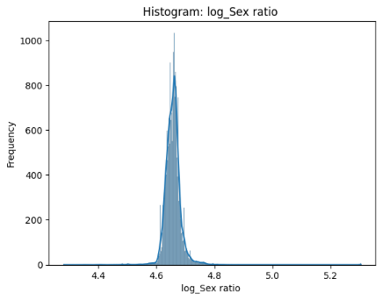 | 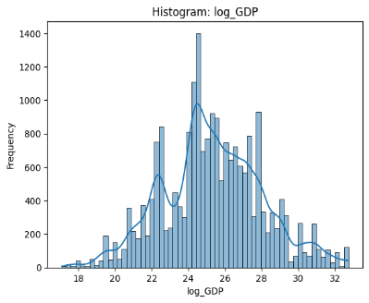
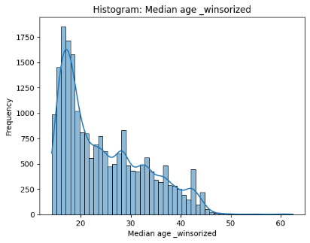 | 