After tunneling into dept server, run the program and you will be greeted with a login page:

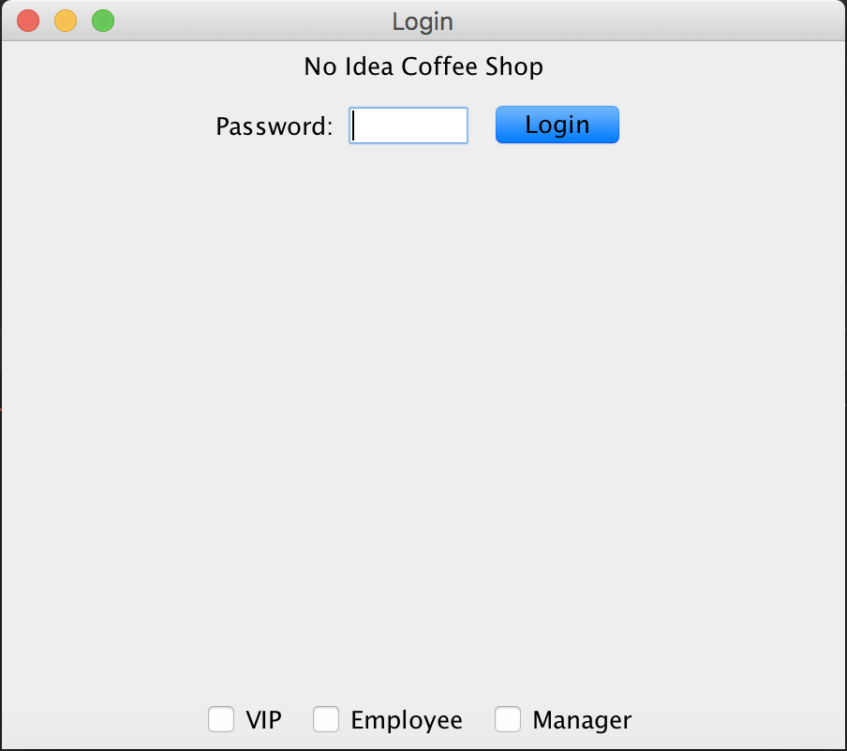You can log in as VIP with password vip,

or log in as Employee with password employee,

or log in as Manager with password manager.

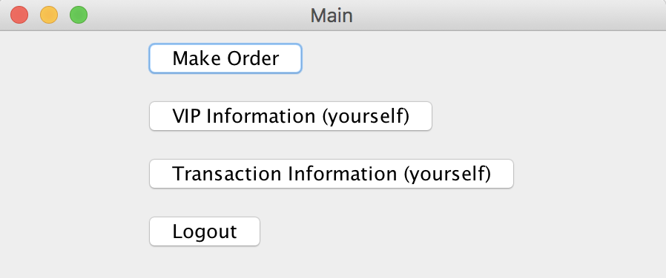

VIPs can make an order, view information about themselves, get their own transaction information.

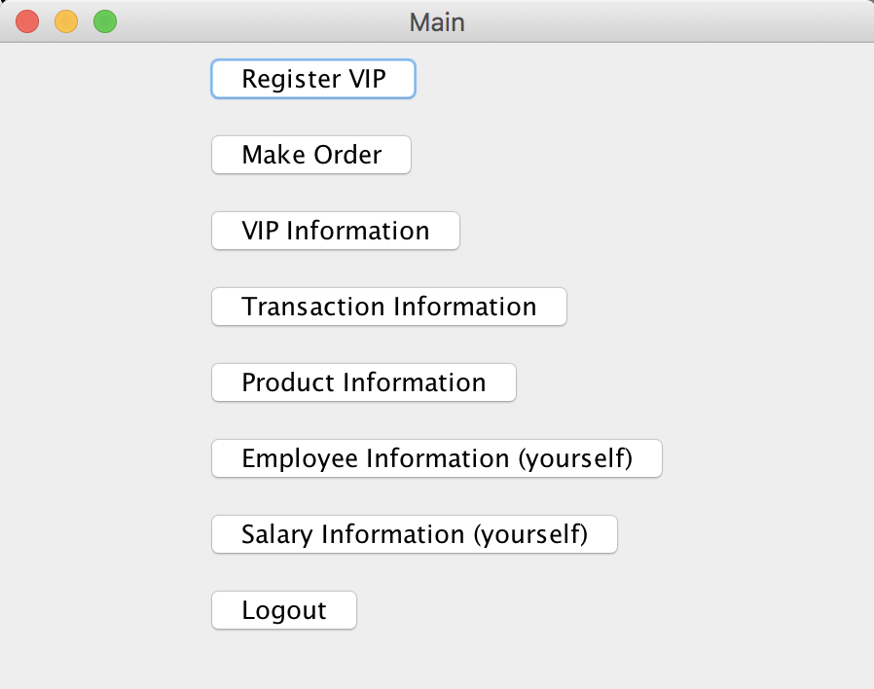

Employees can register new VIP customers, make orders for customers, access information about VIPs, transactions, products, view information about themselves and their salaries.

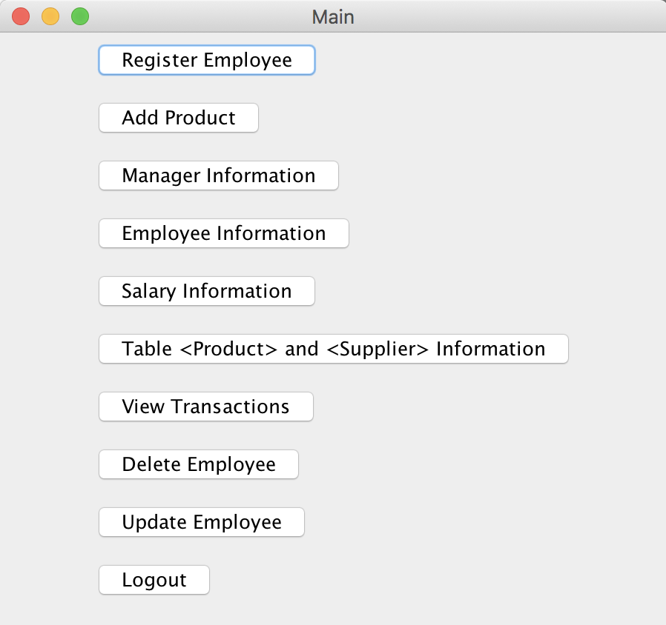

Managers can register employees, add new products, view information about managers, employees, salary, product, supplier, and transactions. They can also update and delete employees.