**Fundamentals of Web Development – HTML5 & CSS**  
***Final Project***

**Milestone: Initial Project Topic**

a) Purpose: What is the purpose of the site? Why are you creating it? What opportunity, problem or issue will your site address?

b) Target Audience: who is your intended audience? Identify age, gender, socioeconomic characteristics, interests, etc.

c) Content: What type of content might be included in your site? Will it include any or all of text, graphics and multimedia, responsive design, mobile, tablet and desktop?

The final project will be a personal portfolio website. The purpose of any portfolio site is to allow the subject to display their work and projects to the world, including potential clients and employers. I want my personal brand to appeal to young professionals and up and commers in the web & design space. My primary visitors will be preprofessional at any age with an interest in web design in addition to potential clients & employers, who would access the site to review existing work. I want to grow a portfolio of completed projects through personal projects in addition to working with local companies and charities. The site will consist of design and development projects completed and in progress when possible. I would eventually include an in-progress section and increase engagement by soliciting suggestions and submissions.   
As the site is serving as a portfolio for web development & design, it’s planned to be responsive and beautiful, even when accessed from a smartphone. The site will include many multimedia examples and eventually will include examples of projects using newer tools like Webflow and Figma in addition to well-known products like WordPress and Wix.

**Milestone 1: Planning Analysis**

1. Web Site Goal: Write a short paragraph explaining the specific goals of the intended work. What do you want the web site to accomplish? How will you determine if it is successful?   
   The specific goal is to create a personal portfolio, showcasing completed and in progress projects to potential employers in addition to other preprofessional users with an interest in web development and design. The website serves as a repository for personal projects in addition to commissioned work, when allowed. It is also a mobile and fluid resume, always available and always changing as new work is constantly added, skill sets are updated and career progresses. Offering new material on a regular basis helps with search engine results in addition to giving casual web users, clients and employers incentive to return on a regular basis.   
   The website is successful when I have repeat visits with regular user interaction in addition to having work commissioned.
2. Form: How will you incorporate a web form? What is its purpose?   
   A webform will be incorporated in the “work with us” section, used to gather basic information from potential clients.
3. Client-side processing: How you will use JavaScript? What is its purpose?   
   Javascript will be used to create an interactive hamburger menu for site navigation. The hamburger menu is commonly recognized as a navigation menu across the web and helps keep the pages clean with consistent design throughout. It will also be used to create an alert when the “work with us” form has been completed and submitted.
4. Page Titles: List the working title of each page in your website   
   Home  
   Portfolio  
   Projects in Progress  
   About  
   Work With Me
5. Required information: research and list where you intend to obtain the content (facts, text, graphics, sounds, video) for the web pages you listed above.   
   Facts, text and graphics will be my own work. I have an adobe account so will look at Adobe Stock for multimedia requirements initially.   
   Information on all subjects can be found online but you must ensure you are using a reliable source with experience and expertise in the subject matter.  
   Before using media found online, its important to understand the license included. Some media requires a one-time upfront payment, some allows any type of use with no attribution to only certain uses and no changes with full attribution. Finding something on the internet does not always mean it is in the public domain or free for use.   
   Royalty free graphics, sounds and video can easily be found online through a search. Websites like YouTube, Free Music Archive, Soundcloud & CCMixter all offer music for your use. Websites like Unsplash, Burst and New Old Stock all offer pictures and video. Pexels and Dareful offer beautiful and interesting stock video free for use.
6. Responsive design: How will you incorporate responsive design and addressing the needs for viewing via mobile, tablet, and desktop viewing.   
   The site will be designed with a mobile-first philosophy as most web traffic is from mobile devices. I will ensure the website is functional and appealing on both phone and desktop view ports by making changes to information and formatting between viewport sizes. The mobile viewport will incorporate simplified styles and streamlined information while still providing essential details and projects.

**Milestone 2: Site Map**

1. Site Map: Using a word processor, PowerPoint, or ruler and pencil, draw a flowchart (storyboard) of your web site that shows the hierarchy of pages and relationships between the pages.   
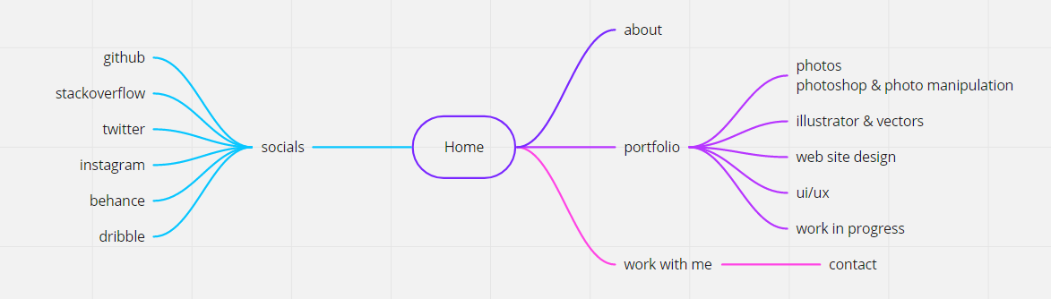

2. Wireframe: Use a computer graphics application, or pencil, to create a wireframe for a sample page on your web site that clearly shows the logo, navigation, content, and footer areas. If you use a graphics application to create a wireframe, save as a .gif or .jpg file.   
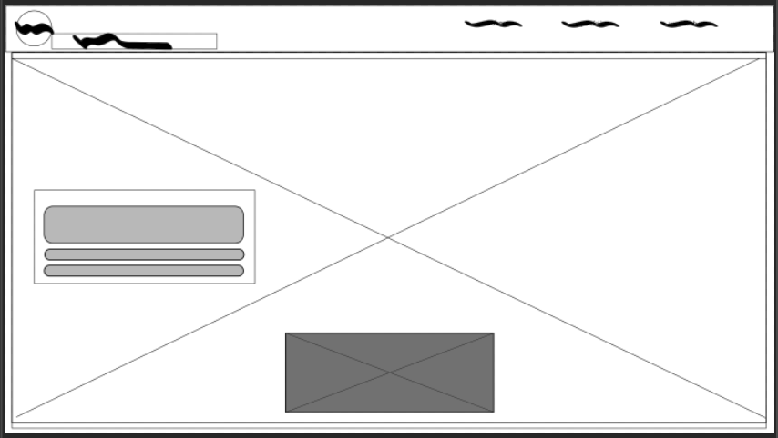  
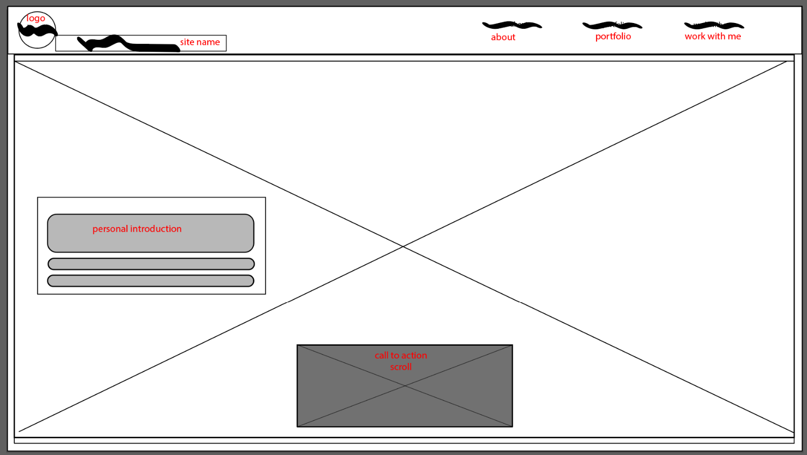

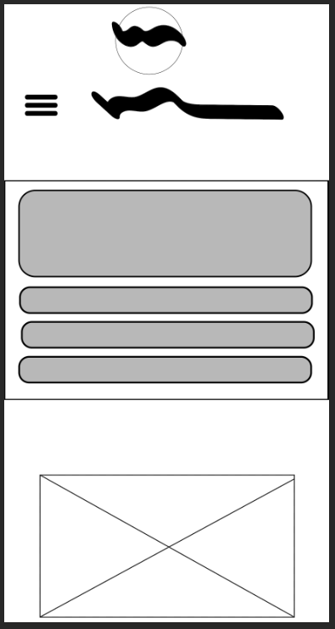

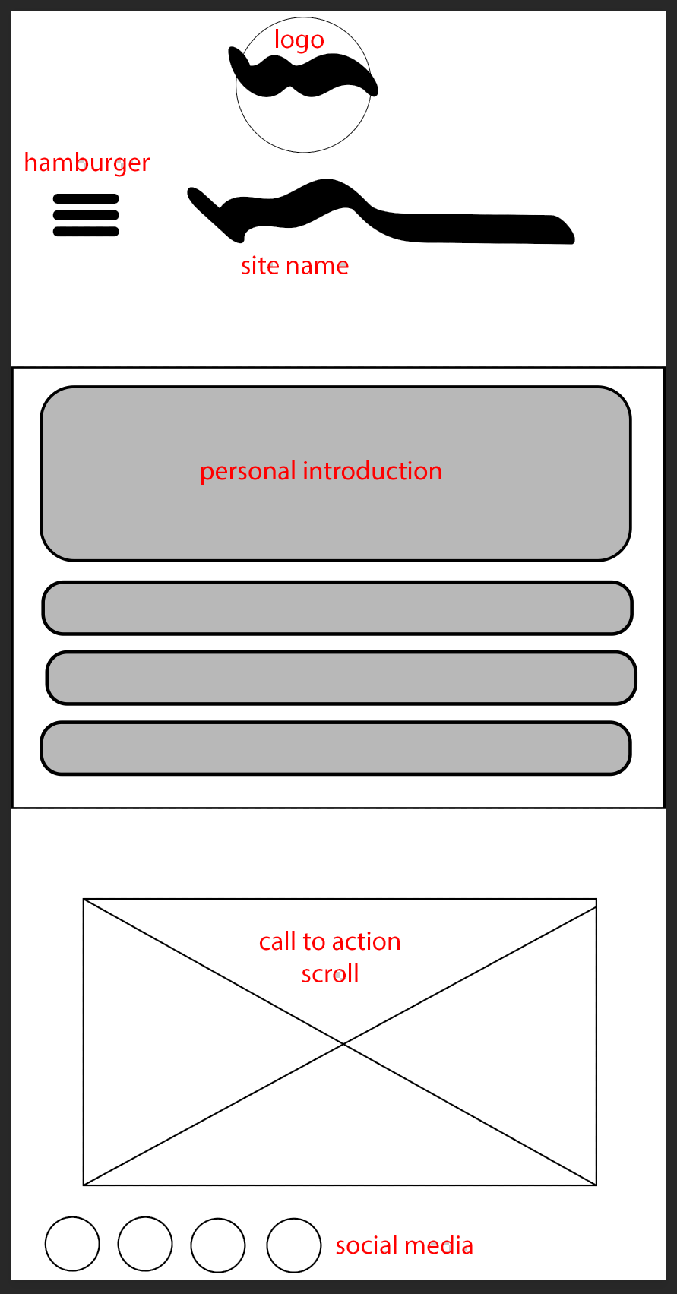

3. Save or label both documents with the name FinalProject2 followed by your first initial and last name for example FinalProject2_FLastname.

4. Submit your documents on the appointed due date to your instructor for “client approval”.