**Jennjamdotcom**

Screen Shots of all pages.

Home  
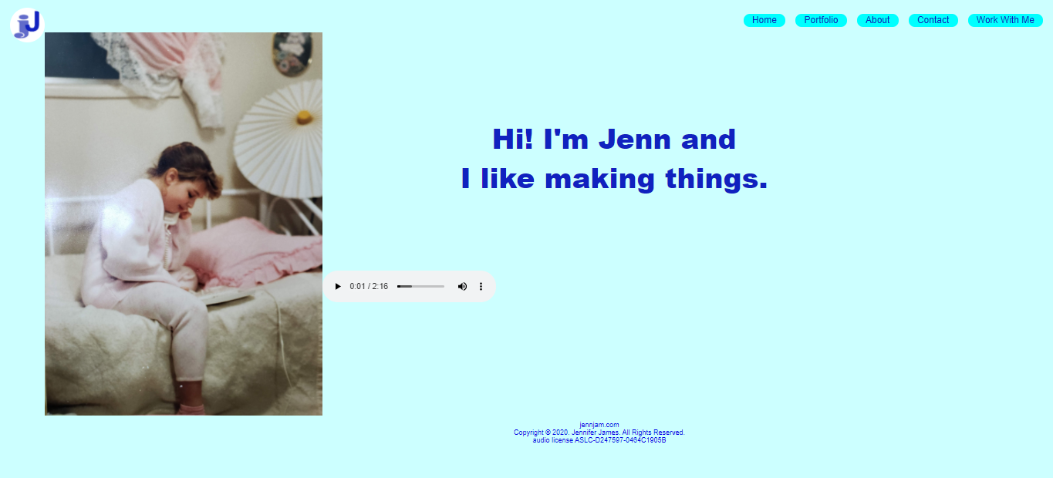

Portfolio  


Photoshop  
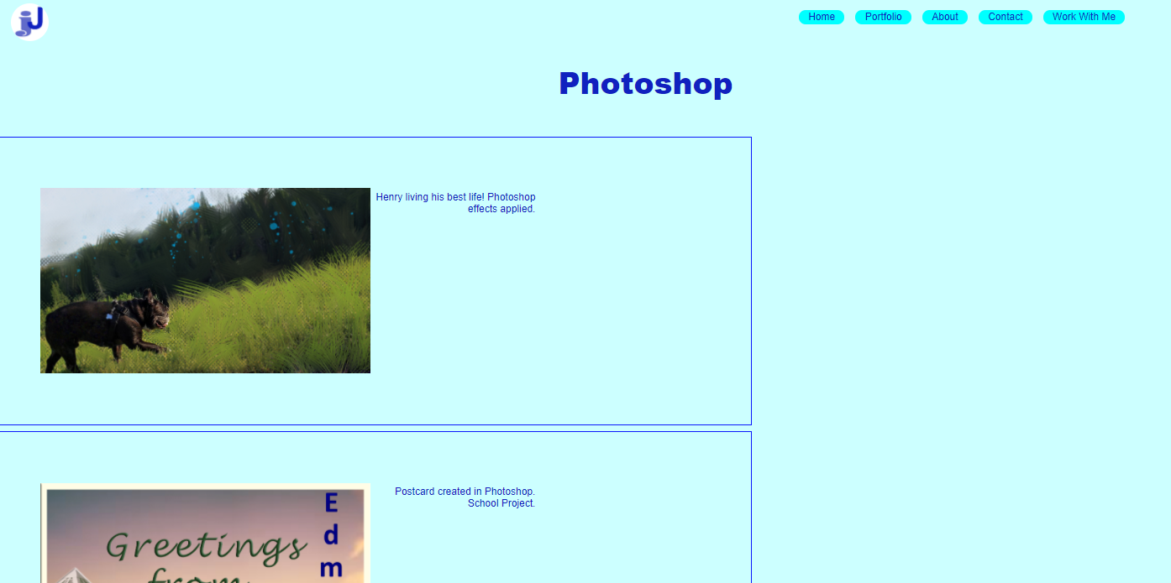  
Illustrator  
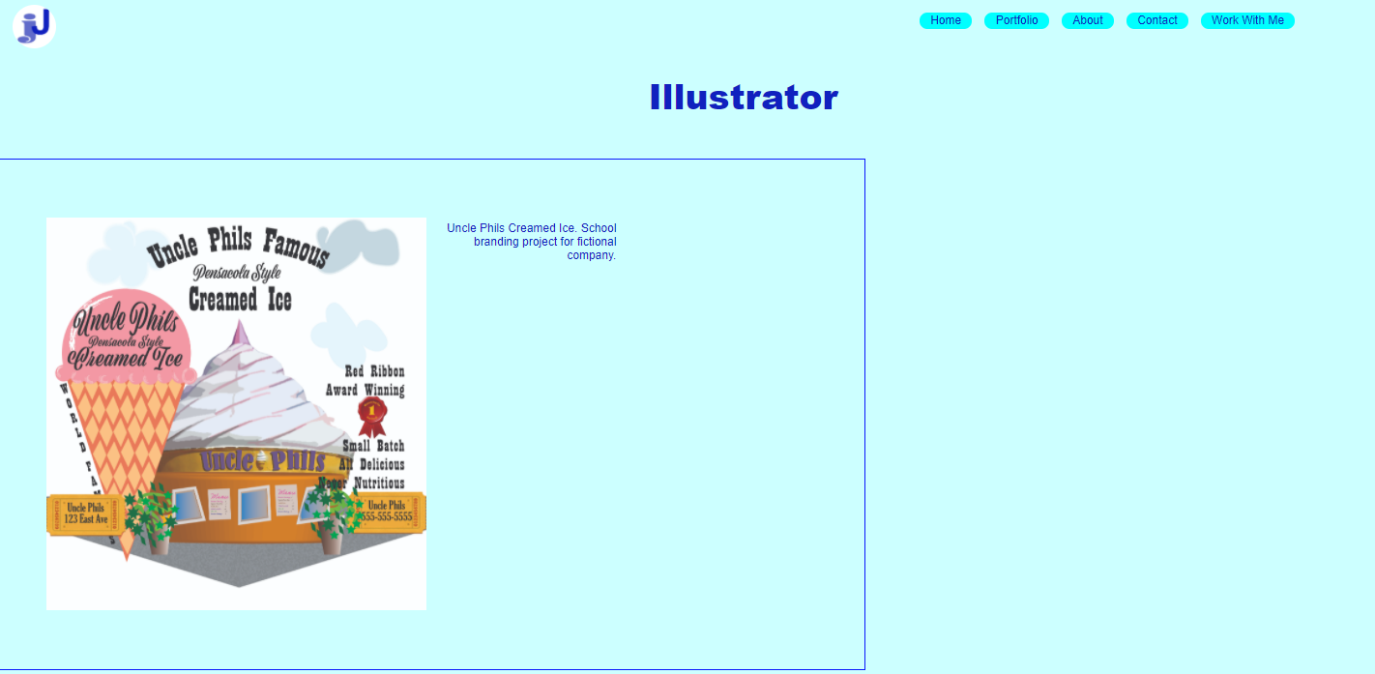

Websites  
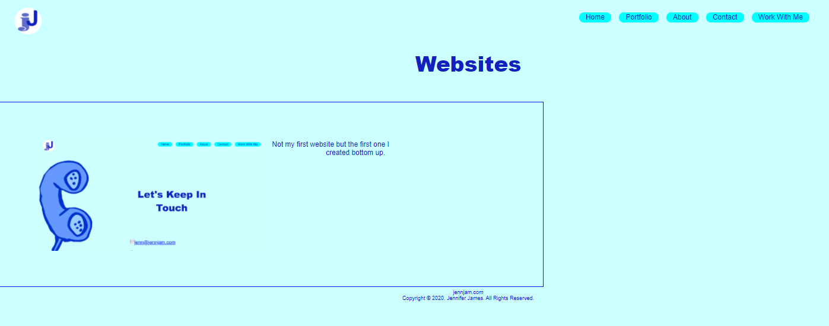

Work In Progress  
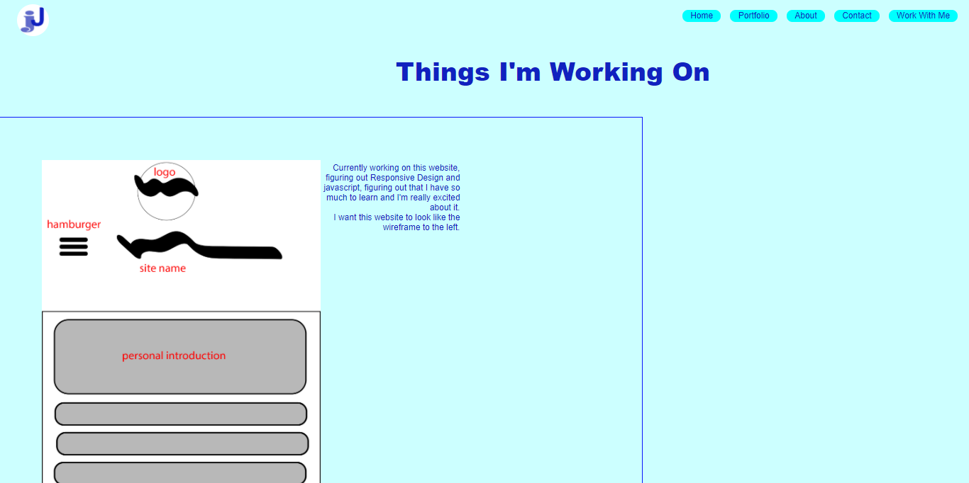

About  
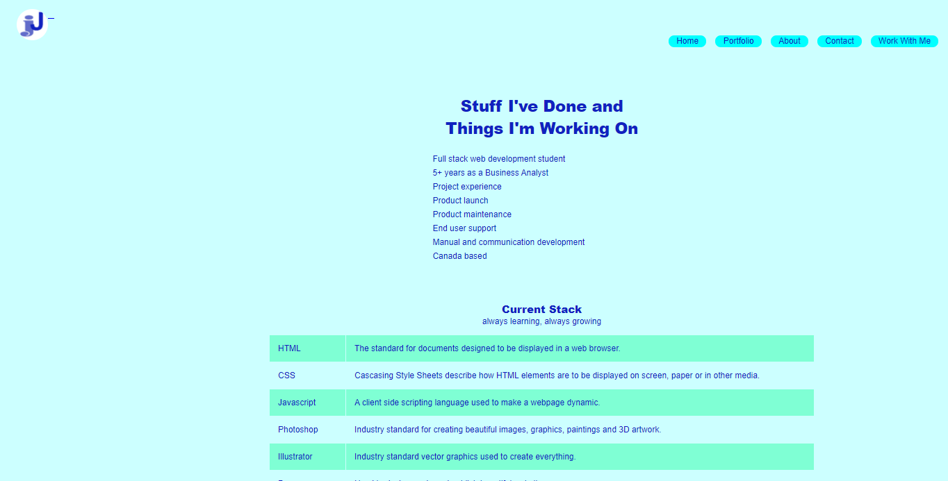

Contact  


Work With Me



Improvements & Requirements:

* + “Submit” button on contact.html must work to send completed form to email.
  + Responsive design & Changing display for mobile & tablet viewports (see wireframe)
    - Addressed during development but a solution was not found.
  + JavaScript used in “hamburger menu” on mobile display
    - In development
  + Fix “submit” button on Work With Me page
  + Find solutions to instances that cause error on validation.
  + Improve CSS image gallery on portfolio pages.
    - Slideshow (CSS & JavaScript)
  + Font selection improvement
  + Socials open on new tab not existing

|  |  |
| --- | --- |
| Visual elements are appealing to target audience | y |
| Navigation is easy to use | y |
| W3C guidelines followed for accessibility | Reviewed and believe site adheres |
| Consistent banner | y |
| Page titles | y |
| Logo area | y |
| Graphics and images | y |
| Multimedia links appropriate and functional | homefin.html |
| E-mail link | contactfin.html |
| Social media links | contactfin.html |
| Appropriate and meaningful meta tags applied | y |
| Appropriate use of tables | y |
| Appropriate use of lists | y |
| Form coding includes meaningful element names | yes |
| Form includes server-side processing to send email | contactfin.html |
| Basic client-side processing provided by JavaScript | no |
| Site incorporates responsive design features | Under construction |
| Appropriate display on mobile, tablet, and desktop viewports | Under construction |
| Inclusion of appropriate HTML5 Elements | y |
| HTML for all pages pass validation | All pages error on <nav> button. Tried to correct but all attempts unsuccessful. |
| CSS external file validates | validates |

HTML Validation :

* + all pages error on <nav>
  + several attempts to correct with no success

contactfin.html

* + <p6> not allowed in this context
    - Used to format text on page
    - Several attempts to correct with no success
    - Will try other solutions

homefin.html

* + Validates

illustratorfin.html

* + Validates

portfoliofin.html

* + Validates

wwmfin.html

* + Validates

photoshopfin.html

* + Validates

websitesfin.html

* + validates

wipfin.html

* + Validates

homestylesfin.css

* + Validates