Jennifer Hott-Leitsch

2/20/16

**All Night Coffee Proposal**

Wireframe:

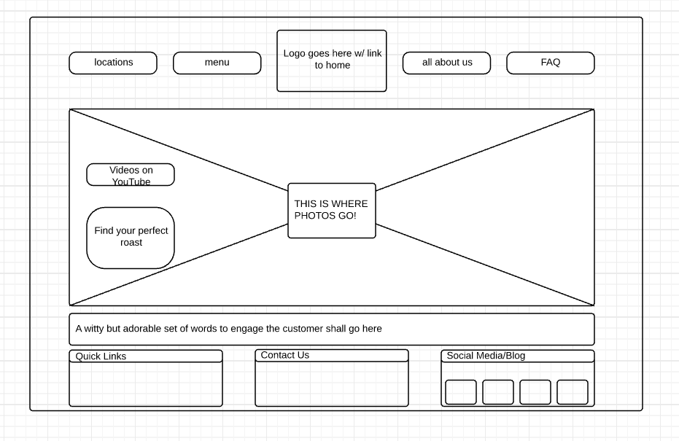

All pages will follow this layout. Photo will change per page, copy below photo will change per page.

Logo:

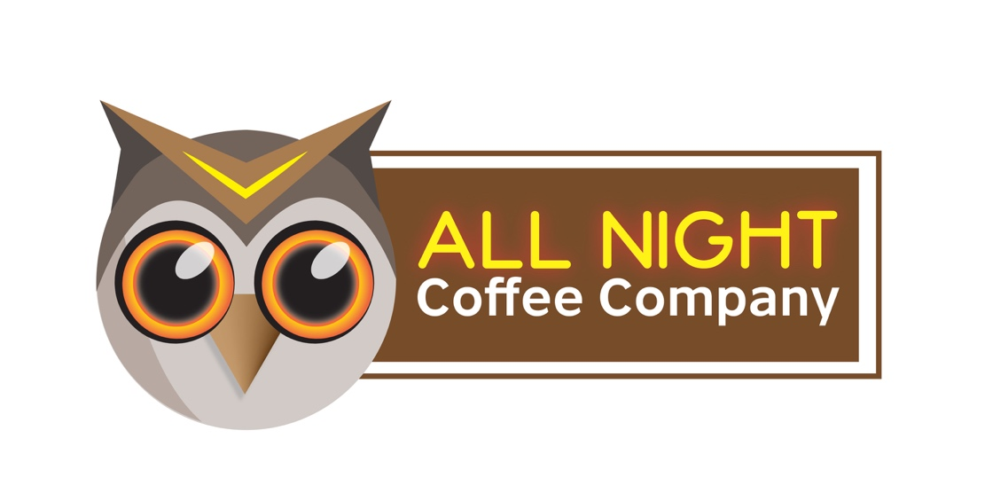

Colors:

Background: White

Headlines: Yellow/Orange made to imitate Neon

Copy Color: Chocolate Brown

Fonts:

Google Font: Raleway. Has 18 different styles. Will be using for both headlines and body copy.

Links: Buttons will be created in Photoshop using a font called Neon. Free for use from DaFont.com.