ECA Analysis
Alexander Carr, 7-Feb-2022

Overview, Purpose and Scope:
The purpose of this Analysis is to provide the Equivalent Clearcut Area of a watershed. This represents the amount of disturbance to the watershed due to the removal of trees and vegetation. Each watershed has a threshold for the % of disturbance before the ecological impact become too high and ecological damage will occur. The scope of this Analysis is to provide a report on one watershed displaying the amount of ECA that is present in the watershed, it will also give data on individual sub-basins within the watershed if they need to be managed separately.

Data Requirements:
Watershed Boundary Feature Class, an empty geodatabase where the data will be created and stored, the DEM covering the watershed, if LiDAR is available this data is preferable. The year of assessment, the growth Increment of the trees in the watershed. If using sub-basins is required, then the watershed feature class needs to contain the boundaries for these sub basins as well and an text field containing their names.

Methodology:
Preparation:
The tool for this Analysis first will clip all of the data to the watershed boundary: BCTS Blocks, roads and SU, FTEN roads, consolidated cutblocks, current and historic fires. BCTS blocks are limited to ADV,LC and HB states and the BCTS SU are limited to WTRA, WTP and NP and removed from the BCTS blocks. Road features are buffered by 10m. Recent fires are limited to the last 25 years and then merged with the historic fires layer to create the fire layer. The road buffers are then removed from the Blocks and Fire data.
Utilizing the DEM and the boundary of the watershed to determine the H60 line (Elevation Line where 60% of the area of the watershed is above it). To do this the DEM is split into 100 equal area slices by elevation, then the slices are added together until 60% of the area is achieved, and this set of slices is turned into a polygon representing the to 60% of the watershed. The reason for calculating this is that all of the disturbances about the H60 line count for 50% less disturbance compared to the area in the lower 40% which is closer to the water body. The H60 data is then imprinted onto all of the prepared features.
If the Analysis is using sub-basins, the sub-basin data is now added onto the prepared features before going into the Calculation Tool.

Calculations:
BCTS Blocks: The tool will determine for each block when it was harvested and calculate the number of years between then and the assessment data and adjust it by 2 years to allow for planting. The resulting number of years is then multiplied by the growth factor to determine how much the trees have grown since the disturbance. This height is now compared to the following chart to determine the recovery about:
Less than 3m | 0% Recovered
3m to 6m | 25% Recovered
6m to 8m | 50% Recovered
8m to 12m | 75% Recovered
Greater than 12m | 100% Recovered

The area of the block is then calculated in hectares and then multiplied by the about recovered to produce the ECA for that block e.g. (A 10ha block 50% recovered counts as 5ha of ECA). If the block is above the H60 line this amount is then again reduced by 50%.
Fires and consolidated blocks are calculated the same except for the planting adjustment. Roads are never recovered and are just adjusted if they are above the H60 Line. The tool then summarizes the data and produces the output report.

Use Instructions:
Arc License Level: Info
- Step 1: Acquire the Boundary of the watershed from the Client
- Step 2: If Sub Basins are required ensure that they are named properly in a field in the Watershed boundary. Look for invalid characters. If Necessary create a new field and Adjust the names.
- Step 3: Acquire the DEM that covers the water shed area and use the extract by mask tool to create a DEM that fits the watershed exactly.
- Step 4: Acquire the year of assessment and growth Increment from the Client
- Step 5: Create and Empty Geodatabase for the files to process in.
- Step 6: Fill out the tool interface with the required data and hit run.
- 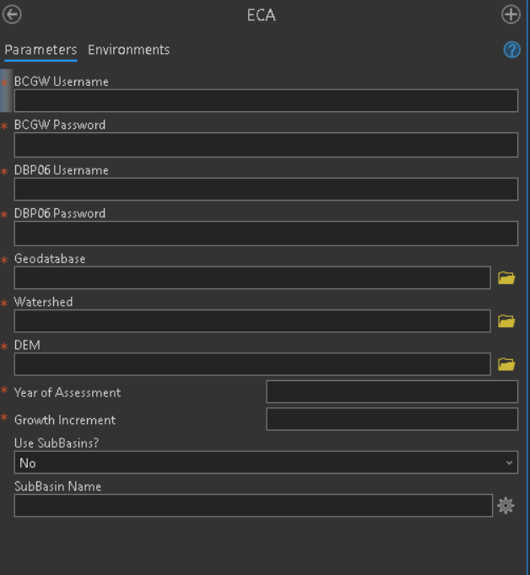
- Step 7: Take a copy of the .csv file created by the script and save it as a .xlsx in the work folder for this request. Named “ECA_Summary” Located here: \\bctsdata.bcgov\data\north_root\Library\Scripts\ECA\Script

Deliverable:
The Client will receive an excel table created by script.

Limitations:
This tool does not account for any kind of growth benefit from fires post burn or account of severity of the fire. This tool does not account for insect damage, land slides or other non-forestry related disturbances in the watershed. This tool does not know the thresholds for individual watersheds so the report does not compare the output to the required threshold, the planner will need to do this themselves. If this ECA Analysis shows the watershed being close to the threshold then advise the Planner to talk to a hydrologist for a more in depth and complex ECA to be done.
If the planner asks for planned blocks or any other BCTS block state in this analysis, there is a query on line 180 of the “Disturbance_Blocks” script that you can modify.

Future Developments:
Right now the .csv file created by the script is output in the ECA script folder next to the python script, I would like to change it so the .csv appears next to the GDB instead by taking the file path to the gdb and removing the gdb portion and replacing it with the csv file name. This is in the “ECA_Calculations” script.
Add in the ability for the analyst to add more block states to the Analysis without needing to modify line 180 of the “Disturbance_Blocks” script.
Better comment “ECA_Calculations” script.

Modification History:
18-April 2023 – Created this document and moved the scripts into the north root folder and set up the tool box in the north root folder.

