Table of Contents

Table of Contents 1
Introduction 2
Methodology 3
Figure 1: Basic Methodology in new ECA Script 3
Figure 2: ECA Recovery curves 6
Things that were Tricky 8
Results 8
Figure 3: ECA results across methods compared 9
Conclusion 10
References 11

Introduction

Equivalent Clear-cut Area (ECA) represents the amount of disturbance to the watershed due to the removal of trees and other vegetation. Each watershed has a threshold for the percentage of disturbance before the ecological impact becomes too high and ecological damage will occur. A truly accurate ECA calculation is based on factors outside of GIS capability such as soil type, permeability and depth and can only be determined by a hydrologist on-site. Generally, the threshold for when a hydrologist is called by BCTS is an ECA of 20%, except in community watersheds or for watersheds feeding a community well, then it’s lower.
In early 2024, the Woodlands Manager for the Cariboo Chilcotin business area requested a report comparing our ECA method (and numbers) to the Foresite deliverables within their annual Landbase Assessment Report (Bryant, 2023). This revealed holes and opportunities for improvement with the BCTS methodology.
The mandate of the BCTS GIS Analytical team is to automate (and overtake) analyses that the Business Areas currently contract out. Thus, the scope of this project was to modify the existing script to match or better the deliverable from Foresite.
Areas updated to meet Foresite’s standard include the incorporation of: (1) burn severity data (2) missing cutblocks/stands <40 years old (3) forest health factors and (4) updating to a more accurate ECA curve. Opportunities to better the process include: (a) using LiDAR for input tree heights, (b) including the current fire year burn severity impacts and (c) adding disturbance from transmission lines, railways, mining and pipelines.

Methodology
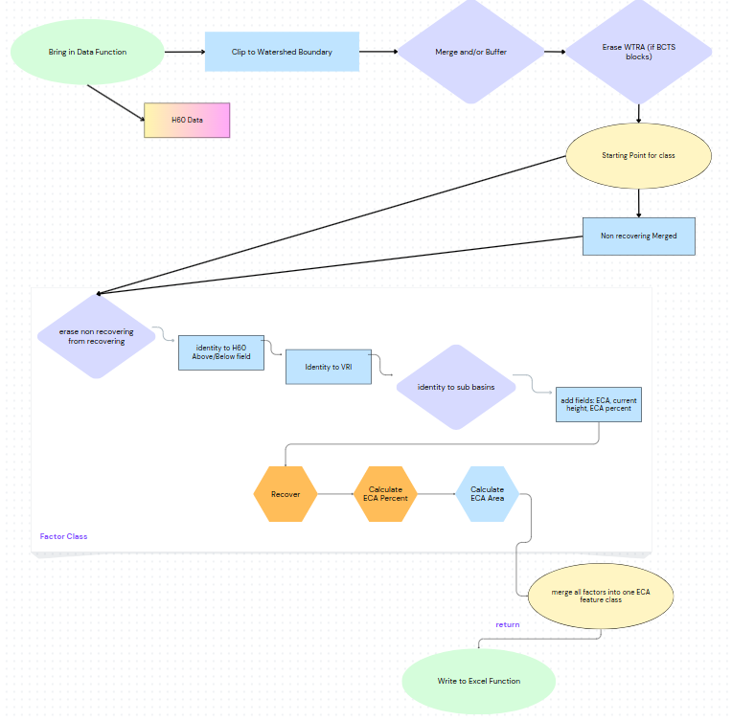

Figure 1: Basic Methodology in new ECA Script

The script is organized into three main components. The first prepares and imports the input data. The second utilizes the factor class to add fields, identify a starting condition, simulate stand growth, and calculate Equivalent Clearcut Area (ECA) percentage and area. The third consolidates all disturbance factors and compiles the results into an output spreadsheet. Technical details are provided below; refer to Appendix D for additional information.
Part I: Data Preparation
The first part of the script preps the data to get an area of disturbance. This involves importing the data, looping through it to clip to the area of interest, buffering linear features, merging features of the same type (e.g., transmission lines), and erasing non-relevant areas. The erasure steps are summarized below:
- WTRA is erased from the BCTS cutblocks (consolidated cutblock already have WTRA erased)
- BCTS blocks are erased from consolidated blocks
- All other disturbance factors are erased from the young VRI to ensure only areas classified as young without a documented disturbance history are retained
Part II: Factors Class
An instance of the Factors class is then created for each ECA factor, using the following input parameters: name, data source, type (recovering or nonrecovering), and startingPercent. The snippet below shows a sample for a non-recovering factor and a recovering factor:
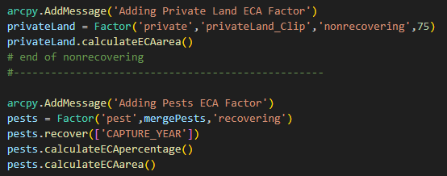
Method: __init__
All factor objects have the following operations performed on them during initialization (__init__):
- Adds an "Origin" field to track the source disturbance (e.g., fire, pest, etc.).
If type == 'recovering':
Adds field StartingPercent and assigns values based on data source and/or field values:
Pest severity (PEST_SEVERITY_DESC):
trace = 1%
light = 5%
moderate = 20%
severe = 40%
very severe = 60%

Fire severity (BURN_SEVERITY_RATING): (percentage breakdown based on Provincial Aquatic Ecosystems Technical Working Group, 2020)
unburned = 0%
low severity burn = 10%,
medium severity burn = 50%
high severity burn = 80%
no burn severity data = 100%

Harvest blocks (consolidatedBlk, bctsBlk):
All polygons set to 100%.

If type == 'recovering':
Erase all non-recovering features

Obtain necessary fields
Identity with Upper_H60 (used to determine if a polygon is above the 60% elevation line)
Adds Above_H60 field and sets it to 'Yes' or 'No'.
If name not VRI:
Identity with VRI (SITE_INDEX field used to choose ECA curve)
If user wants results broken down into sub-basins (input parameter):
Identity to sub-basin feature class (source an input parameter)
Add the following fields:
- CURR_HEIGHT: stores current stand height. Will store the recovered height
- ECA_PERCENT: stores the final ECA percent
- ECA_Area: stores the adjusted disturbed area
For non-recovering types, set all ECA_PERCENT values to the given startingPercent.

Method: recover(yearofDistFields) – outputs a height in meters
The recover method is invoked for stands undergoing recovery to simulate growth since the year of disturbance. It is used by all recovering disturbance factors
This function uses the disturbance year field to calculate CURR_HEIGHT based on a user-defined growth factor:
Growth (m) = growth factor (m/yr) * years since disturbance
If name == bctsBlk:
Handles uncertainty in planting year by checking a flag ('P') and adjusting with a 2-year buffer.
If name == fire or name == pest:
Accounts for varying starting percentages (e.g., due to burn severity or mild pest infection) by converting the starting percentage back to height, then simulating growth from there. The logarithmic function, which is the inverse of the ECA curve.
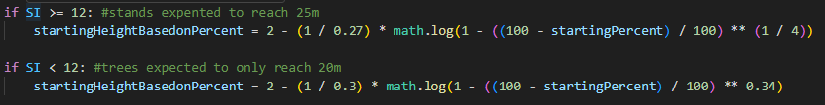

Method: calculateECApercentage() – outputs a percentage
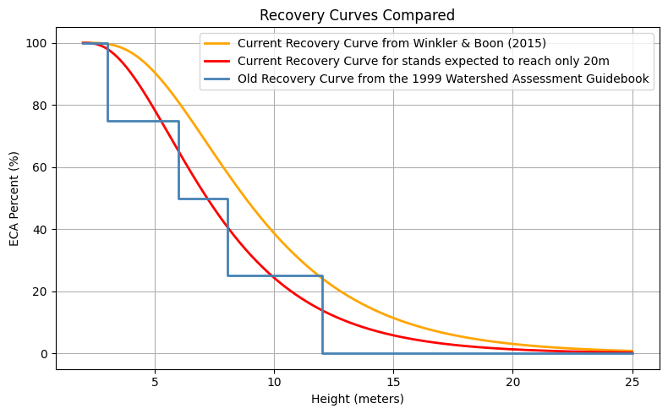

Figure 2: ECA Recovery curves

The calculate ECA percentage method calculates ECA_PERCENT using the Chapman-Richards model from Winkler & Boon (2015). This method is used by ALL recovering factors. Input is a height and output is a percentage.
Based on CURR_HEIGHT and SITE_INDEX:
Models recovery as nonlinear sigmoid growth.
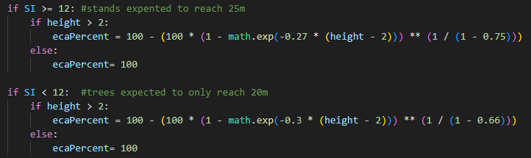

Method: calculateECAarea() – outputs an area
This method calculates ECA area
- ECA_Area = (ECA_PERCENT / 100) * AREA
- If the polygon is Above_H60, increases area by 1.5× multiplier, capped at the actual polygon size.

Part III: Summarize all factors in an output excel sheet
First, merge all factors into one feature class then dissolve, keeping only fields of interest.

Function: writetoExcel(watershed, inECAMerged, subBasin, subBasinName)
- If user wants results broken down into sub-basins (input parameter):
calculates area, disturbance, and ECA (Equivalent Clearcut Area) per sub-basin.
- Calculates total disturbance and ECA across the full watershed.
- Writes results to both a CSV (temporary) and a styled Excel (.xlsx) file summarizing:
  - Full watershed ECA stats.
  - (If applicable) Sub-basin-level ECA stats.
- Deletes the CSV after saving the Excel file.

Things that were Tricky
- The curve referenced in the Foresite Deliverable (Bryant 2023) by Winkler and Boon (2015) provided a basic equation with varying variables. The values for the three variables were determined through trial and error, refining the equation in ChatGPT until it produced matching results (OpenAI, 2025)

- To incorporate feature classes with a starting percentage below 100%—such as areas affected by burn severity or pests—I converted the initial ECA percentage (e.g., 10% for low burn severity) to height in meters using the inverse ECA curve. The stand was then grown from this height, and the current ECA percentage was calculated by converting back using the calculateECApercentage() method. In summary: percentage to meters, grow, then meters back to percentage.

- Null values were as prevalent as expected, requiring numerous code snippets to handle them effectively. For example:
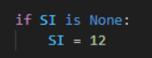
- The script frequently crashed when calling the Slice tool in Spatial Analyst to create the H60 data, but the issue was resolved by calling createH60 first.

- To address overlapping disturbances and determine which to count, I merged all non-recovering areas and erased these from the recovering factors, based on the assumption that non-recovering disturbances represent a higher ECA value (70–100%). The ECA areas from recovering factors were then combined by summing their values when merging all factors at the end. Thus, if a fire and pest infection affected the same area, their ECA effects would be added together.

Results
The following two figures show the difference in ECA percentages for two different watersheds. The first being the initial watershed that prompted this change, and the second being an area more influenced by anthropogenic factors. Note: the VRI polygons in the western region appearing in Foresite’s results were not present in our query for areas where PROJ_AGE < 40
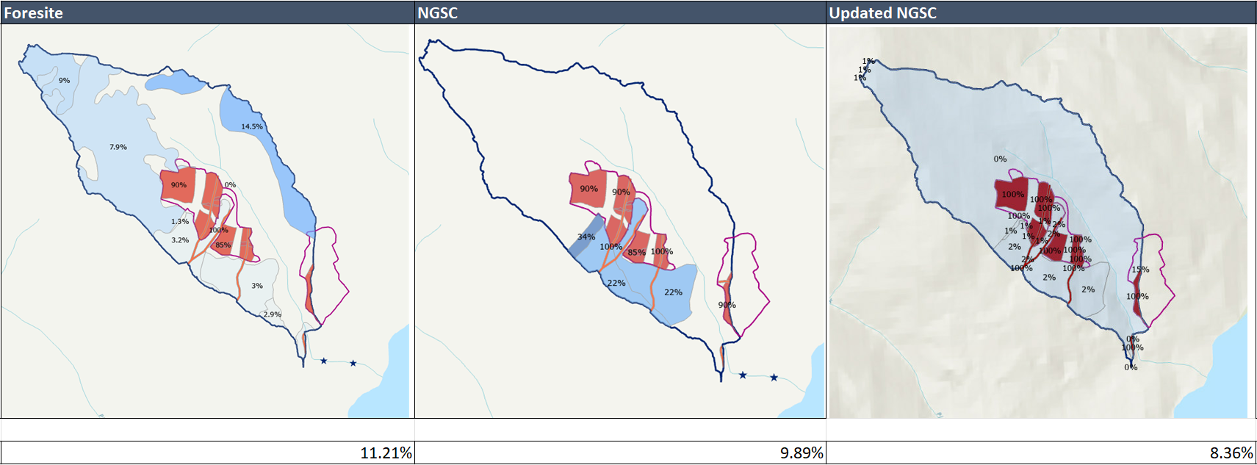
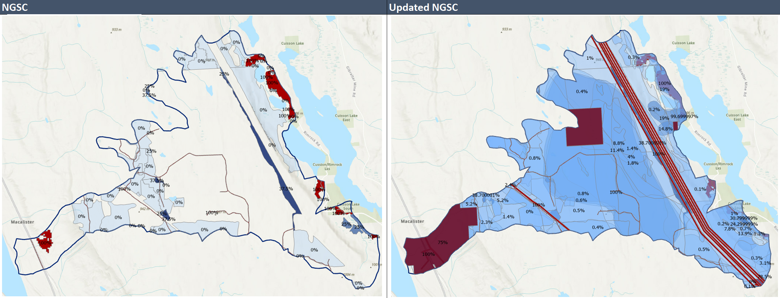

Figure 3: ECA results across methods compared

Conclusion

This project was focused on revitalizing the NGSC’s ECA script to bring analyses in-house. I incorporated several variables to meet the Foresite standard including burn severity, missed harvested polygons and an updated ECA curve. I bettered their approach by: (1) adding forest health factors from all pest species and (2) including disturbance from pipelines, railways and transmission lines.
Remaining work not yet updated includes the tool metadata and quick reference guide, which is referenced by GIS staff before running an analysis.
Opportunities for improvement
Potential Improvements include replacing the current growth factor with more accurate growth curves, as is done on the Coast, where region-specific curves are available for each BEC zone.
Given that BCTS has LiDAR coverage for nearly all operating areas, it would be worthwhile to explore the use of LiDAR-derived canopy height estimates as an alternative to relying on VRI data.
Batch runs would be useful, for multiple watersheds, or even a before/after harvest for the same watershed.
Another opportunity for improvement is the incorporation of burn severity data for wildfires not captured within the FAIB dataset. This would require access to remote sensing imagery that includes both near-infrared (NIR) and shortwave infrared (SWIR) bands, acquired both before and after the fire event, to accurately assess burn severity.

References

Bryant, P., May 2023. Landbase Assessments for the Cariboo Region. Version 1.0. Foresite Consultants Ltd.

OpenAI, 2025. ChatGPT response on ECA summary script. May 26, 2025. Available at: https://chat.openai.com

Provincial Aquatic Ecosystems Technical Working Group – Ministry of Environment and Climate Change Strategy and Ministry of Forests, Lands and Natural Resource Operations and Rural Development, December 2020. Interim Assessment Protocol for Aquatic Ecosystems in British Columbia – Standards for Assessing the Condition of Aquatic Ecosystems under British Columbia’s Cumulative Effects Framework. Available from:
https://www2.gov.bc.ca/assets/gov/environment/natural-resource-stewardship/cumulative-effects/protocols/cef-aquatic-ecosystems-protocol-dec2020.pdf [Accessed 29 Oct 2024]

Winkler, R. and S. Boon, 2015. Revised snow recovery estimates for pine-dominated forests in interior British Columbia. Province of B.C., Victoria, B.C.
Available from:
http://www.for.gov.bc.ca/hfd/pubs/docs/en/EN116.PDF [Accessed 29 Oct 2024]

