Step1: Using the second link https://www.google.com/search?q=%62%36%63%63%62%34%65%63%65%35%34%35%34%64%63%61%65%35%31%37%37%38%62%33%65%32%33%39%65%62%63%32&rlz=1C5CHF
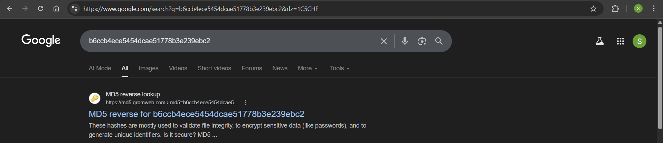
Through the second link provided, I go this MD5 word.
Method 1: visit the website appears in attached photo, we can instantly get the result which is meowmeow
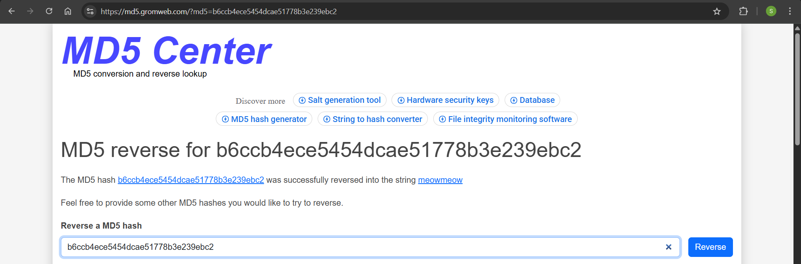
Method 2: write a code to crack it
Using the MD5 word found; b6ccb4ece5454dcae51778b3e239ebc2
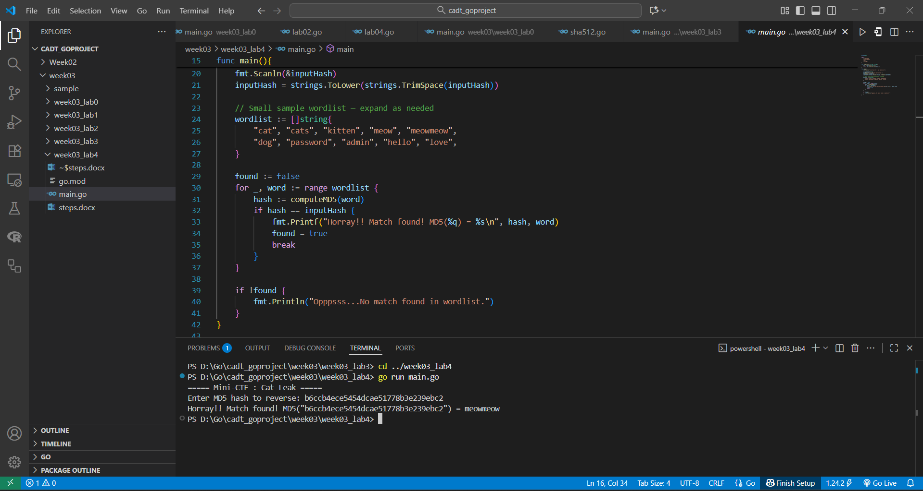

Step2: Verify the answer (using Regex online resource)
