
QUALITY ASSURANCE TEAM

Legislative Budget Board ♦ State Auditor’s Office
Legislative Budget Board  State Auditor’s Office

TO: Governor Rick Perry
Lt. Governor Bill Ratliff Speaker James E. “Pete” Laney
Senator Rodney Ellis Representative Robert “Rob” Junell
Senator Florence Shapiro Representative Rene O. Oliveira
Senator Chris Harris Representative Paul Sadler
Senator John Whitmire Representative Ron Wilson
Representative Talmadge Heflin
Representative Kenny Marchant
FROM: John Keel, CPA, Director, Legislative Budget Board
Lawrence F. Alwin, CPA, State Auditor, Office of the State Auditor
DATE: January 7, 2003
SUBJECT: Quality Assurance Team (QAT) Annual Report
Significant variances remain between the initial cost estimates for information technology projects compared with the final cost when each project concludes. In addition, during the lifecycle of the project, current cost estimates can vary greatly. Of the projects actively monitored by QAT, changes in current project costs ranged from an increase of $17.1 million for a project to a decrease of $23.7 million in yet another project when compared to each project’s initial cost estimate. These project cost deviations represent a cost variability of up to 160%, resulting in impaired planning and service delivery at a statewide level.
For the same QAT monitored projects, the average schedule expansion decreased from 18 to 14 months when compared to the prior year, a positive but modest improvement. The impact of delayed implementation extends beyond the project’s deployment to affect future project initiation and the maintenance of existing systems.
This past year has seen improvement in the amount of monies expended on cancelled projects, though a large number of projects are initiated then cancelled prior to expending funds. The staff time lost in the planning and subsequent cancellation of each project has not been captured but represents a real loss in terms of productivity. Two projects expended $1.4 million before cancellation, a considerable improvement from last year when five projects expended $28 million prior to cancellation. Appendix C identifies each cancelled project.
Successful technology implementation in the state of Texas requires a greater emphasis on strategic planning, specifically more accurate cost estimates during project initiation and better management controls during project development. A statewide enterprise approach to consolidate PeopleSoft™ automation for the state should be pursued. Agencies are still duplicating the cost to enhance and maintain PeopleSoft™ by individually hosting the software and dedicating technical staff to its support. See page three of the attached report for details.
The QAT plans to implement the following improvements in accountability for the development of major automated information systems:
- Review cost estimating techniques used by project teams;
- Rewrite QAT guidelines to reflect changes from the Legislative session; and
- Work with the Department of Information Resources to expand Internal Quality Assurance guidelines.
The report will be available on the LBB website at http://www.lbb.state.tx.us. If you have any questions, please contact John Keel or Richard Corbell of the Legislative Budget Board at (512) 463-1200 and/or Lawrence Alwin or Ed Pier of the Office of the State Auditor at (512) 936-9500.
Attachment
bcc: Melissa Guthrie, Lt. Governor’s Office
Leslie Lemon, Speaker’s Office
Blaine Brunson, Senate Finance Committee
Jess Calvert, House Appropriations Committee
John O’Brien, Deputy Director, LBB
Anita Zinnecker, Assistant Director, LBB
John Newton, Assistant Director, LBB
Susan Noell, Assistant Director, LBB
All Team Managers


Annual Report

Legislative Budget Board
Office of the State Auditor
December 2002

Summary

As of November 2002, 215 projects representing $2 billion in development lifecycle costs were subject to Quality Assurance Team (QAT) review. Forty-eight of these projects have been identified as high risk and are subject to monitoring. Appendix A provides an overview of each monitored project. Appendix B lists the 34 projects which completed this past year. Appendix C provides a list of the cancelled projects for both fiscal years 2001 and 2002, for comparative purposes. Seventeen projects were cancelled in fiscal year 2002.

The QAT identifies projects from agency and university Biennial Operating Plans that met the following criteria: an information technology project with development costs greater than $1.0 million and includes one or more of the following (a) requires a year or more to reach operational status; (b) involves more than one agency or governmental unit; or (c) materially alters the work methods of agency personnel or the delivery of services to agency clients. QAT activities in the past year included review of these projects, research, agency assistance, and project monitoring.

The QAT plans to implement the following improvements in accountability for the development of major automated information systems during the next calendar year:

- Rewrite the QAT guidelines to update instructions and templates. This will include revision of the Project Development Plan, Post Implementation Evaluation Review and reflect any changes from the 78th Legislature.

- The QAT recommends Department of Information Resources (DIR) add the four remaining project management processes defined in the second level of the Capability Maturity Model (CMM) to the DIR Internal Quality Assurance guidelines. CMM is a project development framework used by the federal government and extensively within private industry. These additional processes include Requirements Management, Subcontract Management, Quality Assurance (QA), and Configuration Management.

- The QAT will examine cost estimating techniques and tools used by project managers to determine why large variances continue to occur between initial project cost estimates and final project costs. Previous assessments of project manager training indicate this is an area where project managers have difficulty transferring educational knowledge of tools and techniques to practical use on projects.

As the QAT monitors projects, specific projects stand out because of their impact on state government and the business processes of the affected agency. Such projects warrant more scrutiny than other monitored projects. Projects of particular significance include:

Ambulatory Electronic Medical Record
The University of Texas M. D. Anderson Cancer Center is implementing an electronic medical record system to provide immediate access, documentation, and utilization of patient data. The expected cost for this project is $64,809,978 with a completion date of August 2004. Expenditures to date are $12,452,927 with project completion at 25 percent. If the project requires more time than anticipated to complete, the ambulatory clinical record may not be available on-line when the new Ambulatory Clinic building opens in 2004 making physicians dependent upon paper records to provide patient care.

Compass 21
Compass 21 originated at the Texas Department of Health (TDH) in November 1997 to develop a new integrated Medicaid Management Information System. National Heritage Insurance Corporation (NHIC) was the primary contractor. The system became operational in August 2001 after various timeline extensions and cost overruns; however, claims processing problems became apparent compromising federal certification of the system. The federal government certified the system in June 2002 although there remain some questions related to development costs. The project transferred from TDH to the Health and Human Services Commission (HHSC) who hired an independent verification and validation vendor to mitigate the remaining system issues with NHIC. The current end date for re-work and system corrections is August 2003 at an additional cost of $978,870. The current total project cost, including the rework, is $77,919,276. The QAT monitored the project during development at TDH until it became operational. QAT recently reinstated monitoring on Compass 21 to assure resolution of system problems and questioned costs.

Texas Integrated Eligibility Redesign System (TIERS)
This QAT monitored project is significant for the number of agencies involved in the project - Texas Department of Human Services (TDHS), HHSC, TDH and Texas Workforce Commission - and the impact on the way these agencies will do business. TIERS is a comprehensive project replacing multiple eligibility applications and improving business processes. The project is in the process of piloting a major component of the project at a one month schedule delay. The project began in June 1997. Current cost estimates are $301,398,794, up from $289,321,602 reported last year but still lower than the initial project estimated cost of $352,117,334. The projected end date is August 2005, consistent with the information reported last year.

Enterprise Administrative Systems Implementation (PeopleSoft™)
HHSC has consolidated project management of PeopleSoft™ integrated financial system implementation by the health and human service agencies. Texas Department of Protective and Regulatory Services, Mental Health and Mental Retardation, TDHS, TDH, and HHSC have existing PeopleSoft™ projects that have been incorporated into this consolidation; however, 11 health and human services agencies will eventually migrate to PeopleSoft™. This project will significantly change the work processes of multiple agencies, has a lengthy period for implementation, and represents a large financial undertaking by the respective agencies. Initial cost estimates with individual deployment of PeopleSoft™ were $65,202,085. HHSC believes an enterprise approach will decrease implementation costs and are now projecting a total project cost of $41,443,436 with an end date of August 2004. This is a substantial decrease from the total project cost of $50,924,440 and an end date of August 2006, reported last year. Although the current estimated schedule has shortened considerably, the project is encountering some delays in certain implementation milestones. The project end date has not been adjusted but may need to be adjusted if delays continue.

Business Project Reengineering / Architecture Development
This QAT monitored project at the Texas Workers’ Compensation Commission (TWCC) is composed of several individual technology initiatives which had competing timelines and funding priorities. At the request of the House Appropriations Committee in Spring 2001, the QAT met with the project team and restructured the project into stand-alone components that complete in a biennium and provide functionality regardless of future funding. At present, TWCC is identifying which functions in its legacy computer system should be redeveloped or supplemented with new functionality to meet requirements from House Bill 2600 of the 77th Legislature. Current total project cost estimates are $21,390,000, less than the $24,078,887 reported last year, but the completion date has been changed from August 2006 to August 2007.

Offender Information Management Phase Three, Period One
The project re-engineers the Texas Department of Criminal Justice’s business processes and applications related to the supervision and management of felons. This project has multiple phases of development. Two earlier phases have been completed at a cost of $14,470,539 and include development of a road map for re-engineering, review of business processes, and redesign of systems to support the re-engineering effort. The current phase, at an additional estimated cost of $28,458,892, entails implementation of re-engineering business processes associated with parole supervision. This project cost estimate is lower than the amount reported last year ($31,435,650), but milestones within the project schedule are behind by a few months. The next planned project component (Phase Three, Period Two) envisions automation of incarceration related management processes and is subject to available funding in fiscal years 2004 and 2005.

Appendix A contains additional information on each of these projects, except Compass 21 which was recently reinstated as a monitored project.

Issues and Recommendations

Issue:
Agencies are duplicating the cost to enhance and maintain PeopleSoft™ by individually hosting the software and dedicating technical staff to its support.

Recommendation:
A statewide enterprise approach for PeopleSoft™ support and maintenance should be undertaken. The Comptroller of Public Accounts (CPA), Department of Information Resources (DIR), and agencies using PeopleSoft™ should propose a practical cost-effective approach to deliver consolidated PeopleSoft™ automation for the State. The HHSC enterprise version of Peoplesoft™ should be the initial platform for the rest of the State to use in delivering standard financial and human resource information systems.

Status:
Health and Human Services Commission (HHSC) is continuing with its enterprise approach to PeopleSoft™ implementation for all health and human services agencies, which should result in lower development and maintenance costs. In order for this to work, a central direction must be established and cooperation obtained by participating agencies to agree on common business practices. The approach emphasizes changing business processes rather than employing costly customization of PeopleSoft™ software package. A similar consolidation approach for the rest of the State is needed rather than several agencies maintaining redundant staff and equipment to support multiple versions of PeopleSoft™. This is a sound approach for the entire State.

The Department of Information Resources (DIR) has developed a request for vendors to propose a multi-user PeopleSoft™ service for the State which would be coordinated with the Comptroller of Public Accounts (CPA), the agency tasked to provide central accounting and payroll services for the State. The current effort is on hold because there is not an initial base of users that would provide a vendor certain revenue. Without the user base, vendors are reluctant to pursue such a business venture.

Issue
Quality Assurance (QA) is not routinely practiced by agencies and universities as a component of their project management for technology projects.

Recommendation
QAT recommends DIR revise its administrative rules and guidance for Internal Quality Assurance to clearly state when compliance with QA standards is needed. DIR should consider enhancing its guidelines with specific directions and examples for small automation projects to assist agencies and universities that are unable to devise their own processes. In addition, agency and university accountability for compliance with quality assurance standards will be requested within their respective Information Resources Strategic Plans.

Status
This issue and recommendation remains valid from last year’s report. A statement of compliance with quality assurance standards by agencies and universities has been incorporated into the Information Resources Strategic Plan directions. DIR’s response to this issue is included in the response to the immediately following issue on technology deployment.

The report, A Review of Quality Assurance Used in Automation Development in Texas State Government, is available on the LBB web site at http://www.lbb.state.tx.us that provides details on the issue of quality assurance not routinely practiced by state agencies.
Issue
Successful technology deployment is essential for the delivery of improved services to the State using limited resources. Agencies and universities must develop consistent, effective project management practices to increase the quality of technology projects and minimize risk of failure.

Recommendation
Agencies and universities should actively pursue implementation of best practices and tools to ensure the success of their projects. QAT early on, adopted the Software Engineering Institute’s (SEI) Capability Maturity Model (CMM) basic level two practices as a basis for minimal project management practices expected on major information resource projects. SEI has recently issued a new model for defining best practices in delivering technology projects called the Capability Maturity Model Integrated (CMMI). QAT believes that this model will provide greater guidance on best practices to use in deploying technology. QAT also believes that as a minimum the Department of Information Resources (DIR) guidelines on internal quality assurance processes should be immediately expanded to include the CMM level 2 practices. However, this would be only a start, with further practices added using the new CMMI model to guide the State in defining what standard project management practices should be added as the need is identified.

Status
DIR has responded they will address the recommendations of the QAT when resources can be identified for that purpose. The QAT still believes the CMMI model discussed above will provide an industry-accepted framework for better management of automation projects; however, the QAT will work with DIR in defining best practices that need to be incorporated into the State’s information resource standards and applied on major information resource projects.

Project Review and Monitoring Activity

The QAT reviewed 215 projects this past year. Thirty-four projects were completed and 17 projects were cancelled. One cancelled project resulted from contractor management problems and expended $1,240,000 prior to its termination. A second cancelled project determined that the expected costs to complete the project exceeded the business benefits and the project was halted having spent $242,142. Fifteen additional projects were cancelled prior to initiation and incurred no expenditures. Four projects have been placed on hold by agencies either because funding is still uncertain or because the business case is under review. Substantively, the QAT waived 114 projects from further review assuming no changes to the projects. These projects are believed to have the lowest risk. If the project plan or financial expenditures for the project change, the QAT will re-evaluate the project. Finally, the QAT monitors 48 projects that represent approximately $800 million in development costs. Appendix A provides additional information on each monitored project. Appendix B lists completed projects and Appendix C identifies cancelled projects from both fiscal year 2001 and 2002.

Figure 1 offers a graphic depiction of the status of the projects subject to QAT oversight.
Figure 1: QAT Projects by Status
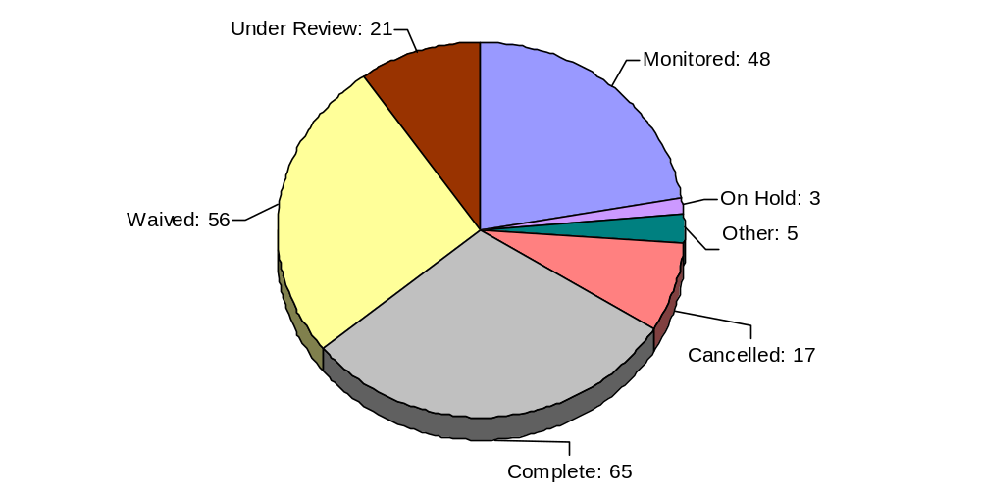
Of the 48 projects under QAT monitoring, 24 are deemed high-risk projects, 16 are classified medium risk, and eight are considered low risk. In many cases, the low and medium risk projects are being undertaken by agencies and universities which have a number of high risk projects under QAT monitoring. Consequently, the QAT has placed all of their projects under monitoring to assure that the numbers of projects simultaneously in development are not adversely impacted. In other instances, an agency or university with a poor prior technology implementation history may have a project selected for monitoring because of their historic performance, not due to a specific concern with management controls over the project.

As project status changes, projects are added and removed from monitoring status throughout the year. Monitoring encompasses various activities including participation in project steering committee meetings, reviewing project schedules and expenditures, and/or providing project management consultation to the project team.

However, all projects under QAT oversight are assigned a level of risk based on the initial review of the project by the QAT. The level of risk is determined through a multiple-step process of evaluating project risks and their potential impact on the success of the project. Projects receive risk ratings of high, medium, or low. These ratings and the corresponding level of monitoring can change as the project progresses.

High-risk projects are those projects currently with the highest level of QAT oversight. Every high-risk project is under QAT monitoring. Medium-risk projects are projects that have warranted requests for additional reporting to the QAT (initial risk analysis questionnaires, project development plans, and/or previous monitoring). In most instances, low-risk projects have been waived from further review. However, as stated earlier, some medium and low-risk projects may be subject to monitoring because the QAT is monitoring all projects associated with the agency/university even though the technical solution for the project may be sound.

Figure 2 illustrates the number of projects subject to QAT review by risk level.
Figure 2: Number of Projects at Each Risk Level

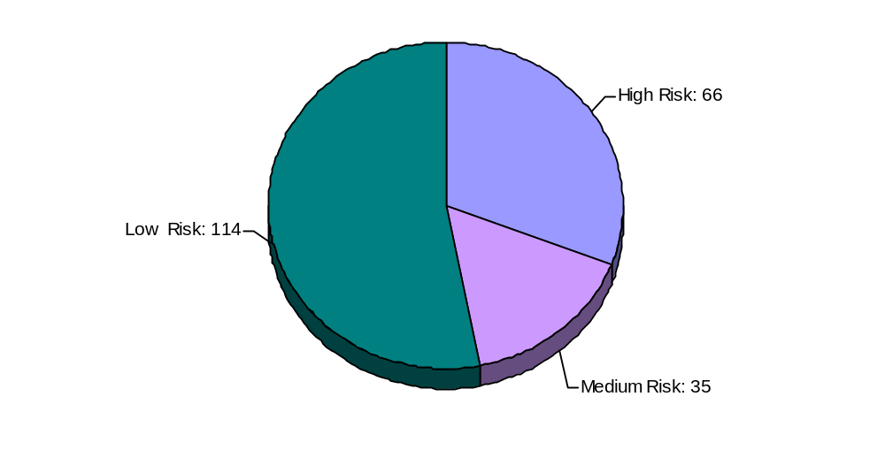
Figure 3 depicts the rounded project costs associated with projects and their risk level. Total project lifecycle cost for all projects subject to QAT oversight: $2,020,771,267. Lifecycle cost includes all costs over the development life of the project – from inception to implementation –and usually covers more than one biennium.
Figure 3: Total Project Lifecycle Cost by Risk Level
(in millions of dollars)

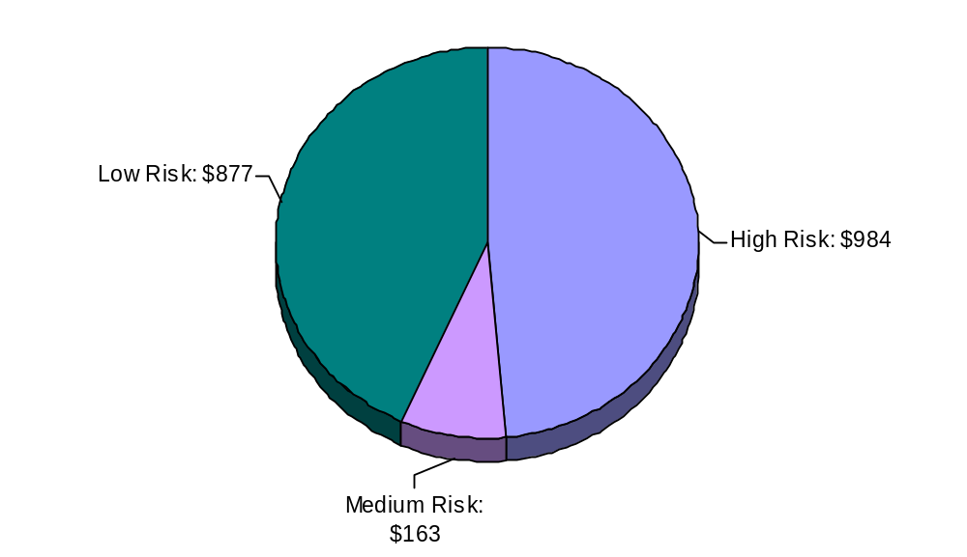
Appendix A provides additional information about the status and lifecycle costs of each monitored projects as reported in the respective agency/university’s Biennial Operating Plan or current monitoring report. Information includes initial estimates of cost, benefits, and implementation dates for projects compared to current project estimates.
Figures 4 and 5 below provide information on the types of projects under QAT oversight and the dollar values associated with the project type.
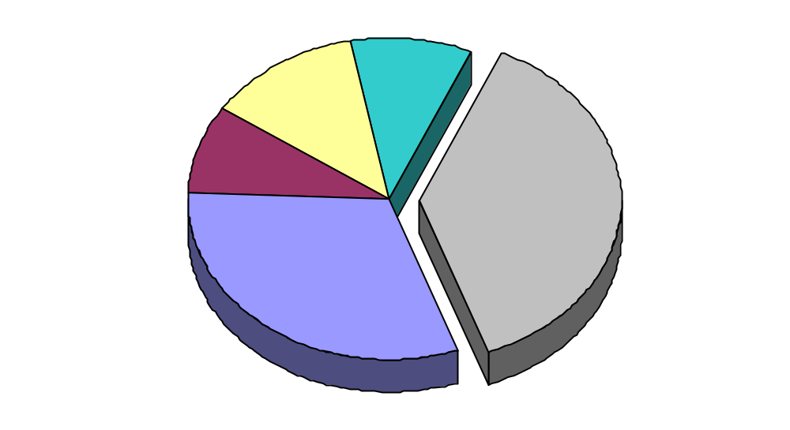
HW / SW Infrastructure31
Data Warehouse10
Imaging / Workflow10
Mainframe9
GIS 9
Medical Support System7
Outsourcing 5
Administrative Systems
27
Telecommunications
21
Other
81
Program Support
67
E-Government
19
Figure 4: Number of Projects by Type

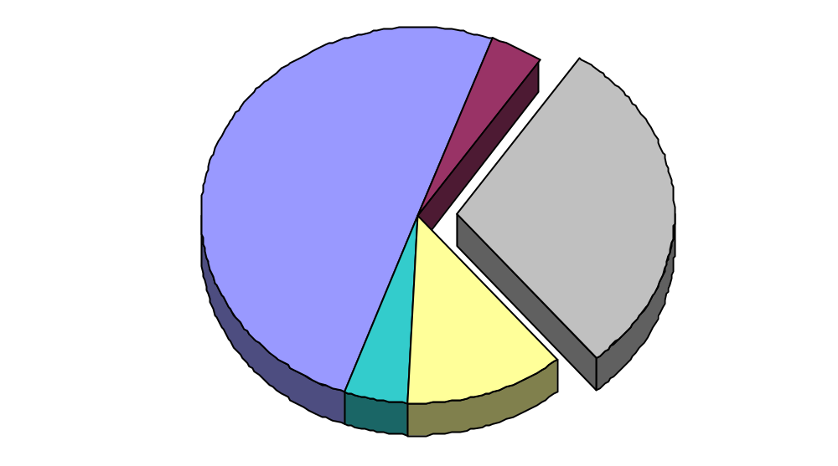
HW / SW Infrastructure$126.2
Outsourcing$106.9
Mainframe$ 99.4
Medical Support System$ 96.6
GIS$ 79.4
Data Warehouse$ 46.7
Imaging / Workflow$ 41.8
Administrative Systems
$293.90
Telecommunications
$94.80
Other
$597.00
Program Support
$1,010.20
E-Government
$81.20
Figure 5: Total Project Lifecycle Cost by Type
(in millions of dollars)
Background

The QAT originated during the 73rd Legislative session within Senate Bill 381 and in the General Appropriations Act. It has continued under the General Appropriations Act of the 74th, 75th, 76th, and 77th Legislative sessions.

The QAT is comprised of representatives from the Legislative Budget Board and State Auditor’s Office. Responsibilities include establishing rules and guidelines to govern the quality assurance process and the review of major information resources projects.

A comprehensive list of all QAT responsibilities is found in Article IX, Section 6.18 and 6.19 of the General Appropriations Act of the 77th Legislative session.

Article I – General Government

Agency: | Attorney General, Office of the (OAG)
Project Name: | Child Support Division’s Texas Integrated Eligibility Reengineering System (TIERS) – Texas Child Support Enforcement System (TXCSES) Interfaces
Description: | Develop interfaces for data sharing with Texas Department of Human Services.
Benefits: | Improve Child Support Division’s service delivery to clients, counties, district clerks, and the public though data sharing and data integrity.
Status/  Explanation of Changes: | Validation requirements have been completed for existing interfaces, test cases have been developed, and the test plan is in development. Project costs have decreased as requirements have been more clearly defined to meet technical objectives being established by the Texas Department of Human Services. The agency will be maintaining the existing interfaces while doing the design and develop of any new interfaces as part of their Daily Operations budget. QAT has identified this project as low risk. Current expenditures are $32,986.
Original Timeline: | 10/01/01 – 08/31/05 | Current Timeline: | 10/01/01 – 09/30/05
Initial Costs: | $5,562,904 | Current Costs: | $2,693,787

Agency: | Attorney General, Office of the (OAG)
Project Name: | Financial Processes Redesign Project
Description: | Texas Child Support Enforcement System (TXCSES) financial processes redesign.
Benefits: | Improved efficiency of automated services for customers and staff.
Status/  Explanation of Changes: | Current work includes system modifications, enhancements and new functionality to improve adjustments processing, future pay, undistributed collections, support order processing, and overall system performance. An original component of this project (Application Architecture) was removed and introduced as a separate project reducing project cost and additional changes to project scope were made to address current business and policy requirements which extended the overall project timeline. QAT has identified this project as medium risk. Current expenditures are $9,538,123.
Original Timeline: | 01/02/99 – 08/31/02 | Current Timeline: | 02/01/00 – 12/31/02
Initial Costs: | $19,052,169 | Current Costs: | $11,715,407

Agency: | Building and Procurement Commission, Texas (TBPC)
Project Name: | Construction Management System
Description: | Information system to manage construction projects and building maintenance.
Benefits: | Better tracking, analysis, and scheduling of projects as well as cost savings to customers resulting in better facilities being built, better coordination of maintenance projects, and single source point of all information.
Status/  Explanation of Changes: | Vendor software testing and evaluation are in progress. Commercial off-the-shelf software will be purchased with the product vendor training agency staff in use and maintenance of the software. Changes in project scope and selection of a commercial software product reduced project costs. QAT has identified this project as high risk. For FY 2002–03, $1,023,769 was appropriated for this project. Current expenditures are $696,564.  System delivery, turnover to staff, and user training have been completed. Loading of historical construction data and evaluation of software alternatives as well as software selection are currently underway. Timeline and cost increases are due to poor project management.
Original Timeline: | 09/01/98 – 08/31/01 | Current Timeline: | 03/01/01 – 12/31/02
Initial Costs: | $1,640,000 | Current Costs: | $900,000
Agency: | Building and Procurement Commission, Texas (TBPC)
Project Name: | Statewide Vehicle Management System
Description: | Procurement of an electronic fleet management system, as recommended by the Council on Competitive Government.
Benefits: | Collection and reporting of data by agencies using the same software will result in higher quality, more consistent data.
Status/  Explanation of Changes: | Project completed. Purchased, installed, and trained participating agencies to use Fleet Anywhere™ software for reporting fleet operations. An original component of this project included an internet application that was not purchased in favor of workstation deployment at a lower cost. QAT has identified this project as high risk. For FY 2002–03, $380,000 was appropriated for this project. Current expenditures are $911,900.
Original Timeline: | 07/25/00 – 08/31/01 | Current Timeline: | 07/21/00 – 10/31/02
Initial Costs: | $1,361,414 | Current Costs: | $911,900

Agency: | Information Resources, Department of (DIR)
Project Name: | Telemanagement System
Description: | Implement telemanagement system to provide enhanced process control as well as asset, resource, and financial management.
Benefits: | Increased efficiency and reduction in agency operational costs.
Status/  Explanation of Changes: | Project transferred to the Department of Information Resources in September 2001 from Texas Building and Procurement Commission. Project is 90% complete. QAT has identified this project as medium risk. For FY 02–03, $563,988 was identified by DIR for this project. Current expenditures are $738,698.
Original Timeline: | 06/01/97 – 09/01/98 | Current Timeline: | 06/01/97 – 10/31/02
Initial Costs: | $2,568,919 | Current Costs: | $3,633,725

Article II – Health and Human Services

Agency: | Health and Human Services Commission (HHSC)
Project Name: | Health and Human Services Administrative System (PeopleSoft™)
Description: | Enterprise approach for replacement of existing administrative information systems across 12 health and human service agencies with PeopleSoft™.
Benefits: | Previously, agencies either developed, or purchased, administrative systems separately resulting in disparate systems. This lack of standardization has been a source of problems when trying to consolidate information among the agencies and is more costly to maintain all of those separate systems.
Status/  Explanation of Changes: | Texas Commission for the Blind and Texas Commission for the Deaf and Hard of Hearing have implemented Core Financials (consisting of Accounts Payable, General Ledger, Asset Management, and Purchasing) as of September 2002. Texas Department of Protective and Regulatory Services is upgrading their Integrated Statewide Administrative System (ISAS) to Health and Human Services Administrative System (HHSAS) Financials V7.52. This is scheduled for completion in December 2002. Planning has begun for Texas Department of Human Services Core Financials and Human Resources implementation.  The following agencies are scheduled for implementation of the Human Resources modules beginning January 2003: Texas Commission for the Deaf and Hard of Hearing, Department on Aging, Texas Department of Human Services, Texas Commission for the Blind, Early Childhood Intervention, Texas Commission on Alcohol and Drug Abuse, and Texas Department of Protective and Regulatory Services.  The following agencies are scheduled for implementation of the Core Financials beginning September 2003: Texas Department of Mental Health and Mental Retardation, Texas Rehabilitation Commission, Texas Department on Aging, Early Childhood Intervention, and Texas Commission on Alcohol and Drug Abuse.  Cost and timeline changes can be attributed to: compression of implementation schedule, delay of Version 8.4 upgrade, decreases in the number of contractors, and removal of Northrop Grumman costs from project reporting.  QAT has identified this project as high risk. For FY02-03, the agency was given conditional authority to transfer lapsed funds from HHS agencies not to exceed $24.9 million. Current expenditures are $8,229,970 for FY 2002–03 only. The agency has requested $23.1 million for FY 2004-05.
Original Timeline: | 09/01/00 − 08/31/07 | Current Timeline: | 09/01/00 – 08/31/04
Initial Costs: | $65,202,085 | Current Costs: | $41,443,436

Agency: | Health, Texas Department of (TDH)
Project Name: | Texas–Wide Integrated Client Encounter System (TWICES)
Description: | Develop an automated system to replace the Integrated Client Encounter System (ICES) maintaining entitlement program participant information.
Benefits: | • Improve client service delivery with a single intake system that provides screening/eligibility information.  • Reduce systems support costs by eliminating tasks required to support software deployment, data migration, and transfer of files.  • Improve responsiveness to legislative and public health reporting requirements, in addition to quality assurance monitoring of contracts  • Eliminate data redundancy and continual reconciliations through the implementation of one centralized database.  • Create a common repository for the client’s medical management; and electronically bills services for various entitlement programs, including Title V, XIX, and XX.
Status/  Explanation of Changes: | The Client Registration and Immunization Services component is complete. Development continues on Child Health, Primary Health Care, Maternal Health, and Family Planning modules. Field-testing of Primary Health module began in August 2002. Design work continues on Maternal Health module and has begun on the Family Planning and Tuberculosis modules. Cost and timeline extensions due to redesign of project technical architecture. For FY 2002–03, $19,000 was appropriated for this project. QAT has identified this project as high risk. Current expenditures are $3,190,142.
Original Timeline: | 09/01/97 – 08/31/00 | Current Timeline: | 04/01/98 – 08/31/03
Initial Costs: | $1,050,000 | Current Costs: | $3,653,947

Agency: | Health, Texas Department of (TDH)
Project Name: | Women, Infants, and Children Electronics Benefit Transfer (WIC–EBT)
Description: | Replace a paper-based WIC food delivery system with an electronic system.
Benefits: | Electronic rather than manual processing of WIC benefits will prove to be more cost effective as participation in WIC increases. Cost avoidance of additional staff and costs associated with a manual system. Electronic processing of WIC purchases will ensure appropriate charges are occurring and allow better management of program through use of food rebates and other initiatives within the federal grant.
Status/  Explanation of Changes: | Project continues in pilot phase. Vendor in-store system, agency system, and fielded system are 82%, 90%, and 30% complete respectively. Planned end dates related to several project milestones have slipped due to the change of a project subcontractor. Cost estimate decreased from initial costs based on the decrease in technology costs and the establishment of a cost sharing methodology with participating grocers. Current costs have increased from last QAT Report with the addition of a Retail Assistance/ Call Center Contract and the purchase of additional workstation peripherals. Timeline extensions attributable to contract negotiations with vendors and additional quality assurance prior to state/ federal user acceptance testing. QAT has identified this project as high risk. For FY 2002–03, $12,618,589 was appropriated for this project. Current expenditures are $4,773,996. The agency has requested $12,541,700 in Federal Funds for FY 2004–05.
Original Timeline: | 03/01/96 − 09/30/01 | Current Timeline: | 04/01/96 – 02/29/04
Initial Costs: | $34,101,866 | Current Costs: | $22,449,164

Agency: | Human Services, Texas Department of (TDHS)
Project Name: | Automation Infrastructure Improvements
Description: | Migrate from mainframe-processing environment to more flexible, industry standard, open systems architecture as well as implementation of a data warehouse.
Benefits: | Provide an infrastructure for more efficient communication and information transfer.
Status/  Explanation of Changes: | Project is 65% complete with 490 (of 500) sites converted to the new infrastructure–Novell Netware, Directory Services, and ZenWorks. Data Warehousing remain on hold. An original component of this project (Directory Services) was removed for inclusion with the TIERS Project reducing project costs. The Mainframe Migration component to conduct initial migration analysis ended April 2002. Software Distribution and Asset Management will continue in FY03. QAT has identified this project as high risk. For FY 2002–03, $958,753 has been identified by the agency for this project. Current expenditures are $1,091,273.
Original Timeline: | 09/01/99 – 08/31/03 | Current Timeline: | 09/11/00 – 08/31/03
Initial Costs: | $5,863,000 | Current Costs: | $2,893,544

Agency: | Human Services, Texas Department of (TDHS)
Project Name: | Long Term Care (LTC) Quality Reporting System
Description: | Web-based information system using existing data to produce facility rankings, ratings, and measurement of programs designed to improve facility compliance.
Benefits: | • Identify and track quality problems;  • Develop “quality report card” for consumer education;  • Develop data mart; and  • Facilitate decision-making based on measuring the quality of long-term care.
Status/  Explanation of Changes: | Development and testing of data mart, analysis and development of Assisted Living, ICF ratings system, and Stage tags related to nursing facilities are complete. Scope change to develop an Early Warning System for LTC facilities impacted costs and timeline. QAT has identified this project as high risk. For FY 2002–03, $440,982 has been identified by the agency for this project. Current expenditures are $1,569,542. The agency has requested $950,000 for FY 2004–05.
Original Timeline: | 09/01/98 – 08/31/01 | Current Timeline: | 09/01/98 – 08/31/05
Initial Costs: | $1,543,220 | Current Costs: | $3,041,553

Agency: | Human Services, Texas Department of (TDHS)
Project Name: | Long Term Care Regulatory Compliance, Assessment, Regulatory Enforcement System (LTCR- CARES)
Description: | Business process reengineering focused on licensure, survey/certification, and complaint investigation.
Benefits: | - Cost avoidance of $366,500 in FTE salaries due to reduction of maintenance of legacy systems;  - Cost avoidance of $679,205 in conversion costs related to Y2K compliance; and  - Cost savings of $359,881 for eliminating manual data file maintenance.
Status/  Explanation of Changes: | Facility Enrollment design and development as well as user documentation is in progress. Reporting requirements analysis complete. Change in both scope and budget relate to lack of planning and the need to change specifications after deployment. An original component of this project (Web Access Facility Enrollment) was removed and introduced as a separate project reducing project cost from the last QAT Report. QAT has identified this project as high risk. For FY 2002–03, $6,708,540 has been identified by the agency for this project. Current expenditures are $9,594,317.
Original Timeline: | 06/01/97 – 08/31/00 | Current Timeline: | 06/01/97 – 08/31/03
Initial Costs: | $3,621,515 | Current Costs: | $11,720,035

Agency: | Human Services, Texas Department of (TDHS)
Project Name: | Texas Integrated Eligibility Reengineering System (TIERS)
Description: | Replacement of multiple eligibility applications and improvement of business processes through the expansion of change centers and fraud prevention tools.
Benefits: | • Quicker staff access to client data and eligibility determination;  • More timely, precise information allowing for better-informed decisions;  • Better, automated communication between State and Federal agencies;  • Improve fraud prevention methods; and  • Facilitate changes to system rules due to legislation, regulations, and policy.
Status/  Explanation of Changes: | Internet Self-screener (STARS) and Scheduler are fully implemented. Texas Works pilot to begin in November 2002. Original cost estimate was for project planning. Current costs have actually decreased from earlier estimates of $352,117,334. Costs have increased since the last QAT Report to include debt service costs and a contract amendment related to software development by Deloitte. QAT has identified this project as high risk. For FY 2002–03, $136,854,506 was appropriated for this project. Current expenditures are $108,213,062. The agency has requested $101 million for FY 2004–05.
Original Timeline: | 06/09/97 − 08/31/04 | Current Timeline: | 09/01/99 – 08/31/05
Initial Costs: | $3,424,420* | Current Costs: | $301,398,794
* Reflects Initial Planning Only

Agency: | Human Services, Department of (TDHS)
Project Name: | Web Accessible Facility Enrollment (WAFER)
Description: | Multi-user intranet application to collect data for Long Term Care Regulatory facility enrollment operations.
Benefits: | • Improve Long Term Care Regulatory business processes;  • Facilitate data transfers;  • Reduce administrative overhead; and  • Emphasize ease of use for staff.
Status/  Explanation of Changes: | Long Term Care provider application processing is 89% complete. Requirements definition for migration of existing Facility Enrollment legacy functionality is complete. Joint Application Development sessions and requirements gathering have occurred for the migration of existing Sanctions standalone functionality. Proposed future work includes migration of existing standalone controlling party functionality. QAT has identified this project as medium risk. Current expenditures are $1,418,963. The agency has requested $3,948,000 in FY 2004-05.
Original Timeline: | 11/01/01 – 08/31/05 | Current Timeline: | 11/01/01 – 08/31/04
Initial Costs: | $11,940,837 | Current Costs: | $11,940,837

Agency: | Mental Health and Mental Retardation, Texas Department of (MHMR)
Project Name: | Client Record System (CRS)
Description: | Develop an integrated client record for inpatient facilities using off-the-shelf software.
Benefits: | • Increase client care through more staff time and better fit of client programs;  • Increase ability to measure and report client responses to treatment;  • Better use of data to monitor and modify treatment, training, and therapy;  • Monitoring and administration of medication with due care; and  • Allow for more efficient billing of third-party payers.
Status/  Explanation of Changes: | Project is 78% complete. Clinician Work Stations pilot complete. Rollout started March 2002. CARES interface (see TDHS project) completed August 2002. Cost decrease based on updated expenditures and better financial tracking. QAT has identified this project as high risk. For FY 2002–03, $2,543,040 was appropriated for this project. Current expenditures are $4,959,857.
Original Timeline: | 09/01/97 − 08/31/00 | Current Timeline: | 09/01/97 − 08/31/03
Initial Costs: | $13,270,000 | Current Costs: | $6,738,264

Agency: | Protective and Regulatory Services, Texas Department of (PRS)
Project Name: | CAPS Web Enablement  (formerly Use Web Technology and Enhance Caps Automation)
Description: | Web-enablement of Child and Adult Protective Services system.
Benefits: | - Provide caseworkers with remote access to case management data, thereby increasing the amount of time that they can meet with clients;  - Increased usability through a reduction in the number of windows/web pages in the current application and removal of redundant data elements; and  - Reduce the amount of time to rollout system improvements and enhancements.
Status/  Explanation of Changes: | Project is 40% complete. Design complete. Resource Directory pilot began June 2002. An adjustment was made to include a technical assessment, which had been overlooked in the initial reported project cost. QAT has identified this project as low risk. For FY 2002–03, $9,928,672 was appropriated for this project. Current expenditures are $2,591,273.
Original Timeline: | 09/01/01− 08/31/03 | Current Timeline: | 09/01/01 − 08/31/03
Initial Costs: | $5,662,128 | Current Costs: | $9,928,672
* Reflects Initial Web Technology Project only

Agency: | Protective and Regulatory Services, Texas Department of (PRS)
Project Name: | Maintain and Enhance Child Care Licensing Automated Support System (CLASS)
Description: | Provide additional functionality to the CLASS web-based application.
Benefits: | - Geographic search capability;  - Increase data collection and improve analysis to determine high-risk situations in child-care settings;  - Increase training information, electronic forms submission, and payment of licensing fees through the Internet;  - Enhance electronic data sharing among state agencies;  - Expand reporting capabilities and make reports more accessible to field staff; and  - Personal computing devices allowing staff remote access at inspection sites.
Status/  Explanation of Changes: | Project is 50% complete. Quick Hit Enhancements and Release 2 changes are complete. Testing is underway and handheld device implementation began. QAT identified this project as low risk. For FY 2002–03, $6,190,044 was appropriated for this project. Current expenditures are $2,534,029.
Original Timeline: | 09/01/01 − 08/31/03 | Current Timeline: | 09/01/01 − 08/31/03
Initial Costs: | $6,190,044 | Current Costs: | $6,190,044

Article III – Education

Agency: | Education Agency, Texas (TEA)
Project Name: | FSP Foundation School Payment System
Description: | Automate business processes for state aid payments to school districts.
Benefits: | More accurate allocation, accounting, and reporting on state aid for public education.
Status/  Explanation of Changes: | Project is complete. Increase in project timeline and cost because of customer requirement changes for the Transportation module, additional work on the Teacher Retirement Health payment module, and production problems. QAT has identified this project as high risk. For FY 2002–03, $300,000 was appropriated for this project. Current expenditures are $3,716,532.
Original Timeline: | 09/01/99 – 08/31/01 | Current Timeline: | 09/01/99 – 11/15/02
Initial Costs: | $3,000,000 | Current Costs: | $3,881,403

Agency: | Education Agency, Texas (TEA)
Project Name: | P–16 Student/Staff Resource
Description: | Expand data mart to include Pre-Kindergarten through Grade 16 student/ staff data in conjunction with State Board of Education Certification and Texas Higher Education Coordinating Board. Continuation of Public Access Initiative Project.
Benefits: | Provide administrators, educators, state leadership, and organizations with access to public education information for research, planning, and decision-making.
Status/  Explanation of Changes: | Data modeling and meta data development underway. QAT has identified this project as medium risk. For FY 2002–03, $7,000,000 was appropriated.
Original Timeline: | 09/01/01 – 08/31/03 | Current Timeline: | 09/17/01 – 08/31/03
Initial Costs: | $7,000,000 | Current Costs: | $7,000,000

Agency: | Education Agency, Texas (TEA)
Project Name: | Permanent School Fund (PSF) Investment Systems Technology
Description: | Reengineer business processes for Texas Permanent School Fund portfolio administration.
Benefits: | Automation of investment management, trading, accounting, compliance, and reporting functions.
Status/  Explanation of Changes: | Project complete. Implementation of commercial-off-the-shelf investment management system. Initial cost and timeline were underestimated; revision based contractor analysis. QAT has identified this project as high risk. For FY 2002–03, $699,000 has been identified by the agency for this project.
Original Timeline: | 09/01/00 – 08/31/01 | Current Timeline: | 04/04/01 – 11/22/02
Initial Costs: | $2,800,000 | Current Costs: | $5,284,573

Agency: | Educator Certification, State Board for (SBEC)
Project Name: | Integrated Technology System (ITS)
Description: | Web-enabled system to maintain teacher certification data from service providers.
Benefits: | • Improve customer service with reduced response time.  • Enhance decision support and reporting through data cleansing and restructuring.  • Provide a statewide distributed system of data collection and reporting.  • Provide an application that meets the objective of "open" architecture to make information and data more accessible to more entities.  • Eliminate fee handling by 87 educator preparation programs.
Status/  Explanation of Changes: | Client-server desktop applications as well as integration of document management functions are complete. Web applications are still in development. Timeline continues to slip. Current costs are considered more accurate. For FY 2002–03, $845,125 was appropriated for this project. QAT has identified this project as high risk. Current expenditures are $5,583,589.
Original Timeline: | 09/01/94 − 08/31/99 | Current Timeline: | 03/01/95 − 08/31/03
Initial Costs: | $7,308,593 | Current Costs: | $6,242,895

Agency: | The University of Texas Health Science Center – Houston (UTHSC–H)
Project Name: | System Technology for Administrative Resources (STAR)
Description: | Replace the payroll and human resources system with PeopleSoft™.
Benefits: | Redefine business processes to meet new and existing functional, reporting, and operational demands.
Status/  Explanation of Changes: | Process design is underway. Timeline and cost increases are due to migration of the legacy applications from the mainframe to a development server. For FY 2002–03, $9,062,270 has been identified by UTHSC-H for this project. QAT has identified this as a medium risk project.
Original Timeline: | 09/01/99 – 08/01/01 | Current Timeline: | 09/01/99 – 08/31/03
Initial Costs: | $11,300,664 | Current Costs: | $15,766,336

Agency: | University of Texas M. D. Anderson Cancer Center (UTMDA)
Project Name: | Ambulatory Electronic Medical Record
Description: | Automate patient data for all functions of the medical record.
Benefits: | • Continuous quality improvement, research, and more accurate determination of costs through clinical outcome data collection;  • Thorough documentation to optimize reimbursement and reduce liability;  • Regulatory compliance;  • Decreased dictation costs through structured text functionality;  • Real-time clinical decision support;  • Reduction of paperwork and duplication of data entry; and  • Improved, secure, efficient access to patient information.
Status/  Explanation of Changes: | This project is leveraging work developed as part of the university’s previous Computer-based Patient Record Phase I project (cancelled in 2001). Development of software is being performed in stages and the first stage has been completed. QAT has identified this project as high risk. Current expenditures are $12,452,927.
Original Timeline: | 08/25/00 – 08/31/10 | Current Timeline: | 09/01/00 – 09/07/04
Initial Costs: | $63,262,483 | Current Costs: | $64,809,978

Agency: | University of Texas Medical Branch at Galveston
Project Name: | Administrative Systems Replacement
Description: | Implementation of PeopleSoft™.
Benefits: | Integrated system will provide more efficiency through improved service delivery and limit redundant data entry.
Status/  Explanation of Changes: | Timeline and cost increases due to delay in PeopleSoft web-based release. Risk assessment and benefits validation has been performed. Analysis and design phase complete for finance implementation. QAT has identified this project as medium risk. Current expenditures are $7,657,956.
Original Timeline: | 07/01/00 – 04/30/04 | Current Timeline: | 07/01/00 – 07/31/05
Initial Costs: | $17,528,003 | Current Costs: | $20,862,750

Agency: | University of Texas Southwestern Medical Center at Dallas
Project Name: | UT* Smart Project (formerly Electronic Medical Record)
Description: | Implement an Integrated Electronic Medical Records system to address patient care and operational needs of Ambulatory Services clinics through the capture, management, and delivery of patient information to health care providers.
Benefits: | • Simplify clinic workflow by facilitating process redesign and staff training;  • Improve operational efficiency;  • Improve the financial position of clinics through timely billings and maximizing reimbursement; and  • Promote patient satisfaction, confidence, and the reputation of the institution.
Status/  Explanation of Changes: | Stage I- pilot clinic- and Stage II are complete. Stage II was delayed to install software updates to manage workflow better and incorporate user education from Stage I. Stage III is approximately 20 percent complete. QAT has identified this project as high risk. Current expenditures are $4,634,535.
Original Timeline: | 09/01/00 – 08/31/03 | Current Timeline: | 09/01/00 – 08/31/03
Initial Costs: | $6,333,320 | Current Costs: | $7,121,088

Article IV – The Judiciary

Agency: | Court Administration, Office of (OCA)
Project Name: | Appellate Court Case Management
Description: | Develop and incorporate technology to facilitate data sharing, systems integration, and data aggregation for the Appellate Court Systems (includes Supreme Court and Court of Criminal Appeals) and software applications.
Benefits: | Savings due to vendor development, improved reporting, easier contract processes, court business process savings, and increased revenue collections.
Status/  Explanation of Changes: | Software development and installation of Version 2 of the Appellate Court Case Management system is complete at 13 of the 14 Courts of Appeals. Requirements for the Court of Criminal Appeals are complete with revisions and updates for Supreme Court Case Management underway. Eleven of 14 intermediate appellate courts have been converted to the Texas Judiciary Online website.  Timeline and costs have continued to increase due to complexity in the development and rollout of the Management system and the amount of personalization required for the Supreme Court and Court of Criminal Appeals. QAT has identified this project as high risk. For FY 2002–03, $703,990 was appropriated for this project. Current expenditures are $4,130,734.
Original Timeline: | 09/01/97 – 08/31/01 | Current Timeline: | 09/01/97 – 08/31/03
Initial Costs: | $2,360,244 | Current Costs: | $4,495,186

Agency: | Court Administration, Office of (OCA)
Project Name: | Appellate Court Technology
Description: | Continuing project to maintain and upgrade local area network and wide area network for appellate judicial system. Implementation of appellate phase of Judicial Information Management System.
Benefits: | • Establishes a centralized, standardized computing environment;  • Maintain operating efficiencies gained through the local and wide area network;  • Maintain a secure network environment;  • Provide a stable operating environment; and  • Improve communication.
Status/  Explanation of Changes: | Servers and operating systems have been upgraded to Windows 2000 in all intermediate appellate courts, Court of Criminal Appeals, and judicial agencies. New hardware has been installed for 24 supported entities as well as infrastructure support. Remaining work includes network software upgrades and security improvements. Cost increase due to purchase of new workstations and printers. Timeline extended to include current biennium. QAT has identified this project as low risk. For FY 2002–03, $2,852,003 was appropriated for this project. Current expenditures are $5,719,289.
Original Timeline: | 09/01/99 – 08/31/01 | Current Timeline: | 09/01/98 – 08/31/03
Initial Costs: | $3,848,235 | Current Costs: | $7,394,032

Agency: | Court Administration, Office of (OCA)
Project Name: | Trial Court Case Management
Description: | Replacement of DOS case management system.
Benefits: | Management of court information and communication will be more efficient. Court officials will have better, quicker access to information regarding cases. Courts will be able to share information. OCA will no longer be required to provide programming maintenance once the new software is implemented.
Status/  Explanation of Changes: | Coordination with the Department of Information Resources to establish statewide contracts for courts to use in acquiring case management software and establishing an application service provider arrangement for courts to use in lieu of on-site. Cost decrease represents reduction in scope and return to original project timeline. QAT has identified this project as medium risk. For FY 2002-03, $495,000 was appropriated for this project. Current expenditures are $190,635.
Original Timeline: | 09/01/01 – 08/31/03 | Current Timeline: | 02/01/01 – 08/31/03
Initial Costs: | $1,886,264 | Current Costs: | $708,694

Agency: | Court Administration, Office of (OCA)
Project Name: | Trial Court Data Management
Description: | Develop electronic method for collection and retrieval of trial court statistics and replacement of DOS/Clipper database.
Benefits: | Project will eliminate redundancies in data collection, provide a better way to share data with other entities, and streamline acquisition and dissemination of data.
Status/  Explanation of Changes: | Developed requirements for data management system to house court caseload statistics and generate required reports. Web-based reporting implemented for justice and municipal courts to report monthly statistics. OCA plans to assist courts in the implementation of connectivity to automate data transfer. Project scope and costs have changed based on requirements definition and guidance from the Judicial Council subcommittee and the Judicial Committee on Information Technology. Specifically, the end date reported in the last QAT Report of August 31, 2006 changed based on the decision to report summary level information instead of case level information. QAT has identified this project as medium risk. For FY 2002–03, $910,000 was appropriated for this project. Current expenditures are $199,461.
Original Timeline: | 09/01/00 – 08/31/03 | Current Timeline: | 02/01/01– 08/31/03
Initial Costs: | $865,753 | Current Costs: | $1,148,128

Article V – Public Safety and Criminal Justice

Agency: | Criminal Justice, Texas Department of (TDCJ)
Project Name: | Offender Information Management Phase III – Period 1
Description: | Reengineering of the agency’s offender information management business processes and application of technology and tools. Efforts are concentrated on a management system to supervise and administer a range of options and sanctions available for felon’s integration back into society following release from confinement.
Benefits: | Correct deficiencies, data inaccuracies, delays in processing information, redundant data entry, and intensive staff processing of information, and numerous transports of hard copy files. In May 1995, an independent consulting firm estimated savings for the entire project in excess of $100 million through FY 2002, assuming 1995 start date and 1999 completion date. Savings estimates have varied throughout this project using different criteria. Current estimate for Phase III, net savings, is $4.3 million for FY 2002-03.
Status/  Explanation of Changes: | This project has been separated into multiple phases. Two earlier phases of the project have been completed at a cost of $14,470,539. These phases provided for the development of road map for reengineering, a review of business processes, and the redesign of systems to support reengineering process is complete.  Phase III – Period 1 currently estimates an additional cost of $28,722,891 for the development of a management system to supervise and administer various options and sanctions available for felon reintegration into society following confinement (parole supervision). Future phases, not included in this timeline or budget, will focus on incarceration related management processes. Application development is complete with data conversion and system testing in process. Training for parole officers using the system is in the planning stages.  Current costs reflect actual costs. End date reflects vendor internal testing delay. QAT has identified this project as high risk. Current expenditures are $19,622,562.
Original Timeline: | 09/01/99 − 08/31/01 | Current Timeline: | 09/01/99 – 03/31/03
Initial Costs: | $31,435,650 | Current Costs: | $28,458,892

Agency: | Criminal Justice, Texas Department of (TDCJ)
Name: | Uniform Statewide Payroll–Personnel System (USPS)
Description: | Enhancement/rewrite of existing Human Resources and Payroll information systems and applications to interface with USPS.
Benefits: | Compliance with mandate for reporting information to the Comptroller of Public Accounts (CPA). An estimated savings through the life of the project is $3,863,791 based on decreased staff time responding to inquiries.
Status/  Explanation of Changes: | Personnel Maintenance, Position Control and Deductions modules have been completed. Cost and timeline increases reflect additional contract services for implementation of legislative changes and internal payroll request to convert at the beginning of a calendar year for tax purposes. QAT has identified this project as high risk. For FY 2002–03, $12,343,322 was appropriated for Computer and Software Acquisitions. Of this appropriation, $588,645 was identified for this project. Current expenditures are $3,987,325.
Original Timeline: | 01/01/97 – 04/01/00 | Current Timeline: | 05/01/97 − 12/31/02
Initial Costs: | $2,704,402 | Current Costs: | $4,143,495

Agency: | Public Safety, Texas Department of (DPS)
Project Name: | Crash Records Information System
Description: | DPS and Texas Department of Transportation are working cooperatively to restructure and redesign the Texas Traffic Accident/Crash Records systems.
Benefits: | Implementation of a crash records information system providing enhanced efficiencies to capture, manage, and disseminate timely and accurate data to parties who need it to improve the safety of the Texas roadways.
Status/  Explanation of Changes: | Agency engaged professional services to perform review and recommend study of current business processes and automation requirements. Project placed on hold for Year 2000 prioritization and restarted in FY 2001. Initial costs represented Business Process Analysis only. Current costs include development and implementation of system. The agency is not requesting appropriations for this project. QAT has identified this project as medium risk. For FY 2002-03, $4,000,000 was appropriated to the Texas Department of Transportation and the Texas Department of Insurance for this project. Current expenditures are $686,000. The Texas Department of Transportation has requested $12,000,000 in FY 2004-05 for this project.
Original Timeline: | 10/01/95 – 09/30/98 | Current Timeline: | 10/01/95 – 09/30/05
Initial Costs: | $2,209,810 | Current Costs: | $15,200,000

Agency: | Public Safety, Department of (DPS)
Project Name: | National Crime Information Center 2000/Texas Law Enforcement Telecommunications System (NCIC 2000/TLETS)
Description: | System modification, development, acquisition, and training to comply with the Federal NCIC upgrade.
Benefits: | Compliance with requirements of the NCIC upgrade and enhancement of law enforcement to exchange criminal justice data at the state and national level.
Status/  Explanation of Changes: | NCIC 2000 application and database development completed and implemented in January 2002. The migration of law enforcement agencies to the satellite system continues with 943 installations and 951 circuit disconnects completed as of August 2002. The Web component feasibility study completed in August 2002 and requirements development is underway.  Timeline extension is due to the web component. Cost increases are attributable to poor initial estimating, addition of data conversion contractor, software upgrades, and additional staff. QAT has identified this project as high risk. For FY 2002–03, $9,869,165 was appropriated for this project. Current expenditures are $13,957,429.  The agency has requested $6,959,226 in FY 2004-05 for payments to the Master Lease Purchase Program.
Original Timeline: | 01/01/97 – 12/31/99 | Current Timeline: | 09/01/98 – 04/30/06
Initial Costs: | $10,698,304 | Current Costs: | $27,826,865

Article VI – Natural Resources

Agency: | Agriculture, Texas Department of (TDA)
Project Name: | The Project  (formerly Information Systems Reeingineering and Redesign)
Description: | Customer-oriented information system supporting license processing, web/information portal, customer relationship management, and management reporting and analysis.
Benefits: | - Information is entered once and used many times;  - Information is available on demand;  - Allows for transactions between TDA and customers using a method chosen by the customer; and  - Provides information to effectively and efficiently allocate resources.
Status/  Explanation of Changes: | Project is 35% complete. Development for Pesticide, Regulatory, and Agricultural Finance programs should complete in FY 2003. Development for Rural Economic Development, Marketing, and Laboratory divisions is underway. Decrease in costs represents actual expenditures. QAT has identified this project as medium risk. For FY 2002-03, $3,500,000 was appropriated for this project. Current expenditures are $542,488.
Original Timeline: | 09/01/00 – 08/31/03 | Current Timeline: | 05/15/00 – 08/31/03
Initial Costs: | $8,500,001 | Current Costs: | $4,375,000

Agency: | Environmental Quality, Texas Commission on (TCEQ)
Project Name: | Central Registry
Description: | Establish common identifiers for management of facility/site information across programs and environmental media to build an information system in which the agency’s core data is placed in one location where it can be centrally administered and quality assured.
Benefits: | Staff time savings, increased data integrity, and improved responses for information.
Status/  Explanation of Changes: | Data migration is ongoing, with 80% completion. Cost increase represents actual expenditures. QAT has identified this project as high risk. For FY 2002-03, $3,700,000 was appropriated for this project. Current expenditures are $4,840,722.
Original Timeline: | 04/01/97 – 08/31/01 | Current Timeline: | 10/22/99 – 08/31/03
Initial Costs: | $5,267,300 | Current Costs: | $8,052,300

Agency: | Environmental Quality, Texas Commission on (TCEQ)
Project Name: | Consolidated Compliance Enforcement Database System  (formerly Waste Database Consolidation)
Description: | Consolidation of over 30 databases into one integrated system.
Benefits: | Improved compliance information exchange among agency offices, improved reporting to the EPA and State legislature, reduced staff time accessing data, improved timeliness and quality of responses to compliance information requests, improved detection of areas requiring increased regulatory focus, improved compliance planning and outreach, and increased efficiency in the tracking and reviewing of data.
Status/  Explanation of Changes: | Regional offices deployment complete. Central campus deployment, development of licensing component, migration of data to central database, and development of compliance history component is underway. Costs have increased because of increased staff time. QAT has identified this project as low risk. For FY 2002-03, $2,060,000 was appropriated for this project. Current expenditures are $5,238,997.
Original Timeline: | 10/02/98 – 12/31/99 | Current Timeline: | 10/02/98 – 08/31/03
Initial Costs: | $1,591,000 | Current Costs: | $6,504,170

Agency: | Environmental Quality, Texas Commission on (TCEQ)
Project Name: | Financial Administration System
Description: | Upgrade and re-develop financial systems.
Benefits: | Improved fiscal reporting capabilities, increased efficiency, and staff time savings.
Status/  Explanation of Changes: | Project is 46% complete. Personnel Action prototype is complete as well as analysis, design, construction, and testing for financial report automation. QAT has identified this project as medium risk. For FY 02–03, $7,590,000 was appropriated for Growth and Expansion of Information Technology Infrastructure. Of this appropriation, $1,361,895 was identified for this project. Current expenditures are $435,212.
Original Timeline: | 09/01/01 – 08/31/03 | Current Timeline: | 09/01/01 – 08/31/05
Initial Costs: | $1,418,500 | Current Costs: | $3,103,000

Agency: | Environmental Quality, Texas Commission on (TCEQ)
Project Name: | State Implementation Plan (SIP) Data Management
Description: | Development of a central database to receive and store area and mobile source emissions inventory data.
Benefits: | Provide required emissions inventory data to various entities as well as greater automation in importing, storing, formatting, managing, and compiling data for air emissions inventory reports and submissions.
Status/  Explanation of Changes: | Project is 20% functional. Construction of the database is 90% complete and the data loader is 70% complete. Delays have occurred because the vendor’s performance did not meet specifications. Agency is currently reviewing vendor qualifications to select a new contractor. In February 2001, temporary services from a different contractor were employed to develop a "clone" of the United States Environmental Protection Agency (EPA)'s National Emissions Inventory database data model which was later abandoned. Timeline and cost increases reflect new reporting requirements and expanded geographic area coverage for multiple pollutants from the EPA Consolidated Emissions Reporting Rule and a federal court decision regarding new National Ambient Air Quality Standards. QAT has identified this project as medium risk. For FY 02–03, $7,590,000 was appropriated for Growth and Expansion of Information Technology Infrastructure. Of this appropriation, $600,000 was identified for this project. Current expenditures are $548,729.
Original Timeline: | 09/01/99 – 08/31/03 | Current Timeline: | 02/21/01 – 08/31/07
Initial Costs: | $1,417,705 | Current Costs: | $3,627,454

Agency: | Environmental Quality, Texas Commission on (TCEQ)
Project Name: | State of Texas Air Reporting System (STARS)
Description: | Database development for a large subset of existing point source database. Ultimately system will allow for electronic submission for most point source data.
Benefits: | Improved importation, storage, formatting, management, and compilation of data required for submission of reports to various entities.
Status/  Explanation of Changes: | Data migration is complete. Electronic reporting is in development. Cost and timeline increases reflect additional contractor services. QAT has identified this project as low risk. For FY 2002-03, $750,000 was appropriated for this project. Current expenditures are $1,664,887.
Original Timeline: | 01/01/97 – 08/31/01 | Current Timeline: | 01/15/97 – 08/31/03
Initial Costs: | $1,517,000 | Current Costs: | $2,610,050

Agency: | Environmental Quality, Texas Commission on (TCEQ)
Project Name: | Water Availability Model (WAM)
Description: | Development of Texas river basins models to determine water availability for issuing permits.
Benefits: | High quality, easily accessible information for evaluation of water rights applications and response to water resource issues.
Status/  Explanation of Changes: | Modeling for 22 of 23 river basins, naturalized flow data sets, and Geographic Information System (GIS) watershed parameters has been completed. The Water Availability Modeling Database, incorporating Water Rights permits and Watermaster Accounting, is also operational. All information integration and code changes for the 23rd river basin model, the Rio Grande, are complete. Development of reports, system interfaces, naturalized flow data, and preliminary GIS watershed parameters are in progress. Cost and timeline increases reflect more accurate cost information and the addition of the Rio Grande Basin for modeling. QAT has identified this project as medium risk. For FY 2002-03, $3,200,000 was appropriated for this project. Current expenditures are $11,972,178.
Original Timeline: | 04/01/97 – 08/31/01 | Current Timeline: | 04/01/97 – 05/29/04
Initial Costs: | $6,040,000 | Current Costs: | $16,786,677

Agency: | Railroad Commission of Texas
Project Name: | Electronic Compliance and Approval Process (ECAP)
Description: | Automate all compliance processes for the oil and gas industry.
Benefits: | Replacement of expensive and time-consuming prepping, filming, and filing of paper documents with an efficient electronic system; reduction in the turnaround time for compliance and approval processes; and decrease in costs for industry.
Status/  Explanation of Changes: | Pilot is complete. An Internet-based drilling permit system was created as the prototype to automate the remaining compliance applications and performance reports. QAT has identified this project as high risk. For FY 2002- 03, $1,049,800 was appropriated for this project. Current expenditures are $2,535,049. For FY 2003 and beyond, future work will be coordinated with mainframe migration priorities.
Original Timeline: | 09/01/99 – 08/31/05 | Current Timeline: | 09/01/99 – 08/31/05
Initial Costs: | $3,429,280 | Current Costs: | $5,467,191

Agency: | Water Development Board, Texas (TWDB)
Project Name: | Water Information Integration and Dissemination (WIID)
Description: | Geographic Information System web-enabled technology for water related information. Joint project with Texas Parks and Wildlife Department and Texas Commission on Environmental Quality.
Benefits: | - Support to communities with planning for water supplies and water-related infrastructure;  - Reduction of costs for communities to obtain needed information, apply for funding, and manage their water-infrastructure-related construction projects; and  - Increased support for emergency water supply planning.
Status/  Explanation of Changes: | Internal planning and design complete. Development of quality assurance plan is nearing completion. Implementation of project will integrate data from all three agencies. QAT has identified this project as medium risk. For FY 2002- 03, the agency identified $1,367,955 for this project and Texas Parks and Wildlife Department identified $98,000. Current expenditures are $193,932. The agency has requested $1,865,141 for FY 2004-05.
Original Timeline: | 09/01/01 – 08/31/05 | Current Timeline: | 06/01/01 – 08/31/05
Initial Costs: | $5,267,456 | Current Costs: | $3,895,404  $8,052,300

Article VII – Business and Economic Development

Agency: | Transportation, Texas Department of (TxDOT)
Project Name: | Licensing Administration Certification and Enforcement (LACE)
Description: | Update and integrate existing automated processes of the Motor Vehicle Division.
Benefits: | Cost avoidance through increased staff morale, decreased turnover, and improved worker productivity.
Status/  Explanation of Changes: | Design analysis completed. Project vendor was terminated impacting the timeline.  Vendor qualifications are under review to select a new contractor. For FY 2002- 03, $76,376,110 was appropriated for Acquisition of Information Resource Technologies. Of this appropriation, $1,973,543 was identified for this project. QAT has identified this as a high risk project. Current expenditures are $1,856,352. The agency has requested $2,379,144 for FY 2004-05.
Original Timeline: | 11/01/99 – 08/31/03 | Current Timeline: | 11/01/99 – 06/30/04
Initial Costs: | $4,226,942 | Current Costs: | $4,226,942

Agency: | Transportation, Texas Department of (TxDOT)
Project Name: | Motor Vehicle Information System
Description: | Vehicle application system for Point of Sale sticker printing.
Benefits: | Web-based capability to renew vehicle registrations.
Status/  Explanation of Changes: | Two subsystems are underway – Point of Sale Sticker Printing and Special Plates. Cost decrease is based on using previous elements from other systems. The agency estimated 2.5 million for the sub-projects that are related to this system. For FY 2002- 03, $76,376,110 was appropriated for Acquisition of Information Resource Technologies. Of this appropriation, $3,196,650 was identified for this project. QAT has identified this project as low risk. Current expenditures are $312,133.
Original Timeline: | 09/01/01 – 08/31/03 | Current Timeline: | 09/01/01 – 08/31/03
Initial Costs: | $19,990,000 | Current Costs: | $17,798,120

Agency: | Transportation, Texas Department of (TxDOT)
Project Name: | Registration and Titling System (RTS–formerly RACER)
Description: | Redesign the Point of Sale portion of the Registration and Title System and provide Internet capabilities for the registration of vehicles.
Benefits: | • Reduction of equipment and manpower required to support system;  • Faster, more stable communications for processing transactions;  • Interfaces with other entities; and  • Improved service levels for vehicle registration.
Status/  Explanation of Changes: | Documentation of the functional requirements is complete. System/Application Architecture and General System Design for re-writing original code are complete. All formal training has been completed. General and Detailed Systems Design to allow web-based access in updating vehicle registrations are being reviewed. Cost increase and timeline change due to new vendor. QAT has identified this project as medium risk. For FY 2002- 03, $76,376,110 was appropriated for Acquisition of Information Resource Technologies. Of this appropriation, $15,358,404 was identified for this project. Current expenditures are $10,491,480.
Original Timeline: | 09/01/00 – 08/31/03 | Current Timeline: | 09/01/00 – 03/31/03
Initial Costs: | $12,135,000 | Current Costs: | $18,866,159

Agency: | Transportation, Texas Department of (TxDOT)
Project Name: | Statewide Traffic Analysis and Reporting System (STARS)
Description: | Collect, analyze, and report various traffic data.
Benefits: | • Integration of all legacy systems to a central location;  • Spatial data analysis;  • Collection and distribution of data via the Internet; and  • Integrated suite of traffic data analysis tools for reporting.
Status/  Explanation of Changes: | Supplementary specifications, Version 2.0 design, and data models have been developed by the vendor. Initial project timeline developed a feasibility study. Actual project development began in August 1999 and construction in November 2000. Cost increased based on additional contractor costs for risk assessment, Joint Application Development sessions, and planning tasks. QAT has identified this project as high risk. For FY 2002- 03, $76,376,110 was appropriated for Acquisition of Information Resource Technologies. Of this appropriation, $4,124,761 was identified for this project. Current expenditures are $6,056,202.
Original Timeline: | 08/01/96 – 09/30/99 | Current Timeline: | 08/01/99 – 12/31/05
Initial Costs: | $4,059,720 | Current Costs: | $10,612,390

Agency: | Transportation, Texas Department of (TxDOT)
Project Name: | TxDOT Enterprise Resource Management System (TERMS II)
Description: | Deployment of PeopleSoft™ to users, evaluation of replacement of Universal Statewide Payroll System (USPS) with PeopleSoft™ Payroll, and implement internet version of PeopleSoft™ Human Resource Management System (HRMS).
Benefits: | Elimination of duplicate data entry and data storage, inconsistencies between existing systems, and inaccessible data.
Status/  Explanation of Changes: | This is a continuation of a previous project, TERMS I. The projects were separated into separate components at the request of the QAT. TERMS I implemented PeopleSoft™ HRMS. Due to a change in the HRMS portion of PeopleSoft™ HRMS, the Time Entry and Leave Accounting systems have to be reworked. TERMS II provides for this rework and deploys the system to an extended group of users. Timeline and costs have increased based on contractor and maintenance costs. QAT has identified this project as low risk. For FY 2002- 03, $76,376,110 was appropriated for Acquisition of Information Resource Technologies. Of this appropriation, $3,100,000 was identified for this project. Current expenditures are $1,377,500. The agency has requested $400,000 for FY 2004-05.
Original Timeline: | 09/01/01 – 08/31/03 | Current Timeline: | 09/01/01 – 08/31/04
Initial Costs: | $4,914,098 | Current Costs: | $5,556,184

Article VIII – Regulatory

Agency: | Medical Examiners, Texas State Board of
Project Name: | Rewrite of TRACER (Texas Registration, Administration, Cash and Enforcement Reporting)
Description: | Redesign and development of registration, licensing and permits database maintaining physician, physician assistant, technician, acupuncturist and certain medical institution data.
Benefits: | • Internet access for verification information on licensees;  • Automation for scheduling and tracking licensure and enforcement actions; and  • Letter and email generation reducing staff workload.
Status/  Explanation of Changes: | Project is 80% complete. Initially, a vendor was contracted to complete project. Current work is being performed by agency programmers. Timeline increase and decrease in costs are both attributable to the agency opting to perform all work in house. In addition, the project scope has been reduced to essential functionality. QAT has identified this project as medium risk. For FY 2002- 03, $130,109 was appropriated for Replacement of Computer Hardware and Software. Of this appropriation, $63,001 was identified for this project. Current expenditures are $815,533.
Original Timeline: | 09/01/98 − 12/31/01 | Current Timeline: | 09/01/99 – 12/31/02
Initial Costs: | $1,812,106 | Current Costs: | $924,066

Agency: | Workers’ Compensation Commission, Texas (TWCC)
Project Name: | Business Process Reengineering/Architecture Development
Description: | Business process reengineering to identify and streamline business processes.
Benefits: | Modernization of agency’s data processing functions that were deemed unreliable and insufficient by the Office of the State Auditor.
Status/  Explanation of Changes: | Database Design and Forms Redesign, Insurance Coverage Web Application Project, and Attorney Fees Web Application have been completed. Current work entails restructuring the Compensation Management System (COMPASS) portion of the project to assure the agency is able to develop each project phase with standalone functionality. The QAT has previously worked with the agency to develop discrete project deliverables and components that can be deployed within each biennium. Since the last QAT Report, the project end has been extended one year for the restructuring of the COMPASS portion of the project. QAT has identified this project as high risk. For FY 2002– 03, $3,560,000 was appropriated for this project. Current expenditures are $1,733,564. For FY 2004- 05, $3,560,000 is being requested for this project.
Original Timeline: | 01/01/99 − 12/31/02 | Current Timeline: | 12/07/99 – 08/31/07
Initial Costs: | $7,310,540 | Current Costs: | $21,390,000

Article I – General Government

Attorney General, Office of the

Welfare Reform Automation
Initial Timeline: 10/01/96 – 10/31/02 Final Timeline: 01/01/99 – 04/01/02
Initial Cost: $65,647,994 Final Cost: $14,188,958

Building and Procurement Commission, Texas
Network Infrastructure Upgrade
Initial Timeline: 09/01/99 – 08/31/00 Final Timeline: 09/01/99 – 08/31/02
Initial Cost: $1,018,000 Final Cost: $1,120,122

Information Resources, Department of
Texas Agency Network (TEX-AN) 2000
Initial Timeline: 07/01/98 – 08/31/00 Final Timeline: 07/01/98 – 06/14/02
Initial Cost: $27,000,000 Final Cost: $5,802,939
Texas Agency Network (TEX-AN) III
Initial Timeline: 07/01/98 – 04/30/02 Final Timeline: 07/01/98 – 06/14/02
Initial Cost: $14,350,000 Final Cost: $15,956,000
Texas Orthoimagery Project*
Initial Timeline: 07/01/95 – 12/31/97 Final Timeline: 07/01/95 – 08/31/01
Initial Cost: $4,858,296 Final Cost: $11,264,728

Secretary of State, Office of the
Corporation System/Uniform Commercial Code (UCC) Replacement
Initial Timeline: 10/01/95 – 08/31/97 Final Timeline: 06/01/97 – 08/31/01
Initial Cost: $495,722 Final Cost: $2,401,576

Article II – Health and Human Services

Health, Texas Department of
Newborn Hearing Screening
Initial Timeline: 01/01/98 – 08/31/01 Final Timeline: 09/01/99 – 08/31/01
Initial Cost: $5,824,854 Final Cost: $5,201,392
Trauma Reporting Analysis and Collection in Texas (TRAC–IT)
Initial Timeline: 02/02/01 – 09/30/01 Final Timeline: 02/02/01 – 06/30/02
Initial Cost: $1,712,547 Final Cost: $2,019,383

Human Services, Texas Department of
Federal Welfare Reform
Initial Timeline: 09/01/96 – 09/30/98 Final Timeline: 09/01/96 – 04/30/02
Initial Cost: $5,339,704 Final Cost: $6,272,914
Integrated Administrative System
Initial Timeline: 09/01/97 – 10/31/01 Final Timeline: 09/01/97 – 08/31/01
Initial Cost: $10,826,089 Final Cost: $1,215,366
Post Welfare Reform
Initial Timeline: 08/01/00 – 03/31/02 Final Timeline: 06/01/01 – 08/31/02
Initial Cost: $6,034,900 Final Cost: $523,926

* Project completed in fiscal year 2001 requiring final completion review by the QAT in fiscal year 2002.
Mental Health and Mental Retardation, Texas Department of
Human Resources System
Initial Timeline: 09/01/96 – 08/31/01 Final Timeline: 09/01/96 – 02/28/02
Initial Cost: $5,365,500 Final Cost: $5,701,540

Article III – Education

Education Agency, Texas
Public Access Initiative*
Initial Timeline: 09/01/98 – 08/31/01 Final Timeline: 02/01/00 – 08/31/01
Initial Cost: $25,804,492 Final Cost: $19,007,547

The University of Texas at San Antonio
Student Information System
Initial Timeline: 08/16/99 – 08/31/01 Final Timeline: 09/01/99 – 08/31/02
Initial Cost: $3,734,137 Final Cost: $4,938,989

The University of Texas Health Science Center – Houston
Clinical Automation Project
Initial Timeline: 06/01/00 – 08/01/01 Final Timeline: 05/01/99 – 07/31/02
Initial Cost: $1,254,500 Final Cost: $1,768,425

The University of Texas M. D. Anderson Cancer Center
Anatomic Pathology
Initial Timeline: 08/04/00 – 12/17/01 Final Timeline: 08/04/00 – 08/30/02
Initial Cost: $2,049,852 Final Cost: $1,665,029
Materials Management and Accounts Payable System
Initial Timeline: 01/01/98 – 05/31/01 Final Timeline: 01/01/98 – 03/31/02
Initial Cost: $7,198,351 Final Cost: $2,237,351
PeopleSoft™ Upgrade Project – Wave I
Initial Timeline: 03/01/00 – 06/30/02 Final Timeline: 02/01/00 – 02/28/02
Initial Cost: $15,772,911 Final Cost: $21,616,380

The University of Texas of the Permian Basin
Mesa Building Technology Upgrades
Initial Timeline: 09/01/01 – 08/31/03 Final Timeline: 09/01/01 – 08/31/02
Initial Cost: $3,036,520 Final Cost: $398,601

The University of Texas System Administration
Office of Information Resources – Common Data Warehouse
Initial Timeline: 09/01/98 – 08/31/02 Final Timeline: 09/01/98 – 08/31/02
Initial Cost: $2,800,000 Final Cost: $1,135,310
Office of Information Resources – UT TeleCampus
Initial Timeline: 09/01/97 – 08/31/03 Final Timeline: 09/01/97 – 08/31/02
Initial Cost: $12,503,000 Final Cost: $10,000

* Project completed in fiscal year 2001 requiring final completion review by the QAT in fiscal year 2002.

Article V – Public Safety and Criminal Justice

Criminal Justice, Texas Department of
Point of Sale/Inventory System*
Initial Timeline: 09/01/97 – 08/31/98 Final Timeline: 09/01/97 – 06/30/00
Initial Cost: $1,661,952 Final Cost: $1,466,205

Public Safety, Texas Department of
Automated Drivers License Testing System
Initial Timeline: 09/01/99 – 08/31/01 Final Timeline: 09/01/99 – 08/31/02
Initial Cost: $1,922,477 Final Cost: $3,668,117
Enterprise Server Upgrade
Initial Timeline: 08/01/95 – 08/31/99 Final Timeline: 01/01/96 – 08/31/02
Initial Cost: $6,334,000 Final Cost: $6,122,755
Infrastructure Hardware/Software Upgrades
Initial Timeline: 09/01/99 – 08/31/02 Final Timeline: 09/01/99 – 08/31/02
Initial Cost: $1,041,404 Final Cost: $1,041,404

Article VI – Natural Resources

Environmental Quality, Texas Commission on (formerly Texas Natural Resource Conservation Commission)
Document and Work Management*
Initial Timeline: 08/31/98 – 08/31/02 Final Timeline: 08/31/98 – 12/31/00
Initial Cost: $1,376,930 Final Cost: $1,077,924
Drinking Water Source Contamination Development
Initial Timeline: 09/01/97 – 08/31/00 Final Timeline: 09/01/97 – 08/31/02
Initial Cost: $3,230,000 Final Cost: $3,069,898
Office of Waste Management–Office of Water Resources Management (OWM–OWRM) Database Consolidation
Initial Timeline: 01/01/97 – 12/31/99 Final Timeline: 01/01/97 – 08/31/02
Initial Cost: $1,591,000 Final Cost: $4,754,321
Title V (Federal Clean Air Act Information Management System)*
Initial Timeline: 09/01/92 – 08/31/98 Final Timeline: 09/01/94 – 08/31/01
Initial Cost: $6,857,971 Final Cost: $7,011,066
Water Utilities Integrated Database*
Initial Timeline: 10/01/97 – 08/31/99 Final Timeline: 10/01/97 – 08/31/01
Initial Cost: $3,310,600 Final Cost: $5,456,510

Article VII – Business and Economic Development

Transportation, Texas Department of
Texas Department of Transportation (TxDOT) Enterprise Resource Management System (TERMS I)*
Initial Timeline: 08/01/97 – 08/31/01 Final Timeline: 08/01/97 – 08/31/01
Initial Cost: $10,715,755 Final Cost: $5,885,316

* Project completed in fiscal year 2001 requiring final completion review by the QAT in fiscal year 2002.
Workforce Commission, Texas
Direct Access Storage Device (DASD) Management and Growth
Initial Timeline: 09/01/01 – 08/31/03 Final Timeline: 09/01/01 – 11/07/01
Initial Cost: $1,585,000 Final Cost: $450,000
UNIX Server Replacement
Initial Timeline: 09/01/01 – 08/31/03 Final Timeline: 09/01/01 – 08/31/02
Initial Cost: $1,630,000 Final Cost: $370,000
Voice Response Unit Replacement
Initial Timeline: 09/01/99 – 08/31/01 Final Timeline: 09/01/00 – 08/31/02
Initial Cost: $1,622,967 Final Cost: $499,584

Cancelled projects for 2001

Article I – General Government

Information Resources, Department of
E-Procurement (TxG2B) Project $0

Article II – Health and Human Services

Health, Texas Department of
Vendor Drug ECM System $0

Mental Health and Mental Retardation, Texas Department of
Texas Community Accountability Project $0

Protective and Regulatory Services, Texas Department of
Consolidate Local Office Operations $0
Promote a Tenured Workforce to Increase Experience $0

Article III – Education

Teacher Retirement System of Texas
Benefit Services Transformation (BeST) Project $14,528,735

The University of Texas M. D. Anderson Cancer Center
Computer-based Patient Record Phase I $11,820,993

The University of North Texas Health Science Center at Fort Worth
Electronic Patient Information System $20,000

Article VI – Natural Resources

Natural Resource Conservation Commission, Texas
Documents and Work Management $747,760
Integrated Financial System $1,153,038

Cancelled projects for 2002

Article I – General Government

Building and Procurement Commission, Texas
Data Warehouse $0

Article II – Health and Human Services

Human Services, Texas Department of
Generic Compliance Intake and Tracking System $0
Web-Based Long Term Care Provider Forms $0

Protective and Regulatory Services, Texas Department of
Enhance Child and Adult Protective Services (CAPS) Automation $0

Article III – Education

Telecommunications Infrastructure Fund Board
TIFBase $1,240,000

The University of Texas at Austin
Academic Computing – Acquire Digital Library Content $0
Academic Computing – Digital Library Delivery System $0
Academic Computing – High Performance Computing $0
Academic Computing – Network Master Plan $0
Academic Computing – Student Portal Project $0
Academic Computing – Technology Classrooms $0
Academic Computing – Virtual K–12 $0

Article V – Public Safety and Criminal Justice

Criminal Justice, Texas Department of
Enterprise Wide Inventory System $0
Manufacturing System $0

Public Safety, Department of
Network Management Software $0

Article VI – Natural Resources

Environmental Quality, Texas Commission on (formerly Texas Natural Resource Conservation Commission)
New Source Review (NSR) / Title V Integration $242,142

Article VII – Business and Economic Development

Workforce Commission, Texas
Voice Response Unit (VRU) System Software Replacement Project $0

