**TY B.Tech. (CSE) – II [ 2024-25 ]**

**6CS371 : Advanced Database System Lab.**

**Name: Daivik Karbhari**

**PRN: 22510111**

**Assignment No. 1**

**Installation, configuration & testing of MySQL**

1. Download / get setup CD of Server & Client (Win/Linux).
2. Read and follow the prerequisite for installation and accordingly set the system.
3. If server already installed, uninstall it.
4. Install MySQL Server on one machine.
5. Install Client (MySQL Workbench) on another machine.
6. Check the connectivity from Web client and SQL command line.

(Note use the demo/example schema)

1. Create new user by your PRN e.g. ***22511234***.
2. Create sample database, create sample tables in newly created database
3. Repeat the step 6 for this new database.
4. Demonstrate the DML on new tables.
5. Create simple form in **Angular** which will connect to the database created in step 7. Allows to choose available tables. Provision in Angular Form to perform the CRUD operations on selected table.

For this assignment I installed mysql workbench on windows and sql server on linux wsl (windows subsystem for linux) below are the images of the steps

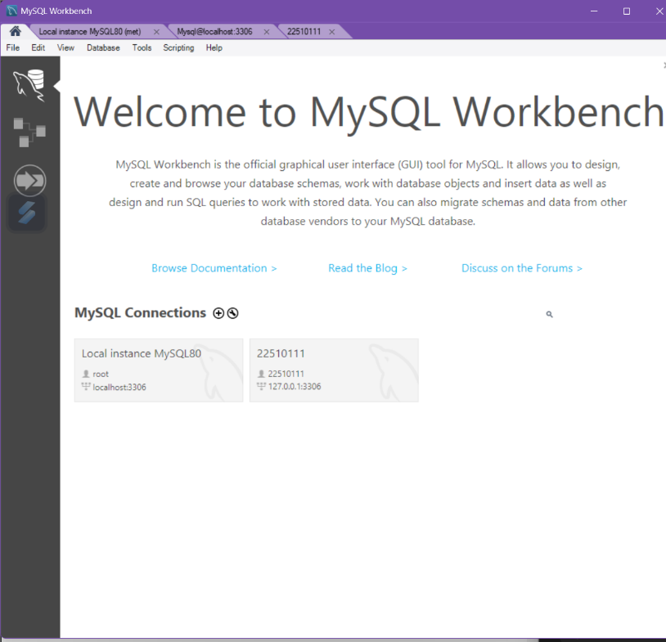

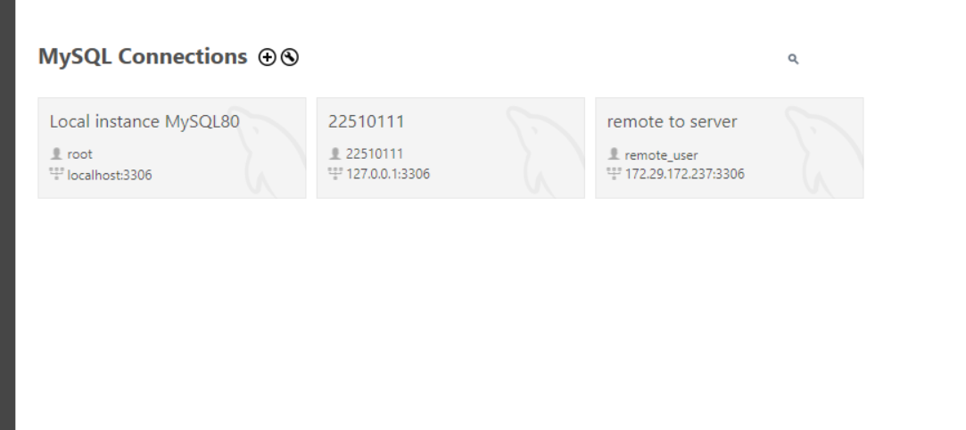

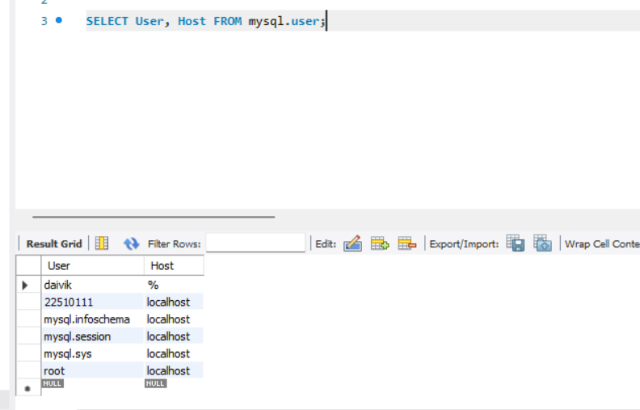

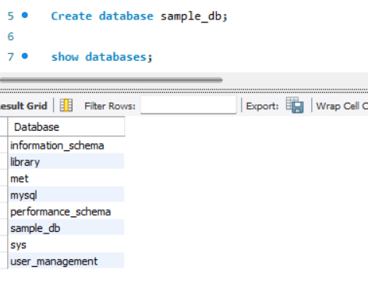

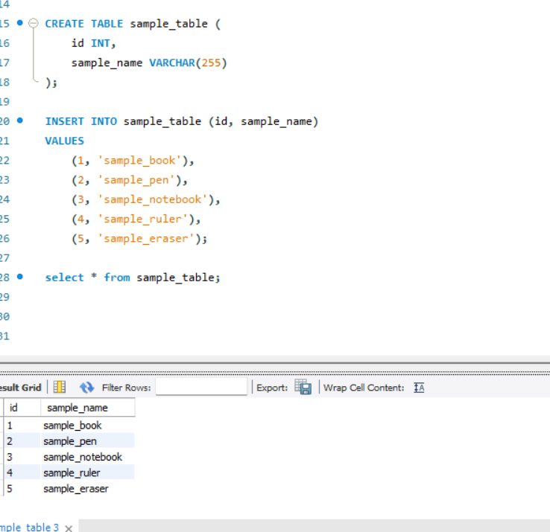

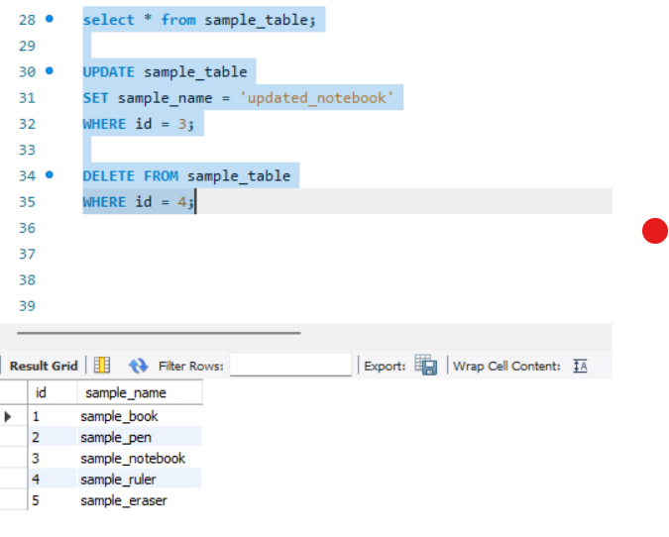

On WSL mysql server:

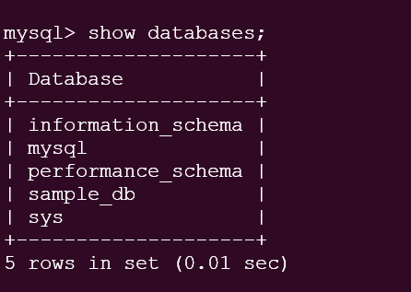

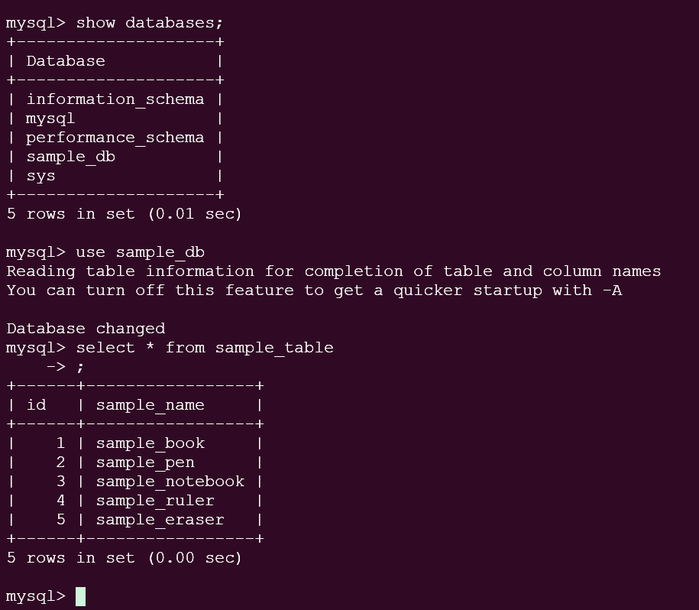

Angular Crud Form:

