**TY B.Tech. (CSE) – II [2024-25]**

**6CS371: Advanced Database System**

**Lab. Assignment No. 2: PSM & ORD**

**Name: Daivik Karbhari**

**PRN: 22510111**

1. **Objective / Aim:**
2. **MySQL / PSM Review :**

a) Create a table called test_table with 2 columns RecordNumber (type : Number(3)) and CurrentDate (type : Date)). Write a procedure in PSM which will insert 50 records into test_table. Insert the current date value into the table.

b) Create a products table products(ProductID number(4),category char(3),detail varchar2(30),price number(10,2),stock number(5)). Insert the sample data. Write PSM procedure with two arguments X & Y which will increase price by X% for all products in category Y. X and Y will be given by user.

1. **Object Relational Databases:**

a) Create Object Table containing field “name” of size 50 characters and member function “countNoOfWords” which returns the no. of words in “name” field. Demonstrate the working by entering different data.

b) Create an address type with the following attributes : address, city, state & pincode. Include the following methods i. to extract the addresses based on given keyword. j. to return the no. of words in each given field (method should accept the name of attribute/field)

c) Create a user defined data type course_Type with 2 attributes course_id, description : i. Create an object table based on the type created. j. Insert rows into the table Demonstrate the working with different data sets

1. **Introduction:**
   1. This assignment demonstrates the creation of tables in MySQL, manipulation of data through stored procedures, and interaction with databases. We will learn how to automate the insertion of data and modify it using user input through PSM (Persistent Stored Modules).
   2. Object Relational Databases (ORD) extend the relational model by incorporating object-oriented features such as user-defined types (UDTs), inheritance, and polymorphism. These features allow databases to model more complex and real-world entities. MySQL supports these features through object tables and user-defined types (UDTs). This assignment demonstrates how to create object tables, define methods within those tables, and perform operations like counting words and extracting data based on keywords.
2. **Theory / Algorithms:**
   1. **Test Table Creation**: The table test_table is created to store two fields:
      1. **RecordNumber**: A number to uniquely identify the record.
      2. **CurrentDate**: Stores the date when the record was inserted.
      3. A stored procedure will insert 50 records into this table, using the CURRENT_DATE function to populate the CurrentDate field.
   2. **Products Table Creation**: The products table will store product details such as Product ID, Category, Description, Price, and Stock. The stored procedure will allow updating the prices of products in a specific category by a given percentage.
   3. **PSM (Persistent Stored Modules)**: PSM is used to create stored procedures that handle database operations, encapsulating logic in the server for efficient execution.
   4. **Object Relational Database (ORD):**

* **Object Tables**: Tables that store objects of user-defined types. Each object in the table can have attributes (fields) and methods (functions).
* **User-Defined Types (UDTs)**: Custom data types created by the user to represent complex entities in the database. These types can have attributes and methods associated with them.

1. **Documentation: Functional Block Diagram/DFD:**
2. **Procedure:**

1.a

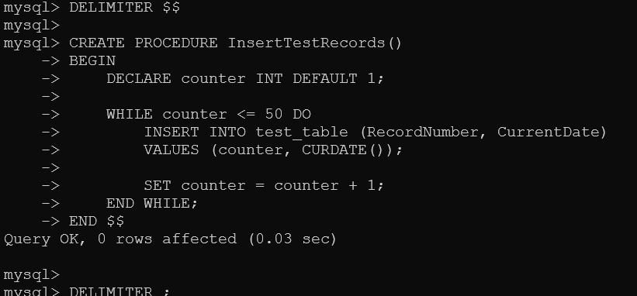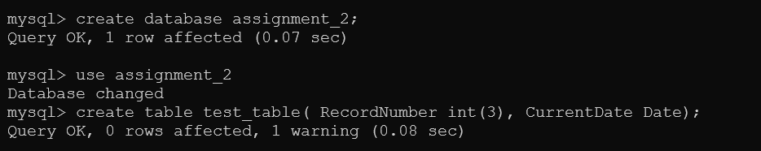

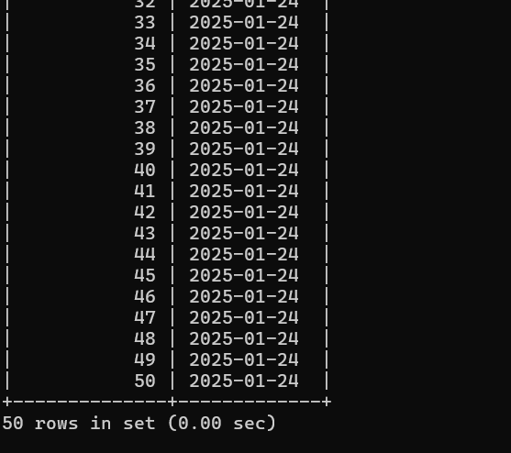 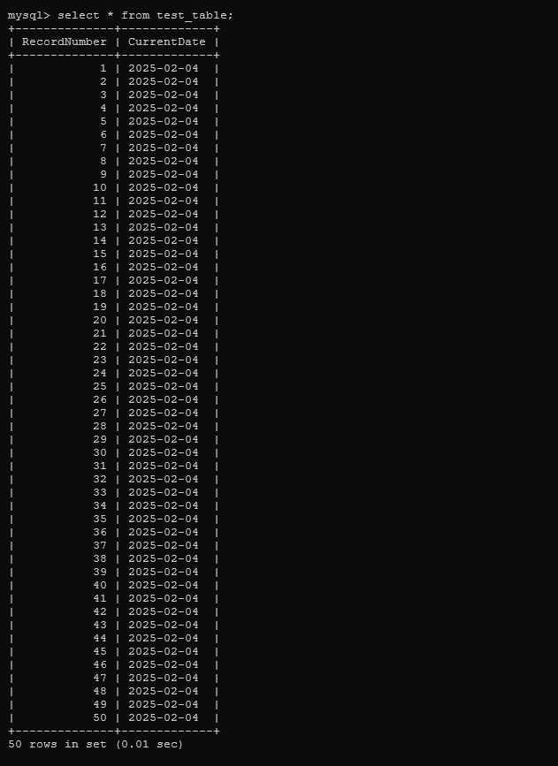

1.b:

1. 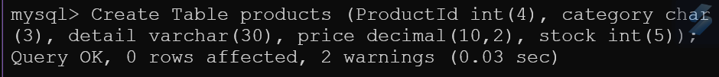Create product table and inserting sample data:

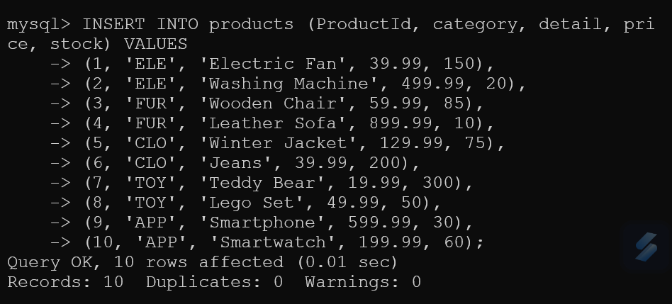

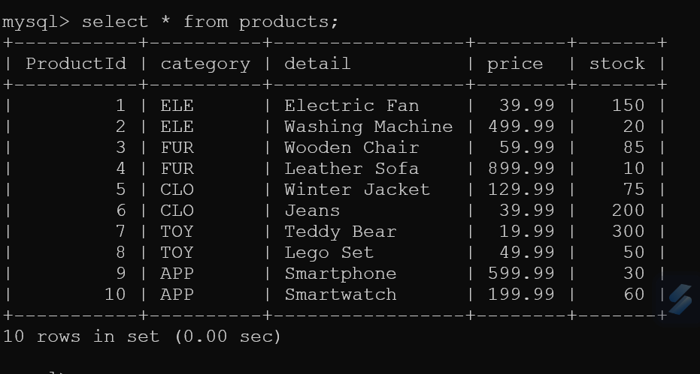

1. Create the stored procedure to increase the price:

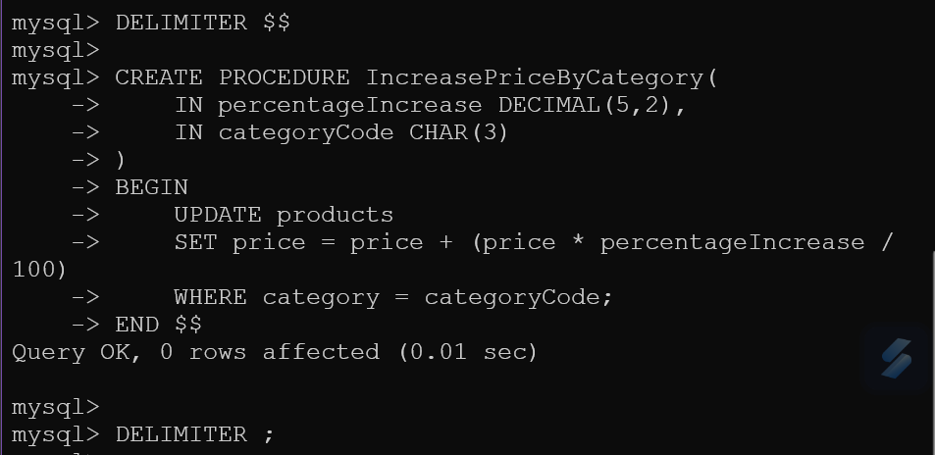

1. Call the procedure to update the price by a percentage for a specific category:

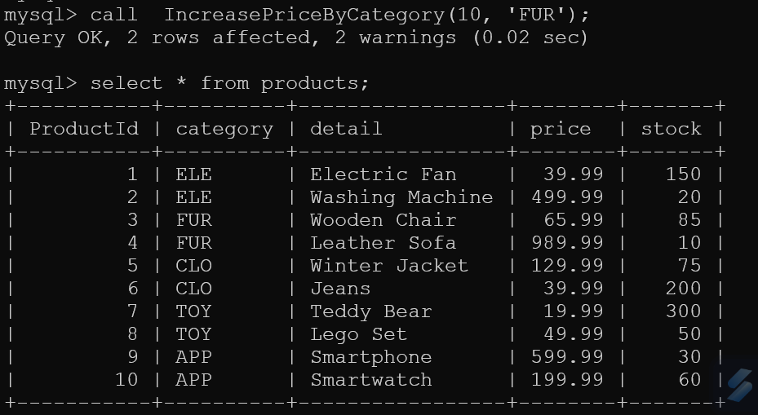

Problem 2: ORD

**(a) Create an Object Table with a Method to Count Words in the "name" Field**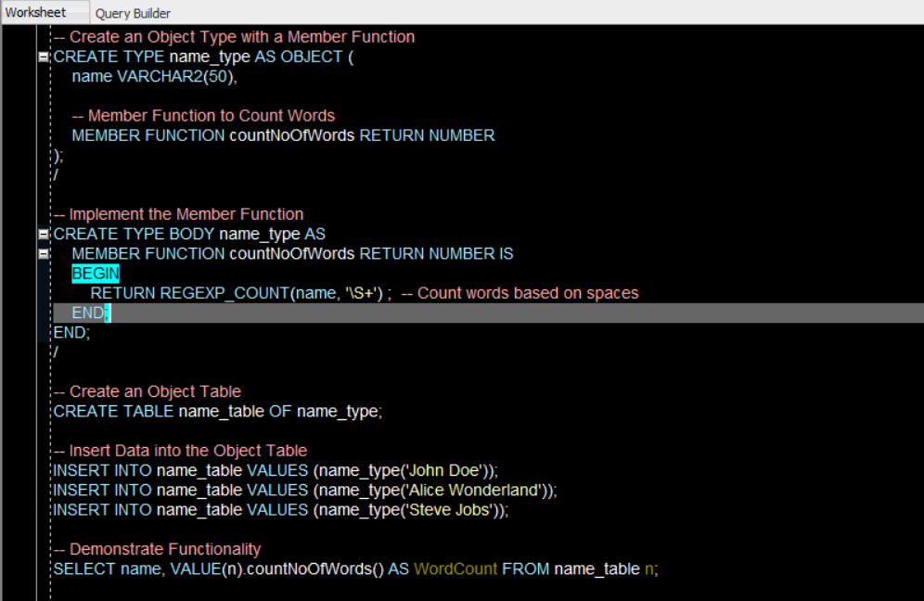

Output:

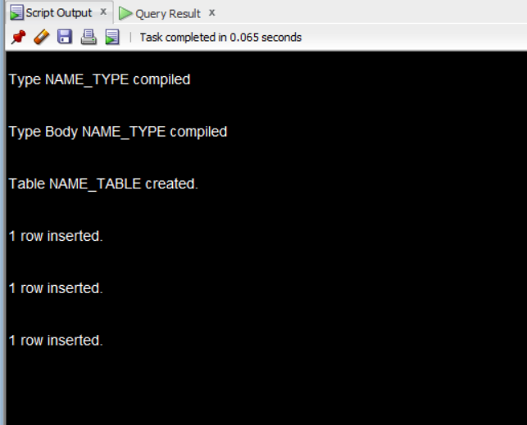

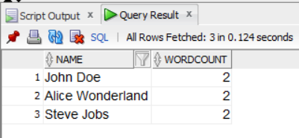

**(b) Create an Address Type with Methods**

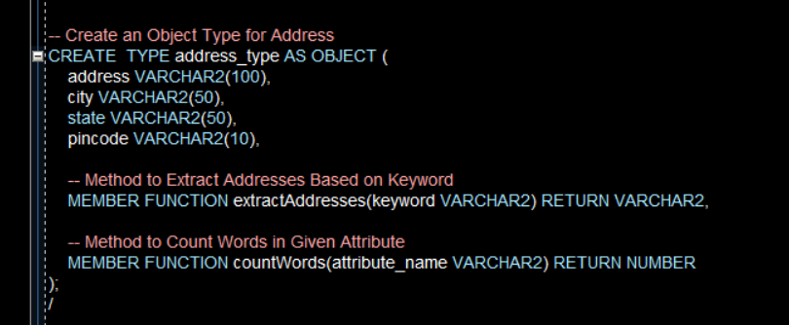

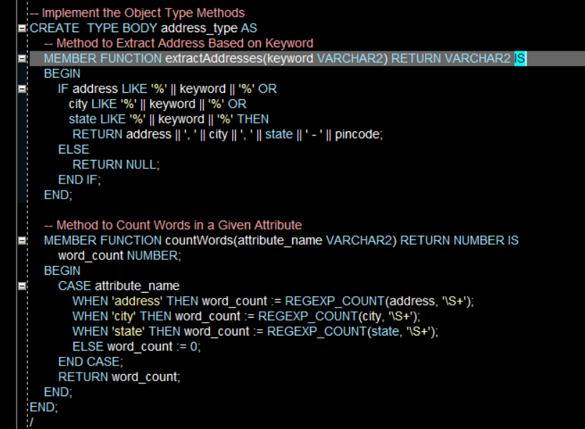

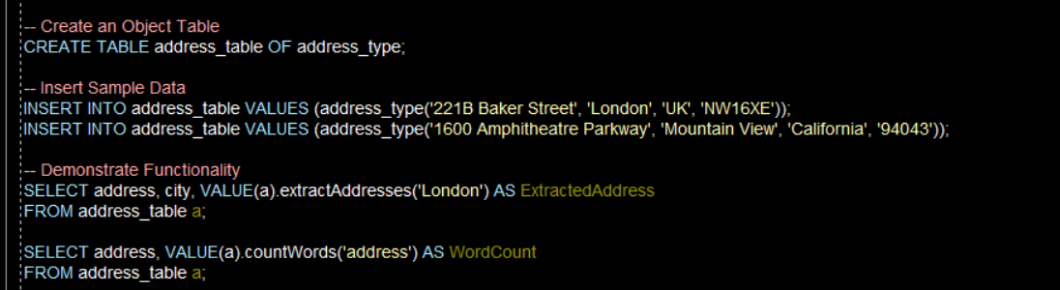

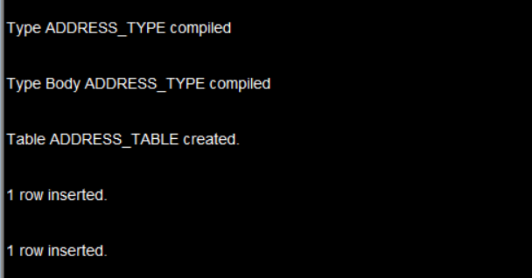

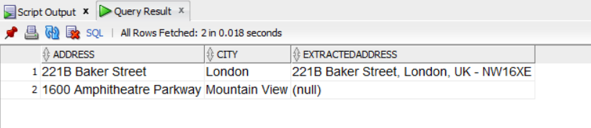

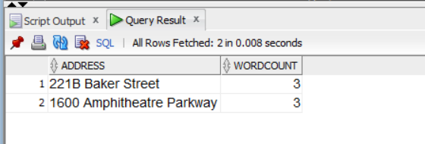

**(c) Create a User-Defined Data Type course_type**

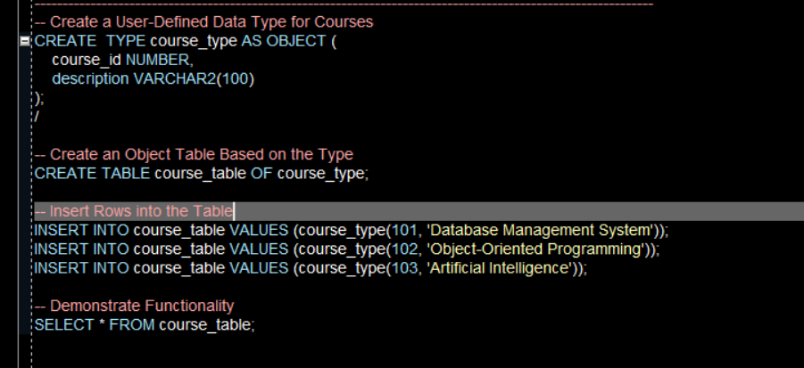

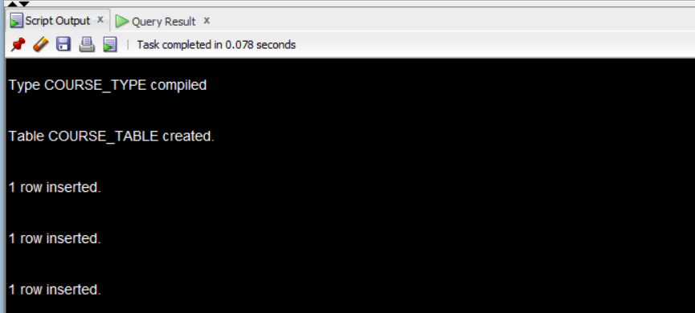

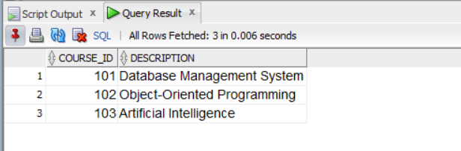

**Conclusion:**

This experiment demonstrates the use of MySQL stored procedures for automating data insertion and manipulation. By using stored procedures, we can efficiently handle data modifications without direct interaction for every record. This approach is useful in large-scale systems with frequent data changes and also The assignment successfully demonstrates the concepts of Object Relational Databases by creating and using object types, object tables, and stored procedures. The key points include:

* The ability to define custom types with fields and methods.
* The use of member functions for operations like word counting.
* The implementation of methods to extract data based on keywords and count words in dynamic fields.

These features allow MySQL to handle complex data structures and operations, making it a powerful tool for advanced data modeling.

1. **References:**

a.MySQL Documentation: <https://dev.mysql.com/doc/>

b. **Oracle PL/SQL Documentation**: For understanding procedural programming in SQL. [Oracle PL/SQL Docs](https://docs.oracle.com/en/database/oracle/oracle-database/19/lnpls/index.html)