**Assignment – 06**

**PRN: 225100111**

**Name: Daivik Karbhari**

1. Find all the stores along with city, state, phone, description, size, weight and unit price that hold a particular item of stock. -->



2. Find all the orders along with customer name and order date that can be fulfilled by a given store.

-->

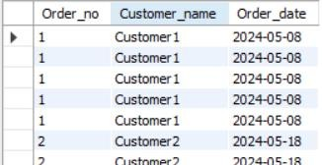

1. Find all stores along with city name and phone that hold items ordered by given customer.

-->



1. Find the headquarter address along with city and state of all stores that hold stocks of an item above a particular level.

-->

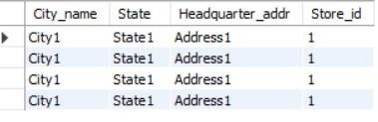

1. For each customer order, show the items ordered along with description, store id and city name and the stores that hold the items. -->

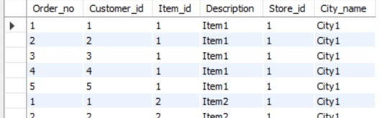

1. Find the city and the state in which a given customer lives. -->



1. Find the stock level of a particular item in all stores in a particular city -->



1. Find the items, quantity ordered, customer, store and city of an order. -->

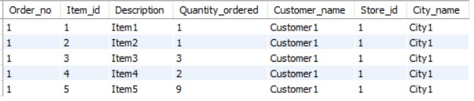

1. Find the walk in customers, mail order customers and dual customers (both walk-in and mail order).

-->

