library(tidyverse)

## ── Attaching packages ──────────────────────────────────────────────────────── tidyverse 1.2.1 ──

## ✔ ggplot2 3.1.0 ✔ purrr 0.2.5  
## ✔ tibble 1.4.2 ✔ dplyr 0.7.8  
## ✔ tidyr 0.8.2 ✔ stringr 1.3.1  
## ✔ readr 1.1.1 ✔ forcats 0.3.0

## ── Conflicts ─────────────────────────────────────────────────────────── tidyverse_conflicts() ──  
## ✖ dplyr::filter() masks stats::filter()  
## ✖ dplyr::lag() masks stats::lag()

library(MASS)

##   
## Attaching package: 'MASS'

## The following object is masked from 'package:dplyr':  
##   
## select

library(caret)

## Loading required package: lattice

##   
## Attaching package: 'caret'

## The following object is masked from 'package:purrr':  
##   
## lift

library(ROCR)

## Loading required package: gplots

## Warning: package 'gplots' was built under R version 3.5.2

##   
## Attaching package: 'gplots'

## The following object is masked from 'package:stats':  
##   
## lowess

parole = read_csv("parole.csv")

## Parsed with column specification:  
## cols(  
## male = col_integer(),  
## race = col_integer(),  
## age = col_double(),  
## state = col_integer(),  
## time.served = col_double(),  
## max.sentence = col_integer(),  
## multiple.offenses = col_integer(),  
## crime = col_integer(),  
## violator = col_integer()  
## )

parole = parole %>%  
 mutate(male = as_factor(as.character(male))) %>%  
 mutate(male = fct_recode(male, "male" = "1", "female" = "0")) %>%  
 mutate(race = as_factor(as.character(race))) %>%  
 mutate(race = fct_recode(race, "white" = "1", "otherwise" = "2")) %>%  
 mutate(state = as_factor(as.character(state))) %>%  
 mutate(state = fct_recode(state, "kentucky" = "2", "louisiana" = "3", "virginia" = "4", "other" = "1")) %>%  
 mutate(crime = as_factor(as.character(crime))) %>%  
 mutate(crime = fct_recode(crime, "larceny" = "2", "drug" = "3", "driving" = "4", "other" = "1")) %>%  
 mutate(multiple.offenses = as_factor(as.character(multiple.offenses))) %>%  
 mutate(multiple.offenses = fct_recode(multiple.offenses, "multiple" = "1", "single" = "0")) %>%  
 mutate(violator = as_factor(as.character(violator))) %>%  
 mutate(violator = fct_recode(violator, "violated" = "1", "didnotviolate" = "0"))

set.seed(12345)  
train.rows = createDataPartition(y = parole$violator, p = 0.7, list = FALSE)  
train = parole[train.rows,]  
test = parole[-train.rows,]

ggplot(train, aes(x = crime, fill = violator)) +  
 geom_bar(position = "fill")

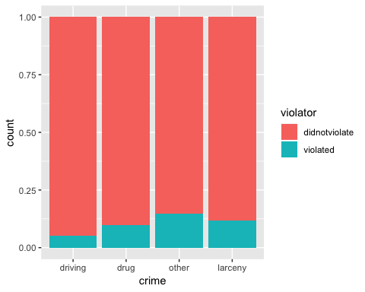

There doesn’t appear to be any signifance in the type of crime vs violator.

ggplot(train, aes(x = multiple.offenses, fill = violator)) +  
 geom_bar(position = "fill")

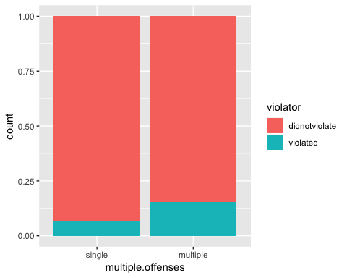

Violating parole appears to be slightly correlated with multiple offenses.

ggplot(train, aes(x = violator, y = time.served)) +  
 geom_boxplot()

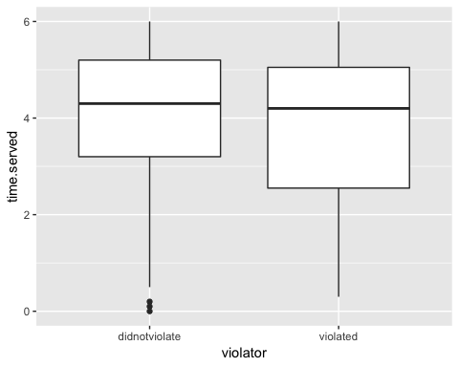

It appears that the max and median time served are similar for violators and non-violators but the minimum time served varies between the two.

ggplot(train, aes(x = violator, y = age)) +   
 geom_boxplot()

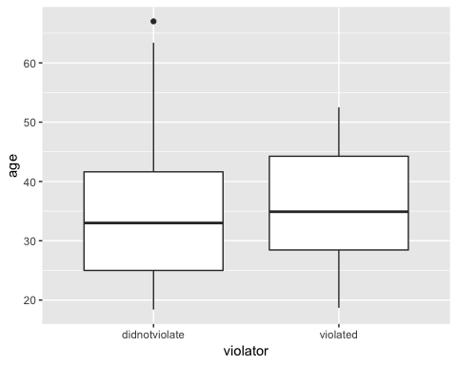

The median age seems to be similar between did not violate and violated but the minimum and maximumage differ.

ggplot(train, aes(x = male, fill = violator)) +  
 geom_bar(position = "fill")

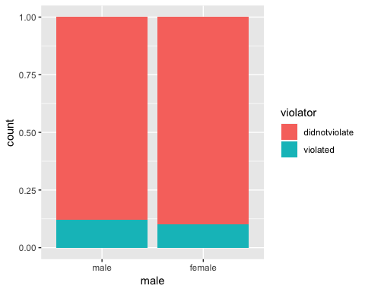

There does not appear to be a difference between the two genders.

ggplot(train, aes(x = race, fill = violator)) +  
 geom_bar(position = "fill")

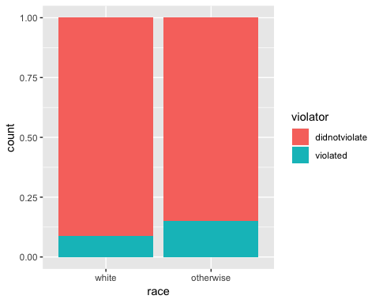

The otherwise race categorization appears to be slightly higher for those who have violated vs did not violate when compared to the white race categorization.

ggplot(train, aes(x = violator, y = max.sentence)) +  
 geom_boxplot()

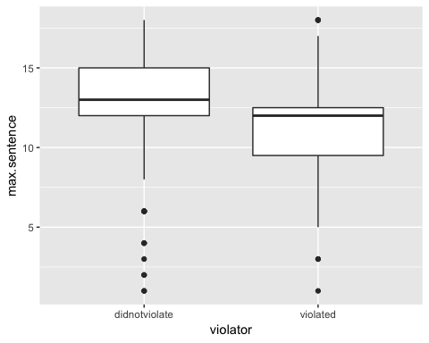

It appears that people are more likely to violate parole when they have a lower max sentence when you compare all three variables: min, median, and max.

ggplot(train, aes(x = violator, y = (time.served/max.sentence))) +   
 geom_boxplot()

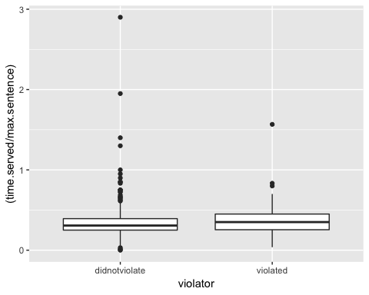

This shows that there is not a significant correlation in the ratio of time served and max sentence.

ggplot(train, aes(x = state,fill = violator)) +  
 geom_bar(position = "fill")

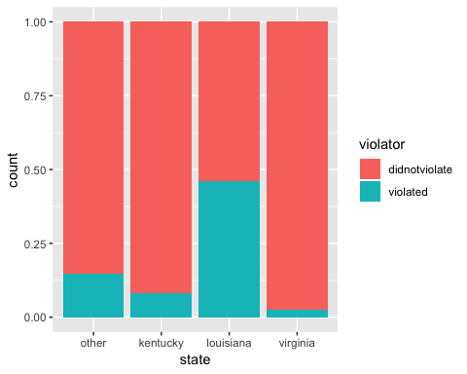 There is a strong correlation between violating parole and the state of Louisiana.

Variables that are most predicitive of violator is state.

model1 = glm(violator ~ state, train, family = "binomial")  
summary(model1)

##   
## Call:  
## glm(formula = violator ~ state, family = "binomial", data = train)  
##   
## Deviance Residuals:   
## Min 1Q Median 3Q Max   
## -1.1106 -0.4084 -0.2255 -0.2255 2.7147   
##   
## Coefficients:  
## Estimate Std. Error z value Pr(>|z|)   
## (Intercept) -1.7677 0.2892 -6.113 9.79e-10 ***  
## statekentucky -0.6747 0.5146 -1.311 0.189803   
## statelouisiana 1.6086 0.3841 4.188 2.81e-05 ***  
## statevirginia -1.8916 0.5046 -3.749 0.000178 ***  
## ---  
## Signif. codes: 0 '***' 0.001 '**' 0.01 '*' 0.05 '.' 0.1 ' ' 1  
##   
## (Dispersion parameter for binomial family taken to be 1)  
##   
## Null deviance: 340.04 on 472 degrees of freedom  
## Residual deviance: 264.58 on 469 degrees of freedom  
## AIC: 272.58  
##   
## Number of Fisher Scoring iterations: 6

The p-values are significant for only some of the variables, thus the model might not be considered a good quality model.

model2 = glm(violator ~ state + max.sentence, train, family = "binomial")  
summary(model2)

##   
## Call:  
## glm(formula = violator ~ state + max.sentence, family = "binomial",   
## data = train)  
##   
## Deviance Residuals:   
## Min 1Q Median 3Q Max   
## -1.161 -0.423 -0.227 -0.224 2.715   
##   
## Coefficients:  
## Estimate Std. Error z value Pr(>|z|)   
## (Intercept) -1.95103 0.68990 -2.828 0.00468 **   
## statekentucky -0.66318 0.51621 -1.285 0.19889   
## statelouisiana 1.66695 0.43335 3.847 0.00012 ***  
## statevirginia -1.89943 0.50521 -3.760 0.00017 ***  
## max.sentence 0.01363 0.04639 0.294 0.76884   
## ---  
## Signif. codes: 0 '***' 0.001 '**' 0.01 '*' 0.05 '.' 0.1 ' ' 1  
##   
## (Dispersion parameter for binomial family taken to be 1)  
##   
## Null deviance: 340.04 on 472 degrees of freedom  
## Residual deviance: 264.49 on 468 degrees of freedom  
## AIC: 274.49  
##   
## Number of Fisher Scoring iterations: 6

Only some of the p values are significant but the AIC Value is slightly higher.

model3 = glm(violator ~ state + max.sentence + multiple.offenses, train, family = "binomial")  
summary(model3)

##   
## Call:  
## glm(formula = violator ~ state + max.sentence + multiple.offenses,   
## family = "binomial", data = train)  
##   
## Deviance Residuals:   
## Min 1Q Median 3Q Max   
## -1.5382 -0.3615 -0.2549 -0.2339 2.6455   
##   
## Coefficients:  
## Estimate Std. Error z value Pr(>|z|)   
## (Intercept) -3.22107 0.82313 -3.913 9.11e-05 ***  
## statekentucky -0.31701 0.53967 -0.587 0.55692   
## statelouisiana 1.31270 0.46155 2.844 0.00445 **   
## statevirginia -2.73971 0.54493 -5.028 4.97e-07 ***  
## max.sentence 0.05839 0.05144 1.135 0.25628   
## multiple.offensesmultiple 1.67458 0.39997 4.187 2.83e-05 ***  
## ---  
## Signif. codes: 0 '***' 0.001 '**' 0.01 '*' 0.05 '.' 0.1 ' ' 1  
##   
## (Dispersion parameter for binomial family taken to be 1)  
##   
## Null deviance: 340.04 on 472 degrees of freedom  
## Residual deviance: 245.58 on 467 degrees of freedom  
## AIC: 257.58  
##   
## Number of Fisher Scoring iterations: 6

The AIC value is less than it was in the previous model.

model4 = glm(violator ~ state + max.sentence + multiple.offenses + race, train, family = "binomial")  
summary(model4)

##   
## Call:  
## glm(formula = violator ~ state + max.sentence + multiple.offenses +   
## race, family = "binomial", data = train)  
##   
## Deviance Residuals:   
## Min 1Q Median 3Q Max   
## -1.5622 -0.3615 -0.2850 -0.1651 2.8178   
##   
## Coefficients:  
## Estimate Std. Error z value Pr(>|z|)   
## (Intercept) -3.50690 0.85551 -4.099 4.15e-05 ***  
## statekentucky -0.43515 0.54530 -0.798 0.42487   
## statelouisiana 0.76022 0.51347 1.481 0.13872   
## statevirginia -3.36095 0.61695 -5.448 5.10e-08 ***  
## max.sentence 0.06763 0.05360 1.262 0.20708   
## multiple.offensesmultiple 1.76711 0.41035 4.306 1.66e-05 ***  
## raceotherwise 1.03845 0.40232 2.581 0.00985 **   
## ---  
## Signif. codes: 0 '***' 0.001 '**' 0.01 '*' 0.05 '.' 0.1 ' ' 1  
##   
## (Dispersion parameter for binomial family taken to be 1)  
##   
## Null deviance: 340.04 on 472 degrees of freedom  
## Residual deviance: 238.81 on 466 degrees of freedom  
## AIC: 252.81  
##   
## Number of Fisher Scoring iterations: 6

AIC decreases a little when race is added to the model.

allmodels = glm(violator ~., train, family = "binomial")  
summary(allmodels)

##   
## Call:  
## glm(formula = violator ~ ., family = "binomial", data = train)  
##   
## Deviance Residuals:   
## Min 1Q Median 3Q Max   
## -1.9635 -0.3638 -0.2354 -0.1449 2.9869   
##   
## Coefficients:  
## Estimate Std. Error z value Pr(>|z|)   
## (Intercept) -5.33220 1.39750 -3.816 0.000136 ***  
## malefemale -0.53377 0.49107 -1.087 0.277051   
## raceotherwise 1.06698 0.41324 2.582 0.009824 **   
## age 0.03361 0.01696 1.982 0.047493 *   
## statekentucky -0.30132 0.56939 -0.529 0.596665   
## statelouisiana 0.87804 0.52428 1.675 0.093984 .   
## statevirginia -3.46523 0.63742 -5.436 5.44e-08 ***  
## time.served -0.03009 0.12159 -0.247 0.804537   
## max.sentence 0.08458 0.05644 1.499 0.133963   
## multiple.offensesmultiple 1.72841 0.41857 4.129 3.64e-05 ***  
## crimedrug 0.11232 0.71712 0.157 0.875535   
## crimeother 0.87795 0.62271 1.410 0.158571   
## crimelarceny 1.06304 0.73146 1.453 0.146139   
## ---  
## Signif. codes: 0 '***' 0.001 '**' 0.01 '*' 0.05 '.' 0.1 ' ' 1  
##   
## (Dispersion parameter for binomial family taken to be 1)  
##   
## Null deviance: 340.04 on 472 degrees of freedom  
## Residual deviance: 230.16 on 460 degrees of freedom  
## AIC: 256.16  
##   
## Number of Fisher Scoring iterations: 6

backwardmodel = stepAIC(allmodels, direction = "backward", trace = TRUE)

## Start: AIC=256.16  
## violator ~ male + race + age + state + time.served + max.sentence +   
## multiple.offenses + crime  
##   
## Df Deviance AIC  
## - time.served 1 230.22 254.22  
## - crime 3 235.30 255.30  
## - male 1 231.41 255.41  
## <none> 230.16 256.16  
## - max.sentence 1 232.46 256.46  
## - age 1 234.09 258.09  
## - race 1 236.97 260.97  
## - multiple.offenses 1 248.67 272.67  
## - state 3 304.40 324.40  
##   
## Step: AIC=254.22  
## violator ~ male + race + age + state + max.sentence + multiple.offenses +   
## crime  
##   
## Df Deviance AIC  
## - crime 3 235.38 253.38  
## - male 1 231.56 253.56  
## <none> 230.22 254.22  
## - max.sentence 1 232.50 254.50  
## - age 1 234.09 256.09  
## - race 1 236.97 258.98  
## - multiple.offenses 1 249.39 271.39  
## - state 3 304.94 322.95  
##   
## Step: AIC=253.38  
## violator ~ male + race + age + state + max.sentence + multiple.offenses  
##   
## Df Deviance AIC  
## - male 1 236.28 252.28  
## <none> 235.38 253.38  
## - max.sentence 1 237.41 253.41  
## - age 1 238.26 254.26  
## - race 1 242.32 258.32  
## - multiple.offenses 1 255.31 271.31  
## - state 3 309.30 321.30  
##   
## Step: AIC=252.28  
## violator ~ race + age + state + max.sentence + multiple.offenses  
##   
## Df Deviance AIC  
## <none> 236.28 252.28  
## - max.sentence 1 238.31 252.31  
## - age 1 238.81 252.81  
## - race 1 243.44 257.44  
## - multiple.offenses 1 256.39 270.39  
## - state 3 309.81 319.80

summary(backwardmodel)

##   
## Call:  
## glm(formula = violator ~ race + age + state + max.sentence +   
## multiple.offenses, family = "binomial", data = train)  
##   
## Deviance Residuals:   
## Min 1Q Median 3Q Max   
## -1.7414 -0.3643 -0.2668 -0.1502 2.7714   
##   
## Coefficients:  
## Estimate Std. Error z value Pr(>|z|)   
## (Intercept) -4.60426 1.13428 -4.059 4.92e-05 ***  
## raceotherwise 1.07386 0.40527 2.650 0.00806 **   
## age 0.02636 0.01660 1.588 0.11224   
## statekentucky -0.41360 0.54930 -0.753 0.45147   
## statelouisiana 0.86000 0.51900 1.657 0.09751 .   
## statevirginia -3.34208 0.62057 -5.386 7.22e-08 ***  
## max.sentence 0.07733 0.05475 1.412 0.15788   
## multiple.offensesmultiple 1.77974 0.41476 4.291 1.78e-05 ***  
## ---  
## Signif. codes: 0 '***' 0.001 '**' 0.01 '*' 0.05 '.' 0.1 ' ' 1  
##   
## (Dispersion parameter for binomial family taken to be 1)  
##   
## Null deviance: 340.04 on 472 degrees of freedom  
## Residual deviance: 236.28 on 465 degrees of freedom  
## AIC: 252.28  
##   
## Number of Fisher Scoring iterations: 6

The most representative model appears to be state, max.sentence, multiple.offenses, and race.

model5 = glm(violator ~ state + multiple.offenses + race, train, family = "binomial")  
summary(model5)

##   
## Call:  
## glm(formula = violator ~ state + multiple.offenses + race, family = "binomial",   
## data = train)  
##   
## Deviance Residuals:   
## Min 1Q Median 3Q Max   
## -1.4553 -0.3862 -0.2931 -0.1787 2.8791   
##   
## Coefficients:  
## Estimate Std. Error z value Pr(>|z|)   
## (Intercept) -2.5582 0.3709 -6.898 5.28e-12 ***  
## statekentucky -0.4816 0.5417 -0.889 0.3740   
## statelouisiana 0.5292 0.4769 1.110 0.2672   
## statevirginia -3.2301 0.6028 -5.358 8.39e-08 ***  
## multiple.offensesmultiple 1.6596 0.3985 4.165 3.12e-05 ***  
## raceotherwise 1.0024 0.3966 2.528 0.0115 *   
## ---  
## Signif. codes: 0 '***' 0.001 '**' 0.01 '*' 0.05 '.' 0.1 ' ' 1  
##   
## (Dispersion parameter for binomial family taken to be 1)  
##   
## Null deviance: 340.04 on 472 degrees of freedom  
## Residual deviance: 240.42 on 467 degrees of freedom  
## AIC: 252.42  
##   
## Number of Fisher Scoring iterations: 6

In this model, only some of the p values are significant. This may not be a good quality model.

newdata = data.frame(state = "louisiana", multiple.offenses = "multiple", race = "white")  
predict(model5, newdata, type = "response")

## 1   
## 0.408682

The predicted probability is 0.408682.

newdata = data.frame(state = "kentucky", multiple.offenses = "single", race = "otherwise")  
predict(model5, newdata, type = "response")

## 1   
## 0.1153326

The predicted probability is 0.1153326.

predictions = predict(model5, type = "response")  
head(predictions)

## 1 2 3 4 5 6   
## 0.07187555 0.17425270 0.07187555 0.17425270 0.17425270 0.07187555

ROCRpred = prediction(predictions, train$violator)  
ROCRperf = performance(ROCRpred, "tpr", "fpr")  
plot(ROCRperf, colorize = TRUE, print.cutoffs.at = seq(0,1, by = 0.1), text.adj = c(-0.2,1.7))

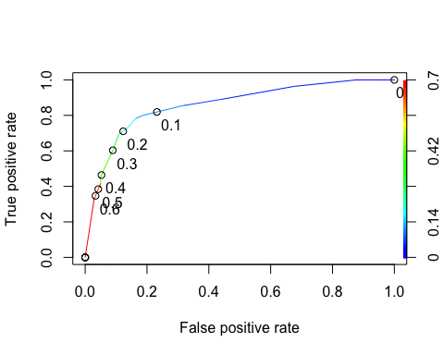

opt.cut = function(perf, pred){  
 cut.ind = mapply(FUN=function(x, y, p){  
 d = (x - 0)^2 + (y-1)^2  
 ind = which(d == min(d))  
 c(sensitivity = y[[ind]], specificity = 1-x[[ind]],  
 cutoff = p[[ind]])  
 }, perf@x.values, perf@y.values, pred@cutoffs)  
}  
print(opt.cut(ROCRperf, ROCRpred))

## [,1]  
## sensitivity 0.7818182  
## specificity 0.8373206  
## cutoff 0.1161882

The sensitivity is 0.7818, the specificity is 0.8373, and the cutoff is 0.1162.

traintable = table(train$violator, predictions > 0.1161882)  
traintable

##   
## FALSE TRUE  
## didnotviolate 357 61  
## violated 14 41

(traintable[1,1] + traintable[2,2])/nrow(train)

## [1] 0.8414376

The accuracy is 0.8414. There is a high number of parolees predicted not to violate who did and the implications of incorrectly classifying a parolee is that if over estimate those who do not violate and you put a parolee into the predicted not to violate parole category, they may slip up and violate parole.

traintable = table(train$violator, predictions > 0.2)  
traintable

##   
## FALSE TRUE  
## didnotviolate 367 51  
## violated 16 39

(traintable[1,1] + traintable[2,2])/nrow(train)

## [1] 0.858351

The accuracy increases by around 0.017.

traintable = table(train$violator, predictions > 0.3)  
traintable

##   
## FALSE TRUE  
## didnotviolate 397 21  
## violated 30 25

(traintable[1,1] + traintable[2,2])/nrow(train)

## [1] 0.8921776

This increases the accuracy by around 0.04.

traintable = table(train$violator, predictions > 0.4)  
traintable

##   
## FALSE TRUE  
## didnotviolate 397 21  
## violated 30 25

(traintable[1,1] + traintable[2,2])/nrow(train)

## [1] 0.8921776

The accuracy remains the same.

testpred = predict(model5, test, type = "response")  
testtable2 = table(test$violator, testpred > 0.1161882)  
testtable2

##   
## FALSE TRUE  
## didnotviolate 156 23  
## violated 12 11

(testtable2[1,1] + testtable2[2,2])/nrow(test)

## [1] 0.8267327

testtable2 = table(test$violator, testpred > 0.3)  
testtable2

##   
## FALSE TRUE  
## didnotviolate 172 7  
## violated 15 8

(testtable2[1,1] + testtable2[2,2])/nrow(test)

## [1] 0.8910891

The accuracy is high with a value of 0.8910891.