Project Proposal

Reservation Information System
For Euaiki Island Resort

Jenny Cooper
12101303
jennifer.cooper@student.ncirl.ie

Higher Diploma in Science in Software Development (HDSSD)

3rd October 2012

Objectives

Client: Euaiki Island Resort

Euaiki Island Resort is a small island resort that has a very basic booking/reservations system.
The storage of the information is inefficient, making it difficult for the staff involved to have easy access to the necessary information.

The system currently used also makes it difficult to look back at important statistical information, for both accounting and marketing purposes.

The objective of this project is to design and implement a user-friendly working software system that will:
- Store all necessary information for bookings, including information about guests
- Make access to this information simple
- Make the information easily accessible to more than one person, from different locations
- Show statistical information from current and previous years

Background

The main problem for the clients is that their reservations employee is based in the main town and does not work on the island.
Bookings and enquiries are made by email, directly to the reservations employee, who stores all information about guests (no. of nights, flight arrival times, dietary requirements etc.) on their computer.
This information then needs to be relayed to the owners of the island and other staff on a regular basis. The island uses solar power only, so the internet router is only turned on for certain hours of the day, which limits internet access.

The new software system will need to be designed to keep these requirements in mind:
- The front end for the client will be a web browser, with security access implemented.
- The main application will be running on a web server, which will access and update the database and dynamic content of the front end web pages.
- A new database will be set up to hold the information about the reservations. This database will be stored on a cloud server.
- Since internet is not always available to the staff on the island, synchronization will occur each day when the island staff log on to the system. This will make a back-up copy of the information to be downloaded onto the computer on the island, so it can always be accessed by staff on the island (i.e. when they don't have internet access).

Technical Approach

- Research to be done on existing frameworks and libraries that are available, to choose an appropriate framework to implement, in order to connect between the database, main application, and web browser pages.
- Research to be done on the best software packages to use for coding (e.g. Eclipse vs. Netbeans).
- Research into using JSP/web servlets for dynamic web pages.
- Requirements Gathering – has already been done with the clients

Special resources required
Hosting online of database, hosting of main application on a web server, and hosting of front-end web pages.

Project Plan

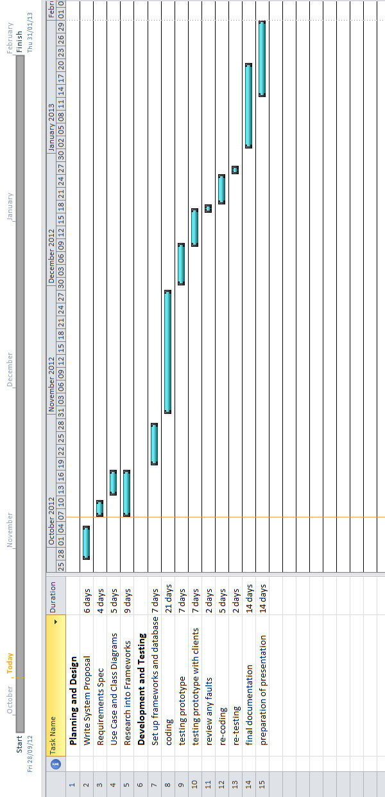

Technical Details
Front end web browser: HTML5 (with embedded java), CSS, Javascript and JQuery
Application Logic: Java
Server-side: Java implementing SQL
Frameworks: still to be decided on.

Evaluation
Real technical data from the clients from last year (and previous years) will be used to test the system.
A working prototype will also be tested by the clients/end users, and modifications will be made as a result.

Consultation with Project Specialisation Coordinator
Brian Gillespie

