# User instructions

## Single frame estimation of myocardial mechanical properties

ZJW 24 May 2016

### Get source code

Clone or download source code from github repository at:

<https://github.com/jennyhelyanwe/LVSimulationSingleFrame.git>

Place code into your selected root folder – note that the file size will end up being quite large once analyses start.

1. In your chosen local directory, type in the command:

git clone <https://github.com/jennyhelyanwe/LVSimulationSingleFrame.git>

This should download the entire repository to your local folder.

2. If I make any changes to the code after you have cloned the repository, for example for bug fixes in the future, then you can update your local version to match that of my remote one by doing:

git pull origin master

### Set up environment variables

Add the environment variables listed in ‘EnvironmentSetup’ to your environment. Do this by entering the command

gedit ~/.bashrc &

and pasting the lines at the bottom of the bashrc text file.

Modify the directory path for HEART\_FAILURE\_ROOT to the local directory you downloaded the code to.

### Input data

**Imaging data**

Place the CIM models under the folder HEART\_FAILURE\_ROOT/CIM\_Models/Studies/

Run python script found at HEART\_FAILURE\_ROOT/CIM\_Models/Processing\_CIM/

python ProcessingCIM.py

**Haemodynamic data**

Enter the pressure data in units of kPa in a text file found at HEART\_FAILURE\_ROOT/HaemoData/RegisteredPressure/

Name the text file as <study\_name>\_registered\_LVP.txt

Format of file:

Column one – MRI frame numbers starting from end diastole.

Colume two – corresponding pressure value at that frame. If unknown for that frame, put 0.0.

**Record study name and frame numbers**

Add details of new study to text file found at HEART\_FAILURE\_ROOT/ParameterEstimation/StudyNames.txt

Format of file:

<study\_name> \tab <diastasis frame number> \tab <end diastole frame number> \tab <end systole frame number> \tab <total number of frames>

Ensure there are no empty lines at the end of the file.

### Analysis

**Generate surface data cloud**

Run python script found at HEART\_FAILURE\_ROOT/GeomData/

python CIMProcessing.py

**Run analysis**

Run python script found at HEART\_FAILURE\_ROOT/ParameterEstimation/Main/

python main.py <study\_number> \space <log file toggle> \space <forward solve toggle> \space <analyses option>

<study\_number> - the line number (starting from zero) at which the study is listed in the StudyNames.txt file.

<log file toggle> - 0: outputs debug information to command line. 1: outputs debug information to text file found in HEART\_FAILURE\_ROOT/ParameterEstimation/Studies/<study\_name>

<forward solve toggle> - Always leave on (1)

<analyses option> - Always leave at 1 for passive analysis.

### Other helpful tips

**Here are some useful links:**

- [Unix command line basics](http://www.ee.surrey.ac.uk/Teaching/Unix/)

- [Github tutorials](https://guides.github.com/" \t "_blank) and the link to the simulation framework [repository](https://github.com/jennyhelyanwe/LVSimulationSingleFrame)

- [Putty download](http://www.putty.org/) link. Once downloaded, enter the following into the interface and pressure open. You should then be able to log in with your upi and password.

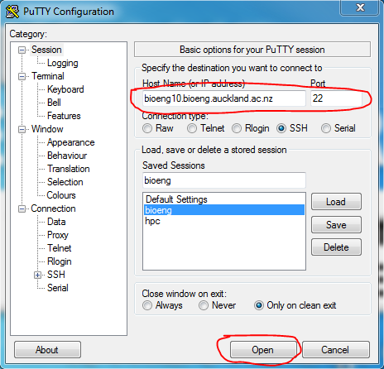

- Email [bioeng-itstaff@list.bioeng.auckland.ac.nz](mailto:bioeng-itstaff@list.bioeng.auckland.ac.nz) for IT support.

- [CMGUI tutorial](https://www.cellml.org/assets/files/embc2010cmgui)

**And some explanations for...**

1. Where to find stress and strain data output:

This can be found in the directory HEART\_FAILURE\_ROOT/ParameterEstimation/Studies/<study\_name>/LVMechanics<study\_name>/PassiveMechanics/OptimisedStressStrain/

The .exdata files in this folder contain the stress or strain values at each element gauss point. I can explain in more detail later on once you are more familiar with running the framework.

2. How to extract basal displacement boundary conditions:

The basal displacement BC's are applied at four nodes at the base of the model. The x, y and z displacements are written to the log file from lines 50 to 53. For example for study PETALE\_P003:

*Nodal displacement:*

*Node 31 x, y, z diplacements =  -1.6981 -8.2657 0.0*

*Node 32 x, y, z diplacements =  -2.3628 0.0 0.7669*

*Node 33 x, y, z diplacements =  -0.6889 -3.1353 0.0*

*Node 34 x, y, z diplacements =  -1.3363 0.0 4.6896*

The log file can be found at HEART\_FAILURE\_ROOT/ParameterEstimation/Studies/<study\_name>/Output