RMarkdown based APA Manuscript with ‘papaja’

|  |
| --- |
| Jenny Rieck1 & Derek Beaton1 |
| 1 Rotman Research Institute |
|  |

Abstract

This is a short example of a completely reproducible manuscript made entirely in RStudio with RMarkdown and various R scripts, functions, and packages.

*Keywords:* reproducible, manuscript, multivariate, APA, papaja, knitr, R, Rmarkdown

RMarkdown based APA Manuscript with ‘papaja’

# Introduction

The aim of this RMarkdown example is to show how to write a reproducible manuscript, which includes numerous bells-and-whistles—with contributions from R, Python, RMarkdown, and LaTeX. This “manuscript” will include only the best (nicest looking) parts from 1_a_Simple_RMarkdown_PDF.Rmd

In order to help make this manuscript look nicer, we are changing some of the YAML (“yet another markup language”) header options, so that we remove line numbers, and allow for tables & figures to appear in text, as opposed to the end.

# Methods

We first make our data with R. This will be followed by a paragraph break because this text precedes a chunk.

Then call off to python for the .describe() method. This, too, will be followed by a paragraph break because this text precedes a chunk.

And then pass the desc object back to R and use the kable() and kableExtra packages to make a nice table of summary statistics for the measures of interest. In this particular part, we also show the code chunk. Furthermore, some particular packages—such as papaja—and certain advanced features from LaTeX require the use of results='asis' in chunk header.

apa_table(py$desc, caption = "A descriptive statistics table.",   
 note = "This formatted through LaTeX via papaja::apa_table() from a python object from the .describe() method, loaded from data in R and written through RMarkdown.")

(#tab:python_describe_via_kable)

*A descriptive statistics table.*

|  |  |  |  |  |  |  |
| --- | --- | --- | --- | --- | --- | --- |
|  | AGE | MOCA | CDRSB | WholeBrain | Hippocampus | MidTemp |
| count | 665.00 | 665.00 | 665.00 | 665.00 | 665.00 | 665.00 |
| mean | 71.92 | 23.89 | 1.20 | 1,057,025.55 | 7,149.61 | 20,301.93 |
| std | 6.87 | 3.28 | 1.34 | 103,672.74 | 1,086.04 | 2,675.57 |
| min | 55.00 | 16.00 | 0.00 | 817,421.23 | 3,731.00 | 12,213.00 |
| 25% | 67.20 | 22.00 | 0.00 | 984,409.91 | 6,510.00 | 18,535.00 |
| 50% | 71.90 | 24.00 | 1.00 | 1,051,621.33 | 7,223.00 | 20,186.00 |
| 75% | 76.60 | 26.00 | 2.00 | 1,120,569.50 | 7,834.00 | 22,088.00 |
| max | 89.60 | 30.00 | 5.50 | 1,486,035.64 | 10,602.00 | 32,189.00 |

*Note.* This formatted through LaTeX via papaja::apa_table() from a python object from the .describe() method, loaded from data in R and written through RMarkdown.

## Procedure

Next we are going to use more features from LaTeX, including various additional LaTeX packages that we define in the YAML header. We can use a number of LaTeX features like inline calls, numbered equations, and, for eaxmple, algorithms. We will use each of those features to describe the covSTATIS method (see also [our covSTATIS project repository](https://github.com/jennyrieck/C-MARINeR)). Our description of covSTATIS is extremely truncated here and is only meant to illustrate features of writing a manuscript in RMarkdown.

CovSTATIS is a multi-table principal components analysis, specifically designed to integrate and analyze multiple correlation or covariance matrices. Each correlation matrix—${\bf R}_{[k]}$—is double-centered by way of a centering matrix as $Ξ=I−1(I^{−1})1^{T}$ as

$$\begin{equation}
{\bf S}_{[k]} = \frac{1}{2}{\boldsymbol \Xi}{\bf R}_{[k]}{\boldsymbol \Xi}.
\label{eq:double_center}
\end{equation}$$

After we perform the double-centering in Eq. @ref(eq:double_center), we then compute $α$ weights of each matrix where first we vectorize each ${\bf S}_{[k]}$ and storing those each column vector in a new matrix as $\mathbf{Z} = [ \mathrm{vec\{ {\bf S}_{[1]}, \dots, {\bf S}_{[k]}, \dots, {\bf S}_{[K]} \}} ]$ and then decompose $Z$ with the singular value decomposition (SVD):

$$Z=UΔV^{T}.$$

The $alpha$ weights are $α=v_{1}×(v_{1}^{T}1)^{−1}$. We then compute the compromise cross-product matrix as $S_{[+]}=\sum_{i=1}^{K}{α_{k}}S_{[k]}$, and finally decompose $S_{[+]}$ with the eigenvalue decomposition (EVD) as

$$S_{[+]}=QΛQ^{T}.$$

We can also outline these steps algorithmically as

## Data analysis

The papaja package includes the ability to generate a bibliography directly from all the loaded packages (via cite_r()). This document includes R (Version 3.5.1; R Core Team, 2018) and the R-packages *covstatis* (Version 0.1.0.0; Rieck & Beaton, n.d.), *dplyr* (Version 0.7.6; Wickham et al., 2018), *ExPosition* (Version 2.8.23; Beaton et al., 2014a), *factoextra* (Version 1.0.5; Kassambara & Mundt, 2017), *forcats* (Version 0.3.0; Wickham, 2018a), *ggplot2* (Version 3.0.0; Wickham, 2016), *gridExtra* (Version 2.3; Auguie, 2017), *GSVD* (Version 0.2.0; Beaton, n.d.), *here* (Version 0.1; Müller, 2017), *kableExtra* (Version 0.9.0; Zhu, 2018), *knitr* (Version 1.23.2; Xie, 2015), *ours* (Version 0.0.0.9000; Sunderland & Beaton, n.d.), *papaja* (Version 0.1.0.9842; Aust & Barth, 2018), *prettyGraphs* (Version 2.1.6; Beaton et al., 2014b), *purrr* (Version 0.2.5; Henry & Wickham, 2018), *readr* (Version 1.1.1; Wickham et al., 2017), *reticulate* (Version 1.9; Allaire, Ushey, & Tang, 2018), *RevoUtils* (Version 11.0.1; Corporation, 2018b, 2018a), *RevoUtilsMath* (Version 11.0.0; Corporation, 2018a), *stringr* (Version 1.3.1; Wickham, 2018b), *tibble* (Version 1.4.2; Müller & Wickham, 2018), *tidyr* (Version 0.8.1; Wickham & Henry, 2018), and *tidyverse* (Version 1.2.1; Wickham, 2017) for all our analyses.

# Results

Like in the other example RMarkdown file, we call off to an R script

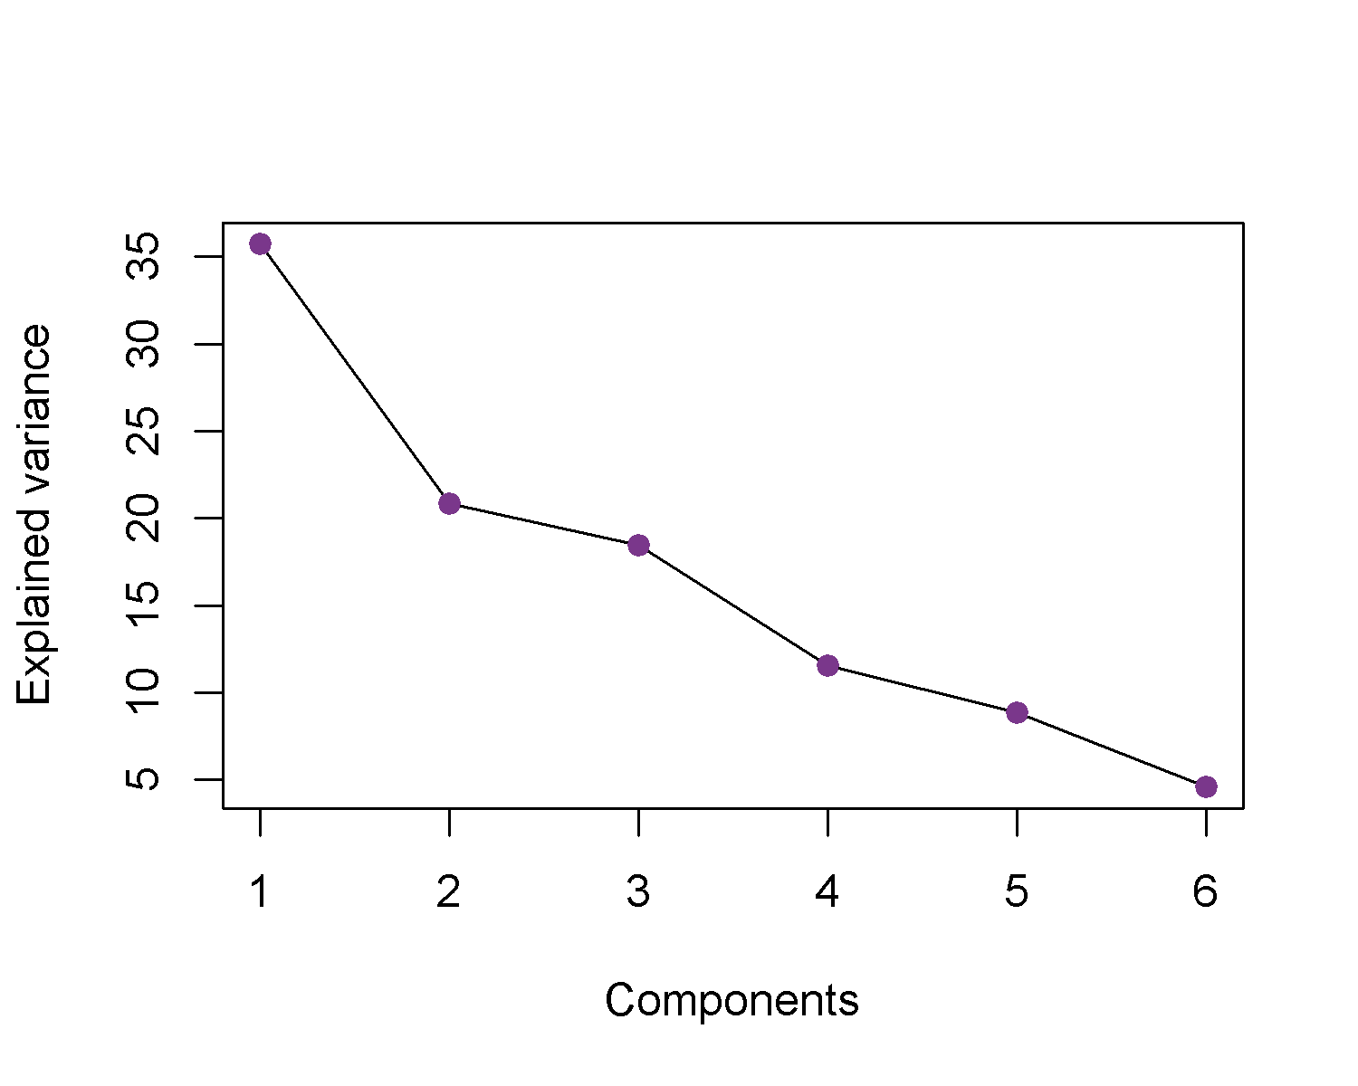

Figure 1 Scree plot of the covSTATIS compromise results.

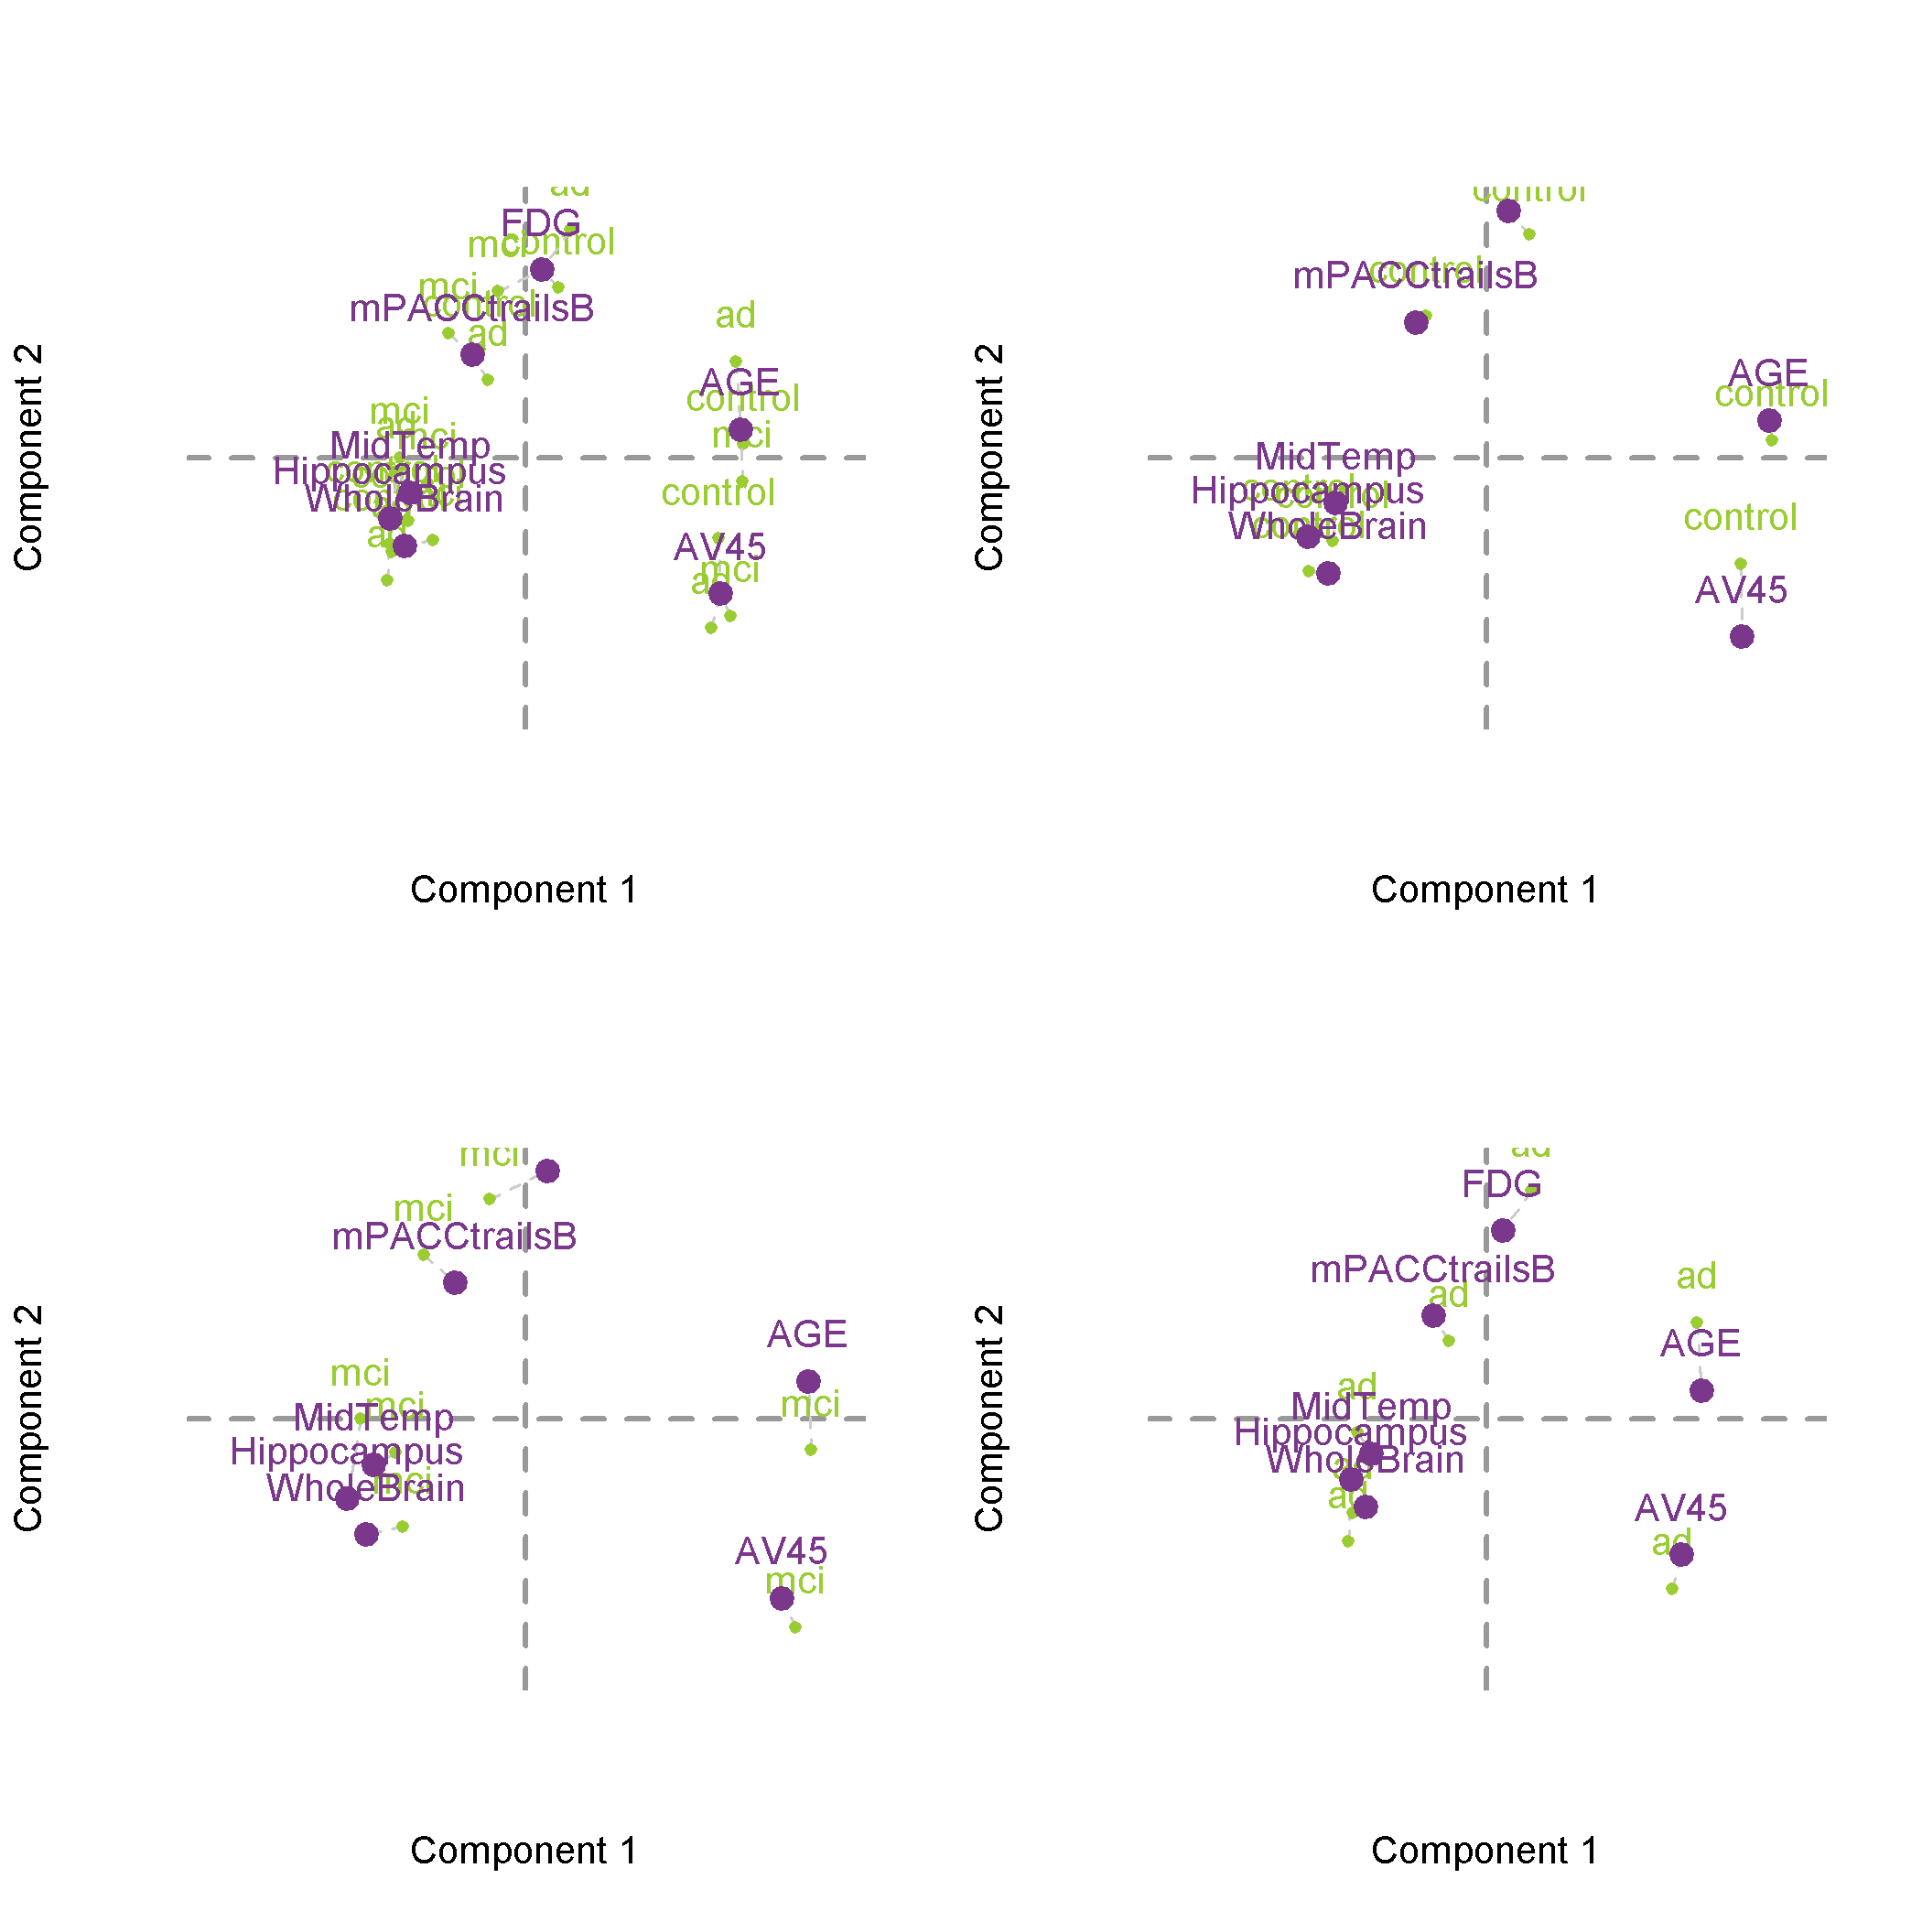

Figure 2 Component maps with the compromise (purple) and each group’s results (green) projected onto the compromise.

# Discussion

This example manuscript provides an illustrative view of how to write a reproducible paper in RMarkdown with the help of various external tools (e.g., LaTeX, Python) and R/RStudio tools. References can be included in two ways: through LaTeX bibliography files or through the use of additional R packages and Rstudio plugins, such as [citr](https://github.com/crsh/citr).

# References

Allaire, J., Ushey, K., & Tang, Y. (2018). *Reticulate: Interface to ’python’*. Retrieved from <https://CRAN.R-project.org/package=reticulate>

Auguie, B. (2017). *GridExtra: Miscellaneous functions for "grid" graphics*. Retrieved from <https://CRAN.R-project.org/package=gridExtra>

Aust, F., & Barth, M. (2018). *papaja: Create APA manuscripts with R Markdown*. Retrieved from <https://github.com/crsh/papaja>

Beaton, D. (n.d.). *GSVD: The generalized singular value decomposition*.

Beaton, D., Fatt, C. R. C., & Abdi, H. (2014a). An ExPosition of multivariate analysis with the singular value decomposition in R. *Computational Statistics & Data Analysis*, *72*(0), 176–189. <https://doi.org/10.1016/j.csda.2013.11.006>

Beaton, D., Fatt, C. R. C., & Abdi, H. (2014b). An ExPosition of multivariate analysis with the singular value decomposition in R. *Computational Statistics & Data Analysis*, *72*(0), 176–189. <https://doi.org/10.1016/j.csda.2013.11.006>

Corporation, M. (2018a). *RevoUtilsMath: Microsoft r services math utilities package*.

Corporation, M. (2018b). *RevoUtils: Microsoft r utility package*.

Henry, L., & Wickham, H. (2018). *Purrr: Functional programming tools*. Retrieved from <https://CRAN.R-project.org/package=purrr>

Kassambara, A., & Mundt, F. (2017). *Factoextra: Extract and visualize the results of multivariate data analyses*. Retrieved from <https://CRAN.R-project.org/package=factoextra>

Müller, K. (2017). *Here: A simpler way to find your files*. Retrieved from <https://CRAN.R-project.org/package=here>

Müller, K., & Wickham, H. (2018). *Tibble: Simple data frames*. Retrieved from <https://CRAN.R-project.org/package=tibble>

R Core Team. (2018). *R: A language and environment for statistical computing*. Vienna, Austria: R Foundation for Statistical Computing. Retrieved from <https://www.R-project.org/>

Rieck, J., & Beaton, D. (n.d.). *Covstatis: CovSTATIS*.

Sunderland, K., & Beaton, D. (n.d.). *Ours: OUtliers and robust structures*.

Wickham, H. (2016). *Ggplot2: Elegant graphics for data analysis*. Springer-Verlag New York. Retrieved from <http://ggplot2.org>

Wickham, H. (2017). *Tidyverse: Easily install and load the ’tidyverse’*. Retrieved from <https://CRAN.R-project.org/package=tidyverse>

Wickham, H. (2018a). *Forcats: Tools for working with categorical variables (factors)*. Retrieved from <https://CRAN.R-project.org/package=forcats>

Wickham, H. (2018b). *Stringr: Simple, consistent wrappers for common string operations*. Retrieved from <https://CRAN.R-project.org/package=stringr>

Wickham, H., François, R., Henry, L., & Müller, K. (2018). *Dplyr: A grammar of data manipulation*. Retrieved from <https://CRAN.R-project.org/package=dplyr>

Wickham, H., & Henry, L. (2018). *Tidyr: Easily tidy data with ’spread()’ and ’gather()’ functions*. Retrieved from <https://CRAN.R-project.org/package=tidyr>

Wickham, H., Hester, J., & Francois, R. (2017). *Readr: Read rectangular text data*. Retrieved from <https://CRAN.R-project.org/package=readr>

Xie, Y. (2015). *Dynamic documents with R and knitr* (2nd ed.). Boca Raton, Florida: Chapman; Hall/CRC. Retrieved from <https://yihui.name/knitr/>

Zhu, H. (2018). *KableExtra: Construct complex table with ’kable’ and pipe syntax*. Retrieved from <https://CRAN.R-project.org/package=kableExtra>