Bevel Probabilistic Selection Task Performance

## Task Information

* Total Number of Trials = 104
* Sweet taste and bitter taste were selected by participant to reflect reward & punishment

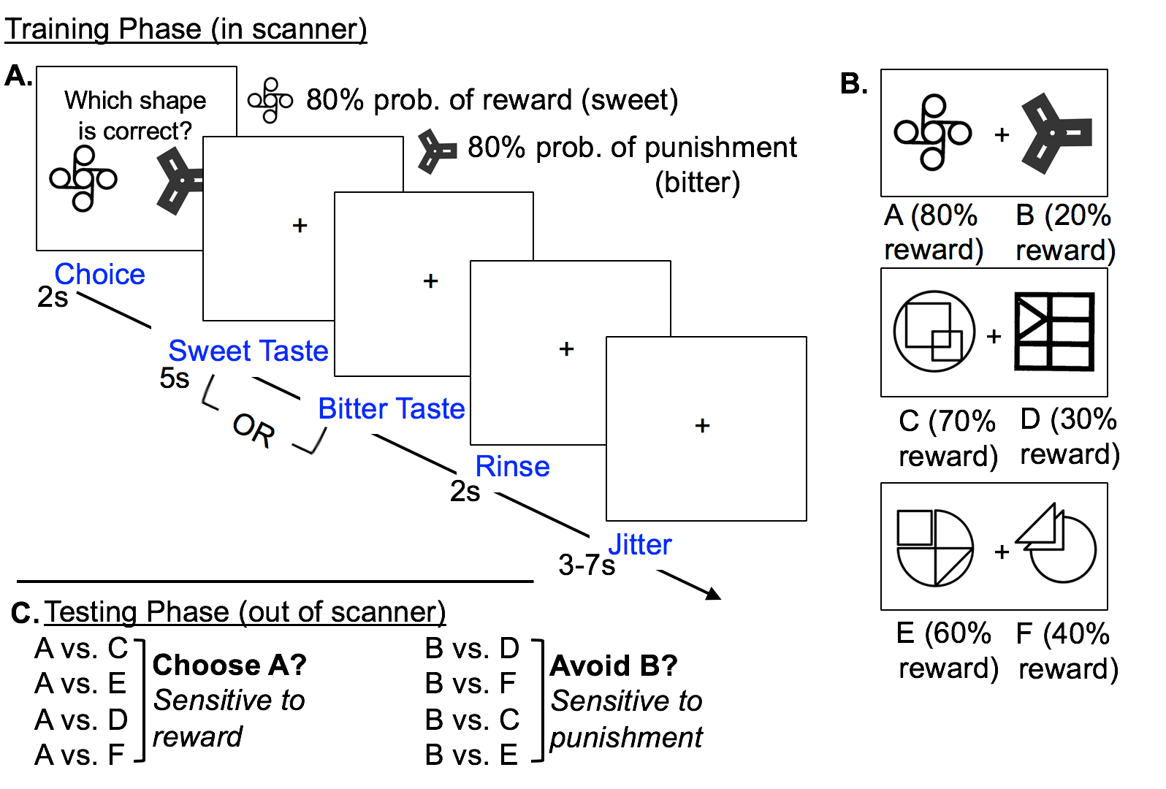

# Learning Curves for each Shape Pair

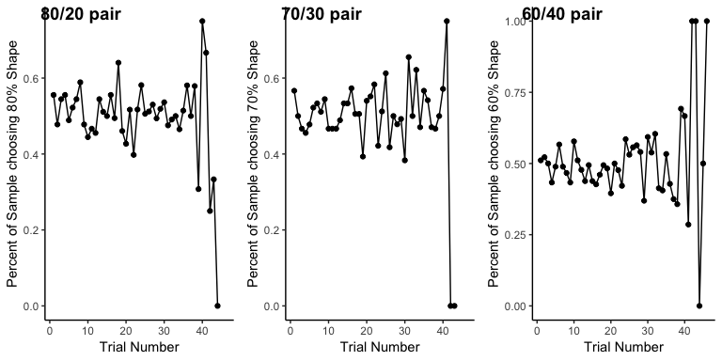

# X Axis = trial number

Y Axis = Percent of participants who chose the higher probability shape on a given trial

# Learning Curves Overlaid on Same Plot

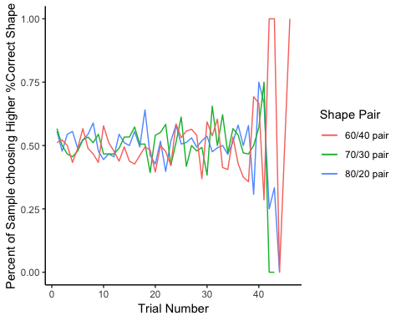

# “Heatmap” of Outcomes During Training

# 

Details

X Axis : Trials

Y Axis : Participants

Each tile represents the reinforcer received on that given trial. More green tiles later in the training would suggest learning, as participants optimize their choices.

# “Heatmap” of Choices During Training

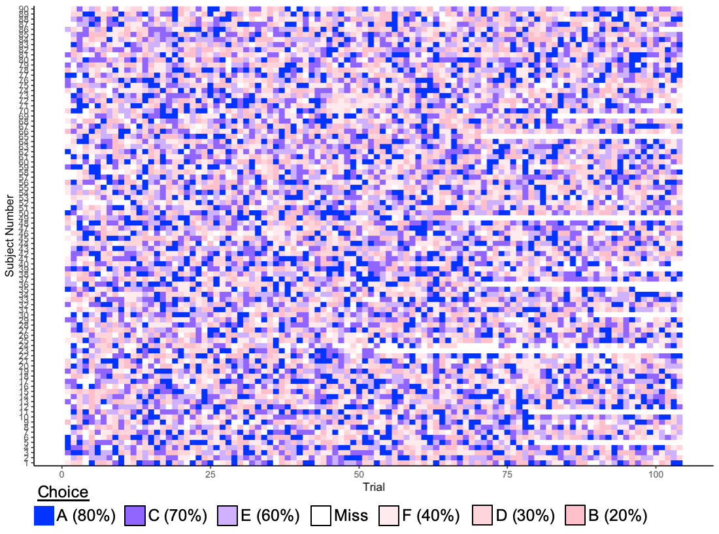

Details

X Axis : Trials

Y Axis : Participants

Each tile represents the shape the participant selected on that given trial. More blue tiles later in the training would suggest learning, as participants choose the shapes that are more likely to be rewarded.

# Groups Based on Posttest Performance

Good Posttest = Top Quartile of %Choose A on posttest (>57.9%)

Bad Posttest = Bottom Quartile of %Choose A on posttest (44.4%)

summary(data0$sensitivity_reward)

## Min. 1st Qu. Median Mean 3rd Qu. Max. NA's   
## 0.2917 0.4444 0.5000 0.5096 0.5789 0.7500 104

data0$learn[data0$sensitivity_reward < 0.444]<- "Bad Posttest"  
data0$learn[ data0$sensitivity_reward >= 0.57]<- "Good Posttest"

# Are there differences in training between posstest groups?

mytable <- xtabs(~choice+learn, data=data0)  
ftable(mytable) # print table

## learn didn't learn maybe learn ok pretty good  
## choice   
## A 362 248 417 460  
## B 331 242 420 441  
## C 359 236 401 425  
## D 353 240 413 377  
## E 332 224 410 407  
## F 358 270 384 418  
## Miss 116 81 164 115

summary(mytable) # chi-square test of indepedence

## Call: xtabs(formula = ~choice + learn, data = data0)  
## Number of cases in table: 9004   
## Number of factors: 2   
## Test for independence of all factors:  
## Chisq = 23.464, df = 18, p-value = 0.1734

mytable <- xtabs(~outcome+learn, data=data0)  
ftable(mytable) # print table

## learn didn't learn maybe learn ok pretty good  
## outcome   
## Miss 116 81 164 115  
## punish 1032 717 1218 1227  
## reward 1063 743 1227 1301

summary(mytable) # chi-square test of indepedence

## Call: xtabs(formula = ~outcome + learn, data = data0)  
## Number of cases in table: 9004   
## Number of factors: 2   
## Test for independence of all factors:  
## Chisq = 10.656, df = 6, p-value = 0.09961

mytable <- xtabs(~congruent+learn, data=data0)  
ftable(mytable) # print table

## learn didn't learn maybe learn ok pretty good  
## congruent   
## matched 1489 997 1734 1777  
## mismatched 606 463 711 751  
## Miss 116 81 164 115

summary(mytable) # chi-square test of indepedence

## Call: xtabs(formula = ~congruent + learn, data = data0)  
## Number of cases in table: 9004   
## Number of factors: 2   
## Test for independence of all factors:  
## Chisq = 13.713, df = 6, p-value = 0.03301

# There is a difference between the number of mismatched trials in the “learners” and “non-learners.” Those who “don’t learn” have more mismatches.

# “Heatmap” of Outcomes During Training by Posttest Performance

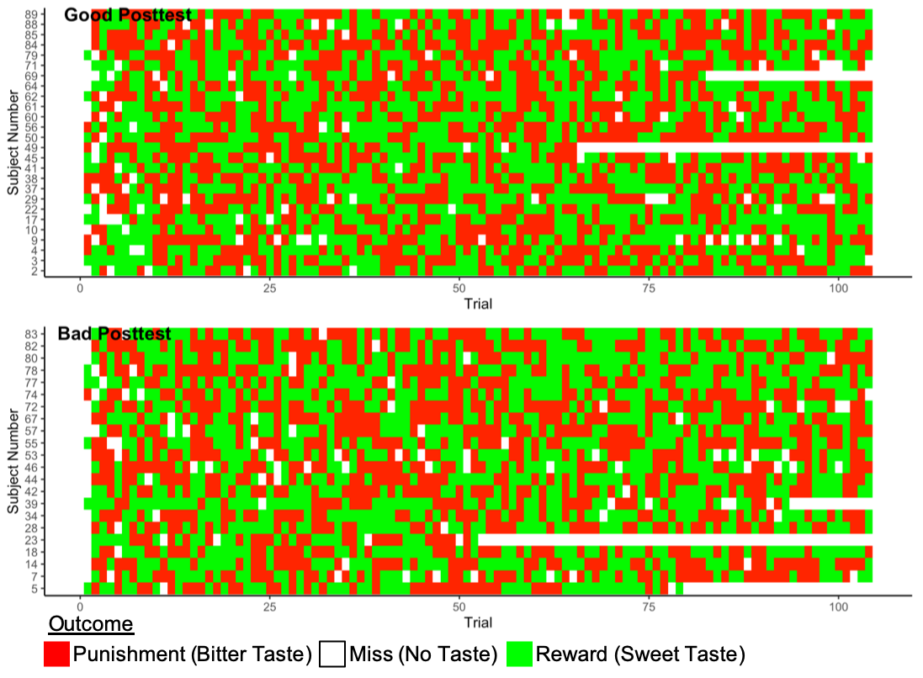

Details

X Axis : Trials

Y Axis : Participants

Each tile represents the reinforcer received on that given trial. More green tiles later in the training would suggest learning, as participants optimize their choices. Differences between the groups would possibly explain posttest difference.

# “Heatmap” of Choice During Training by Posttest Performance

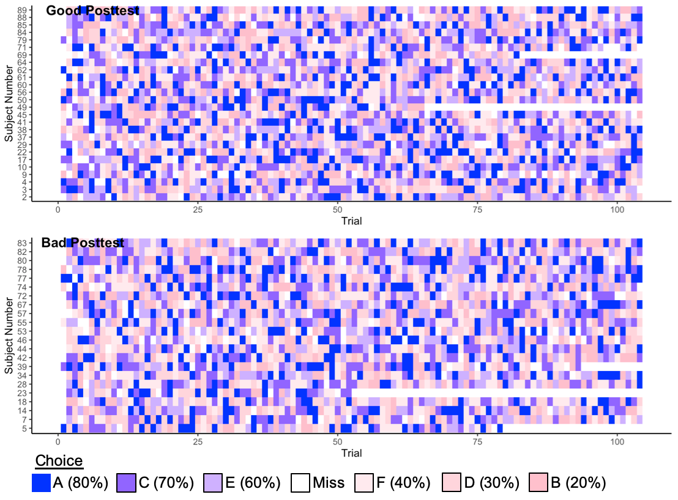

Details

X Axis : Trials

Y Axis : Participants

Each tile represents the shape the participant selected on that given trial. More blue tiles later in the training would suggest learning, as participants choose the shapes that are more likely to be rewarded. Differences between the groups would possibly explain posttest difference.