Bevel Probabilistic Selection Task Performance

## Task Information

# Total Number of Trials = 104

# Sweet taste and bitter taste was selected by participant to reflect reward & punishment

# 

# 

## Warning: package 'ggpubr' was built under R version 3.5.2

# Learning Curves for each Shape Pair

all_plot<-ggarrange(plot1, plot2, plot3,   
 labels = c("80/20 pair", "70/30 pair", "60/40 pair"),   
 ncol = 3, nrow = 1)

## Warning: Removed 2 rows containing missing values (geom_path).

## Warning: Removed 2 rows containing missing values (geom_point).

## Warning: Removed 3 rows containing missing values (geom_path).

## Warning: Removed 3 rows containing missing values (geom_point).

all_plot

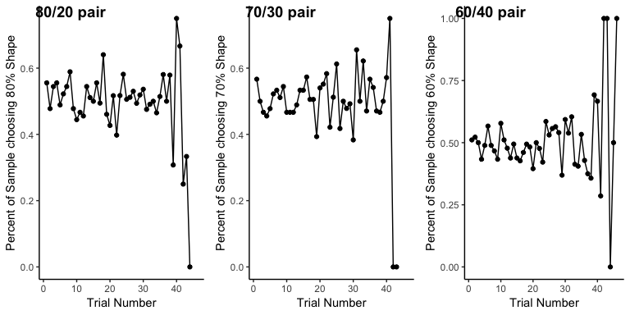

# Learning Curves Together

plot4

## Warning: Removed 2 rows containing missing values (geom_path).

## Warning: Removed 3 rows containing missing values (geom_path).

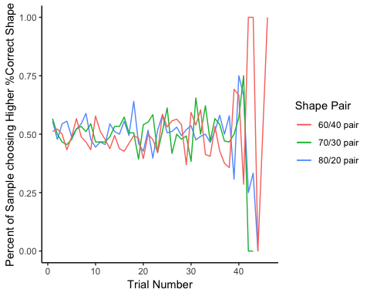

# Begin Processing Graphs for Each Participant

## Warning: package 'data.table' was built under R version 3.5.2

# Plot “Heatmaps” of Outcomes During Training

mydata$outcome0[mydata$outcome == "Miss"] <- 0

## Warning: Unknown or uninitialised column: 'outcome0'.

mydata$outcome0[mydata$outcome == "punish"] <- -10  
mydata$outcome0[mydata$outcome == "reward"] <- 10  
  
hmTOTAL<-ggplot(mydata,aes(as.numeric(Count), as.factor(sub_num) , fill=outcome0))+  
 geom_tile()+  
 scale_fill_gradient2(low="red", high="green", na.value="black", name="")+  
 theme_classic()+ xlab(label = "Trial") + ylab(label= 'Subject Number')+  
 guides(fill=guide_legend(title='Outcome'))  
 #geom_point(aes(shape=as.factor(choice), size=1, color=as.factor(choice)))

# Plot “Heatmaps” of Outcomes During Training

## -10 (red) = punishment (bitter taste)

## 0 (white) = missed press (no taste)

## 10 (green) = reward (sweet taste)

hmTOTAL

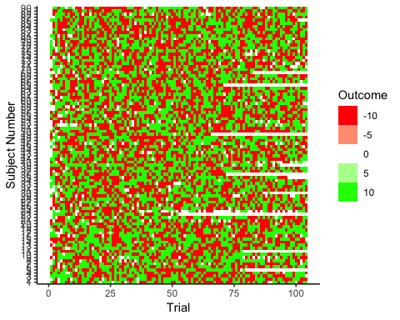

Overlay with Shape Selected & Outcome

hmTOTAL1

## Warning: The shape palette can deal with a maximum of 6 discrete values  
## because more than 6 becomes difficult to discriminate; you have 7.  
## Consider specifying shapes manually if you must have them.

## Warning: Removed 482 rows containing missing values (geom_point).

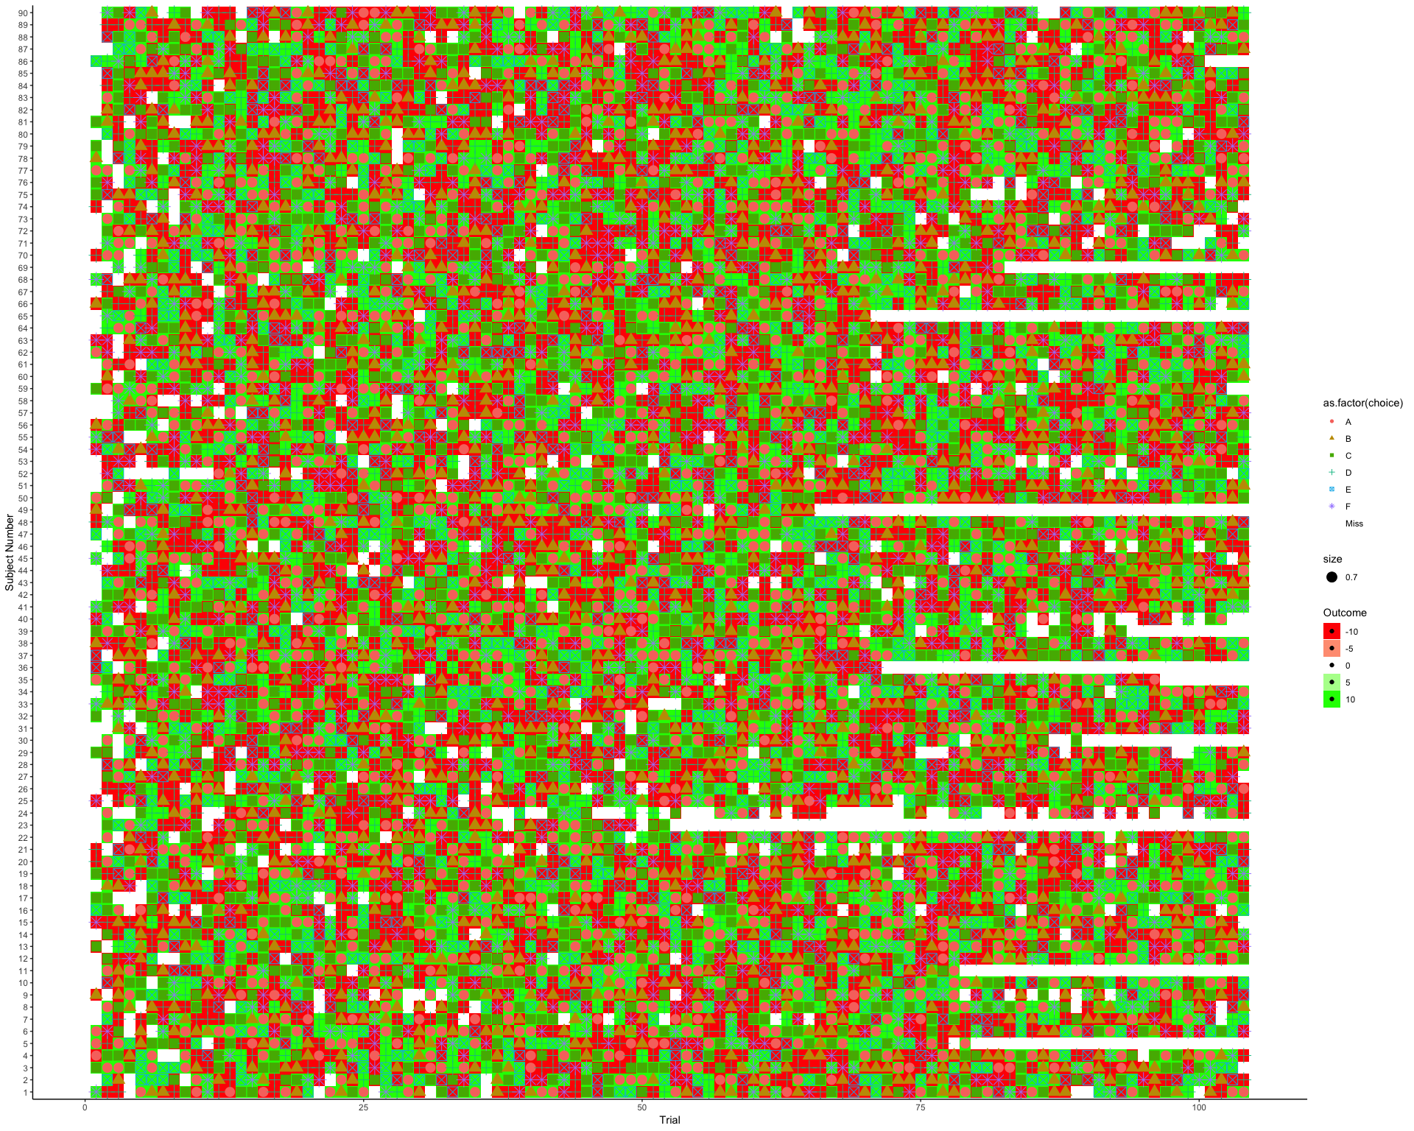

# Split Into Groups Based on Posttest Performance

summary(data0$sensitivity_reward)

## Min. 1st Qu. Median Mean 3rd Qu. Max. NA's   
## 0.2917 0.4444 0.5000 0.5096 0.5789 0.7500 104

data0$learn[data0$sensitivity_reward < 0.444]<- "didn't learn"  
data0$learn[data0$sensitivity_reward >= 0.444 & data0$sensitivity_reward < 0.5 ]<- "maybe learn"  
data0$learn[ data0$sensitivity_reward >= 0.5 & data0$sensitivity_reward < 0.57 ]<- "ok"  
data0$learn[ data0$sensitivity_reward >= 0.57]<- "pretty good"  
summary(as.factor(data0$learn))

## didn't learn maybe learn ok pretty good NA's   
## 2211 1541 2609 2643 104

hmTOTALgood<-ggplot(subset(data0, learn == "pretty good"),aes(as.numeric(Count), as.factor(sub_num) ,fill=outcome0))+  
 geom_tile()+  
 scale_fill_gradient2(low="red", high="green", na.value="black", name="") +  
 theme_classic()+ xlab(label = "Trial") + ylab(label= 'Subject Number') +  
 guides(fill=guide_legend(title='Outcome'))   
 #geom_point(aes(shape=as.factor(choice), size=1, color=as.factor(choice)))  
#hmTOTALgood  
  
  
hmTOTALbad<-ggplot(subset(data0, learn == "didn't learn"),aes(as.numeric(Count), as.factor(sub_num) ,fill=outcome0))+  
 geom_tile()+  
 scale_fill_gradient2(low="red", high="green", na.value="black", name="") +  
 theme_classic()+ xlab(label = "Trial") + ylab(label= 'Subject Number') +  
 guides(fill=guide_legend(title='Outcome'))   
 #geom_point(aes(shape=as.factor(choice), size=1, color=as.factor(choice)))  
#hmTOTALbad  
  
test1<-ggarrange(hmTOTALgood,hmTOTALbad,   
 labels = c("Good Posttest", "Bad Posttest"),   
 ncol = 1, nrow = 2)

# Split Into Groups Based on Posttest Performance

test1

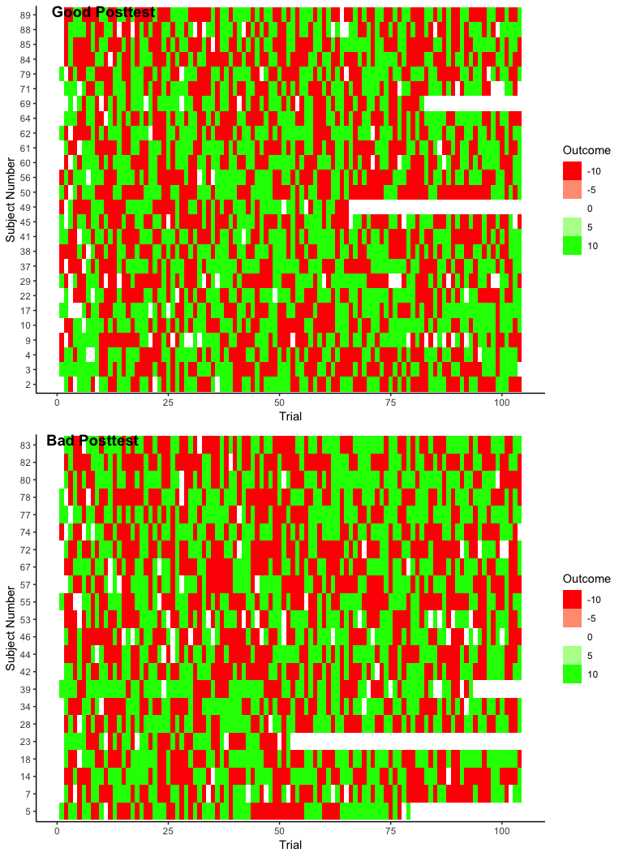

# Plot “Heatmaps” of Choices During Training

## -30 (pink) = Choose F (40% correct)

## -20 (mid pink) = Choose D (30% correct)

## -10 (light pink) = Choose B (20% correct)

## 0 (white) = missed press (no choice)

## 10 (light blue) = Choose E (60% correct)

## 20 (mid blue) = Choose C (70% correct)

## 30 (blue) = Choose A (80% correct)

test2

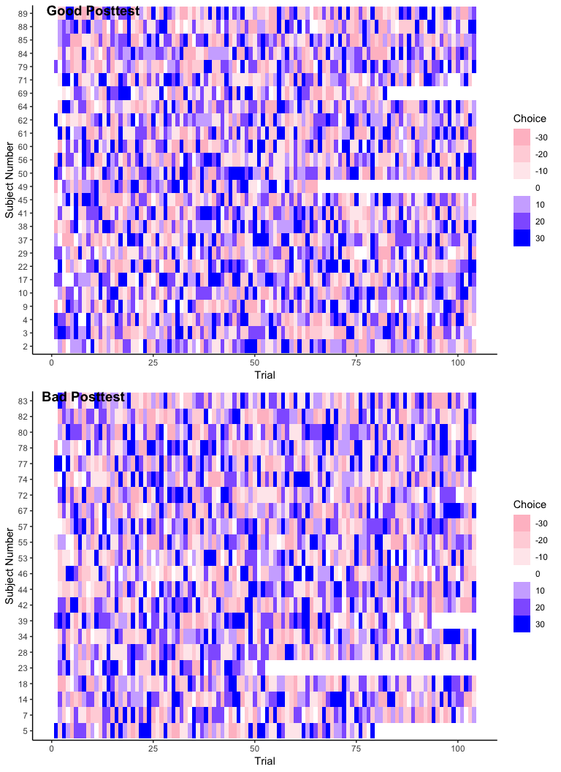

# Are there differences in training between posstest groups?

mytable <- xtabs(~choice+learn, data=data0)  
ftable(mytable) # print table

## learn didn't learn maybe learn ok pretty good  
## choice   
## A 362 248 417 460  
## B 331 242 420 441  
## C 359 236 401 425  
## D 353 240 413 377  
## E 332 224 410 407  
## F 358 270 384 418  
## Miss 116 81 164 115

summary(mytable) # chi-square test of indepedence

## Call: xtabs(formula = ~choice + learn, data = data0)  
## Number of cases in table: 9004   
## Number of factors: 2   
## Test for independence of all factors:  
## Chisq = 23.464, df = 18, p-value = 0.1734

mytable <- xtabs(~outcome+learn, data=data0)  
ftable(mytable) # print table

## learn didn't learn maybe learn ok pretty good  
## outcome   
## Miss 116 81 164 115  
## punish 1032 717 1218 1227  
## reward 1063 743 1227 1301

summary(mytable) # chi-square test of indepedence

## Call: xtabs(formula = ~outcome + learn, data = data0)  
## Number of cases in table: 9004   
## Number of factors: 2   
## Test for independence of all factors:  
## Chisq = 10.656, df = 6, p-value = 0.09961

mytable <- xtabs(~congruent+learn, data=data0)  
ftable(mytable) # print table

## learn didn't learn maybe learn ok pretty good  
## congruent   
## matched 1489 997 1734 1777  
## mismatched 606 463 711 751  
## Miss 116 81 164 115

summary(mytable) # chi-square test of indepedence

## Call: xtabs(formula = ~congruent + learn, data = data0)  
## Number of cases in table: 9004   
## Number of factors: 2   
## Test for independence of all factors:  
## Chisq = 13.713, df = 6, p-value = 0.03301

# Ah ha moment

# There is a difference between the number of mismatched trials in the “learners” and “non learners.” Those who “don’t learn” have more mismatches.