Troubleshooting of DARLA-Ground Station
JuHyeong (Jenny) Seon
Saint Louis University
Advisor : Michael Swartwout, Ph.D.
Abstract
This report presents the troubleshooting efforts conducted during the Summer 2025 internship at Saint Louis University’s Space Systems Research Laboratory (SSRL), funded by the NASA Missouri Space Grant Consortium. The primary objective of the project was to establish reliable uplink and downlink communication between the SLU ground station’s UHF radio system and DARLA, a CubeSat mission in its final mission phase. The troubleshooting process began with the migration of the ground station software environment to a new computer, during which multiple configuration errors were encountered, including attribute errors in the ARES software and missing FPGA image files for the BladeRF software-defined radio (SDR). These issues were resolved through reinstallation of proper firmware and file migration from the original ground station hardware. Subsequently, version mismatches in the DARLAUI.py interface software were identified and corrected, enabling initial communication between DARLA and the ground station. Further testing revealed a persistent carrier signal interference issue that exceeded the ground station’s desired signal strength. Hardware-based solutions, including a MATLAB-designed hairpin bandpass filter implemented in GNU Radio also proved insufficient. Ultimately, replacing the BladeRF transmitter with a HackRF One SDR eliminated the carrier signal, suggesting that simultaneous transmit and receive operations on the BladeRF were generating unintended noise. Additionally, an unexpected power system anomaly was discovered, in which DARLA exhibited a repeating brownout cycle during battery charging. As of the conclusion of this internship, both the communication and power system issues remain under active investigation, with several candidate solutions identified for future work.
Introduction
The Space Systems Research Laboratory (SSRL) at Saint Louis University (SLU) operates a ground station responsible for communicating with DARLA, a CubeSat mission in its final operational phase. During the Summer 2025 internship period, funded by the NASA Missouri Space Grant Consortium, the primary objective was to establish and verify reliable uplink and downlink communication between the SLU ground station's UHF radio system and DARLA. As DARLA was in its final mission phase, the scope of work centered primarily on troubleshooting existing issues rather than developing new systems. This report documents the sequence of problems encountered, the methods used to diagnose and address each issue, and the status of outstanding work.
Ground Station Basic Setup
The first task required migrating the ground station software environment to a new computer, as the previous machine had developed hardware faults. The migration involved reinstalling DARLAUI.py, the Python-based interface responsible for configuring the software-defined radio (SDR) and managing communication links, as well as the Artificial Reasoning for Exploration and Space (ARES) software suite. During the reinstallation of ARES, an attribute error was encountered upon execution. The likely cause was a version mismatch between the C++ build components and the associated Python bindings used by ARES. Given that more than ten modules were found to be incompatible, a full dependency resolution was deemed impractical. As an alternative, all files and configurations were copied directly from the original ground station’s hard drive to the new machine. This approach successfully reproduced the working software environment and allowed the migration to proceed.
Initial Ground Station Testing
Following the software migration, initial testing of the ground station was conducted by executing DARLAUI.py and verifying that the SDR could send and receive signals at the designated UHF frequency. During this process, two additional errors were encountered. The first error was a missing FPGA image file, and the other error was an undefined symbol error. Both associated with the BladeRF SDR hardware. These errors were resolved by downloading and installing the appropriate FPGA firmware images from the Nuand website and completing the BladeRF configuration process. A separate mismatch issue within GNU Radio, an open-source software toolkit used for signal processing and software-defined radio implementation, was also identified at this stage. As this issue did not prevent the ground station from transmitting signals, it was noted for future resolution and not addressed immediately.
Communication Testing Between DARLA and the Ground Station
To verify two-way communication, DARLA and the ground station were operated simultaneously within the same room. Initial testing revealed that no uplink or downlink was being established between the two systems. Investigation identified the cause as the use of an incorrect version of DARLAUI.py. Multiple versions of the file existed due to iterative revisions made over the course of prior development cycles, and the version in use was incompatible with DARLA’s current software configuration. Upon selecting the correct version, communication between DARLA and the ground station was successfully established.
Full Ground Station Setup Testing
Following the successful bench test, a more complete test was conducted using the full ground station configuration, including the rooftop antenna and all hardware components intended for operational use. Prior to testing, it was discovered that the amplifier wiring configuration, established during the Summer 2024 setup, was incorrect and was not receiving sufficient power to operate. An RCA connector was implemented as a solution to manually control power delivery to the amplifier. However, thermal testing revealed that the amplifier reached elevated temperatures after approximately ten minutes of operation. Automated thermal management for the amplifier was identified as a necessary area of future work.
Carrier Signal Interference
During full ground station testing, a significant carrier signal was detected at a magnitude exceeding that of the ground station's intended transmission signal. While this issue did not affect bench-level testing due to the proximity of DARLA to the ground station, it was identified as a critical problem for on-orbit operations, where the elevated carrier signal could interfere with other satellites or disrupt DARLA's own receiver.Troubleshooting was conducted in parallel on both the hardware and software sides. On the hardware side, a hairpin bandpass filter was designed using MATLAB's RF toolbox. However, the mission's strict frequency constraints, specifically the extremely narrow required bandwidth and the high signal magnitude differential, made physical fabrication of the filter infeasible within the laboratory's capabilities.Software-based filtering was then attempted by implementing a bandpass filter within GNU Radio. This approach also proved insufficient to meet the required attenuation specifications. Adjustments to gain parameters within DARLAUI.py were explored as well, but while these changes shifted the carrier signal frequency slightly, the signal remained within a range that posed a risk of future interference.To determine whether the BladeRF SDR itself was the source of the carrier signal, a trade study was conducted to evaluate alternative SDR platforms. Two candidates were considered under DARLA's mission constraints. The first was a Raspberry Pi paired with an RPiT Hat, which was disqualified due to indeterminate timing behavior in message transmission and reception. The second candidate was the HackRF One, a half-duplex SDR transceiver compatible with GNU Radio. As the HackRF One was the only viable alternative, it was procured for testing. Upon replacing the BladeRF on the transmit side with the HackRF One, the carrier signal was eliminated. This result indicated that using the BladeRF for simultaneous transmission and reception, despite its full-duplex design specification, was generating unintended noise or spurious signals on the transmit output.
DARLA Communication Failure
Following the resolution of the carrier signal issue, a final communication test was initiated. During this test, DARLA ceased transmitting entirely. Standard diagnostic procedures were performed, including restarting the DARLA software and clearing cached data, but the system did not resume communication. Although the onboard software appeared to be executing normally and transmission commands were being issued, all received messages were blank. The software subsystem team conducted additional debugging and code review, but DARLA remained unresponsive. As a final diagnostic step, one panel of the DARLA chassis was disassembled to allow physical inspection of the UHF transceiver hardware. The findings from this inspection and subsequent steps remain part of ongoing investigation.
Power System Troubleshooting
Following the communication troubleshooting efforts, an unexpected anomaly was discovered in DARLA's power system. During preparations for further testing, DARLA exhibited unstable power behavior and irregular charging characteristics. The team attempted to charge DARLA using multiple light sources, including LED grow lights, halogen work lamps rated at 600 W, and direct natural sunlight. Under all conditions, the battery voltage was observed to rise gradually to approximately 6.39 V. Upon reaching this threshold, DARLA initiated a boot sequence, which caused an immediate voltage drop, a condition known as a brownout. Following the brownout, the voltage stabilized between approximately 6.2 V and 6.3 V before gradually rising again, repeating the cycle continuously.The initial hypothesis was that the light sources were providing insufficient charging power. However, the use of higher-wattage halogen lamps and direct sunlight did not meaningfully accelerate the charging rate, suggesting that light source intensity was not the primary limiting factor. A second hypothesis proposed that the external charging circuit had been damaged, potentially due to a prior short circuit on the charge pin as indicated by feedback from NanoAvionics. It was noted, however, that the solar panel charging pathway was likely still functional, indicating the issue was not solely attributable to hardware failure in the charging circuit.Further analysis suggested that the Electrical Power System (EPS) was contributing to the observed behavior. It appeared that at approximately 6.4 V, the EPS activated the spacecraft's systems, creating a sudden and substantial increase in power demand that the incoming charge current could not sustain, thereby triggering a brownout. A ratcheting voltage pattern was also observed, in which the voltage incrementally increased, partially dropped, and then increased again. This pattern suggested that the Maximum Power Point Tracking (MPPT) system was attempting to regulate the charging process but was unable to provide sufficient power to support system startup.Several candidate solutions were identified. One approach involved extending the charging duration to allow the battery to accumulate sufficient charge to sustain the boot sequence. A second approach involved increasing effective power input by combining multiple light sources or using reflective surfaces to concentrate light on the solar panels. A third approach proposed using an external power supply to simulate solar panel input under controlled conditions. More invasive options were also discussed, including direct battery charging by bypassing the EPS, and reconfiguring the EPS turn-on voltage threshold. These approaches were recognized as carrying potential risk to the system and would require careful evaluation before implementation.
Conclusion
The Summer 2025 internship at SSRL focused on troubleshooting the communication system between the SLU ground station and DARLA, a CubeSat mission in its final operational phase. Over the course of the internship, several critical issues were identified and resolved. The ground station software environment was successfully migrated to a new computer, BladeRF firmware configuration errors were corrected, and version incompatibilities in DARLAUI.py were identified and addressed, enabling initial two-way communication between the ground station and DARLA. Most significantly, a persistent carrier signal interference issue was resolved by replacing the BladeRF on the transmit side with a HackRF One SDR, indicating that simultaneous transmit and receive operations on the BladeRF were generating unintended spurious signals.
However, three issues remained unresolved at the conclusion of the internship. First, DARLA ceased transmitting entirely during final communication testing, returning only blank messages despite the onboard software appearing to execute normally. Physical inspection of the UHF transceiver was initiated but not yet completed. Second, an unexpected power system anomaly was discovered in which DARLA exhibited a repeating brownout cycle during battery charging, preventing the system from sustaining power through the boot sequence. Third, automated thermal management for the ground station amplifier had not yet been implemented. Future work will focus on completing the UHF transceiver inspection, resolving the EPS power threshold behavior, and implementing an automated power control solution for the amplifier in order to support a fully verified communication test prior to DARLA’s launch.
Acknowledgements
The author would like to thank Dr.Michael Swartwout for his guidance and support throughout this research. The author would also like to thank Kaya Bain for her collaboration and contributions as Communications Lead during the summer troubleshooting efforts. This work was funded by the NASA Missouri Space Grant Consortium through NASA Cooperative Agreement #80NSSC20M0100.
Biography
JuHyeong (Jenny) Seon is a junior pursuing a Bachelor of Science in Aerospace Engineering at Saint Louis University, originally from Gwangju, South Korea. She maintains a GPA of 3.8/4.0 and currently serves as the Communication Subsystem co-Lead at. The Space Systems Research Laboratory (SSRL), where she oversees UHF ground station operations and leads the development of a new S-Band ground station. During the Summer 2025 internship period, she conducted the troubleshooting efforts described in this report as part of her work supporting the DARLA CubeSat mission. Her academic and research interests lie in spacecraft systems and orbital mechanics, and she aspires to pursue a Ph.D. with a focus in orbital mechanics following the completion of her undergraduate degree.
Appendix
filter = filterCombline
show(filter)
N = 3;
Ripple = 0.01;
BandWidth = 50;
Z0 = 50;
f = linspace(4e8, 4.8e8,400);
%%EpsilonR = 6.15;
Height = 1.27e-3;

filter.FilterOrder = 11

filter.Substrate = dielectric("teflon")
filter.Conductor = metal("copper")
filter.ResonatorLength = [120e-3,100e-3,120e-3,100e-3,120e-3,100e-3,120e-3,100e-3,120e-3,100e-3,120e-3]
% filter.ResonatorLength = [96e-3, 136e-3,96e-3, 120e-3,96e-3, 136e-3, 96e-3,]%106e-3,106e-3,106e-3, 106e-3]
filter.GroundPlaneWidth = 140e-3
filter.FeedOffset = 45e-3
filter.ResonatorSpacing = 10e-6

show(filter)

spar = sparameters(filter,f);
figure;
rfplot(spar);

Figure 1. MATLAB code for hairpin bandpass filter. This code implements a hairpin bandpass filter using MATLAB’s RF Toolbox to attenuate out-of-band carrier interference observed in the ground station.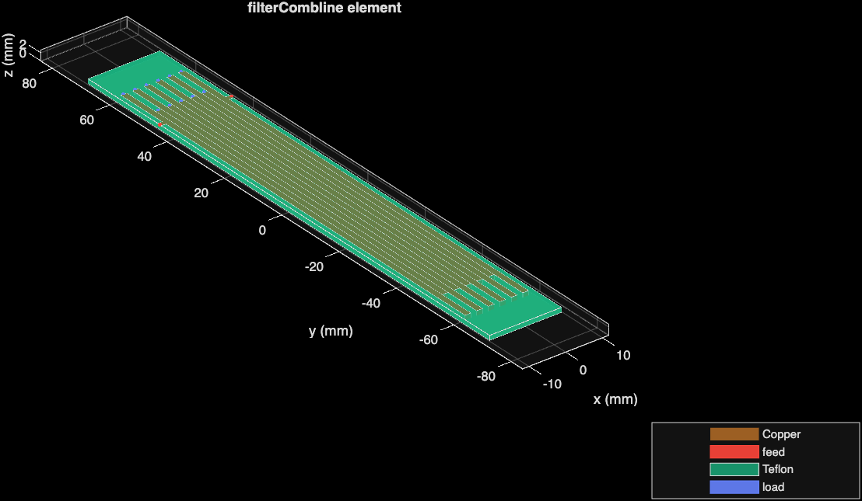
Figure 2. Example image for hairpin bandpass filter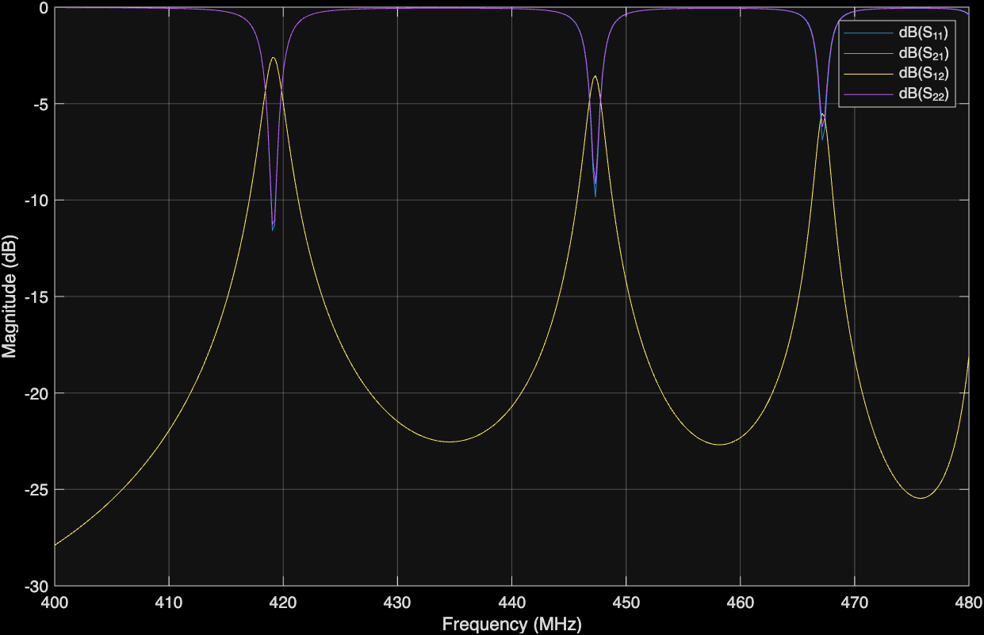
Figure 3: Example Image for filtering effect of hairpin bandpass filter

