**Prof. Zoltán Kutalik**   
 University Center for Primary Care and Public Health  
 University of Lausanne   
 Switzerland

Lausanne, XX April 2022

Dear Editor,

We would be grateful if you could consider the enclosed manuscript, entitled “***The contribution of mate-choice, couple convergence and confounding to assortative mating”*** for publication as an Article in *Nature Human Behaviour*.

Many studies have consistently shown that romantic partners tend to have increased phenotypic similarity compared to random pairs. This phenomenon is known as assortative mating and has been observed across a wide variety of traits, including physical, behavioural, sociocultural, and disease-related traits. These observations may be due to several factors: (1) direct mate-choice for partners who are more similar to oneself, (2) partner convergence overtime due to partner influence, interaction or shared environment, and (3) confounding factors such as sociocultural or geographical barriers resulting in non-random mate-choice. However, dissecting these components is not a trivial task, and requires distinguishing confounding from causation. While previous studies have identified a genetic basis for AM and suggested the presence of indirect genetic effects across couples, to our knowledge no study has sought to examine the direct-causality between partners at a phenome-wide level.

In this report, we sought to disentangle these components by investigating causal effects among couples using Mendelian randomisation (MR). While MR has gained widespread recognition as a reliable approach to identify causal relationships from an exposure to outcome using observational, genetic data, here we propose to extend its typic scope to investigate causal effects between individuals (i.e. couples), where the exposure and outcome occur in different individuals. By applying this technique to a large panel of 118 phenotypes in 51,664 couples of European descent, we were able to identify widespread causal effects between couples (64 of the 118 tested traits showed evidence of causality after adjustment for multiple tests), and that these effects were strong female-to-male compared to male-to-female. We also found significant evidence for confounding factors involved phenotypic similarity observations among couples. Indeed, 43 of the 118 traits showed discrepant phenotypic correlation from causal effects. Our approach also allowed us to identify many potential confounders for these relationships (22.56 on average). Notably, education and income were found to be important confounders across all 118 traits tested, on average explaining 29.8 and 11.6% of phenotypic correlations, respectively. Finally, extending our approach to two-traits revealed many cross-trait causal effects (1088), and follow-up analyses suggest that these observations are primarily due to the combination of AM occurring in a single trait and the presence of a causal effect (in one individual) between the traits, rather than a direct effect from an exposure in one partner, to an outcome in the other.

In the light if these discoveries, we hope that the manuscript is of interest to the broad leadership of *Nature Human Behaviour.* We suggest XX, XX and XX as reviewers for this manuscript.

Yours sincerely,

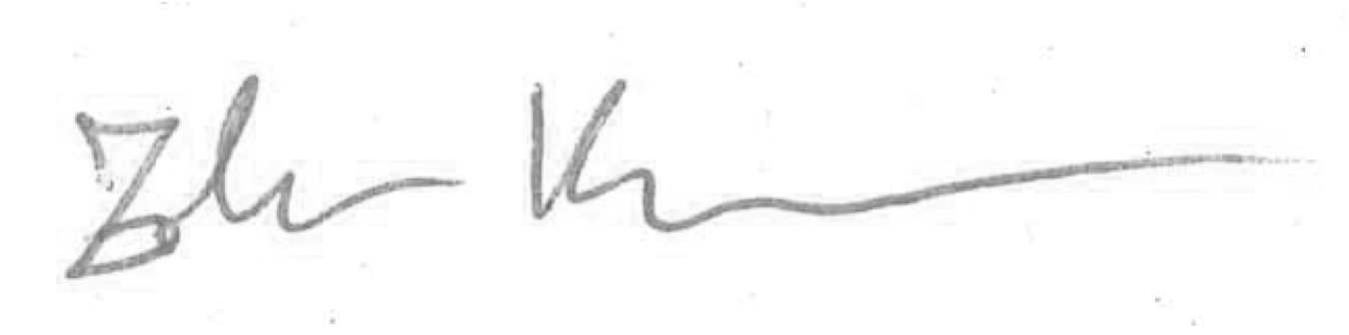

Zoltán Kutalik

PS - We confirm that all the authors have approved this manuscript and agree with its submission.