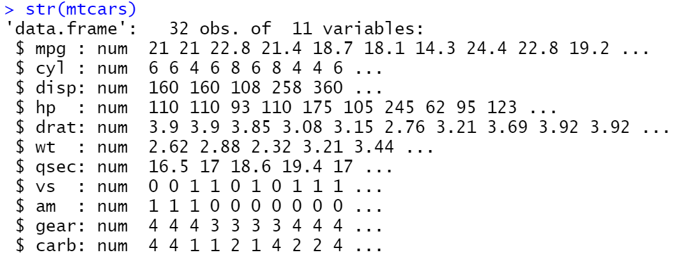

**data types**

**columns**

**values**