# Environment Setup

1. Download Anaconda 5.0.1 For Windows Installer from <https://www.anaconda.com/download/> .
2. select

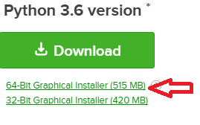

1. Install it to c:\anaconda folder. Select add conda to windows PATH.

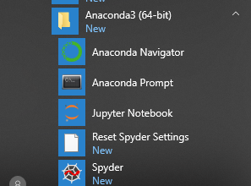

1. Once installed, try out by opening Anaconda prompt. Type conda list. A list of libraries will appear.

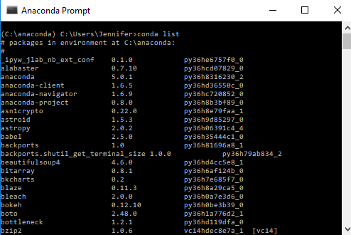

<https://conda.io/docs/user-guide/getting-started.html>

<https://docs.anaconda.com/anaconda/user-guide/>

1. Install pandas-datareader package:

<https://anaconda.org/anaconda/pandas-datareader>

To install this package with conda run:  
conda install -c anaconda pandas-datareader

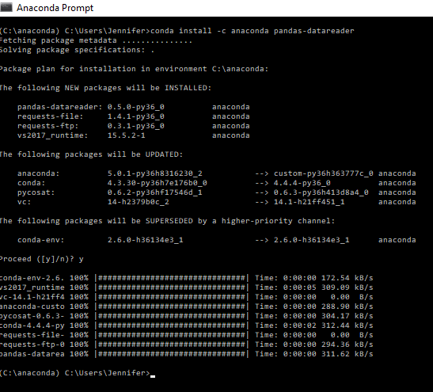

# Use Jupyter Notebook

1. launch Jupyter Notebook.
2. Click New and select Python 3.
3. Type up code and click File🡪download as .py. Example, I saved test1.py.
4. To run code in Jupyter Notebook, Shift+Enter.

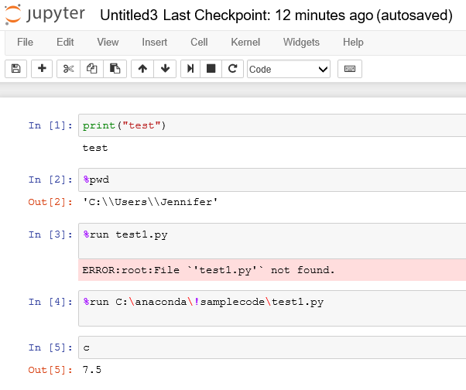

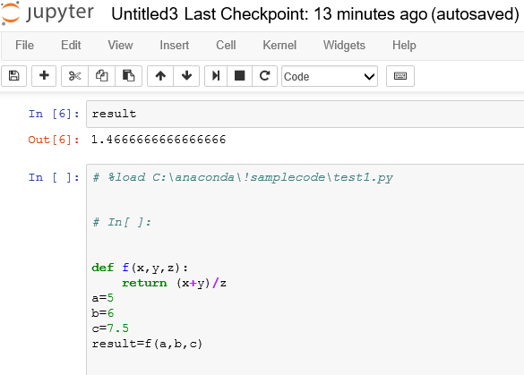

# Use numpy and matplotlib

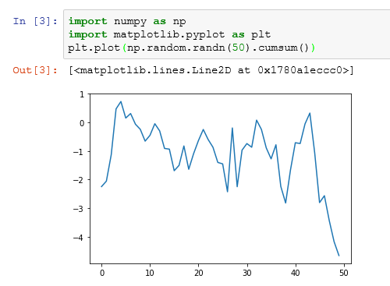

# Reading a CSV file using pandas

Pay attention to the file directive.

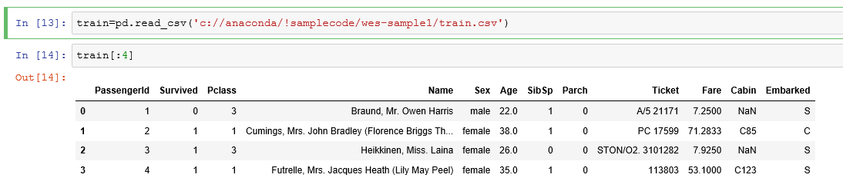

Time Series Data Basics with Pandas Part 1: Rolling Mean, Regression, and Plotting

<https://www.youtube.com/watch?v=OwnaUVt6VVE>

<https://github.com/mGalarnyk/Python_Tutorials/blob/master/Time_Series/Part1_Time_Series_Data_BasicPlotting.ipynb>

# How to find methods and functions in a module?

* module.<tab> will show you all objects defined in the module (functions, classes and so on)
* module.ClassX.<tab> will show you the methods and attributes of a class
* module.function_xy? or module.ClassX.method_xy? will show you the docstring of that function / method
* module.function_x?? or module.SomeClass.method_xy?? will show you the source code of the function / method.

Example: to see what’s in requests module, type .<tab>

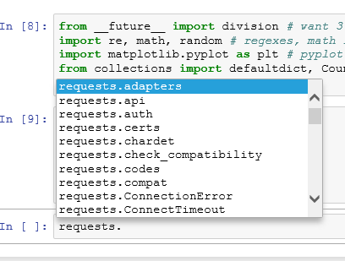

Type help(requests) will show all kinds of info.

Type dir(requests) will show a list of methods.

# Pyplot tutorial

<https://matplotlib.org/tutorials/introductory/pyplot.html#sphx-glr-tutorials-introductory-pyplot-py>

# scikit-learn package

<http://scikit-learn.org/stable/index.html>

More study guide:

Wes Mckinney: Python for data analysis

<https://github.com/wesm/pydata-book>

<http://wesmckinney.com>

Joel grus: <https://github.com/joelgrus>

<https://github.com/joelgrus/data-science-from-scratch>

https://d3js.org/