

CS2102 Database Systems

Project Report

**Kenneth Lim Kun Ming**

**Joanne Lee Chee Lam**

**Lim Jun Yu Victor**

**Wang Jingjing**

**Jenny Vien**

**Table of Content**

Introduction 3

ER Diagram 3

Relational Schema 4

Sample and Representative SQL code and function 5

Screen shots of Web Interface 6

# Introduction

Our project is a Job Offers web application that contains a catalogue of job offers and job applicants. We have 2 separate portal where users can choose to sign up or login as an employer or as a job applicants. An employer can submit job offers and view applications to the job offers. While a job applicant can browse job offers submitted by employers and apply for the job.

We used both HTTP and PHP for our sever page language which is hosted on SoC Zone sever. The database management system is handled by Oracle SQL Developer

# ER Diagram

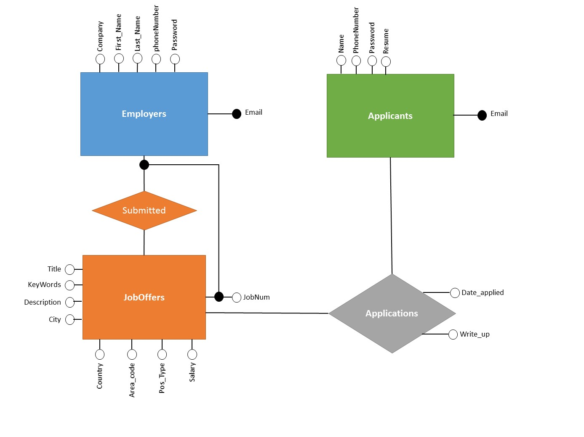

Figure 1. Entity Relation (ER) Diagram for the application

# Relational Schema

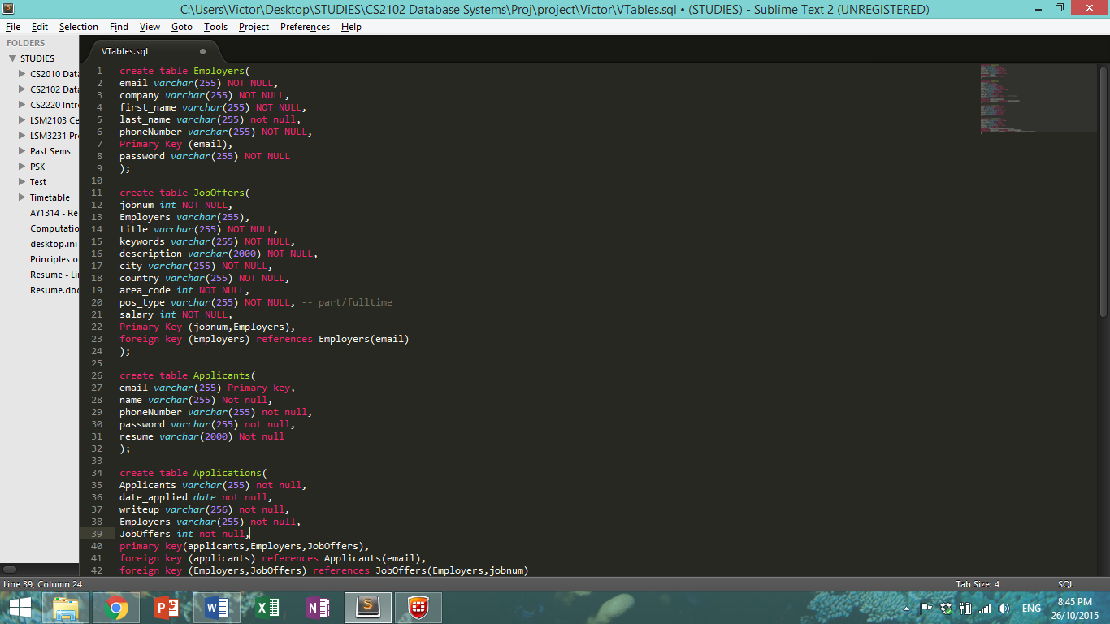

Figure 2. Relational Schema for Employers in SQL DDL



Figure 3. Relational Schema for Job Offers in SQL DDL



Figure 4. Relational Schema for Applicants in SQL DDL

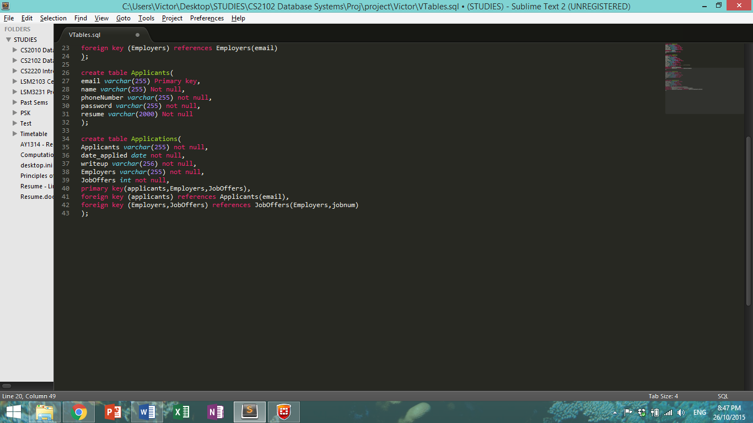

Figure 5. Relational Schema for Job application in SQL DDL

# Sample and Representative SQL code and function

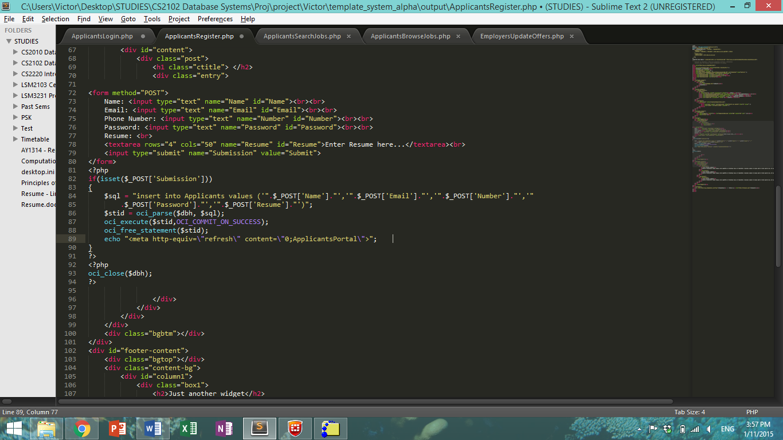

Figure 6. Applicants Register SQL code

Figure 6 shows the SQL code when a person register as an applicants to browse and apply for jobs. It will insert into the database their information so that employers can look through the information of the applicants. Similar code also exist for the employer side where they can register as an employer to submit job offers.

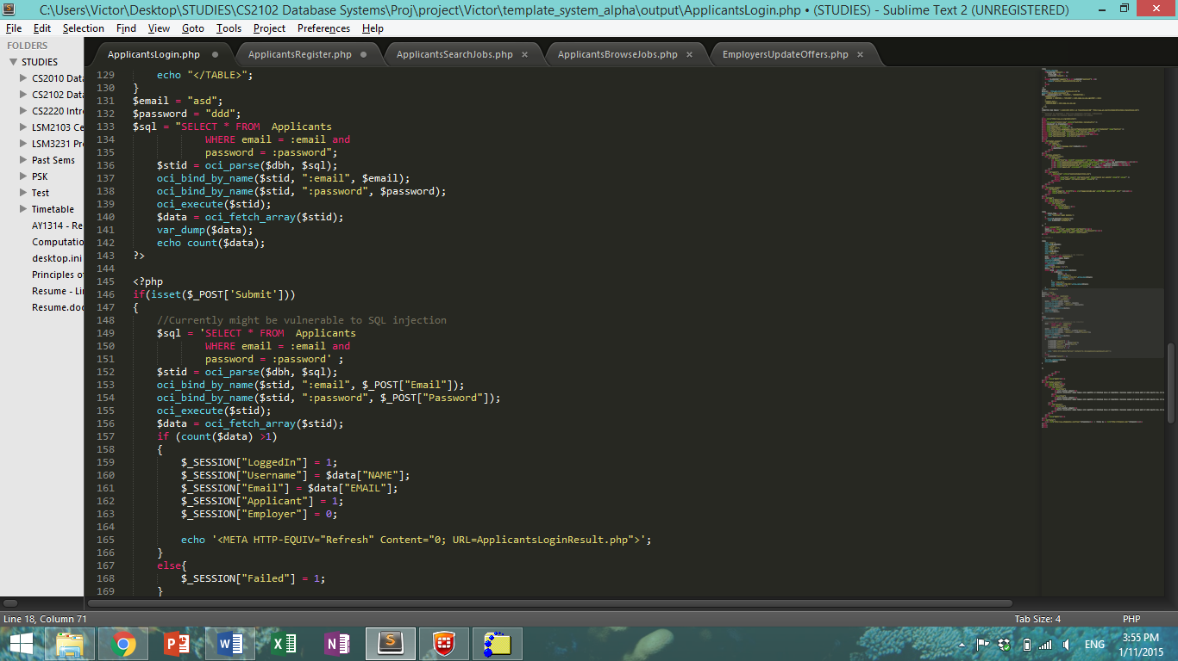

Figure 7. Applicants Login SQL code

Figure 7 shows the SQL code to search the database for applicants to log them into the system. The SQL code check the database for the presence of such applicants and check if their password is correct before logging them in. Similar code exist for the employer side so that employers can log in also.

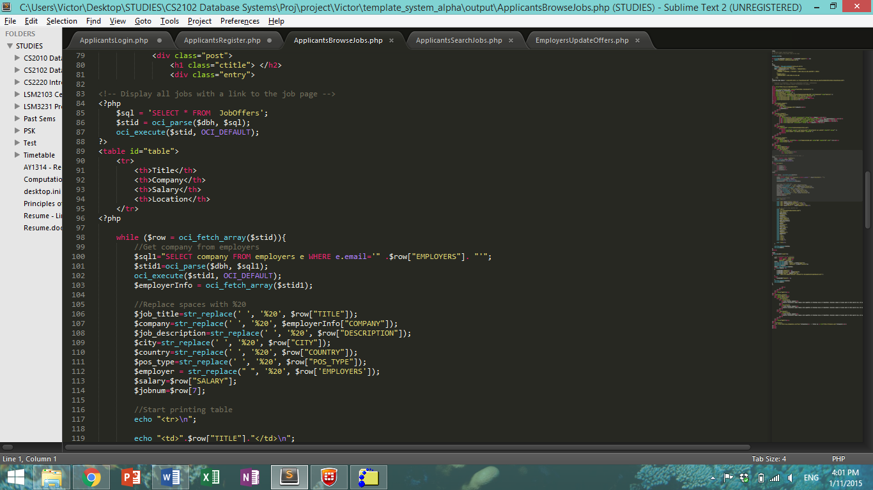

Figure 8. Applicants Browse Job Offers SQL code

Figure 8 shows the SQL code to display the job offers for applicants to see, with a link for applicantion besides each jobs.

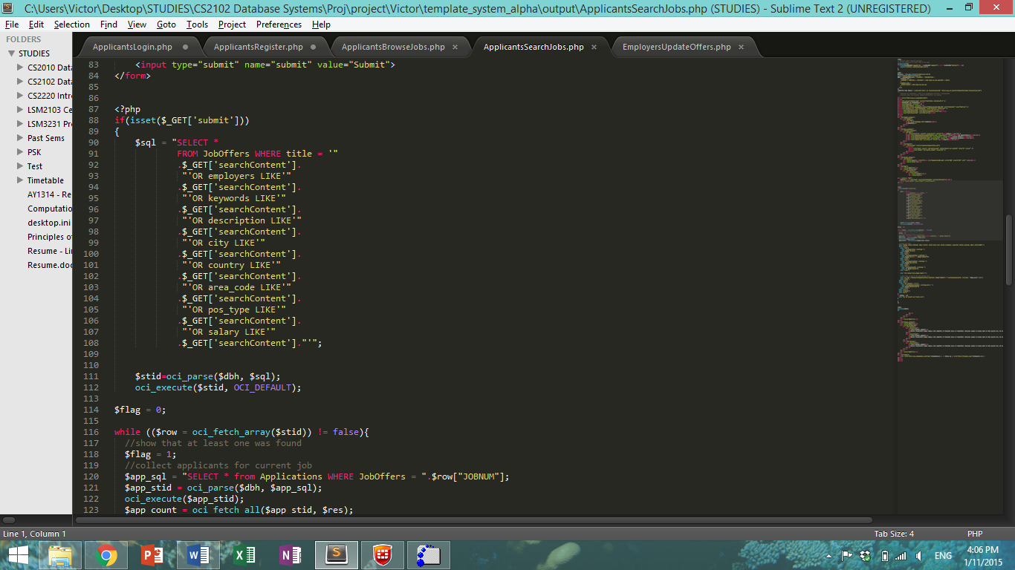

Figure 9. Applicants Search Job Offers SQL code

Figure 9 shows the SQL code for the applicants to search the database for job offers submitted with certain keywords. The code search all content of the job offers including the employer, keywords, description, location, position type and salary.

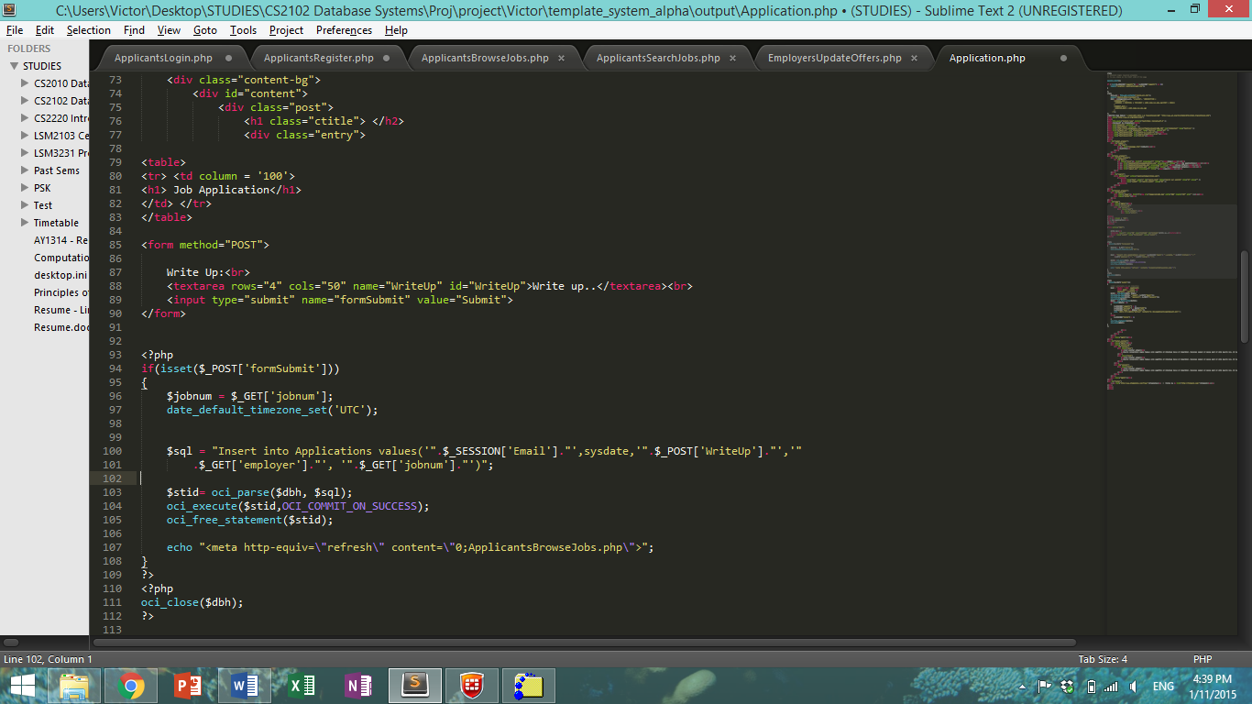

Figure 10. Applicant Application for Jobs SQL code

Figure 10 show the code when the applicants apply for jobs. It will add the application into the database.

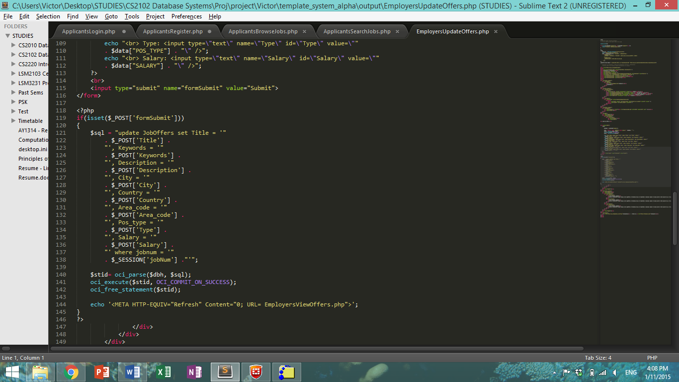

Figure 11. Employer Update Job Offers SQL code

# Screen shots of Web Interface

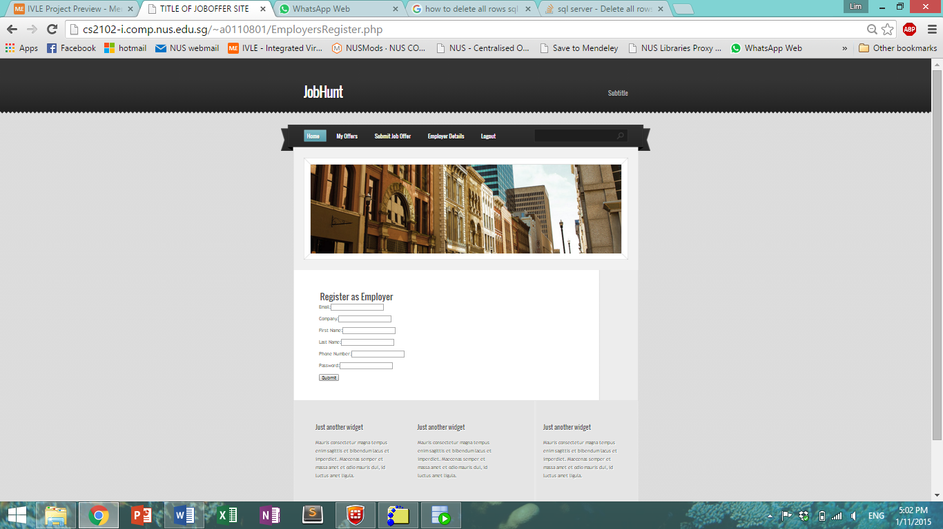

Figure 12. Screenshot of Register as Employer

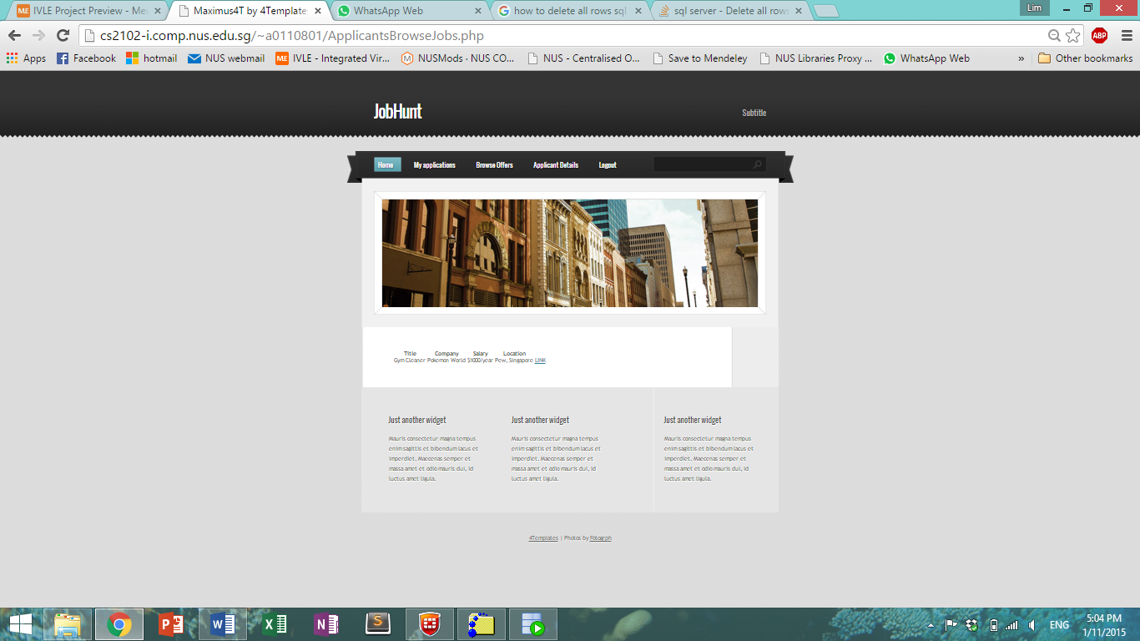

Figure 13. Screenshot of Browse Job Offers