
SMART PARKING MANAGEMENT SYSTEM

SYSTEM DOCUMENTATION

SUBMITTED BY,
YOUR FULL OFFICIAL NAME
YOUR ADMNO

A SYSTEM DOCUMENTATION SUBMITTED IN PARTIAL FULFILMENT FOR THE AWARD OF DIPLOMA IN ?????????????????????????? BY ZETECH UNIVERSITY

APRIL 2026

DECLARATION

DEDICATION

ABSTRACT

DEFINITION OF KEY TERMS

ABBREVIATIONS AND ACRONYMS

LIST OF FIGURES

LIST OF TABLES

TABLE OF CONTENTS

CHAPTER ONE: PROJECT PLANNING AND ANALYSIS
(WORKPLAN)
  - Statement of Problem
Urban areas are increasingly experiencing rapid growth in vehicle ownership, leading to high demand for parking spaces in commercial, residential, and public areas. Despite this , many parking facilities, particularly in developing and middle-income cities, continue to rely on manual or semi-automated systems for tracking available parking slots, vehicle entry and exit, and payment collection. Such methods often result in inefficiencies, overcrowding, disputes over space allocation, and loss of revenue(Bibri, 2020).
In the parking facilities under study, information about vehicle occupancy, slot availability, and booking is recorded manually or across disconnected digital tools that do not communicate with each other. This fragmentation limits the ability of parking attendants and management to provide real-time information to drivers, optimize space utilization, and monitor facility usage effectively (Malikopoulos, 2024). observations indicate that these manual systems contribute to congestion, extended waiting times for parking, unauthorized use of slots, and customer dissatisfaction.
As vehicle numbers continue to rise and urban traffic congestion intensifies, reliance on manual or poorly integrated parking management systems becomes unsustainable (Malikopoulos, 2024). Without a centralized and automated system to manage parking operations, monitor slot availability, and secure transactions, parking facilities face inefficiency, revenue loss, and reduced customer satisfaction. (Gragera, 2021)This creates a pressing need to design and implement an integrated Parking Management System that centralizes parking data, automates operations, enhances security, and supports real-time decision-making for both management and driver

  - Study Justification
The development of a smart parking Management System is justified by the increasing demand for efficient, accurate, and secure car parking services. A Smart Parking System will addresses these challenges by providing parking availability, online reservations and automated slot management (Gragera, 2021). The system will minimize congestion, save time, improve security and ensures efficient use of available parking spaces.

  - System Objectives

    - General Objective
- To design and develop smart parking Management System

    - Specific Objectives
(i) To implement a user authentication system that controls access to the parking management system.
(ii) To develop a database for secure storage and management of parking slot, vehicle, and booking records.
(iii) To enhance parking security by implementing a vehicle entry and exit logging mechanism.
(iv) To implement a secure payment module for recording and managing parking transactions.

  - Functional Requirements
User | User Activities | Features
Parking attendant | - Record vehicle entry and exit  - Assign parking slots  - Confirm driver reservations  - Update slot status | - Vehicle entry/exit logging  - Parking slot allocation  - Reservation verification  - Slot status update
Driver | - Register and log in  - View available parking slots  - Book a parking space  - Make parking payment  - View booking history | - User login and registration  - Parking slot availability display  - Slot booking system  - Payment module  - Booking history
Administrator (Admin) | - Manage system users  - Add or update parking slots  - Monitor parking records  - View payment transactions  - Generate reports | - Admin login dashboard  - User management system  - Parking slot management  - Transaction monitoring  - Report generation
Table 1.4 Functional Requirements Table

  - Breakdown of Tools & Resources to Be Used
1. Laptop
• Specifications: Intel Core i5, 8GB RAM, 512GB SSD, Windows 11
• Purpose: Used for system development, testing, and documentation.
2. Front End
• Languages: HTML, CSS, JavaScript
• Purpose: Used to create the user interface for drivers, attendants, and admin.
3. IDE
• Tool: Visual Studio Code
• Purpose: Used for writing and managing the system code.
4. Back End
• Technologies: Nodejs, MySQL
• Purpose: Used to handle system logic and communication with the database.
5. Database
• System: MySQL
• Purpose: Stores user details, parking records, and payment information.
6. Internet
• Speed: 5 Mbps
• Purpose: Used for research, testing, and system deployment.
7. Deployment
• Platform: Free web hosting service
• Purpose: Used to host the parking management system online.

1.6 Project Schedule Breakdown
 | PROJECT MILESTONES
WEEKS | Project Planning & Analysis  (System Documentation: Coverpage & Chapter One) | Project Design & Modeling  (System Documentation Chapter Two) | Project Development & Testing  (System Documentation Chapter Three) | Project Deployment  (System Documentation Chapter Three) | Final Touches of System Documentation  (Preliminary Pages, Chapter Four & References) | Project Presentation
7-9 Jan
12-16 Jan
19-23 Jan
26-30 Jan
2-6 Feb
9-13 Feb
16-20 Feb
23-27 Feb
2-6 Mar
9-13 Mar
16-20 Mar
23-27 Mar
3rd April
Table 1.6 Project Schedule Breakdown

CHAPTER TWO: DESIGN AND MODELING

2.1 Introduction to Modelling
This chapter presents the design and modeling artifacts that were developed to visualize the Parking Management System before actual implementation. Modeling the system prior to development provided several benefits, including identifying potential design flaws early, ensuring all functional requirements were addressed, and creating a clear roadmap for developers. The models presented in this chapter translate the functional requirements identified in Chapter One into visual representations that guide the development process. These designs include user interface models showing how the system will appear to different users, and logic models illustrating the underlying processes, data structures, and interactions that enable the system to function as specified. By modeling the system first, the development team gains a shared understanding of the system's behavior, data flows, and user interactions, which reduces ambiguity and accelerates the coding phase.

2.2 User Interface Models
The user interface models presented in this section represent hand-sketched designs of all system screens. These designs were created to visualize how users will interact with the system before coding began, ensuring that all functional requirements are accommodated in the user experience. Each interface is designed with the end-user in mind, following principles of simplicity, clarity, and consistency.
2.2.1 Login Page Design
The login page serves as the entry point for all system users: drivers, parking attendants, and administrators. The hand-sketched design shows a clean layout with a centered card containing two input fields labeled "Email/Username" and "Password," a "Login" button, and a link for new drivers to "Register here." The design also includes a simple header with the system logo and name. This interface implements the user authentication requirement by providing a secure gateway to the system.
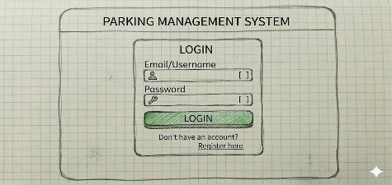
Fig 2.2.1 Login Page Design, Hand-Sketched
2.2.2 Driver Registration Form Design
The registration form is designed for new drivers to create an account. The sketch displays a form with fields for Full Name, Email Address, Phone Number, Vehicle Registration Number, Password, and Confirm Password. Below the fields, a "Register" button and a link back to the login page are included. Validation notes are sketched near each field (e.g., "password must be at least 8 characters"). This interface implements the user registration functional requirement.
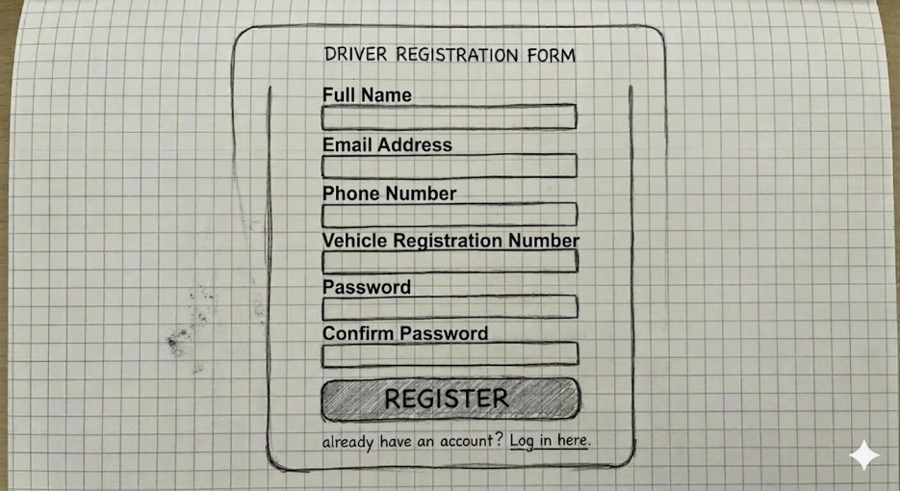
Fig 2.2.2 Driver Registration Form Design, Hand-Sketched
2.2.3 Driver Dashboard Design
The driver dashboard is the main screen after login. The hand-sketch shows a top navigation bar with links to "Available Slots," "My Bookings," "Payments," and "Profile." The central area displays a grid of parking slots, each represented by a rectangle. Available slots are colored green, booked slots are yellow, and occupied slots are red. A legend explains the colors. Below the grid, a summary shows the number of available slots and a quick booking option. This interface implements the parking slot availability display functional requirement.
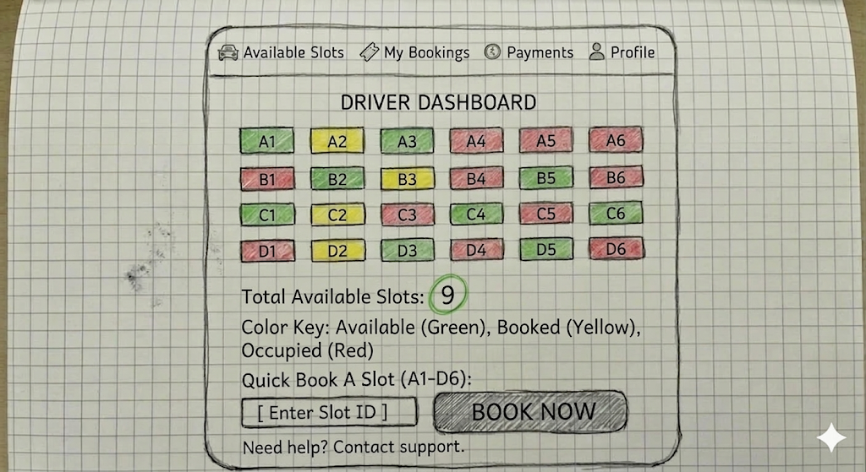
Fig 2.2.3 Driver Dashboard Design, Hand-Sketched

2.2.4 Slot Booking Form Design
When a driver clicks on an available slot, the booking form appears. The sketch shows a pop-up card with the slot number, location details, hourly rate, and a date/time picker for selecting the booking duration. A "Calculate Total" button displays the estimated cost. After confirmation, a "Confirm Booking" button is enabled. This interface implements the slot booking system functional requirement.
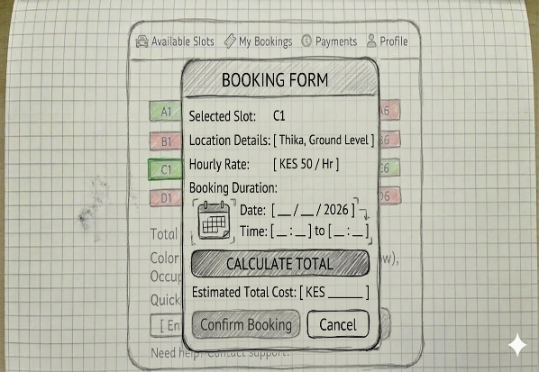
Fig 2.2.4 Slot Booking Form Design, Hand-Sketched
2.2.5 Payment Module Design
The payment interface displays the booking summary (slot, duration, total amount) and presents payment options: "Cash" and "Mobile Money." For mobile money, fields for phone number and payment provider are shown. A "Pay Now" button processes the payment. Below the button, a placeholder for a payment confirmation message appears. This interface implements the payment module functional requirement for drivers.
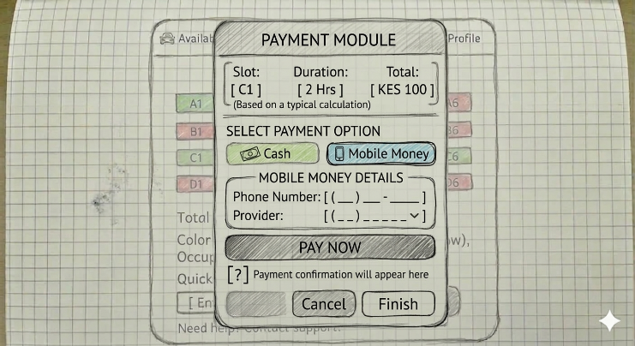
Fig 2.2.5 Payment Module Design, Hand-Sketched

2.2.6 Attendant Dashboard Design
The attendant dashboard is optimized for quick actions. The hand-sketch includes a top bar with the current date and time, and a notification area. The main section contains large buttons: "Record Entry," "Record Exit," "View Occupancy," "Verify Reservation," and "Update Slot Status." Below the buttons, a mini-map of the parking lot shows real-time occupancy with color-coded slots. This interface implements the attendant's core functional requirements: vehicle entry/exit logging, slot allocation, reservation verification, and slot status updates.
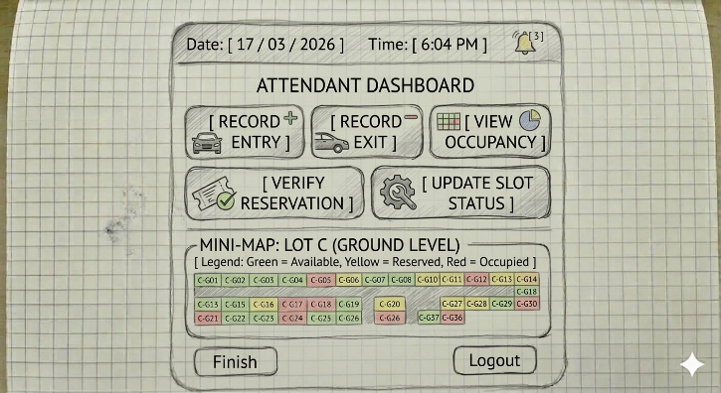
Fig 2.2.6 Attendant Dashboard Design, Hand-Sketched
2.2.7 Vehicle Entry Logging Interface
This screen appears when the attendant clicks "Record Entry." The sketch shows a simple form with a field for "Vehicle Registration Number," a dropdown for "Select Slot" (with only available slots listed), and a button "Auto-assign Slot." Below, a section displays driver details if the vehicle is linked to a reservation. A "Confirm Entry" button records the entry and updates the slot status. This interface implements the vehicle entry logging functional requirement.
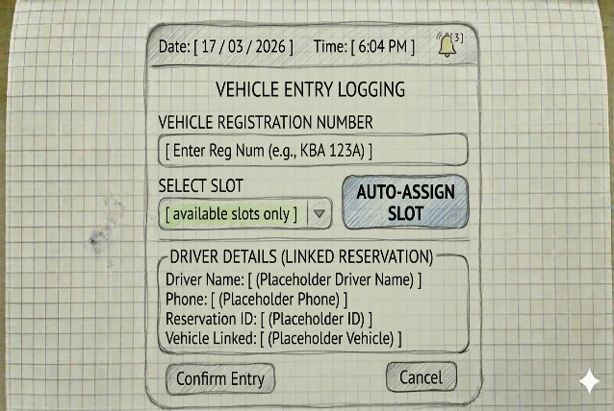
Fig 2.2.7 Vehicle Entry Logging Interface Design, Hand-Sketched
2.2.8 Vehicle Exit Logging Interface
When processing an exit, the attendant sees a similar form. The sketch includes a field for "Vehicle Registration Number" and a "Lookup" button that retrieves the entry record. The system displays the entry time, calculated duration, and total charges. A "Payment Received" checkbox (for cash payments) and a "Process Exit" button complete the transaction. This interface implements the vehicle exit logging functional requirement.
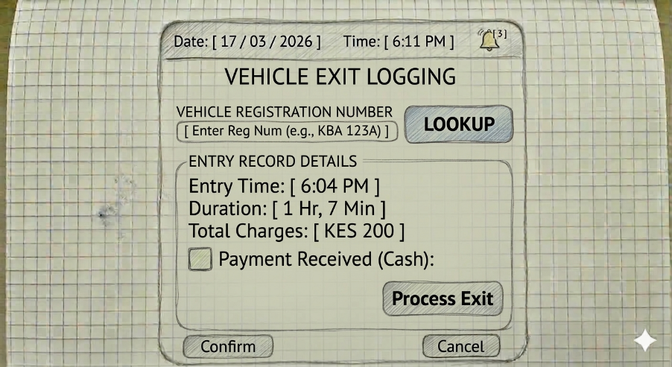
Fig 2.2.8 Vehicle Exit Logging Interface Design, Hand-Sketched

2.2.9 Reservation Verification Interface
This interface lists all upcoming and active reservations. The sketch shows a table with columns: Reservation ID, Driver Name, Vehicle Number, Slot Number, Start Time, End Time, and Status. A search bar allows filtering by vehicle number. Each row has a "Verify" button that the attendant clicks when the driver arrives, automatically marking the reservation as checked in and updating the slot status. This interface implements the reservation verification functional requirement.
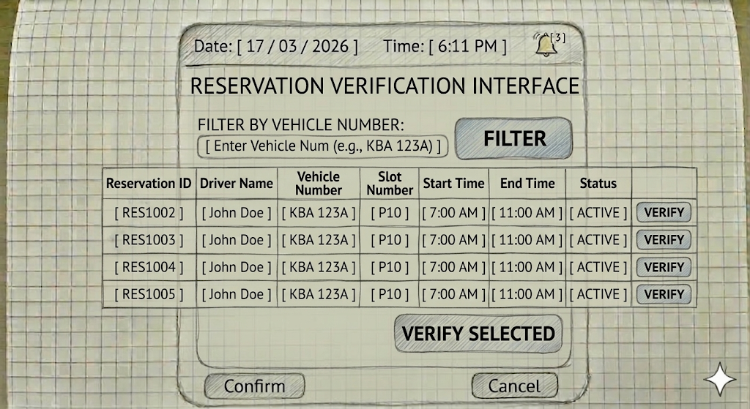
Fig 2.2.9 Reservation Verification Interface Design, Hand-Sketched
2.2.10 Administrator Dashboard Design
The admin dashboard provides an overview of system health. The hand-sketch displays a top row of summary cards: Total Users, Active Bookings, Occupancy Rate, Today's Revenue. Below, line charts show occupancy trends and revenue over time. A sidebar menu includes links to "User Management," "Slot Management," "Payment Monitoring," and "Reports." This interface implements multiple admin functional requirements.
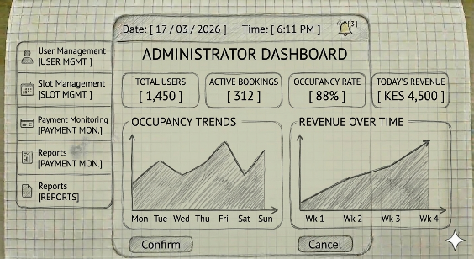
Fig 2.2.10 Administrator Dashboard Design, Hand-Sketched
2.2.11 User Management Interface Design
Admins can manage all users through this interface. The sketch shows a table with columns: ID, Name, Email, User Type (Driver/Attendant/Admin), Status (Active/Inactive). Buttons for "Add New User," "Edit," "Deactivate" appear above the table. A filter dropdown allows filtering by user type. This interface implements the manage system users functional requirement. Fig 2.2.11 User Management Interface Design, Hand-Sketched
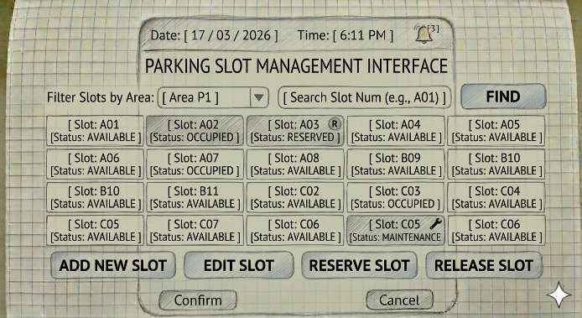
2.2.12 Parking Slot Management Interface Design
This interface allows admins to configure parking slots. The sketch shows a visual grid of slots, each with a slot number and status. Admins can click a slot to edit its details (rate, type, availability). Buttons for "Add New Slot" and "Bulk Update" are provided. A form on the side allows updating slot details manually. This interface implements the add or update parking slots functional requirement.
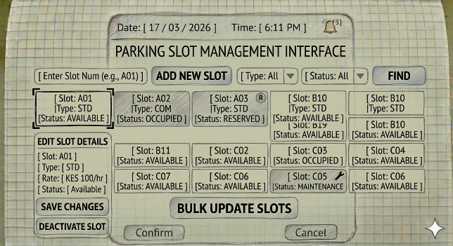
Fig 2.2.12 Parking Slot Management Interface Design, Hand-Sketched

2.2.13 Payment Monitoring Interface Design
Admins view all payment transactions here. The sketch displays a table with columns: Transaction ID, Driver Name, Amount, Payment Method, Status (Paid/Pending/Refunded), Date. Filters by date range and status are available. An "Export" button allows downloading the data. This interface implements the view payment transactions functional requirement.
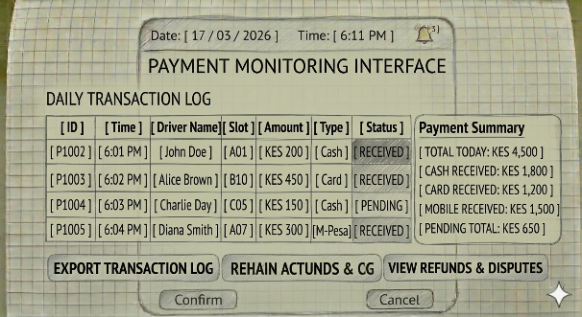
Fig 2.2.13 Payment Monitoring Interface Design, Hand-Sketched

2.2.14 Reports Generation Interface Design
The reports interface provides options to generate various reports. The sketch shows radio buttons for report type: Occupancy Report, Revenue Report, User Activity Report. Date range pickers and a "Generate Report" button are included. Below, a preview area shows a sample report table. Export buttons for PDF and Excel are placed at the bottom. This interface implements the generate reports functional requirement.
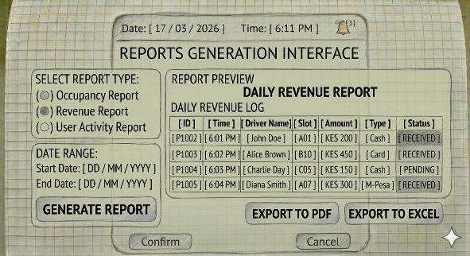
Fig 2.2.14 Reports Generation Interface Design, Hand-Sketched
2.2.15 Booking History Display Design
Drivers can view their past and upcoming bookings. The sketch shows a list of bookings in card format, each displaying slot number, date, duration, total paid, and status (Upcoming/Completed/Cancelled). A "View Details" button expands each card. This interface implements the booking history functional requirement for drivers.
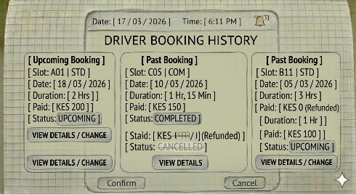
Fig 2.2.15 Booking History Display Design, Hand-Sketched

2.3 Logic Models
This section presents the process architecture diagrams that visualize how the system will function internally. These models illustrate data flows, process sequences, and system structures that implement the functional requirements. Each diagram is described in detail, and its role in the development process is explained.
2.3.1 System Use Case Diagram
The use case diagram provides a high-level view of the system's functionality and the actors that interact with it. The hand-sketched diagram shows three actors: Driver, Parking Attendant, and Administrator. Use cases for the Driver include: Register, Log in, View Available Slots, Book Slot, Make Payment, View Booking History. Use cases for the Attendant include: Log Vehicle Entry, Log Vehicle Exit, Assign Slot, Verify Reservation, Update Slot Status. Use cases for the Administrator include: Manage Users, Manage Slots, Monitor Payments, Generate Reports. The diagram clearly links each actor to their respective functional requirements, ensuring complete coverage.
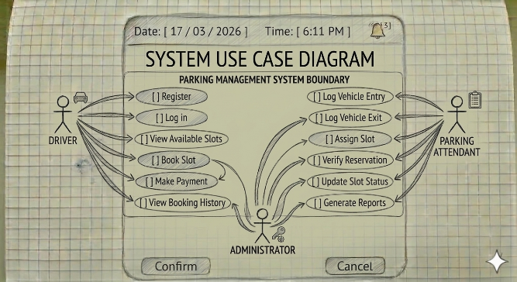
Fig 2.3.1 System Use Case Diagram, Hand-Sketched
2.3.2 User Registration and Login Process Flowchart
This flowchart details the steps for user registration and authentication. The diagram starts with the "Login Page" decision point. If the user is new, they navigate to the registration form, fill in details, and submit. The system validates input (e.g., email format, password strength) and checks for duplicate email. If validation fails, error messages are shown; if successful, the user record is saved in the database and a success message appears. For existing users, they enter credentials; the system verifies them against the database. On success, the user is redirected to their respective dashboard based on user type. This flowchart ensures that the authentication mechanism is correctly implemented. Fig 2.3.2 User Registration and Login Process Flowchart, Hand-Sketched
2.3.3 Slot Booking Process Flowchart
The booking process flowchart begins when a driver views available slots. The driver selects a slot and chooses booking duration. The system checks if the slot is still available (to handle concurrent bookings). If unavailable, an error message prompts the driver to choose another. If available, the system calculates the total cost and displays payment options. After the driver confirms payment, the system processes the payment (via integrated gateway or marks as pending for cash). Upon successful payment, a booking record is created, the slot status is updated to booked, and a confirmation is shown. This flowchart implements the slot booking system and payment module requirements. Fig 2.3.3 Slot Booking Process Flowchart, Hand-Sketched
2.3.4 Vehicle Entry Process Flowchart
This flowchart models the actions taken by an attendant when a vehicle arrives. The attendant enters the vehicle registration number. The system checks if there is an existing reservation for that vehicle. If a reservation exists, it is verified and the corresponding pre-booked slot is assigned. If not, the system presents a list of available slots for manual selection or auto-assigns one. The attendant confirms the entry, and the system records the entry timestamp, updates the slot status to occupied, and optionally sends a notification to the driver. This flowchart implements vehicle entry logging and reservation verification. Fig 2.3.4 Vehicle Entry Process Flowchart, Hand-Sketched
2.3.5 Vehicle Exit Process Flowchart
When a vehicle exits, the attendant enters the registration number. The system retrieves the associated entry record. It calculates the parking duration and total charge based on the slot's hourly rate. If the driver already paid online, the system marks the payment as completed. If not, the attendant collects cash and records the payment. The system then updates the slot status to available, records the exit timestamp, and generates a receipt. This flowchart implements vehicle exit logging and payment recording. Fig 2.3.5 Vehicle Exit Process Flowchart, Hand-Sketched
2.3.6 Class Diagram for the System
The class diagram represents the static structure of the system. The hand-sketched diagram includes the following classes: User (abstract, with attributes: userID, name, email, password, userType), Driver (extends User, with vehicleNumber), Attendant (extends User), Administrator (extends User). ParkingSlot (slotID, location, rate, status). Booking (bookingID, driverID, slotID, startTime, endTime, totalCost, status). Payment (paymentID, bookingID, amount, method, status, timestamp). VehicleEntry (entryID, bookingID, vehicleNumber, entryTime, slotID, attendantID). VehicleExit (exitID, entryID, exitTime, attendantID). Relationships (one-to-many, many-to-one) are drawn with appropriate multiplicities. This diagram directly supports the database design requirement.
Fig 2.3.6 Class Diagram for the System, Hand-Sketched
2.3.7 Sequence Diagram for Slot Booking Process
This sequence diagram illustrates the interaction between objects during booking. Objects include Driver, BookingInterface, BookingController, SlotManager, PaymentProcessor, and Database. The flow: Driver selects slot and duration → BookingInterface sends request to BookingController → BookingController calls SlotManager.checkAvailability() → SlotManager queries Database → if available, BookingController creates a Booking object and calls PaymentProcessor.processPayment() → PaymentProcessor interacts with external gateway or records cash payment → on success, BookingController saves Booking to Database and updates Slot status. The diagram clarifies the order of method calls and data flow. Fig 2.3.7 Sequence Diagram for Slot Booking Process, Hand-Sketched
2.3.8 Sequence Diagram for Vehicle Entry Process
This diagram shows the objects involved in vehicle entry: Attendant, EntryInterface, EntryController, SlotManager, BookingVerifier, Database. The attendant enters vehicle number → EntryController calls BookingVerifier.checkReservation(vehicleNumber) → BookingVerifier queries Database → if reservation exists, returns booking details; EntryController assigns the booked slot; otherwise, EntryController calls SlotManager.getAvailableSlots() → SlotManager queries Database → returns list → attendant selects slot → EntryController creates VehicleEntry record and updates Slot status in Database. This sequence ensures that the entry process is correctly coordinated. Fig 2.3.8 Sequence Diagram for Vehicle Entry Process, Hand-Sketched
2.3.9 Entity Relationship Diagram (ERD)
The ERD details the database schema. Tables: users (user_id PK, name, email, password, user_type, vehicle_number, created_at). parking_slots (slot_id PK, slot_number, location, hourly_rate, status). bookings (booking_id PK, user_id FK, slot_id FK, start_time, end_time, total_cost, status). payments (payment_id PK, booking_id FK, amount, payment_method, status, transaction_id, created_at). vehicle_entries (entry_id PK, booking_id FK, vehicle_number, entry_time, slot_id FK, attendant_id FK). vehicle_exits (exit_id PK, entry_id FK, exit_time, attendant_id FK). Relationships are drawn with crow's foot notation. This ERD directly implements the requirement for secure storage and management of parking data.
Fig 2.3.9 Entity Relationship Diagram, Hand-Sketched
2.3.10 Data Flow Diagram (Level 0 - Context Diagram)
The context diagram shows the entire system as a single process with external entities: Driver, Attendant, Administrator, and Payment Gateway. Data flows: from Driver to System (registration details, booking requests, payment info); from System to Driver (slot availability, booking confirmation, receipts); from Attendant to System (vehicle entry/exit data, reservation verifications); from System to Attendant (slot status, driver info); from Administrator to System (user/slot management commands, report requests); from System to Administrator (reports, transaction data); and with Payment Gateway (payment requests, confirmations). This diagram defines the system boundary. Fig 2.3.10 Data Flow Diagram (Level 0 - Context Diagram), Hand-Sketched
2.3.11 Data Flow Diagram (Level 1)
The Level 1 DFD decomposes the main system into processes: 1.0 User Management, 2.0 Slot Management, 3.0 Booking Management, 4.0 Payment Processing, 5.0 Report Generation. Data stores: D1 Users, D2 Slots, D3 Bookings, D4 Payments. Flows between processes and stores are shown. For example, Booking Management reads/writes to Slots and Bookings, and triggers Payment Processing. This diagram helps developers understand data movement and process dependencies. Fig 2.3.11 Data Flow Diagram (Level 1), Hand-Sketched
2.3.12 Payment Processing Flowchart
This flowchart details the payment sub-process. It begins after booking details are confirmed. The system calculates the total amount. The driver selects payment method (cash or mobile money). If cash, the system creates a pending payment record and informs the attendant to collect at exit. If mobile money, the system initiates a request to the payment gateway, waits for callback, and updates payment status accordingly. On success, the booking is confirmed; on failure, the driver is prompted to retry or choose another method. This flowchart ensures robust payment handling. Fig 2.3.12 Payment Processing Flowchart, Hand-Sketched
2.3.13 Administrator Report Generation Flowchart
This flowchart illustrates the steps an admin takes to generate a report. The admin selects report type (occupancy, revenue, user activity), specifies date range, and optionally adds filters. The system queries the relevant data stores, aggregates data, and displays a preview. The admin can then export the report in PDF or Excel format. This process implements the generate reports functional requirement. Fig 2.3.13 Administrator Report Generation Flowchart, Hand-Sketched
2.3.14 Slot Status Update State Diagram
The state diagram models the lifecycle of a parking slot. States: Available, Booked, Occupied, Under Maintenance. Transitions: Available → Booked (when driver books); Booked → Occupied (when vehicle enters); Occupied → Available (when vehicle exits); Available → Under Maintenance (admin action); Under Maintenance → Available (admin action); Booked → Available (if booking expires or is canceled). This diagram ensures that slot status changes are correctly managed in the system.
Fig 2.3.14 Slot Status Update State Diagram, Hand-Sketched
2.3.15 System Architecture Diagram
The system architecture diagram shows the technical layers. At the top, the Presentation Layer includes HTML, CSS, JavaScript running in the browser. Below, the Business Logic Layer is implemented in Nodejs on a web server, handling HTTP requests, session management, and business rules. The Data Layer is a MySQL database. Arrows indicate request/response flow. This diagram aligns with the Breakdown of Tools & Resources from Chapter One and provides a blueprint for deployment. Fig 2.3.15 System Architecture Diagram, Hand-Sketched

CHAPTER THREE: SYSTEM IMPLEMENTATION
(DEVELOPMENT, TESTING AND DEPLOYMENT)

3.1 Introduction
This chapter provides an overview of the development ,testing and deployment phase of smart parking system .it details the transition form, design to a functional and technical solutions covering the construction other front user interface ,backend logic that handles data processing and testing procedures used to ensure the system works it describes the environment used to host the application of end user access

3.2 User Interface Development
3.2.1 sign in page design for driver

3.2.2 sign up page for diver

3.2.3

3.3 Logic Development
Your system has two sides – the user side (where different users can interact with the system) and the logic side. The logic side is how the system is performing activities using data e.g. login validation, processing checkout and generating a receipt, storing data into database, retrieving products from DB and showing them on a certain page. This is called logic.
Under this section you will screenshot all the Codes or Simulations that handle different processes/activities. Organize them into subheadings e.g. 3.3.1 Login Validation Code (herein, explain in brief how the system handles login, take screenshots of the login validation code, and caption it)
3.4 Testing
Detail out what actions you took to test whether different features of your system are working. And corrections you made to different parts to ensure that they are working as planned.

3.5 Deployment
Mention on what platform have you deployed your system (e.g. if it’s a website, what web hosting platform did you use – and copy paste a link to your website, if it’s an android application – the process of putting up your app on Google Playstore.). Essentially, detail out the process of how you transformed your project into a form that can be run/installed by anybody.

CHAPTER FOUR: CONCLUSION AND RECOMMENDATION
4.1 Conclusion
A paragraph summarizing chapter one, two and three. And finish by telling the reader what new things you learnt during the entire time developing your project, and challenges faced.

4.2 Recommendation
Here, speak as if addressing another developer of the same project you’ve been working on. Suggest to him/her things that they can do to improve the system if they so choose to pick it up and enhance it. E.g. if you created an e-receipt for customers, suggest to him/her to consider integrating a physical receipt printer since some customers would prefer that and also you couldn’t implement that because you didn’t have the budget for a printer. If your system is a staff clock-in-and-out system and in your system a staff has to type in their staff number into the system, suggest to the developer what better technologies he/she can use to enhance that specific part e.g. biometric or swipe-card, maybe since you did not have the budget to buy those devices and/or didn’t have the technical skills for that. Or if for payment your system is using Pay-After-Delivery, suggest to him/her to consider integrating with MPESA or Bank Card for pre-delivery payments.
NB: Recommendation is not an excuse for a NOT WORKING system, e.g. it is not saying that your system can’t store any data because you didn’t have the time to implement a database, No. It is a suggestion for how your ALREADY WORKING SYSTEM (with the lower technologies you’ve used) can be MADE BETTER, with HIGHER/BETTER TECHNOLOGIES. E.g. you used MySQL to store structured data, suggest for them to use a NO-SQL approach to store non-structured data like customer feedback and product reviews.

REFERENCES
A list of all the websites, articles, books, YouTube channels, AI Conversations (copy link address) that helped you during your project.
Format them in APA7 format, in alphabetical order.
A guide on referencing from web articles/tutorials: https://libraryguides.vu.edu.au/apa-referencing/7Webpages (see in-black-box)
A guide on referencing from social media articles: https://libraryguides.vu.edu.au/apa-referencing/7SocialMedia (see in-black-box)
A guide on referencing from conversations you had with AI e.g. ChatGPT: https://libraryguides.vu.edu.au/apa-referencing/generativeAI (scroll to end of page)

Done with references, now go back to PRELIMINARY PAGES (pages before chapter one), and fill those pages

