# Cloud foundry concepts

Cloud Foundry is an open source cloud application platform, providing a choice of clouds, developer frameworks, and application services. Cloud Foundry makes it faster and easier to build, test, deploy, and scale applications.

## Cloud Foundry Overview

### What is a cloud computing platform?

Broadly speaking, three major categories of cloud computing:

* Infrastructure-as-a-Service (IaaS), which provides only a base infrastructure, leaving the end user responsible for the platform and environment configurations necessary to deploy applications. Amazon Web Services and Microsoft Azure are prime examples of IaaS.
* Platform-as-a-Service (PaaS), which helps to reduce application development overhead (i.e. environment configuration) by providing a ready-to-use platform. PaaS services can be hosted on top of infrastructure provided by an IaaS.
* Software-as-a-Service (SaaS), which provide a finished product for end users, such as Gmail or Salesforce.

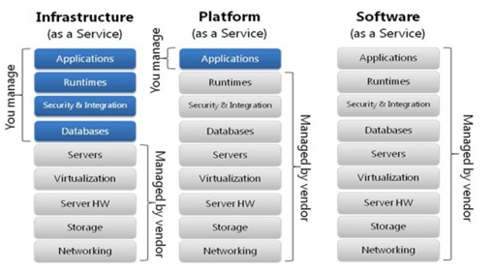

Since it’s easy to become a bit confused when thinking about cloud platforms, it’s important to be able to visualize exactly which elements of the compute ecosystem are which party’s responsibilities. While there is no precise definition, it’s reasonable to say that a platform requires only that you take care of your applications.

With that in mind, the platform layer should be able to provide the following features:

* A suitable environment to run an application.
* Application life cycle management.
* Self-healing capacity.
* Centralized management of applications.
* A distributed environment.
* Easy integration.
* Easy maintenance (such as upgrades, patches, etc.).

## History of Cloud Foundry

## Cloud Foundry Orgs, Spaces

|  |  |  |  |
| --- | --- | --- | --- |
| Cloud Foundry | SAP Cloud Foundry | Contains | Description |
| Foundation | Global Account | Orgs | For shared components: domains, service tiles, and the physical infrastructure |
| Org | Subaccount | Spaces | A group of users who share a resource quota plan, apps, services availability, and custom domains |
| Space | Space | Apps | A shared location for app development, deployment, and maintenance |

Dev, Quality, Production environment should be divided from Global account layer.

### Foundations

Foundations roughly map to a company and environments. See the following diagram for an illustration:

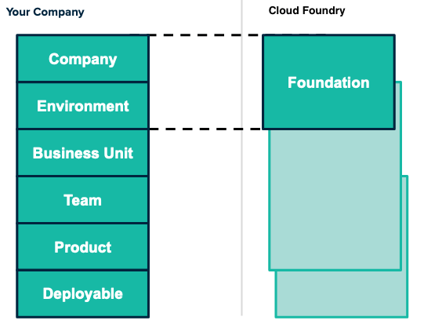

The diagram shows a box on the left labeled 'Your Company' and a box on the right labeled 'Cloud Foundry'. In the 'Your Company' box, there are two smaller boxes labeled 'Company' and 'Environment', which are linked to a section in the 'PCF Organizational Model' labeled 'Foundation'.

### Orgs

Orgs most often map to a business unit in a particular foundation. To understand how you can map your company structure to a Cloud Foundry org, see the diagram below:

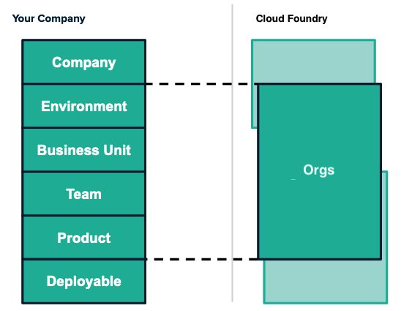

orgs can encompass Business Units, environments, teams, or products

### Spaces

Spaces can encompass teams, products and specific deployables. To understand how you can map your company structure to a Cloud Foundry space, see the diagram below:

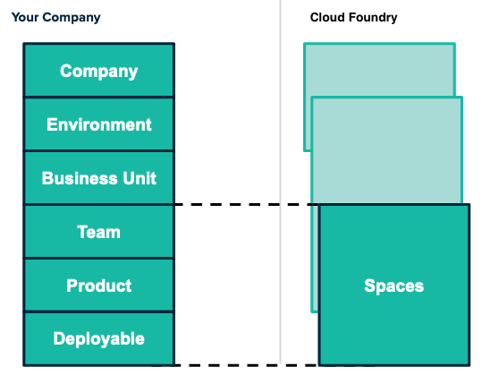

Spaces can encompass Teams, Products and specific deployables

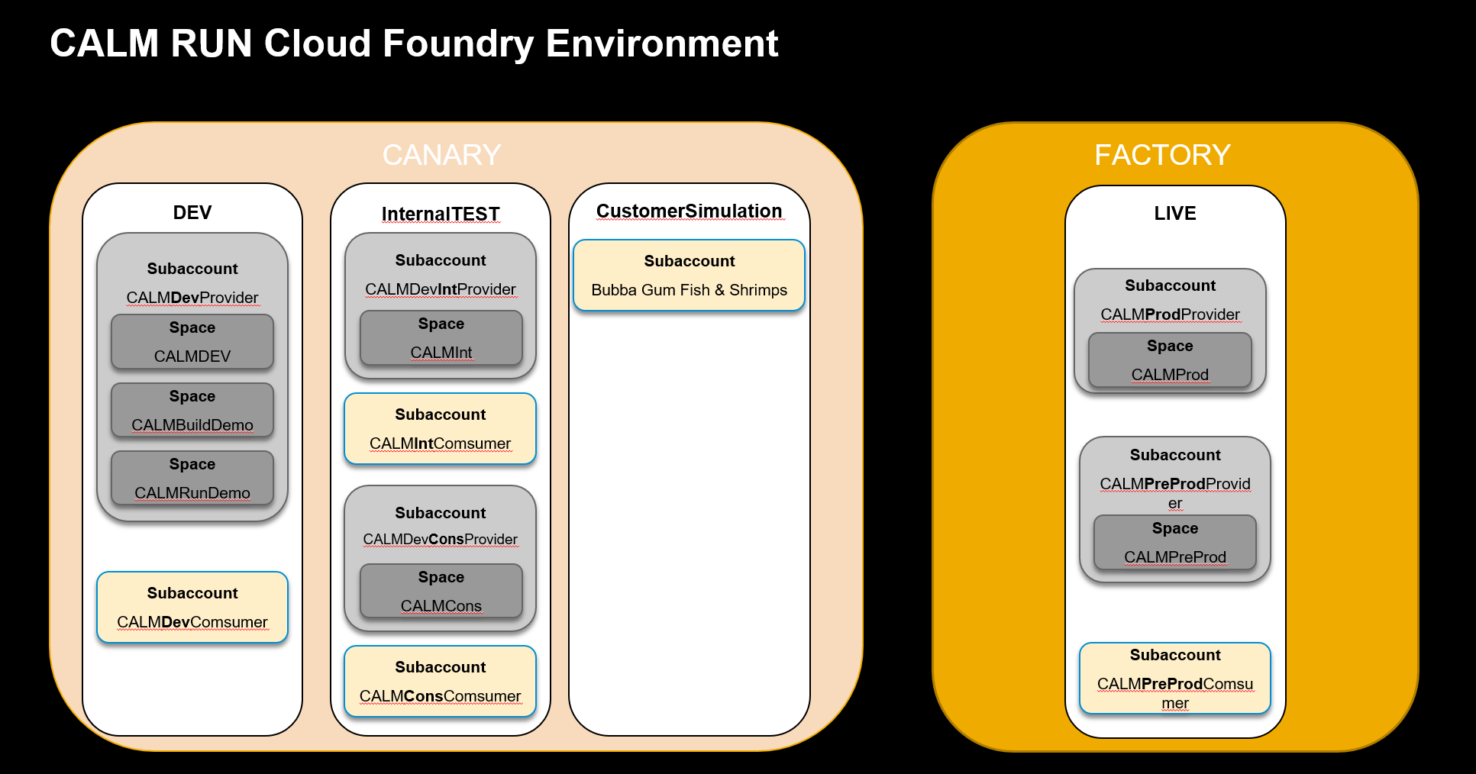

# Diego Components in Cloud Foundry

## What does Diego do?

Diego is the container runtime that tailor-made for the CF Application Runtime

## Sharing Service Instances

$ cf enable-feature-flag service_instance_sharing

$ cf share-service SERVICE-INSTANCE -s OTHER-SPACE [-o OTHER-ORG]

<https://jtrack.wdf.sap.corp/browse/CPCORE-1134?jql=text%20~%20%22share-service%22>

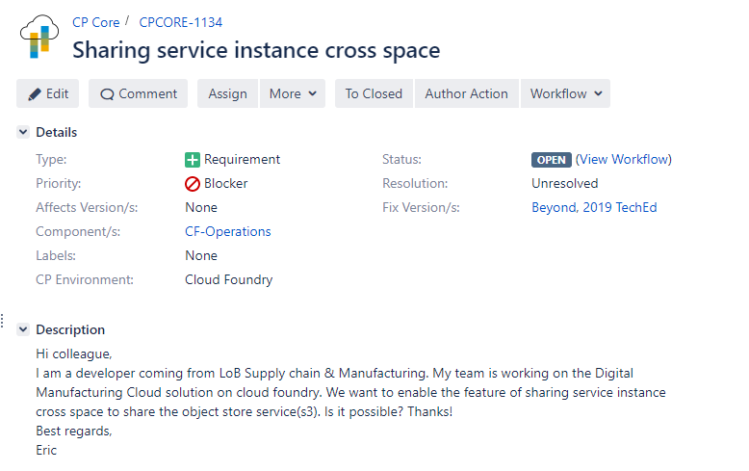

# References

<https://cloudacademy.com/blog/cloud-foundry-benefits/>